## The algorithm:

The main idea of this approach is to consider the order for pipair, while discovering bug by the method of part 1(a).

In our code implementation, we have change structure of HashMap ‘location’ from Map<Set,Set> into Map<List,Set>. For example, the key of this HashMap will store a list of [A,B] rather than a set of (A,B). In this way, we can distinguish the list of [A,B] from the list of [B,A].

More detailed steps are summarized as below:

Step 1: Traverse the call graphs to generate HashMap ‘location’.

Step 2: Call the HashMap ‘location’ to calculate support and confidence, and determine if a callee function is a bug in a caller function.

Step 3: If a bug is found, print that bug

## The output:

Run the command as below, and replace binary file name for different test case



Table1 the number of bug line for testcase

|  |  |  |
| --- | --- | --- |
|  | Part1(D) | Part1(A) |
| test2_3_65 | 2 | 4 |
| test3_3_65 | 226 | 205 |
| test3_10_80 | 34 | 34 |

## The analysis

As shown in table, we can see that Part1(D) has 2 bugs for test2_3_65.out, while Part1(A) has 4 bugs for test2_3_65.out, so the number of bug in Part1(D) is smaller. Besides, Part1(D) has 226 bugs for test3_3_65.out in total, but some parts of bugs are original bug in Part1(A) after reducing false positive, the other parts are new bugs. Also, the number of bug in test3_10_10.out is the same for Part1(A) and Part1(D).

### Reduce false positive

The goal of our approach is to extract beliefs from code and to check for violated beliefs.

**We should distinguish ordered pipair from disordered pipair. In Part1(A) the pipair has no order, and there are more pipair, which means the support of pipair will be larger. It increases the portability to meet threshold support and confidence for generating May Belief. In Part1(D), the support of ordered pipair is smaller and there will be less May Belief to check bug. As a result May Belief in Part1(A) is not a May Belief in Part(D), and false positive will be reduced in Part1(D). For example, the support of (A,B) is 3 in Part1(A) test2_3_65.out. But the support of [A,B] is 2 and support of [B,A] is 1 in Part1(D) test2_3_65.out, so the support of [A,B] or [B,A] in Part1(D) does not meet threshold support, so Part1(D) only print 2 bug. In this way the false positive is reduced.**

**Part1(A) test2_3_65.out**

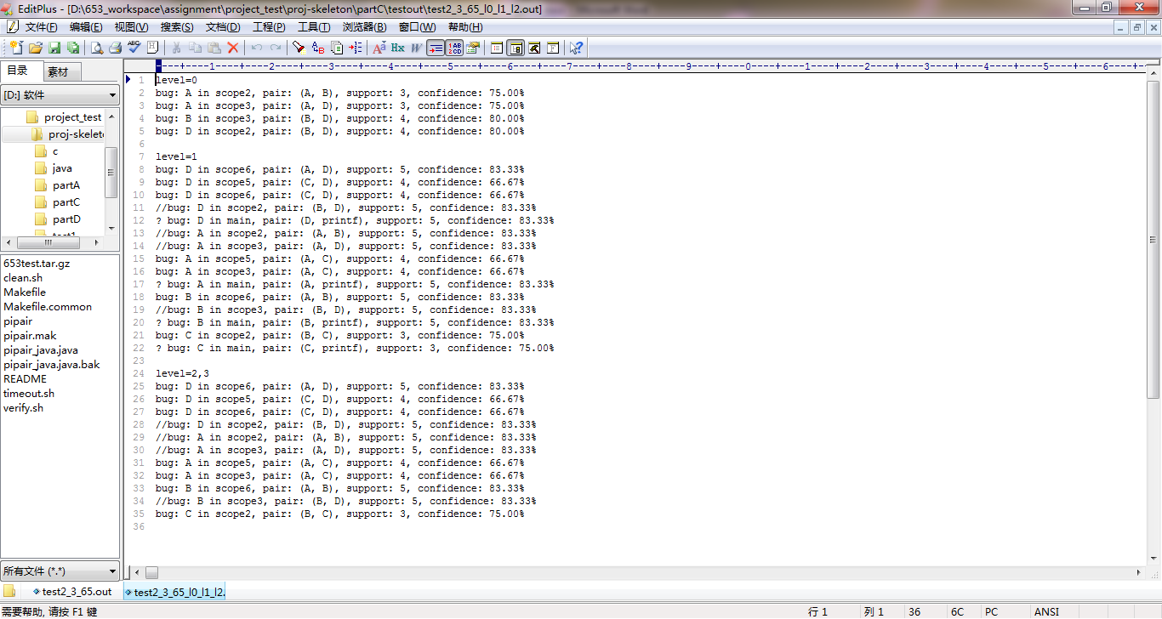

**Part1(D) test2_3_65.out**

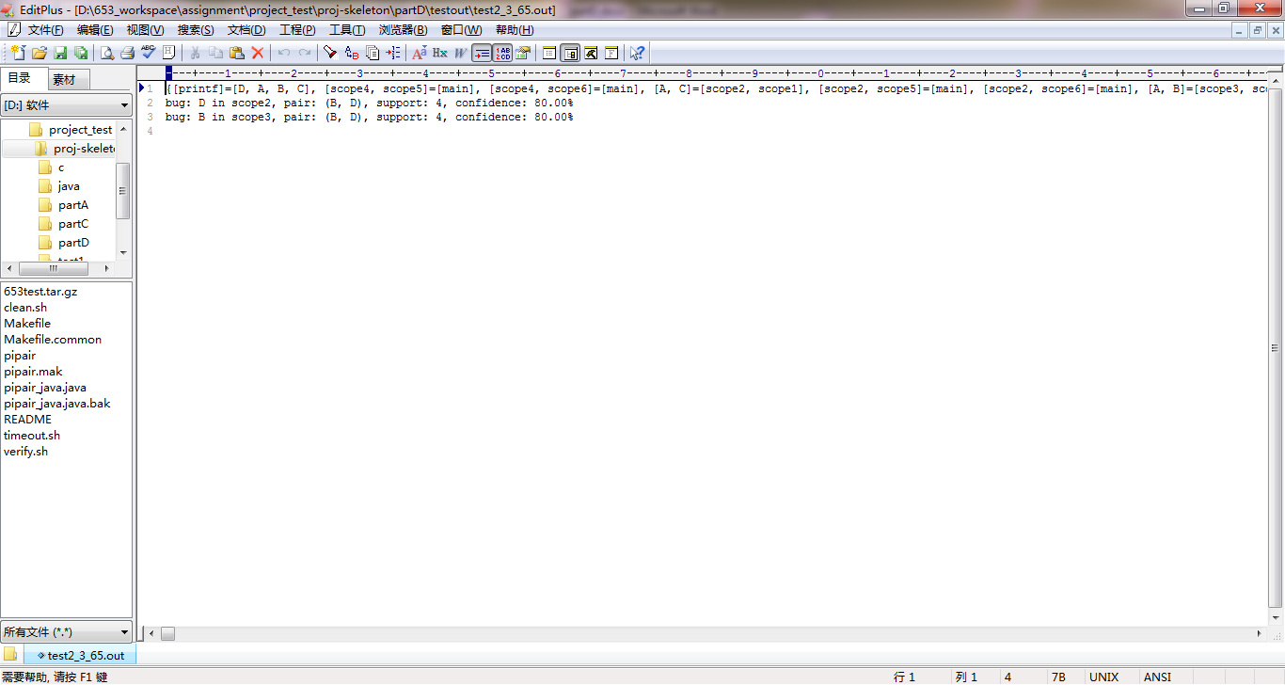

### Find more bug

**There will be three kinds of new bug generated in Part1(D) due to ordered pipair.**

**First kind of bug is that the single function should appear more than once, but only appear once. For example, in test3_3_65.out the support of (ms_bad_conn, ms_bad_conn) is 6, which means that ‘ms_bad_conn’ should appear more than once.**

**The bug output for ‘ms_bad_conn’**



**The callgraph for ‘ms_bad_conn’ should appear more than once**

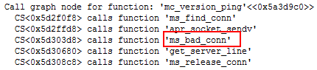

**Second kind of bug is that the function should be called in proper order, but actually in reverse order. For example, in test3_3_65.out the support of (get_server_line, ms_bad_conn) is 6, which means that (get_server_line, ms_bad_conn) should be the right order. So Even though it has pipair ( ms_bad_conn, get_server_line),it is not right ordered pipair.**

**The bug output for ‘ms_bad_conn’**



**The callgraph for wrong order**

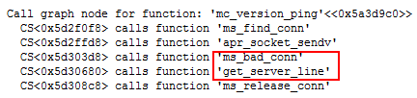

**Third kind of bug is that ordered and reversed ordered pipair both meet May belief to check bug in Part1(D), while only disordered pipair meet May Belief in Part1(A). So the number of some bug in Part1(D) maybe twice than that of Part1(A). For example, in test3_3_65.out the support of (get_server_line, ms_bad_conn) is 6 and the support of (ms_bad_conn, get_server_line) is 7, which means that ‘ms_bad_conn’ should be either pair: (get_server_line, ms_bad_conn) or pair: (ms_bad_conn, get_server_line) rather than single function.**

**The bug output for ‘ms_bad_conn’**



**The callgraph for ‘ms_bad_conn’ should appear with other function**

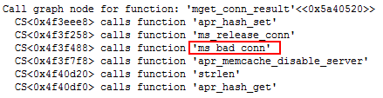

## Reference

[1] Engler, Dawson, et al. *Bugs as deviant behavior: A general approach to inferring errors in systems code*. Vol. 35. No. 5. ACM, 2001.

[2] Back, Godmar, and Dawson Engler. *MJ-a system for constructing bug-finding analyses for Java*. Technical report, Stanford University, 2003.

[3] Hovemeyer, David, Jaime Spacco, and William Pugh. "Evaluating and tuning a static analysis to find null pointer bugs." *ACM SIGSOFT Software Engineering Notes*. Vol. 31. No. 1. ACM, 2005.