Project 1(b).

I use the code and hash map data structure in (a) to list the bug numbers for all the pairs. Then I can figure out which 2 pairs can form 10 locations. As seen below, I list the 2 pairs I found.

1. Pair (apr_thread_mutex_lock, apr_thread_mutex_unlock) as shown below, which has totally 6 bug locations.

bug: apr_thread_mutex_lock in apr_dbd_mutex_lock, pair: (apr_thread_mutex_lock, apr_thread_mutex_unlock), support: 43, confidence: 95.56%

bug: apr_thread_mutex_lock in apu_dso_mutex_lock, pair: (apr_thread_mutex_lock, apr_thread_mutex_unlock), support: 43, confidence: 95.56%

bug: apr_thread_mutex_unlock in apr_dbd_mutex_unlock, pair: (apr_thread_mutex_lock, apr_thread_mutex_unlock), support: 43, confidence: 91.49%

bug: apr_thread_mutex_unlock in apr_global_mutex_trylock, pair: (apr_thread_mutex_lock, apr_thread_mutex_unlock), support: 43, confidence: 91.49%

bug: apr_thread_mutex_unlock in apr_global_mutex_unlock, pair: (apr_thread_mutex_lock, apr_thread_mutex_unlock), support: 43, confidence: 91.49%

bug: apr_thread_mutex_unlock in apu_dso_mutex_unlock, pair: (apr_thread_mutex_lock, apr_thread_mutex_unlock), support: 43, confidence: 91.49%

Then I check the source code of several locations and I find out some false positives. As shown in the picture below, I read the source code of apr_dbd_mutex_lock(). Apparently, this method apr_dbd_mutex_lock() is only used to define mutex_lock, using the apr_thread_mutex_lock. There is no need for apr_dbd_mutex_lock() to include an unlock function. In practical use,apr_dbd_mutex_lock() is called by the other functions to perform a lock operation, and apr_dbd_mutex_unlock() is called to perform an unlock operation. In such case, apr_dbd_mutex_lock() does not need an unlock, and similarly apr_dbd_mutex_unlock() does not need a lock.

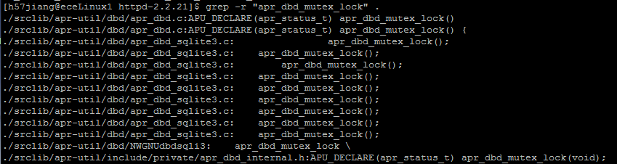

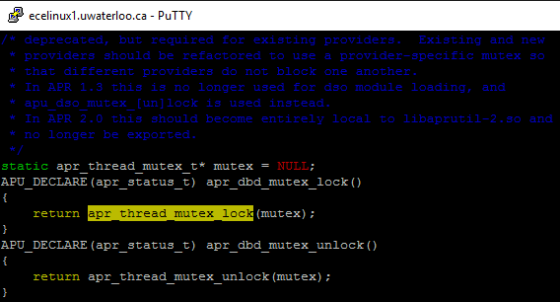

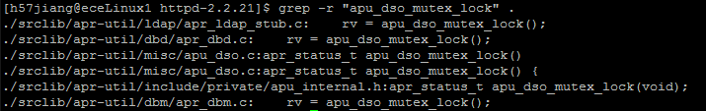

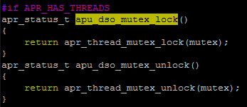

1. Pair (apr_table_setn, apr_table_unset) as shown below, which has totally 4 bug locations.

bug: apr_table_unset in add_env_module_vars_unset, pair: (apr_table_setn, apr_table_unset), support: 8, confidence: 66.67%

bug: apr_table_unset in ap_read_request, pair: (apr_table_setn, apr_table_unset), support: 8, confidence: 66.67%

bug: apr_table_unset in basic_http_header, pair: (apr_table_setn, apr_table_unset), support: 8, confidence: 66.67%

bug: apr_table_unset in strip_headers_request_body, pair: (apr_table_setn, apr_table_unset), support: 8, confidence: 66.67%

Then I check the source code of several locations and I find out the false positive. As shown in the picture below, I read the source code of add_env_module_vars_unset. In this function, apr_table_unset() follows apr_table_set() instead of apr_table_setn(). As add_env_module_vars_unset is generally achieve an unset functions, I believe it is right that apr_table_set() instead of apr_table_setn() is ahead of apr_table_unset().

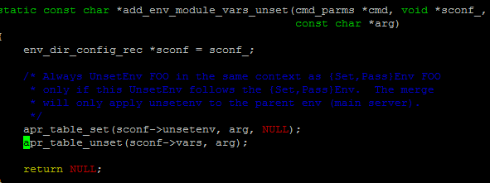

bug: apr_dir_close in apr_match_glob, pair: (apr_dir_close, qsort), support: 4, confidence: 80.00%