Abstract— This paper illustrates advantages of MySQL and MongoDB and their feature on data model, transaction and scalability. Then we write python script to reorganize datasets and implement operations on these datasets based on business requirement.
Combine MySQL and MongoDB
Xiyue, Zhang

INTRODUCTION
As the popularity of NoSQL growing, some e-commerce applications prefer a combination of MongoDB and MySQL. For example, the user-defined blog, which includes different attributes, is a good for MongoDB’s flexible data model. On the other hand, the banking system, which requires complex transactions, would likely be built on MySQL [1]. In this paper, the database of P2P-lending system will be redesign based on relational database and document oriented database to improve the searching efficiency and transaction security. The data will be divided into two different structured dataset. Part of dataset will be reorganized and moved to MongoDB, while other part may be left as original structure or modified based on JSON format document in MySQL.

The MySQL and MongoDB are both popular open source database manage software. MySQL is relational database management system and it stores data in tables. Database schema should be pre-defined based on system requirements. In MySQL, related information may be stored in separate tables, but associated through the use of joins. In this way, data duplication is minimized [1]. MySQL is good for complex, multi-row transactions, but not fit for searching or updating semi-structured dataset. MongoDB is document oriented database to stores data in JSON-like documents and can vary its structure. In MongoDB, related information is stored together for fast query access [1]. MongoDB is for organizing semi-structured dataset, but not better for multi-document transactions.

Compared the feature between MySQL and MongoDB, they have both advantage and disadvantage for certain development situation. MongoDB is good for storing big data. The big data has common features that they are large-scaled and semi-structured. To make efficient use of these features, MongoDB ignores some processes in relational database such as pre-designed table, join query and some ACID transaction properties, because it will take much time for responding to these processes [2]. However, relational data model is necessary for designing many-to-many relation. Besides, transaction is widely used in some security operation like updating balance or security information. It is very important to have ACID transaction properties in case that the database rollback operation after it breaks down. So MySQL, as a relational database is fit for these applications

The original database structure
The original data in this paper is from a P2P-lending financial platform, which is for financier to make a loan and investor to invest money. The data include user information (investor and financier), loan information, investment information and payment information. Furthermore the user information is basic data about login account and payment account. The loan information records amount and interest, as well as financier detail information for investor to see. The investment information record the user applied investment amount and benefit and so on. The payment information records transfer money and account name when investing and repaying.

Figure 1 Relational Data Model

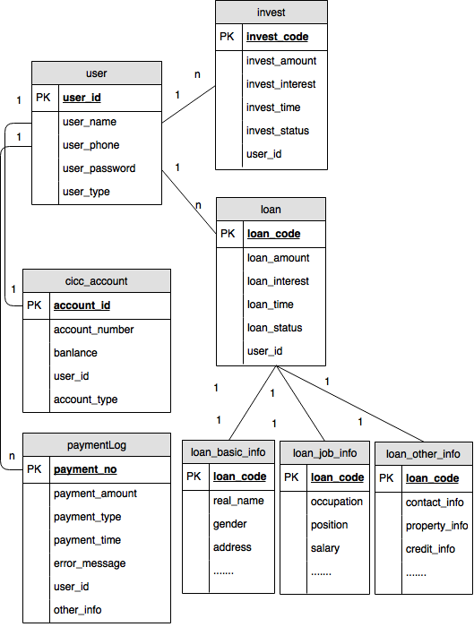

A. Data Model
Financiers’ data attached to loan is semi-structured because financiers can be either personal or enterprise. Also financiers will fill in multiple information like contacts, property, credits when applying loan. Hence, there is no way to predict the exact amount and structure of data. Only a rough estimate of the structure is known: A list of key-value-pairs [3]. In relational schema According to ‘loan_info_basic’ in Fig1, one column related to one attribute and if row has no value for attribute, the column is filled with NULL. This schema is structured and need to update table column for semi-structured data. If new dataset ‘loan_family_info’ is added into ‘loan_info_basic’, the table structure will be changed. Besides, query must join tables ‘loan_info_basic’, ‘loan_info_job’ and ‘loan_info_contact’ to find all loan information, it take much time on joining operation. So semi-structured is hard to be organized in relational database.

B. Transaction
There are parts of the data model which do require ACID transactions and strong consistency as well as parts which do not require this functionality [3]. For example, any update operation for payment balance should be regarded as ACID transactions. However payment dataset is semi-structure. it will loss transaction properties if stored in MongoDB, while dataset structure is hard to organized if stored in MySQL. So we should consider the tradeoff between flexible data model and transaction or combine their features to design special data structure, which can be applied to certain situation.

C. Scalability
The module of application has its business logic to generate certain query to database. Developer may change business logic when developing application at early stage. So business logic may influence schema in database. MongoDB store all the relation in one document rather than joining the document, so business logic has more influence on MongoDB than MySQL. For MySQL, Developer can add table for new business without changing original table, then write query to join new table and original table. However for MongoDB, the dataset in Embedded Data Models has fixed relation, and It is hard to reorganize document by adding new subset into original semi-structured dataset. If the dataset is in Normalized Data Models, we have to do multiple queries because MongoDB does not support join.

The new database structure
Figure 2 Semi-structured Data Model

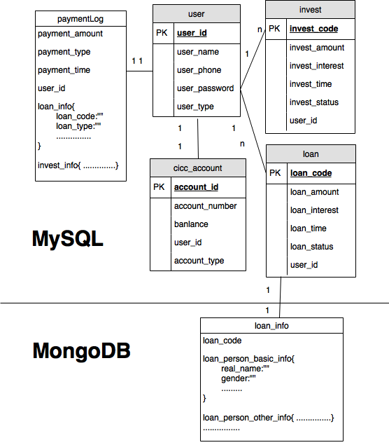

A. Loan Data in Embedded Models
Figure 3 Financier Webpage http://demo.fero.com.cn/
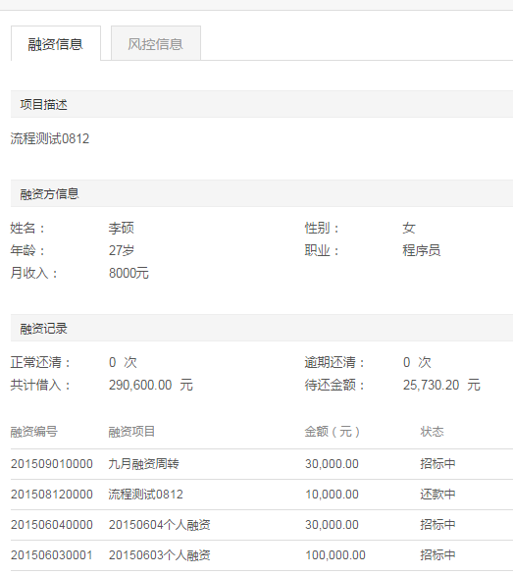
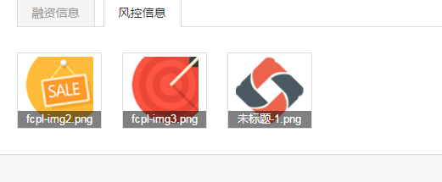
Financier information is distributed into three table called ‘loan_info_basic’, ‘loan_info_job’ and ‘loan_info_contact’. Three tables have join relation with loan table by foreign key ‘loan_code’. According to Figure 3, financier dataset has some special features as below:

- Financier information is semi-structured due to diverse information they fill in when applying loan.
- Financier information show together with loan to make loan data trustworthy for investor, and financier information is always attached to loan.
- Financier information will be audited by staff before published to website, if wrong information inserted, staff will ask financier to change their information and apply again. Financier information in database is rarely changed after published to website, and all the information will be viewed frequently by investor.
Considering these features, we can take full advantages of MongoDB to improve application performance. MongoDB has two data model for dataset, which are Normalized Data Model and Embedded Data Model. Embedded Data Models allow applications to store related pieces of information in the same database record. As a result, applications may need to issue fewer queries and provides better searching performance. In general, use embedded data models when: you have “contains” relationships between entities. In these relationships the “many” or child documents always appear with or are viewed in the context of the “one” or parent documents [5]. As financier information is semi-structured, inserted with loan information together when applying new loan and viewed with loan information on webpage frequently, so the application will increase searching speed and inserting speed for loan and financier information if financier dataset is stored as Embedded Data Model in MongoDB.

B. Payment Data Combining Transaction with JSON
RDBMS offers many intrinsic qualities that make it desirable for storing sensitive data like ordering and payment information [4]. The operation for loan, investment and payment data is a kind of multi-transaction, so all of relative dataset should be stored in MySQL. However, the payment dataset is semi-structured which is fit for MongoDB. Here is an approach to deal with this tradeoff by combining transaction feature and JSON format feature.

Payment information is in table called ‘paymentLog’. Here are dome special features for payment dataset as below:

- Payment information is semi-structured due to various payment methods. For example the payment for investment is different from lending or transfer money.
- Payment is multi-transaction operation. When repaying money from financier to investors, the application will generate many insert queries for payment data, which is a typical multi-transaction operation.
- Payment information is more frequently to be inserted into database than searched by user, because user can search the investment and loan information, which more briefly describes payment process than payment log information.
In MongoDB, write operation is atomic at document level, and no single write operation can atomically affect more than one document or more than one collection. Normalizing the data would split the data across multiple collections and would require multiple write operations that are not atomic collectively [5]. However, we can take advantages of JSON format document in MongoDB. As JSON data model is semi-structured, ‘paymentLog’ table can add columns to store these semi-structured dataset as JSON data model, in this way it does not have to define schema first and is easily adapt to changes in the future. In general, JSON data model can be added to RDBMSs, gaining some of the traditional benefits of relational systems in the bargain [7]. So the application can insure the payment transaction while updating payment dataset structure.

C. User Data for Business Logic Scalability
Database architecture to use is one that should be made in the early stages of application design. That decision will be influenced by answering questions about the data, the expected behavior of the application, and ultimately the business requirements [3].So developer should make it clear that which kind of query or business logic the application needs, then choose appropriate strategy to solve certain problem.

If it is uncertain that what relation will be added or updated in the future, or we prefer scalable business, it is better to design relational schema first in MySQL at early stage. So user login account information is still as relational data model in MySQL even though it does need complex transaction, and it is flexible to write join query to show the relation among user account table, loan table, investment table and payment table, if there is new transfer business from account to account in future, we can design new table for new business and query joining these tables with user login account table. However, we can also move user login account information to MongoDB as Normalized Data Models, but it does not improve much searching speed, because MongoDB will do multiple queries on searching key in login account first and then searching new document by this key. Also it takes more time on connecting database across MySQL and MongoDB.

Implement

A. Data Migration Module
Before loading data from MySQL to MongoDB, we should analyze which part of data should be migrated, and how to redesign the new data structure. New models must be identical to original models in terms of semantic and conceptual structure. In general, the dataset with huge data volume should be migrated, and existing relations have to be adequately represented without loss or distortion of data. Here is a framework named NoSQLayer to perform data and model migration from MySQL to NoSQL databases, more specifically MongoDB, in a transparent and automatic manner [8]. According to the principle of NoSQLayer, we write loading.py to reorganize the data from MySQL and load data into MongoDB as below:

Figure 4 Main Scripts for data migration module
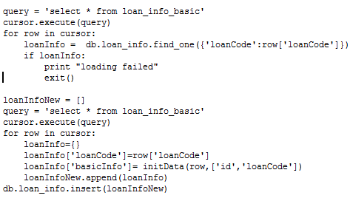

B. Business module
According to the business requirement for P2P-lending system, There are some main operation including searching information, applying for loan, investing, effecting loan and repaying loan. So we write modules for these operations as below:
Figure 5 Programs for business module


Evaluation

A. Searching performance
As the loan_info data model is changed and moved from MySQL into MongoDB, The program called testcase_time.py is designed to compare searching time for financier information in MySQL and MongoDB respectively. If the loan_info dataset stored in MongoDB, we will only write one searching query rather than more queries in MySQL:

Figure 6 Searching Scripts for MySQL
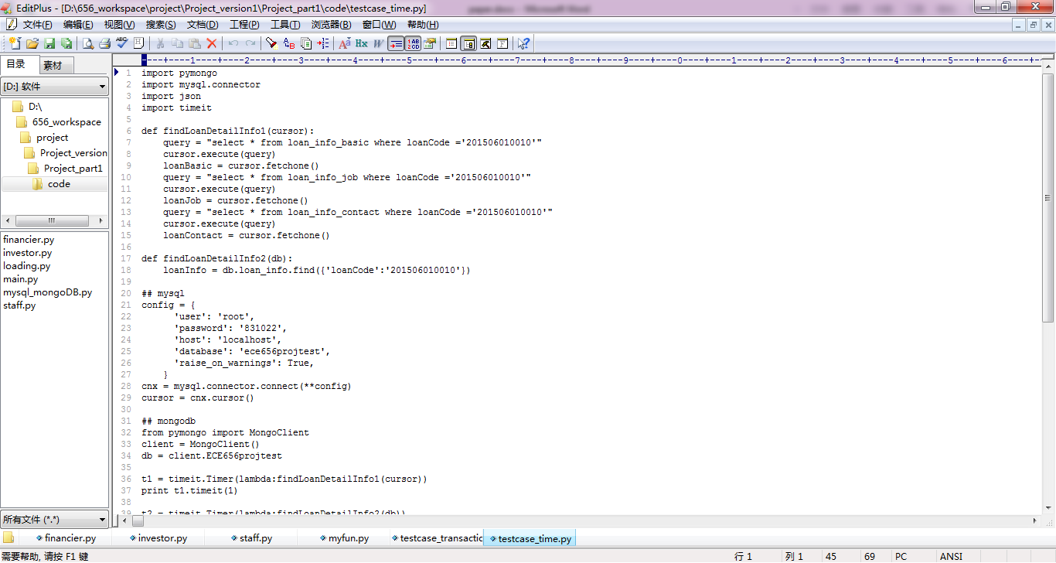

Figure 7 Searching Scripts for MongoDB

Figure 8 Measure Scripts for Time Measurement
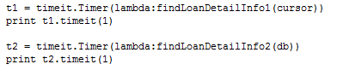

TABLE 1 The searching time for MySQL and MongoDB
MySQL | MongoDB
0.0046s | 0.000075s
As shown in the table, it takes much less time to search financier information in MySQL than MongoDB. Because financier information is stored as Embedded Data Models in MongoDB rather than Relational Data Model in MySQL, so compared with MySQL, MongoDB only need one query to search all the financier information.

B. Transaction performance
One of multi-transaction in P2P-lending system is loan repay process. When money is repaid from financier to investor, Payment information for different users should be inserted into database together at once. The program called testcase_transaction.py is designed to generate multi-transaction result, and the result can be viewed in database directly.

Figure 9 Insert payment data for MySQL
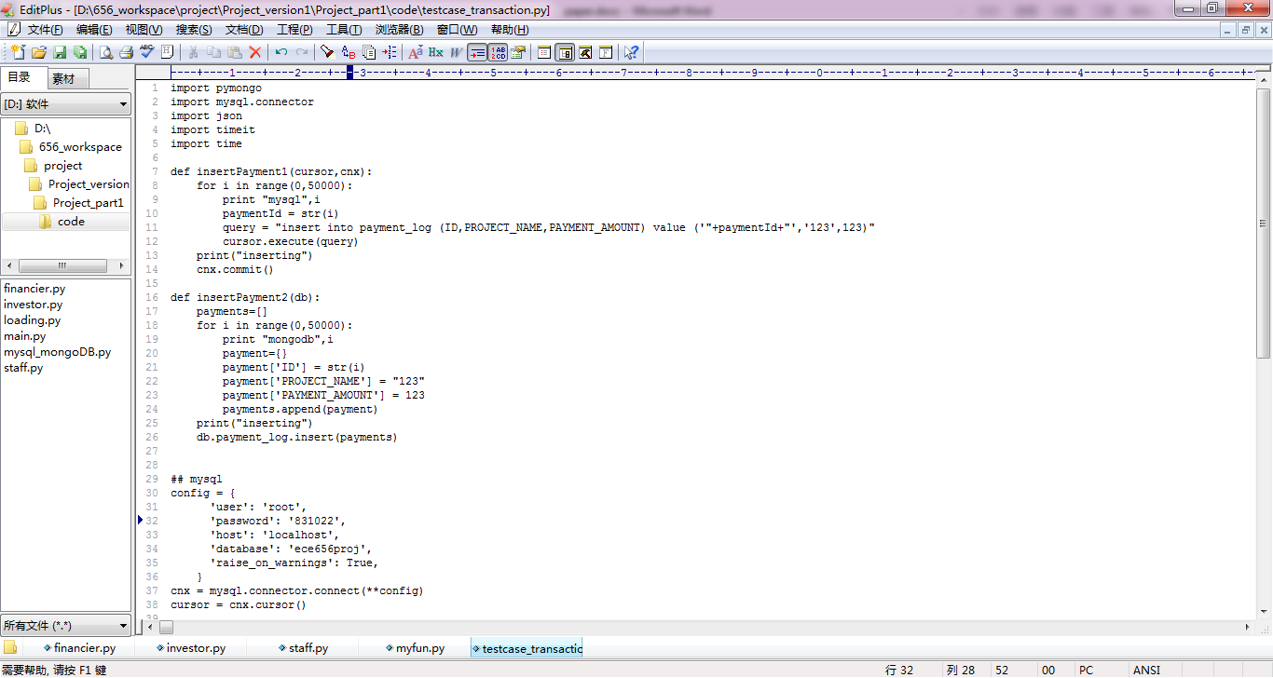

Figure 10 Insert payment data for Mongo
If we force the application above to exit, we will see different result. In MySQL, there is no data because the multi-transaction rollback inserted data. However, in MongoDB, 17000 of 50000 payment information is inserted as below, so multi-transaction in MySQL is significant to complex business logic.

Figure 11 Window for MongoDB Result

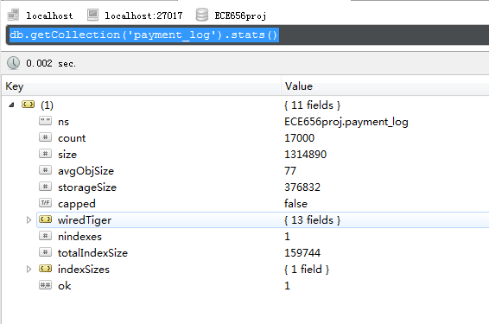

Conclusion
In this paper, relational data model is reorganized into a semi-structured data model to improve application performance. We have analyzed advantages of MySQL and MongoDB and their feature on data model, transaction and scalability. Then we write scripts to reorganize dataset and implement operations on these datasets based on business requirement. In general, MySQL can guarantees ACID transaction such as payment, while MongoDB can improve searching speed by redesign flexible data model such as the financier information and its related dataset. The Evaluation result confirm that searching speed increased by 98% in MongoDB, and multi-transaction is insured in MySQL.

References
- https://www.mongodb.com/compare/mongodb-mysql
- Aboutorabi, Seyyed Hamid, et al. "Performance evaluation of SQL and MongoDB databases for big e-commerce data." Computer Science and Software Engineering (CSSE), 2015 International Symposium on. IEEE, 2015.
- Ebel, Marius, and Martin Hulin. "Combining relational and semi-structured databases for an inquiry application." Multidisciplinary Research and Practice for Information Systems. Springer Berlin Heidelberg, 2012. 73-84.
- Ploetz, Aaron. A Study of MongoDB and Oracle in an E-commerce Environment. Diss. Regis University, 2013.
- https://docs.mongodb.org/manual/core/data-model-design/
- https://docs.mongodb.org/manual/core/data-modeling-introduction
- Chasseur, Craig, Yinan Li, and Jignesh M. Patel. "Enabling JSON Document Stores in Relational Systems." WebDB. 2013.
- Rocha, Leonardo, et al. "A Framework for Migrating Relational Datasets to NoSQL." Procedia Computer Science 51 (2015): 2593-2602.

 

