**Implementation of Empirical Mode Decomposition filters to reduce the Baseline wander noise of an ECG real time signal.**

1.Introduction

1.1 Theory

1.2 State of the art

1.3 Literature gap

2. Methods

Base the [1], [2] an EMD algorithm implemented in C++ coding for Linux operation system (OS). The scope of this code is to approach the IMF (Intrinsic Mode Function) and evaluated using the Hilbert space computing. The two characteristic as mentioned in [1], [2] of IMF is a) the number of extrama to be equal with the number of zero crossing or equal with the number of zero crossing minus one and b) the oscillation to be symmetric.

- Instantanious frequency determine base the Hilber transformation:

Reference:CHAPTER 2 B-SPLINE BASED EMPIRICAL MODE DECOMPOSITION (2.2)

-ppt for methods description

2.1 Algorithm C++ implementation

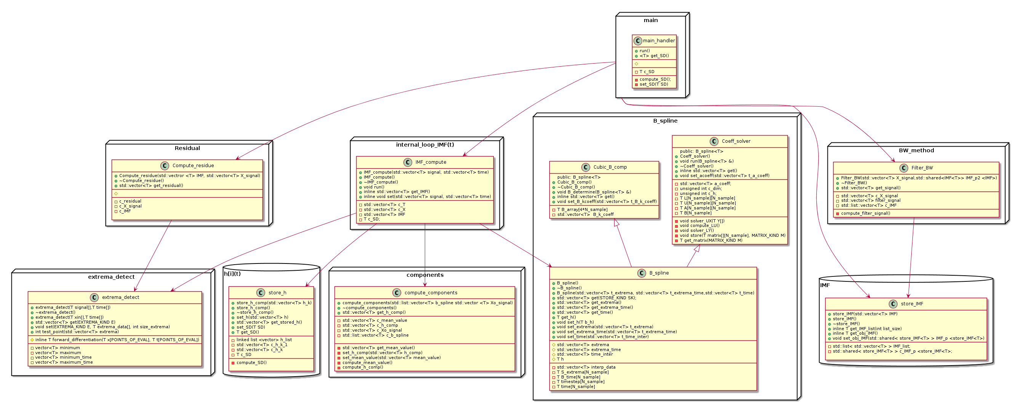In the follow diagrams someone could obtain the sequence of diagrams and class diagrams of the C++ code implementation of the EMD algorithm.

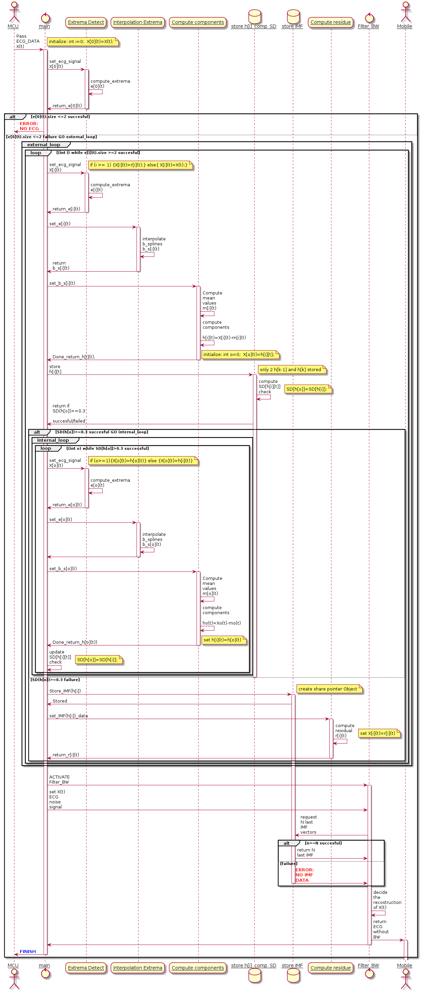

2.1.1 Sequence diagram

2.1.2 Class diagram

3.Results

3.1 Verification of code

3.1.1 Constant impulse test

3.1.2 Constant ECG test

3.1.3 Real time ECG test

4 Future Work

5. Discussion

6. Reference

[1] Manuel Blanco-Velasco, Binwei Weng, Kenneth E. ‘ECG signal denoising and baseline wander correction based on the empirical mode decomposition’, 18 June 2007

[2] N o r d e n E. H u a n g , Z h e n g S h e n, S t e v e n R. L o n g , M a n l i C. W u, H s i n g H. S h i h, Q u a n a n Z h e n g , N a i-C h y u a n Y e n , C h i C h a o T u n g a n d H e n r y H. L i u ‘The empirical mode decomposition and the Hilbert spectrum for nonlinear and non-stationary time series analysis’,4 November 1996

[3] Gabriel Rilling, Patrick Flandrin and Paulo Gon, ON EMPIRICAL MODE DECOMPOSITION AND ITS ALGORITHMS.