https://supabase.com/dashboard/org/ycfvqljkiznrjgfzhglt

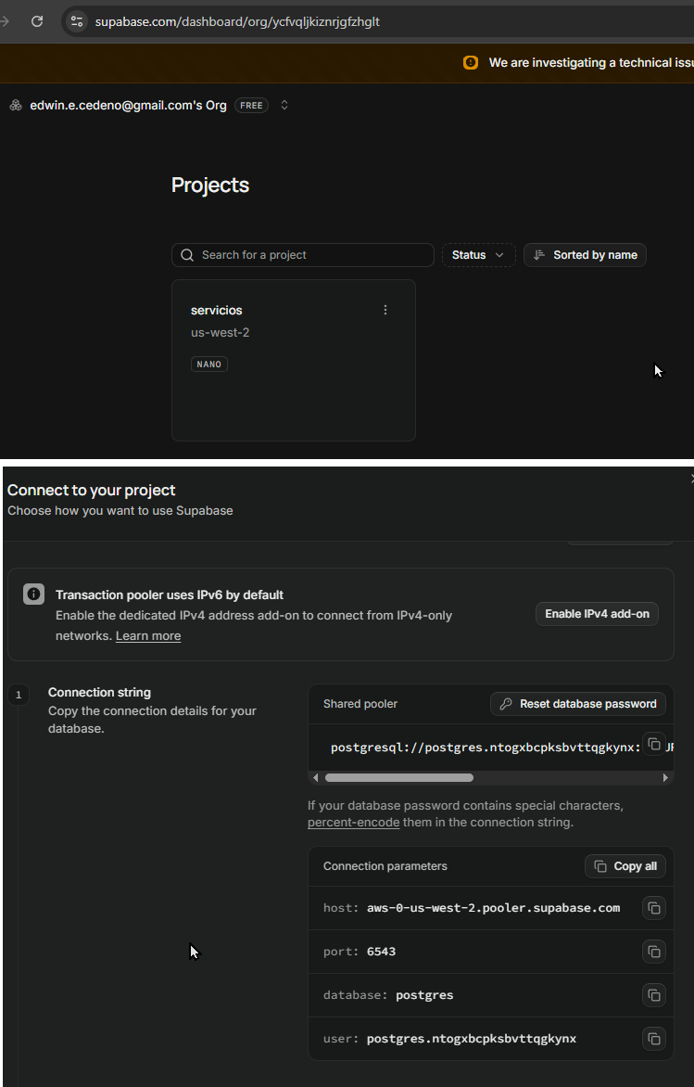
host=aws-0-us-west-2.pooler.supabase.com
port=6543
database=postgres
user=postgres.ntogxbcpksbvttqgkynx

