
GOVERNMENT COLLEGE OF ENGINEERING, BODINAYAKKANUR.

PROJECT EXPO-2026

SMART WILD PIG DETECTION AND CROP PROTECTION SYSTEM USING IoT AND AI

TEAM MEMBERS:
DHANYASRI.J
LAVANYA.V
ARUNACHALAM.M
SUJITH.N
TABLE OF CONTENTS
CHAPTER  NO | TITLE | PAGE  NO
 | ABSTRACT
 | LIST OF FIGURES
1 | INTRODUCTION
 | 1.1 Background
 | 1.2 Problem Statement
 | 1.3 Motivation
 | 1.4 Objectives
 | 1.5 Scope of the Project
 | 1.6 Proposed Solution
 | 1.7 Advantages
 | 1.8 Organization of the Report
2 | LITERATURE SURVEY
 | 2.1 Introduction
 | 2.2 Existing Methods for Wild Animal Detection
 | 2.3 IoT Based Animal Detection
 | 2.4 PIR Based Motion Detection
 | 2.5 Camera Based Animal Detection
 | 2.6 Artificial Intelligence for Image Classification
 | 2.7 Transfer Learning
 | 2.8 Comparison of Existing Approaches
 | 2.9 Research Gap
 | 2.10 Summary
3 | SYSTEM ANALYSIS AND DESIGN
 | 3.1 System Requirements
 | 3.2 Proposed Solution
 | 3.3 Working Principle
 | 3.4 Python
 | 3.5 TensorFlow / Keras
 | 3.6 MobileNetV2
 | 3.7 Antigravity IDE
 | 3.8 Summary
4 | DATASET AND AI MODEL
 | 4.1 Dataset Collection
 | 4.2 Dataset Organization
 | 4.3 Pig and Non-Pig Classes
 | 4.3.1 Pig Class
 | 4.3.2 Non-Pig Class
 | 4.4 Dataset Statistics
 | 4.5 Data Preprocessing
 | 4.6 MobileNetV2 Transfer Learning
 | 4.6.1 Global Average Pooling
 | 4.6.2 Dense Layer
 | 4.6.3 Sigmoid Activation
 | 4.7 Model Training
 | 4.8 Model Testing
 | 4.9 Prediction Processing
 | 4.10 Camera Image Prediction
 | 4.11 AI Model Workflow
 | 4.12 Summary
5 | HARDWARE AND SOFTWARE IMPLEMENTATION
 | 5.1 ESP32-CAM Setup
 | 5.2 PIR Sensor Interface
 | 5.3 LED Interface
 | 5.4 Buzzer Interface
 | 5.5 Camera Image Capture
 | 5.6 Wi-Fi Communication
 | 5.7 Python–ESP32-CAM Communication
 | 5.8 AI Prediction Integration
 | 5.9 Alert Generation
 | 5.10 Hardware Implementation Results
 | 5.11 Overall Software Workflow
 | 5.12 Summary
6 | TESTING AND RESULTS
 | 6.1 Introduction
 | 6.2 Hardware Testing
 | 6.3 PIR Motion Detection Test
 | 6.4 LED Testing
 | 6.5 Buzzer Testing
 | 6.6 ESP32-CAM Testing
 | 6.7 Image Capture Test
 | 6.8 AI Model Testing
 | 6.9 Pig Image Prediction Test
 | 6.10 Non-Pig Image Prediction Test
 | 6.11 Camera-Based AI Testing
 | 6.12 Functional Test Cases
 | 6.13 Performance Evaluation
 | 6.14 Error Analysis
 | 6.15 Reliability Testing
 | 6.16 Limitations Observed During Testing
 | 6.17 Summary
7 | CONCLUSION AND FUTURE SCOPE
 | 7.1 Conclusion
 | 7.2 Advantages
 | 7.3 Limitations
 | 7.4 Future Improvements
 | 7.4.1 Larger and More Diverse Dataset
 | 7.4.2 Real-Time AI Integration
 | 7.4.3 Mobile Notification
 | 7.4.4 Voice Alert
 | 7.4.5 Night-Time Monitoring
 | 7.4.6 Field Development
 | 7.4.7 Advanced Object Detection
 | 7.5 Final Conclusion

CHAPTER 1 — INTRODUCTION

1.1 Background
Agriculture plays an important role in supporting the livelihood of farmers. However, crop damage caused by wild animals is a major challenge in many agricultural areas. Among different animals, wild pigs can cause significant damage to crops by entering agricultural fields, feeding on plants, and disturbing the soil. Such intrusion can occur particularly during night-time, making continuous human monitoring difficult.
Traditional methods of protecting agricultural fields include manual monitoring, fencing, lights, and conventional alarm systems. These methods may require continuous human involvement and may also produce false alarms when animals or people other than wild pigs are detected. Therefore, an automated system that can detect the presence of a wild pig and provide an immediate alert can help improve crop protection.
Recent developments in the Internet of Things (IoT), embedded systems, cameras, and Artificial Intelligence (AI) provide an opportunity to develop a smart monitoring system. IoT devices can collect information from the field, while camera-based AI models can analyze captured images and distinguish between a wild pig and other objects.
The proposed project, “Smart Wild Pig Detection and Crop Protection System Using IoT and AI,” combines a PIR sensor, ESP32-CAM, and an AI-based image classification model. The PIR sensor is used to detect motion, and the ESP32-CAM captures an image when motion is detected. The captured image is transferred to a computer for classification using a trained MobileNetV2-based deep learning model. If the image is classified as a wild pig, an LED and buzzer are activated to provide an immediate local alert.

1.2 Problem Statement
Wild pig intrusion into agricultural fields can lead to crop damage and economic loss for farmers. Continuous manual monitoring of large agricultural areas is difficult and time-consuming. Conventional motion-based alarm systems can also generate false alarms because they detect movement without identifying the object or animal.
Therefore, there is a need for an automated system that can:
- Detect movement in the agricultural field.
- Capture an image of the detected object.
- Identify whether the object is a wild pig using AI.
- Reduce unnecessary alerts for non-pig objects.

1.3 Motivation
The main motivation of this project is to develop a simple and practical technology-based solution for detecting wild pig intrusion in agricultural fields. Instead of relying only on motion detection, the proposed system uses image classification to provide additional information about the detected object.
The system also provides a local LED and buzzer alert, which allows the farmer to notice the warning without depending entirely on a mobile application or internet notification.

1.4 Objectives
The main objectives of the proposed system are:
- To detect movement using a PIR sensor.
- To capture images using an ESP32-CAM.
- To transmit the captured image to a computer through Wi-Fi.
- To classify the captured image as PIG or NON-PIG using a deep learning model.
- To activate an LED and buzzer when a wild pig is detected.
- To avoid activating the alert for images classified as non-pig.
- To develop a low-cost prototype suitable for agricultural field monitoring.

1.5 Scope of the Project
The scope of this project is to develop a prototype for automated wild pig detection and alert generation. The system uses a PIR sensor for motion detection and an ESP32-CAM for image capture. A MobileNetV2-based AI model is used for binary image classification into pig and non-pig categories.
The prototype is intended to demonstrate the basic concept of AI-assisted wild pig detection. The current implementation performs AI inference on a computer connected through the network. Future versions can be developed to perform AI inference on an edge device and improve operation under different lighting, distances, backgrounds, and environmental conditions.

1.6 Proposed Solution
The proposed system consists of two main stages: motion detection and AI-based classification.
First, the PIR sensor detects movement in the monitored area. When motion is detected, the ESP32-CAM captures an image. The image is then transferred through Wi-Fi to a computer running the trained AI model.The MobileNetV2-based model analyzes the captured image and produces one of two classifications:
PIG → LED ON + Buzzer ON ,
NON-PIG → LED OFF + Buzzer OFF

:

1.7 Advantages
The proposed system provides the following advantages:
- Automated monitoring of agricultural fields.
- AI-based classification instead of relying only on motion detection.
- Immediate local alert using LED and buzzer.
- Camera-based verification of detected objects.
- Wireless image transfer using Wi-Fi.
- Low-cost prototype using commonly available components.
- Can be further developed for real-time field monitoring.

1.8 Organization of the Report
This report is organized into several chapters. Chapter 1 introduces the project, problem statement, motivation, objectives, scope, and proposed solution. Chapter 2 presents the literature survey and existing approaches related to wild animal detection, IoT, and AI-based image classification. Chapter 3 describes the system analysis, architecture, hardware components, and software requirements. Chapter 4 explains the dataset, preprocessing, AI model, training, and testing. Chapter 5 presents the hardware and software implementation. Chapter 6 discusses the testing, experimental results, and performance evaluation. Chapter 7 concludes the project and presents its future scope.

CHAPTER 2 — LITERATURE SURVEY

2.1 Introduction
The use of technology in agriculture has increased significantly with the development of the Internet of Things (IoT), embedded systems, wireless communication, computer vision, and Artificial Intelligence (AI). These technologies can be used to monitor agricultural fields and detect unwanted animal intrusion. Wild pig detection is particularly challenging because wild pigs can enter fields at different times of the day and may cause considerable crop damage.
This chapter reviews existing approaches for animal intrusion detection and discusses technologies that are relevant to the proposed Smart Wild Pig Detection and Crop Protection System Using IoT and AI.

2.2 Existing Methods for Wild Animal Detection
Traditional agricultural protection methods include physical fencing, manual monitoring, lighting, noise-based deterrents, and motion-activated alarm systems. These methods can provide basic protection but have several limitations.
Manual monitoring requires continuous human presence and may not be practical for large agricultural fields. Physical barriers can be expensive to install and maintain. Motion-based alarm systems can detect movement but generally cannot determine whether the detected object is a wild pig, human, or another animal.
Therefore, camera-based systems combined with AI can provide an additional level of verification.

2.3 IoT-Based Animal Detection
The Internet of Things enables sensors and embedded devices to collect and exchange information over a network. In agricultural applications, sensors can be used to monitor environmental conditions, movement, and animal activity.
Microcontrollers such as ESP32-based devices are suitable for prototype development because they provide sensor interfaces and wireless connectivity. In the proposed system, the ESP32-CAM provides both image acquisition and Wi-Fi communication.
However, an IoT system based only on a motion sensor cannot reliably identify the type of object causing the movement. Therefore, sensor-based detection can be combined with camera-based AI classification.

2.4 PIR-Based Motion Detection
A Passive Infrared (PIR) sensor detects changes in infrared radiation caused by moving objects. PIR sensors are inexpensive, simple to interface, and consume relatively low power.
In the proposed system, the PIR sensor acts as the first-stage detection mechanism. When movement is detected, it provides a trigger for image capture by the ESP32-CAM.
Although PIR sensors are useful for detecting motion, they cannot determine whether the detected object is a wild pig. This limitation is addressed by using an AI-based image classification stage.

2.5 Camera-Based Animal Detection
Camera-based monitoring systems capture images or video of the monitored area. Unlike motion-only sensors, cameras provide visual information that can be analyzed to identify objects.
The ESP32-CAM is suitable for the proposed prototype because it combines a camera with a Wi-Fi-enabled microcontroller. Captured images can be transferred to a computer for further processing.
The major challenge is that camera images can vary due to lighting, background, distance, viewing angle, and image quality. Therefore, an appropriate image classification model and representative dataset are required.

2.6 Artificial Intelligence for Image Classification
Artificial Intelligence and deep learning techniques have become widely used for image classification. Convolutional Neural Networks (CNNs) can automatically learn important visual features from images and classify them into different categories.
For this project, a MobileNetV2-based transfer learning approach is used. MobileNetV2 is designed to provide efficient image recognition while requiring fewer computational resources than many larger CNN architectures.
Instead of training a complete network from the beginning, a pre-trained MobileNetV2 model is adapted to classify images into two categories:
- PIG
- NON-PIG
This approach reduces the amount of training required and is suitable for developing the prototype.

2.7 Transfer Learning
Transfer learning is a technique in which knowledge learned from a previously trained model is reused for a new classification task. A pre-trained model can provide useful feature representations, allowing the new model to be trained using a smaller task-specific dataset.
In the proposed system, the MobileNetV2 base model is used as a feature extractor, and a classification layer is added for binary classification.

The basic process is:

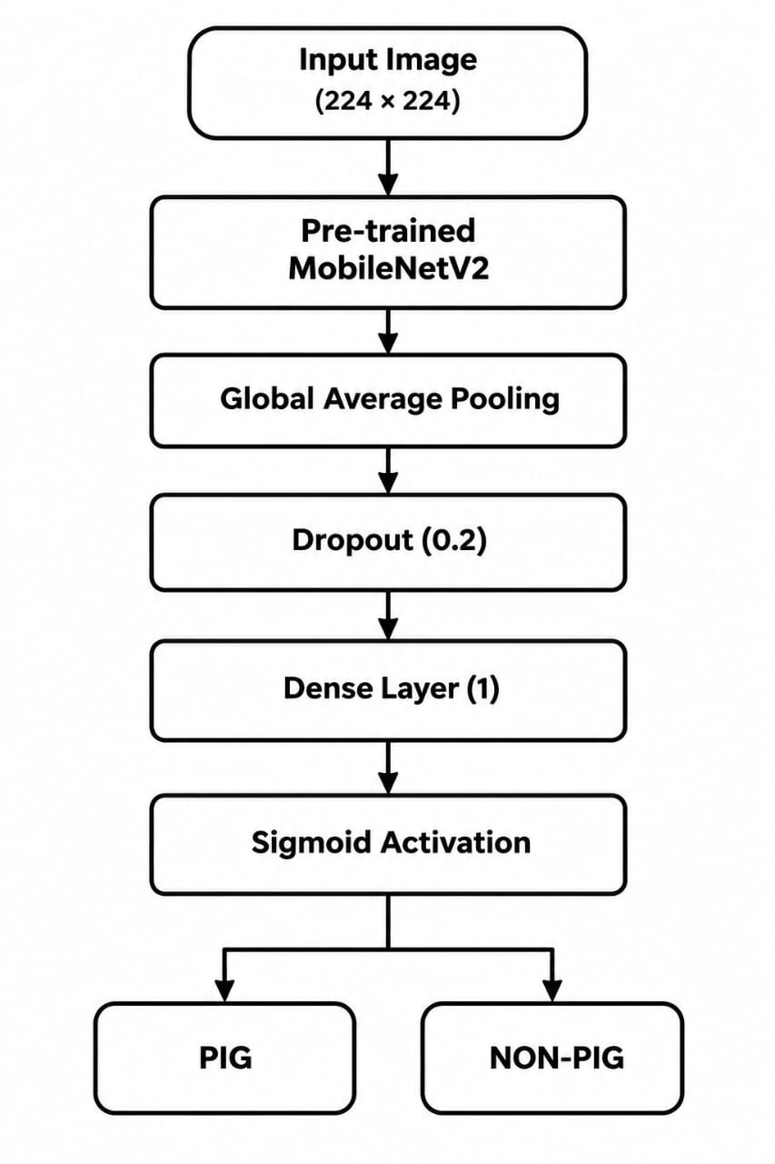
2.8 Comparison of Existing Approaches
Method | Motion  Detection | Object  Identification | Camera  Required | AI Required | False Alarm  Reduction
Manual monitoring | Human-based | Human observation | No | No | Depends on observer
Physical fencing | No | No | No | No | Not applicable
PIR alarm | Yes | No | No | No | Limited
Camera monitoring | No/Optional | Visual | Yes | No | Moderate
AI-based camera  system | Optional | Yes | Yes | Yes | Better potential
Proposed system | Yes | Yes | Yes | Yes | Improved through  classification

2.9 Research Gap
Existing motion-based systems can identify movement but cannot determine the identity of the detected object. Camera-based systems provide visual information, but manual inspection of images can require human attention.
The proposed system addresses this gap by combining PIR-based motion detection with camera-based AI classification. The PIR sensor provides an initial trigger, while the AI model analyzes the captured image to distinguish between pig and non-pig objects.
The system also provides a local LED and buzzer alert so that the detection result can be communicated immediately.

2.10 Summary
The literature survey shows that IoT, PIR sensors, camera modules, and AI-based image classification can be combined to develop an automated animal intrusion detection system. PIR sensors provide an efficient method for detecting movement, while camera-based deep learning can provide object classification.
Based on these observations, the proposed project combines an ESP32-CAM, PIR sensor, MobileNetV2-based AI model, LED, and buzzer to develop a smart wild pig detection prototype.

CHAPTER 3 — SYSTEM ANALYSIS AND DESIGN

3.1 System Requirements
The proposed Smart Wild Pig Detection and Crop Protection System using IoT and AI requires both hardware and software components. The system is designed to detect motion, capture images, classify the detected object as pig or non-pig, and generate an alert when a wild pig is identified.

Hardware Requirements
S.No | Component | Purpose
1 | ESP32-CAM | Image capture and Wi-Fi communication
2 | PIR Sensor | Detects motion
3 | LED | Visual alert
4 | Passive Buzzer | Audible alert
5 | NodeMCU ESP8266 | USB-to-serial programming interface
6 | Resistors | LED current limiting
7 | Power Supply | Provides power to the circuit

Software Requirements
- Arduino IDE
- Python
- TensorFlow/Keras
- MobileNetV2
- Antigravity IDE
- Required Python libraries such as NumPy and Requests

3.2 Proposed System
The proposed system combines IoT, sensors, camera technology, and artificial intelligence for detecting wild pigs.
The PIR sensor first detects movement in the monitored area. When motion is detected, the ESP32-CAM captures an image. The captured image is transferred through Wi-Fi to a computer where a trained MobileNetV2-based deep learning model classifies the image into two categories: PIG or NON-PIG.
If the detected object is classified as a pig, the system activates an LED and buzzer to provide an immediate warning. If the object is classified as non-pig, no alert is generated.

3.3 Working Principle
The system operates through the following sequence:
- The PIR sensor continuously monitors the area for movement.
- When movement is detected, the PIR sensor sends a HIGH signal to the ESP32-CAM.
- The ESP32-CAM camera captures an image of the detected object.
- The image is transferred to the computer using Wi-Fi and HTTP communication.
- The captured image is given as input to the trained MobileNetV2 deep learning model.
- The model performs binary classification.
- If the output is PIG, the alert system is activated.
- The LED glows and buzzer produces sound.
- If the output is NON-PIG, the LED and buzzer remain OFF.
HARDWARE DESCRIPTION:
ESP32-CAM:
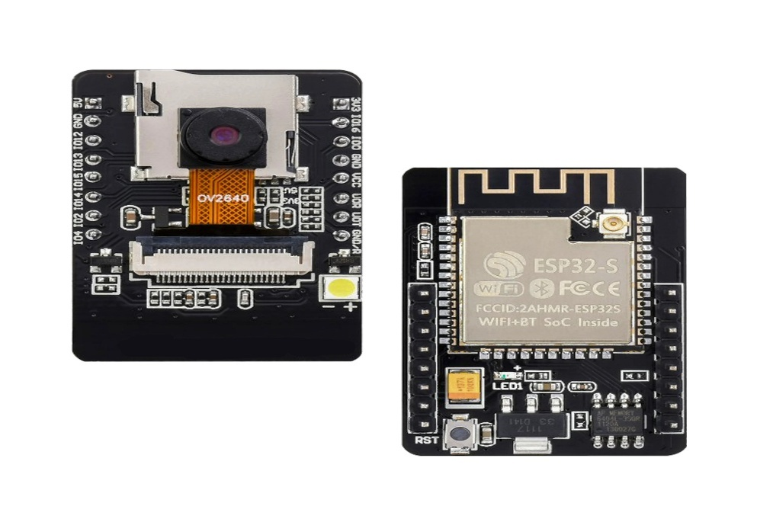
The ESP32-CAM is a compact development board containing an ESP32 microcontroller and camera module. It is used in the proposed system to capture images of objects detected in the monitored area.

Functions:
- Image capture
- Camera interfacing
- Communication
- Image transfer/processing interface
ESP8266:
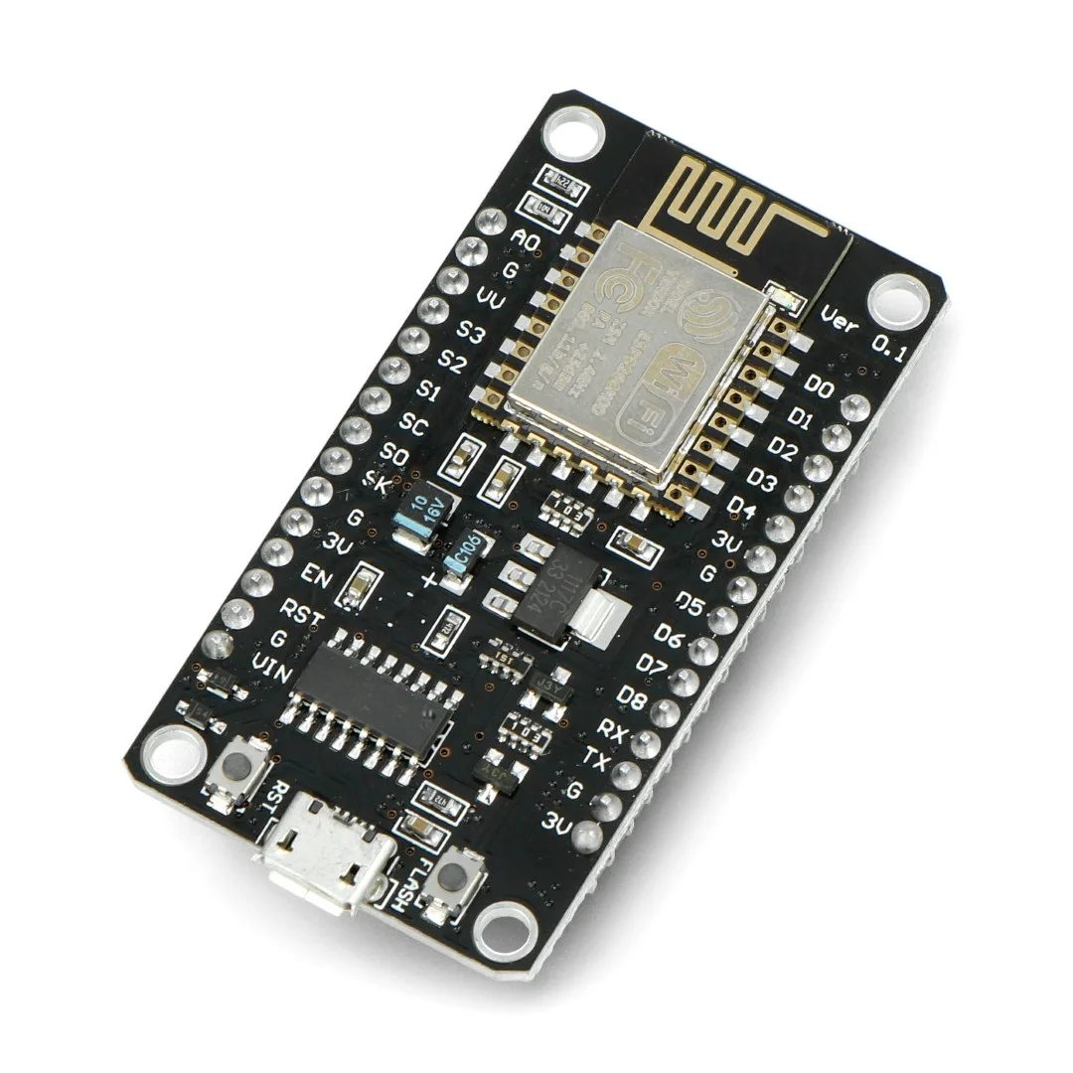
The ESP8266 is used as a control and communication interface in the prototype.
Functions:
- Receives the PIR sensor signal.
- Controls the detection sequence.
- Interfaces with the ESP32-CAM section.
- Helps coordinate the prototype hardware.
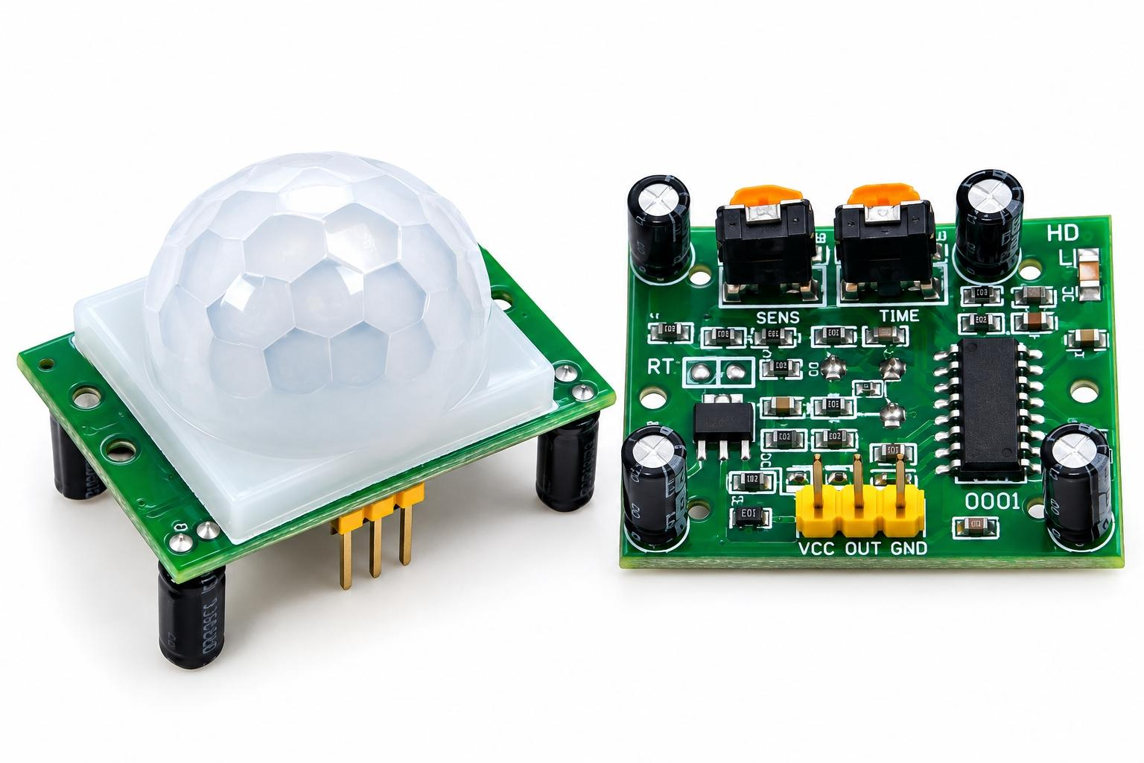
PIR SENSOR:
A PIR sensor detects changes in infrared radiation associated with movement.
When a moving object enters the detection area, the PIR sensor produces an output signal.
Function:
Detect motion → Trigger camera/detection process.
The PIR sensor itself does not identify a wild pig. It only provides the initial motion trigger. The image-based AI verification is used for animal identification.

BUZZER / ALARM:
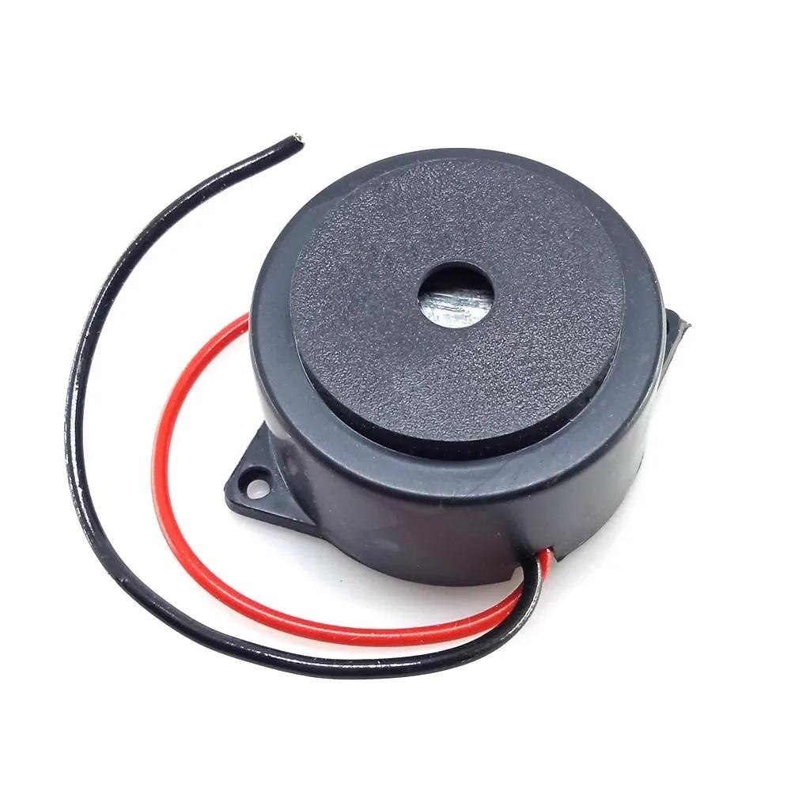
The buzzer produces an audible warning when the AI system confirms the presence of a wild pig.
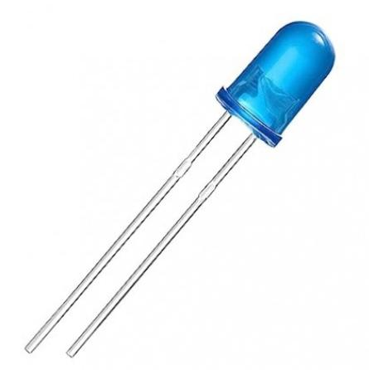
LED / WARNING LIGHT:
The LED or warning light provides a visual indication that a wild pig has been detected.

3.4 Python
Python is used for image processing, camera communication, and AI prediction.
The Python programs perform tasks such as:
- Capturing images from ESP32-CAM
- Loading the trained model
- Preprocessing images
- Predicting PIG/NON-PIG
- Displaying prediction confidence

3.5 TensorFlow/Keras
TensorFlow/Keras is used to build and load the deep learning model.
The trained model is stored as:
pig_detection_model.keras

3.6 MobileNetV2
MobileNetV2 is used as the pre-trained CNN architecture for image feature extraction and classification.
The model uses transfer learning to classify the input image into:
- PIG
- NON-PIG

3.7 Antigravity IDE
Antigravity IDE is used as the development environment for writing and executing the Python programs used in the AI portion of the project.

3.8 Summary
This chapter presented the system requirements, proposed system, architecture, block diagram, working principle, hardware components, and software requirements of the Smart Wild Pig Detection and Crop Protection System. The proposed design combines PIR-based motion detection, ESP32-CAM image capture, Wi-Fi communication, and MobileNetV2-based image classification to provide an automated wild pig detection and alert system.

CHAPTER 4 — DATASET AND AI MODEL

4.1 Dataset Collection
A dataset containing images of wild pigs and non-pig objects was used to train the image classification model. The dataset was organized into two classes:
- Pig
- Non-Pig
The images were collected from publicly available image sources and arranged according to the requirements of the deep learning model.
The main objective of the dataset is to enable the model to distinguish wild pig images from other objects that may be detected by the PIR sensor.

4.2 Dataset Organization
The dataset was divided into three main sets:

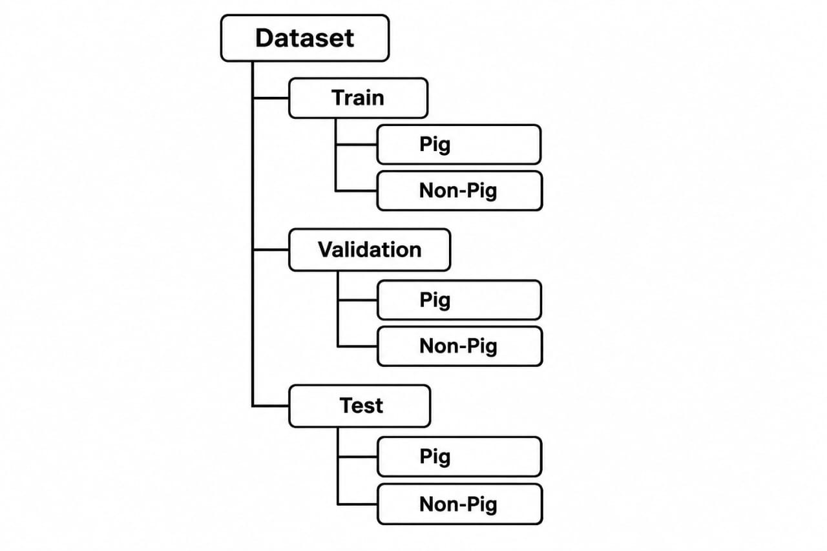
Dataset Distribution
Dataset | Pig | Non-Pig | Total
Training | 653 | 826 | 1479
Validation | 117 | 168 | 285
Testing | 233 | 84 | 317
Total | 1003 | 1078 | 2081
The training set is used to learn the features of the two classes. The validation set is used during training to monitor model performance, while the test set is used for final evaluation.

4.3 Pig and Non-Pig Classes

4.3.1 Pig Class
The Pig class contains images of pigs. These images help the model learn visual features such as body shape, head structure, legs, ears, and other characteristic patterns.

4.3.2 Non-Pig Class
The Non-Pig class contains images that do not represent pigs. This class is important because the PIR sensor can detect any moving object, including humans or other animals.
Therefore, the AI model is required to distinguish:
Pig not = Other Objects
This helps reduce false alerts caused by motion from non-pig objects.

4.4 Dataset Statistics
A total of 2081 images were used in the project.
- Training images: 1479
- Validation images: 285
- Testing images: 317
The dataset contains:
- Pig images: 1003
- Non-pig images: 1078
The images were organized into separate folders so that TensorFlow/Keras could automatically assign the corresponding class labels.

4.5 Data Preprocessing
Before being given to the deep learning model, the input images are resized to:
224×224 pixels
The image is converted into a numerical array that can be processed by the neural network.
The input image can be represented as:
I∈R^224×224×3I

where the three channels represent the RGB components.
The MobileNetV2 preprocessing layer scales the pixel values before they are passed to the pre-trained network.

4.6 MobileNetV2 Transfer Learning
MobileNetV2 is a lightweight convolutional neural network architecture designed for efficient image recognition.
In this project, a pre-trained MobileNetV2 model is used as the feature extraction network. The model was originally trained on the ImageNet dataset and already contains useful visual features.
Instead of training the complete network from the beginning, the pre-trained layers are kept frozen and used for feature extraction.

4.6.1 Global Average Pooling
The feature maps obtained from MobileNetV2 are converted into a compact feature representation using Global Average Pooling.
It reduces the spatial dimensions of the feature maps while retaining important information.
4.6.2 Dense Layer
A single-neuron Dense layer is used for binary classification.
Dense(1)
The output is then passed through a sigmoid activation function.

4.6.3 Sigmoid Activation
The sigmoid function converts the model output into a value between 0 and 1.
σ(x)=1/1+e−x
The classification rule used in the project is:
P≥0.5⇒PIG
P<0.5⇒NON-PIG
where P represents the sigmoid output.

4.7 Model Training
The MobileNetV2-based model was trained using the training dataset.
The following parameters were used:
Parameter | Value
Model | MobileNetV2
Input Size | 224 × 224
Batch Size | 32
Epochs | 10
Optimizer | Adam
Loss Function | Binary Cross-Entropy
Output | Sigmoid
Classes | Pig / Non-Pig
Dropout | 0.2

The binary cross-entropy loss function is used because the project performs binary classification.
The model was trained for 10 epochs using the training dataset and evaluated using the validation dataset.
The trained model was saved as:
pig_detection_model.keras

4.8 Model Testing
After training, the model was evaluated using the separate test dataset.
The obtained results were:
Metric | Result
Training Accuracy | 99.59%
Validation Accuracy | 98.94%
Test Accuracy | 99.05%
The test accuracy of approximately 99.05% indicates that the model performed well on the prepared test dataset.
However, this value represents performance on the prepared test dataset and should not be interpreted as guaranteed real-world accuracy.

4.9 Prediction Process
After training, individual images were tested using the saved model.

Pig Image Test-A separate pig image was provided to the model.
Result:
Prediction: PIG
Confidence: 99.95%

Non-Pig Image Test-A separate non-pig image was provided to the model.
Result:
Prediction: NON-PIG
Confidence: 99.88%
These tests demonstrate that the trained model can classify the selected sample images into the two required categories.

4.10 Camera Image Prediction
The trained model was also tested with an image captured directly from the ESP32-CAM.
The captured image was saved as:
captured.jpg
The image was then given to the trained MobileNetV2 model.

4.11 AI Model Workflow
The complete AI processing sequence is:
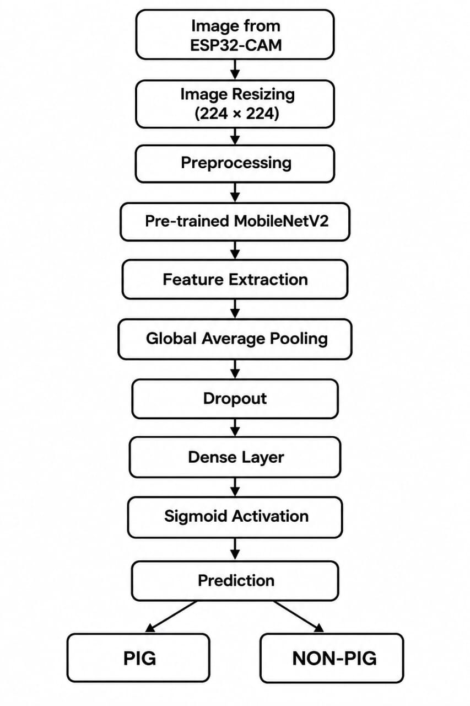

4.12 Summary
This chapter presented the dataset preparation and AI model used for wild pig classification. A total of 2081 images were organized into pig and non-pig classes and divided into training, validation, and testing sets. A pre-trained MobileNetV2 model with transfer learning was used for binary image classification. The model achieved 99.05% test accuracy on the prepared test dataset. Separate sample tests also successfully identified pig and non-pig images, while camera-based testing revealed the need for further improvement under real-world conditions.

CHAPTER 5 — HARDWARE AND SOFTWARE IMPLEMENTATION

5.1 ESP32-CAM Setup
The AI-Thinker ESP32-CAM is used as the main camera and IoT module in the proposed system. It is responsible for capturing images of objects detected in the monitored area and communicating with the computer through Wi-Fi.
The ESP32-CAM was programmed using the Arduino IDE. During programming, a NodeMCU ESP8266 was used as a USB-to-serial interface.
The ESP32-CAM was successfully configured with the CameraWebServer program, and the camera webpage was accessed through its assigned IP address.
The basic sequence is:

ESP32-CAM

↓

Connect to Wi-Fi

↓

Obtain IP Address

↓

Open Camera Web Server

↓

Capture Image

5.2 PIR Sensor Interface
A PIR (Passive Infrared) sensor is used to detect motion in the monitored area.
The PIR sensor is connected to GPIO 2 of the ESP32-CAM.
PIR Sensor | ESP32-CAM
VCC | 5V
GND | GND
OUT | GPIO 2

When motion is detected, the PIR sensor produces a HIGH signal.
The operation can be represented as:
Motion→PIR=HIGH
No Motion→PIR=LOW
The PIR sensor was tested successfully, and motion detection was observed through the Serial Monitor.

5.3 LED Interface
An LED is used as a visual indication for the alert condition.
The LED is connected to GPIO 13 of the ESP32-CAM through a current-limiting resistor.
ESP32-CAM GPIO 13
↓
Resistor
↓
LED
↓
GND

The LED operation is:

Condition | LED
Alert | ON
No Alert | OFF

5.4 Buzzer Interface
A two-pin passive buzzer is used to provide an audible alert.
The buzzer is connected to GPIO 12.
ESP32-CAM GPIO 12 ─── Buzzer (+)
ESP32-CAM GND ─────── Buzzer (-)
Since a passive buzzer is used, a tone signal is generated using the tone() function.
A frequency of approximately:
f=2000 Hz
was used during testing.
The buzzer successfully produced an audible sound during the hardware test.

5.5 Camera Image Capture
The ESP32-CAM provides a web-based interface for camera operation. After connecting to Wi-Fi, the camera can be accessed through its IP address.
The /capture endpoint was used to obtain a still image from the ESP32-CAM.
The Python program sends an HTTP request to the camera:

Python Program

↓

HTTP Request

↓

ESP32-CAM /capture

↓

JPEG Image

↓

Computer
The captured image was successfully received and saved as:
captured.jpg
This confirms that image communication between the ESP32-CAM and computer was successfully established.

5.6 Wi-Fi Communication
The ESP32-CAM communicates with the computer using a Wi-Fi network.
The communication process is:

ESP32-CAM

↓

Wi-Fi Network

↓

Computer

↓

Python Program
The camera's IP address is used by the Python program to access the image capture endpoint.
HTTP communication is used to request the captured image from the ESP32-CAM.

5.7 Python–ESP32-CAM Communication
Python is used to communicate with the ESP32-CAM and retrieve captured images.
The basic implementation consists of:
- Establishing the ESP32-CAM IP address.
- Sending an HTTP request to the /capture endpoint.
- Receiving the JPEG image.
- Saving the image as captured.jpg.
- Passing the image to the AI model.

The basic workflow is:

Start
↓
Connect to ESP32-CAM
↓
Send /capture Request
↓
Receive Image
↓
Save captured.jpg
↓
Send Image to AI Model
↓
Display Prediction

5.8 AI Prediction Integration
The captured image is given to the trained MobileNetV2-based classification model.
The Python program loads:
pig_detection_model.keras
The captured image is resized to:
224×224
and passed to the model.
The model produces a sigmoid output between 0 and 1.

5.9 Alert Generation
The alert section is designed to provide an immediate warning when a wild pig is detected.
For a PIG classification:
- LED is activated.
- Buzzer is activated.
- The farmer receives a local warning.
For a NON-PIG classification:
- LED remains OFF.
- Buzzer remains OFF.
- No alert is generated.
5.10 Hardware Implementation Results
The individual hardware components were tested before complete system integration.
Component | Test Result | Status
PIR Sensor | Motion detected successfully | Pass
LED | ON/OFF operation successful | Pass
Passive Buzzer | Audible tone produced | Pass
ESP32-CAM | Camera webpage opened | Pass
Image Capture | captured.jpg successfully created | Pass
Wi-Fi Communication | Image received through HTTP | Pass

these tests confirm that the major hardware components are functioning correctly.
5.11 Overall Software Workflow
The complete software workflow of the proposed system is:

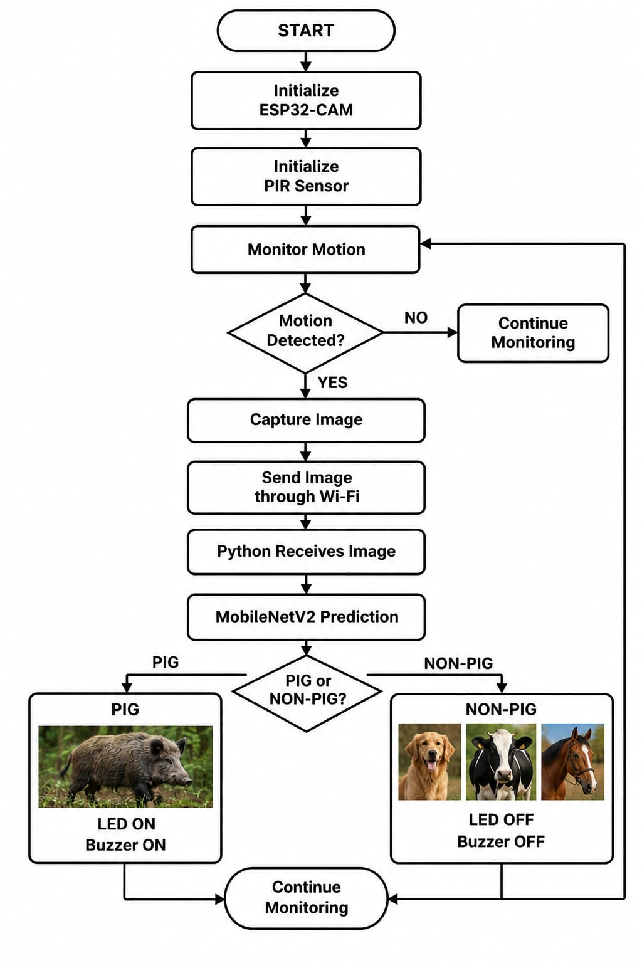

5.12 Summary
This chapter described the implementation of the proposed system using the ESP32-CAM, PIR sensor, LED, passive buzzer, NodeMCU, Python, and MobileNetV2. The PIR sensor, LED, buzzer, camera, and image-capture functions were successfully tested individually. The ESP32-CAM was also successfully connected to the computer through Wi-Fi, and captured images were processed using the trained AI model. The complete AI-based alert integration remains the next stage of implementation and testing.

CHAPTER 6 — TESTING AND RESULTS

6.1 Introduction
This chapter presents the testing and experimental results of the proposed Smart Wild Pig Detection and Crop Protection System using IoT and AI. The individual hardware components, camera communication, image capture, and AI classification model were tested separately to verify the functionality of the system.
The testing was performed in different stages to identify errors and evaluate the performance of the proposed system.

6.2 Hardware Testing
The hardware components were tested individually before integrating them into the complete system.
The following components were tested:
- PIR sensor
- LED
- Passive buzzer
- ESP32-CAM
- Wi-Fi communication
The results obtained during testing are summarized below.
Component | Test Result | Status
PIR Sensor | Motion detected successfully | Pass
LED | ON/OFF operation successful | Pass
Passive Buzzer | Audible tone produced | Pass
ESP32-CAM | Camera webpage opened | Pass
Image Capture | captured.jpg successfully created | Pass
Wi-Fi Communication | Image received through HTTP | Pass

6.3 PIR Motion Detection Test
The PIR sensor was connected to GPIO 2 of the ESP32-CAM.
When a moving object was present in front of the sensor, the Serial Monitor displayed:
Motion Detected
When no motion was detected, the system displayed:
No Motion
Thus, the PIR sensor successfully performed its intended function as the first-stage motion detector.

6.4 LED Testing
The LED was connected to GPIO 13.
The LED was tested under both motion and no-motion conditions.
Condition | LED
Alert | ON
No Alert | OFF

6.5 Buzzer Testing
A two-pin passive buzzer was connected to GPIO 12.
Since a passive buzzer requires an oscillating signal, the tone() function was used for testing.
A frequency of approximately 2000 Hz successfully produced an audible sound.
Therefore, the buzzer was confirmed to be suitable for providing a local audible warning.

6.6 ESP32-CAM Testing
The ESP32-CAM was tested using the CameraWebServer program.
After successful initialization, the camera webpage was opened through the IP address assigned by the Wi-Fi network.
The camera successfully started and provided access to the camera interface.
Result:
Camera Ready
Camera Web Server Accessible
Hence, the camera module was successfully tested.

6.7 Camera Image Capture Test
The /capture endpoint of the ESP32-CAM was used to capture a still image.
A Python program sent an HTTP request to the ESP32-CAM and received the JPEG image.
The captured image was successfully saved as:
captured.jpg
The result confirms successful communication between the ESP32-CAM and the Python program.

6.8 AI Model Testing
The trained MobileNetV2 model was tested using the separate test dataset.
The obtained performance was:
Metric | Result
Training Accuracy | 99.59%
Validation Accuracy | 98.94%
Test Accuracy | 99.05%
The test accuracy shows that the trained model performed well on the prepared test dataset.
However, this accuracy should not be considered as guaranteed field accuracy because real-world camera images can differ from the dataset.

6.9 Pig Image Prediction Test
A separate pig image was provided to the trained model.
The model produced:
Prediction: PIG
Confidence: 99.95%
Therefore, the selected pig image was correctly classified.
Result: PASS

6.10 Non-Pig Image Prediction Test
A separate non-pig image was provided to the trained model.
The model produced:
Prediction: NON-PIG
Confidence: 99.88%
Therefore, the selected non-pig image was correctly classified.
Result: PASS

6.11 Camera-Based AI Testing
The system was further tested using an image captured directly from the ESP32-CAM.
A pig image was shown in front of the camera and the camera captured the image successfully.
However, the AI model produced approximately:
Prediction: NON-PIG
Confidence: 67%
This was an incorrect classification.
This result indicates that the model's performance on prepared test images does not necessarily represent its performance on camera-captured images.
Possible reasons include:
- Different lighting conditions
- Camera image quality
- Distance between camera and object
- Background differences
- Camera angle
- Image resolution
- Difference between dataset images and real camera images
This test is useful for identifying the limitations of the current prototype.
6.12 Functional Test Cases
Test Case | Expected Result | Actual Result | Status
PIR detects motion | Motion detected | Motion detected | Pass
PIR detects no motion | No motion | No motion | Pass
LED with motion | LED ON | LED ON | Pass
LED without motion | LED OFF | LED OFF | Pass
Buzzer test | Sound produced | Sound produced | Pass
Camera startup | Camera webpage opens | Opened successfully | Pass
Image capture | JPEG image generated | captured.jpg generated | Pass
Pig sample classification | PIG | PIG, 99.95% | Pass
Non-pig sample classification | NON-PIG | NON-PIG, 99.88% | Pass
The overall functional tests performed so far are shown below.

6.13 Performance Evaluation
The AI model achieved a test accuracy of:
99.05%
on the prepared test dataset.
The individual sample predictions also showed high confidence:
Pig image=99.95%
Non-pig image=99.88%
However, the camera-based test produced an incorrect prediction. Therefore, the current results demonstrate that the model works well on the prepared dataset but requires additional optimization and real-world testing before claiming reliable field performance.

6.14 Error Analysis
The camera-based misclassification provides an important observation about the system.
The prepared dataset contains images with different backgrounds, poses, and image qualities. However, the image captured by the ESP32-CAM may have different characteristics.
The following factors can contribute to classification errors:
- Lighting: Poor or changing illumination can affect image features.
- Distance: A distant object may occupy only a small portion of the image.
- Background: Complex backgrounds can make classification difficult.
- Camera quality: ESP32-CAM images may differ from high-quality dataset images.
- Object position: The pig may appear at different orientations or sizes.
- Dataset variation: More camera-like images may be required for improved generalization.

6.15 Reliability Testing
The hardware components were tested individually and operated successfully.
The PIR sensor reliably produced motion signals during testing. The LED responded correctly to the motion condition, and the passive buzzer successfully generated an audible tone.
The ESP32-CAM successfully started the camera server and captured images through the HTTP interface.
Therefore, the individual hardware modules demonstrated satisfactory operation during prototype testing.

6.16 Limitations Observed During Testing
The following limitations were identified:
- The current AI model is running on the computer rather than directly on the ESP32-CAM.
- Camera-captured images may not always be classified correctly.
- The complete AI-to-LED/buzzer automatic feedback loop is not yet fully integrated.
- The system has been tested as a prototype and not under actual agricultural field conditions.
- Further real-world images are required to improve robustness.

6.17 Summary
The proposed system was tested in multiple stages. The PIR sensor, LED, passive buzzer, ESP32-CAM, Wi-Fi communication, and image capture were successfully tested. The trained MobileNetV2 model achieved 99.05% accuracy on the prepared test dataset and correctly classified selected pig and non-pig sample images with high confidence.
However, a camera-captured pig image was incorrectly classified as non-pig with approximately 67% confidence. This result highlights the difference between laboratory dataset performance and real-world camera performance. Further camera-based dataset collection and complete hardware-AI integration are required to improve the reliability of the system.

CHAPTER 7 — CONCLUSION AND FUTURE SCOPE

7.1 Conclusion
The Smart Wild Pig Detection and Crop Protection System using IoT and AI was developed to provide an automated method for detecting wild pig movement and generating a local warning.
The proposed system combines a PIR sensor, ESP32-CAM, Wi-Fi communication, and a MobileNetV2-based deep learning model. The PIR sensor detects movement, while the ESP32-CAM captures the image of the detected object. The captured image is transferred to a computer through Wi-Fi and classified as PIG or NON-PIG using the trained AI model.
The hardware components were successfully tested individually. The PIR sensor detected motion, the LED provided visual indication, and the passive buzzer successfully generated an audible alert. The ESP32-CAM also successfully captured images and transferred them to the computer.
The trained MobileNetV2 model achieved 99.05% accuracy on the prepared test dataset. Separate sample testing also correctly classified a pig image with 99.95% confidence and a non-pig image with 99.88% confidence.
However, testing with a camera-captured pig image resulted in an incorrect classification. This shows that additional real-world testing and model improvement are required for reliable field operation.
Overall, the prototype demonstrates the feasibility of combining IoT, sensor-based motion detection, camera-based monitoring, and artificial intelligence for smart crop protection.

7.2 Advantages
The proposed system provides the following advantages:
- Automatic detection of moving objects.
- AI-based classification of pig and non-pig images.
- Reduced false alerts compared with using a PIR sensor alone.
- Real-time image capture using ESP32-CAM.
- Local LED and buzzer alert for immediate warning.
- Wireless communication through Wi-Fi.
- Low-cost prototype using commonly available components.
- The system can be further adapted for agricultural field monitoring.
- The approach can be extended to other animal detection applications.

7.3 Limitations
The current prototype has some limitations:
- The AI model currently runs on a computer rather than directly on the ESP32-CAM.
- The model does not always classify camera-captured images correctly.
- The dataset needs more real-world camera images for better generalization.
- The prototype has not yet been extensively tested in actual agricultural fields.
- Performance can be affected by lighting, distance, camera angle, background, and image quality.
- Complete automatic communication from the AI prediction back to the ESP32-CAM alert circuit requires further integration.

7.4 Future Improvements
The system can be improved in several ways.

7.4.1 Larger and More Diverse Dataset
More pig and non-pig images can be collected from real field conditions. Images with different:
- Lighting conditions
- Backgrounds
- Distances
- Camera angles
- Pig poses
can be included to improve model performance.

7.4.2 Real-Time AI Integration
The current model runs on a computer. In the future, the AI model can be optimized for an edge device so that classification can be performed closer to the camera.

7.4.3 Mobile Notification
In future, a mobile application or cloud-based IoT platform can be added to send notifications to farmers when a wild pig is detected.

7.4.4 Voice Alert
A voice-based alert can be added using a suitable audio module so that the system can provide a local warning in the farmer's preferred language.

7.4.5 Night-Time Monitoring
Additional illumination or suitable low-light/infrared camera support can be incorporated for improved detection during nighttime.

7.4.6 Field Deployment
The system can be packaged in a weather-resistant enclosure and deployed near agricultural fields for long-term testing.

7.4.7 Advanced Object Detection
In future versions, an object-detection model such as YOLO can be explored to identify the location of a pig within the camera frame instead of performing only image-level classification.

7.5 Final Conclusion
The developed prototype demonstrates the potential of IoT and AI technologies for smart crop protection. The successful operation of the PIR sensor, ESP32-CAM, LED, buzzer, image capture, and AI classification establishes the basic foundation of the proposed system.
Further improvement of the dataset, real-world testing, edge-AI implementation, and automatic alert integration can make the system more reliable and suitable for practical agricultural applications.

APPENDIX

Appendix A — Arduino Source Code

ARDUINO SOURCE CODE – PIR, LED AND BUZZER TEST
#define PIR_PIN 2
#define LED_PIN 13
#define BUZZER_PIN 12

void setup()
{
Serial.begin(115200);

pinMode(PIR_PIN, INPUT);
pinMode(LED_PIN, OUTPUT);
pinMode(BUZZER_PIN, OUTPUT);

digitalWrite(LED_PIN, LOW);
noTone(BUZZER_PIN);

Serial.println("Smart Wild Pig Detection");
Serial.println("System Ready");
}

void loop()
{
int motion = digitalRead(PIR_PIN);

if (motion == HIGH)
{
digitalWrite(LED_PIN, HIGH);
tone(BUZZER_PIN, 2000);

Serial.println("Motion Detected");
Serial.println("LED ON");
Serial.println("BUZZER ON");
}
else
{
digitalWrite(LED_PIN, LOW);
noTone(BUZZER_PIN);

Serial.println("No Motion");
}

delay(500);
}

Appendix B – ESP32-CAM Camera and Alert Source Code

B.1 Alert Handler Added

static esp_err_t alert_handler(httpd_req_t *req)

{

char query[20];

if (httpd_req_get_url_query_str(req, query, sizeof(query)) == ESP_OK)

{

if (strstr(query, "pig=1"))

{

digitalWrite(13, HIGH);

tone(12, 2000);

Serial.println("AI RESULT: PIG");

Serial.println("LED ON - BUZZER ON");

}

else if (strstr(query, "pig=0"))

{

digitalWrite(13, LOW);

noTone(12);

Serial.println("AI RESULT: NON-PIG");

Serial.println("LED OFF - BUZZER OFF");

}

}

httpd_resp_send(req, "Alert command received", HTTPD_RESP_USE_STRLEN);

return ESP_OK;

}
This is the main modification we made. It receives pig=1 or pig=0 through the URL and controls the alert devices accordingly.

B.2 New /alert URI Added
We added a new HTTP URI for the alert command:
httpd_uri_t alert_uri = {
.uri = "/alert",
.method = HTTP_GET,
.handler = alert_handler,
.user_ctx = NULL
};
This creates the /alert endpoint in the CameraWebServer.

B.3 Alert URI Registered
The new alert URI was registered with the camera web server:
httpd_register_uri_handler(camera_httpd, &alert_uri);
This was added along with the existing CameraWebServer URI handlers.

Appendix C — Python Source Code

1.check_dataset.py
import os

folders = [
"train/pig",
"train/non_pig",
"valid/pig",
"valid/non_pig",
"test/pig",
"test/non_pig"
]

print("SMART WILD PIG DETECTION")
print("------------------------")

total = 0

for folder in folders:
files = os.listdir(folder)
count = len(files)
print(folder, ":", count)
total += count

print("------------------------")
print("Total images:", total)

2. train_model.py
import tensorflow as tf
from tensorflow.keras import layers, models
from tensorflow.keras.applications import MobileNetV2

# Image settings
IMG_SIZE = (224, 224)
BATCH_SIZE = 32

# Load dataset
train_data = tf.keras.utils.image_dataset_from_directory(
"train",
image_size=IMG_SIZE,

batch_size=BATCH_SIZE,
label_mode="binary"
)

valid_data = tf.keras.utils.image_dataset_from_directory(
"valid",
image_size=IMG_SIZE,
batch_size=BATCH_SIZE,
label_mode="binary"
)

# Save class names
print("Classes:", train_data.class_names)

# Improve loading speed
AUTOTUNE = tf.data.AUTOTUNE
train_data = train_data.prefetch(AUTOTUNE)
valid_data = valid_data.prefetch(AUTOTUNE)

# MobileNetV2 CNN
base_model = MobileNetV2(
input_shape=(224, 224, 3),
include_top=False,
weights="imagenet"
)

# Freeze the pretrained layers
base_model.trainable = False

# Build model
model = models.Sequential([
layers.Rescaling(1./127.5, offset=-1),
base_model,
layers.GlobalAveragePooling2D(),
layers.Dropout(0.2),
layers.Dense(1, activation="sigmoid")
])

# Compile
model.compile(
optimizer="adam",
loss="binary_crossentropy",
metrics=["accuracy"]
)

# Train
history = model.fit(
train_data,
validation_data=valid_data,
epochs=10
)

# Save model
model.save("pig_detection_model.keras")

print("Training completed!")
print("Model saved as pig_detection_model.keras")

3.test_model.py
import tensorflow as tf

# Load the trained model
model = tf.keras.models.load_model("pig_detection_model.keras")

# Test image settings
IMG_SIZE = (224, 224)
BATCH_SIZE = 32

# Load test dataset
test_data = tf.keras.utils.image_dataset_from_directory(
"test",
image_size=IMG_SIZE,
batch_size=BATCH_SIZE,
label_mode="binary",
shuffle=False
)

# Test the model
loss, accuracy = model.evaluate(test_data)

print("------------------------")
print("TEST RESULTS")
print("------------------------")
print("Test Loss:", loss)
print("Test Accuracy:", accuracy)
print("------------------------")

4.predict.py
import tensorflow as tf
import numpy as np

# Load trained model
model = tf.keras.models.load_model("pig_detection_model.keras")

# Image size
IMG_SIZE = (224, 224)

# Enter your image path here
image_path = "my_nonpig.jpg"

# Load image
image = tf.keras.utils.load_img(
image_path,
target_size=IMG_SIZE
)

# Convert image to array
image_array = tf.keras.utils.img_to_array(image)

# Add batch dimension
image_array = np.expand_dims(image_array, axis=0)

# Make prediction
prediction = model.predict(image_array)[0][0]

# Display result
if prediction >= 0.5:
print("Prediction: PIG")
print("Confidence:", prediction * 100, "%")
else:
print("Prediction: NON-PIG")
print("Confidence:", (1 - prediction) * 100, "%")

5.capture_camera.py
import requests

ESP32_IP = "http://10.162.128.8"

url = ESP32_IP + "/capture"

response = requests.get(url, timeout=10)

if response.status_code == 200:
with open("captured.jpg", "wb") as f:
f.write(response.content)

print("Image captured successfully!")
print("Saved as captured.jpg")
else:
print("Camera error:", response.status_code)

7.predict_camera.py
import tensorflow as tf
import numpy as np
import requests

# ESP32-CAM IP address
ESP32_IP = "http://10.162.128.8"

# Load trained AI model
model = tf.keras.models.load_model("pig_detection_model.keras")

IMG_SIZE = (224, 224)

# Load captured image
image = tf.keras.utils.load_img(
"captured.jpg",
target_size=IMG_SIZE
)

image_array = tf.keras.utils.img_to_array(image)
image_array = np.expand_dims(image_array, axis=0)

# AI prediction
prediction = model.predict(image_array, verbose=0)[0][0]

if prediction >= 0.5:

confidence = prediction * 100

print("Prediction: PIG")
print("Confidence:", confidence, "%")

# Send PIG alert to ESP32-CAM
response = requests.get(
ESP32_IP + "/alert?pig=1",
timeout=5
)

print("ESP32:", response.text)

else:

confidence = (1 - prediction) * 100

print("Prediction: NON-PIG")
print("Confidence:", confidence, "%")

# Send NON-PIG command to ESP32-CAM
response = requests.get(
ESP32_IP + "/alert?pig=0",
timeout=5
)

print("ESP32:", response.text)

