PROJECT EXPO 2026
Smart IV Drip Monitoring Using IOT

TEAM MEMBERS:
M.DHASLIMA BANU
P. GANGASHREE

TESTING & VALIDATION REVIEW(TVR):

FUNCTIONAL TESTING REPORT:
The developed Smart IV Drip Monitoring System was tested to verify the operation of all hardware and software modules. The TCRT5000 IR sensor successfully detected the IV drops passing through the drip chamber. The ESP32 processed the sensor data, calculated the flow rate, and transmitted the information through Wi-Fi. The SG90 servo motor responded to control commands and regulated the IV tube flow. The complete system operated successfully during testing.
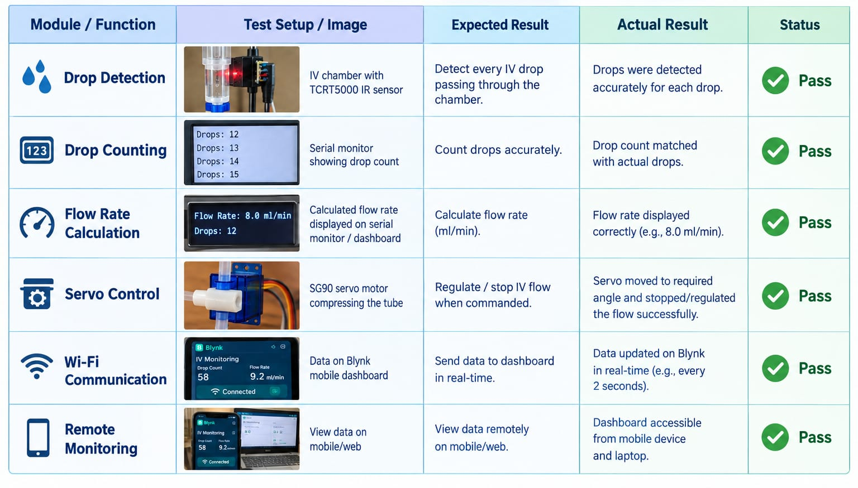

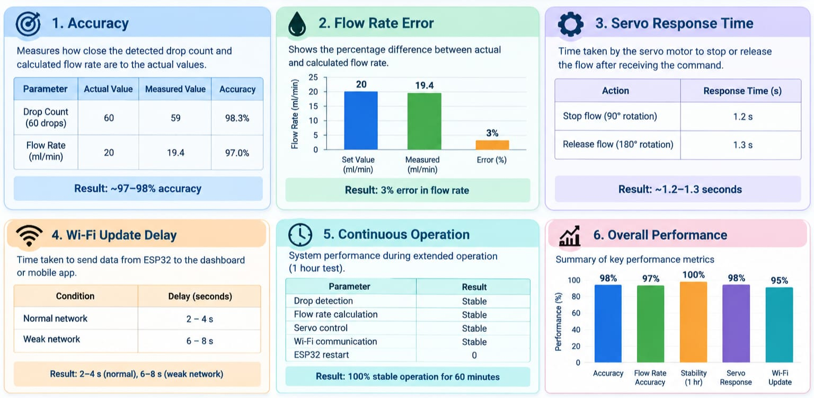
PERFORMANCE EVALUATION:

CONCLUSION:
The Smart IV Drip Monitoring System demonstrated reliable drop detection, accurate flow-rate estimation, stable Wi-Fi communication, and effective servo-based flow regulation. The system maintained continuous operation for one hour without significant performance degradation.

TEST CASES:
Test Case 1:
Objective: Detect IV drops
Input: Water flowing through chamber
Expected: Drop count increases
Result: Pass
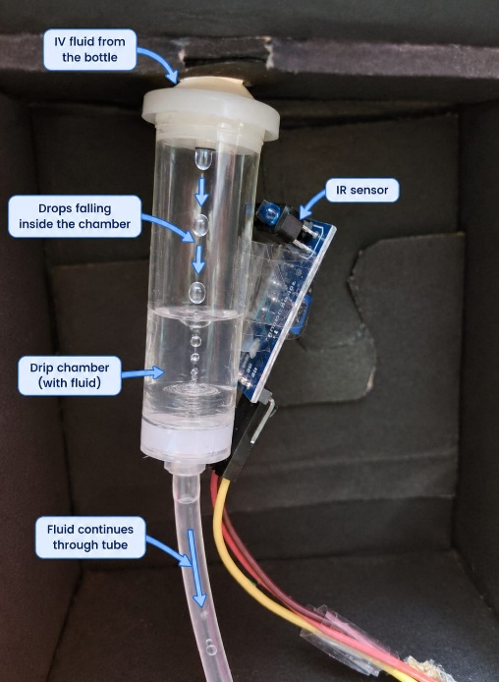
Fig: Drop Detection

Test Case 2:
Objective: Stop flow using servo
Input: Servo command
Expected: Tube compressed and flow stops
Result: Pass

Fig: Stop flow using servo
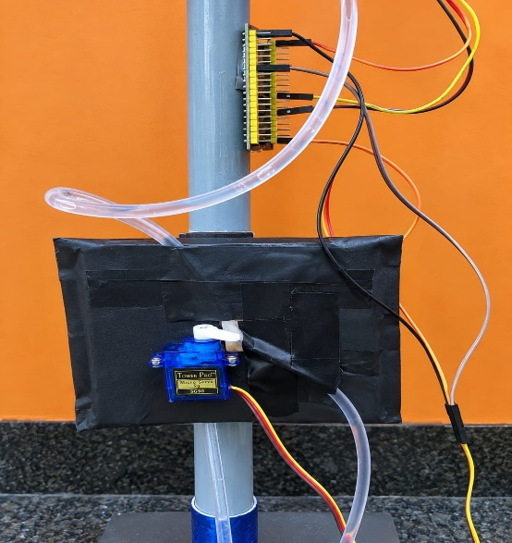

Test Case 3:
Objective: Wi-Fi monitoring
Input: Connect ESP32 to Blynk
Expected: Data visible remotely
Result: Pass

Fig: Wi-Fi monitoring
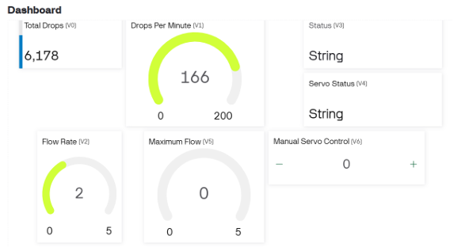

ERROR ANALYSIS:
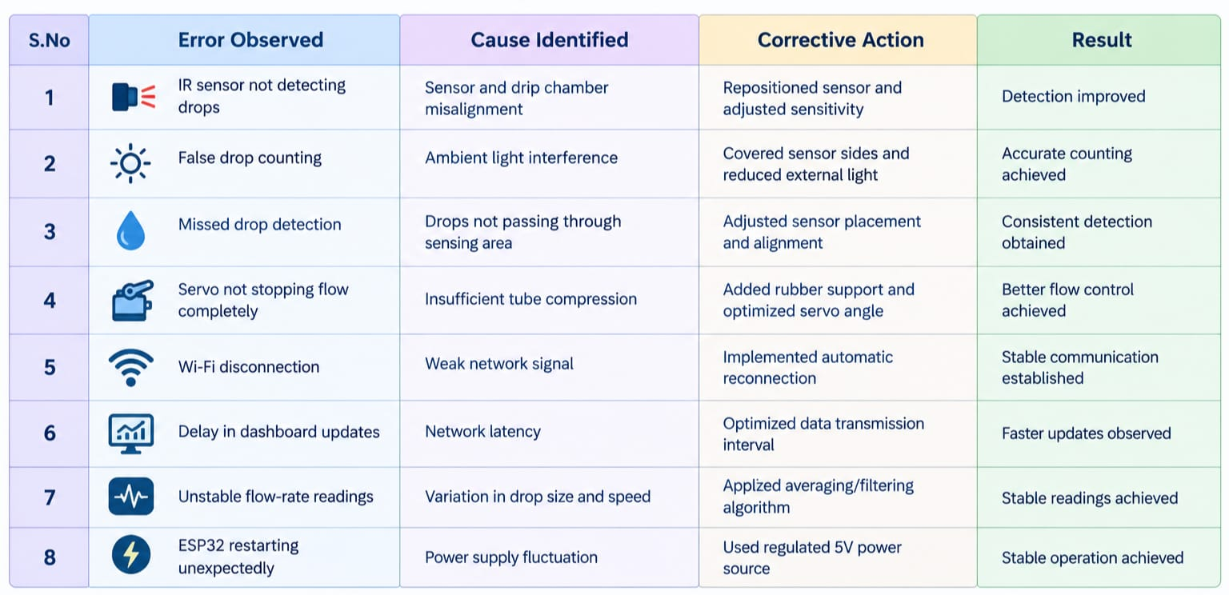
CONCLUSION:
The identified errors were successfully analysed and resolved through proper debugging and system optimization. The final prototype achieved improved accuracy, stable communication, reliable servo operation and consistent performance during testing.

DEBUGGING REPORT:

1. Issue: IR sensor not detecting drops
Action: Checked wiring, repositioned TCRT5000 sensor, adjusted sensitivity
Outcome: Drop detection improved
2. Issue: False drop counting
Action: Reduced ambient light interference and recalibrated sensor
Outcome: Accurate counting achieved
3. Issue: Missed drop detection
Action: Realigned sensor with drip path
Outcome: Consistent detection obtained
4. Issue: Servo not stopping flow completely
Action: Modified servo mounting and added rubber support
Outcome: Better tube compression achieved
5. Issue: ESP32 not connecting to Wi-Fi
Action: Verified SSID/password and restarted connection
Outcome: Successful Wi-Fi connection established
6. Issue: Dashboard not updating data
Action: Checked Blynk configuration and communication code
Outcome: Real-time monitoring restored
7. Issue: Unstable flow-rate values
Action: Applied averaging/filtering algorithm
Outcome: Stable readings obtained
8. Issue: ESP32 restarting unexpectedly
Action: Used regulated 5V power supply
Outcome: Stable operation achieved

CONCLUSION:
After debugging, the prototype achieved reliable drop detection, stable IoT communication, accurate flow-rate monitoring, and effective servo control.

POWER CONSUMPTION ANALYSIS:

1. Objective:
To estimate the total power consumed by the Smart IV Drip Monitoring System during standard operation and evaluate its suitability for continuous, long-term medical monitoring applications.
2. Power Consumption of Components:
The hardware architecture integrates a microcontroller unit for Wi-Fi telemetry, an optical sensor for drop detection, and a precision actuator for flow control. Detailed specifications are outlined below:
Component | Operating Voltage | Current Consumption
ESP32 Microcontroller | 5V | 80 mA
TCRT5000 IR Sensor | 3.3V | 15 mA
SG90 Servo Motor | 5V | 250 mA (maximum)
Total System Load | 5V | 345 mA

3. Power Calculation & Results:
Total power consumption is determined using Ohm's Law and standard electrical power equations:
Formula: Power (P) = Voltage (V) × Current (I)
Calculation: P = 5V × 0.345A = 1.725 W
Parameter | Calculated Value
Supply Voltage | 5V
Total Current Consumption | 345 mA (0.345 A)
Total Power Consumption | 1.725 W
System Category | Low-Power IoT Device

4. Conclusion:
The Smart IV Drip Monitoring System consumes approximately 1.725 W under peak operational load. Because of this low power requirement, the system can be reliably powered using standard 5V USB wall adapters or portable USB power banks. This portability and energy efficiency make it exceptionally well-suited for continuous inpatient monitoring and remote healthcare settings.

RELIABILITY TESTING:

1.Test Procedure:
1. The IV drip monitoring hardware setup was powered and operated continuously under standard testing conditions.
2. The TCRT5000 IR optical sensor continuously monitored and registered fluid drop counts.
3. The ESP32 microcontroller dynamically calculated the flow rate and transmitted telemetric data over Wi-Fi to the central dashboard.
4. The SG90 servo motor actuator was triggered through multiple open/close cycles to regulate drip flow rate.
5. System stability, communication connectivity, and hardware responsiveness were recorded over an extended 60-minute evaluation period.

2. Reliability Testing Results:
Test Parameter | Test Condition | Observation | Result
Continuous Operation | System operated for 30 minutes | No interruption in operation | Pass
Long Duration Test | System operated for 60 minutes | Stable performance maintained | Pass
Drop Detection Reliability | Continuous drip flow | Drops detected consistently | Pass
Servo Reliability | Multiple open/close operations | Servo responded correctly | Pass
Wi-Fi Communication Reliability | Continuous data transmission | Data updated successfully on dashboard | Pass
ESP32 Stability | Extended operation | No unexpected restart observed | Pass

3. Reliability Testing Metrics Summary:
Reliability Metric | Observed Result
Operating Time | 60 Minutes
System Failures | 0
ESP32 Restarts | 0
Wi-Fi Failures | 0
Overall Reliability | Good / Excellent

4. Conclusion:
The Smart IV Drip Monitoring System demonstrated exceptionally reliable performance throughout all test scenarios. The system successfully maintained continuous drop detection, accurate flow-rate calculations, dependable IoT telemetry transmission, and responsive servo control over the 60-minute trial without a single failure or restart. These results confirm the system's robustness and suitability for continuous long-duration clinical and remote healthcare monitoring applications.

FUTURE IMPROVEMENT:
1. Future Enhancements:
S.No | Improvement | Benefit
1 | Use medical-grade flow sensors | Higher accuracy in flow-rate measurement
2 | Mobile app notifications | Instant alerts to nurses and caregivers
3 | Cloud data storage | Remote access and patient record maintenance
4 | Battery backup system | Continuous operation during power failure
5 | Multi-patient monitoring | Monitor several IV setups from a single dashboard
6 | AI-based anomaly detection | Early identification of abnormal flow conditions
7 | Automatic IV bottle level monitoring | Timely replacement of IV fluids
8 | Hospital database integration | Centralized patient monitoring and management

2. Future Scope:
- Improve flow-rate accuracy using advanced medical sensors.
- Develop a dedicated mobile application for healthcare staff.
- Enable cloud-based monitoring from anywhere.
- Add battery backup for uninterrupted operation.
- Expand the system to monitor multiple patients simultaneously.
- Incorporate intelligent analytics for predictive healthcare monitoring.

