PROJECT REPORT
Automatic Solar Panel Tracker with Light Alert System
An ESP32-Based Embedded System for Solar Energy Optimization
Team Members: Nithisha S.K, Santhiya K
1. Problem Statement
Fixed-mount solar photovoltaic panels are oriented at a single, unchanging angle and therefore capture sunlight optimally only during a narrow window of time each day. As the position of the sun shifts continuously from east to west, the angle of incidence between sunlight and a stationary panel surface increases, leading to a progressive drop in the amount of solar energy absorbed. Field studies have repeatedly shown that this loss is significant enough to reduce the overall power yield of a solar installation across a full day of operation. In residential and small-scale settings, where cost and complexity restrict the use of high-end tracking hardware, this inefficiency is rarely addressed, resulting in solar systems that operate well below their potential output. There is therefore a need for a tracking mechanism that is inexpensive, simple to build, and reliable enough while still delivering a measurable improvement in energy capture over a fixed panel.

2. Abstract
This project presents the design and implementation of a low-cost, microcontroller-based automatic solar tracking system intended to improve the energy-harvesting efficiency of small-scale photovoltaic installations. The system is built around an ESP32 microcontroller, which continuously monitors the intensity of incident sunlight through two Light Dependent Resistors (LDRs) mounted on either side of the solar panel. By comparing the analog readings from these two sensors, the microcontroller determines the direction in which sunlight is strongest and issues a corresponding command to a servo motor, which physically reorients the panel to align it more directly with the sun. This sense-compare-actuate cycle repeats continuously throughout the day, allowing the panel to track the sun's apparent motion without any manual adjustment. A tolerance band is built into the control logic to prevent unnecessary oscillation of the servo when the two sensor readings are nearly equal, ensuring smooth and stable operation even under fluctuating light conditions such as partial cloud cover. The system further incorporates a light-alert feature that flags significant changes in ambient brightness, a capability that can be extended toward event logging or user notification. The complete system is implemented using the Arduino IDE and the ESP32Servo library, and it demonstrates, at low cost, the core principles of closed-loop feedback control, analog sensor interfacing, and embedded actuation. Given its simplicity, modularity, and affordability, the design offers a practical and scalable model for improving solar energy capture in educational, residential, and small commercial contexts, with clear potential for extension toward dual-axis tracking and IOT-based remote monitoring.
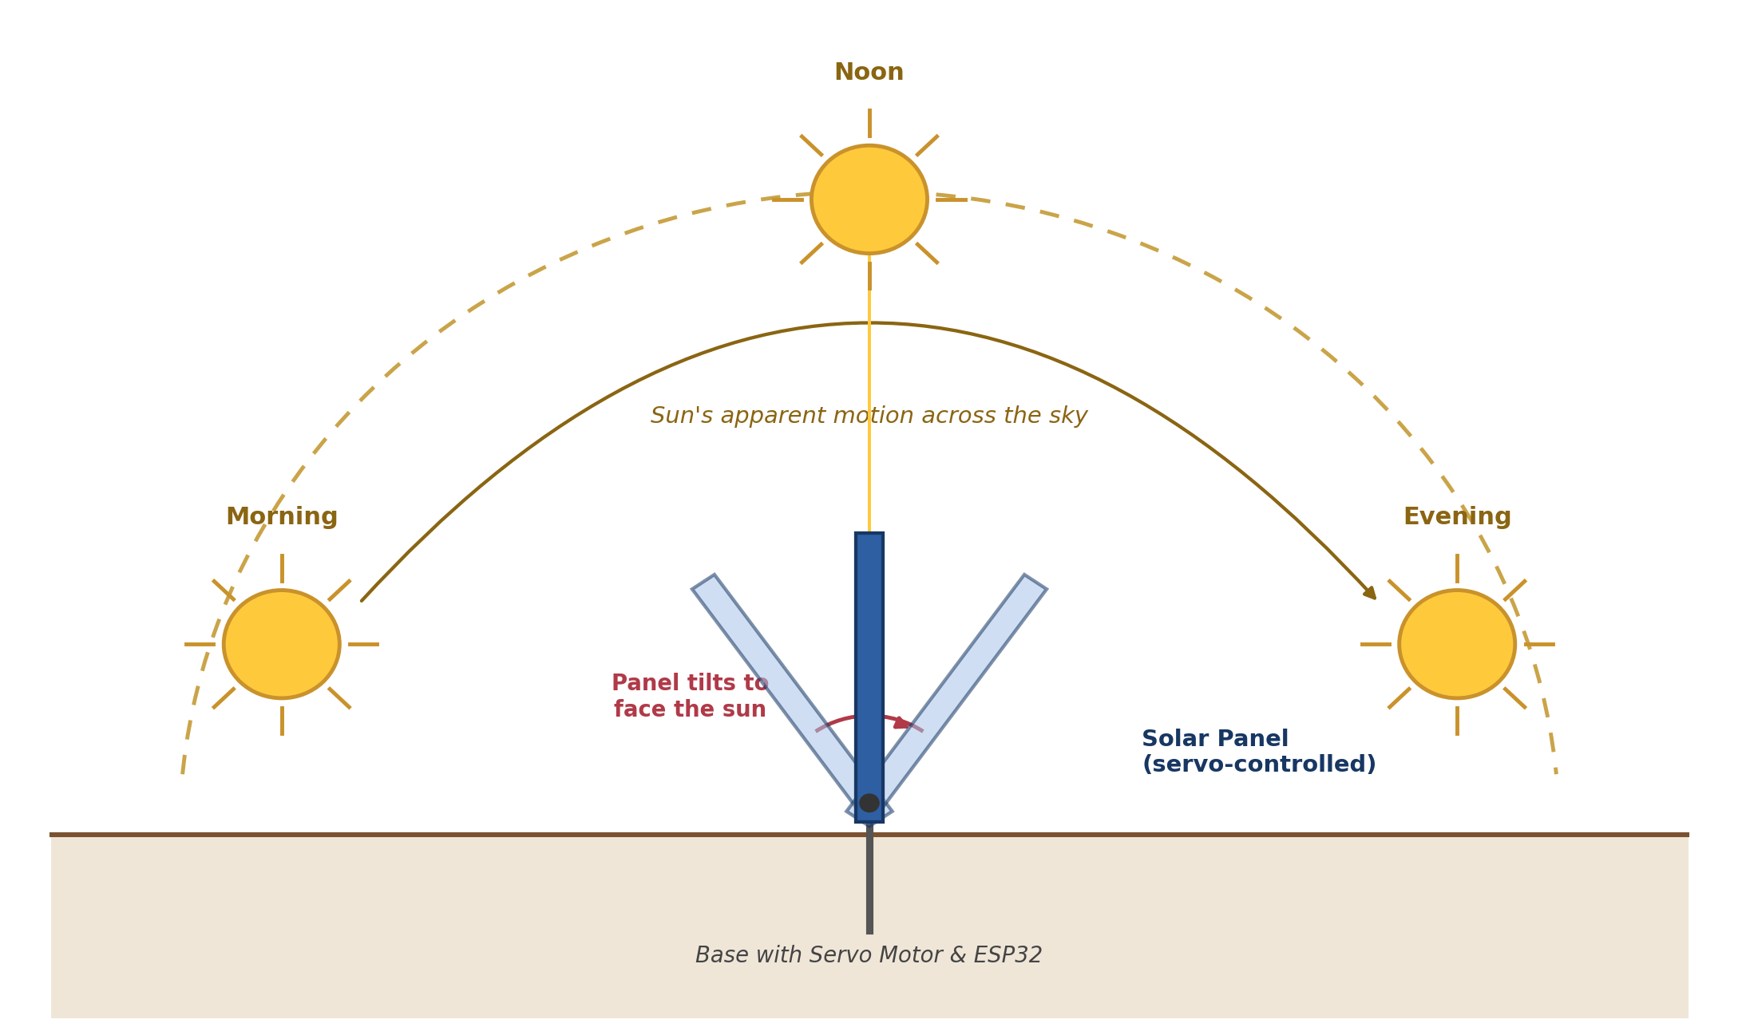

3. Objectives
1. To design and implement a low-cost solar tracking mechanism using an ESP32 microcontroller and readily available components.
2. To achieve real-time detection of the direction of maximum sunlight intensity using a pair of LDR sensors arranged in a differential configuration.
3. To develop closed-loop control logic that translates sensor differential readings into precise servo motor movement for panel reorientation.
4. To incorporate a light-intensity alert mechanism capable of signalling significant variation in ambient brightness.
5. To evaluate the improvement in light-capture efficiency of the tracking system relative to a fixed, stationary panel under identical conditions.
6. To build the system in a modular manner that allows future extension to dual-axis tracking and IoT-based monitoring.

4. Scope of the Project
The system covers the design of the sensing circuit (dual LDR voltage-divider configuration), the control algorithm implemented on the ESP32, and the mechanical actuation through a single servo motor. The project includes calibration procedures to tune sensor thresholds for varying ambient light conditions and basic testing to compare tracking performance against a fixed panel. The scope does not extend to the design or fabrication of the photovoltaic cell itself, large-scale industrial tracker mechanisms involving hydraulic or heavy-duty motor assemblies, or grid-tied power electronics. Dual-axis tracking, cloud-based data logging, and mobile application integration are identified as extensions beyond the current scope and are addressed separately under future scope.

5. Expected Outcomes
- A fully functional prototype that automatically reorients a solar panel toward the direction of maximum sunlight intensity throughout the day.
- Demonstrable improvement in light-capture efficiency compared to an identical fixed panel under the same test conditions.
- A stable control algorithm that avoids unnecessary servo oscillation under fluctuating or borderline light conditions.
- A working light-alert feature capable of detecting and reporting significant ambient brightness changes.
- Documented calibration data (threshold values, response behaviour) that can be reused or adapted for similar embedded sensing projects.
- A low-cost, reproducible design suitable for use as an academic demonstration or a foundation for further renewable-energy research.

6. Literature Survey
A number of prior studies have explored microcontroller-based solar tracking as a means of improving photovoltaic efficiency. Hassan and Abubakar designed an Arduino Uno-based tracker using LDR sensors and servo motors across two axes, in which the microcontroller compared LDR readings to determine the sun's position and commanded the servos to keep the panel perpendicular to incoming rays; their testing compared output in fixed mode against tracking mode and recorded a clear improvement in energy yield under tracking operation.
Study / Source | Methodology / Approach | Key Findings
Hassan & Abubakar [1] | Arduino Uno-based tracker using LDR sensors and servo motors across two axes; microcontroller compares LDR readings to keep the panel perpendicular to incoming rays. | Tracking mode showed a clear improvement in energy yield compared with fixed mode.
Five-LDR dual-axis system [3] | Five LDR sensors with an Arduino platform and two servo motors, programmed in C, tested across repeated intervals. | Tracking consistently outperformed a static panel; most stable output observed at ten-minute adjustment intervals.
LDR + MPU-6050 dual-axis design | Combined LDR sensing with an MPU-6050 gyroscope module to track angular sun movement more precisely. | Reported an efficiency improvement of roughly one quarter over a fixed installation.
Low-cost 2-DOF tracker [4] | Closed-loop LDR-based comparison strategy; LDR orientation configurable to sense one, two, three, or four incident directions. | Aimed to preserve tracking precision while minimizing component cost.
Arduino Nano single-axis design [6] | Simple single-axis design using incremental servo movement driven by LDR comparison. | Produced smooth, autonomous tracking suitable for small-scale replication by students and hobbyists.
Across this body of work, a consistent pattern emerges: LDR pairs (or small LDR arrays) combined with a microcontroller and one or more servo motors form a reliable, low-cost basis for closed-loop solar tracking, and every reviewed implementation reports a measurable efficiency gain over fixed-panel operation, though the magnitude of improvement and the sophistication of the control logic vary considerably between designs.

7. Existing Solutions Analysis
Solution Type | Description | Limitations
Fixed-mount panels | Panel installed at a single fixed tilt angle, no moving parts. | Significant efficiency loss outside peak sun hours; no adaptation to seasonal sun-angle change.
Dual-axis multi-LDR trackers | Five-LDR or gyroscope-assisted systems with two servo motors for azimuth and elevation control. | Higher component count and cost; more complex control logic; harder for a beginner to replicate.
Stepper-motor trackers | Uses stepper motors for finer angular control and higher torque handling. | Requires driver ICs and more current; increased cost and wiring complexity for small installations.
Commercial hydraulic/motorised trackers | Industrial-grade tracking systems used in utility-scale solar farms. | High capital cost; not accessible or necessary for student or small-scale use cases.

8. Gap Analysis
The reviewed literature and existing commercial solutions reveal a consistent gap between tracking sophistication and accessibility. The key limitations observed are as follows:
- High-precision dual-axis and gyroscope-assisted systems offer strong efficiency gains but rely on a larger sensor count, multiple actuators, and more elaborate control code, making them harder and costlier for students or hobbyists to replicate.
- Purely fixed installations are simple and cheap but forfeit a substantial share of potential energy capture.
- Very few reviewed designs give explicit emphasis to a lightweight alert mechanism that flags significant ambient brightness changes as a secondary, low-overhead feature alongside tracking.
- Many existing write-ups do not document a clear tolerance-band strategy to prevent servo oscillation under borderline lighting, a practical issue that affects real-world stability but receives limited attention.
This project addresses that gap by combining a minimal two-LDR, single-servo tracking design with an explicit calibrated tolerance band for stability, and a supplementary light-alert function, aiming for a design that is simple enough for a beginner to build and calibrate within a short project timeline, while still capturing the core efficiency benefit demonstrated in more complex systems.

9. Solution Analysis
Problem Statement: Fixed-mount solar panels lose significant energy across the day because their tilt cannot follow the sun's changing angle, and existing tracking hardware capable of correcting this is too costly and complex for student or small-scale use.
Proposed Solution: An ESP32-based single-axis tracker that uses two LDR sensors to sense sunlight direction and a servo motor to reorient the panel, with a tolerance band for stability and a light-alert feature, delivering the core efficiency benefit of complex trackers at low cost and complexity.
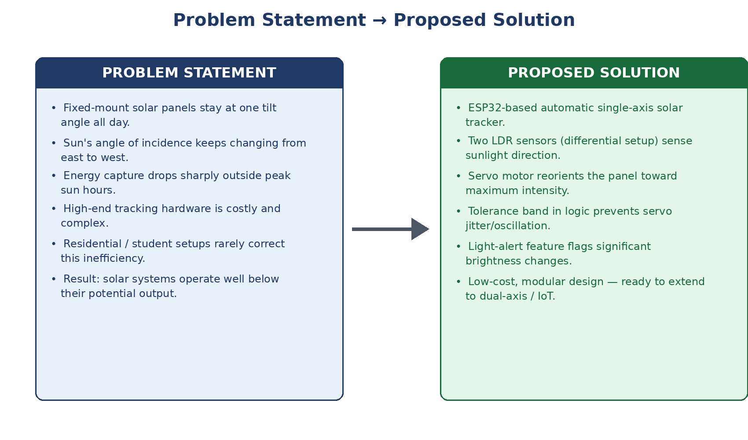

10. References
[1] R. Hassan and B. Abubakar, "Intelligent Arduino Based Automatic Solar Tracking System Using Light Dependent Resistors (LDRs) and Servo Motor," Optics, vol. 9, no. 2, pp. 13–18, Dec. 2020.
[2] Automatic Solar Tracking Using LDR and Stepper Motor Based on Arduino, Academia.edu, 2022.
[3] High-Efficiency Dual-Axis Solar Tracking Development Using Arduino, IEEE Conference Publication, IEEE Xplore, Document ID 6611961.
[4] Design and Construction of a Low-Cost Solar Tracker Two Degree of Freedom (DOF) Based on Arduino, IEEE Conference Publication, IEEE Xplore, Document ID 9557665.
[5] P. Ramya and R. Ananth, "The Implementation of Solar Tracker Using Arduino with Servomotor," International Research Journal of Engineering and Technology (IRJET), vol. 3, no. 10, 2016.
[6] Smart Solar Tracker Using Arduino Nano and LDR Sensors, International Journal of Advanced Research in Science, Communication and Technology (IJARSCT).
[7] Smart Arduino-Based Solar Tracking System for Enhanced PV Efficiency and Sustainable Power Generation, International Journal of Interpreting Enigma Engineers (IJIEE).
[8] Espressif Systems, "ESP32 Series Datasheet," Espressif Systems Co., Ltd., 2023.
[9] Arduino Documentation, "ESP32Servo Library Reference," Arduino IDE Library Manager.

