Automatic Solar Panel Tracker with Light Alert System
An ESP32-Based Embedded System for Solar Energy Optimization
Team Members: Nithisha S.K, Santhiya K

System Architecture

Overall Solution Architecture
The Automatic Solar Panel Tracker is built around an ESP32 microcontroller, which continuously monitors the intensity of incident sunlight through two Light Dependent Resistors (LDRs) mounted on either side of the solar panel. By comparing the analog readings from these two sensors, the microcontroller determines the direction in which sunlight is strongest and issues a corresponding command to a servo motor, which physically reorients the panel to align it more directly with the sun. This sense-compare-actuate cycle repeats continuously, allowing the panel to track the sun's apparent motion without manual adjustment. A tolerance band is built into the control logic to prevent unnecessary oscillation of the servo when the two sensor readings are nearly equal. The system further incorporates a light-alert feature that flags significant changes in ambient brightness. As the project is built as a fully hardware-driven system, the emphasis throughout this design stage is on the sensing circuit, the actuation circuit, and the physical wiring that carries out this logic.

Data Flow Diagram
The data flow diagram below traces how data moves through the system: from raw analog light intensity at the two LDRs, through analog-to-digital conversion on the ESP32, into the compare-and-control logic, and out to the two actuation paths — the servo motor (position correction) and the LED/buzzer alert (brightness-change notification).
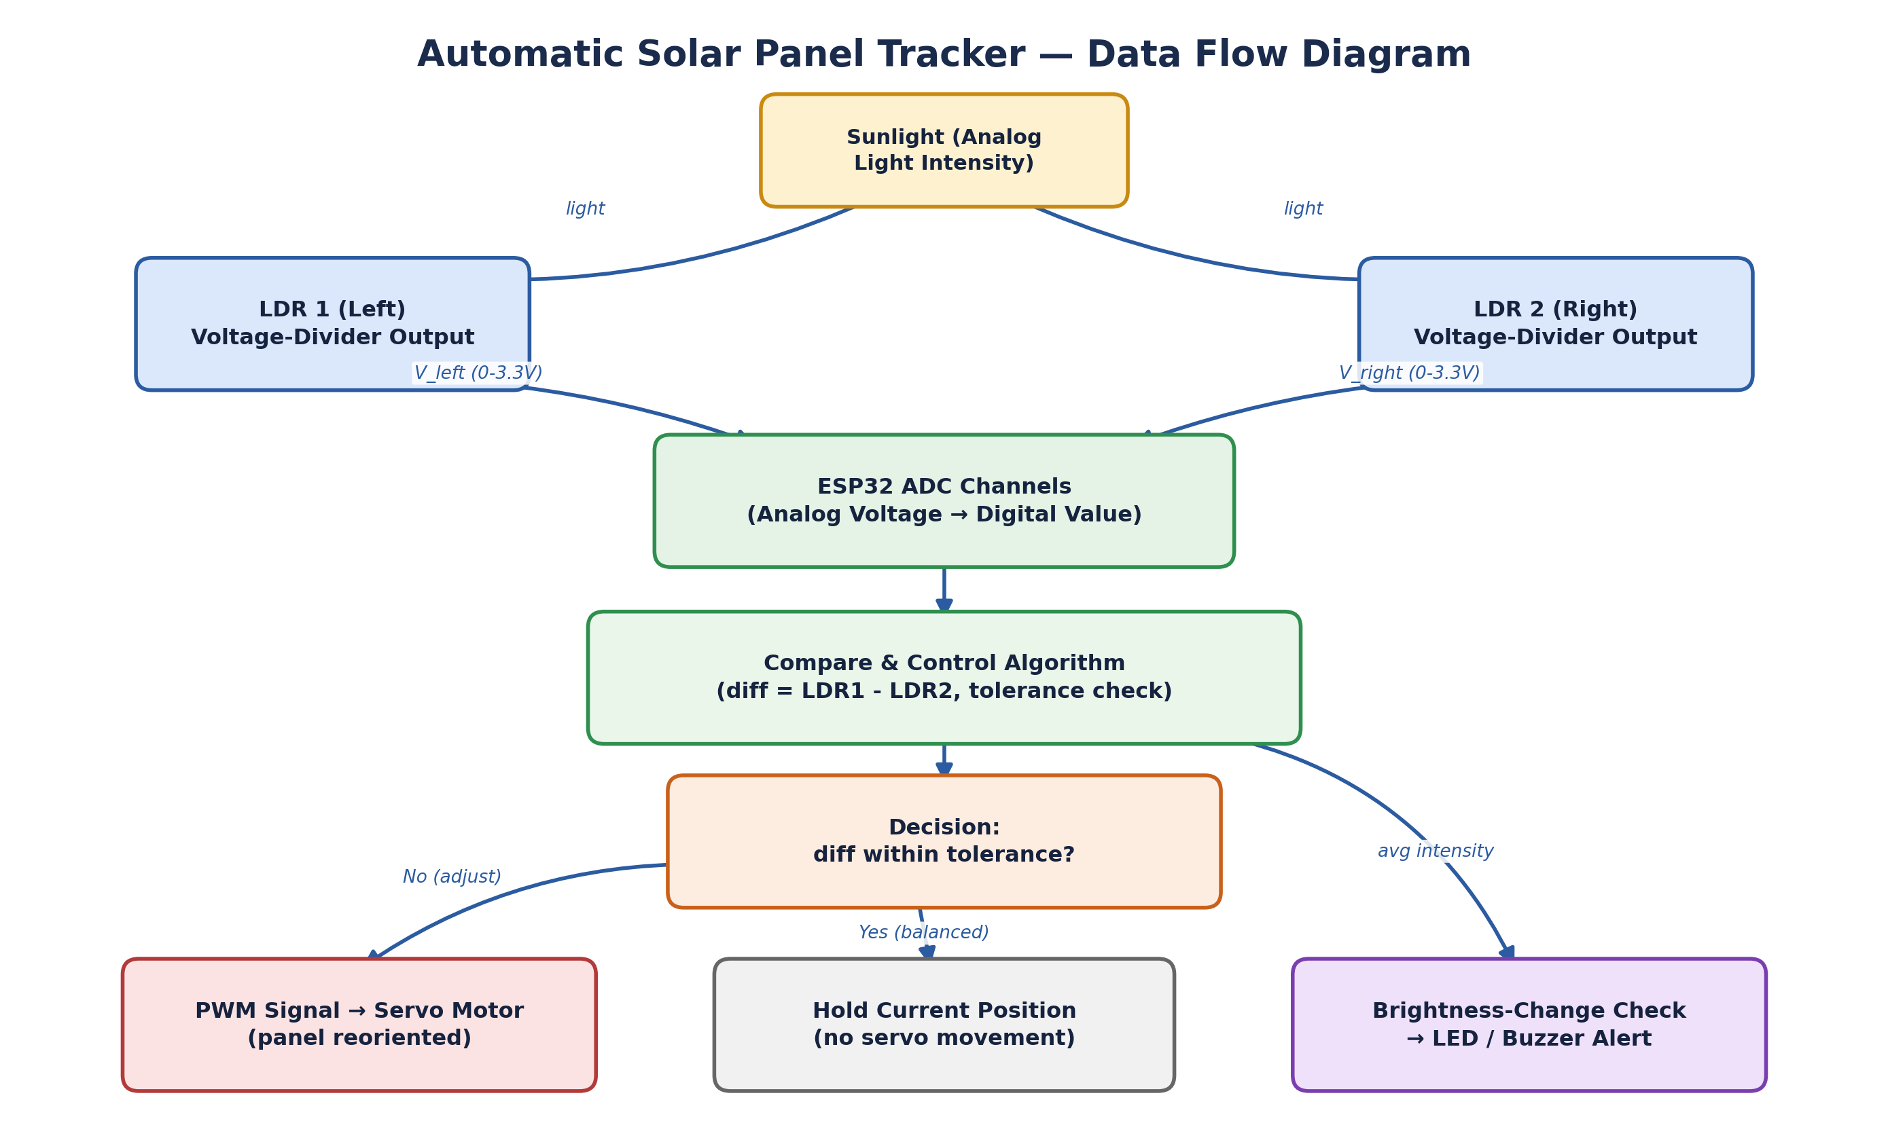
Figure 1 — Data Flow Diagram

Functional Block Diagram
The functional block diagram identifies the major functional units of the system and the direction of signal/control flow between them: the two LDR sensing blocks, the ESP32 microcontroller (which performs comparison and decision-making), the servo actuator, the resulting panel reorientation, and the light-alert feedback block.
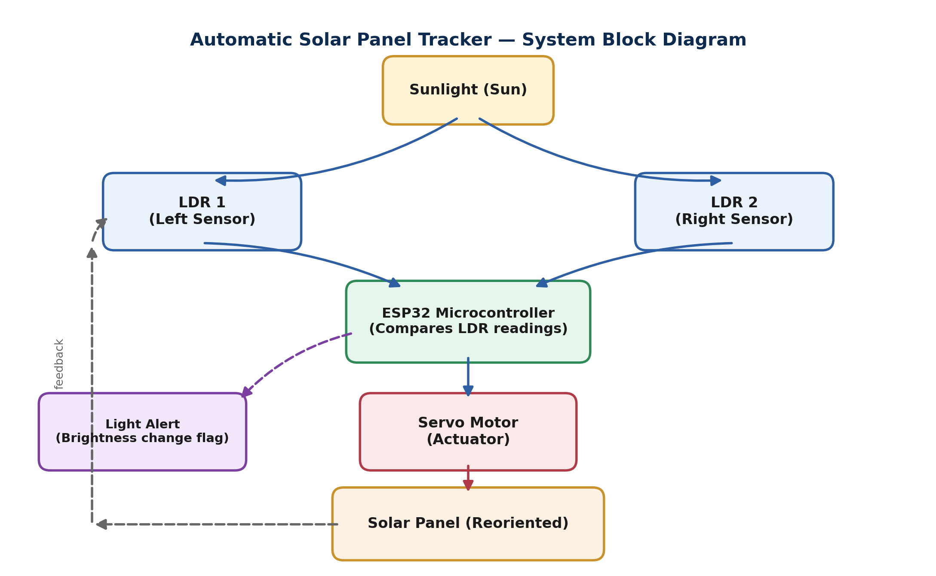
Figure 2 — System Functional Block Diagram

Hardware-Software Partitioning
The table below states which responsibilities are implemented in hardware (physical sensing/actuation) and which are implemented in the minimal on-board control logic that runs the hardware, clarifying the division of labour across the system.
Function | Partition | Implementation Detail
Light sensing | Hardware | LDR1 / LDR2 in voltage-divider configuration with 10 kΩ resistors (R1, R2)
Analog-to-digital conversion | Hardware | ESP32 on-chip ADC peripheral
Comparison / decision logic | Hardware-driven control logic | diff = LDR1 − LDR2 with tolerance-band check, running directly on the ESP32
Panel reorientation | Hardware | Servo motor (MOTOR-SERVO) driven by PWM signal from an ESP32 GPIO pin
Brightness-change alert | Hardware | GPIO-driven LED-GREEN / LED-RED (via R3, R5) and buzzer (BUZ1)
Power supply | Hardware | 5 V source (V1) regulated to the ESP32-WROOM and peripheral rails

Hardware Design

Final Block Diagram
The final hardware block diagram (Figure 2, reproduced above) was carried forward unchanged into the hardware design stage: two LDR sensing blocks feed the ESP32-WROOM module, which drives one servo motor for actuation and one LED/buzzer pair for alerting. No additional hardware blocks were introduced during detailed design; the effort at this stage focused on translating each block into a concrete circuit, listed in the schematic and component sections below.

Circuit Schematics
The full circuit was designed and manually built, component-by-component, in the Wokwi online circuit simulator by the project team. The circuit diagram below shows the ESP32 development board wired to the Left LDR and Right LDR sensor modules with their respective 10 kΩ pull-down resistors, the LED-GREEN/LED-RED indicator pair with current-limiting resistors, the buzzer, and the servo motor, all powered directly from the ESP32 board's onboard supply rails. The lower panel of the diagram shows the live serial monitor output, confirming real-time readings such as Left LDR, Right LDR, Average, Difference, and the resulting Servo angle as the control logic executes.
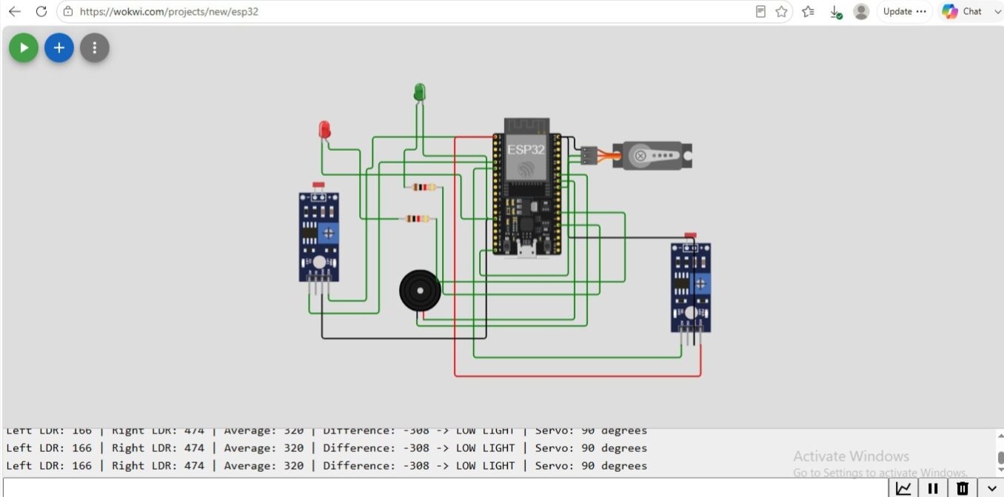
Figure 3 — Wokwi ESP32 Circuit Simulation

Component Selection
Each component was selected for low cost, easy availability, and suitability for a beginner-friendly, breadboard-scale prototype, in line with the project's stated goal of an inexpensive and reproducible design.
Component | Selection Justification
ESP32-WROOM Dev Module | Integrated Wi-Fi/BLE for future IoT extension, multiple ADC channels, native PWM output for servo control, low cost relative to capability
LDR (x2) | Simple, low-cost analog light sensor suited to differential (left/right) sunlight sensing
10 kΩ Resistor (x2, R1/R2) | Pull-down resistors forming a voltage divider with each LDR for stable analog readout
220 Ω Resistor (x2, R3/R5) | Current-limiting resistors protecting LED-GREEN and LED-RED indicators
LED-GREEN / LED-RED (D1/D2) | Low-cost visual indication of normal vs. alert brightness state
Buzzer (BUZ1) | Low-cost audible alert for significant ambient brightness change
Servo Motor | Provides precise angular actuation for single-axis panel reorientation; directly compatible with ESP32Servo library
5 V Source (V1) | Common, regulated supply rail compatible with the ESP32-WROOM and peripheral components

Bill of Materials (BOM)
# | Component | Specification | Qty
1 | ESP32-WROOM Dev Board | Wi-Fi/BLE, multi-channel ADC, PWM-capable GPIO | 1
2 | LDR (Light Dependent Resistor) | Standard photoresistor, 5 mm | 2
3 | Resistor | 10 kΩ, 1/4 W (LDR pull-down) | 2
4 | Resistor | 220 Ω, 1/4 W (LED current limiting) | 2
5 | LED | 5 mm, Green | 1
6 | LED | 5 mm, Red | 1
7 | Buzzer | Active buzzer, 5 V | 1
8 | Servo Motor | Standard hobby servo (e.g., SG90-class), PWM control | 1
9 | Power Source | 5 V regulated DC supply | 1
10 | Connecting Wires / Breadboard | Jumper wires, breadboard for prototype assembly | As required

Simulation

Simulation Tool
Circuit-level simulation and validation of the hardware design was carried out in the Wokwi online circuit simulator. The circuit was designed and manually built component-by-component by the project team, without use of a template or auto-generated layout, using the ESP32, LDR, resistor, LED, buzzer, and servo motor parts from the Wokwi component library, as shown in Figure 3 above.

Simulation Setup
The simulated circuit mirrors the intended physical build: the Left LDR and Right LDR are each wired in a voltage-divider configuration with a 10 kΩ resistor into two ESP32 ADC-capable pins; the servo motor's control line is wired to a PWM-capable GPIO pin; LED-GREEN and LED-RED are wired through current-limiting resistors to separate GPIO pins; the buzzer is wired to a further GPIO pin; and the whole circuit is powered from the ESP32 board's onboard supply rails. The Wokwi serial monitor confirms correct operation during simulation, streaming live values for Left LDR, Right LDR, Average, Difference, and the resulting Servo angle as the tracker responds to changing light conditions.

Advantages of the Design
The resulting hardware design offers several practical benefits for a low-cost, fully hardware-driven solar tracker: it uses only common, inexpensive components (ESP32-WROOM, LDRs, resistors, a single servo motor) that are easy to source and replace; the tolerance-band logic keeps the servo from wearing out through constant micro-adjustments; the light-alert branch adds a useful safety/monitoring feature without any extra sensors; and the single-axis, breadboard-friendly layout keeps the circuit simple enough to build, test, and debug by hand while still leaving room for future upgrades such as a second axis or IoT connectivity.
End of Phase 3 — System Design Review Deliverables

