Urban Behavior Analysis Report
This project analyzes urban behavior patterns using mobility, air quality, and environmental data collected from multiple cities.
The purpose of the study is to understand how mobility trends changed over time and how environmental indicators such as PM2.5 and temperature may affect urban activity.
Machine learning techniques were also applied to determine the most important variables influencing mobility behavior.

1. Dataset Information
The dataset used in this project combines mobility, environmental, and demographic indicators from different cities including Ankara, Istanbul, and London.
Main variables used in the analysis:
• Mobility percentages
• PM2.5 air pollution values
• Temperature data
• Transit station mobility changes
• Grocery and pharmacy mobility changes
• Workplace mobility changes
• Residential mobility changes
• Day of week and month information
The mobility data was mainly based on Google Mobility Reports, while environmental variables were collected from open urban and air quality datasets.

2. Methodology
The project was completed using Python data analysis libraries including Pandas, NumPy, Matplotlib, Seaborn, and Scikit-learn.
Main analysis steps:
1. Data cleaning and preprocessing
2. Handling missing values
3. Feature engineering
4. Exploratory Data Analysis (EDA)
5. Visualization of mobility and environmental trends
6. Machine Learning using Random Forest Regressor
7. Feature importance analysis
The Random Forest model was used to identify which variables had the strongest effect on mobility behavior.

3. Project Objectives
The main objectives of this project are:
• To compare mobility trends between cities
• To evaluate air quality differences
• To analyze the relationship between mobility and environmental indicators
• To identify important predictors affecting mobility patterns
• To visualize urban behavior changes over time

4. Mobility Comparison Across Cities
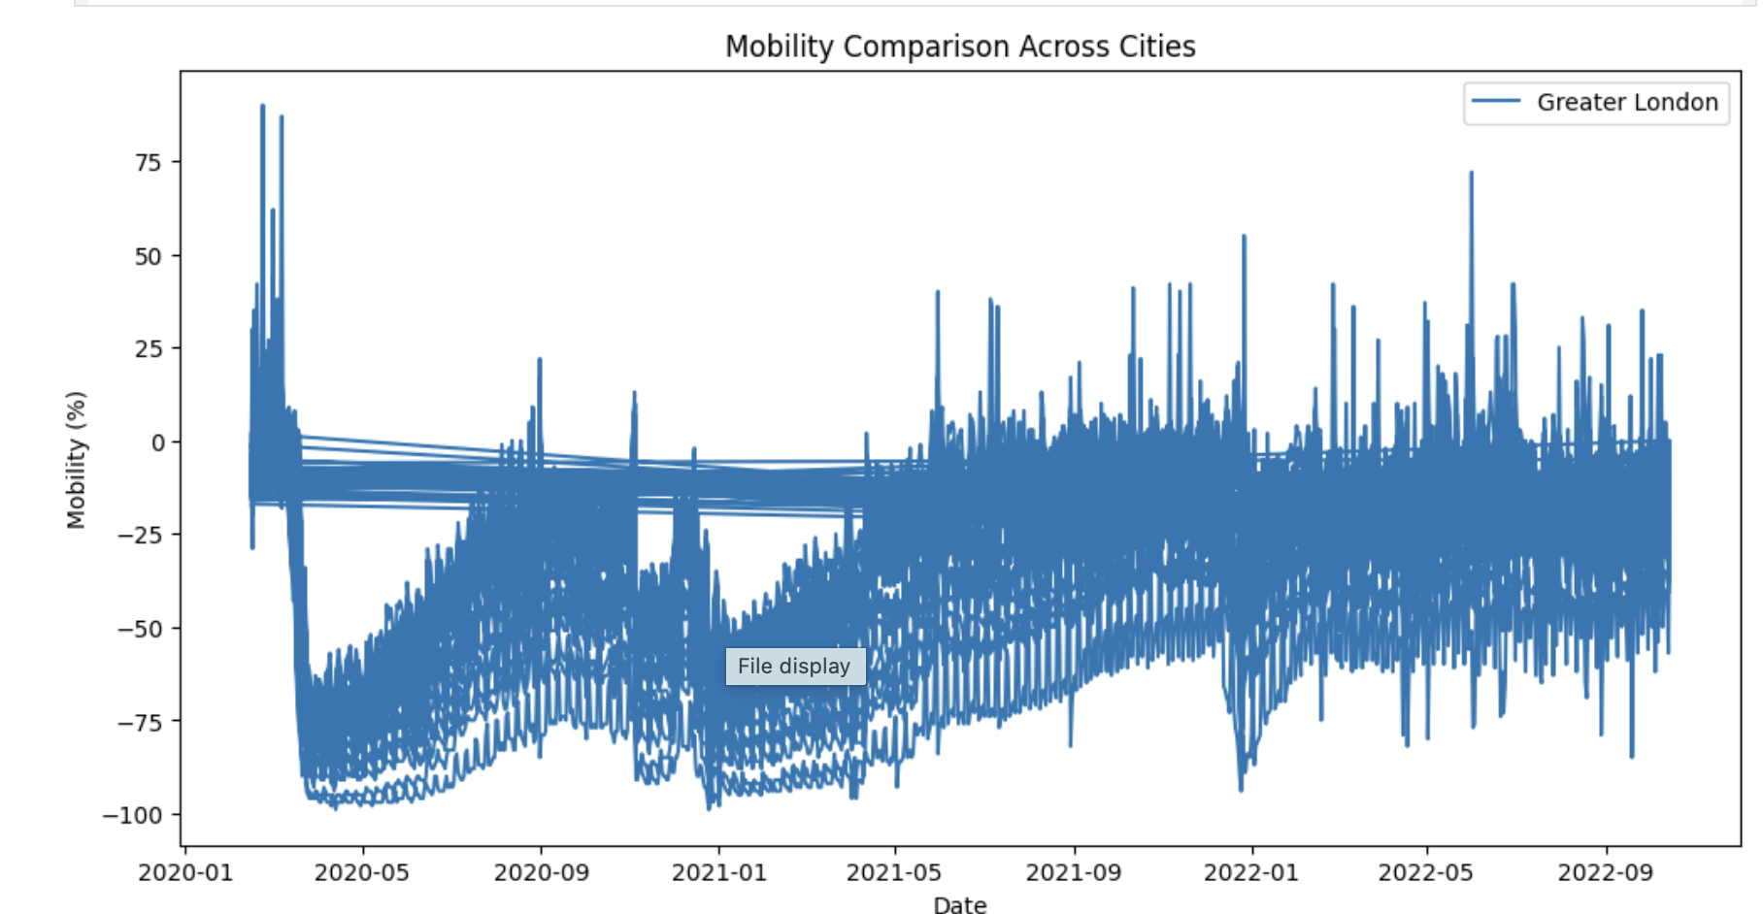
This graph illustrates mobility changes over time in Greater London. The results show major mobility fluctuations during different periods, especially during pandemic-related restrictions and recovery phases.

5. Mobility Distribution Across Cities
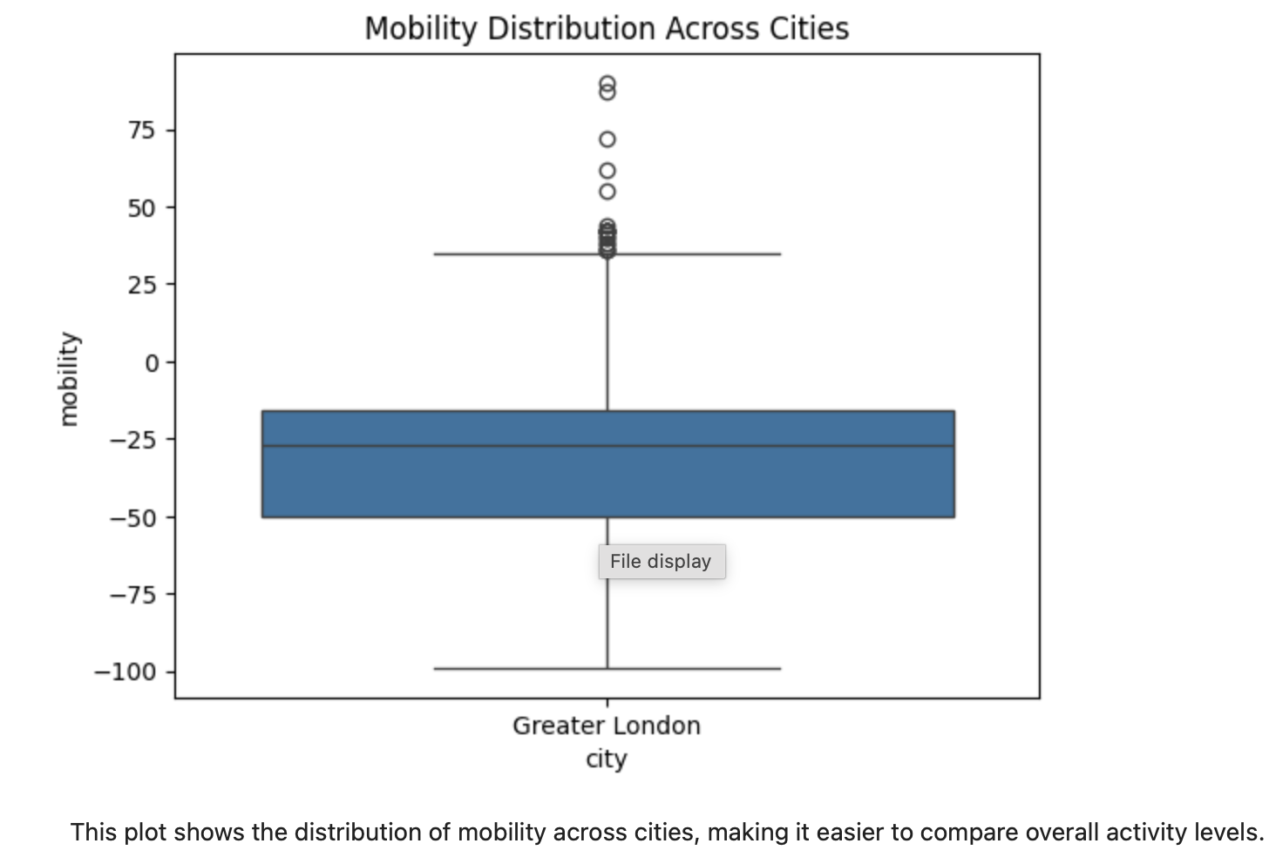
This boxplot presents the overall distribution of mobility values. Several outliers can be observed, indicating unusual periods with extremely high or low mobility activity.

6. Average PM2.5 by City
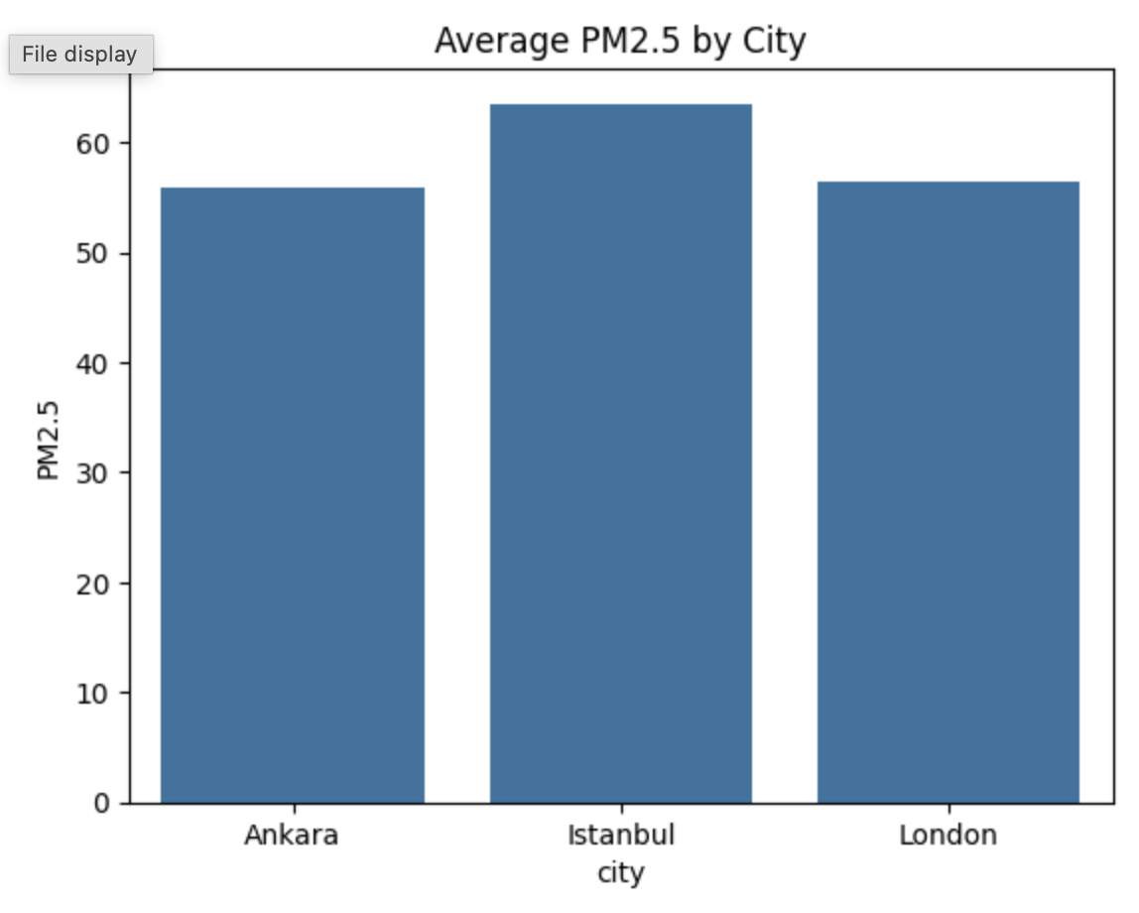
This graph compares PM2.5 pollution levels across Ankara, Istanbul, and London. Istanbul recorded the highest average PM2.5 values among the selected cities.

7. City Comparison: Mobility, Air Quality, Temperature
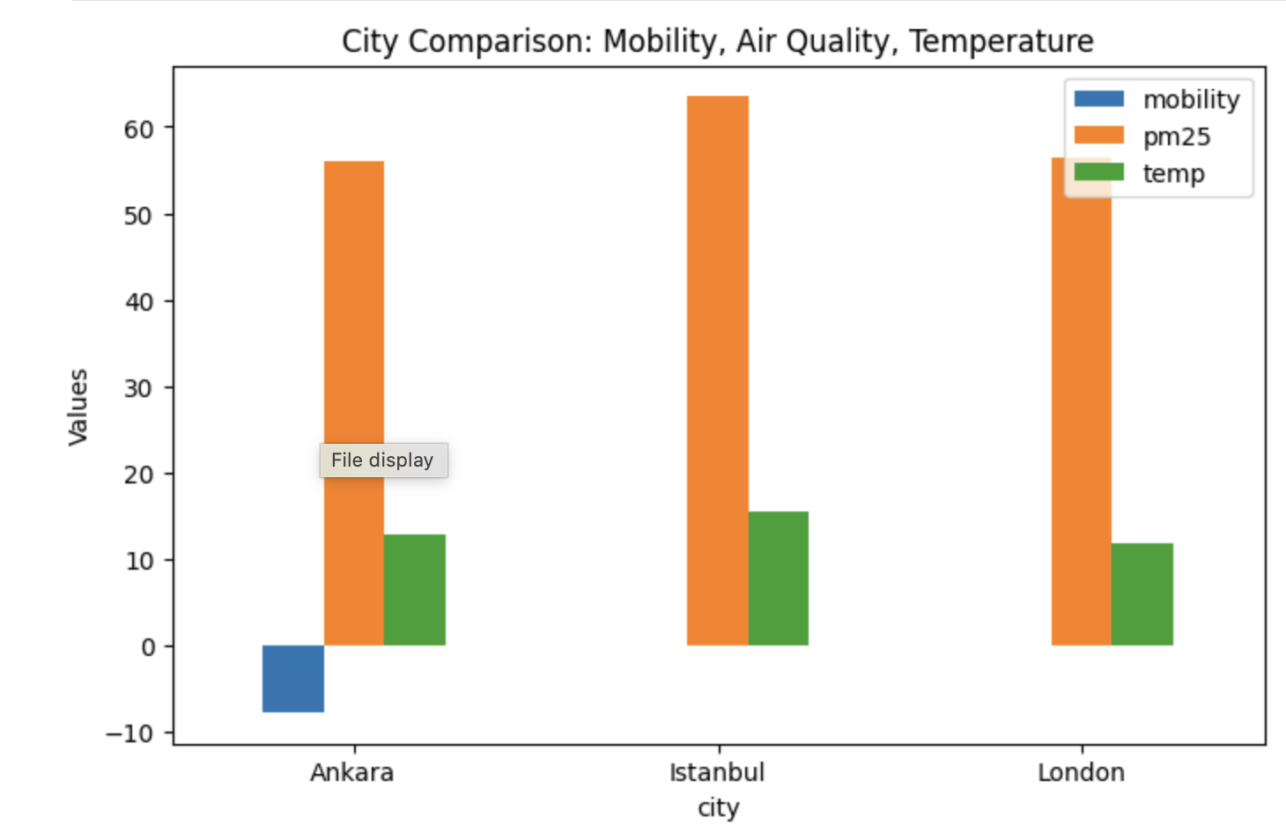
This visualization compares mobility, PM2.5, and temperature indicators simultaneously. The graph highlights noticeable environmental and behavioral differences between the cities.

8. Feature Importance – Random Forest (Demographic Features)
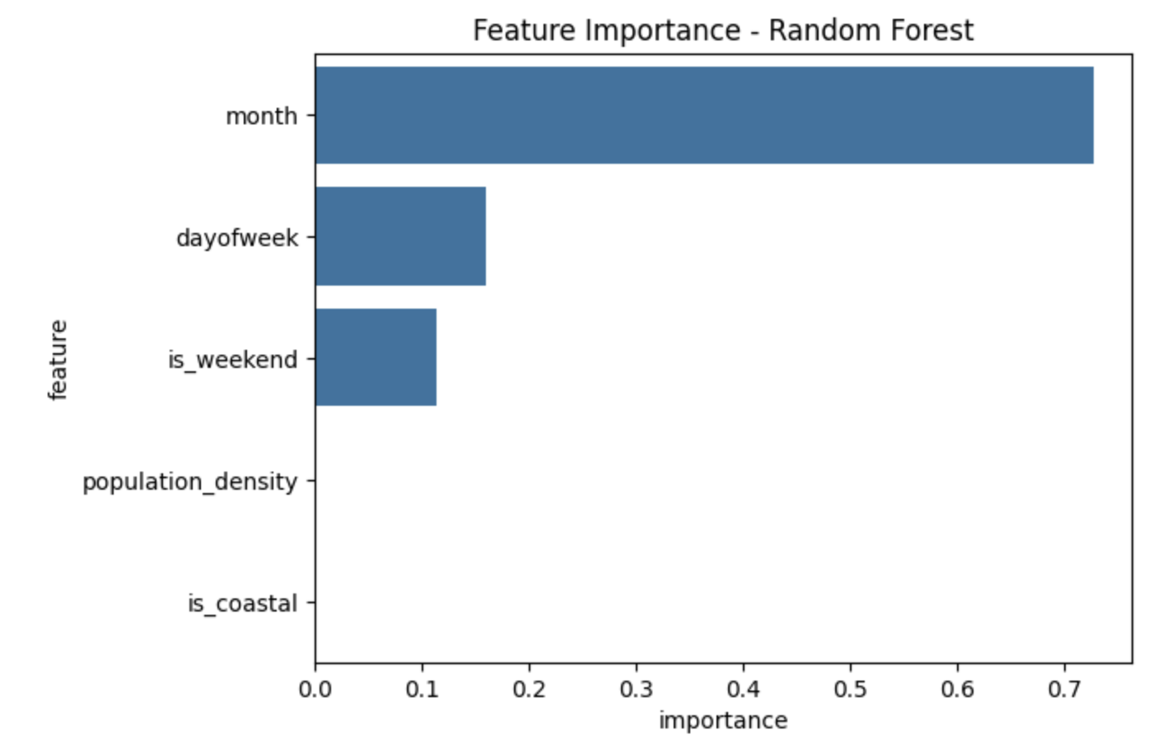
This chart shows the importance of demographic and temporal variables in the Random Forest model. The month variable was identified as the strongest contributor in the prediction process.

9. Feature Importance – Random Forest (Mobility Features)
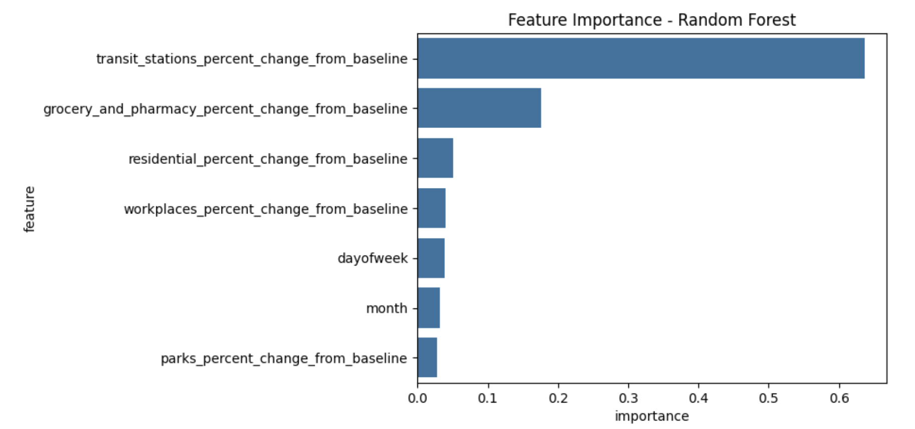
Transit station mobility changes were found to be the most influential variable affecting mobility behavior. Grocery and pharmacy mobility changes also contributed significantly to the model.

10. Mobility Distribution by City – Greater London
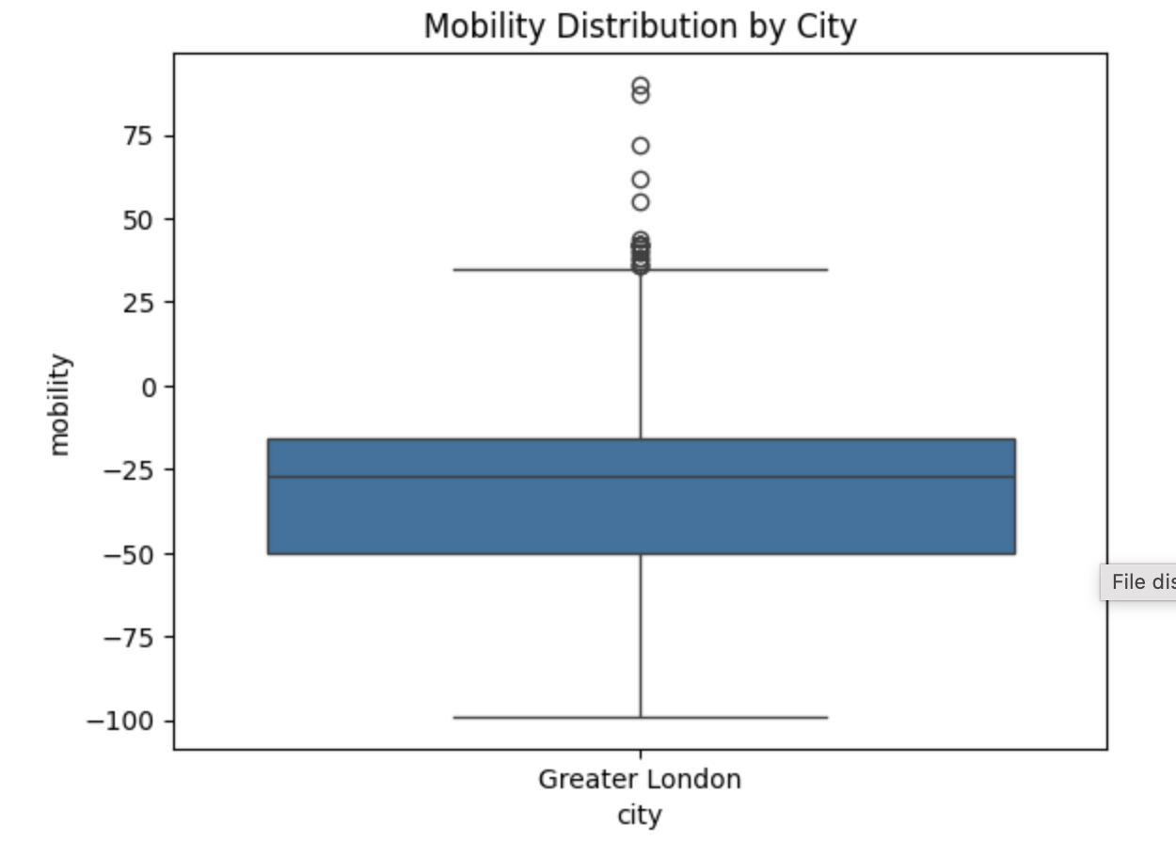
The mobility distribution in Greater London demonstrates a generally negative mobility trend with several high positive outliers. This reflects unstable urban movement patterns during certain periods.

11. Mobility Distribution by City – Ankara
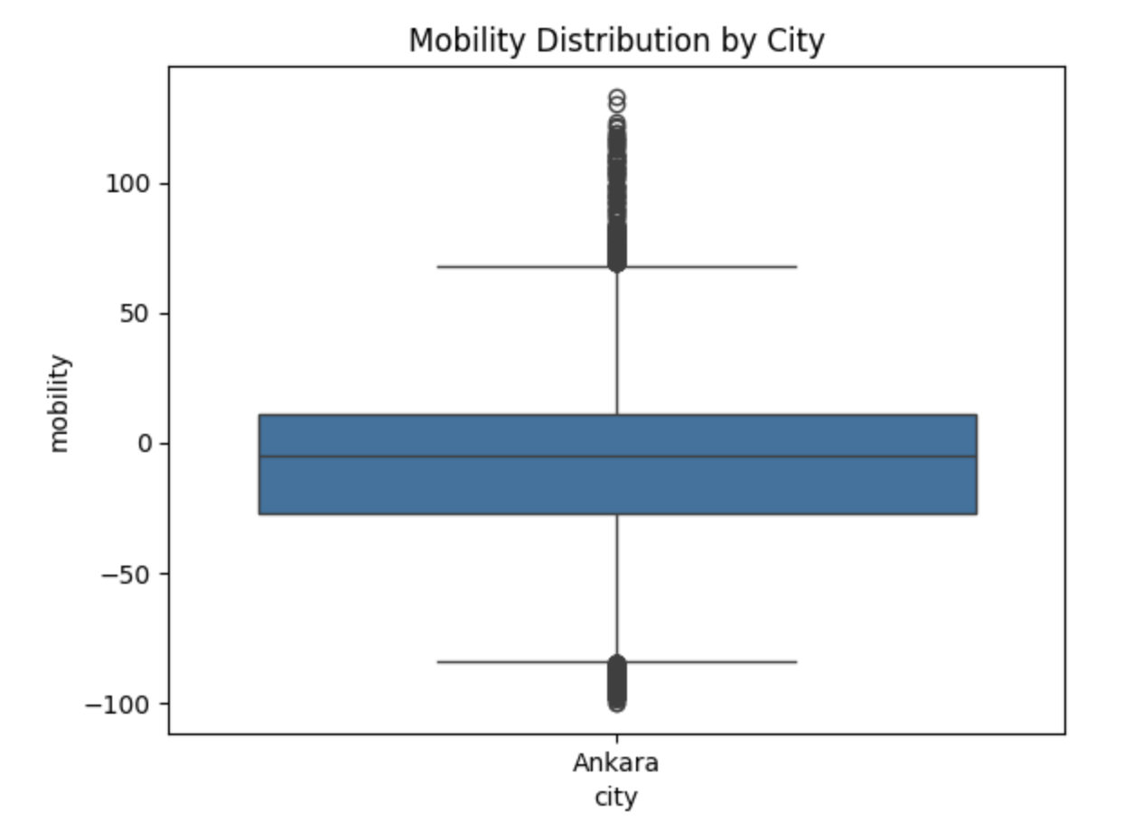
Ankara’s mobility distribution shows a wider spread of values compared to London. The city experienced both significant decreases and sharp increases in mobility during the analysis period.

12. Final PM2.5 Comparison
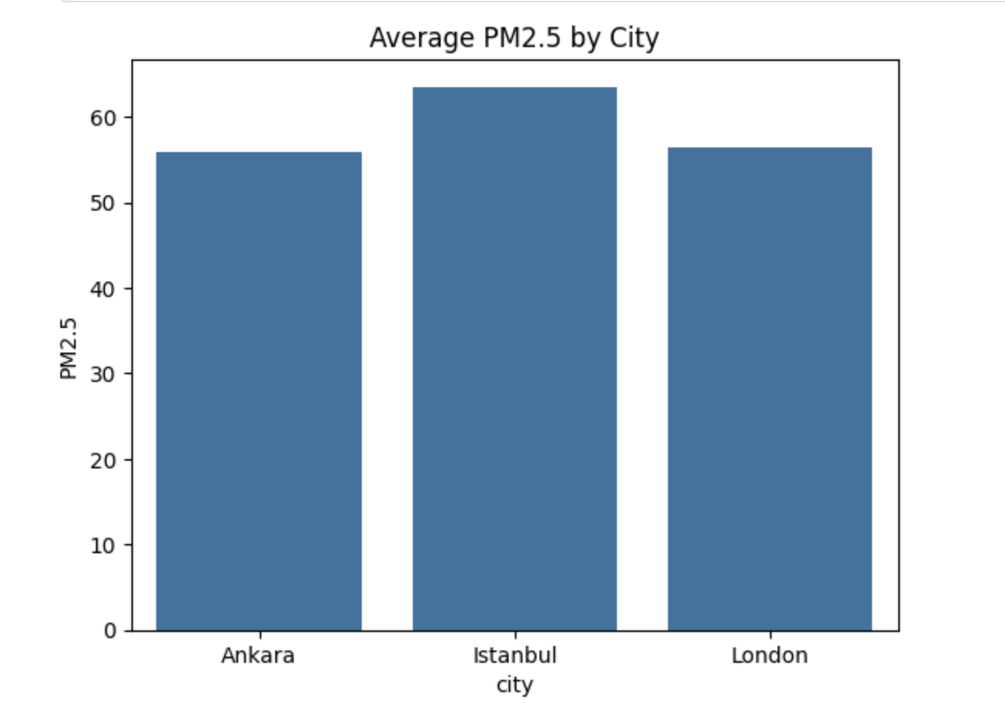
The final PM2.5 comparison confirms that Istanbul has the highest pollution average among the analyzed cities. Ankara and London displayed relatively similar air quality levels.

13. Conclusion
The analysis demonstrates that mobility behavior is strongly associated with environmental and temporal variables.
Machine learning results showed that transit-related mobility indicators were among the most important predictors of urban movement patterns.
In addition, air quality comparisons revealed noticeable differences between cities, especially in Istanbul where PM2.5 values were consistently higher.
Overall, the project highlights how urban mobility data and environmental indicators can be combined to better understand city dynamics and human behavior.

14. Future Work
Future improvements for this project may include:
• Using larger datasets from more cities
• Applying deep learning methods
• Including real-time mobility tracking
• Expanding environmental indicators
• Developing predictive urban behavior systems

