We will need a table to keep track of user clicks. Below is a rough structure of the table, but it is incomplete in the following ways:
- There are no primary keys,
- More columns may need to be added,
- The data types are not all specified.
Copy the table below, paste it into your response, and complete the missing parts of the schema according to the list above. You may provide a brief explanation as needed.
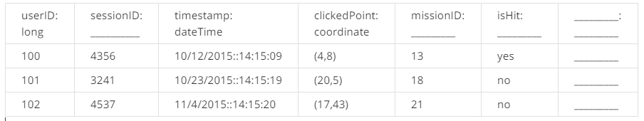

-For isHit there are two options: ENUM (yes - no ) , allowed input or simply string.

Next, we will look at the chat data. We know users can chat when they discuss their team’s strategy or when they decide if a new player should join a team. This can be modeled as a graph, as shown below.

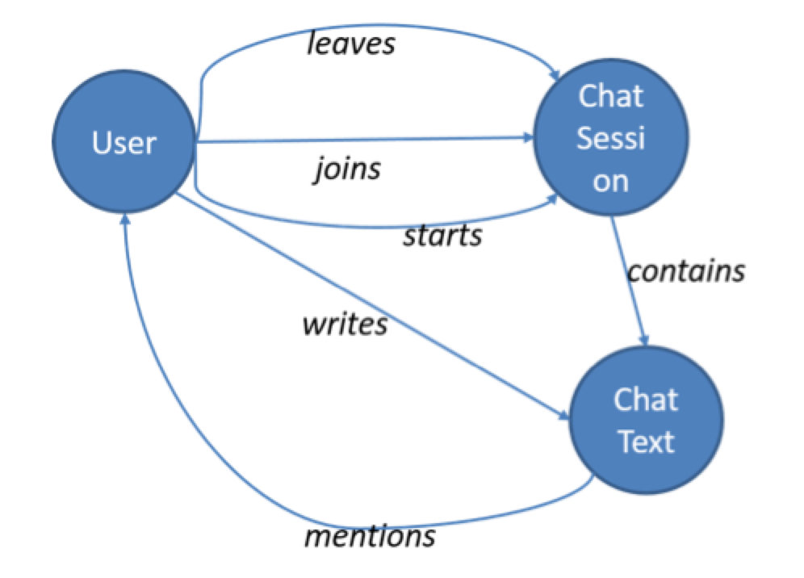

The nodes of the graph are entities and the edges are actions they take and the content of the chat. When this graph is populated, we need to include a number of properties to the nodes and edges (recall the lecture covering the property graph model). For example, each action edge should have a timestamp attribute to indicate when the action occurred. Using this graph, we should be able to analyze different types of questions.
List all node and edge properties for a graph.
Briefly explain how you would use the graph to answer the following five questions?
- Which teams are having more conversations?
- Do users chat more (or less) before they leave a team?
- What are the dominant terms (words) used in a chat session within a specific time period?
- Which users are most active in a specific chat session?
- How many chat sessions is a user participating in at the same time?
ID Node
1 User
2 Session
3 Text

srcID descID Edge
1 2 Joins
1 2 Leaves
1 2 Starts
2 3 Contains
1 3 Writes
3 1 Mention

1-Find and count the number of sessions of the teams
2-Group messages are examined in 3 categories(join , start , leaves ) .But we dont know about more or less
3-we have to calculate the tfid scores of words formed in each time period
4-we need to group for each node and edge (type write) , then we should count by userID or sessionID.
5-we need to group for each node and edge (type join , starts) , then we should count by userID or sessionID.

We will need to design the structure of the game itself. We will use the following partially specified semistructured data object.

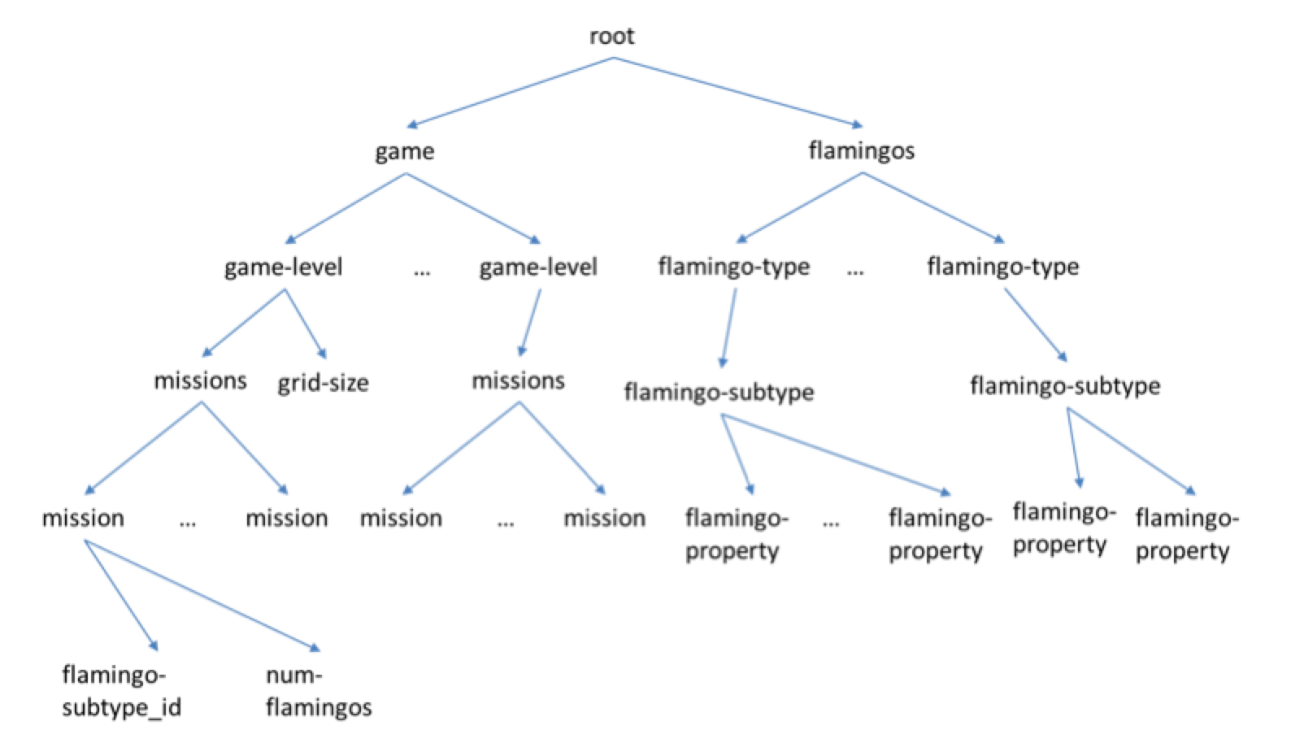

We have seen that both XML and JSON are essentially trees. The tree here says that the “missions” category can have several “mission” items. Each mission item will have an associated flamingo type (e.g., flamingos with stars on their backs) and the number of flamingos of that type released to the users to catch. We also have flamingos of different types and subtypes, where each subtype will have a list of properties.
Explain how you might extend the tree with at least five specific flamingo properties. For example, beak-color whose values might be “bright-red” or “pink”.
Your objective is to make sure the tree has enough properties to launch the game and connect with the three data structures we have used so far.

I should extend the flamingo properties because the game grows over time. New flamingos will be released in the future for free or paid and it should be enough difference and properties between each flamingo

Flamingo Properties:
- flamingoName (string) ex. "Real Flaming"
- beakColor (string) ex. pink, purple, white...
- plumeColor (string) ex. pink, blue, black...
- legsColor (string) ex. pink, orange, white
- dim (tuples of int, one for X and one for Y)
- catchingFoods (list of string)
- life (int, the number of hits for catch)
- scoreHit (int) ex. from 1 to 10 or 20.

