LAB 11

Upload from both Classroom (classroom.google.com) and DEUZEM-SAKAI (online.deu.edu.tr) until 28 April 2020, 17:00.

1- Write a Circular Linked List class which includes the following methods:

- Add (which inserts a new element to the beginning of the list)

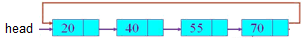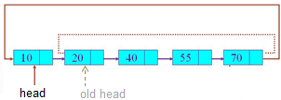

- Display (which prints all items in the list)

- Josephus(X,Y) (which determines the last remaining man in the circle)

The "Josephus" problem is to identify the position of the last remaining man when X men stand in a circle and every Y^{th} man will be successively eliminated from the circle.
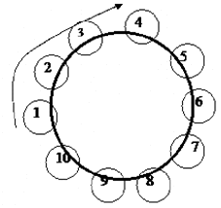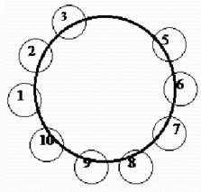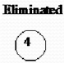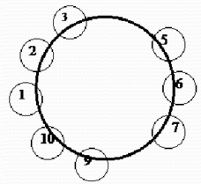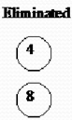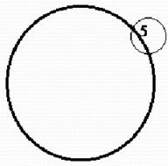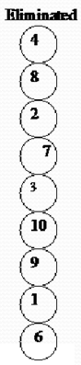

Write a main program that takes two integers (X and Y) from the user and then prints the result of the "Josephus" problem.

Example:

CircularLinkedList CLL = new CircularLinkedList();

// Take X and Y from the user

// for ... add numbers to the circular queue
CLL.Add(i);

CLL.display(); // 1 2 3 4 5 6 7 8 9 10 ...

System.out.println(Josephus(X,Y));

Notes

1- Upload format
Step1: Create a new folder, named by your student number and name (without any space)
Step2: Copy all java files into this folder (only java files)
Step3: Compress the folder 2015510012_Ali_Tas.zip
Step4: Upload the file 2015510012_Ali_Tas.zip

2- Don’t use ENIGMA or any other extra library.

3- Lab assignment must be your individual work.
Cheating is strictly prohibited.

