LAB 10

Upload this assignment until 21 April 2020, 17:00.

Write a program that constructs a multi-linked list from a two-dimensional array with any size and then traverse multi-linked list to determine whether the matrix is a scalar matrix or not.

A scalar matrix is basically a square matrix whose all diagonal elements are equal and all other elements means off diagonal elements are zero.

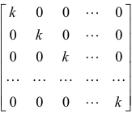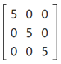

Don’t take any input from the user. Assign the matrix in the code.

Examples:
int[][] matrix = {{55,0,0,0,0},{0,55,0,0,0},{0,0,55,0,0},{0,0,0,55,0},{0,0,0,0,55}}
Output: true

int[][] matrix = {{18,0,0,0},{0,18,0,0},{0,0,18,0},{0,0,0,18}}
Output: true

int[][] matrix =
{{6,0,0,0,0,0},{0,6,0,0,0,0},{0,0,6,0,0,5},{0,0,0,6,0,0},{0,0,0,0,6,0},{0,0,0,0,0,6}}
Output: false

int[][] matrix =
{{6,0,0,0,0,0},{0,6,0,0,0,0},{0,0,6,0,0,0},{0,0,0,6,0,0},{0,0,0,0,7,0},{0,0,0,0,0,6}}
Output: false

Example:

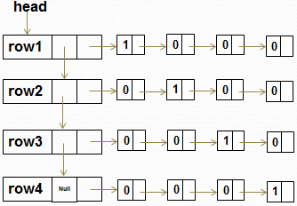

Output: True

Notes

1- Upload format
Step1: Create a new folder, named by your student number and name (without any space)
For example: 2015510012_Ali_Tas
Step2: Copy all java files into this folder (only java files)
Step3: Compress the folder 2015510012_Ali_Tas.zip
Step4: Upload the file 2015510012_Ali_Tas.zip

2- Don’t use ENIGMA or any other extra library.

3- Lab assignment must be your individual work.
Cheating is strictly prohibited.

