|  |  |  |  |  |  |  |  |  |  |
| --- | --- | --- | --- | --- | --- | --- | --- | --- | --- |
| Court of Common Pleas of Philadelphia County  Trial Division  **Civil Cover Sheet** | | | | | For Prothonotary Use Only (Docket Number) | | | | |
|  | | | | |
| PLAINTIFF'S NAME  {{ plaintiffname1 }} | | | | | DEFENDANT'S NAME  {{ defendantname1 }} | | | | |
| PLAINTIFF'S ADDRESS  {{ plaintiffstreetaddress1 }}  {{ plaintiffcity1 }}, {{ plaintiffzipcode1 }} | | | | | DEFENDANT'S ADDRESS  {{ defendantstreetaddress1 }}  {{ defendantcity1 }}, {{ defendantzipcode1 }} | | | | |
| PLAINTIFF'S NAME  {% if plaintiffnumber > 1 %} {{ plaintiffname2 }} {% else %} {% endif %} | | | | | DEFENDANT'S NAME  {% if defendantnumber > 1 %} {{ defendantname2 }} {% else %} {% endif %} | | | | |
| PLAINTIFF'S ADDRESS  {% if plaintiffnumber > 1 %}  {{ plaintiffstreetaddress2 }}  {{ plaintiffcity2 }}, {{ plaintiffzipcode2 }}  {% else %} {% endif %} | | | | | DEFENDANT'S ADDRESS  {% if defendantnumber > 1 %}  {{ defendantstreetaddress2 }}  {{ defendantcity2 }}, {{ defendantzipcode2 }}  {% else %} {% endif %} | | | | |
| PLAINTIFF'S NAME  {% if plaintiffnumber > 2 %} {{ plaintiffname3 }} {% else %} {% endif %} | | | | | DEFENDANT'S NAME  {% if defendantnumber > True %} {{ defendantname3 }} {% else %} {% endif %} | | | | |
| PLAINTIFF'S ADDRESS  {% if plaintiffnumber > 2 %}  {{ plaintiffstreetaddress3 }}  {{ plaintiffcity3 }}, {{ plaintiffzipcode3 }}  {% else %} {% endif %} | | | | | DEFENDANT'S ADDRESS  {% if defendantnumber > 2 %}  {{ defendantstreetaddress3 }}  {{ defendantcity3 }}. {{ defendantzipcode3 }}  {% else %} {% endif %} | | | | |
| TOTAL NUMBER OF PLAINTIFFS  {{ plaintiffnumber }} | | TOTAL NO. OF DEFENDANTS    {{ defendantnumber }} | | COMMENCEMENT OF ACTION  **X** Complaint  Writ of Summons | | COMMENCEMENT OF ACTION  Petition Action  Transfer From Other Jurisdictions | | | COMMENCEMENT OF ACTION  Notice of Appeal |
| AMOUNT IN CONTROVERSY  $50,000.00 or less More than $50,000.00 | COURT PROGRAMS  Arbitration  Jury  Non-Jury  **X** Other: Ejectment | | Mass Tort  Savings Action  Petition | | Minor Court  Appeal Statutory  Appeals Commerce (Completion of Addendum Required) | | | Settlement  Minors  W/D/Survival | |
| CASE TYPE AND CODE (SEE INSTRUCTIONS)  **3R Rent, Lease, Ejectment** | | | | | | | | | |
| STATUTORY BASIS FOR CAUSE OF ACTION (SEE INSTRUCTIONS) | | | | | | | | | |
| RELATED PENDING CASES (LIST BY CASE CAPTION AND DOCKET NUMBER)  **N/A** | | | | | | | IS CASE SUBJECT TO COORDINATION ORDER?  Yes No | | |
| TO THE PROTHONOTARY:  Kindly enter my appearance on behalf of Plaintiff/Petitioner/Appellant: Papers may be served at the address set forth below. | | | | | | | | | |
| NAME OF PLAINTIFF'S/PETITIONER'S/APPELLANT'S ATTORNEY  {{ plaintiffname1}} | | | | | ADDRESS *(*SEE INSTRUCTIONS)  {{ plaintiffstreetaddress1 }}  {{ plaintiffcity1 }}, {{ plaintiffzipcode1}} | | | | |
| PHONE NUMBER  {{ phonenumber }} | | FAX NUMBER  {{ faxnumber }} | | |
| SUPREME COURT IDENTIFICATION NO. | | | | | E-MAIL ADDRESS  {{ email }} | | | | |
| SIGNATURE  {{ signature1 }} | | | | | DATE  {{ date }} | | | | |

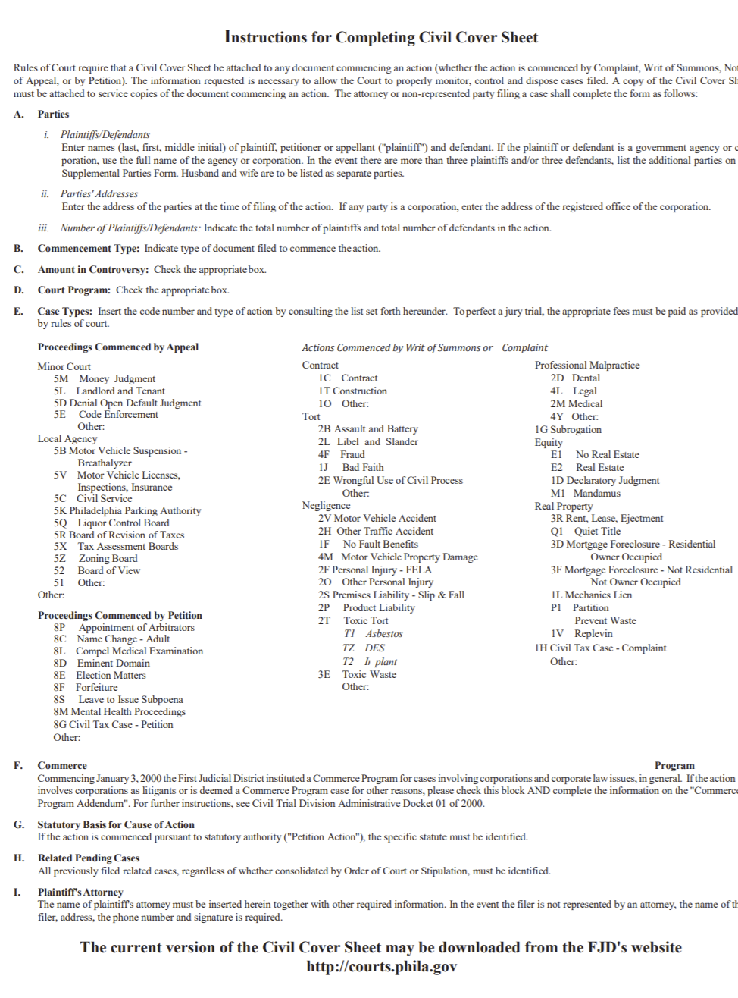

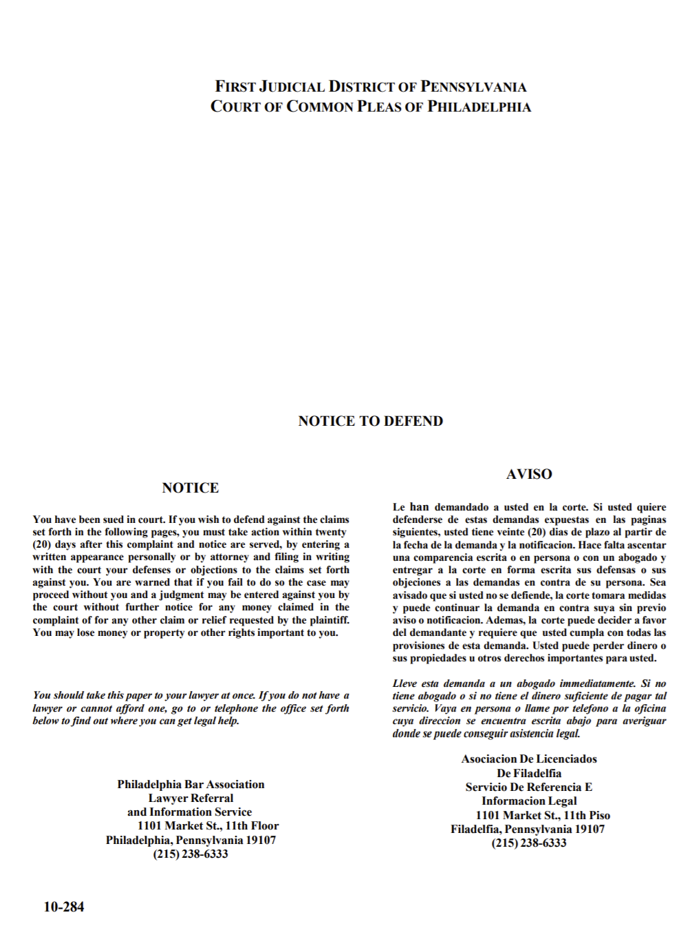

{{ plaintiffname1 }}

{% if plaintiffnumber > 1%} {{ plaintiffname2 }} {% else %}{% endif %}

{% if plaintiffnumber > 2 %} {{ plaintiffname3 }} {% else %}{% endif %}

Plaintiff(s)

vs.

{{ defendantname1 }}

{% if defendantnumber > 1 %} {{ defendantname2 }} {% else %}{% endif %}

{% if defendantnumber > 2 %}{{ defendantname3 }} {% else %}{% endif %}

Defendant(s)

**IN THE COURT OF COMMON PLEAS OF PHILADELPHIA COUNTY FIRST JUDICIAL DISTRICT OF PENNSYLVANIA**

**TRIAL DIVISION – CIVIL**

|  |  |
| --- | --- |
| {{ plaintiffname1 }}  {% if plaintiffnumber > 1%} {{ plaintiffname2 }} {% else %}{% endif %}  {% if plaintiffnumber > 2 %} {{ plaintiffname3 }} {% else %}{% endif %}  Plaintiff(s)  vs.  {{ defendantname1 }}  {% if defendantnumber > 1 %} {{ defendantname2 }} {% else %}{% endif %}  {% if defendantnumber > 2 %}{{ defendantname3 }} {% else %}{% endif %}  Defendant(s) |  |

**COMPLAINT IN EJECTMENT**

1. Plaintiff(s) is (are) {{ plaintiffname1 }}{% if plaintiffnumber > 1%}, {{ plaintiffname2 }} {% else %}{% endif %}{% if plaintiffnumber > 2 %}, {{ plaintiffname3 }} {% else %}{% endif %} with an address of {{ plaintiffstreetaddress1 }}, {{ plaintiffcity1 }}, {{ plaintiffzipcode1 }}.
2. Defendant(s) is (are) {{ defendantname1 }}{% if defendantnumber > 1%}, {{ defendantname2 }} {% else %}{% endif %}{% if defendantnumber > 2%}, {{ defendantname3 }} {% else %}{% endif %} who occupy the Property located at {{ defendantstreetaddress1 }}, {{ defendantcity1 }}, {{ defendantzipcode1 }}.

{% if admin == ‘No’%}

1. Plaintiff(s) is (are) the legal owner(s) of the property by virtue of the attached Deed. A complete copy of the Deed attached is the last recorded Deed. **[Exhibit A – Deed]**

{% else %}

3. Plaintiff(s) is (are) authorized to commence this action on the property by virtue of the attached documents and Deed. The attached Deed is the last recorded Deed. **[Exhibit A – Deed and Documents]**

{% endif %}

1. Defendant(s) do not have a lease and Plaintiff(s) and Defendant(s) are not Landlord(s) and Tenant(s).
2. Plaintiff(s) is (are) entitled to immediate possession of the Property.
3. Plaintiff(s) has (have) demanded possession of the Property from the Defendant(s) and Defendant(s) has (have) refused to deliver up possession to Plaintiff(s).

WHEREFORE, Plaintiff(s) requests Judgment for possession of the Property.

By: {{ signature1 }}

Signature

**{{ plaintiffname1 }}**

Print Address: {{ plaintiffstreetaddress1 }}

{{ plaintiffcity1 }}, {{ plaintiffzipcode1 }}

**(ATTACH A COMPLETE COPY OF THE DEED AS EXHIBIT A)**

**VERIFICATION**

Plaintiff(s) {{ plaintiffname1 }}{% if plaintiffnumber > 1 %}, {{ plaintiffname2 }} {% else %}{% endif %}{% if plaintiffnumber > 2 %}, {{ plaintiffname3 }} {% else %}{% endif %} hereby verify that the statements set forth in the foregoing Complaint are true and correct to the best of my knowledge, information, and belief. I understand that these statements are made subject to the penalties of 18 Pa.C.S. §4904, relating to unsworn falsification to authorities.

{{ signature2 }}

Signature of {{ plaintiffname1 }}

Dated: {{ date }}