|  |  |  |  |  |  |  |  |  |  |
| --- | --- | --- | --- | --- | --- | --- | --- | --- | --- |
| Court of Common Pleas of Philadelphia County  Trial Division  **Civil Cover Sheet** | | | | | For Prothonotary Use Only (Docket Number) | | | | |
|  | | | | |
| PLAINTIFF'S NAME  {{ plaintiffname1 }} | | | | | DEFENDANT'S NAME  {{ defendantname1 }} | | | | |
| PLAINTIFF'S ADDRESS  {{ plaintiffstreetaddress1 }}  {{ plaintiffcity1 }}, {{ plaintiffzipcode1 }} | | | | | DEFENDANT'S ADDRESS  {{ defendantstreetaddress1 }}  {{ defendantcity1 }}, {{ defendantzipcode1 }} | | | | |
| PLAINTIFF'S NAME  {% if plaintiffnumber > 1 %} {{ plaintiffname2 }} {% else %} {% endif %} | | | | | DEFENDANT'S NAME  {% if defendantnumber > 1 %} {{ defendantname2 }} {% else %} {% endif %} | | | | |
| PLAINTIFF'S ADDRESS  {% if plaintiffnumber > 1 %}  {{ plaintiffstreetaddress2 }}  {{ plaintiffcity2 }}, {{ plaintiffzipcode2 }}  {% else %} {% endif %} | | | | | DEFENDANT'S ADDRESS  {% if defendantnumber > 1 %}  {{ defendantstreetaddress2 }}  {{ defendantcity2 }}, {{ defendantzipcode2 }}  {% else %} {% endif %} | | | | |
| PLAINTIFF'S NAME  {% if plaintiffnumber > 2 %} {{ plaintiffname3 }} {% else %} {% endif %} | | | | | DEFENDANT'S NAME  {% if defendantnumber > True %} {{ defendantname3 }} {% else %} {% endif %} | | | | |
| PLAINTIFF'S ADDRESS  {% if plaintiffnumber > 2 %}  {{ plaintiffstreetaddress3 }}  {{ plaintiffcity3 }}, {{ plaintiffzipcode3 }}  {% else %} {% endif %} | | | | | DEFENDANT'S ADDRESS  {% if defendantnumber > 2 %}  {{ defendantstreetaddress3 }}  {{ defendantcity3 }}. {{ defendantzipcode3 }}  {% else %} {% endif %} | | | | |
| TOTAL NUMBER OF PLAINTIFFS  {{ plaintiffnumber }} | | TOTAL NO. OF DEFENDANTS    {{ defendantnumber }} | | COMMENCEMENT OF ACTION  **X** Complaint  Writ of Summons | | COMMENCEMENT OF ACTION  Petition Action  Transfer From Other Jurisdictions | | | COMMENCEMENT OF ACTION  Notice of Appeal |
| AMOUNT IN CONTROVERSY  $50,000.00 or less More than $50,000.00 | COURT PROGRAMS  Arbitration  Jury  Non-Jury  Other: Ejectment | | Mass Tort  Savings Action  Petition | | **X** Minor Court Appeal  Statutory Appeals  Commerce (Completion of Addendum Required) | | | Settlement  Minors  W/D/Survival | |
| CASE TYPE AND CODE (SEE INSTRUCTIONS)  **3R Rent, Lease, Ejectment** | | | | | | | | | |
| STATUTORY BASIS FOR CAUSE OF ACTION (SEE INSTRUCTIONS) | | | | | | | | | |
| RELATED PENDING CASES (LIST BY CASE CAPTION AND DOCKET NUMBER)  **N/A** | | | | | | | IS CASE SUBJECT TO COORDINATION ORDER?  Yes No | | |
| TO THE PROTHONOTARY:  Kindly enter my appearance on behalf of Plaintiff/Petitioner/Appellant: Papers may be served at the address set forth below. | | | | | | | | | |
| NAME OF PLAINTIFF'S/PETITIONER'S/APPELLANT'S ATTORNEY  {{ plaintiffname1}} | | | | | ADDRESS *(*SEE INSTRUCTIONS)  {{ plaintiffstreetaddress1 }}  {{ plaintiffcity1 }}, {{ plaintiffzipcode1}} | | | | |
| PHONE NUMBER  {{ phonenumber }} | | FAX NUMBER  {{ faxnumber }} | | |
| SUPREME COURT IDENTIFICATION NO. | | | | | E-MAIL ADDRESS  {{ email }} | | | | |
| SIGNATURE  {{ signature1 }} | | | | | DATE  {{ date }} | | | | |

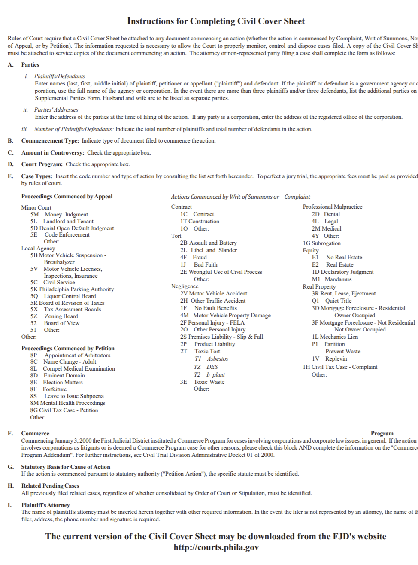

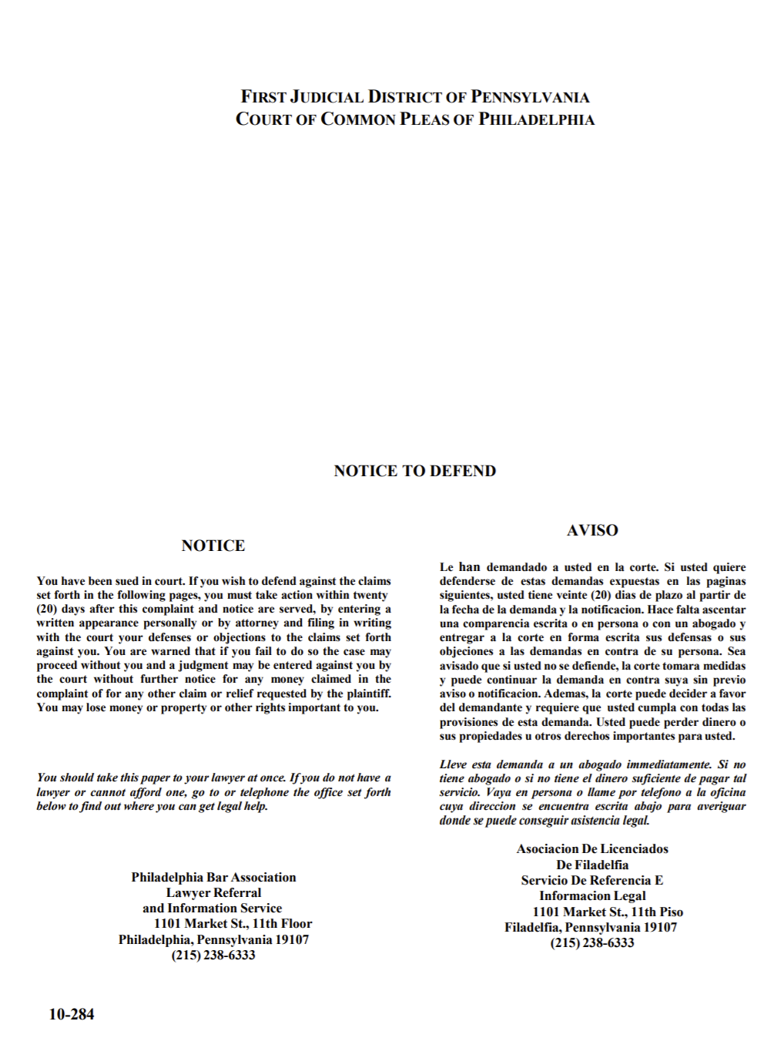

{{ plaintiffname1 }}

{% if plaintiffnumber > 1%} {{ plaintiffname2 }} {% else %}{% endif %}

{% if plaintiffnumber > 2 %} {{ plaintiffname3 }} {% else %}{% endif %}

Plaintiff(s)

vs.

{{ defendantname1 }}

{% if defendantnumber > 1 %} {{ defendantname2 }} {% else %}{% endif %}

{% if defendantnumber > 2 %}{{ defendantname3 }} {% else %}{% endif %}

Defendant(s)

{% if nines == ‘No’%}

Case No. _________

{% elif nines == ‘Yes’ %}

Case No. {{ serial }}

{% endif %}

Control No. __________

**IN THE COURT OF COMMON PLEAS OF PHILADELPHIA COUNTY FIRST JUDICIAL DISTRICT OF PENNSYLVANIA**

**TRIAL DIVISION – CIVIL**

|  |  |
| --- | --- |
| {{ plaintiffname1 }}  {% if plaintiffnumber > 1%} {{ plaintiffname2 }} {% else %}{% endif %}  {% if plaintiffnumber > 2 %} {{ plaintiffname3 }} {% else %}{% endif %}  Plaintiff(s)  vs.  {{ defendantname1 }}  {% if defendantnumber > 1 %} {{ defendantname2 }} {% else %}{% endif %}  {% if defendantnumber > 2 %}{{ defendantname3 }} {% else %}{% endif %}  Defendant(s) | {% if nines == ‘No’%}    Case No. _________    {% elif nines == ‘Yes’ %}  Case No. {{ serial }}  {% endif %}  Control No. __________ |

**COMPLAINT**

1. {{ paragraph1 }}
2. {{ paragraph2 }}
3. {{ paragraph3 }}
4. {{ paragraph4 }}

WHEREFORE, Plaintiff(s) requests Judgment for possession of the Property.

By: {{ signature1 }}

Signature

**{{ plaintiffname1 }}**

Print Address: {{ plaintiffstreetaddress1 }}

{{ plaintiffcity1 }}, {{ plaintiffzipcode1 }}

**(ATTACH A COMPLETE COPY OF THE DEED AS EXHIBIT A)**

**VERIFICATION**

Plaintiff(s) {{ plaintiffname1 }}{% if plaintiffnumber > 1 %}, {{ plaintiffname2 }} {% else %}{% endif %}{% if plaintiffnumber > 2 %}, {{ plaintiffname3 }} {% else %}{% endif %} hereby verify that the statements set forth in the foregoing Complaint are true and correct to the best of my knowledge, information, and belief. I understand that these statements are made subject to the penalties of 18 Pa.C.S. §4904, relating to unsworn falsification to authorities.

{{ signature2 }}

Signature of {{ plaintiffname1 }}

Dated: {{ date }}