



Essay / Assignment Title:
Large-Scale E-commerce Behaviour Analysis Using Hadoop and Apache Spark
Programme title:
MSc Data Analytics
Name:
Ece Saruhan
Year:
2026

CONTENTS

Statement of compliance with academic ethics and the avoidance of plagiarism

I honestly declare that this dissertation is entirely my own work and none of its part has been copied from printed or electronic sources, translated from foreign sources and reproduced from essays of other researchers or students. Wherever I have been based on ideas or other people texts I clearly declare it through the good use of references following academic ethics.
(In the case that is proved that part of the essay does not constitute an original work, but a copy of an already published essay or from another source, the student will be expelled permanently from the postgraduate program).

Name and Surname (Capital letters):

.......................................................................................................................................

Date: ........................./........../.........

INTRODUCTION

The aim of this project is to examine user and customer behavior in the e-commerce environment by using big data analytics. A large number of transactions, such as product views, adding products to the shopping cart and purchases, take place on e-commerce platforms. Analyzing these data provides information about customer behavior and helps to understand consumer behavior and gain insights into customer experiences (Theodorakopoulos and Theodoropoulou, 2024).
In this project, the “eCommerce behavior data from a multi-category store” dataset from October 2019 was analyzed. The dataset is approximately 5.67 GB in size and contains 42.4 million records. Due to its large size and variety, the dataset provides an appropriate environment for applying big data technologies, as it contains data such as the number of product views, products added to the shopping cart, and purchases made by users. Big data analytics is used in different fields to obtain meaningful information from large and complex datasets and to perform predictive analysis (Jamarani et al., 2024).
Different big data technologies were used in this project to store and process the large amount of data. The dataset was stored on Hadoop HDFS, while Hadoop MapReduce and Apache Spark were used for distributed data processing. In addition, a machine learning model was implemented using Spark to analyze user behavior and predict purchase behavior. In the e-commerce field, big data analytics architectures support the storage, processing, and analysis of large amounts of e-commerce data and help to generate useful information for businesses (Munshi et al., 2023).
The aim of this project is not only to technically process a large dataset, but also to transform the results obtained from analyzing user behavior, product and category preferences, daily user activities, and the relationship between adding products to the shopping cart and purchases into meaningful information for e-commerce businesses. In addition, purchase behavior was evaluated using machine learning. Research findings such as these can contribute to helping e-commerce businesses better understand customer behavior and develop data-driven decisions.

TASK 1: Business Problem and Big Data Dataset

Business Problem and Context
A large number of user interactions take place on e-commerce platforms every day. As the amount of data continues to grow, analyzing these behaviors becomes increasingly difficult. E-commerce businesses use different technologies to analyze this large amount of user data. The aim of this project is to analyze user behaviors, such as viewing products, adding products to the shopping cart, and making purchases, by using these technologies and to obtain meaningful information about the purchasing process. In particular, the project examines which products and categories receive more attention, how users’ daily activities change, and how the purchasing behavior of users who add products to their shopping carts differs.
These analyses can help businesses better understand their users and develop product, category, and customer strategies based on the data obtained.

Why Big Data?
Big Data technologies were used in this project because the dataset contains a large amount of data and includes different user interactions. The dataset used in this project is approximately 5.67 GB in size and contains 42.4 million records. Storing, processing, and analyzing data of this size can be very difficult using traditional methods. Therefore, Hadoop HDFS, Hadoop MapReduce, and Apache Spark were used to store and process the large amount of data in a distributed way (Jamarani et al., 2024).

Five Vs of Big Data
Volume:
The dataset has a large volume of data. The October 2019 dataset is approximately 5.67 GB in size and contains 42.4 million records. Therefore, data volume is an important Big Data characteristic of this project.
Velocity:
User interactions on e-commerce platforms occur continuously. Activities such as product views, adding products to the shopping cart, and purchases can generate a large number of events within a short period of time.
Variety:
The dataset contains different types of information. Along with user activities, it includes variables such as products, categories, brands, prices, and user sessions.
Veracity:
The dataset contains some missing values. In particular, missing values are present in the category_code and brand fields, making it necessary to check data quality before analysis.
Value:
Analysing the dataset can provide useful information about users' product and category preferences, purchasing behaviour, and shopping cart activities. These insights can support data-driven decision-making in e-commerce businesses (Jamarani et al., 2024).

Dataset Selection and Characteristics
In this project, the “eCommerce behavior data from a multi-category store” dataset was used. The dataset was obtained from Kaggle and contains user activities from a multi-category e-commerce store during October 2019. The size of the dataset and the variety of user interactions make it a suitable dataset for applying big data technologies.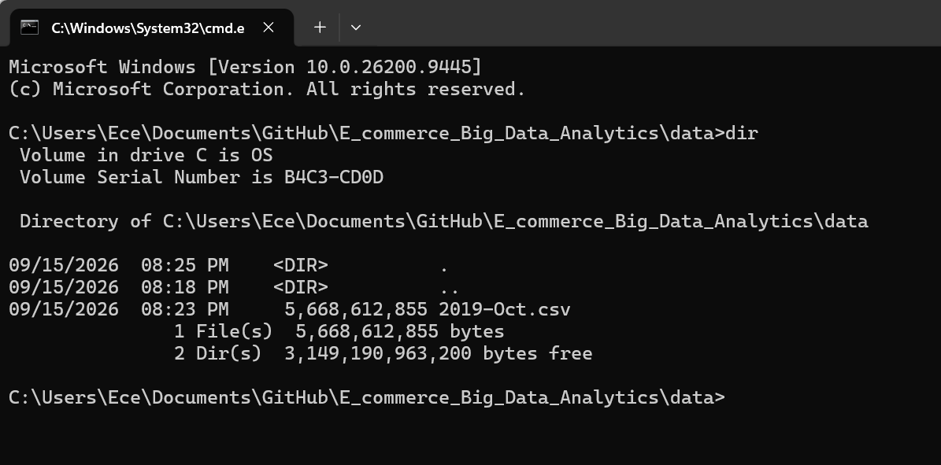
Figure 1. Dataset file size
The dataset consists of 42,448,764 records and 9 variables. These variables are event_time, event_type, product_id, category_id, category_code, brand, price, user_id, and user_session.
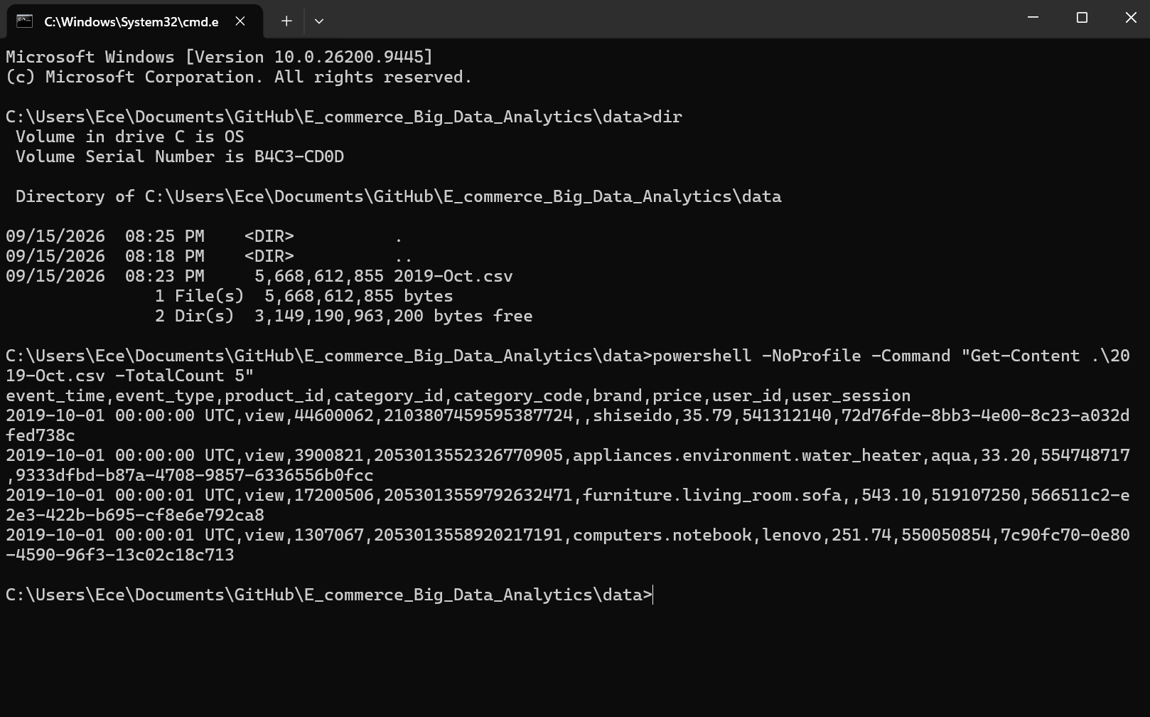
Figure 2. Dataset preview and variables
The dataset contains 42,448,764 records, as confirmed by the record count. The data covers the period from 1 October 2019 to 31 October 2019 and includes different user activities such as product views, adding products to the shopping cart, and purchases.
Figure 3. Total number of dataset records
The dataset includes three main event types: view, cart, and purchase. Product views represent the largest proportion of user activities, followed by adding products to the shopping cart and purchases.
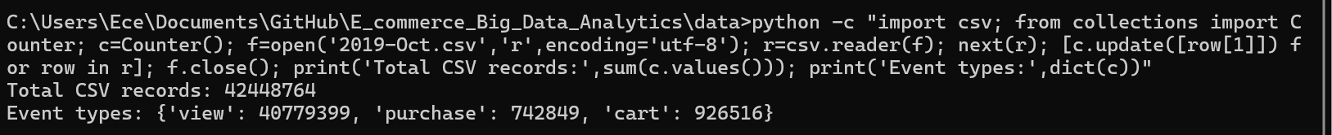
Figure 4. Distribution of e-commerce event types

Ethical and Data Governance Considerations
As the dataset contains fields related to user behaviour, such as user_id and user_session, data privacy and ethical considerations were taken into account in this project. The data was used only for analysis, and no actions were taken to access personal user information. In addition, missing values were checked before the analysis in order to identify issues that could affect the reliability of the results.

TASK 2: Hadoop Environment and HDFS

Hadoop Architecture
In this project, a Hadoop environment was established on Docker to store and process the large dataset. In the Hadoop environment, HDFS was used for data storage, while YARN was used for resource management and distributed process management. NameNode was used to manage the metadata of files and blocks in HDFS, while DataNode was used to store the data physically. Within YARN, ResourceManager manages the resources, while NodeManager monitors running processes and resources.
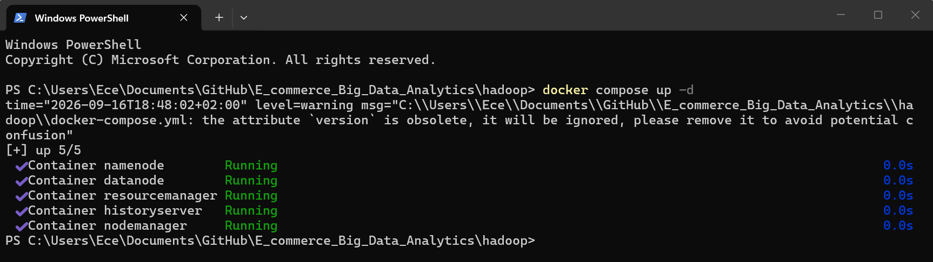
Figure 5. Hadoop Docker containers

HDFS and Data Storage
HDFS is a file system in the Hadoop environment that enables large amounts of data to be stored in a distributed way. In this project, the 5.67 GB 2019-Oct.csv dataset was uploaded to HDFS.
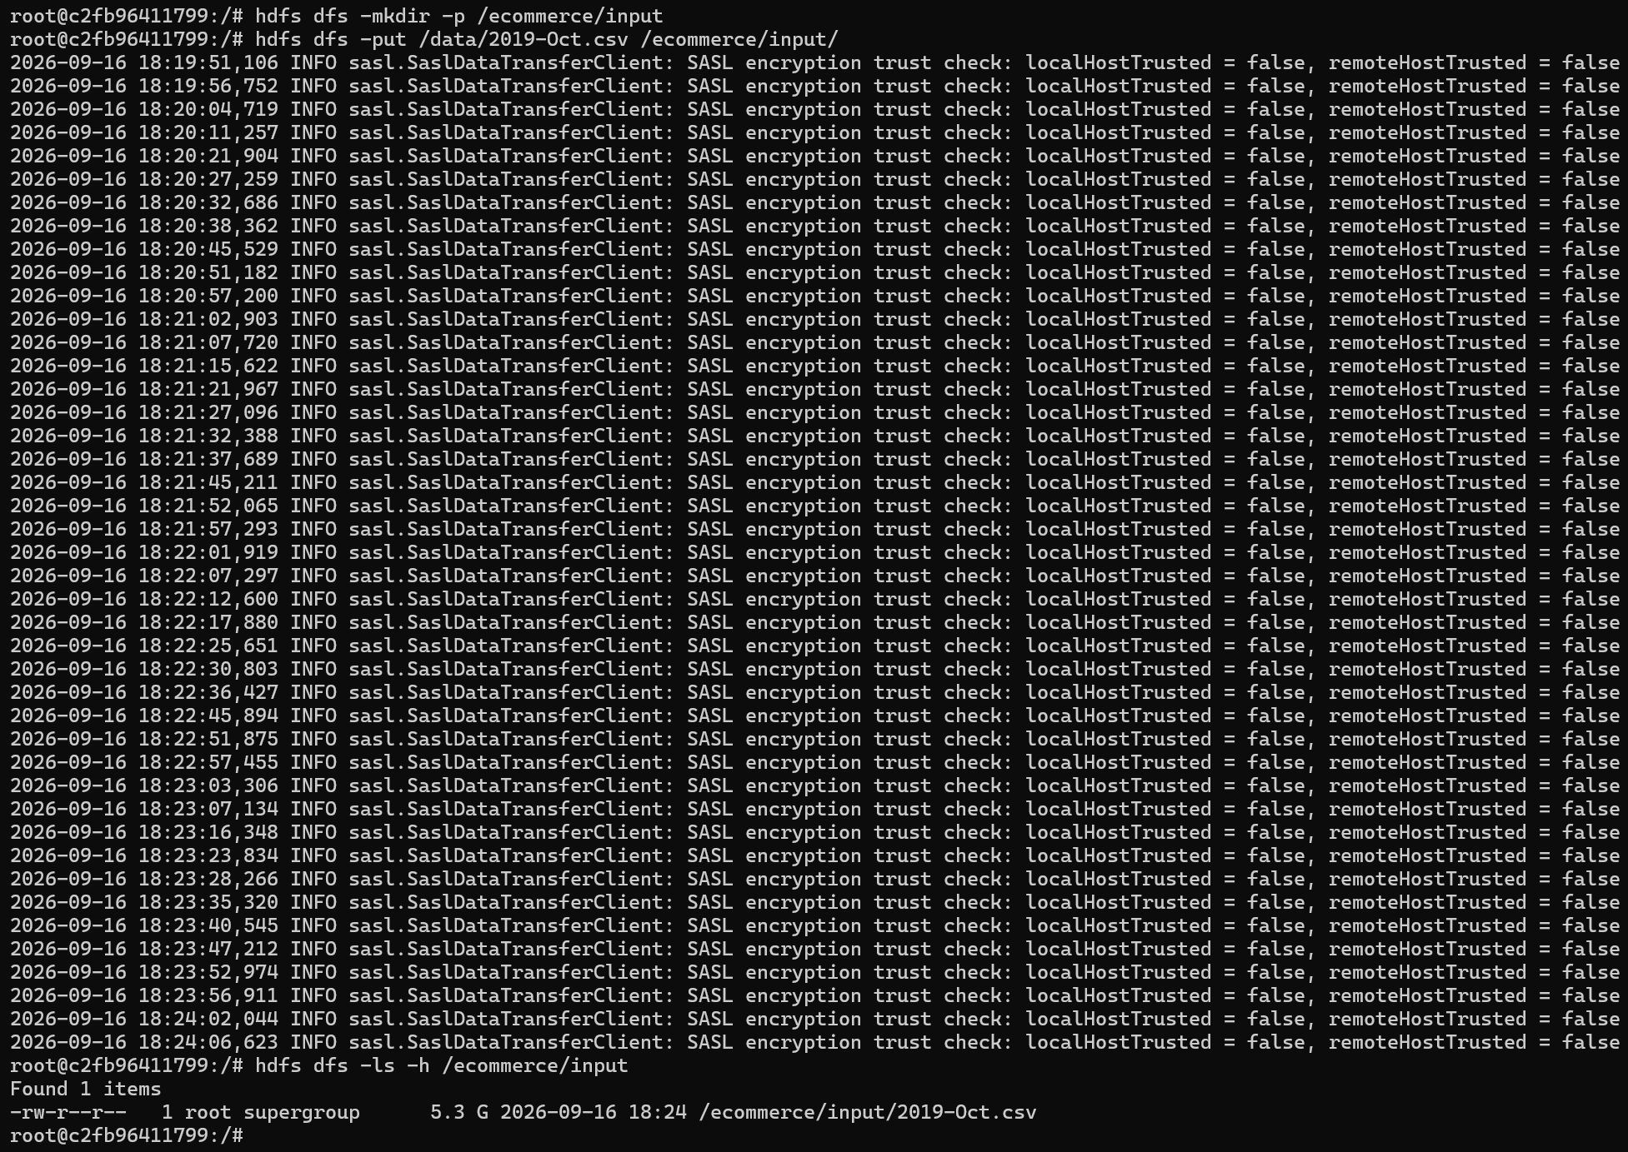
Figure 6. Dataset uploaded to HDFS
The dataset was stored under the /ecommerce/input/2019-Oct.csv path and was divided into blocks by HDFS and stored on the DataNode.

HDFS Implementation and Dataset Ingestion
The dataset was uploaded to HDFS using the HDFS command line. First, the /ecommerce/input directory was created using the hdfs dfs -mkdir command. The 2019-Oct.csv file was then uploaded using the hdfs dfs -put command. After the upload, the hdfs dfs -ls command was used to verify that the file was successfully stored in HDFS. The file was displayed with a size of approximately 5.3 GB.
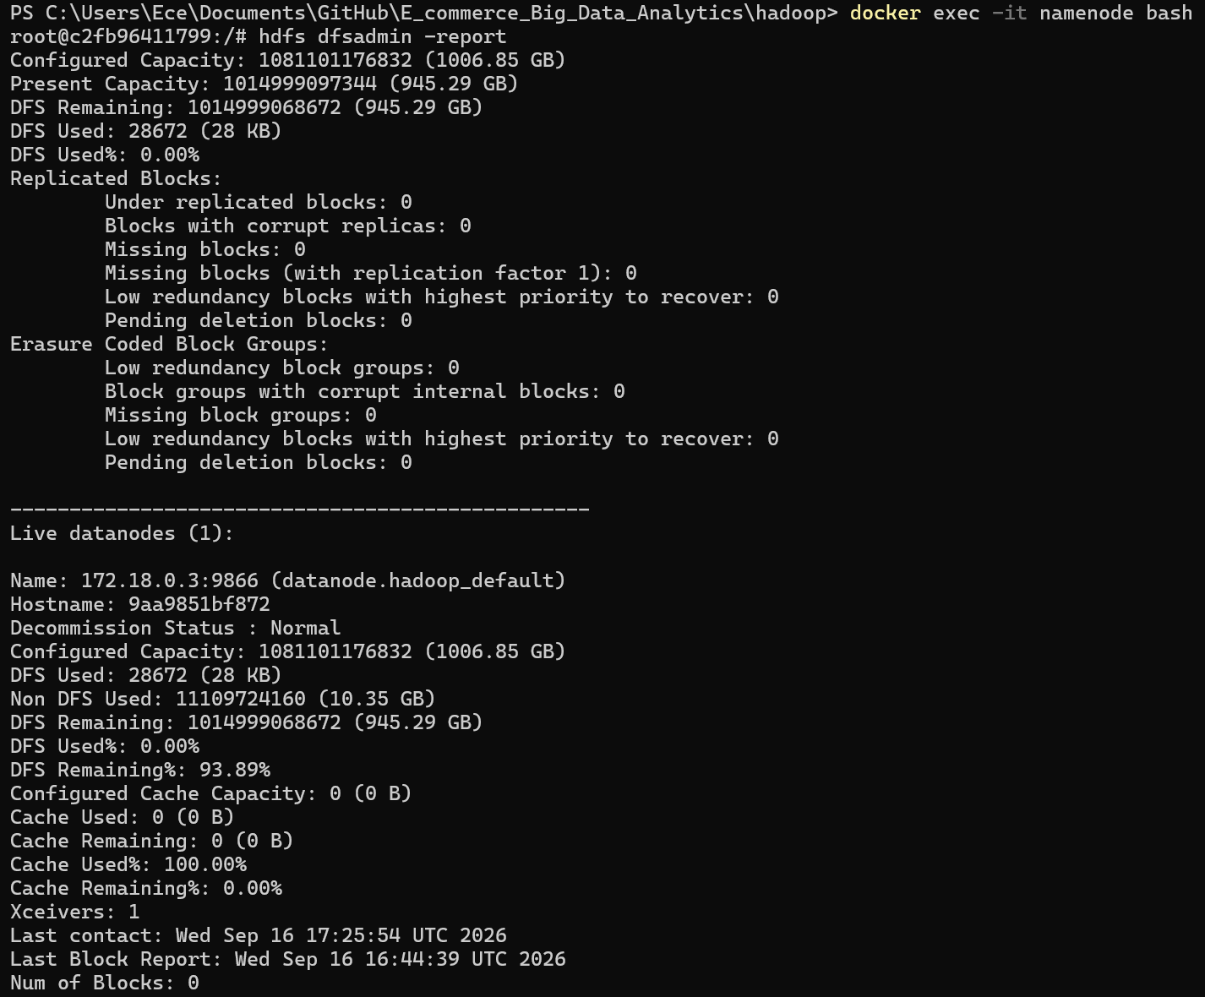
Figure 7. HDFS DataNode and storage status
The HDFS report showed one live DataNode with normal status, confirming that the storage node was available for the dataset.

YARN and Resource Management
YARN is a resource management system that enables resource management and the execution of distributed processes in the Hadoop environment. In this project, the ResourceManager was used to manage cluster resources and control the resource requirements of processes, while the NodeManager was used to monitor running processes and resource usage in order to manage distributed data processing operations performed on Hadoop.
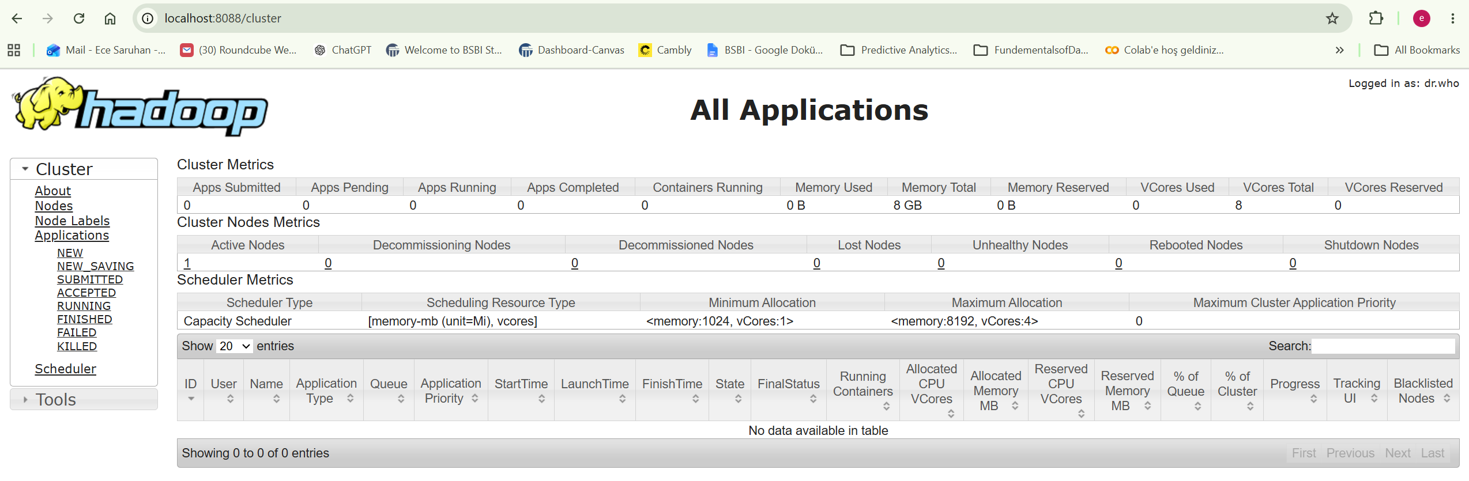
Figure 8. YARN ResourceManager

HDFS Blocks, Replication and Checkpointing
In this project, the 5.67 GB 2019-Oct.csv was a very large data file, so it was divided into 43 blocks by HDFS. The necessary checks were performed, and it was concluded that there were no missing or corrupted blocks in the file. In the configuration used, the replication factor was set to 1. Therefore, there was only one copy of each block.
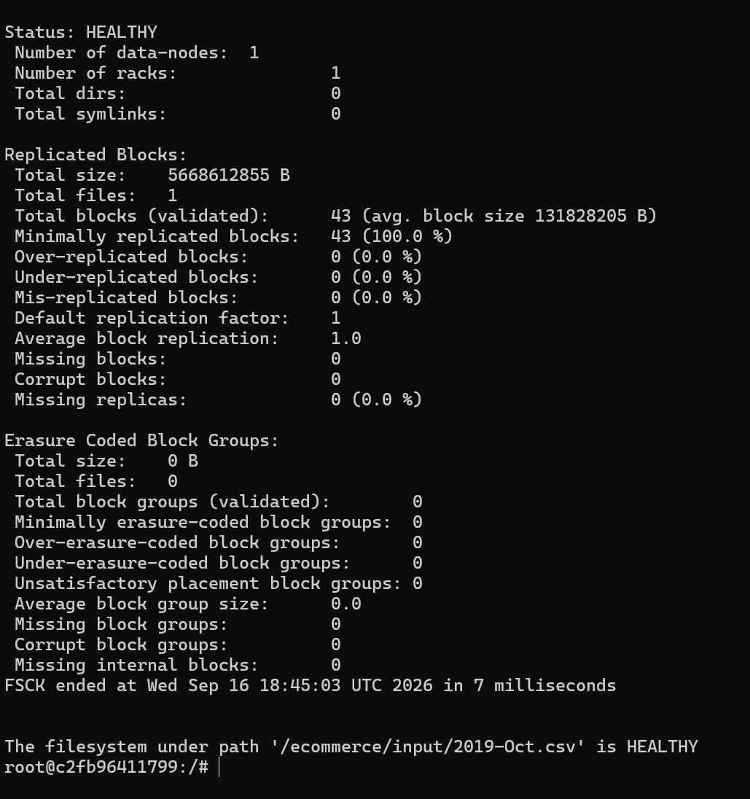
Figure 9. HDFS blocks, replication and file system health
In HDFS, FSImage represents the image in which the current metadata information about the file system is stored, while EditLog records the changes made to the file system. The checkpointing process allows the changes in the EditLog to be merged with the FSImage to create an updated file system image. This process helps metadata management on the NameNode to be performed in a more organized way. Since the provided Docker configuration did not include a separate Secondary NameNode service, this component was not run as a separate container in practice, and its role and the checkpointing mechanism were considered theoretically.

Implementation Issues and Limitations
During the setup of the Hadoop environment and the data processing stage, it was identified that Python was not available inside the Hadoop container. Therefore, shell scripts were used instead of Python for the MapReduce operations. Since the Hadoop environment used one DataNode and a replication factor of 1, this configuration limited data redundancy against data loss. In addition, the provided Docker configuration did not include a separate Secondary NameNode container. Since the project was implemented based on the Hadoop Docker configuration provided in the course, a separate Secondary NameNode container was not added in order to avoid changing the existing structure and to maintain the integrity of the project. Therefore, the Secondary NameNode and checkpointing mechanism were explained theoretically but were not implemented as a separate service.

TASK 3: Distributed Processing

Hadoop MapReduce

Hadoop Streaming Implementation

Apache Spark Processing

Spark SQL

MapReduce and Spark Comparison

TASK 4: Analytics and Machine Learning

Data Quality and Analysis

E-commerce Behavior Analysis

Product, Category and Temporal Analysis

Cart and Purchase Behavior

Machine Learning Approach and Results

Visualizations and Business Insights

CONCLUDING REMARKS

BIBLIOGRAPHY

- Theodorakopoulos, L. and Theodoropoulou, A. (2024) ‘Leveraging Big Data Analytics for Understanding Consumer Behavior in Digital Marketing: A Systematic Review’, Human Behavior and Emerging Technologies, 2024, Article 3641502.
Available at: https://onlinelibrary.wiley.com/doi/10.1155/2024/3641502
(Accessed: 17 September 2026).
- Jamarani, A., Haddadi, S., Sarvizadeh, R. et al. (2024) ‘Big data and predictive analytics: A systematic review of applications’, Artificial Intelligence Review, 57, Article 176.
Available at: https://link.springer.com/article/10.1007/s10462-024-10811-5
(Accessed: 17 September 2026).
- Munshi, A., Alhindi, A., Qadah, T.M. and Alqurashi, A. (2023) ‘An Electronic Commerce Big Data Analytics Architecture and Platform’, Applied Sciences, 13(19), 10962.
Available at: https://www.mdpi.com/2076-3417/13/19/10962
(Accessed: 17 September 2026).
- Apache Hadoop (2026) Apache Hadoop Documentation.
Available at: https://hadoop.apache.org/
(Accessed: 18 September 2026).
- Apache Spark (2026) Apache Spark Documentation.
Available at: https://spark.apache.org/
(Accessed: 18 September 2026).

APPENDIX (if necessary)

