**CHAPTER ONE**

**INTRODUCTION**

**1.1 BACKGROUND OF STUDY**

Recent advances in the Web have rapidly changed our life in various ways. These advances provide new ways for people to communicate on a global scale and assess vast amounts of information [1]. Website has become an essential part of the technology advancement and has provided educators with opportunities to implement a range of new teaching and learning practices which redefine classroom-learning experience [1]. Websites can be used in various fashions: a personal website, a corporate website for a company, a government website, an organization website e.g., Institutions, etc. website has become very important that any business, government, organization, or person can create a website on the internet. Today, the internet consists of billions of websites created by billions of different people [2]. Different kinds of websites have different purposes depending on who the intended audience is. Some websites are geared towards selling products and other websites are geared towards providing practical information, while others are merely for entertainment [3]. A website can either be Static or Dynamic. A Static website is one that has web pages stored on the server in the format that is sent to a client web browser. A Dynamic website is one that changes and customizes itself frequently and automatically.

The design and implementation of a comprehensive and interactive departmental website has come to replace the current paper records and the crude way of dispensing information. The lecturers are able to directly access all aspects of a student’s academic progress through a secure, online interface embedded in the departmental website, also provide a learning platform designed to provide educators, administrators and learners with a single robust, secure and integrated system to create personalised learning environments [4] which is the Moodle. The system utilizes user authentication, displaying only information necessary for an individual’s duties. Additionally, each sub-system has authentication allowing authorized users to create and update information in that sub-system. All data is thoroughly reviewed and validated on the server before actual record alteration occurs. In addition to a staff user interface the system plans for a student user interface, allowing users to access information, effectively use the Moodle and submit requests online thus reducing processing time [4].

All data is stored securely on SQL servers managed by the administrator and ensures the highest possible level of security. While paper records are a traditional way of managing student data there are several drawbacks to this method. First to convey information to students it should be displayed on the notice board and the student has to visit the notice board to check that information. It takes a very long time to convey the information to the student. All problems are solved using the website [4].

**1.2 DEFINITION OF TERMS**

**Web page**

A document which can be displayed in a web browser such as Firefox, Google Chrome, Opera, Microsoft Internet Explorer or Edge, or Apple’s Safari. These are often called ‘pages’ [5].

**Website**

One of the most common reasons for us to be hanging around on the internet every day is the abundance of information it is loaded with. The information is generated by multiple sources and is carefully organized in the form of files and web pages, which, when grouped together to form a single entity, become a website. Therefore, a site or website is a central location of web pages that are related and accessed by visiting the homepage of the website using a browser [2].

**Web design**

It is the process of collecting ideas and implanting them. web design is the visual aesthetics and page layout of a website. It works with web development in the creation of a static website or dynamic web application [5].

**Web server**

A web server is a computer hosting one or more websites. “Hosting” means that all the webpages and their supporting files are available on that computer. The web server will send any web page from the website it is hosting to any user’s browser, per user request [6].

**Website development**

It is also known as web programming, is the creation of dynamic web applications. Examples of web applications are social networking sites like Facebook or e-commerce sites like Amazon [6].

**Website implementation**

Web implementation is the process of building the web according to its design. A web implementor creates Hypertext Markup Language (HTML), Common Gateway Interface (CGI) programs, and/or Java scripts and/or applets [7].

**Search engine**

A web service that helps you find other web pages from other websites, such as Google, Bing, Yahoo, or DuckDuckGo. Search engines are normally accessed through a web browser or through a web page [5].

## 1.3 TYPES OF WEB DESIGN

* Static website-small websites
* Basic Brochure website
* Fixed design Layout
* Advanced static website
* Dynamic website Design- large/complex websites
* Responsive design Layout
* Content Management System (CMS) websites
* Liquid or Fluid design Layout
* eCommerce website

## 1.4 APPLICATION OF WEB DESIGN

### 1.4.1 Static website design - small websites

A static website is one without any server-side functionality and has no database or interactive content. Static web design is appropriate for smaller websites that don’t need any complex features or content. Static websites can still be designed to look really good with stylish graphics and content, they just can’t do anything clever based upon any behind-the-scenes programming. The advantage is that a static website is easier, faster and cheaper to design and build but is still professional and stylish [8].

### 1.4.2 Basic brochure website

For individuals and small businesses with a low budget; a simple but professional website that acts as a brochure or advert for you and your business [8]. Brochure websites can have as few as one or two pages (usually five or six) and typically follow a common format:

1. Home Page - an eye-catching introduction to your business with clear summary information about what you do
2. About / Philosophy - who you are, your credentials and your values
3. Your Services - one page for each different service you offer
4. Contact - a contact form, address/telephone/email, location map
5. Links

**1.4.3 Fixed design layout**

Fixed web pages have a set width that won’t alter when the browser is resized, no matter what device the website is being viewed on. Contents are harder to view with smaller devices, such as smartphones or tablets and can be annoying for users due to the need to scroll horizontally to view the rest of the content on the page or continuously “pinch and expand” to zoom into the page’s text [9].

### 1.4.4 Advanced static website

For small/medium businesses: static websites can be enhanced with advanced web design features to make them slick, stylish and interesting including [8]:

1. Drop-down navigation
2. Animated jQuery (JavaScript) effects
3. Flash content
4. Multimedia (video/audio)
5. News page
6. Social Network plugins
7. Image gallery

### 1.4.5 Dynamic website design - large/complex websites

Dynamic websites make use of server-side programming and databases to store and deliver the content. This allows web pages to perform more complex functions and display complex data and interactive content. This is the standard way that larger websites are designed as it makes adding large numbers of pages based upon the same template very easy. The downside is that it requires more initial work than a static website so it isn’t economical for small sites [8].

**1.4.6 Responsive design layout**

This approach aims to make website viewing easier by displaying websites on different devices in forms that are easy to read and navigate. Websites are created using responsive design to display different content as the browser is expanded or reduced to predetermined sizes. This avoids the user from having to resize, pan or scroll through the webpage to read the website’s content [9].

Essentially the website is easily viewable and usable on desktop computers, tablets and smartphones [9].

### 1.4.7 Content management system (CMS) website

For a firm who wants to make frequent changes/updates or want full control over their website CMS is the ideal design for them. A CMS can be part of just about any kind of website. Depending on your needs this can be as simple as the ability to add new items to a news page or image gallery, or full what-you-see-is-what-you-get (WYSIWYG) control over the content of each page [8].

**1.4.8 Liquid or fluid design layout**

When resizing the browser, the content on the page spreads itself out to fill the width of the browser when expanded, hence the term liquid design, and will look enlarged or as though it has shrunk. The columns containing the content on the webpage are built using percentages, rather than fixed columns used in fixed design, therefore the columns increase or decrease in size relative to each other [9].

### 1.4.9 eCommerce websites

For businesses that make money through their website either by selling goods from an online shop or offering premium (paid for) online services. This can range from simple integration with PayPal to sell a small number of items in an online shop where PayPal handles the entire checkout and stock-management process to large, self-contained shops which securely process credit card payments for hundreds of items. eCommerce websites are (almost) always dynamic and database driven and usually have the provision for the client to add new items and update prices, descriptions, images and stock levels from a dedicated admin system [8]. Sometimes some of the features of an eCommerce website will be integrated into a different kind of website e.g., a Band/Musician might have a website with images, news and information about their music but also has the ability to sell that music as a digital download.

**1.5 AIM & OBJECTIVES**

**1.5.1 Aim**

To design and implement a website for the Electronic Engineering Department.

**1.5.2 Objectives:**

1. To design a responsive and dynamic Website that will be active, easily navigated and user friendly, unlike the previous sites.

2. To create and link databases of both present and past students.

3. To create a learning platform or course management system (Moodle) to enable lecturers to access students easily on the website.

4. To connect the department to the World Wide Web, hence giving room for ample development in the future.

5. To create a website where students can have access to seminar materials, information about the department, various courses information from lecturers and past questions of courses.

**1.6 SCOPE OF PROJECT**

**The software environment in which the application will be deployed comprises of**

1. A web browser (independent of OS) to access applications.
2. A web server to host applications.
3. The database for the website.

The application will be hosted on a web server. This is very relevant because the administrative backend and the detailed application will be based on JavaScript and it will be convenient to access the website from anywhere. The administrative end will be accessed via a web browser on the PC, because of that it will not be dependent on the OS since it is web based. The student end will run on a web browser too.

**The hardware environment in which the website application will be deployed comprises of**

1. PC
2. Mobile devices and Tablets

**The human environment on which the website will be deployed will comprise of**

1. Student
2. Returning students
3. Alumni
4. Staff
5. Lecturers
6. HOD
7. Administrative
8. Maintenance and application manager
9. Developer

The updating, maintenance and upload of data will be done on PCs. The administrative end is proposed to be accessed from a PC. However, students can access it on their phones or other mobile devices compatible.

**1.7 JUSTIFICATION**

There will be ease of accessibility as far as technology is concerned, this in connection with stress-free dissemination of information and notification between students of the department and the staff. It is also a generative means of keeping the profile of the alumni for reference, awards of the department and recognition. In addition to the aforementioned points, the site is designed to meet responsive specification at this it stands a chance of continuity as it can be accessed with all forms of GPRS enabled devices without shrinking.

**1.8 SIGNIFICANCE**

To design and implement a responsive website for the department of Electronic Engineering, the website will be able to perform the following functions;

* Upload and download of lecture notes by students.
* View best performing students in each course and in the overall department.
* Ease access to Moodle by lecturers to upload their quiz, assignments, grades and any other activity available.
* Ease access to Moodle to take and submit assignments, tests, check grades and other activities by students.
* Profile of alumni and current students.
* News alert and current trends of information and scholarships accessible by the department to the student.
* Upload and download of seminars, project defence by lecturers and students for reference and learning purpose by the lecturers and administrator.

**1.9 METHODOLOGY**

Management of the software development process

Requirement Engineering

System Design

Coding

Testing and Implementing

Evaluation and Evolving

*Figure 1.1 Block Diagram of The Software Development [8]*

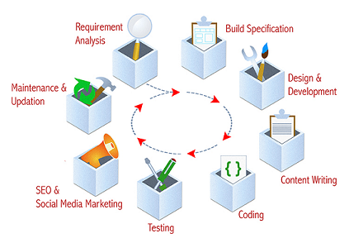

*Figure 1.2: Website development cycle [9]*

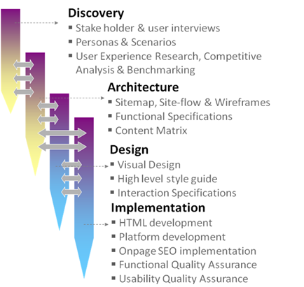

*Figure 1.3: Website development phases [8]*

**CHAPTER TWO**

**LITERATURE REVIEW**

**2.1 REVIEW ON THE DEPARTMENTAL WEBSITES IN CANADA UNIVERSITY**

In view of the design and implementation of electronic engineering websites. I conducted a thorough literature review and came up with a comprehensive report on 3 different departmental websites in Canada, namely:

* University of Toronto under the department of computer and mathematical sciences [19].
* McGill University under the department of Electrical and Computer Engineering [20].
* University of British Columbia under the department of Electrical and Computer Engineering [21].

A comprehensive website report is always based on data. Some of these data include: Effective navigation, well planned information architecture, Fast load time, Browser consistency, Contrasting colour scheme, good error handling, Mobile compatibility, etc.

Much of these data can be obtained by using the following methods

* Google Analytics or similar analytical software that gathers information directly from the website and analyses it.
* Personal survey (personal data) from the website.
* Direct feedback from the users of the website (User Survey).

For the purpose of this report, I adopted the first two methods which are the usage of website analytics [18] and my own personal survey.

**2.1.1 Reports on computer and mathematical sciences in university of Toronto**

Personal survey**:** Under this survey, I visited the aforementioned university website and based my research on the department of computer and mathematical sciences with is a close relation to Electronic Engineering, I gathered my data using the following website features:

* **Navigation**: there is effective navigation of web pages, good user interface, one does not require external help to find what he/she is searching for, the contents are easily accessible and without stress with proper organization. Below is Figure 2.1 and figure 2.2 showing a screenshot from University of Toronto website depicting effective navigation below.

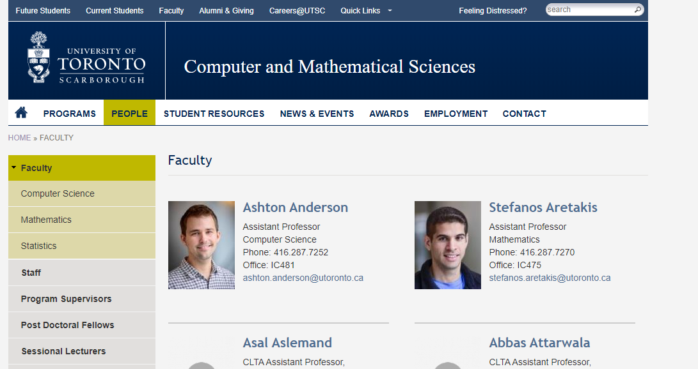

*Figure 2.1 University of Toronto website shows effective navigation [19]*

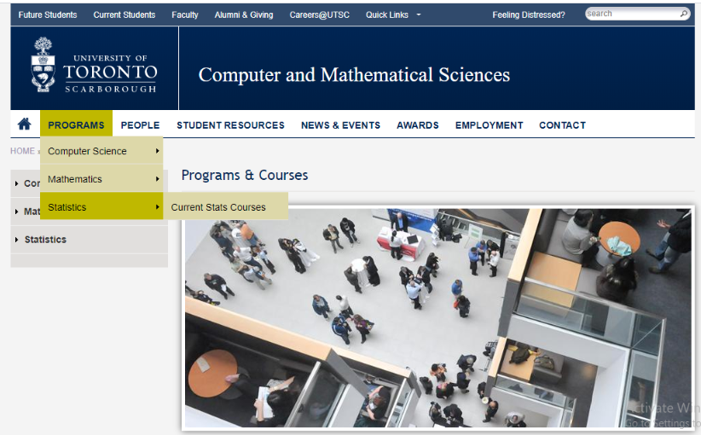

*Figure 2.2 University of Toronto website shows effective navigation [19]*

* **Graphical representation**- There is no graphical representation present.
* **Organization**- The website is organized in such a way that it is easily accessible, appreciable. The images and words used are well arranged and the organization is maintained no matter the browser used.
* **Content utility**- Each webpage has adequate contents. Its home page has a program admission requirement for 2020 on the side links. There is a brief write up about the departments and due to the fact, there are two departments joined together, there are links to explain more on the individual department and courses with included guides for the first-year students to make their choices. Below is the homepage content as shown in figure 2.3.



*Figure 2.3 University of Toronto shows the homepage setting [19]*

I also noticed that the header and footer is the same architecture organization with the school website.

* **Purpose**- The purpose of the website was achieved by making information available to both staff, students, alumni and to new students too.
* **Simplicity**- the website is very simple to read and operate.
* **Readability**- the contents are large enough and can be viewed easily and the words used were basic.
* **Valid links**- The links are valid in the sense that the links takes you to the appropriate webpage.
* **Impartiality**- Every write up was given the available space for it
* **Credibility**- It is very credible, the information loaded on the website are up to date to the most recent event.
* **Consistency/reliability**- The website is very reliable and the information consistent
* **Accuracy**- There are less or no errors in the write ups, one can depend on the information provided.
* **Loading speed**- The load time is very fast.
* **Security/privacy**- The website is secured with Https ‘s’ for security
* **Interactive**- The website is very interactive and user friendly.
* **Learnability**- It can be easily learned and navigated through.

**My Observations:** In the departmental website there is no avenue for online assessment for students in the classroom and tests taking.

**Website Analytics:** I made use of Google page insights to view my reports.

According to the analysis, the **mobile** view of the website was rated 63% as can be seen in the figure 2.4 below.

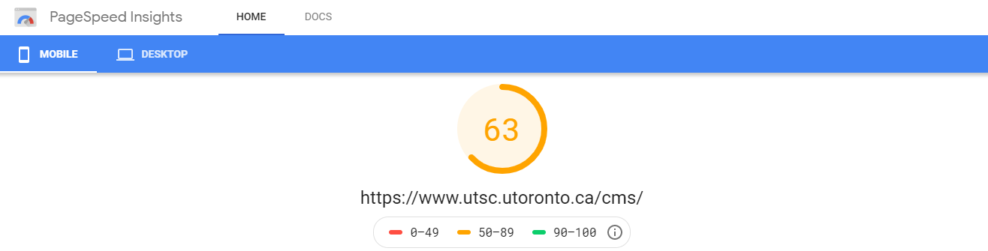

*Figure 2.4: Page Speed Insights website shows the mobile view of the website rating [19]*

Here are the lab data collected shown in figure 2.5

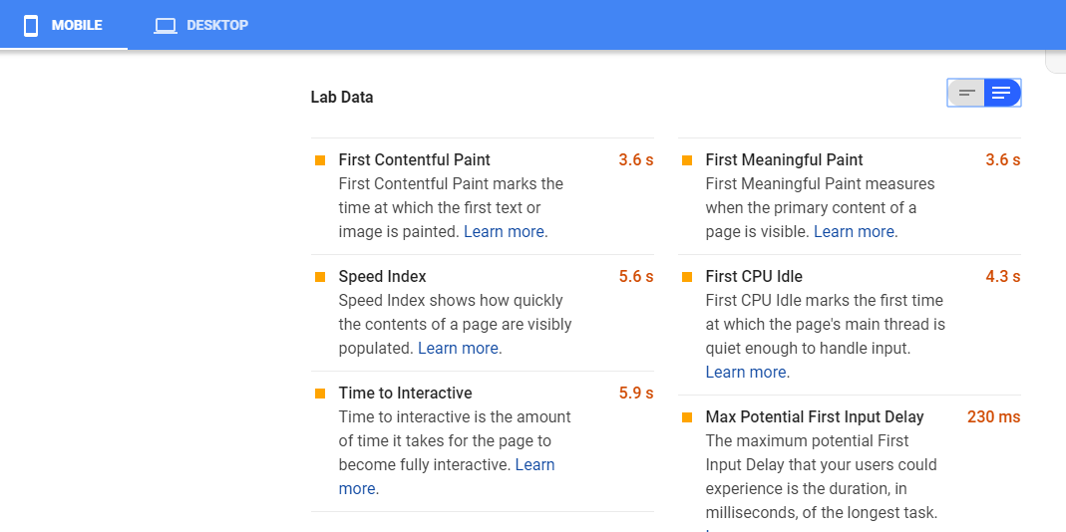

*Figure 2.5: Page Speed Insights website shows the Lab data [19]*

The **desktop** view of the website was rated 84% and can be seen in the figure 2.6 below

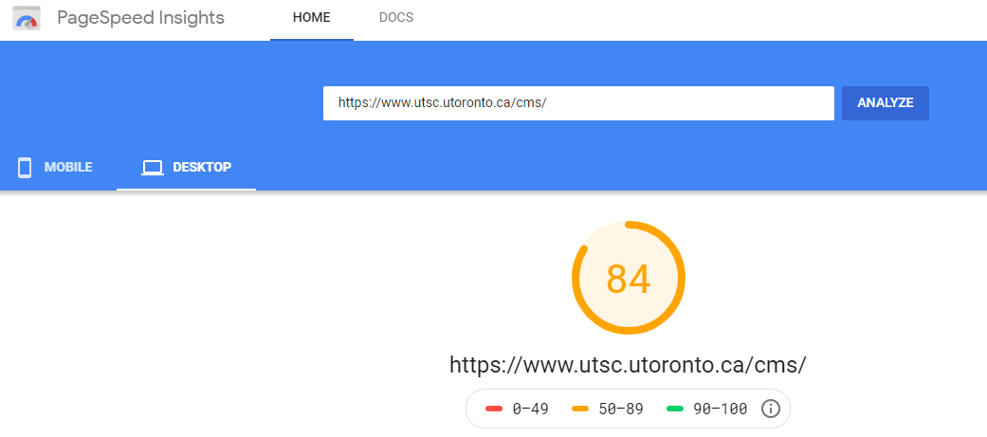

*Figure 2.6: Page Speed Insights shows the desktop view of the website rating [19]*

In summary, all pages served from this origin have a **Fast** speed compared to other pages in the [18] over the last 30 days.

Here are the lab data collected as shown in figure 2.7 below

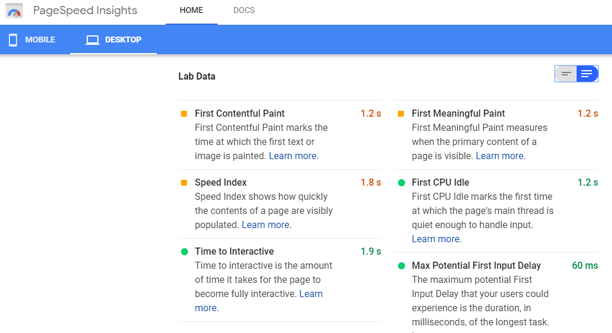

*Figure 2.7: Page Speed Insights website shows the Lab data [19]*

**2.1.2 Reports on electrical and computer engineering in McGill university**

The campus is located in the downtown area of the multicultural and lively city of Montreal, with more than 900 undergraduate students, 350 graduate students, 20 staff members and 40 faculty members in ECE

**Personal Survey:** Under this survey, I visited the aforementioned university website and based my research on the department of Electrical and Computer Engineering. I collected my data using the following website features:

* **Navigation**: There is effective navigation of the website as shown in figure 2.8 below.

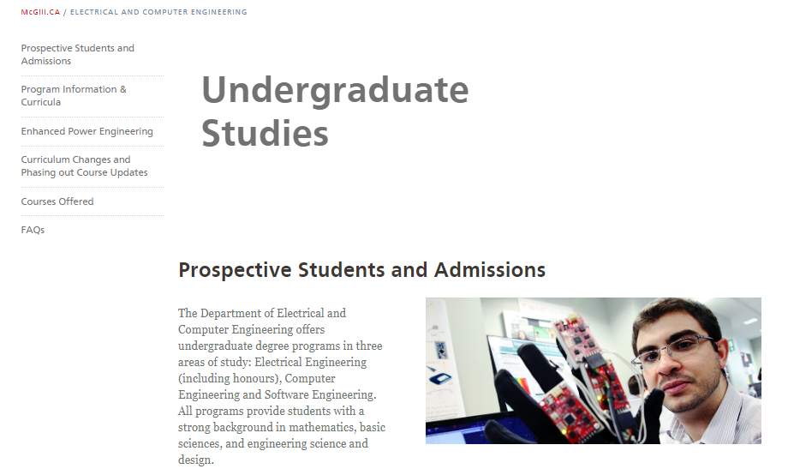

*Figure 2.8: MCGILL University website shows effective navigation [20]*

* **Graphical representation**: there is no graphical representation
* **Organization**: the website is organized but not effectively. The arrangement of the side links and the main contents do not match well.
* **Content utility**: the contents are neatly placed with images and contain useful information. Figure 2.9 shows the home page content with a high-tech image spanning almost half of the page.

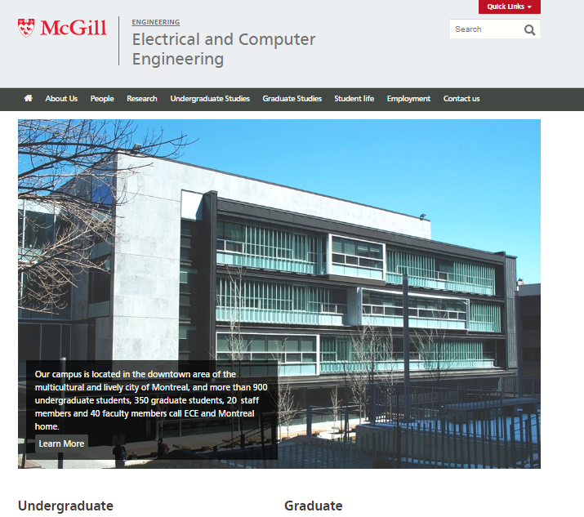

*Figure 2.9: MCGILL University website shows the homepage setting [20]*

* **Purpose**: The purpose of the website is to make information available to both staff, students, alumni and to new students too.
* **Simplicity**- the website is too simple and lacks creativity.
* **Readability**- the write ups are not enough and need to be zoomed to see clearly
* **Valid links**- The links are valid in the sense that the links takes you to the appropriate webpage.
* **Credibility**- It is very credible, the information loaded on the website are up to date to the most recent event.
* **Consistency/reliability**- The website is very reliable and the information consistent
* **Accuracy**- There is less or no errors in the write ups and the information is accurate
* **Loading speed**- The load time is fast.
* **Security/privacy**- The website is secured with Https ‘s’ for security
* **Interactive**- The website is barely interactive and user friendly.
* **Efficiency**- It is very efficient.
* **Learnability**- It can be easily learned
* In my observation, there is no avenue for an E-learning platform.

**Website Analytics:** I made use of Google page insights to view my reports.

According to the analysis, the **mobile** view of the website was rated 19% as can be seen in the figure 2.10 below.

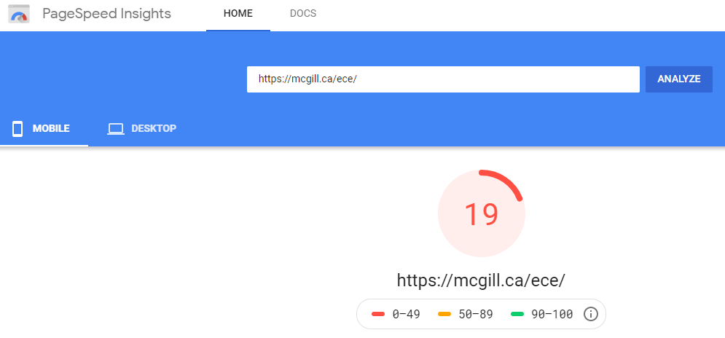

*Figure 2.10: Page Speed Insights website shows the mobile view of the website rating [20]*

**Origin Summary:** All pages served from this origin have a **Slow** speed compared to other pages in the [18] over the last 30 days.

Here are the lab data collected as shown in figure 2.11 below.

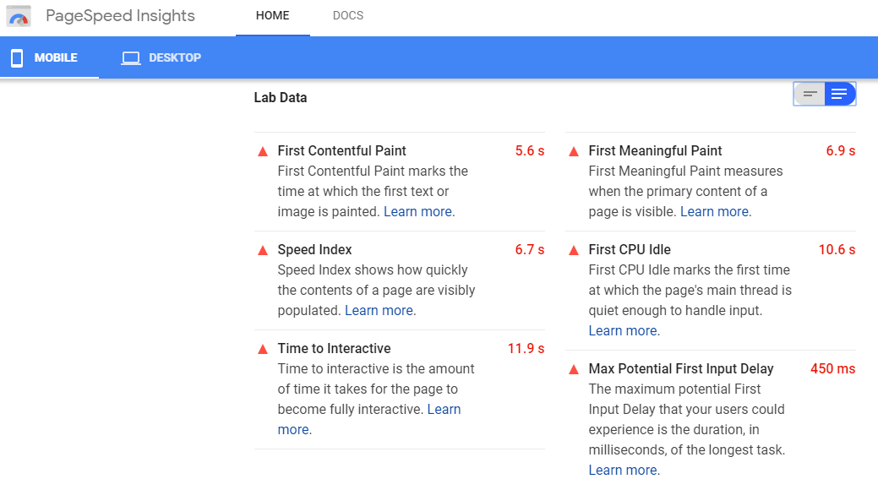

*Figure 2.11: Page speed insights website shows the lab data [20]*

The **desktop** view of the website was rated 84% and can be seen in the figure 2.12 below

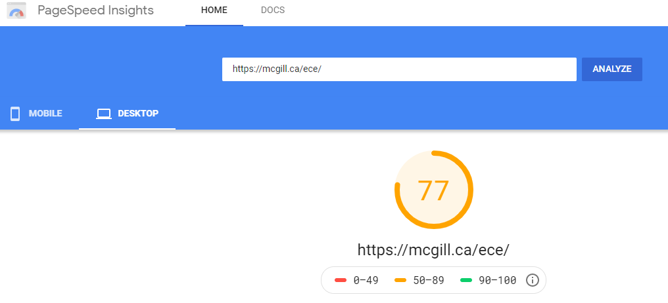

*Figure 2.12: Page Speed Insights website shows the desktop view of the website rating [20]*

**Origin Summary:** All pages served from this origin have a **Moderate** speed compared to other pages in the [18] over the last 30 days.

Here is the lab data collected as shown in figure 2.13 below

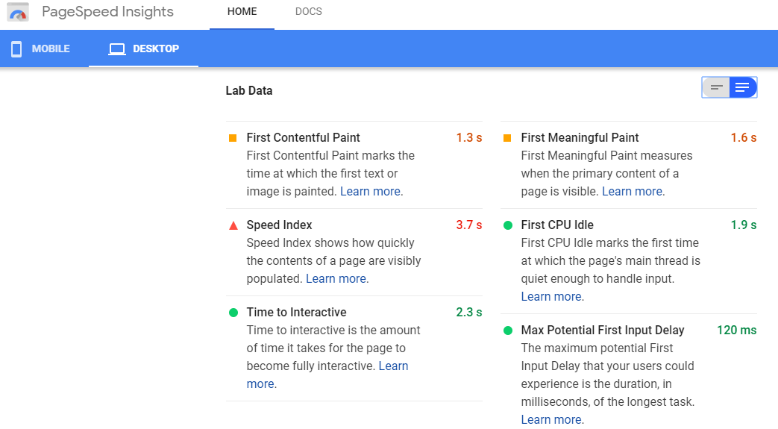

*Figure 2.13: Page Speed Insights website shows the Lab data [20]*

**2.1.3 Reports on electrical and computer engineering in university of British Columbia**

**Personal Survey:** Under this survey, I visited the aforementioned university website and based my research on the department of Electrical and Computer Engineering because it is the course closest to Electronic Engineering. I collected my data using the following website features:

* **Navigation**: There is proper navigation of the website shown in figure 2.14 below.

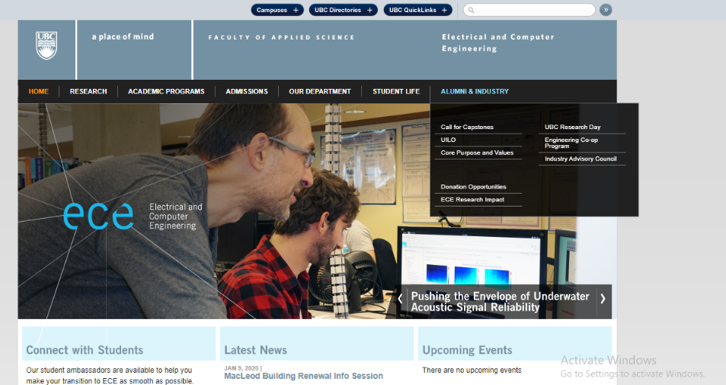

*Figure 2.14: University of British Columbia website shows effective navigation [21]*

* + **Graphical representation**: there is no graphical representation.
  + **Organization**: the website is organized effectively. The arrangement of the side links and the main contents match well.
  + **Content utility**: the contents are neatly placed with images and contain useful information. Figure 2.15 shows the home page content with a high-tech image spanning almost half of the page.

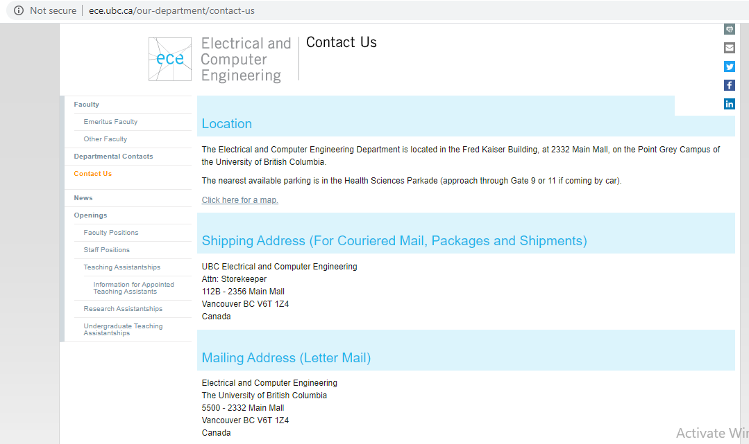

*Figure 2.15: University of British Columbia website shows effective navigation [21]*

* + **Purpose-** The purpose of the website is to make information available to both staff, students, alumni and to new students too.
  + **Simplicity**- the website is very simple and nice. The color contrast is very professional. Figure 2.16 shows the home page content with a high-tech image spanning almost half of the page.

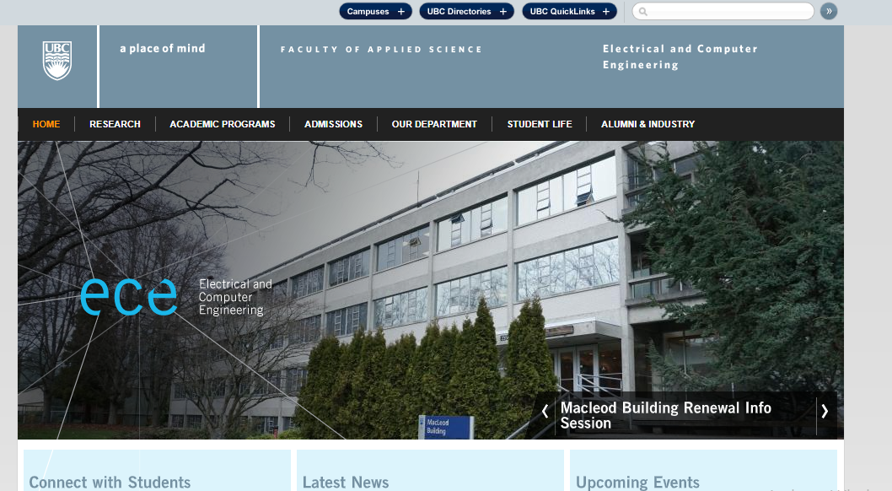

*Figure 2.16: University of British Columbia website shows the homepage setting [21]*

* + **Readability**- the write ups are good enough and can be viewed easily.
  + **Valid links**- The links are valid in the sense that the links take you to the appropriate webpage.
  + **Impartiality**- Every write up was given the available space for it
* **Credibility**- It is very credible and recommendable.
* **Consistency/reliability**- The website is very reliable and consistent with information dissipation.
* **Accuracy**- There are less or no errors in the write ups.
* **Loading speed**- The load time is relatively fast between web pages.
* **Security/privacy**- The website is not secured.
* **Interactive**- The website is very interactive and user friendly.
* **Efficiency**-The website is very efficient
* **Learnability-** It can be easily learned.

In my observation, there is no avenue for an E-learning platform.

**Website Analytics:** I made use of Google page insights to view my reports.

According to the analysis, the **mobile** view of the website was rated 22% as can be seen in figure 2.17 below.

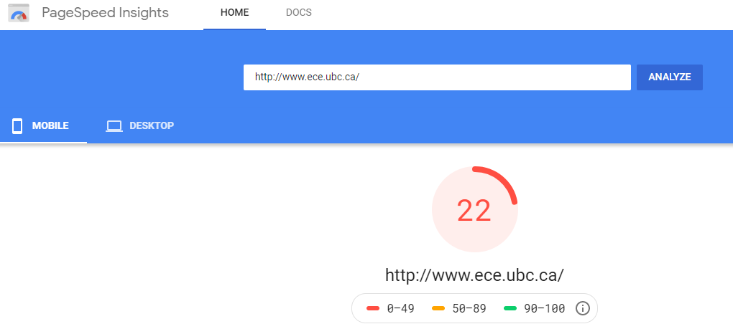

*Figure 2.17: Page Speed Insights website shows the mobile view of the website rating [21]*

**Origin Summary:** All pages served from this origin have a **Slow** speed compared to other pages in the [18] over the last 30 days.

Here are the lab data collected as shown in figure 2.18 below.

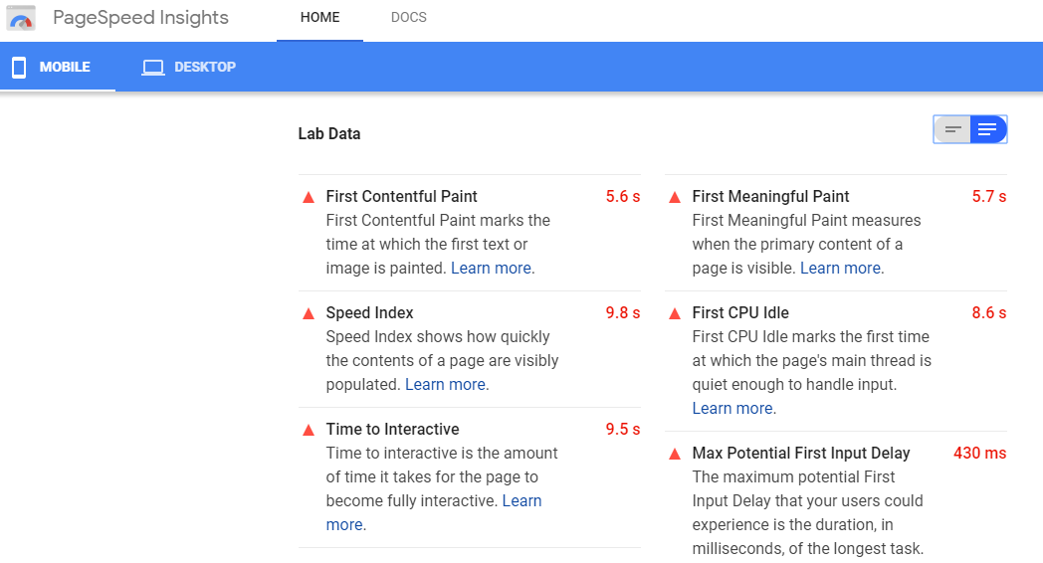

*Figure 2.18: Page Speed Insights website shows the Lab data [21]*

The **desktop** view of the website was rated 63% and can be seen in the figure 2.19 below

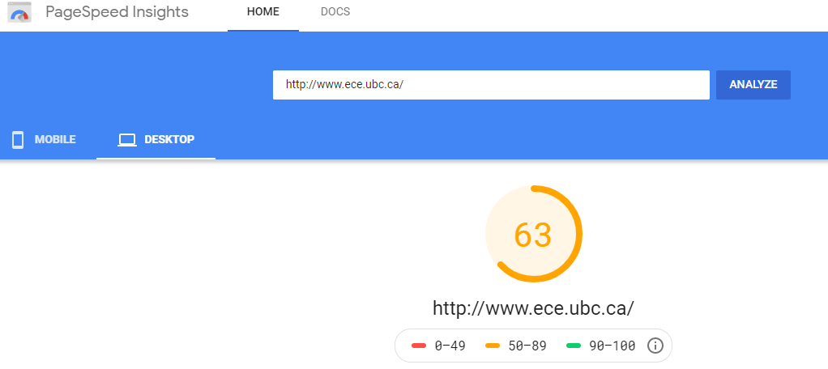

*Figure 2.19: Page Speed Insights website shows the desktop view of the website rating [21]*

**Origin Summary:** All pages served from this origin have a **Moderate** speed compared to other pages in the [18] over the last 30 days.

Here are the lab data collected as shown in figure 2.20 below.



*Figure 2.20: Page Speed Insights website shows the Lab data [21]*

**2.2 REVIEW ON THE DEPARTMENTAL WEBSITES IN THE NIGERIAN**

**UNIVERSITIES**

In view of the design and implementation of electronic engineering website. I conducted a thorough literature review and came up with a comprehensive report on 3 different departmental websites in Nigeria, namely:

* Obafemi Awolowo University under the department of Electrical and Electronic Engineering [24].
* Covenant University under the department of Electrical and Electronic Engineering [22].
* University of Nigeria Nsukka under the department of Electrical Engineering [23].

**2.2.1 Reports on Electrical and Electronic Engineering Website in Obafemi Awolowo**

**University**

1st impression on the website, it looked simple and user friendly, the design and layout were not too complex for their departmental website nevertheless I observed that it took about 15 seconds to load completely

The website will be reviewed on the following criteria

1. **Navigation**: it is relatively easy to navigate through this website. It contains almost every subpage in the main page as a drop-down menu. One need not look too much to find what he or she needs on the website.
2. **Functionality**: the website is not really functional, the purpose for a departmental website is to create a space on the internet where the works of the department can be easily reached, and students in the department will be able to see their lecturers, courses, and a few departmental researches on this space. These goals were not reached by this website; it is not functional enough.
3. **Content**: irrespective of the lack of functionality of the website, the content contained in it is relevant to the department. Though the content is not so much, the little content available is relevant to the department of electrical and electronic engineering.
4. **Optimization**: the website was attempted to be open on different browsers like chrome and Mozilla, and it was open successfully and similarly.it was then tested again with a laptop and an android phone and it operated similarly and effectively. Therefore, it is safe to say that the website is well optimized.
5. **Responsiveness**: the website was responsive in the sense that it adjusted to changes effectively. When it was run on a laptop, it adjusted its Layout to fill the screen of the laptop, a lot of buttons and drop-down menu boxes were aligned horizontally. On the other hand, when it was tested on a smaller device, it changed its Layout to also fit the screen of that device. On a Phone, the buttons and drop-down menus were aligned vertically to fill the phone screen efficiently.
6. **Speed**: A speed test was done on the website. It should be noted that the accuracy of this speed test was marred by the inefficiencies of network service providers. Every speed test referred to in this article is relative to other websites contained in this text. The load time of this website therefore is referred to as average.
7. The website is relatively secure and protected.
8. **Accessibility**: the website is equally accessible to all users in that the website architecture was well planned. The blind can easily make use of the website with the aid of screen readers
9. **Error handling**: it displays the right error messages when an error occurs. It has a good error handling ability.
10. **Usable forms**: unavailability of adequate usable forms that will have aided the website to become more interactive and generally user friendly.
11. **Color schemes**: the colors used for the texts and that of the background are clearly different and not conflicting.

Table 2.1 shows the overall grading of electrical and electronic engineering website of Obafemi Awolowo university

|  |  |  |
| --- | --- | --- |
| Property | Grade | Percentage |
| Navigation | 9 | 90% |
| Functionality | 6 | 60% |
| Content | 9 | 90% |
| Optimization | 10 | 100% |
| Responsiveness | 10 | 100% |
| Speed | 5 | 50% |
| Security | 10 | 100% |
| Accessibility | 8 | 80% |
| Error handling | 10 | 100% |
| Usable forms | 4 | 40% |
| Colour schemes | 9 | 90% |
| Total=81.8% |  |  |

*Table2.1: overall grading of electrical and electronic engineering website of Obafemi Awolowo university [24]*

Therefore, this website is a relatively good model

* + 1. **Reports on Electrical and Electronic Engineering Website in Covenant University**

1st impression: it looks like it was designed just to be a page and not a departmental.

Website Navigation: it is relatively easy to navigate through this website. It contains almost every subpage in the main page as a drop-down menu. Navigation on this website is not as effective as that of OAU.

1. **Functionality**: the website is not functional, the purpose for a departmental website is to create a space on the internet where the works of the department can be easily reached, and students in the department will be able to see their lecturers, courses, and a few departmental researches on this space. These goals were not reached by this website; it is not functional enough. Still less functional than the OAU
2. **Content**: This website is also poor in content. The only content in it seems to be the faces of their various lecturers. Nothing relevant to the department was included in the website. There is a welcome note by the HOD of the department to the website viewer and that’s all. It is way below mediocre in regards to relevant content
3. **Optimization**: the website was attempted to be open on different browsers like chrome and Mozilla, and it was open successfully and similarly.it was then tested again with a laptop and an android phone and it operated similarly and effectively. Therefore, it is safe to say that the website is well optimized.
4. **Responsiveness**: the website was responsive in the sense that it adjusted to changes effectively. When it was run on a laptop, it adjusted its Layout to fill the screen of the laptop, a lot of buttons and drop-down menu boxes were aligned horizontally. On the other hand, when it was tested on a smaller device, it changed its Layout to also fit the screen of that device. On a Phone, the buttons and drop-down menus were aligned vertically to fill the phone screen efficiently.
5. **Speed**: the load time of this website is quite impressive, it takes little or no time to finish loading, and once a button/menu is selected, it responds immediately. The website speed is good.
6. The website is relatively secure and protected
7. **Accessibility**: the website is not easily accessible to all users in that the website architecture was not well planned. The blind can’t easily make use of the website with the aid of screen readers.
8. **Error handling**: it displays the right error messages when an error occurs. It has a good error handling ability
9. become more interactive and generally user friendly. It doesn’t contain any forms at all unlike the OAU EEE website that had some forms
10. **Color schemes**: the colors used for the texts and that of the background are clearly different and not conflicting. But it doesn’t look modern in any form.

Table 2.2 shows the overall grading of electrical and electronic engineering website in Covenant University

|  |  |  |  |  |
| --- | --- | --- | --- | --- |
| Property | | Grade | | Percentage |
| Navigation | | 5 | | 50% |
| Functionality | | 4 | | 40% |
| Content | | 1 | | 10% |
| Optimization | | 10 | | 100% |
| Responsiveness | | 10 | | 100% |
| Speed | | 10 | | 100% |
| Security | | 10 | | 100% |
| Accessibility | | 4 | | 40% |
| Error handling | | 10 | | 100% |
| Usable forms | | 0 | | 0% |
| Colour schemes | | 5 | | 50% |
| Total=62.7% | |  | |  | | |

*Table2.2: overall grading of electrical and electronic engineering website in Covenant University [22]*

Therefore, this is not as good a model as OAU.

* + 1. **Reports on electrical department in University of Nigeria Nsukka.**

First impression: This website looks empty.

1. **Navigation**: it is relatively easy to navigate through this website. It contains almost every subpage in the main page as a drop-down menu. Navigation on this website is not as effective because of the lack of well detailed footers.
2. **Functionality**: the website is not functional, the purpose for a departmental website is to create a space on the internet where the works of the department can be easily reached, and students in the department will be able to see their lecturers, courses, and a few departmental researches on this space. These goals were not reached by this website; it is not functional enough. Less functional than the OAU but more functional than the CU
3. **Content**: This website is also poor in content. It has little relevant content related to the department of electrical Engineering.it only contains a few articles which are not enough relevant content for a departmental website
4. **Optimization**: the website was attempted to be open on different browsers like chrome and Mozilla, and it was open successfully and similarly.it was then tested again with a laptop and an android phone and it operated similarly and effectively. Therefore, it is safe to say that the website is well optimized.
5. **Responsiveness**: the website was responsive in the sense that it adjusted to changes effectively. When it was run on a laptop, it adjusted its Layout to fill the screen of the laptop, a lot of buttons and drop-down menu boxes were aligned horizontally. On the other hand, when it was tested on a smaller device, it changed its Layout to also fit the screen of that device. On a Phone, the buttons and drop-down menus were aligned vertically to fill the phone screen efficiently.
6. **Speed**: A speed test was done on the website. It should be noted that the accuracy of this speed test was marred by the inefficiencies of network service providers. Every speed test referred to in this article is relative to other websites contained in this text. The load time of this website therefore is referred to as average. The speed is similar to that of Obafemi Awolowo University and less than that of Covenant University.
7. The website is relatively secure and protected
8. **Accessibility**: the website is a little bit accessible to all users in that the website architecture was planned. The blind can make use of the website with the aid of screen readers.
9. **Error handling**: it displays the right error messages when an error occurs. It has a good error handling ability
10. **Usable forms:** availability of a few usable forms which have aided the website to become more interactive and generally user friendly. It contains some forms unlike the Covenant University EEE website that had no forms at all
11. **Color** **schemes**: the colors used for the texts and that of the background are clearly different and not conflicting. But it doesn’t look modern.
12. **Usable forms**: unavailability of any usable forms that will have aided the website.

Table 2.3 shows the overall grading of electrical engineering website of University of Nigeria Nsukka.

|  |  |  |
| --- | --- | --- |
| Property | Grade | Percentage |
| Navigation | 6 | 60% |
| Functionality | 4 | 40% |
| Content | 2 | 20% |
| Optimization | 10 | 100% |
| Responsiveness | 9 | 90% |
| Speed | 6 | 60% |
| Security | 10 | 100% |
| Accessibility | 6 | 60% |
| Error handling | 10 | 100% |
| Usable forms | 5 | 50% |
| Colour schemes | 6 | 60% |

Total= 67.2%

*Table 2.3: overall grading of electrical engineering website of University of Nigeria Nsukka [23]*

Therefore, this is not as good a model as OAU.

**2.3 REVIEW ON THE DEPARTMENTAL WEBSITES IN UNITED KINGDOM (UK)**

**UNIVERSITIES**

In view of the design and implementation of electronic engineering websites. I conducted a thorough literature review and came up with a comprehensive report on 3 different departmental websites in Nigeria, namely:

* Department of Engineering Sciences in Oxford University [26].

**Personal Survey**

* + - 1. **Navigation**: At first glance and perusal of the website, it becomes obvious that navigating through the website is a difficult task. The main page contains little means of finding what you are looking for and as such, if you are new to the site, require external help from someone who has used it often.
      2. **Functionality**: For a website that is for the department of engineering sciences, it doesn’t satisfy the need it was created for. Works and other related research the department has undergone is not showcased.
      3. **Content**: Owing to the lack of functionality, there is also a lack thereof of relevant content for the department. A list of courses that students will undergo throughout their extensive period of study in the department is showcased, which could be seen as a nod in the right direction as far as content goes, but nothing else highlights the vast content that should be contained on the website.
      4. **Optimization**: The website was opened across several browsers such as Google Chrome and UC Browser and devices such as a Laptop and a Mobile Phone. For the browsers used, the site showed the same level of optimization on the laptop, both times, it displayed exactly the same content. However, problems arose when it was opened on a mobile phone as part of the home page was distorted and made for clumsy navigation through the website, showing that this site was perfectly optimized mainly for desktop or laptop computers.
      5. **Responsiveness**: The website adapted to changes of browsers on the laptop seamlessly, it immediately adjusted layout to fill out the screen of the laptop and presented its content clearly irrespective of the browser being used. However, using it on a mobile phone proved difficult as the layout wasn’t responsive enough and made for a hard time navigating.
      6. **Speed**: Irrespective of network service provider employed, the website loaded fast with negligible drawback.
      7. **Color Scheme**: The color grading used conflicted and required enforced perception to read words clearly.

**CHAPTER THREE**

**DESIGN METHODOLOGY**

**3.1 INFORMATION GATHERING**

**3.1.1 Analysis**

The first essential step in Web design is context analysis, where we elicit and understand the system’s major objectives and requirements, as well as the needs of the system’s typical users and the organization that needs the system [10].

This first stage of Web design can be known as the analysis stage of Web design, which includes the targeted audience and the contents of the site in view. The contents of the site include the Home, Alumni, Research, Programs, Staff, E-learning, Contact Us and About Us.

The website is made in such a way that it would be responsive, in order to be better than the previous ones earlier designed. It is also meant to provide information as well as create an avenue or a platform to promote enlightenment and to step up the department to World class standard.

In addition to the requirements, potential demands on the functionality, usability, speed, error handling, accessibility, responsiveness, navigation, optimization and performance of the system need to be specifically elicited and understood by the developers at the beginning of the development process [10].

Based on this information, developers then arrive at the website’s functional, technical and non-technical requirements, which in turn influence the system’s architectural design [10].

Finally, context analyses can eliminate or minimize the major problems associated with website development and projects at large.

**3.1.2 Organisation**

The next phase after context analyses of the website is organising the contents in order. As far as this project is concerned, below are the contents structured in the site map:

* Home
* About Us
* Program
* Staff
* Research
* E-learning
* News & Events
* Contact Us

**3.2 DATA FLOW DIAGRAM**

A Data Flow Diagram (DFD) as shown in figure 3.1, is a graphical representation of the flow of the website contents. A data flow diagram can also be used for the visualization of Data processing [11]. DFD shows the interaction between the system and an outside entry. This context-level DFD is then used to show more detail of the system being modelled. Data flow diagrams are commonly used during problem analysis because it views a system as a function that transforms the given input into required output [4].

**SITE MAP**

Home

About us

E-learning

Program

Staff

Research

News &events

Contact us

Undergraduate

Communication

Academic

Moodle

Control

Post-Graduate

Technical

Online courses

Administrative

Digital

*Figure 3.1 The flow chart diagram [14]*

**3.3 PLANNING / SYSTEM DESIGN**

Having gathered the information needed in the first phase, and considering the end users, we plan an easy-to-understand system. Create an easy navigation site that is relational and can be opened with different user end device resolution.

This also involves data flow diagram, detailed flow graph, requirement analysis, and the design process of the front and back-end design of the website [10].

* An overall system architecture describing how the network and the various servers (Web servers, application servers and database servers) work hand in hand.
* A software architecture depicting various software and database modules required to implement the application architecture
* A hardware architecture identifying various information modules, the display and the functions they support.

**3.3.1 Website component (interface design)**

In the website interface design, we decide on various components of the system and how they are linked. The project is made up of 5 mains sections namely:

The Homepage Section

The Program Section

The Student Section

The Management Section

The Alumni Section

**3.3.2 The homepage section**

This is the first page of the site. It contains in it the summary of the website. It is dynamic and adapted to each student and staff alike.

**3.3.3 The program section**

This section is grouped into the two programs offered by the department, which are the Undergraduate.

Degree Programs and the Post-graduate Degree Programs. It can be viewed in the section together with the various course titles and course codes offered at every level.

**3.3.4** **The student section**

This section provides more detailed information on the courses available and offered by the students. It also shows the Moodle for the student’s assessment. It is visible to the Heads of Department, Staff alongside the student.

**3.3.5 The management section**

This section involves mainly the backend of the departmental website. It is made available to the developers, administrators and to the staff in certain occasions as to update their profile.

**3.3.6 The alumni section**

This provides more detailed information about the past students of the department. It gives access to their achievements, contacts, the best student of each year and what they have done for the department.

**3.4 DESIGN/EXECUTION**

At this point, the website structure will come to life, it involves;

* Creating the graphical user interface (GUI)
* Creating the content
* Converting the web designs from images into codes which are the markup languages the web browser can interpret.

Figure 3.2 shows the flow chart which is part of the project execution

**3.4.1 The design of the project was done using 4 methods**

* Requirement Analysis
* Designing the Application Map
* Designing the database
* Designing the web pages

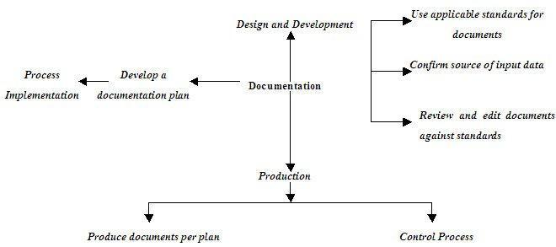

*Figure 3.2 Diagram showing flow chart showing part for project execution [14]*

**3.5 REQUIREMENT ANALYSIS**

The website would provide various services such as the:

* departmental Alumni’s profile,
* Lecturer’s profile,
* alumni records,
* courses offered,
* programs offered,
* research papers by lecturers,
* current news and seminars for both students and lecturers.

In addition to the aforementioned the web application should also be able to:

* upload student’s data,
* upload lecture notes,
* upload news and events,
* the lecturers can update his/her personal information and update them.
* upload awards,
* upload seminars.

The Moodle will have login details provided for both staff and students and the students that have registered courses successfully can write assignments and quizzes on the Moodle. lecturers can release the grades of the students, upload questions and other things via the Moodle.

In order for the web application to work effectively, various requirements have to be made available. These requirements are further elaborated on:

**3.5.1 Data**

It involves all the data that would be uploaded into the database for further use by the students and the management. Emphasis of this project is data content. Here are some basic student information that will help the outcome make more sense:

1. Students’ data
2. Staff data
3. Alumni information
4. Past seminars and projects
5. Research conducted by lecturers, etc

**3.5.2 Functional requirements**

The departmental website aims to improve the efficiency of college information management, and the main function is managing and maintaining information [12]. The administrator and students are two major functional requirements in the system.

The administrator will be given more powers to enable, disable and update than other users. It will be ensured that the information entered is of correct format. The Administrator handles the backend of the website while the students see just the front-end [4].

**3.5.3 Technical requirements**

This involves the various technical tools employed in order to access and use the web application. These tools include:

1. A memory device, preferably an external hard disk drive. This is used to store all of the information and data that would be used on the application. The memory device to be used is the 500GB hard disk drive.
2. A Computer system: this would be used as the display to access the application on the internet. It could either be a desktop or a laptop computer with at least 512MB RAM, a 20GB hard disk drive, a 1.27GHz processor, a 32-bit operating system.
3. A mobile phone can be used as an alternative to access the application on the internet. It must be WAP enabled in order to access the internet. The phone would use wireless technologies such as GPRS, EDGE or 3G to connect to the internet.

**3.5.4 Non-functional requirements**

1. **Performance Requirements:**

The proposed website which we are going to develop will be used as the chief performance system for helping the department in managing the whole database of the students studying in the department. Therefore, it is expected that the database would perform functionally all the requirements that are specified [4].

1. **Safety Requirements:**

The database may get crashed at any certain amount of time due to a virus or the operating system failure. Nevertheless, it is required to take the database backup [13].

1. **Security Requirements:**

One main expectation of such an application is its security and safety. Some of the security measures taken into consideration in the course of the development of this application are:

* Access levels.
* Authentication.
* Active records scripting for the database.
* Valid inputs.

In view of that, there are various categories of people namely; Administrator, Student who will be retrieving information from the database. Depending on the access rights decided to each user, it means if the user is an administrator, then he can be able to modify the data, a append, etc. while other users only have the rights to retrieve the information about the database [4].

**3.5.5 Designing the application map**

The application map consists of meaningful and essential information about the structure of the webpages. It shows all the pages in the application (represented with some blocks) and the main relationship between them.

**3.5.6 Designing the database**

It is right to say that databases play a critical role in almost all areas where computers are used, including electronic commerce, business, engineering, law, medicine, education and library science [4]. Therefore, a database is an organized collection of related data for one or more purposes, usually in digital form. It is designed to offer an organized mechanism for storing, managing and retrieving information through the use of entity relationship models.

A database has the following implicit properties:

• A database represents some aspect of the real world, sometimes called the mini-world or the Universe Of

Discourse (UOD) changes to the mini world are reflected in the database.

• A database is a logically coherent collection of data with some inherent meaning. A random assortment of data

cannot correctly be referred to as a database.

• A database is designed, built, and populated with data for a specific purpose. It is an intended group of users

and some preconceived applications which these users are interested in [4].

It is represented to reduce repetition to the barest minimum. Scaling and integration with existing systems is put into consideration.

**3.5.7 Design of the page structure**

The website makes use of a conventional web page design.

### 3.5.8 Responsive/mobile compatible design

The application makes use of a responsive design model. This model allows the application to be accessible over the majority of devices-PC, tablets, pads and phones. This strategy of design reduces development time considerably, that is, the same piece of codes can be used to serve all media devices without having to redesign specifically for separate devices

**3.6 TECHNOLOGIES USED**

**3.6.1 Html**

HTML is a hypertext markup language which is in reality a backbone of any website. Every website can’t be structured without the knowledge of html. If we make our web page only with the help of html, then we cannot add many other effective features in a webpage, for making a web page more effective we use various platforms such as CSS (Cascading Style Sheet). To make our web pages dynamic, we are using Javascript [14, 15, 16].

**3.6.2 CSS**

CSS which stands for “Cascading Style Sheet” are used to format the layout or Web pages. They can be used to define text styles, table size, color, padding and other aspects of Web pages that previously could only be defined in a page’s HTML [14]. The primary purpose of CSS is to separate the content of a web document which is written in Markup Languages from its presentation which is written using Cascading Style Sheets. There are lots of benefits that one can extract through CSS like improved content accessibility, better flexibility, colourful, organized and moreover CSS gives a level of control over the various presentation characteristics of the document. CSS gives options of selecting various style schemes and rules according to the requirements and it also allows the same HTML document to be presented along-side it [14, 15].

**3.6.3 Java script**

JavaScript is considered to be one of the most famous scripting languages of all time. JavaScript is a Scripting Language of the World Wide Web. Its main purpose is to add various Web functionalities, Web form validations, browser detections, responsiveness, dynamism, use in the creation of cookies, etc. JavaScript is one of the most popular scripting languages and that is why it is supported by almost all web browsers today.

The browsers range from Firefox, Opera or Internet Explorer. JavaScript is considered to be one of the most powerful scripting languages in use today. It is often used for the development of client-side web development. It is used to make interactive and dynamic web pages. JavaScript is lightweight and it is embedded directly into the HTML code. JavaScript, as the name suggests, was influenced by many languages, especially Java [15].

**3.6.4 PHP**

PHP precisely is a very powerful server-side scripting language for developing dynamic web applications. PHP is one you can use and build interactive and dynamic websites with ease. PHP script can be embedded straight into the heart of html code. It is compatible with various web servers like Apache and Microsoft's IIS as well. All PHP scripts are executed on the server and it supports various databases like MySQL, Oracle, Solid, Generic ODBC etc [16].

**3.6.5 SQL**

SQL stands for Structured Query Language. It allows access and manipulation of databases. SQL is an ANSI (American National Standards Institute) standard. It can execute queries against a database, set permissions on tables, retrieve data from a database, insert records in a database, delete records from a database, create stored procedures in a database, create new databases, create new tables in a database create views in a database, update records in a database, procedures and views [16, 17].

**CHAPTER FOUR**

**DESIGN AND IMPLEMENTATION**

**4.1 SYSTEM DESIGN**

In system architecture design, I decide on various components of the system and how they are linked [10] and based my decision on:

* An overall system architecture describing how the network and the various servers should interact.
* An application architecture depicting various information modules and the functions they support; and
* A software architecture identifying various software and database modules required to implement the application architecture.

**4.2 WEB PAGE DESIGN**

The webpage design is an important activity; it shows what information is presented and how it is presented to the users. Based on the feedback from the stakeholders of the department and supervisor, the webpages are modified [7].

The webpage content development needs to take into consideration the stakeholders of the department’s requirements, users’ cognitive abilities [7], technical issues and considerations, nontechnical issues, experiences of developers and users and lessons learned from taking literature reviews of similar web applications.

**4.3 PROJECT MANAGEMENT**

The purpose of project management is to ensure that all the key processes and activities work in harmony. Studies have shown that poor project management is the root cause of web failures both during development and subsequent operational phases. Poor project management will defeat good engineering; good project management is a recipe for success. Therefore, successfully managing a large, complex website like that of the departmental website is a challenging task requiring multidisciplinary skills and is, in some ways, different from managing traditional IT projects. Quality control, assurance and documentation are other important activities, but they are often neglected. Like project management, these activities need to spread throughout the web development life cycle [4].

**4.4 TESTING, METRICS AND QUALITY**

The testing of a website has many dimensions in comparison to conventional software testing. Each unit of a web application such as page code, site, navigation, standards, legal requirements must be tested [4]. Web engineers need to create explicit testing strategies that include the relevant tests. Web metrics and quality are interlinked, and like software metrics, under-utilized. However, more tools are becoming available and web engineers need to evolve conscious policies to test their sites and applications.

In order to take precautions, the test planning needs to be carried out early in the project life cycle. A test plan provides a roadmap so that the Website can be evaluated through requirements or design stages. It also helps to estimate the time and effort needed for testing [4].

Here are the broad categories that provides excellent practical guidelines on how to test Web-based systems:

* Browser compatibility
* Page display
* Session management
* Performance
* System integration
* Login and security
* internalization
* Usability
* Availability
* Content analysis
* Backup and recovery
* Shopping, order processing
* Transactions

We all know that web pages should load quickly and if it loads too slowly, it can be ditched for another site. There are many technical websites today and considering all the different browsers they need to work on, both the desktop and mobile devices. It really takes a team of experts to make a website that will perform maximally [18].

Google has provided a tool for everyone to help measure website speeds and also give meaningful suggestions which is Page Speed Insights from developers.google.com. It helps to analyse and optimize websites. It provides the user with the ability to use Page Speed suggestions to make the website faster through the online tools available.

A good Page Speed score should be in the range of 92-100. The best score any normal website can probably expect to achieve is 90 or 91[18].

After running the analysis on the departmental website, we gathered the following data as shown in figure 4.1 and figure 4.3 while suggestions for optimization as shown in figure 4.2 and figure 4.4.

**Mobile View**

The page speed for the page is 37%.

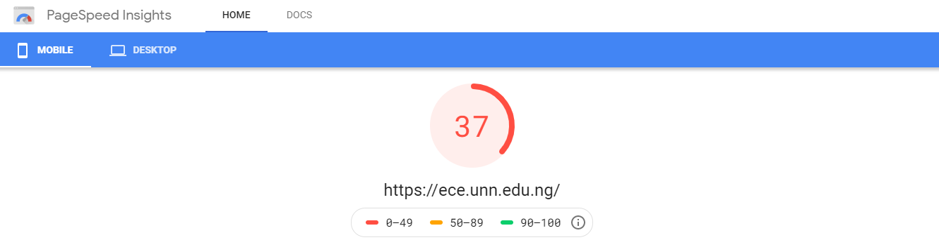

*Figure 4.1 Page speed insights website shows the lab data [18]*

Here are the suggestions for improvements on the website.

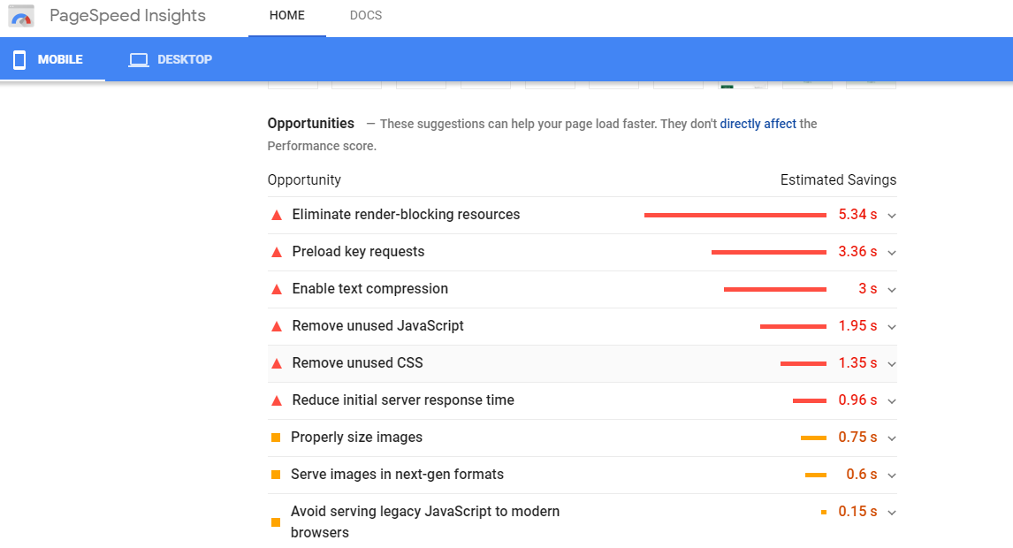

*Figure 4.2 Page speed insights website shows the mobile view of the website ration* [25]

**Desktop View**

The page speed for the page is 73%.

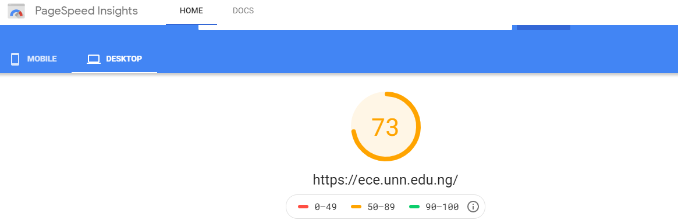

*Figure 4.3 Page speed insights website shows the desktop view of the website rating [25]*

Here are the suggestions for improvements on the website.

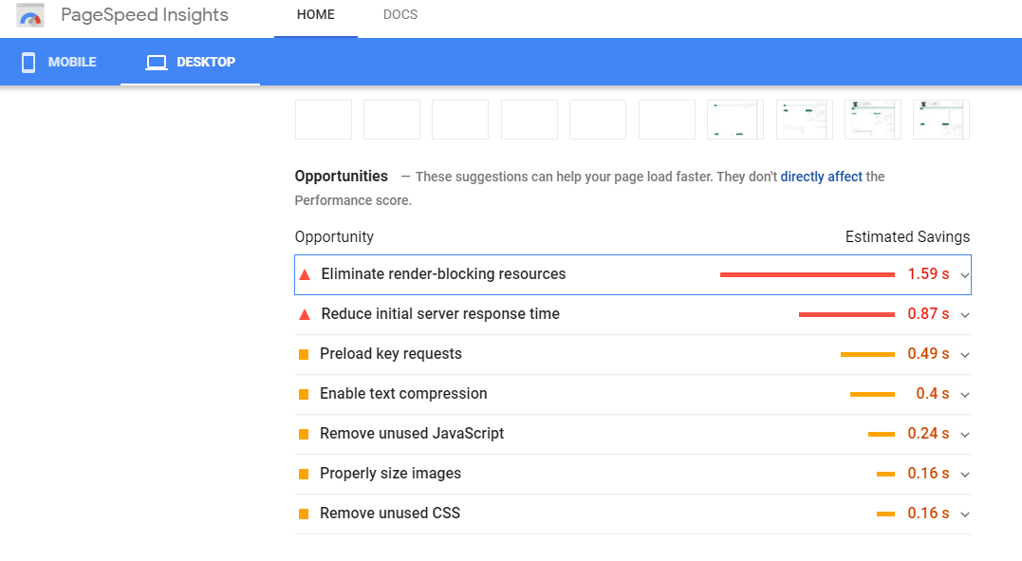

*Figure 4.4 Page speed insights website shows the desktop view of the website rating [25]*

**CHAPTER FIVE**

**RECOMMENDATION AND CONCLUSION**

**5.1 CONCLUSION**

The departmental website was able to achieve stability, smooth functionality, reliability, maintainability, scalability and security. This website can stipulate the departmental growth and overall development. It provides accurate information always and helps easy access to all years of gathered information which has been saved on the website. The data stored helps in taking intelligent decisions by the management. Therefore, it is concluded that studies on the departmental website should be continuous and at intervals maintained and receive feedback from users by the managers of the website with a view to meeting up with user requirements for more effective use and service. It may not be wise to initiate a website without taking into consideration user’s perceptions, requirements, needs and challenges, all of which will contribute to the overall goal of the department to enhance learning and disseminate accurate information.

**5.2 RECOMMENDATION**

Upon the completion of this project and based on my findings, I hereby recommend the following

The website should be made to accommodate additional features for the users.

The general functionality of the website should be improved upon such as areas of giving the staff access to update their accurate profile on the website under the supervision of the ICT representative of the department.

There should be a student's section where they can access lecture materials, videos, submit assignments, also a feedback section and similar features, this alone will ensure constant visit of the site amongst other reasons.

**REFERENCES**

[1] Giovanni, F. & Rosella, CA Web-Based Instruction System to support

design activities in Architecture, Paper presented to AusWeb 99, Fifth Australian

World Wide Web Conference. .1999.

[2] Computer Hope, “Website”. <https://www.computerhope.com/jargon/w/website.htm> 2020

[3] Scott D’Ambra, “What is the Purpose of a Website?” ClearTech Interactive <https://www.cleart.com/what-is-the-purpose-of-a-website.html>

[4] S.R.Bharamagoudar, Geeta R.B., S.G.Totad, et al, “Web Based Student Information Management System”. International Journal of Advanced Research in Computer and Communication Engineering Vol. 2, June 2013.

[5] Codeconquest, “Introduction to Web Design” <https://www.codeconquest.com/what-is-coding/web-design/> 2020

[6] MDN contributors, “What is the difference between webpage, website, web server, and search engine?” 2019

[7] John December, “Implementation” [https://www.december.com/web/develop/implement.html 2019](https://www.december.com/web/develop/implement.html%202019)

[8] Jacob Seidelin (Copenhagen), “HTML5 Games Creating fun with, HTML 5, CSS 3 and webGL, First Edition. 2012.

[9] Expert. “Different Types of Website Design ” [https://expert.services/blog/managing-your-website/custom-website-trends/responsive-design](https://expert.services/blog/managing-your-website/custom-website-trends/responsive-design%20)  [.2018](https://expert.services/blog/managing-your-website/custom-website-trends/responsive-design%20%20.2018)

[10] Jatinder Manhas. “Web Engineering: A Multidisciplinary Field for Web Development”.[https://www.researchgate.net/publication/274070633 2013](https://www.researchgate.net/publication/274070633%202013)

[11] Zhi-gang YUE, You-wei JIN, “The development and design of the student management system based on the network environment” International Conference on Multimedia Communications, 978-0-7695- 4136-5/10 2010 IEEE. 2010

[12] TANG Yu-fang,ZHANG Yong-sheng, ,“Design and implementation of college student information management system based on the web services”. Natural Science Foundation of Shandong Province(Y2008G22), 978-1-4244-3930-0/09 2009 IEEE.

[13] M.A. Norasiah and A. Norhayati. “Intelligent student information system”. 4th International conference on telecommunication technology proceedings, Shah Alam, Malaysia, 0-7803-7773-7/03 2003 IEEE.

[14] Tiffany B. Brown, “Jump start HTML 5 Basic”, IOS press. ISBN 978-9922794-8-6 (eBook). 2013

[15] Benjamin LaGrone. “HTML and CSS Responsive Webdesign cookbook”. Production Reference: 1160513, ISBN 978-184969-544-2. 2013

[16] “History of PHP and related project”. The PHP Group. Retrieved 2008.

[17] Janet Valade PHP and MYSQL for Dummies” (2ND Edition). [Online]. 29(5). Available: http://[www.dummies.com/register. 2012](http://www.dummies.com/register.%202012).

[18] “PageSpeed Insights,” *Google*. [Online]. Available: https://developers.google.com/speed/pagespeed/insights/. [Accessed: 19-May-2019].

[19] “UTSC Homepage,” *Computer and Mathematical Sciences*. [Online]. Available: https://www.utsc.utoronto.ca/cms/. [Accessed: 19-May-2019].

[20] *Electrical and Computer Engineering*. [Online]. Available: https://mcgill.ca/ece/. [Accessed: 19-Apr-2019].

[21] “UNDERGRADUATE PROGRAMS,” *Department of Electrical and Computer Engineering*. [Online]. Available: http://www.ece.ubc.ca/. [Accessed: 19-May-2019].

[22] “Home,” *Electrical and Electronics Engineering*. [Online]. Available: http://eee.covenantuniversity.edu.ng/. [Accessed: 19-Apr-2019].

[23] “Home,” *Dept. of Electrical Engineering*, 06-Jan-2021. [Online]. Available: https://electrical.unn.edu.ng/. [Accessed: 19-May-2021].

[24] Samphina Academy, “Universities Offering Electrical / Electronics Engineering,” *Samphina Academy*, 02-Jun-2021. [Online]. Available: https://samphina.com.ng/universities-offering-electrical-electronics-engineering-nigeria/. [Accessed: 19-Jul-2021].

[25] “PageSpeed Insights,” *Google*. [Online]. Available: https://developers.google.com/speed/pagespeed/insights/?url=https%3A%2F%2Fece.unn.edu.ng%2F&tab=mobile. [Accessed: 19-Apr-2019].

[26] “Engineering Science,” *University of Oxford*. [Online]. Available: http://www.ox.ac.uk/admissions/undergraduate/courses-listing/engineering-science. [Accessed: 19-May-2019].

**APPENDIX**

**HOMEPAGE…**

<!DOCTYPE html>

<html class="html js-focus-visible" lang="en-US" data-js-focus-visible=""><head> <script type="text/javascript">if(!gform){document.addEventListener("gform_main_scripts_loaded",function(){gform.scriptsLoaded=!0}),window.addEventListener("DOMContentLoaded",function(){gform.domLoaded=!0});var gform={domLoaded:!1,scriptsLoaded:!1,initializeOnLoaded:function(o){gform.domLoaded&&gform.scriptsLoaded?o():!gform.domLoaded&&gform.scriptsLoaded?window.addEventListener("DOMContentLoaded",o):document.addEventListener("gform_main_scripts_loaded",o)},hooks:{action:{},filter:{}},addAction:function(o,n,r,t){gform.addHook("action",o,n,r,t)},addFilter:function(o,n,r,t){gform.addHook("filter",o,n,r,t)},doAction:function(o){gform.doHook("action",o,arguments)},applyFilters:function(o){return gform.doHook("filter",o,arguments)},removeAction:function(o,n){gform.removeHook("action",o,n)},removeFilter:function(o,n,r){gform.removeHook("filter",o,n,r)},addHook:function(o,n,r,t,i){null==gform.hooks[o][n]&&(gform.hooks[o][n]=[]);var e=gform.hooks[o][n];null==i&&(i=n+"_"+e.length),null==t&&(t=10),gform.hooks[o][n].push({tag:i,callable:r,priority:t})},doHook:function(o,n,r){if(r=Array.prototype.slice.call(r,1),null!=gform.hooks[o][n]){var t,i=gform.hooks[o][n];i.sort(function(o,n){return o.priority-n.priority});for(var e=0;e<i.length;e++)"function"!=typeof(t=i[e].callable)&&(t=window[t]),"action"==o?t.apply(null,r):r[0]=t.apply(null,r)}if("filter"==o)return r[0]},removeHook:function(o,n,r,t){if(null!=gform.hooks[o][n])for(var i=gform.hooks[o][n],e=i.length-1;0<=e;e--)null!=t&&t!=i[e].tag||null!=r&&r!=i[e].priority||i.splice(e,1)}}}</script>

<meta charset="UTF-8">

<link rel="profile" href="https://gmpg.org/xfn/11">

<meta name="viewport" content="width=device-width, initial-scale=1">

<!-- This site is optimized with the Yoast SEO plugin v15.5 - https://yoast.com/wordpress/plugins/seo/ -->

**TITLE…**

<title>Home - Dept of Electronics Engineering</title>

<meta name="robots" content="index, follow, max-snippet:-1, max-image-preview:large, max-video-preview:-1">

<link rel="canonical" href="https://electronics.unn.edu.ng/">

<meta property="og:locale" content="en_US">

<meta property="og:type" content="website">

<meta property="og:title" content="Home - Dept of Electronics Engineering">

<meta property="og:description" content="BRIEF HISTORY The Department of Electronic Engineering was created in 1981 by splitting the existing department of Electrical/Electronic Engineering into two distinct departments. The creation of the two departments had the approval of the NUC. The department of Electronic Engineering was created to harness the explosion of knowledge in the field of electronics to satisfy […]">

<meta property="og:url" content="http://electronics.unn.edu.ng/">

<meta property="og:site_name" content="Dept of Electronics Engineering">

<meta property="article:modified_time" content="2021-01-06T12:59:08+00:00">

<meta name="twitter:card" content="summary_large_image">

<meta name="twitter:label1" content="Est. reading time">

<meta name="twitter:data1" content="3 minutes">

<script type="application/ld+json" class="yoast-schema-graph">{"@context":"https://schema.org","@graph":[{"@type":"WebSite","@id":"https://electronics.unn.edu.ng/#website","url":"https://electronics.unn.edu.ng/","name":"Dept of Electronics Engineering","description":"Just another University Of Nigeria Nsukka Sites site","potentialAction":[{"@type":"SearchAction","target":"https://electronics.unn.edu.ng/?s={search_term_string}","query-input":"required name=search_term_string"}],"inLanguage":"en-US"},{"@type":"WebPage","@id":"http://electronics.unn.edu.ng/#webpage","url":"http://electronics.unn.edu.ng/","name":"Home - Dept of Electronics Engineering","isPartOf":{"@id":"https://electronics.unn.edu.ng/#website"},"datePublished":"2018-03-12T14:42:06+00:00","dateModified":"2021-01-06T12:59:08+00:00","inLanguage":"en-US","potentialAction":[{"@type":"ReadAction","target":["http://electronics.unn.edu.ng/"]}]}]}</script>

<!-- / Yoast SEO plugin. -->

<link rel="dns-prefetch" href="//s.w.org">

<link rel="alternate" type="application/rss+xml" title="Dept of Electronics Engineering » Feed" href="https://electronics.unn.edu.ng/feed/">

<link rel="alternate" type="application/rss+xml" title="Dept of Electronics Engineering » Comments Feed" href="https://electronics.unn.edu.ng/comments/feed/">

<script type="text/javascript">

window._wpemojiSettings = {"baseUrl":"https:\/\/s.w.org\/images\/core\/emoji\/13.0.1\/72x72\/","ext":".png","svgUrl":"https:\/\/s.w.org\/images\/core\/emoji\/13.0.1\/svg\/","svgExt":".svg","source":{"concatemoji":"https:\/\/electronics.unn.edu.ng\/wp-includes\/js\/wp-emoji-release.min.js?ver=ffe78d6bfc0e4b943ea88a12227b3404"}};

!function(e,a,t){var r,n,o,i,p=a.createElement("canvas"),s=p.getContext&&p.getContext("2d");function c(e,t){var a=String.fromCharCode;s.clearRect(0,0,p.width,p.height),s.fillText(a.apply(this,e),0,0);var r=p.toDataURL();return s.clearRect(0,0,p.width,p.height),s.fillText(a.apply(this,t),0,0),r===p.toDataURL()}function l(e){if(!s||!s.fillText)return!1;switch(s.textBaseline="top",s.font="600 32px Arial",e){case"flag":return!c([127987,65039,8205,9895,65039],[127987,65039,8203,9895,65039])&&(!c([55356,56826,55356,56819],[55356,56826,8203,55356,56819])&&!c([55356,57332,56128,56423,56128,56418,56128,56421,56128,56430,56128,56423,56128,56447],[55356,57332,8203,56128,56423,8203,56128,56418,8203,56128,56421,8203,56128,56430,8203,56128,56423,8203,56128,56447]));case"emoji":return!c([55357,56424,8205,55356,57212],[55357,56424,8203,55356,57212])}return!1}function d(e){var t=a.createElement("script");t.src=e,t.defer=t.type="text/javascript",a.getElementsByTagName("head")[0].appendChild(t)}for(i=Array("flag","emoji"),t.supports={everything:!0,everythingExceptFlag:!0},o=0;o<i.length;o++)t.supports[i[o]]=l(i[o]),t.supports.everything=t.supports.everything&&t.supports[i[o]],"flag"!==i[o]&&(t.supports.everythingExceptFlag=t.supports.everythingExceptFlag&&t.supports[i[o]]);t.supports.everythingExceptFlag=t.supports.everythingExceptFlag&&!t.supports.flag,t.DOMReady=!1,t.readyCallback=function(){t.DOMReady=!0},t.supports.everything||(n=function(){t.readyCallback()},a.addEventListener?(a.addEventListener("DOMContentLoaded",n,!1),e.addEventListener("load",n,!1)):(e.attachEvent("onload",n),a.attachEvent("onreadystatechange",function(){"complete"===a.readyState&&t.readyCallback()})),(r=t.source||{}).concatemoji?d(r.concatemoji):r.wpemoji&&r.twemoji&&(d(r.twemoji),d(r.wpemoji)))}(window,document,window._wpemojiSettings);

</script><script src="https://electronics.unn.edu.ng/wp-includes/js/wp-emoji-release.min.js?ver=ffe78d6bfc0e4b943ea88a12227b3404" type="text/javascript" defer=""></script>

<style type="text/css">

img.wp-smiley,

img.emoji {

display: inline !important;

border: none !important;

box-shadow: none !important;

height: 1em !important;

width: 1em !important;

margin: 0 .07em !important;

vertical-align: -0.1em !important;

background: none !important;

padding: 0 !important;

}

</style>

<link rel="stylesheet" id="ekit-mini-cart-css" href="https://electronics.unn.edu.ng/wp-content/plugins/elementskit/widgets/woo-mini-cart/assets/css/mini-cart.css?ver=1.5.2" type="text/css" media="all">

<link rel="stylesheet" id="neat_slider_style-css" href="https://electronics.unn.edu.ng/wp-content/plugins/neat-slider/css/slider-style.css?ver=ffe78d6bfc0e4b943ea88a12227b3404" type="text/css" media="all">

<link rel="stylesheet" id="main_css-css" href="https://electronics.unn.edu.ng/wp-content/plugins/newstastic-post-slider/css/front.css?ver=ffe78d6bfc0e4b943ea88a12227b3404" type="text/css" media="all">

<link rel="stylesheet" id="join_css-css" href="https://electronics.unn.edu.ng/wp-content/plugins/newstastic-post-slider/css/join.css?ver=ffe78d6bfc0e4b943ea88a12227b3404" type="text/css" media="all">

<link rel="stylesheet" id="elementor-frontend-legacy-css" href="https://electronics.unn.edu.ng/wp-content/plugins/elementor/assets/css/frontend-legacy.min.css?ver=3.0.13" type="text/css" media="all">

<link rel="stylesheet" id="elementor-frontend-css" href="https://electronics.unn.edu.ng/wp-content/plugins/elementor/assets/css/frontend.min.css?ver=3.0.13" type="text/css" media="all">

<link rel="stylesheet" id="elementor-post-110-css" href="https://electronics.unn.edu.ng/wp-content/uploads/sites/143/elementor/css/post-110.css?ver=1609937366" type="text/css" media="all">

<link rel="stylesheet" id="pfc-style-css" href="https://electronics.unn.edu.ng/wp-content/plugins/posts-from-category/assets/pfc-style.css?ver=ffe78d6bfc0e4b943ea88a12227b3404" type="text/css" media="all">

<link rel="stylesheet" id="wp-block-library-css" href="https://electronics.unn.edu.ng/wp-includes/css/dist/block-library/style.min.css?ver=ffe78d6bfc0e4b943ea88a12227b3404" type="text/css" media="all">

<link rel="stylesheet" id="wp-block-library-theme-css" href="https://electronics.unn.edu.ng/wp-includes/css/dist/block-library/theme.min.css?ver=ffe78d6bfc0e4b943ea88a12227b3404" type="text/css" media="all">

<link rel="stylesheet" id="menu-image-css" href="https://electronics.unn.edu.ng/wp-content/plugins/menu-image/includes/css/menu-image.css?ver=3.0.1" type="text/css" media="all">

<link rel="stylesheet" id="page-list-style-css" href="https://electronics.unn.edu.ng/wp-content/plugins/sitemap/css/page-list.css?ver=4.3" type="text/css" media="all">

<link rel="stylesheet" id="spl-styles-css" href="https://electronics.unn.edu.ng/wp-content/plugins/socail-profile-linking/includes/css/spl-styles.css?ver=1.0" type="text/css" media="all">

<link rel="stylesheet" id="wpnw-public-style-css" href="https://electronics.unn.edu.ng/wp-content/plugins/wp-news-and-widget-pro/assets/css/wpnw-pro-public.min.css?ver=2.2" type="text/css" media="all">

<link rel="stylesheet" id="wpos-slick-style-css" href="https://electronics.unn.edu.ng/wp-content/plugins/wp-news-and-widget-pro/assets/css/slick.css?ver=2.2" type="text/css" media="all">

<link rel="stylesheet" id="wppsac-public-style-css" href="https://electronics.unn.edu.ng/wp-content/plugins/wp-responsive-recent-post-slider/assets/css/recent-post-style.css?ver=2.5.1" type="text/css" media="all">

<link rel="stylesheet" id="font-awesome-css" href="https://electronics.unn.edu.ng/wp-content/themes/oceanwp/assets/fonts/fontawesome/css/all.min.css?ver=5.15.1" type="text/css" media="all">

<link rel="stylesheet" id="simple-line-icons-css" href="https://electronics.unn.edu.ng/wp-content/themes/oceanwp/assets/css/third/simple-line-icons.min.css?ver=2.4.0" type="text/css" media="all">

<link rel="stylesheet" id="magnific-popup-css" href="https://electronics.unn.edu.ng/wp-content/themes/oceanwp/assets/css/third/magnific-popup.min.css?ver=1.0.0" type="text/css" media="all">

<link rel="stylesheet" id="slick-css" href="https://electronics.unn.edu.ng/wp-content/themes/oceanwp/assets/css/third/slick.min.css?ver=1.6.0" type="text/css" media="all">

<link rel="stylesheet" id="oceanwp-style-css" href="https://electronics.unn.edu.ng/wp-content/themes/oceanwp/assets/css/style.min.css?ver=2.0.2" type="text/css" media="all">

<link rel="stylesheet" id="elementskit-framework-css-frontend-css" href="https://electronics.unn.edu.ng/wp-content/plugins/elementskit/libs/framework/assets/css/frontend-style.min.css?ver=1.5.2" type="text/css" media="all">

<link rel="stylesheet" id="elementskit-parallax-style-css" href="https://electronics.unn.edu.ng/wp-content/plugins/elementskit/modules/parallax/assets/css/style.css?ver=1.5.2" type="text/css" media="all">

<link rel="stylesheet" id="tablepress-default-css" href="https://electronics.unn.edu.ng/wp-content/plugins/tablepress/css/default.min.css?ver=1.12" type="text/css" media="all">

<link rel="stylesheet" id="elementor-icons-css" href="https://electronics.unn.edu.ng/wp-content/plugins/elementor/assets/lib/eicons/css/elementor-icons.min.css?ver=5.9.1" type="text/css" media="all">

<link rel="stylesheet" id="elementor-animations-css" href="https://electronics.unn.edu.ng/wp-content/plugins/elementor/assets/lib/animations/animations.min.css?ver=3.0.13" type="text/css" media="all">

<link rel="stylesheet" id="elementor-post-108-css" href="https://electronics.unn.edu.ng/wp-content/uploads/sites/143/elementor/css/post-108.css?ver=1608348896" type="text/css" media="all">

<link rel="stylesheet" id="elementor-pro-css" href="https://electronics.unn.edu.ng/wp-content/plugins/elementor-pro/assets/css/frontend.min.css?ver=2.10.3" type="text/css" media="all">

<link rel="stylesheet" id="elementskit-css-widgetarea-control-editor-css" href="https://electronics.unn.edu.ng/wp-content/plugins/elementskit/modules/controls/assets/css/widgetarea-editor.css?ver=1.5.2" type="text/css" media="all">

<link rel="stylesheet" id="elementor-global-css" href="https://electronics.unn.edu.ng/wp-content/uploads/sites/143/elementor/css/global.css?ver=1608348897" type="text/css" media="all">

<link rel="stylesheet" id="elementor-post-48-css" href="https://electronics.unn.edu.ng/wp-content/uploads/sites/143/elementor/css/post-48.css?ver=1609937988" type="text/css" media="all">

<link rel="stylesheet" id="boosted-elements-progression-frontend-styles-css" href="https://electronics.unn.edu.ng/wp-content/plugins/boosted-elements-progression/assets/css/frontend.min.css?ver=ffe78d6bfc0e4b943ea88a12227b3404" type="text/css" media="all">

<link rel="stylesheet" id="boosted-elements-progression-prettyphoto-optional-css" href="https://electronics.unn.edu.ng/wp-content/plugins/boosted-elements-progression/assets/css/prettyphoto.min.css?ver=ffe78d6bfc0e4b943ea88a12227b3404" type="text/css" media="all">

<link rel="stylesheet" id="elementskit-vendors-css" href="https://electronics.unn.edu.ng/wp-content/plugins/elementskit/widgets/init/assets/css/vendors.css?ver=1.5.2" type="text/css" media="all">

<link rel="stylesheet" id="elementskit-style-css" href="https://electronics.unn.edu.ng/wp-content/plugins/elementskit/widgets/init/assets/css/style.css?ver=1.5.2" type="text/css" media="all">

<link rel="stylesheet" id="elementskit-responsive-css" href="https://electronics.unn.edu.ng/wp-content/plugins/elementskit/widgets/init/assets/css/responsive.css?ver=1.5.2" type="text/css" media="all">

<link rel="stylesheet" id="google-fonts-1-css" href="https://fonts.googleapis.com/css?family=Roboto%3A100%2C100italic%2C200%2C200italic%2C300%2C300italic%2C400%2C400italic%2C500%2C500italic%2C600%2C600italic%2C700%2C700italic%2C800%2C800italic%2C900%2C900italic%7CRoboto+Slab%3A100%2C100italic%2C200%2C200italic%2C300%2C300italic%2C400%2C400italic%2C500%2C500italic%2C600%2C600italic%2C700%2C700italic%2C800%2C800italic%2C900%2C900italic&amp;ver=ffe78d6bfc0e4b943ea88a12227b3404" type="text/css" media="all">

<script type="text/javascript" src="https://electronics.unn.edu.ng/wp-includes/js/jquery/jquery.min.js?ver=3.5.1" id="jquery-core-js"></script>

<script type="text/javascript" src="https://electronics.unn.edu.ng/wp-includes/js/jquery/jquery-migrate.min.js?ver=3.3.2" id="jquery-migrate-js"></script>

<script type="text/javascript" src="https://electronics.unn.edu.ng/wp-content/plugins/newstastic-post-slider/js/scroller.js?ver=1.0" id="j_tools_js-js"></script>

<script type="text/javascript" src="https://electronics.unn.edu.ng/wp-content/plugins/newstastic-post-slider/js/front.js?ver=1.0" id="main_js-js"></script>

<script type="text/javascript" src="https://electronics.unn.edu.ng/wp-content/plugins/posts-from-category/assets/pfc-custom.js?ver=4.0.1" id="pfc-custom-js"></script>

<script type="text/javascript" src="https://electronics.unn.edu.ng/wp-content/plugins/elementskit/modules/parallax/assets/js/jarallax.js?ver=1.5.2" id="jarallax-js"></script>

<link rel="https://api.w.org/" href="https://electronics.unn.edu.ng/wp-json/"><link rel="alternate" type="application/json" href="https://electronics.unn.edu.ng/wp-json/wp/v2/pages/48"><link rel="EditURI" type="application/rsd+xml" title="RSD" href="https://electronics.unn.edu.ng/xmlrpc.php?rsd">

<link rel="wlwmanifest" type="application/wlwmanifest+xml" href="https://electronics.unn.edu.ng/wp-includes/wlwmanifest.xml">

<link rel="shortlink" href="https://electronics.unn.edu.ng/">

<link rel="alternate" type="application/json+oembed" href="https://electronics.unn.edu.ng/wp-json/oembed/1.0/embed?url=https%3A%2F%2Felectronics.unn.edu.ng%2F">

<link rel="alternate" type="text/xml+oembed" href="https://electronics.unn.edu.ng/wp-json/oembed/1.0/embed?url=https%3A%2F%2Felectronics.unn.edu.ng%2F&amp;format=xml">

<script type="text/javascript">

var elementskit_module_parallax_url = "https://electronics.unn.edu.ng/wp-content/plugins/elementskit/modules/parallax/"

</script>

<style type="text/css">.recentcomments a{display:inline !important;padding:0 !important;margin:0 !important;}</style><link rel="icon" href="https://electronics.unn.edu.ng/wp-content/uploads/sites/143/2018/04/cropped-UNN-logo1-1-32x32.png" sizes="32x32">

<link rel="icon" href="https://electronics.unn.edu.ng/wp-content/uploads/sites/143/2018/04/cropped-UNN-logo1-1-192x192.png" sizes="192x192">

<link rel="apple-touch-icon" href="https://electronics.unn.edu.ng/wp-content/uploads/sites/143/2018/04/cropped-UNN-logo1-1-180x180.png">

<meta name="msapplication-TileImage" content="https://electronics.unn.edu.ng/wp-content/uploads/sites/143/2018/04/cropped-UNN-logo1-1-270x270.png">

<!-- OceanWP CSS -->

<style type="text/css">

/* General CSS */a:hover,a.light:hover,.theme-heading .text::before,.theme-heading .text::after,#top-bar-content >a:hover,#top-bar-social li.oceanwp-email a:hover,#site-navigation-wrap .dropdown-menu >li >a:hover,#site-header.medium-header #medium-searchform button:hover,.oceanwp-mobile-menu-icon a:hover,.blog-entry.post .blog-entry-header .entry-title a:hover,.blog-entry.post .blog-entry-readmore a:hover,.blog-entry.thumbnail-entry .blog-entry-category a,ul.meta li a:hover,.dropcap,.single nav.post-navigation .nav-links .title,body .related-post-title a:hover,body #wp-calendar caption,body .contact-info-widget.default i,body .contact-info-widget.big-icons i,body .custom-links-widget .oceanwp-custom-links li a:hover,body .custom-links-widget .oceanwp-custom-links li a:hover:before,body .posts-thumbnails-widget li a:hover,body .social-widget li.oceanwp-email a:hover,.comment-author .comment-meta .comment-reply-link,#respond #cancel-comment-reply-link:hover,#footer-widgets .footer-box a:hover,#footer-bottom a:hover,#footer-bottom #footer-bottom-menu a:hover,.sidr a:hover,.sidr-class-dropdown-toggle:hover,.sidr-class-menu-item-has-children.active >a,.sidr-class-menu-item-has-children.active >a >.sidr-class-dropdown-toggle,input[type=checkbox]:checked:before{color:#096c3a}input[type="button"],input[type="reset"],input[type="submit"],button[type="submit"],.button,#site-navigation-wrap .dropdown-menu >li.btn >a >span,.thumbnail:hover i,.post-quote-content,.omw-modal .omw-close-modal,body .contact-info-widget.big-icons li:hover i,body div.wpforms-container-full .wpforms-form input[type=submit],body div.wpforms-container-full .wpforms-form button[type=submit],body div.wpforms-container-full .wpforms-form .wpforms-page-button{background-color:#096c3a}.widget-title{border-color:#096c3a}blockquote{border-color:#096c3a}#searchform-dropdown{border-color:#096c3a}.dropdown-menu .sub-menu{border-color:#096c3a}.blog-entry.large-entry .blog-entry-readmore a:hover{border-color:#096c3a}.oceanwp-newsletter-form-wrap input[type="email"]:focus{border-color:#096c3a}.social-widget li.oceanwp-email a:hover{border-color:#096c3a}#respond #cancel-comment-reply-link:hover{border-color:#096c3a}body .contact-info-widget.big-icons li:hover i{border-color:#096c3a}#footer-widgets .oceanwp-newsletter-form-wrap input[type="email"]:focus{border-color:#096c3a}input[type="button"]:hover,input[type="reset"]:hover,input[type="submit"]:hover,button[type="submit"]:hover,input[type="button"]:focus,input[type="reset"]:focus,input[type="submit"]:focus,button[type="submit"]:focus,.button:hover,#site-navigation-wrap .dropdown-menu >li.btn >a:hover >span,.post-quote-author,.omw-modal .omw-close-modal:hover,body div.wpforms-container-full .wpforms-form input[type=submit]:hover,body div.wpforms-container-full .wpforms-form button[type=submit]:hover,body div.wpforms-container-full .wpforms-form .wpforms-page-button:hover{background-color:#096c3a}#scroll-top{background-color:#096c3a}#scroll-top:hover{background-color:#096c3a}/* Header CSS */#site-header.has-header-media .overlay-header-media{background-color:rgba(0,0,0,0.5)}#site-logo #site-logo-inner a img,#site-header.center-header #site-navigation-wrap .middle-site-logo a img{max-width:500px}

</style><style type="text/css">/* Chart.js */

@-webkit-keyframes chartjs-render-animation{from{opacity:0.99}to{opacity:1}}@keyframes chartjs-render-animation{from{opacity:0.99}to{opacity:1}}.chartjs-render-monitor{-webkit-animation:chartjs-render-animation 0.001s;animation:chartjs-render-animation 0.001s;}</style><style id="fit-vids-style">.fluid-width-video-wrapper{width:100%;position:relative;padding:0;}.fluid-width-video-wrapper iframe,.fluid-width-video-wrapper object,.fluid-width-video-wrapper embed {position:absolute;top:0;left:0;width:100%;height:100%;}</style></head>

BODY…

<body class="home page-template page-template-elementor_header_footer page page-id-48 wp-custom-logo wp-embed-responsive oceanwp-theme dropdown-mobile default-breakpoint content-full-width content-max-width page-header-disabled has-breadcrumbs elementor-default elementor-template-full-width elementor-kit-108 elementor-page elementor-page-48" itemscope="itemscope" itemtype="https://schema.org/WebPage" data-elementor-device-mode="mobile">

<div id="outer-wrap" class="site clr">

<a class="skip-link screen-reader-text" href="#main">Skip to content</a>

<div id="wrap" class="clr">

<header id="site-header" class="minimal-header clr" data-height="74" itemscope="itemscope" itemtype="https://schema.org/WPHeader" role="banner">

<div id="site-header-inner" class="clr container">

<div id="site-logo" class="clr" itemscope="" itemtype="https://schema.org/Brand">

<div id="site-logo-inner" class="clr">

<a href="https://electronics.unn.edu.ng/" class="custom-logo-link" rel="home" aria-current="page"><img width="891" height="131" src="https://electronics.unn.edu.ng/wp-content/uploads/sites/143/2018/03/cropped-electronics-1.png" class="custom-logo" alt="Dept of Electronics Engineering" srcset="https://electronics.unn.edu.ng/wp-content/uploads/sites/143/2018/03/cropped-electronics-1.png 891w, https://electronics.unn.edu.ng/wp-content/uploads/sites/143/2018/03/cropped-electronics-1-300x44.png 300w, https://electronics.unn.edu.ng/wp-content/uploads/sites/143/2018/03/cropped-electronics-1-768x113.png 768w, https://electronics.unn.edu.ng/wp-content/uploads/sites/143/2018/03/cropped-electronics-1-24x4.png 24w, https://electronics.unn.edu.ng/wp-content/uploads/sites/143/2018/03/cropped-electronics-1-36x5.png 36w, https://electronics.unn.edu.ng/wp-content/uploads/sites/143/2018/03/cropped-electronics-1-48x7.png 48w, https://electronics.unn.edu.ng/wp-content/uploads/sites/143/2018/03/cropped-electronics-1-400x59.png 400w" sizes="(max-width: 891px) 100vw, 891px"></a>

</div><!-- #site-logo-inner -->

</div><!-- #site-logo -->

<div id="site-navigation-wrap" class="clr">

<nav id="site-navigation" class="navigation main-navigation clr" itemscope="itemscope" itemtype="https://schema.org/SiteNavigationElement" role="navigation">

<ul id="menu-main-menu" class="main-menu dropdown-menu sf-menu sf-js-enabled" style="touch-action: pan-y;"><li id="menu-item-50" class="menu-item menu-item-type-post_type menu-item-object-page menu-item-home current-menu-item page_item page-item-48 current_page_item menu-item-has-children dropdown menu-item-50"><a href="https://electronics.unn.edu.ng/" class="menu-link sf-with-ul"><span class="text-wrap">Home <span class="nav-arrow fa fa-angle-down"></span></span></a>

<ul class="sub-menu" style="display: none;">

<li id="menu-item-52" class="menu-item menu-item-type-post_type menu-item-object-page menu-item-52"><a href="https://electronics.unn.edu.ng/about-us/" class="menu-link"><span class="text-wrap">About Us</span></a></li></ul>

</li><li id="menu-item-53" class="menu-item menu-item-type-post_type menu-item-object-page menu-item-53"><a href="https://electronics.unn.edu.ng/admission-requirement/" class="menu-link"><span class="text-wrap">Admission Requirement</span></a></li><li id="menu-item-61" class="menu-item menu-item-type-post_type menu-item-object-page menu-item-has-children dropdown menu-item-61"><a href="https://electronics.unn.edu.ng/programmes/" class="menu-link sf-with-ul"><span class="text-wrap">Programmes <span class="nav-arrow fa fa-angle-down"></span></span></a>

<ul class="sub-menu" style="display: none;">

<li id="menu-item-106" class="menu-item menu-item-type-post_type menu-item-object-page menu-item-106"><a href="https://electronics.unn.edu.ng/postgraduate-degree-programmes/" class="menu-link"><span class="text-wrap">POSTGRADUATE DEGREE PROGRAMMES</span></a></li></ul>

</li><li id="menu-item-54" class="menu-item menu-item-type-post_type menu-item-object-page menu-item-54"><a href="https://electronics.unn.edu.ng/course-modules/" class="menu-link"><span class="text-wrap">Course Modules</span></a></li><li id="menu-item-55" class="menu-item menu-item-type-post_type menu-item-object-page menu-item-has-children dropdown menu-item-55"><a href="https://electronics.unn.edu.ng/staff/" class="menu-link sf-with-ul"><span class="text-wrap">Staff <span class="nav-arrow fa fa-angle-down"></span></span></a>

<ul class="sub-menu" style="display: none;">

<li id="menu-item-89" class="menu-item menu-item-type-custom menu-item-object-custom menu-item-89"><a href="http://www.unn.edu.ng/internals/staff/deptshow/ELETROENG" class="menu-link"><span class="text-wrap">Staff Profile</span></a></li></ul>

</li><li id="menu-item-84" class="menu-item menu-item-type-custom menu-item-object-custom menu-item-84"><a href="http://electronics.unn.edu.ng/?p=82" class="menu-link"><span class="text-wrap">Alumni</span></a></li><li id="menu-item-87" class="menu-item menu-item-type-custom menu-item-object-custom menu-item-87"><a href="http://electronics.unn.edu.ng/?p=85" class="menu-link"><span class="text-wrap">Journals</span></a></li><li id="menu-item-58" class="menu-item menu-item-type-post_type menu-item-object-page menu-item-58"><a href="https://electronics.unn.edu.ng/external-resources/" class="menu-link"><span class="text-wrap">External Resources</span></a></li><li id="menu-item-59" class="menu-item menu-item-type-post_type menu-item-object-page menu-item-59"><a href="https://electronics.unn.edu.ng/contact-us/" class="menu-link"><span class="text-wrap">Contact Us</span></a></li><li class="search-toggle-li"><a href="javascript:void(0)" class="site-search-toggle search-dropdown-toggle" aria-label="Search website"><span class="icon-magnifier" aria-hidden="true"></span></a></li></ul>

<div id="searchform-dropdown" class="header-searchform-wrap clr">

<form role="search" method="get" class="searchform" action="https://electronics.unn.edu.ng/">

<label for="ocean-search-form-1">

<span class="screen-reader-text">Search for:</span>

<input type="search" id="ocean-search-form-1" class="field" autocomplete="off" placeholder="Search" name="s">

</label>

</form>

</div><!-- #searchform-dropdown -->

</nav><!-- #site-navigation -->

</div><!-- #site-navigation-wrap -->

<div class="oceanwp-mobile-menu-icon clr mobile-right">

<a href="javascript:void(0)" class="mobile-menu" aria-label="Mobile Menu">

<i class="fa fa-bars" aria-hidden="true"></i>

<span class="oceanwp-text">Menu</span>

<span class="oceanwp-close-text">Close</span>

</a>

</div><!-- #oceanwp-mobile-menu-navbar -->

</div><!-- #site-header-inner -->

<div id="mobile-dropdown" class="clr">

<nav class="clr" itemscope="itemscope" itemtype="https://schema.org/SiteNavigationElement">

<ul id="menu-main-menu-1" class="menu"><li class="menu-item menu-item-type-post_type menu-item-object-page menu-item-home current-menu-item page_item page-item-48 current_page_item menu-item-has-children menu-item-50"><a href="https://electronics.unn.edu.ng/" aria-current="page">Home<span class="dropdown-toggle"></span></a>

<ul class="sub-menu">

<li class="menu-item menu-item-type-post_type menu-item-object-page menu-item-52"><a href="https://electronics.unn.edu.ng/about-us/">About Us</a></li>

</ul>

</li>

<li class="menu-item menu-item-type-post_type menu-item-object-page menu-item-53"><a href="https://electronics.unn.edu.ng/admission-requirement/">Admission Requirement</a></li>

<li class="menu-item menu-item-type-post_type menu-item-object-page menu-item-has-children menu-item-61"><a href="https://electronics.unn.edu.ng/programmes/">Programmes<span class="dropdown-toggle"></span></a>

<ul class="sub-menu">

<li class="menu-item menu-item-type-post_type menu-item-object-page menu-item-106"><a href="https://electronics.unn.edu.ng/postgraduate-degree-programmes/">POSTGRADUATE DEGREE PROGRAMMES</a></li>

</ul>

</li>

<li class="menu-item menu-item-type-post_type menu-item-object-page menu-item-54"><a href="https://electronics.unn.edu.ng/course-modules/">Course Modules</a></li>

<li class="menu-item menu-item-type-post_type menu-item-object-page menu-item-has-children menu-item-55"><a href="https://electronics.unn.edu.ng/staff/">Staff<span class="dropdown-toggle"></span></a>

<ul class="sub-menu">

<li class="menu-item menu-item-type-custom menu-item-object-custom menu-item-89"><a href="http://www.unn.edu.ng/internals/staff/deptshow/ELETROENG">Staff Profile</a></li>

</ul>

</li>

<li class="menu-item menu-item-type-custom menu-item-object-custom menu-item-84"><a href="http://electronics.unn.edu.ng/?p=82">Alumni</a></li>

<li class="menu-item menu-item-type-custom menu-item-object-custom menu-item-87"><a href="http://electronics.unn.edu.ng/?p=85">Journals</a></li>

<li class="menu-item menu-item-type-post_type menu-item-object-page menu-item-58"><a href="https://electronics.unn.edu.ng/external-resources/">External Resources</a></li>

<li class="menu-item menu-item-type-post_type menu-item-object-page menu-item-59"><a href="https://electronics.unn.edu.ng/contact-us/">Contact Us</a></li>

<li class="search-toggle-li"><a href="javascript:void(0)" class="site-search-toggle search-dropdown-toggle" aria-label="Search website"><span class="icon-magnifier" aria-hidden="true"></span></a></li></ul>

<div id="mobile-menu-search" class="clr">

<form method="get" action="https://electronics.unn.edu.ng/" class="mobile-searchform" role="search" aria-label="Search for:">

<label for="ocean-mobile-search2">

<input type="search" name="s" autocomplete="off" placeholder="Search">

<button type="submit" class="searchform-submit" aria-label="Submit search">

<i class="icon-magnifier" aria-hidden="true"></i>

</button>

</label>

</form>

</div><!-- .mobile-menu-search -->

</nav>

</div>

</header><!-- #site-header -->

<main id="main" class="site-main clr" role="main">

<div data-elementor-type="wp-page" data-elementor-id="48" class="elementor elementor-48" data-elementor-settings="[]">

<div class="elementor-inner">

<div class="elementor-section-wrap">

<section class="elementor-section elementor-top-section elementor-element elementor-element-1d4a9e79 elementor-section-full_width elementor-section-height-min-height elementor-section-height-default elementor-section-items-middle elementskit-parallax-multi-container" data-id="1d4a9e79" data-element_type="section" data-settings="{&quot;ekit_has_onepagescroll_dot&quot;:&quot;yes&quot;}">

<div class="elementor-background-overlay"></div>

<div class="elementor-container elementor-column-gap-no">

<div class="elementor-row">

<div class="elementor-column elementor-col-100 elementor-top-column elementor-element elementor-element-13182083" data-id="13182083" data-element_type="column">

<div class="elementor-column-wrap elementor-element-populated">

<div class="elementor-widget-wrap">

<div class="elementor-element elementor-element-29911ac9 elementor-widget elementor-widget-boosted-elements-slider" data-id="29911ac9" data-element_type="widget" data-settings="{&quot;ekit_we_effect_on&quot;:&quot;none&quot;}" data-widget_type="boosted-elements-slider.default">

<div class="elementor-widget-container">

<div class="boosted-elements-slider-loader-height"> <div class="boosted-elements-progression-slider-container boosted-no-delay-animate boosted_elements_slider_arrow_visiblity_hover boosted_elements_slider_dots_visiblity_visible">

<div id="boosted-elements-progression-flexslider-29911ac9" class="boosted-elements-slider-main">

<ul class="boosted-elements-slides">

<li class="elementor-repeater-item-2193ec7 bosted_animate_in" data-thumb-alt="" style="width: 100%; float: left; margin-right: -100%; position: relative; opacity: 0; display: block; z-index: 1;">

<div class="boosted-elements-slider-background">

<div class="boosted-elements-slider-display-table">

<div class="boosted-elements-slider-content-container">

<div class="boosted-elements-slider-container-fixed-optional">

<div class="boosted-elements-slider-content">

<div class="bosted-element-content-margin">

<div class="clearfix-boosted-element"></div>

</div><!-- close .bosted-element-content-margin -->

</div><!-- close .boosted-elements-slider-content -->

</div><!-- close .boosted-elements-slider-container-fixed-optional -->

</div><!-- close .boosted-elements-slider-content-container -->

<div class="boosted-elements-slider-gradient-overlay"></div>

</div>

</div><!-- close .boosted-elements-slider-background -->

</li>

<li class="elementor-repeater-item-d70c84f bosted_animate_in boosted-elements-slider-active-slide" data-thumb-alt="" style="width: 100%; float: left; margin-right: -100%; position: relative; opacity: 1; display: block; z-index: 2;">

<div class="boosted-elements-slider-background">

<div class="boosted-elements-slider-display-table">

<div class="boosted-elements-slider-content-container">

<div class="boosted-elements-slider-container-fixed-optional">

<div class="boosted-elements-slider-content">

<div class="bosted-element-content-margin">

<div class="clearfix-boosted-element"></div>

</div><!-- close .bosted-element-content-margin -->

</div><!-- close .boosted-elements-slider-content -->

</div><!-- close .boosted-elements-slider-container-fixed-optional -->

</div><!-- close .boosted-elements-slider-content-container -->

<div class="boosted-elements-slider-gradient-overlay"></div>

</div>

</div><!-- close .boosted-elements-slider-background -->

</li>

</ul>

<ol class="boosted-elements-slider-control-nav boosted-elements-slider-control-paging"><li><a href="#" class="">1</a></li><li><a href="#" class="boosted-elements-slider-active">2</a></li></ol><ul class="boosted-elements-slider-direction-nav"><li class="boosted-elements-slider-nav-prev"><a class="boosted-elements-slider-prev" href="#"></a></li><li class="boosted-elements-slider-nav-next"><a class="boosted-elements-slider-next" href="#"></a></li></ul></div><!-- #boosted-elements-progression-flexslider-29911ac9 -->

</div><!-- close .boosted-elements-progression-slider-container -->

</div><!-- close .boosted-elements-slider-loader-height --> <div class="clearfix-boosted-element"></div>

<script type="text/javascript">

jQuery(document).ready(function($) {

'use strict';

$('#boosted-elements-progression-flexslider-29911ac9').flexslider({

namespace: "boosted-elements-slider-",

selector: ".boosted-elements-slides > li",

prevText: "",

touch: true,

nextText: "",

slideshow:true,

slideshowSpeed: 7000,

animation: "fade",

animationSpeed: 500,

pauseOnHover: true,

});

$("#boosted-elements-progression-flexslider-29911ac9 a.boosted-elements-slider-lightbox[data-rel^='prettyPhoto']").prettyPhoto({

theme: 'pp_default',

hook: 'data-rel',

opacity: 0.7,

show_title: false,

deeplinking: false,

overlay_gallery: false,

custom_markup: '',

default_width: 900,

default_height: 506,

social_tools: ''

});

});

</script>

</div>

</div>

</div>

</div>

</div>

</div>

</div>

</section>

<section class="elementor-section elementor-top-section elementor-element elementor-element-17f70c77 elementor-section-boxed elementor-section-height-default elementor-section-height-default elementskit-parallax-multi-container" data-id="17f70c77" data-element_type="section" data-settings="{&quot;ekit_has_onepagescroll_dot&quot;:&quot;yes&quot;}">

<div class="elementor-container elementor-column-gap-default">

<div class="elementor-row">

<div class="elementor-column elementor-col-100 elementor-top-column elementor-element elementor-element-69ce9c8a" data-id="69ce9c8a" data-element_type="column">

<div class="elementor-column-wrap elementor-element-populated">

<div class="elementor-widget-wrap">

<div class="elementor-element elementor-element-21084151 elementor-widget elementor-widget-text-editor" data-id="21084151" data-element_type="widget" data-settings="{&quot;ekit_we_effect_on&quot;:&quot;none&quot;}" data-widget_type="text-editor.default">

<div class="elementor-widget-container">

BRIEF HISTORY… <div class="elementor-text-editor elementor-

clearfix"><strong>BRIEF HISTORY</strong>

The Department of Electronic Engineering was created in 1981 by splitting the existing department of Electrical/Electronic Engineering into two distinct departments. The creation of the two departments had the approval of the NUC. The department of Electronic Engineering was created to harness the explosion of knowledge in the field of electronics to satisfy deep national needs for skilled engineers in the vital areas of telecommunication, control, instrumentation, digital and computer engineering.

The department produced the first batch of graduates in 1985. In 1984 the department started postgraduate (PG) programme for M. Eng. and Ph.D. Degrees aimed at producing specialists for industry and universities. The PG programme was intended to foster collaborative researches between the department, other related departments in other universities and industries locally and internationally. As the oldest department of Electronic Engineering in Nigeria, the department has always been keenly aware of its leadership role in spreading awareness of the importance of Electronic Engineering in the industrial development of the nation. In 1985, it organized a highly successful national workshop on microprocessors. And in 1989, it organized an international conference on developing countries and the new information age.

The Department’s vigorous strive for academic and professional excellence for both its students and staff culminated into a number of teaching and research collaborations with other national and international institutions.

<ol>

<li>There is collaboration with the Digital Bridge Institute (DBI), Abuja at national level. DBI is an International Centre for Professional Training in Telecommunications and ICT. It was established in 2004 by the National Communications Commission (NCC). This collaboration involves bilateral/multilateral training and research linkages with both national and multinational telecom and ICT industries. Through this, UNN-DBI Training– To–Placement Programme was designed to bridge the gap between the prevailing academic curricula of our national universities and the manpower needs of the emerging telecommunication and information technology industries in the country.</li>

<li>The international linkage of the department includes teaching, research and exchange collaborations with the Delft University of Technology (TU Delft) in the Netherlands. The University of Nigeria, Nsukka signed an MOU with Delft University of Technology on behalf of the Department of Electronic Engineering and other departments (Physics, Computer Science, Electrical Engineering) of the university to establish a Centre of Excellence in Microsystems and Nanoelectronics at UNN. Currently, two of our academic staff are in TU Delft on exchange programme. Two years ago, the UNN received two TU Delft students on the same programme.</li>

<li>At the International and national levels, the University and consequently the department formed collaborations under NetTel@Africa – an international postgraduate programme in ICT Policy and Regulations. The programme was basically a transnational network for capacity building and knowledge sharing in the information and communication technologies (ICT) and telecommunications (telecoms) policy, regulation and applications. The collaboration was with three other National Universities (UNILAG, OAU, UNIJOS) and nineteen international universities (twelve in Africa, two in Europe and five in North Africa). The network included, some international ICT Regulatory Organizations/Authorities in Africa (TRASA, ARICEA, WATRA AND EARPTO), and America, USA (NARUC, FCC), and some international Resource/Donor Organizations (CTO, ITU, SIDA, CATIA, DFID, GSA, USAID)</li>

</ol>

The department has recorded many significant milestones. Since its inception in 1981, the Department has produced the highest number of first class graduates than any other departments in the university. It has also produced many overall best graduating students more than any department in the university; it has produced overall university bests for three consecutive academic sessions in 1995/1996, 1996/1997 and 1997/1998. The 1996/1997 university best, Osita Onuma, in 1998/1999 produced best ever recorded result (aggregate of 98.85 on a 100-point scale – 98.85%) in the 124 year-history of taught postgraduate programme at Imperial College and the entire University of London. The department earned two national designations (honours) as a Centre of Excellence in Electronics and in Information and Communication Technology (ICT) in 1986 and 2001 an Education Trust Fund (ETF) Center Of Excellence in ICT and Telecommunication Networks.</div>

</div>

</div>

</div>

</div>

</div>

</div>

</div>

</section>

</div>

</div>

</div>

</main><!-- #main -->

<div class="ekit-template-content-markup ekit-template-content-footer"><style>.elementor-110 .elementor-element.elementor-element-26ea9c29:not(.elementor-motion-effects-element-type-background), .elementor-110 .elementor-element.elementor-element-26ea9c29 > .elementor-motion-effects-container > .elementor-motion-effects-layer{background-color:#096C3A;}.elementor-110 .elementor-element.elementor-element-26ea9c29{transition:background 0.3s, border 0.3s, border-radius 0.3s, box-shadow 0.3s;overflow:visible;}.elementor-110 .elementor-element.elementor-element-26ea9c29 > .elementor-background-overlay{transition:background 0.3s, border-radius 0.3s, opacity 0.3s;}.elementor-110 .elementor-element.elementor-element-1496aec4 .elementor-text-editor{text-align:right;}.elementor-110 .elementor-element.elementor-element-1496aec4{color:#FFFFFF;}.elementor-110 .elementor-element.elementor-element-1496aec4 > .elementor-widget-container{margin:20px 0px 0px 0px;}</style> <div data-elementor-type="wp-post" data-elementor-id="110" class="elementor elementor-110" data-elementor-settings="[]">

<div class="elementor-inner">

<div class="elementor-section-wrap">

<section class="elementor-section elementor-top-section elementor-element elementor-element-26ea9c29 elementor-section-boxed elementor-section-height-default elementor-section-height-default elementskit-parallax-multi-container" data-id="26ea9c29" data-element_type="section" data-settings="{&quot;background_background&quot;:&quot;classic&quot;,&quot;ekit_has_onepagescroll_dot&quot;:&quot;yes&quot;}">

<div class="elementor-container elementor-column-gap-default">

<div class="elementor-row">

<div class="elementor-column elementor-col-50 elementor-top-column elementor-element elementor-element-3b33e0a5" data-id="3b33e0a5" data-element_type="column">

<div class="elementor-column-wrap elementor-element-populated">

<div class="elementor-widget-wrap">

<div class="elementor-element elementor-element-1b24c68f elementor-widget elementor-widget-image" data-id="1b24c68f" data-element_type="widget" data-settings="{&quot;ekit_we_effect_on&quot;:&quot;none&quot;}" data-widget_type="image.default">

<div class="elementor-widget-container">

<div class="elementor-image">

<img width="300" height="90" src="https://electronics.unn.edu.ng/wp-content/uploads/sites/143/2021/01/unn-logo.png" class="attachment-medium size-medium" alt="" loading="lazy" srcset="https://electronics.unn.edu.ng/wp-content/uploads/sites/143/2021/01/unn-logo.png 300w, https://electronics.unn.edu.ng/wp-content/uploads/sites/143/2021/01/unn-logo-24x7.png 24w, https://electronics.unn.edu.ng/wp-content/uploads/sites/143/2021/01/unn-logo-36x11.png 36w, https://electronics.unn.edu.ng/wp-content/uploads/sites/143/2021/01/unn-logo-48x14.png 48w" sizes="(max-width: 300px) 100vw, 300px"> </div>

</div>

</div>

</div>

</div>

</div>

<div class="elementor-column elementor-col-50 elementor-top-column elementor-element elementor-element-653577ad" data-id="653577ad" data-element_type="column">

<div class="elementor-column-wrap elementor-element-populated">

<div class="elementor-widget-wrap">

<div class="elementor-element elementor-element-1496aec4 elementor-widget elementor-widget-text-editor" data-id="1496aec4" data-element_type="widget" data-settings="{&quot;ekit_we_effect_on&quot;:&quot;none&quot;}" data-widget_type="text-editor.default">

<div class="elementor-widget-container">

<div class="elementor-text-editor elementor-clearfix"><p>© 2020 University of Nigeria&nbsp; Powered by Tenece</p></div>

</div>

</div>

</div>

</div>

</div>

</div>

</div>

</section>

</div>

</div>

</div>

</div>

</div><!-- #wrap -->

</div><!-- #outer-wrap -->

<a id="scroll-top" class="scroll-top-right" href="#" style="display: none;"><span class="fa fa-angle-up" aria-label="Scroll to the top of the page"></span></a>

<link rel="stylesheet" id="elementor-icons-shared-0-css" href="https://electronics.unn.edu.ng/wp-content/plugins/elementor/assets/lib/font-awesome/css/fontawesome.min.css?ver=5.12.0" type="text/css" media="all">

<link rel="stylesheet" id="elementor-icons-fa-solid-css" href="https://electronics.unn.edu.ng/wp-content/plugins/elementor/assets/lib/font-awesome/css/solid.min.css?ver=5.12.0" type="text/css" media="all">

<script type="text/javascript" id="mail-chimp-script-js-extra">

/* <![CDATA[ */

var ekit_site_url = {"siteurl":"http:\/\/electronics.unn.edu.ng"};

/* ]]> */

</script>

<script type="text/javascript" src="https://electronics.unn.edu.ng/wp-content/plugins/elementskit/widgets/mail-chimp/assets/js/mail-chimp.js?ver=1.0" id="mail-chimp-script-js"></script>

<script type="text/javascript" src="https://electronics.unn.edu.ng/wp-content/plugins/elementskit/widgets/chart/assets/js/chart.js?ver=ffe78d6bfc0e4b943ea88a12227b3404" id="chart-kit-js-js"></script>

<script type="text/javascript" src="https://electronics.unn.edu.ng/wp-content/plugins/neat-slider/js/jquery.fractionslider.min.js?ver=ffe78d6bfc0e4b943ea88a12227b3404" id="slider-js-js"></script>

<script type="text/javascript" src="https://electronics.unn.edu.ng/wp-includes/js/imagesloaded.min.js?ver=4.1.4" id="imagesloaded-js"></script>

<script type="text/javascript" src="https://electronics.unn.edu.ng/wp-content/themes/oceanwp/assets/js/third/magnific-popup.min.js?ver=2.0.2" id="magnific-popup-js"></script>

<script type="text/javascript" src="https://electronics.unn.edu.ng/wp-content/themes/oceanwp/assets/js/third/lightbox.min.js?ver=2.0.2" id="oceanwp-lightbox-js"></script>

<script type="text/javascript" id="oceanwp-main-js-extra">

/* <![CDATA[ */

var oceanwpLocalize = {"isRTL":"","menuSearchStyle":"drop_down","sidrSource":null,"sidrDisplace":"1","sidrSide":"left","sidrDropdownTarget":"link","verticalHeaderTarget":"link","customSelects":".woocommerce-ordering .orderby, #dropdown_product_cat, .widget_categories select, .widget_archive select, .single-product .variations_form .variations select"};

/* ]]> */

</script>

<script type="text/javascript" src="https://electronics.unn.edu.ng/wp-content/themes/oceanwp/assets/js/main.min.js?ver=2.0.2" id="oceanwp-main-js"></script>

<script type="text/javascript" src="https://electronics.unn.edu.ng/wp-content/plugins/elementskit/libs/framework/assets/js/frontend-script.js?ver=1.5.2" id="elementskit-framework-js-frontend-js"></script>

<script type="text/javascript" id="elementskit-framework-js-frontend-js-after">

//console.log(window.elementskit);

var elementskit = {

resturl: 'https://electronics.unn.edu.ng/wp-json/elementskit/v1/',

}

//console.log(window.elementskit);

</script>

<script type="text/javascript" src="https://electronics.unn.edu.ng/wp-content/plugins/elementskit/widgets/init/assets/js/nav-menu.js?ver=ffe78d6bfc0e4b943ea88a12227b3404" id="ekit-nav-menu-js"></script>

<script type="text/javascript" src="https://electronics.unn.edu.ng/wp-content/plugins/elementskit/widgets/init/assets/js/ui-slim.min.js?ver=ffe78d6bfc0e4b943ea88a12227b3404" id="ekit-slim-ui-js"></script>

<script type="text/javascript" src="https://electronics.unn.edu.ng/wp-content/plugins/elementskit/modules/parallax/assets/js/TweenMax.min.js?ver=1.5.2" id="tweenmax-js"></script>

<script type="text/javascript" src="https://electronics.unn.edu.ng/wp-content/plugins/elementskit/modules/parallax/assets/js/jquery.easing.1.3.js?ver=1.5.2" id="jquery-easing-js"></script>

<script type="text/javascript" src="https://electronics.unn.edu.ng/wp-content/plugins/elementskit/widgets/init/assets/js/tilt.jquery.min.js?ver=ffe78d6bfc0e4b943ea88a12227b3404" id="tilt-js"></script>

<script type="text/javascript" src="https://electronics.unn.edu.ng/wp-content/plugins/elementskit/modules/parallax/assets/js/anime.js?ver=1.5.2" id="animejs-js"></script>

<script type="text/javascript" src="https://electronics.unn.edu.ng/wp-content/plugins/elementskit/modules/parallax/assets/js/magician.js?ver=1.5.2" id="magicianjs-js"></script>

<script type="text/javascript" src="https://electronics.unn.edu.ng/wp-includes/js/wp-embed.min.js?ver=ffe78d6bfc0e4b943ea88a12227b3404" id="wp-embed-js"></script>

<!--[if lt IE 9]>

<script type='text/javascript' src='https://electronics.unn.edu.ng/wp-content/themes/oceanwp/assets/js/third/html5.min.js?ver=2.0.2' id='html5shiv-js'></script>

<![endif]-->

<script type="text/javascript" src="https://electronics.unn.edu.ng/wp-content/plugins/boosted-elements-progression/assets/js/flexslider.js?ver=1.0" id="boosted_elements_progression_flexslider_js-js"></script>

<script type="text/javascript" src="https://electronics.unn.edu.ng/wp-content/plugins/boosted-elements-progression/assets/js/video-backgrounds.js?ver=1.0" id="boosted_elements_progression_video_background_js-js"></script>

<script type="text/javascript" src="https://electronics.unn.edu.ng/wp-content/plugins/boosted-elements-progression/assets/js/prettyPhoto.js?ver=1.0" id="boosted_elements_progression_prettyphoto_js-js"></script>

<script type="text/javascript" src="https://electronics.unn.edu.ng/wp-content/plugins/boosted-elements-progression/assets/js/jquery.matchHeight-min.js?ver=1.0" id="boosted_elements_progression_matchheight_js-js"></script>

<script type="text/javascript" src="https://electronics.unn.edu.ng/wp-content/plugins/elementor/assets/js/frontend-modules.min.js?ver=3.0.13" id="elementor-frontend-modules-js"></script>

<script type="text/javascript" src="https://electronics.unn.edu.ng/wp-content/plugins/elementor-pro/assets/lib/sticky/jquery.sticky.min.js?ver=2.10.3" id="elementor-sticky-js"></script>

<script type="text/javascript" id="elementor-pro-frontend-js-before">

var ElementorProFrontendConfig = {"ajaxurl":"https:\/\/electronics.unn.edu.ng\/wp-admin\/admin-ajax.php","nonce":"e655fb6eb8","i18n":{"toc_no_headings_found":"No headings were found on this page."},"shareButtonsNetworks":{"facebook":{"title":"Facebook","has_counter":true},"twitter":{"title":"Twitter"},"google":{"title":"Google+","has_counter":true},"linkedin":{"title":"LinkedIn","has_counter":true},"pinterest":{"title":"Pinterest","has_counter":true},"reddit":{"title":"Reddit","has_counter":true},"vk":{"title":"VK","has_counter":true},"odnoklassniki":{"title":"OK","has_counter":true},"tumblr":{"title":"Tumblr"},"delicious":{"title":"Delicious"},"digg":{"title":"Digg"},"skype":{"title":"Skype"},"stumbleupon":{"title":"StumbleUpon","has_counter":true},"mix":{"title":"Mix"},"telegram":{"title":"Telegram"},"pocket":{"title":"Pocket","has_counter":true},"xing":{"title":"XING","has_counter":true},"whatsapp":{"title":"WhatsApp"},"email":{"title":"Email"},"print":{"title":"Print"}},"facebook_sdk":{"lang":"en_US","app_id":""},"lottie":{"defaultAnimationUrl":"https:\/\/electronics.unn.edu.ng\/wp-content\/plugins\/elementor-pro\/modules\/lottie\/assets\/animations\/default.json"}};

</script>

<script type="text/javascript" src="https://electronics.unn.edu.ng/wp-content/plugins/elementor-pro/assets/js/frontend.min.js?ver=2.10.3" id="elementor-pro-frontend-js"></script>

<script type="text/javascript" src="https://electronics.unn.edu.ng/wp-includes/js/jquery/ui/core.min.js?ver=1.12.1" id="jquery-ui-core-js"></script>

<script type="text/javascript" src="https://electronics.unn.edu.ng/wp-content/plugins/elementor/assets/lib/dialog/dialog.min.js?ver=4.8.1" id="elementor-dialog-js"></script>

<script type="text/javascript" src="https://electronics.unn.edu.ng/wp-content/plugins/elementor/assets/lib/waypoints/waypoints.min.js?ver=4.0.2" id="elementor-waypoints-js"></script>

<script type="text/javascript" src="https://electronics.unn.edu.ng/wp-content/plugins/elementor/assets/lib/swiper/swiper.min.js?ver=5.3.6" id="swiper-js"></script>

<script type="text/javascript" src="https://electronics.unn.edu.ng/wp-content/plugins/elementor/assets/lib/share-link/share-link.min.js?ver=3.0.13" id="share-link-js"></script>

<script type="text/javascript" id="elementor-frontend-js-before">

var elementorFrontendConfig = {"environmentMode":{"edit":false,"wpPreview":false},"i18n":{"shareOnFacebook":"Share on Facebook","shareOnTwitter":"Share on Twitter","pinIt":"Pin it","download":"Download","downloadImage":"Download image","fullscreen":"Fullscreen","zoom":"Zoom","share":"Share","playVideo":"Play Video","previous":"Previous","next":"Next","close":"Close"},"is_rtl":false,"breakpoints":{"xs":0,"sm":480,"md":768,"lg":1025,"xl":1440,"xxl":1600},"version":"3.0.13","is_static":false,"legacyMode":{"elementWrappers":true},"urls":{"assets":"https:\/\/electronics.unn.edu.ng\/wp-content\/plugins\/elementor\/assets\/"},"settings":{"page":[],"editorPreferences":[]},"kit":{"global_image_lightbox":"yes","lightbox_enable_counter":"yes","lightbox_enable_fullscreen":"yes","lightbox_enable_zoom":"yes","lightbox_enable_share":"yes","lightbox_title_src":"title","lightbox_description_src":"description"},"post":{"id":48,"title":"Home%20-%20Dept%20of%20Electronics%20Engineering","excerpt":"","featuredImage":false}};

</script>

<script type="text/javascript" src="https://electronics.unn.edu.ng/wp-content/plugins/elementor/assets/js/frontend.min.js?ver=3.0.13" id="elementor-frontend-js"></script><span id="elementor-device-mode" class="elementor-screen-only"></span>

<script type="text/javascript" src="https://electronics.unn.edu.ng/wp-content/plugins/elementskit/widgets/init/assets/js/elementor.js?ver=1.5.2" id="elementskit-elementor-js"></script>

<script type="text/javascript" src="https://electronics.unn.edu.ng/wp-content/plugins/elementskit/modules/sticky-content/assets/js/jquery.sticky.js?ver=1.5.2" id="elementskit-sticky-content-script-js"></script>

<script type="text/javascript" src="https://electronics.unn.edu.ng/wp-content/plugins/elementskit/modules/sticky-content/assets/js/init.js?ver=1.5.2" id="elementskit-sticky-content-script-init-js"></script>

<script type="text/javascript" src="https://electronics.unn.edu.ng/wp-content/plugins/elementskit/modules/parallax/assets/js/widget-init.js?ver=1.5.2" id="elementskit-parallax-widget-init-js"></script>

<script type="text/javascript" src="https://electronics.unn.edu.ng/wp-content/plugins/elementskit/modules/parallax/assets/js/section-init.js?ver=1.5.2" id="elementskit-parallax-section-init-js"></script>

<script type="text/javascript" src="https://electronics.unn.edu.ng/wp-content/plugins/elementskit/modules/controls/assets/js/widgetarea-editor.js?ver=1.5.2" id="elementskit-js-widgetarea-control-editor-js"></script>

</body></html>