**MUSICAL INSTRUMENTS SHOP**

*Ece Yücesoy*

**ER DIAGRAM**

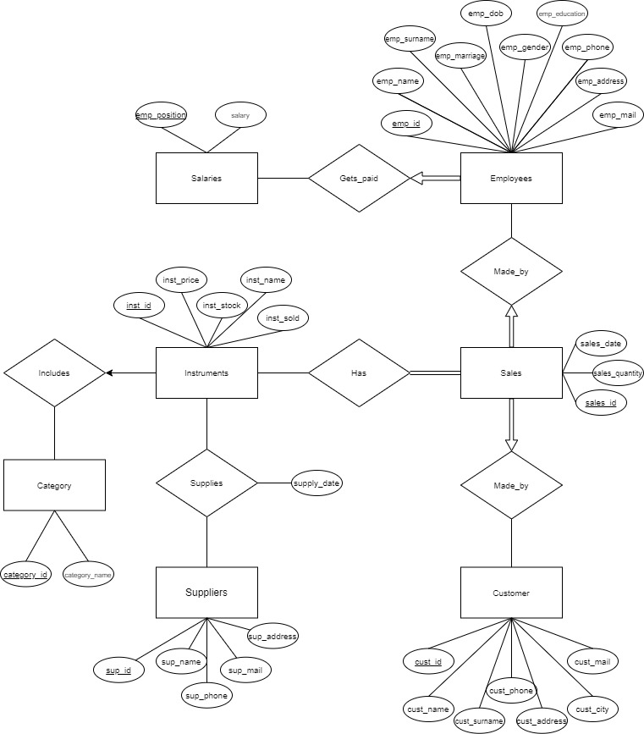

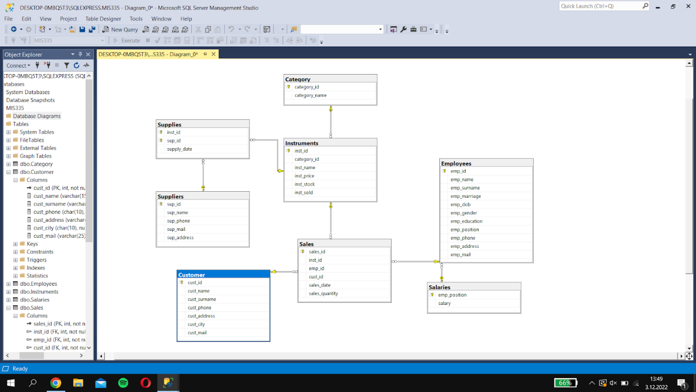

**RELATIONAL SCHEMA**

Salaries(emp_position, salary)

        P.K.

Employees (emp_id, emp_name, emp_surname, emp_marriage, emp_dob, emp_gender,

P.K.

emp_education, emp_position, emp_phone, emp_address, emp_mail)                                       F.K.

Suppliers(sup_id, sup_name, sup_phone, sup_mail, sup_address)

      P.K.

Customer(cust_id, cust_name, cust_surname, cust_phone, cust_address, cust_city, cust_mail)

      P.K.

Category(category_id, category_name)

P.K

Instruments(inst_id, category_id, inst_name, inst_price, inst_stock, inst_sold)

P.K F.K

Sales(sales_id, inst_id, emp_id, cust_id, sales_date, sales_quantity)

P.K   F.K        F.K     F.K.

Supplies(inst_id, sup_id, supply_date)

    F.K.      F.K.