**COVID Vaccinations Among 80+ Population**

Evan Chaffey

**Original Visualization:**

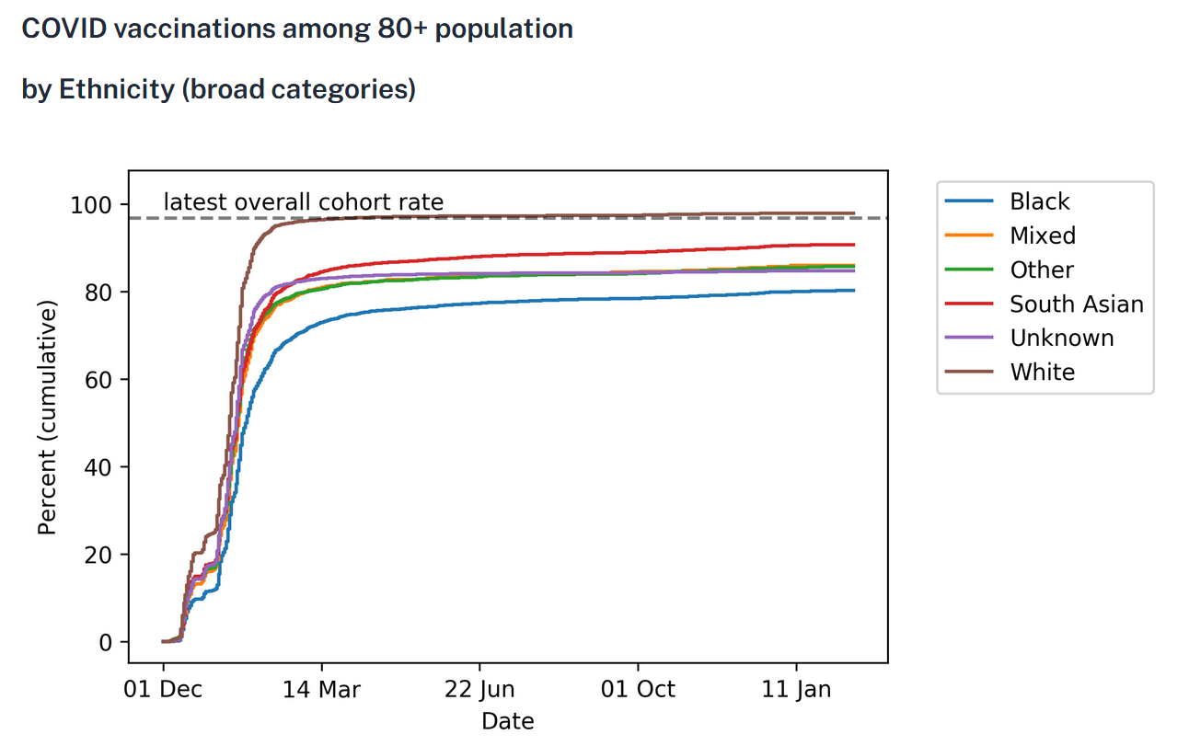

**Make Over:**

Its animated but the visualization and source code can be found here:

https://github.com/echaffey/BIO-230G-Visualizations/blob/main/1/src/visualization.gif

**Visualization data source:**

https://reports.opensafely.org/reports/vaccine-coverage/

**Original data source:**

Curtis, H. J., MacKenna, B., Croker, R., Inglesby, P., Walker, A. J., Morley, J., ... & Goldacre, B. (2022). OpenSAFELY NHS Service Restoration Observatory 1: primary care clinical activity in England during the first wave of COVID-19. *British Journal of General Practice*, *72*(714), e63-e74.

https://data.world/makeovermonday/2021w28

**How credible is the data source:**

The data was originally sourced from the British Journal of General Practice (BJGP) which is the leading journal in primary care research worldwide, according to the journal’s website [1]. The journal has a large editorial board consisting of experts in their respective fields as well as a larger international advisory board with representation from 30 different countries. Additionally, the BJGP has a 5-year running impact score of 5.666 which lends credence to this journal being highly reputable and credible.

The visualization was sourced from the OpenSAFELY platform which is a National Health Services of England project to help deliver research and information regarding the pandemic. Being sponsored and funded by a national British service like the NHS, OpenSAFELY can be regarded as credible due to the service’s interest in serving the public need.

**Target audience:**

The target audience for the original visualization was for academia and clinical use, as stated on the OpenSAFELY source page [2]. The visualization was displaying raw data in a chart that was useful to the targeted audience but lacklustre to any other populations. The makeover is more visually appealing, and as such will appeal to a more general audience that is looking for a more simple breakdown of the information.

**Appraisal of design and layout:**

The original visualization design was a very simple Python chart which just simply displayed the results of the vaccination raw data and identified the overall cohort rate. This chart was likely unintended to be used as an informative visualization for the general public as much as it was designed to just display the data cleanly to the targeted audience. As such, standard fonts, colors and layouts were all unchanged when this visualization was made.

The makeover visualization is more appealing to a wider audience by being animated and spreading out the data a bit. Being able to compare the different populations on a single chart is important to get the overall comparison between populations. The progress-style bars at the top, while displaying the same information, allow you to see the numerical values that may be harder to interpret from the plot. Additionally, the animation helps to make it readily apparent that this visualization represents data collected over a span of time. With many people in the general public having short attention spans, the animation helps reduce the amount of time needed to decipher what information is being displayed.

There is definitely need for improvement on the makeover but I feel that it displays the data accurately. If I were to continue on with this project, I may add breakpoints in the animation to point out areas of interest; dates of first availability for the first, second and booster vaccines, for example. I also have a bit too much whitespace for my liking so I could have added in another plot with a different view on the data or overlayed a light background image.

**Evaluation of impact:**

I wouldn’t say that the actual impact has changed much at all, as it currently now has a total reach of 3 people: myself, you and the nice woman on the plane next to me while I made it. However, it is more polished and ready for social media platforms than the original was which has the potential to increase the impact.

**References:**

1. https://bjgp.org/page/about
2. https://reports.opensafely.org/reports/vaccine-coverage/