**Global Annual Beer Consumption**

Evan Chaffey

**Original Visualization:**

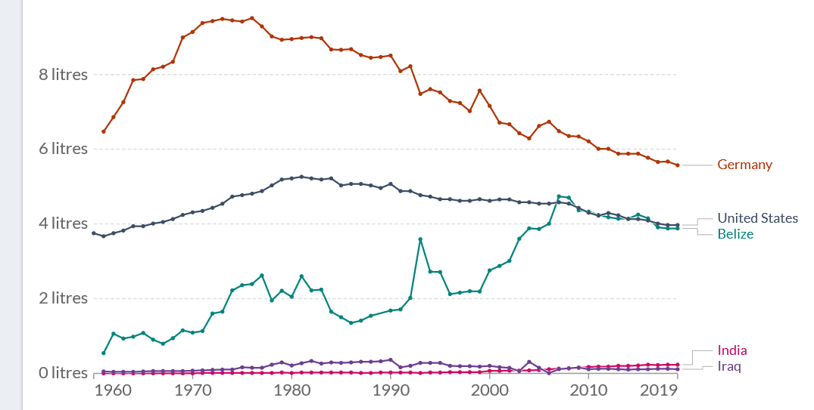

**Make Over:**

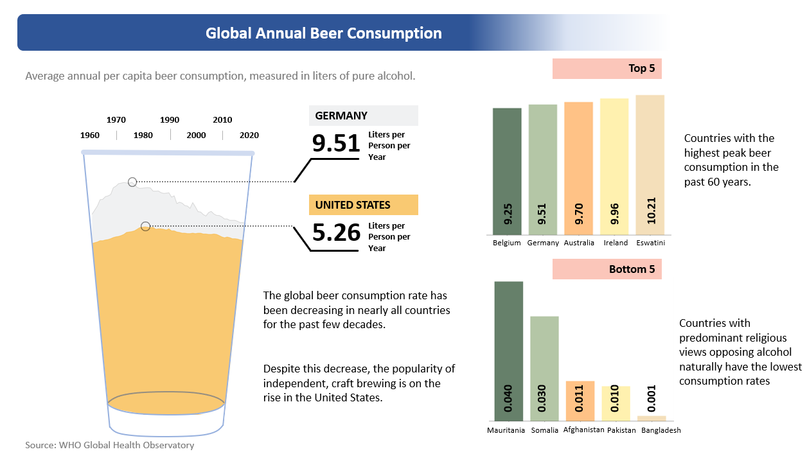

Files and source code found here:  
https://github.com/echaffey/BIO-230G-Visualizations/tree/main/2

**Visualization data source:**

https://ourworldindata.org/alcohol-consumption

**Original data source:**

World Health Organization. (n.d.). Alcohol, total per capita (15+) consumption (in litres of pure alcohol) (SDG indicator 3.5.2). World Health Organization. Retrieved March 30, 2022, from https://www.who.int/data/gho/data/indicators/indicator-details/GHO/total-(recorded-unrecorded)-alcohol-per-capita-(15-)-consumption

**How credible is the data source:**

The data was originally sourced from the World Health Organization’s (WHO) database on total global alcohol consumption. The WHO is a global scientific organization responsible for collecting, conducting and disseminating information to the world. Because of their extensive reach and regard with global countries, the WHO is considered to be highly credible.

**Target audience:**

The target audience for the original visualization was mainly for academia and clinical use. The visualization was displaying raw data in a chart that was useful to the targeted audience but lacklustre to any other populations. The makeover is more visually appealing, and as such will appeal to a more general audience that is looking for a simpler breakdown of the information.

**Appraisal of design and layout:**

The original visualization design was a minimally interactive javascript chart which just simply displayed the results of the beer consumption raw data and selectively displayed a handful of countries. This chart was likely unintended to be used as an informative visualization for the general public as much as it was designed to just display the data cleanly to the targeted audience.

The makeover visualization is more appealing to a wider audience with selectively choosing the highest and lowest consumption countries, comparing the US and Germany with an interesting visualization that plays into the theme of the data. Comparing the highest and lowest peak consumption countries provides an interesting perspective into the data and could allow for further research as to the causes. The data is also presented with minimal text to keep it clutter free. There is still room improvement on the makeover but I feel that it displays the data accurately.

**Evaluation of impact:**

I wouldn’t say that the actual impact has changed much at all from the original visualization but it is much more suited for sharing on social media. I’d imagine that it would garner at least a few more clicks than the original scatter plot as well.