**Which Generation Owns the Most Wealth?**

Evan Chaffey

**Original Visualization:**

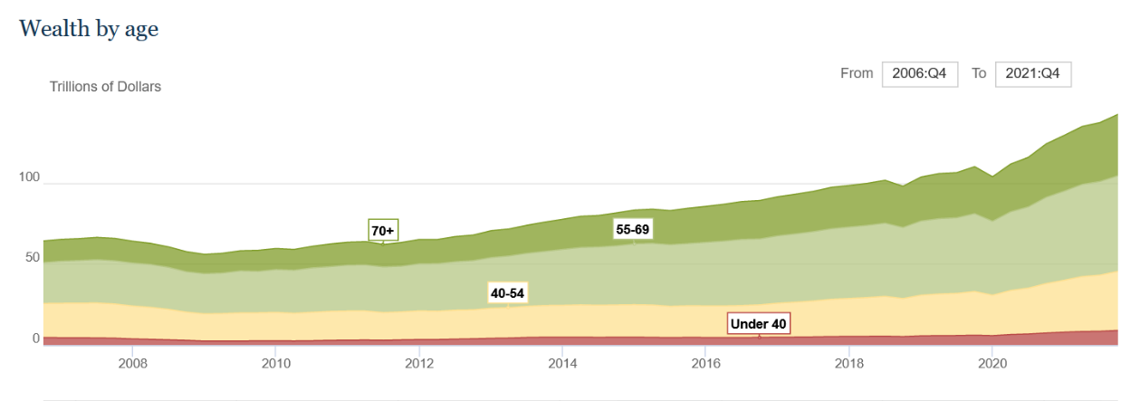

**Make Over:**

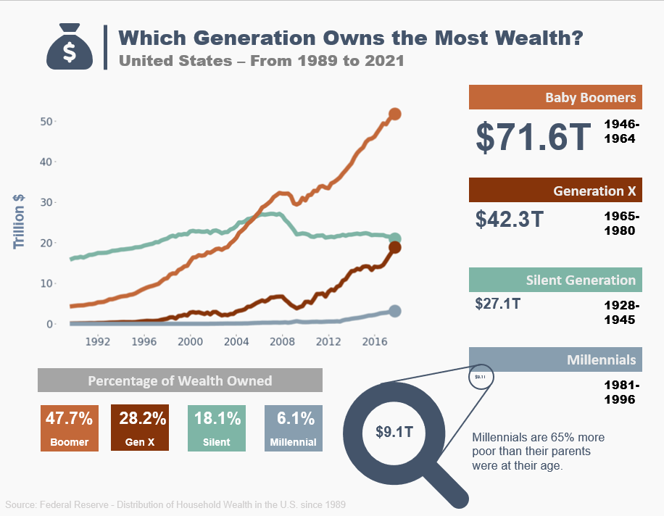

Files and source code found here:  
https://github.com/echaffey/BIO-230G-Visualizations/tree/main/3

**Visualization data source:**

https://www.federalreserve.gov/releases/z1/dataviz/dfa/distribute/chart/#quarter:129;series:Net%20worth;demographic:age;population:all;units:levels

**Original data source:**

Federal Reserve. (n.d.). *Board of governors of the Federal Reserve System*. The Fed -Distribution: Distribution of Household Wealth in the U.S. since 1989. Retrieved April 10, 2022, from https://www.federalreserve.gov/releases/z1/dataviz/dfa/distribute/chart

**How credible is the data source:**

The data was originally sourced from the Federal Reserve’s database on the distributional financial accounts of persons in the United States since 1989. The Fed is the central bank of the United States and is responsible for collecting, conducting and disseminating financial information to US citizens. Because of their status as a government agency, and access to financial data, the Fed is considered to be credible.

**Target audience:**

The target audience for the original visualization was for anyone looking for information about the subject. It is publicly available on the Fed’s website. It is a simply laid out and interactive chart which makes it easy to interpret. The visualization was displaying raw data in a chart that was useful to the targeted audience but lacking in visual appeal. The makeover is more eye catching and as such, will appeal to a more general audience that is looking for a simple breakdown of the information.

**Appraisal of design and layout:**

The original visualization design was a minimally interactive javascript chart which just simply displayed the varying levels of wealth in the US since 1989 and is filterable by many different sub-categories. This chart was likely unintended to be used as an informative visualization for the general public as much as it was designed to just display the data cleanly to the targeted audience.

The makeover visualization is more appealing to a wider audience by selectively choosing the key data points and using an animated visual to capture attention to the magnitude of the wealth gap. The colors are more appealing (in my opinion) than the original visualization which makes the likelihood of someone spending time to go through the content more likely. The data is also presented with minimal text to keep it clutter free. There is still room improvement on the makeover but I feel that it displays the data accurately.

**Evaluation of impact:**

I wouldn’t say that the actual impact has changed much at all from the original visualization but it is much more suited for sharing on social media. Its far more visually appealing and would (hopefully) grab a few more clicks if posted on publicly.