Download and Configure Cisco AnyConnect Secure Mobility Client for Interline Brands, Inc.

1. Download and install Cisco AnyConnect Secure Mobility Client from the Cisco website at <http://tinyurl.com/pzj8exo>.
2. Once installed this Icon  will appear in the system tray. This is on the lower right side of your screen next to where the time appears.
3. Click on the Icon and this window will pop up.

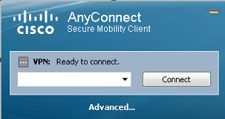

1. In the empty box enter one of the following addresses:

* jaxvpn.interlinebrands.net
* phlvpn.interlinebrands.net

1. Click the **Connect** button.
2. Once a connection has been made the following window will appear:

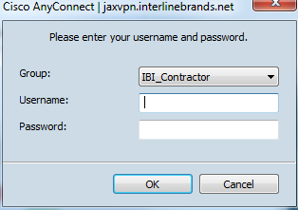

1. In the Group: field select IBI_Contractor.
2. Enter the User Name provided.
3. Enter the Password provided.
4. Once you have authenticated the window will drop down to the system tray and you are actively connected to the Interline Brands VPN Network.