Reproductive mechanisms underlying operation sex ratio variation in *Silene acaulis*

**Introduction**

* Mating system evolution
  + Gynodioecy vs hermaphroditism
    - Gynodioecious evolutionary trajectory
    - Cyto-nuclear system
      * Females must produce just as many or more seeds/offspring than hermaphrodites in a cyto-nuclear system.
    - Balancing selection allowing females to invade a population and stabilize at a particular sex ratio
* Maintenance of gynodioecy
  + Inbreeding depression
  + Pollen limitation
  + Superior seed production or seed provisioning
  + Shift toward greater male character in hermaphrodites
* Sex ratios
* Factors impacting sex ratios
  + Population structure
    - Isolation
  + Climate conditions
  + Accessibility to pollinators
* In this study, we explored the mechanisms maintaining the gynodioecious mating system in the alpine and arctic tundra species, *Silene acaulis*. We compared female and hermaphrodite plants through floral morphological traits, rates of pollination, and a controlled pollination field experiment at two populations that differed in the OSR. We sought to answer the question 1) what mechanisms determine the sex ratio in a population?
  + Pre-fertilization
    - How do floral traits differ?
    - How do floral traits and sex impact pollination?
    - How does sex ratio impact pollination?
  + Post-fertilization
    - How do females and hermaphrodites compare in resource allocation to seed and fruit production?
    - Are females and hermaphrodites pollen limited?
    - Does inbreeding affect fruit and seed production in hermaphrodites?
    - How does sex ratio impact seed and fruit production?

**Methods**

Study System

*Silene acaulis* is a long-lived, gynodioecious cushion plant. The squat alpine and arctic tundra species has a distribution that is almost circumpolar, occurring throughout North Americ, Europe, and Eastern Russia at high elevations and latitudes. Individual plants have a single taproot with a dense, elliptical cluster of leafy rosettes. *S. acaulis* only reproduces sexually with mature plants producing a few flowers on small plants to hundreds of flowers on the largest plants. The flowering duration of a plant can extend for a few weeks as the phenology of individual flowers can vary substantially. Females and hermaphrodites vary in their morphology and when the stigma is receptive. Hermaphrodites generally have larger flowers (Shykoff, 1992) and are protandrous, meaning that the anthers mature and dehisce prior to the stigma becoming receptive.

*Silene acaulis* plants that survive to the largest size class are estimated to live up to 338 years (Morris & Doak, 1998). However, few plants, approximately 1.8% of seedlings, survive to 300 years. On average, female and hermaphrodite plants reach reproductive maturity at around 20 and 30 years respectively. In Alaska, female plants are estimated to produce 4.4 times the number of seeds as hermaphrodites throughout their lifetime (Morris & Doak, 1998). Other studies at lower latitudes annual seed production is 2 to 3 times higher in females thant hermaphrodites (Hermanutz & Innes, 1994; Shykoff, 1988). Seed number per fruit do not differ between females and hermaphrodites (Delph et al., 1999), but females do reallocate resources from pollen production to produce more flowers and fruit on a plant (Delph et al., 1999; Shykoff, 1988; Shykoff et al., 2003). Females tend to have seeds with higher establishment rates than hermaphrodites (Shykoff, 1988). However, seed provisioning does not differ between females and hermaphrodites (Delph et al., 1999), and the seed quality is not fully explained by inbreeding depression in hermaphrodites (Shykoff, 1988). Others have hypothesized that the differences in seed establishment depend on the timing or quality of pollen receipt (Shykoff, 1988, 1992), and as of yet, other unknown differences in seed quality (Delph et al., 1999; Shykoff, 1988; Shykoff et al., 2003).

Sites

We established two sites at the Niwot Ridge Long-Term Ecological Research station in Colorado. We selected sites that were surveyed for OSR the previous year (2023). OSR was surveyed by recording the sex of 200 plants along parallel transects horizontal to the slope. The East Krummholz site was at 11,348 feet in elevation, just above tree line on an east facing slope. The West Knoll site was at 11,845 ft in elevation, near the top of the ridge on a south facing slope. The OSR (proportion of hermaphrodites in the population) of the East Krummholz and West Knoll sites were 0.75 and 0.39 respectively.

Pre-fertilization experiment

We compared floral traits, pollen deposition, and pollen removal between female and hermaphrodites and between sites with different operational sex ratios. We marked 30 female and hermaphrodite plants in both sites. During flowering, three buds were marked the day before flowering and one bud was collected and placed in 70% ethanol for storage. Four days after the bud opened, the marked flowers were collected. We established that day four had maximum pollen deposition in a pilot study the year prior to this experiment. The anthers still attached to each collected flower were removed and placed in one microcentrifuge tube with 70% ethanol. The full pistil from each collected flower was placed in a microcentrifuge tube with 3 parts acetic acid:1 part 100% ethanol for 24 hours for fixation before the pistil was transferred to 70% ethanol following a protocol from Kearns and Inouye (1993).

Flowers on each plant were marked and collected three times during the course of this experiment, if plants were still in flower. Additional plants were added to the dataset in the East Krummholz site, because individuals that were originally marked in week one were finished flowering. Each day the plants were marked, the number of female and hermaphrodite plants within a 1-meter distance from the focal plant were recorded to obtain a micro sex ratio.

Stigmas were measured to the nearest millimeter using a ruler and the whole pistil was mounted on a microscope slide. The number of Caryophyllaceae pollen grains on each stigma and the number of ovules in the ovary were counted using a light microscope (Accu-Scope® EXI-310). The anthers were vortexed in a solution of 70% alcohol. Fifty microliters of the pollen solution was mounted on a microscope slide and all pollen was counted and extrapolated to the total pollen count following the protocol of Bergamo et al. (2024).

Post-fertilization experiment

We used a pollination experiment to compare the reproductive success of female and hermaphrodite plants. We marked 30 female and 30 hermaphrodite *S. acaulis* plants at the West Knoll and the East Krummholz sites. The pollination experiment had four crossing treatments for hermaphrodites (no pollen, open pollinated, outcrossed, and selfed) and three from females (all treatments except selfed). To apply the treatments, we selected four (or three) buds that would open the next day. For the open pollination treatment, we marked one bud by placing a dot on the calyx with an oil-based marker and by inserting a colored toothpick near the bud. No other manipulation was applied for the open pollination treatment. For the three other treatments, we covered buds with a pollinator exclusion contraption fashioned from a cut microcentrifuge tube and mesh. The exclusion contraptions were marked with different colors to designate the separate treatments. No other manipulation was applied to the no pollen treatment. Three days later, manual pollination by pressing the anthers of one flower against the stigma of the focal flower was used to apply the outcrossed and selfed treatments. For the outcrossed treatment, 2 flowers from 2 plants at least 10 meters away were collected and used for the pollination. For the selfed treatment on hermaphrodites only, two flowers were collected from the same plant as the focal flower and used for the pollination. The pollinator exclusion contraptions were replaced over the flowers and left until the flowers developed into fruit. Three weeks later, the fruit or remnant, unfertilized flowers from each treatment were collected. Fruit set, seed number, total seed mass per fruit, and seed viability were recorded. We determined seed viability by whether the seeds germinated in a germination trial or not.

***Figure XX.*** *(A) Crossing treatments on the plants with transparent circles indicating pollinator exclusion contraptions. (B) Predicted outcomes for viable seed number for the crossing treatments.*

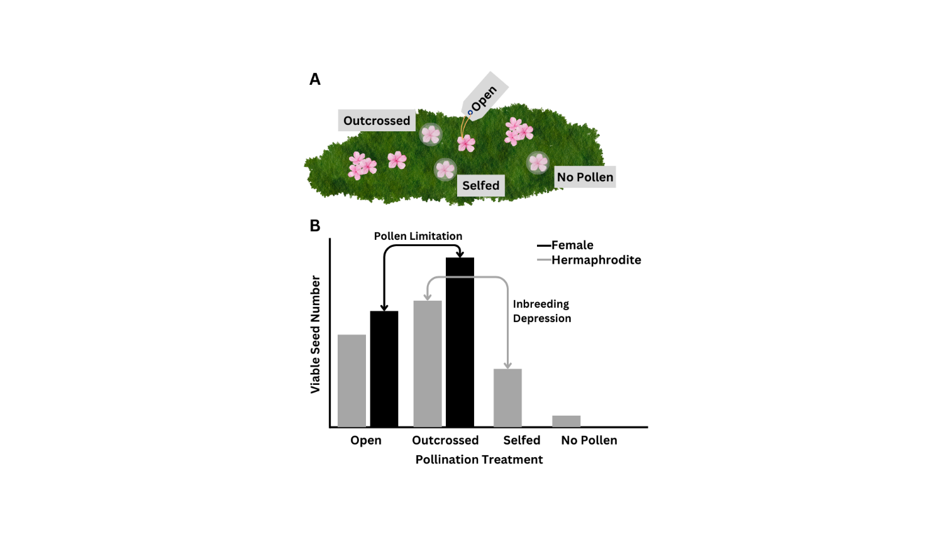

Analysis

*Pre-fertilization*

Stigma length was analyzed using a linear mixed effect model with sex, site, and the interaction between sex and site as the fixed effects, and individual plant ID as the random effect. We also predicted stigma length by ovule number using a linear mixed effects model with individual plant ID as the random effect again.

Female function was estimated in two ways: production of ovules (binomial) and number of ovules in the ovary, given that the ovary had ovules. We analyzed ovule production using a generalized linear mixed effect model with a binomial distribution. Sex, site, and the interaction between sex and site were the fixed effects and individual plant ID was the random effect. Ovule number was predicted in the same way, except with a Poisson distribution.

The response variable, pollen deposition, was also estimated in two ways: pollen deposited (binomial) and number of pollen grains deposited, given that pollen was deposited. Pollen deposition was analyzed using a generalized linear mixed effect model with a binomial distribution. The fixed effects in the model were stigma length, sex, the interaction between stigma length and sex, and site. Plant ID was the random effect. Pollen number was analyzed using the same model structure, except with a Poisson distribution. We examined how the micro sex ratio affected pollen deposition and pollen number using generalized mixed effects models with the response variable predicted by micro sex ratio, sex, and site with week collected and plant ID as the random effects. For pollen deposition we used a binomial distribution and for pollen number we used a Poisson distribution.

*Post-fertilization*

Fruit production was analyzed using a generalized linear model with a binomial distribution. The fixed effects were sex, treatment, site, and the interactions between all predictors. Seed number and seed germination were analyzed using the same model structure, but with a Poisson distribution and quasibinomial distribution respectively.

**Results**

***Pre-fertilization***

* *How do floral traits differ between sexes and individuals?*

Females have stigmas that are 1.38 mm longer on average than hermaphrodite stigmas (χ2=47.044, p<0.001, Supplementary Information Figure XX). The stigma lengths did not differ between the two populations (χ2=0.469, p=0.494). Individual plants differed in stigma lengths (χ2=31.164, p<0.001).

Females were 24% more likely to produce ovules than hermaphrodites (χ2=18.048, p<0.001, Supplementary Information Figure XX). Both females and hermaphrodites from the West Knoll were 17% less likely to produce ovules than individual from the East Krummholz site (χ2=8.322, p=0.004). The likelihood of having female function did vary with individual plants (χ2=31.164, p=0.002).

In flowers with ovules, there were no differences in the number of ovules between the two sexes (χ2=0.192, p=0.661), the two sites (χ2=0.008, p=0.927), and among individuals (χ2=0, p=1).

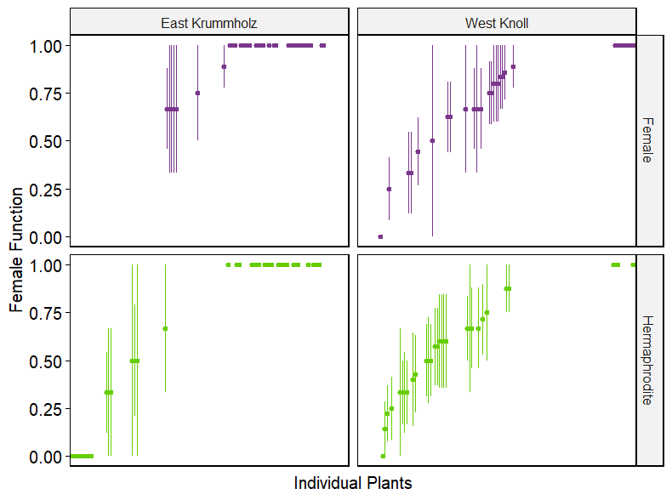

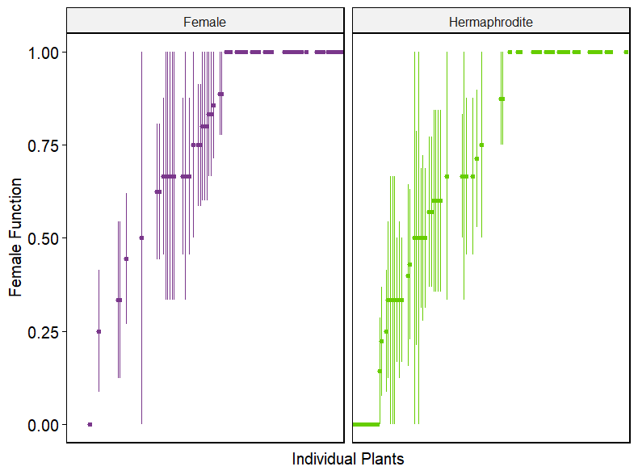

* *How do floral traits and sex impact pollination?*

The sex and stigma length determine if pollen is deposited on the stigma. For every 1 mm increase in stigma length, the probability of having pollen deposited on the stigma increases over three-fold (χ2=45.965, p<0.001). On average, hermaphrodite flowers are twice as likely to have pollen deposited on the stigmas as female flowers (χ2=22.588, p<0.001). The interactions between stigma length and sex and site and sex were also statistically significant. The probability of pollen deposition increases with stigma length more intensely for females than hermaphrodites (χ2=8.145, p=0.004), though pollen deposition on hermaphrodites is higher in the West Knoll site compared to the East Krummholz site (χ2=4.503, p=0.033).

However, if pollen was deposited on the stigma, there was no difference between the sexes (χ2=0.621, p=0.431) for the number of pollen grains deposited and the difference between sites was marginally insignificant (χ2=3.778, p=0.052). The interactions between stigma length and sex (χ2=123.360, p<0.001), stigma length and site (χ2=13.376, p<0.001), sex and population (χ2=10.028, p=0.002), and stigma length, sex, and population (χ2=35.169, p<0.001) for pollen deposition were also statistically significant. Individual plants varied in the amount of pollen deposition on flowers (χ2=1488.6, p<0.001).

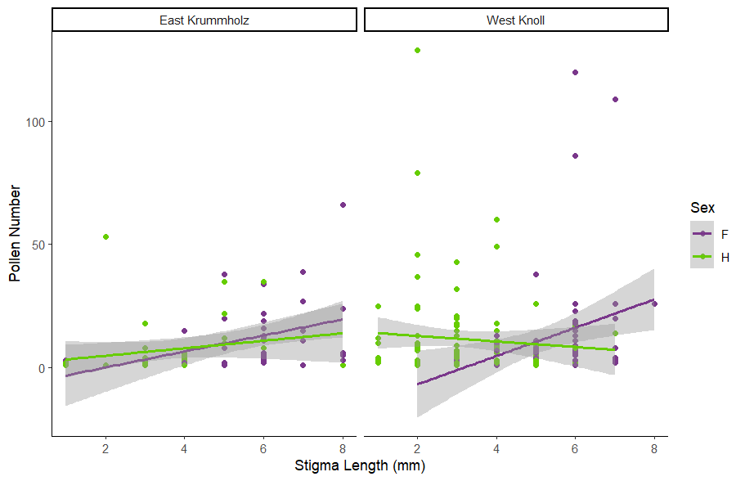

* *How does sex-ratio impact pollination?*

Micro sex ratio did not affect the deposition of pollen (χ2=3.802, p=0.051). However, the number of pollen grains deposited on the stigma is affected by the micro sex ratio (χ2=21.338, p<0.001).

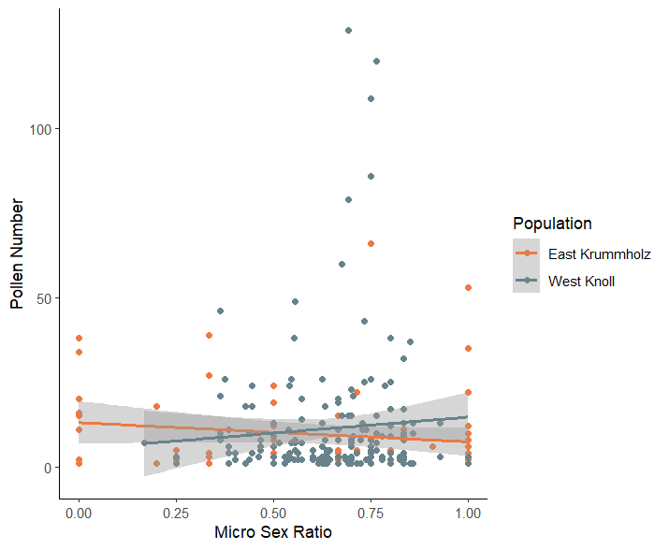

***Post-fertilization***

* *Are females and hermaphrodites pollen limited?*

Both females and hermaphrodites are pollen limited. The flowers assigned the open pollination treatment in both sexes rarely developed into fruit (χ2=109.831, p<0.001) and produced a smaller number of seeds (χ2=55.529, p<0.001) and specifically viable seeds (χ2=20.427, p=0.001) than flowers in the outcrossed and selfed (hermaphrodites only) treatments.

* *How do females and hermaphrodites compare in resource allocation to seed and fruit production?*
* *Does inbreeding affect fruit and seed production in hermaphrodites?*
* *How does sex ratio impact seed and fruit production?*

Figure XX. Proportion of flowers that set fruit (dark green) in each pollination treatment in female and hermaphrodite plants from both sites.

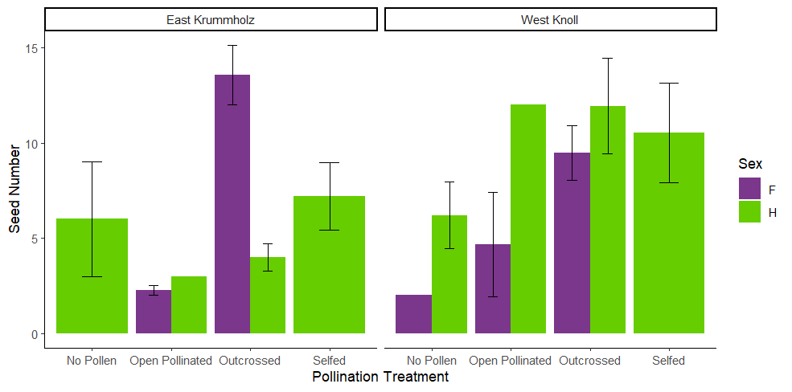

Figure XX. Average number of seeds per fruit in females (purple) and hermaphrodites (green) in all pollination treatments at the East Krummholz and West Knoll sites.

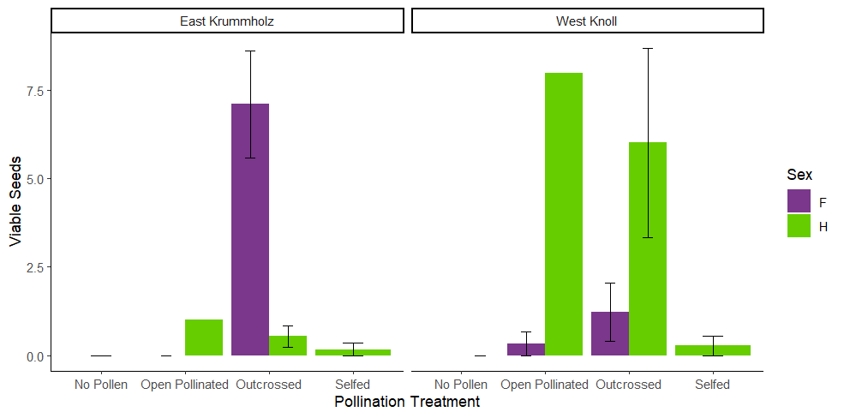

Figure XX. The average number of seeds from female (purple) and hermaphrodite (green) plants that germinated at the East Krummholz and West Knoll sites. Error bars indicate the standard error.

**Herbivory**

Herbivory on the floral structures marked and collected occurred almost exclusively at the East Krummholz site (χ2=31.919, p<0.001). There was a site by sex interaction (χ2=4.119, p<0.042). At the East Krummholz site, hermaphrodite flowers were three times as likely as female flowers to experience herbivory, based on a post hoc analysis with Tukey pairwise comparisons (p=0.019, Supplemental Figure XX).

**Supplementary Information**

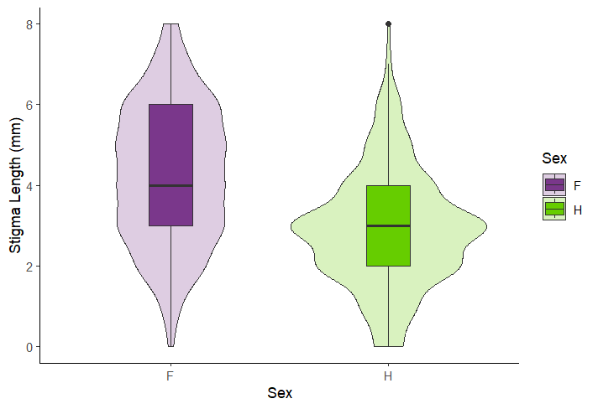

Figure XX. Stigma length (mm) of females and hermaphrodites in both the East Krummholz and West Knoll populations.

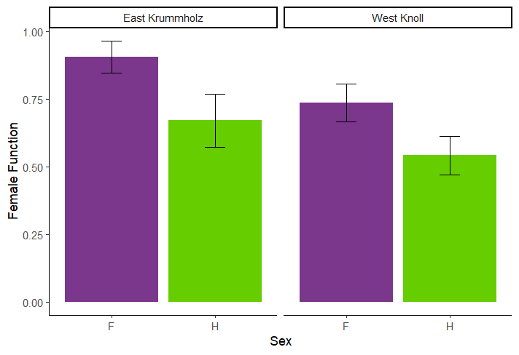

Figure XX. Proportion of flowers with female function (ovules) for female and hermaphrodite plants at the East Krummholz and West Knoll sites.

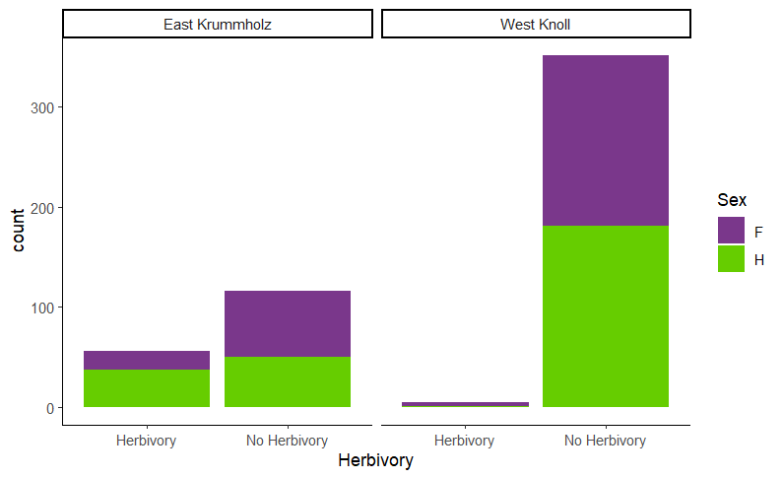

SI Figure XX. Counts of herbivory on marked and collected flowers at the East Krummholz and West Knoll sites for female and hermaphrodite plants