Supplementary

Table XX. ANOVA table for all models tested in the pollination experiment.

 | Fruit Set |  |  | Seed Set |  |  | Seed Germination |  |  | Cumulative Reproductive Output
Term | χ² | dF | p | χ² | dF | p | χ² | dF | p | χ² | dF | p
Sex | 7.343 | 1 | 0.007 | 0.006 | 1 | 0.938 | 14.363 | 1 | <0.001 | 3.381 | 1 | 0.066
Treatment | 102.949 | 3 | <0.001 | 31.476 | 3 | <0.001 | 128.873 | 3 | <0.001 | 69.203 | 3 | <0.001
Site | 0.000 | 1 | 0.990 | 7.058 | 1 | 0.007 | 14.801 | 1 | <0.001 | 1.163 | 1 | 0.281
Female Ct | 0.412 | 1 | 0.521 | 6.274 | 1 | 0.012 | 0.786 | 1 | 0.375 | 0.025 | 1 | 0.874
Hermaphrodite Ct | 1.682 | 1 | 0.195 | 6.968 | 1 | 0.008 | 3.337 | 1 | 0.068 | 0.012 | 1 | 0.912
Sex:Treatment | 21.342 | 2 | <0.001 | 0.553 | 2 | 0.758 | 8.347 | 2 | 0.015 | 0.565 | 2 | 0.754
Sex:Fem Ct | 2.987 | 1 | 0.084 | 22.620 | 1 | <0.001 | 5.815 | 1 | 0.016
Sex:Herm Ct | 11.428 | 1 | <0.001 | 36.470 | 1 | <0.001 | 56.157 | 1 | <0.001 | 1.573 | 1 | 0.210
Treatment:Fem Ct | 4.118 | 3 | 0.249 | 4.192 | 3 | 0.241 | 10.817 | 3 | 0.013
Treatment:Herm Ct | 12.131 | 3 | 0.007 | 21.335 | 3 | <0.001 | 13.666 | 3 | 0.003 | 1.913 | 3 | 0.591

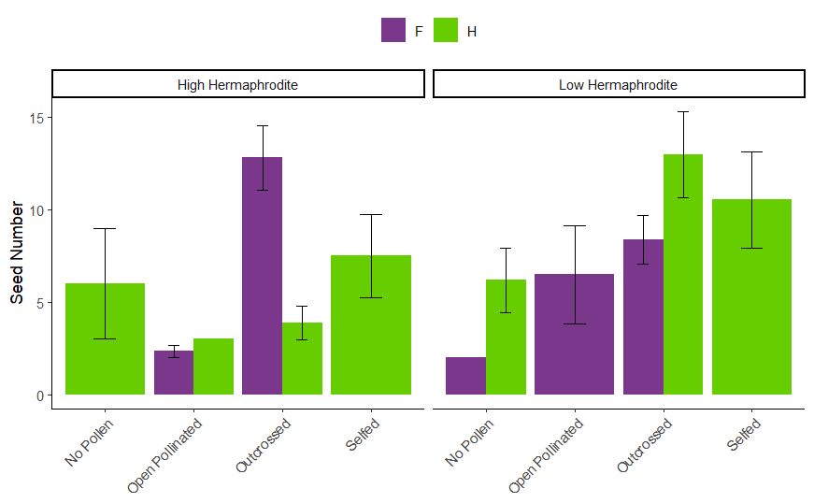
Supp FigXX. Seed number in pollination experiment.
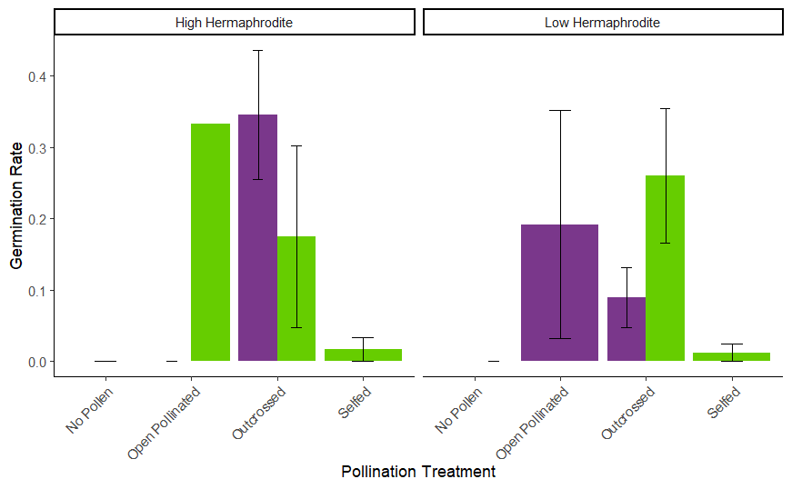
Supp fig XX. Germination rate for each treatment in the pollination experiment.

Table XX. Mean and standard deviation of seed production for the outcrossed and open treatment of the pollination treatment for the two populations (high and low hermaphrodite) and two sexes (female and hermaphrodite). Pollen limitation is a calculated value describing the pollen limitation from the seed production of the outcrossed and open treatment.
Population | Sex | Outcrossed | Open | Pollen Limitation | 95% CI
 |  | Mean | Mean
High hermaphrodite | Female | 10.5 ±8.57 | 0.375 ±0.875 | 3.33 | (2.517, 5.019)
High hermaphrodite | Hermaphrodite | 1.58 ±2.50 | 0.125 ±0.612 | 2.53 | (1.097, 7.773)
Low hermaphrodite | Female | 6.29 ±6.41 | 0.930 ±2.92 | 1.91 | (0.955, 5.009)
Low hermaphrodite | Hermaphrodite | 7.00 ±9.61 | 0.001 ±0 | 8.85 | (8.258, 9.253)

