Drivers of sexual differentiation in the gynodioecious species, Silene acaulis
Introduction
Macroevolution of dioecy
- Dioecy has evolved many times across angiosperms, an estimated number between 871 and 5000 times, even though only 6% of all angiosperms are dioecious (Renner, 2014). The transition from hermaphroditism to dioecy has been of evolutionary interest since Darwin’s time (Darwin, 1877). Darwin argues that this is a gradual process, whereby the sexual organs of one sex becomes reduced and is followed by the opposite, as is evidenced by remnants of male or female organs on single-sex flowers. Darwin described the two-step process by which dioecy evolves, the loss of function for one sex and then the other. The transition from hermaphroditism to dioecy through an initial loss in male function (gyno-dioecy) is more common across angiosperms than the initial loss of female function (andro-dioecy) (Cite Darwin and Charlesworth).
- Dioecy is advantageous for two reasons: by promoting outcrossing and improving efficiency by a division of labor. Inbreeding reduces genetic variation and increases the expression of recessive deleterious alleles. By separating female and male function, dioecious plants are obligate outcrossers, though inbreeding among close relatives is still possible. By dividing the female and male function, efficiency of …
Gynodioecy
- Gynodioecy is a mating system characterized by the maintenance of both hermaphrodite and female individuals.
- Dufay citation, Shykoff meta-analysis
- Charlesworth citation
- Varga meta-analysis
- Female compensation (Gavini, 2023). Sex determination in gynodioecy often is cyto-nuclear. Cytoplasmic male sterility results in females. Eventually, mutations that restore male function are introduced into the nuclear genome. Females must only

Sex ratio
- The sex ratio of a population depends on the primary sex ratio (proportion of each sex produced at birth) and sex-specific vital rates. The sex ratio is constrained by negative frequency dependence. As the relative number of one sex increases, the number of potential mates decreases reducing the fitness of individuals of the dominant sex. The fitness of the rare sex
- Varga, Svoen, Alotalo
- Frequency dependence
Sexual differentiation
- Resources allocated to reproduction can differ remarkable between sexes. Prior to fertilization, competition for mates through the attraction of pollinators or easily dispersing/collecting pollen. Post fertilization sexual differentiation in resource allocation can be even more costly in the form provisioning seeds with resources. Differential selection between the sexes ensures efficient modes of selection that promote the fittest of a generation. However, sexual conflict can also arise when traits that improve female fitness are detrimental to male fitness, buffering the potential for divergence between sexes.
- For example, in hermaphrodite flowers, the female and male components are often separated temporally through protandry. Sexual conflict can arise through the amount of time that the female vs male components are exposed for pollination.
- Though these divergences between the sexes may be in conflict, where traits that improve female fitness do not improve male fitness. Thus, sexual conflict buffers the extent of sexual differentiation.
  - Stephen Barrot paper
- Hermaphrodite flowers are generally bigger and in some cases produce more nectar (Gavini, 2023) – more attractive to pollinators. However, females may have larger displays of more flowers per plant (citation) or produce more concentrated nectar (Gavini, 2023). Pollinators have been observed to spend more time on female flowers in gynodioecious species (Shykoff, 1992), which may be a result of having more concentrated nectar (Gavini, 2023)
- Environmental conditions may impact the fitness of females and hermaphrodites differently, whether in the form of survival, growth, or reproductive output. Such demographic responses can impact the relative numbers of females and males or sex ratio.

- Is there differential selection for floral traits in females and hermaphrodites?
- Do the site-level and micro-level sex ratios impact the fitness of females and hermaphrodites?
- What are the implications of patterns of selection for the evolutionary trajectory of this species?
Gynodioecy
- Gynodioecy, characterized by females and hermaphrodites,
First sentence and last sentence- and the supporting evidence
Don’t worry about citing
What are the three things I need to talk about
- Female and male fitness
- Frequency dependent selection
- Sex ratios
- Gynodioecy

- How broad with the mating systems?
- More specific audience!!

Just say something- does it need to be justified

Reproductive strategies in angiosperms are immensely diverse. Gynodioecy, a dioecious mating system with individuals that are either hermaphrodite or female, controlled genetically. Hermaphrodite pass genes to the next generation through both pollen and seeds, while females only contribute to progeny via seeds; begging the question how are females maintained in a population? Gynodioecy is thought to arise by the introduction of mutations in either the nuclear or cytoplasmic DNA that confer male sterility and nuclear restorer genes that reintroduce hermaphroditism (Delph & Carroll, 2001; Lloyd, 1974). Male-sterility is favorable in populations suffering inbreeding depression, allowing “female” individuals to vigorously invade a population (Charlesworth, 1981). Negative frequency dependence in the form of pollen limitation and reduced female fertility then favors hermaphrodite morphs, which are reintroduced in a population due to mutations in nuclear DNA restoring male function. Balancing selection shifts the female and hermaphrodite frequency around an equilibrium sex ratio. If male sterility is inherited through cytoplasmic DNA, females must only have non-zero compensation to be maintained in a population, due to maternal cytoplasmic inheritance in angiosperms (Delph et al., 2007). Non-zero compensation in females is accomplished through the avoidance of inbreeding by obligate outcrossing (Charlesworth & Charlesworth, 1978) and reallocation of resources to increased flower and seed production (Asikainen & Mutikainen, 2003; Morris & Doak, 1998; Shykoff et al., 2003), more effectively producing gametes of one sex. However, balancing selection acts by suppressing female advantage through pollen limitation (Alonso, 2005). While balancing selection maintains both females and hermaphrodites in a population, the ratio at which they are maintained is often highly variable.
Environmental factors can influence the reproductive success and potentially other vital rates of females and hermaphrodites to different extents. The operational sex ratio (OSR; proportion of hermaphrodites in a population) can serve as a snapshot of the relative advantage for females and hermaphrodites in the recent past. Yet, the mechanisms that drive sex ratio in a population are understudied. Variation in sex ratio can be attributed to many factors, such as resource competition, the underlying genetics of sex-determination, or demographic biases (Field et al., 2013). In terms of reproductive output, female vs hermaphrodite advantage depends on resource limitation, pollen limitation, inbreeding depression, and isolation from potential mates. When resources are limited, females have the advantage requiring fewer resources for female function. Pollen limitation or the lack of pollinator access severely disadvantages females in a population. Hermaphrodites in isolated locations or with limited access to pollinators have the advantage of pollen on the same plant and flower with the potential for selfing, geitonogamously (different flowers of the same plant) or autogamously (within a flower). High rates of selfing, however, leads to inbreeding depression. The fitness of progeny produced by females that are outcrossed may be higher than those from self-fertilization, which have a higher chance of expressing deleterious, recessive alleles.
Gynodioecy is thought to be an intermediate state in the evolution of dioecy. Female and male function become segregated among individuals as females allocate more resources to seed production and progeny survival. The male function of hermaphrodites ultimately contributes more to the reproductive output in a population than the female function on hermaphrodite plants. Eventually, female function is lost in favor or allocating more resources to pollen production, leading to a dioecious system. Differential selection on floral traits on the two sexes leads to dimorphic flowers. Hermaphrodites and females generally already differ in morphology. Hermaphrodites have larger flowers than females due to the additional space required for pollen and anther production in addition to the carpels (Shykoff et al., 2003). The resources required for producing larger flowers and male traits are thought to be reallocated to increased seed production or superior seed provisioning in females. The style and stigmatic surface on females are also typically larger than on hermaphrodites for two reasons: stronger selection for more prominent styles and stigmas in females for pollen collection and reduced time for pollen receipt in hermaphrodites. First, seed production is only possible for females when pollen from a separate plant is deposited on the stigma. Female plants with a larger stigmatic area are more likely to be pollinated and produce seeds in a pollen limited environment. Second, many species that have hermaphrodite flowers are protandrous, with separate male and female phases temporally spaced to reduce self-fertilization. The length of time spent in the female phase may be reduced, disrupting style development. While these mechanisms are theorized to affect sex ratio, few studies have explicitly observed how these mechanisms differ in populations with different sex ratios.
In this study, we explored the interplay of these mechanisms maintaining the gynodioecious mating system in the alpine and arctic tundra species, Silene acaulis. We compared female and hermaphrodite plants through floral morphological traits, rates of pollination, and a controlled pollination field experiment at two populations that differed in the OSR. We sought to answer the questions:

Methods
Study System
Silene acaulis is a long-lived, gynodioecious cushion plant. The squat, alpine and arctic tundra species has a distribution that is almost circumpolar, occurring throughout North America, Europe, and Eastern Russia at high elevations and latitudes. Individual plants have a single taproot with a dense, elliptical cluster of leafy rosettes. S. acaulis only reproduces sexually with mature plants producing a few flowers on small plants to hundreds of flowers on the largest plants. The flowering duration of a plant can extend for a few weeks as the phenology of individual flowers can vary substantially. Females and hermaphrodites vary in their morphology and when the stigma is receptive. Hermaphrodites generally have larger flowers (Shykoff, 1992) and are protandrous, meaning that the anthers mature and dehisce prior to the stigma becoming receptive.
Silene acaulis plants that survive to the largest size class are estimated to live up to 338 years (Morris & Doak, 1998). However, few plants, approximately 1.8% of seedlings, survive to 300 years. On average, female and hermaphrodite plants reach reproductive maturity at around 20 and 30 years respectively. In Alaska, female plants are estimated to produce 4.4 times the number of seeds as hermaphrodites throughout their lifetime (Morris & Doak, 1998). Other studies at lower latitudes annual seed production is 2 to 3 times higher in females thant hermaphrodites (Hermanutz & Innes, 1994; Shykoff, 1988). Seed number per fruit do not differ between females and hermaphrodites (Delph et al., 1999), but females do reallocate resources from pollen production to produce more flowers and fruit on a plant (Delph et al., 1999; Shykoff, 1988; Shykoff et al., 2003). Females tend to have seeds with higher establishment rates than hermaphrodites (Shykoff, 1988). However, seed provisioning does not differ between females and hermaphrodites (Delph et al., 1999), and the seed quality is not fully explained by inbreeding depression in hermaphrodites (Shykoff, 1988). Others have hypothesized that the differences in seed establishment depend on the timing or quality of pollen receipt (Shykoff, 1988, 1992), and as of yet, other unknown differences in seed quality (Delph et al., 1999; Shykoff, 1988; Shykoff et al., 2003).

Sites
We established two sites at the Niwot Ridge Long-Term Ecological Research station in Colorado. We selected sites that were surveyed for OSR the previous year (2023). OSR was surveyed by recording the sex of 200 plants along parallel transects horizontal to the slope. The East Krummholz site was at 11,348 feet in elevation, just above tree line on an east facing slope. The West Knoll site was at 11,845 ft in elevation, near the top of the ridge on a south facing slope. The OSR (proportion of hermaphrodites in the population) and 95% confidence intervals of the East Krummholz and West Knoll sites were 0.75 (0.68, 0.80) and 0.43 (0.36, 0.50) respectively.

Pre-fertilization experiment
We compared floral traits, pollen deposition, and pollen removal between female and hermaphrodites and between sites with different operational sex ratios. We marked 30 female and hermaphrodite plants in both sites. During flowering, three buds were marked the day before flowering and one bud was collected and placed in 70% ethanol for storage. Four days after the bud opened, the marked flowers were collected. We established that day four had maximum pollen deposition in a pilot study the year prior to this experiment. The anthers still attached to each collected flower were removed and placed in one microcentrifuge tube with 70% ethanol. The full pistil from each collected flower was placed in a microcentrifuge tube with 3 parts acetic acid:1 part 100% ethanol for 24 hours for fixation before the pistil was transferred to 70% ethanol following a protocol from Kearns and Inouye (1993).
Flowers on each plant were marked and collected three times during the course of this experiment, if plants were still in flower. Additional plants were added to the dataset in the East Krummholz site, because individuals that were originally marked in week one were finished flowering. Each day the plants were marked, the number of female and hermaphrodite plants within a 1-meter distance from the focal plant were recorded to obtain a micro operational sex ratio (micro OSR).
Stigmas were measured to the nearest millimeter using a ruler and the whole pistil was mounted on a microscope slide. The number of Caryophyllaceae pollen grains on each stigma and the number of ovules in the ovary were counted using a light microscope (Accu-Scope® EXI-310).

Post-fertilization experiment
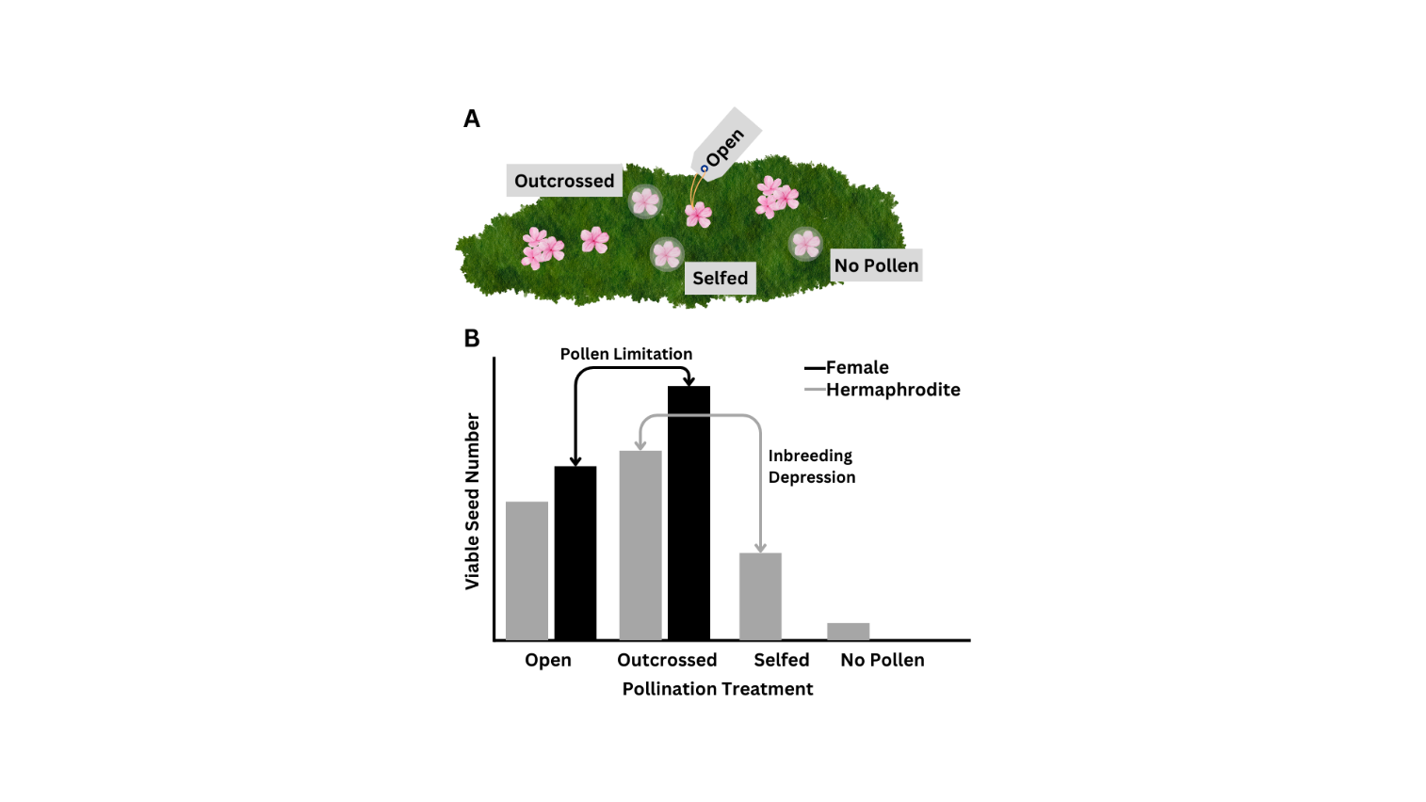
We used a pollination experiment to compare the reproductive success of female and hermaphrodite plants. We marked 30 female and 30 hermaphrodite S. acaulis plants at the West Knoll and the East Krummholz sites. The pollination experiment had four crossing treatments for hermaphrodites (no pollen, open pollinated, outcrossed, and selfed) and three from females (all treatments except selfed). To apply the treatments, we selected four (or three) buds that would open the next day. For the open pollination treatment, we marked one bud by placing a dot on the calyx with an oil-based marker and by inserting a colored toothpick near the bud. No other manipulation was applied for the open pollination treatment. For the three other treatments, we covered buds with a pollinator exclusion contraption fashioned from a cut microcentrifuge tube and mesh. The mesh was added to allow airflow into the contraption and reduce the greenhouse effect of the small plastic tube. However, some warming of the bud and flower likely occurred. The exclusion contraptions were marked with different colors to designate the separate treatments. No other manipulation was applied to the no pollen treatment. The no pollen treatment was included to access how common autogamous selfing is in hermaphrodites and ensure that the pollinator exclusion contraptions prevented pollination based on female fruit production in the no pollen treatment.
Figure XX. (A) Crossing treatments on the plants with transparent circles indicating pollinator exclusion contraptions. (B) Predicted outcomes for viable seed number for the crossing treatments.

Three days later, manual pollination by pressing the anthers of one flower against the stigma of the focal flower was used to apply the outcrossed and selfed treatments. For the outcrossed treatment, 2 flowers from 2 plants at least 10 meters away were collected and used for the pollination. For the selfed treatment on hermaphrodites only, two flowers were collected from the same plant as the focal flower and used for the pollination. The pollinator exclusion contraptions were replaced over the flowers and left until the flowers developed into fruit. Three weeks later, the fruit or remnant, unfertilized flowers from each treatment were collected. Fruit set, seed number, total seed mass per fruit, and seed viability were recorded. We determined seed viability by whether the seeds germinated in a germination trial or not over the course of six weeks. We did not conduct a tetrazolium test, so seeds may still have been viable even though they did not readily germinate.

Analysis
Pre-fertilization
Stigma length was analyzed using a mixed effects linear regression model (lmer, lme4; (Bates et al., 2015) with sex and site as fixed effects and the individual plant as the random effect. Due to our interest in the presence of female function and an excess of ovaries with no ovules in our dataset (zero inflation), we used a hurdle model approach for ovule number. Female function was modeled as a binary (with ovules, without ovules) using a generalized mixed effects model with a binomial distribution (glmer, lme4). Ovule number, given female function, was modeled using a negative binomial generalized mixed effects model (glmer.nb, lme4). The structure for the hurdle model included sex, stigma length, the interaction between sex and stigma length, and site as fixed effects and the individual plant as a random effect.
To test the effect of floral traits and micro sex ratio on pollination, we modeled the pollen count as a hurdle model. Pollen deposition was modeled as a binary variable (pollen deposition, no pollen deposition) and pollen count, given pollen was deposited on the stigma, was continuous. The general structure for the model included the fixed effects stigma length, female count, hermaphrodite count, sex, and site, and the interactions between sex and stigma length, female count, and hermaphrodite count. Plant ID was a random effect in the model. The micro sex ratio was broken down into the female and hermaphrodite count to account for plants surrounded by plants of only one sex. Pollen deposition was modeled using a generalized mixed effects model with a binomial distribution (glmer, lme4) and pollen number using a negative binomial generalized mixed effects model (glmer.nb, lme4), due to zero inflation.
Post-fertilization
Fruit set and the cumulative reproductive output were analyzed using generalized linear models. Fruit set was analyzed using a binomial distribution with the fixed effects sex, treatment, site, a count of surrounding female plants, and a count of surrounding hermaphrodite plants. Interactions with sex were included for treatment, the female count, and hermaphrodite count. Interactions with treatment were also included for female count and hermaphrodite count. The cumulative reproductive output was calculated by multiplying the fruit set (0,1) by the seed number and germination rate (proportion of seeds from a fruit that germinated). The model structure analyzing cumulative reproductive output was the same as fruit set, except female count was dropped from the interaction terms because of a lack of power. Cumulative reproductive output was analyzed with a Poisson distribution. One female flower produced a fruit in the no pollen treatment. This was likely an error caused by the accidental application of pollen by researchers or a pollinator entering the pollinator exclusion contraption and pollinating the flower. Thus, the one observation was dropped from all analyses.
Pollen limitation was calculated using the seed set from the outcrossed and open pollinated groups. The calculation for pollen limitation from Knight et al. All analyses were performed in R 4.4.1.

Results

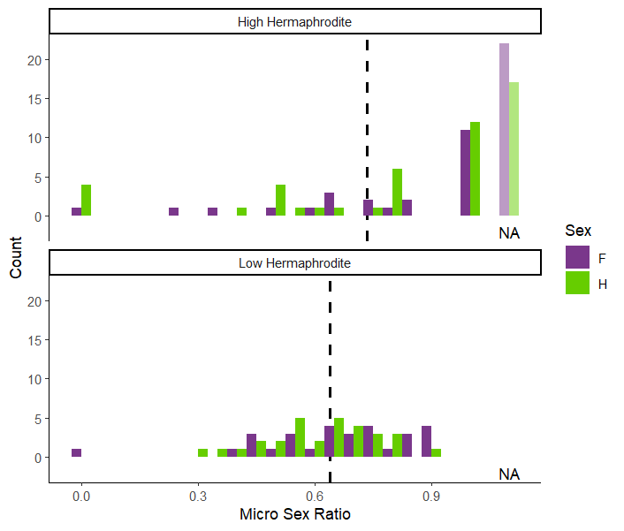
Figure XX. Histogram of the average micro sex ratio (hermaphrodite count divided by total number of plants within a 1m radius area) for each plant in the study in the high and low hermaphrodite populations. The color purple indicates that the focal plant was female and green that the focal plant was a hermaphrodite. Vertical dotted line shows the mean micro sex ratio. Transparent columns indicate the number of NA’s or focal plants with no other plants within the 1m radius area.

Pre-fertilization
How do floral traits differ between sexes and individuals?
Females have stigmas that are 1.34 mm longer on average than hermaphrodite stigmas (χ²=47.008, p<0.001). The stigma lengths did not differ across the two populations (χ²=1.434, p=0.231). Individual plants varied in the stigma lengths (χ²=31.305, p<0.001).
The likelihood of producing ovules did not depend on sex (χ²=1.480, p=0.224), but plants from the East Krummholz site were more likely to produce ovules than individuals from the West Knoll site (χ²=7.490, p=0.006). We found that the likelihood of producing ovules was related to stigma length (χ²=47.846, p<0.001). Flowers with longer stigmas were more likely to have ovules. Individuals varied in the mean likelihood of ovule production (χ²=11.009, p<0.001). Some hermaphrodite plants in both populations were functionally male and did not develop ovules in the flowers sampled. One female plant developed no ovules in the two flowers sampled. In flowers with ovules, there were no differences in the number of ovules between the two sexes (χ²<0.007, p=0.932), with increasing stigma length (χ²=1.791, p=0.181), and between the two sites (χ²=0.118, p=0.731).

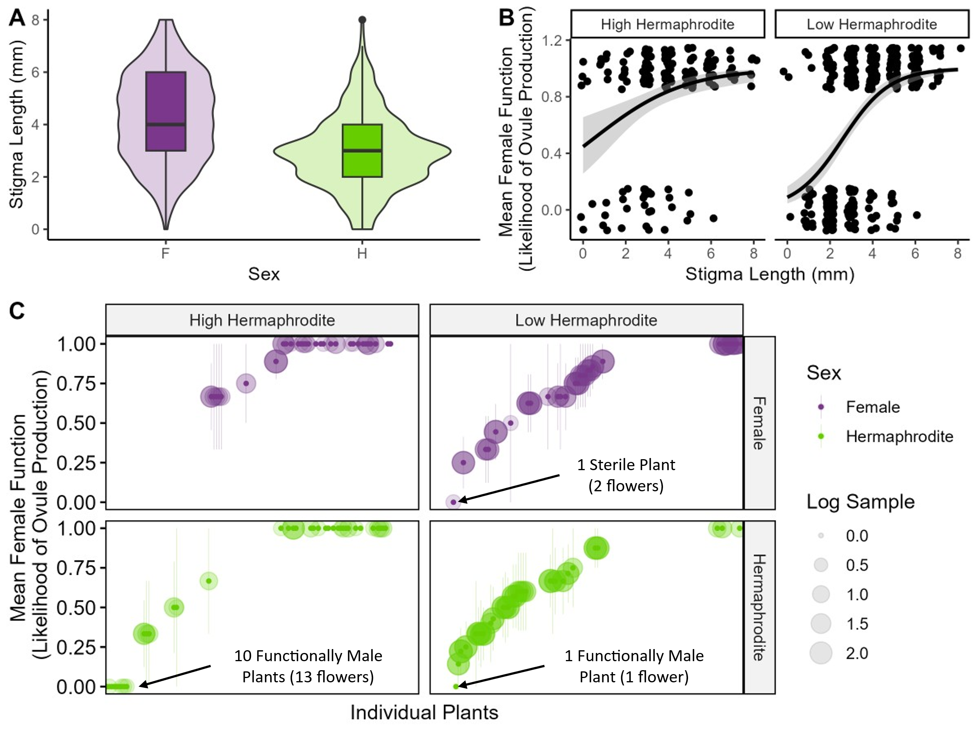

Figure XX. Plant traits in females and hermaphrodites from the East Krummholz and West Knoll sites. Box plot of stigma length (A) showing the median and violin overlay with the density. Average female function, or likelihood of ovule production (B), with error bars showing the standard error. Female function of individual plants (C) with points indicating the mean female function, error bars indicating the standard error, and bubbles indicating the sample size for each individual.

Female function
Site level sex ratio from the demography plots

How do floral traits and micro sex ratio affect pollination?
The likelihood of receiving pollen depended on the stigma length (χ²=41.819, p<0.001), sex (χ²=21.080, p<0.001), and the interaction between stigma length and sex (χ²=11.678, p<0.001). The interaction between sex and hermaphrodite count was marginally significant (χ²=2.737, p=0.098). Pollen deposition depended on the individual plant (χ²=4.547, p=0.033).
Given that pollen was deposited on the stigma, pollen number depended on stigma length (χ²=19.044, p<0.001) and the interaction between stigma length and sex (χ²=12.967, p<0.001). Sex was marginally significant (χ²=3.564, p=0.059). Individual plants varied in the number of pollen grains deposited on the stigmas (χ²=2722, p<0.001).

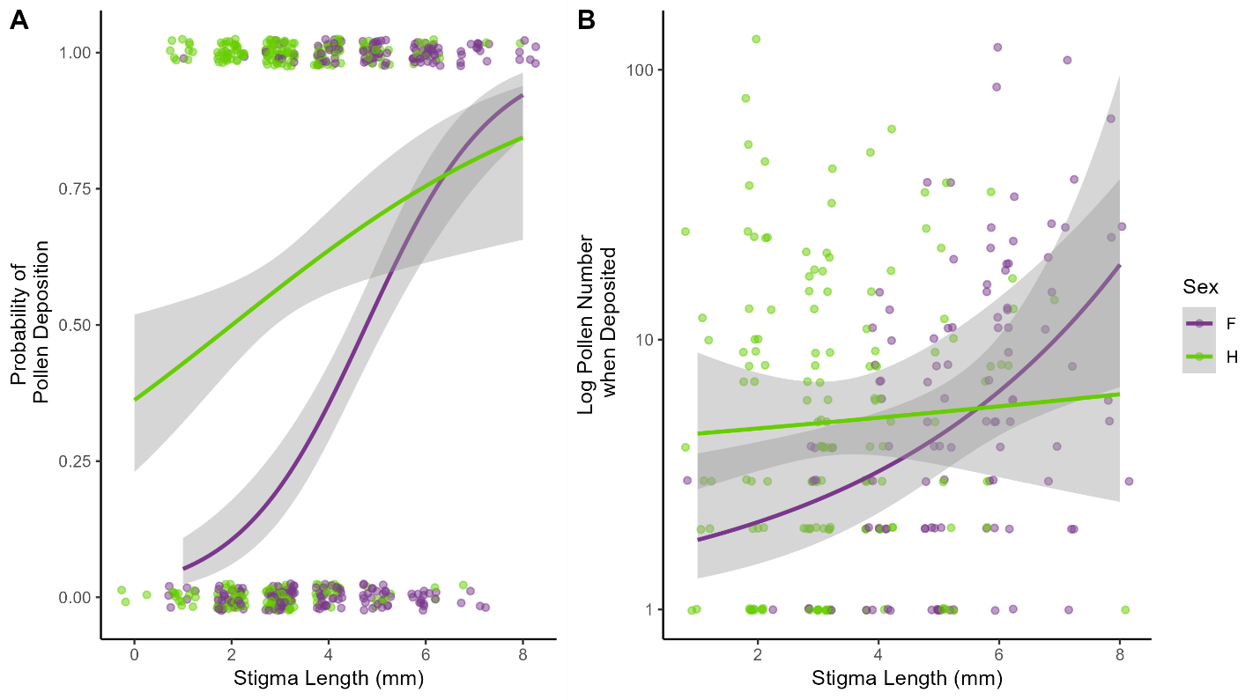

Figure XX. The likelihood of pollen deposition (A) and number of pollen grains deposited (B) as stigma length increases for females (purple) and hermaphrodites (green).

Post-fertilization

Table XX. ANOVA table for all models tested in the pollination experiment.

 | Fruit Set |  |  | Cumulative Reproductive Output
Term | χ² | dF | p | χ² | dF | p
Sex | 6.718 | 1 | 0.010 | 3.381 | 1 | 0.066
Treatment | 104.420 | 3 | <0.001 | 69.980 | 3 | <0.001
Site | 0.000 | 1 | 0.991 | 1.163 | 1 | 0.281
Female Ct | 0.596 | 1 | 0.440 | 0.025 | 1 | 0.874
Hermaphrodite Ct | 1.119 | 1 | 0.290 | 0.012 | 1 | 0.912
Sex:Treatment | 24.981 | 2 | <0.001 | 0.565 | 2 | 0.754
Sex:Fem Ct | 2.662 | 1 | 0.103
Sex:Herm Ct | 9.468 | 1 | 0.002 | 1.573 | 1 | 0.210
Treatment:Fem Ct | 3.691 | 3 | 0.297
Treatment:Herm Ct | 10.646 | 3 | 0.014 | 1.913 | 3 | 0.591

Fruit set
The production of fruit was determined by sex, treatment, and the interaction between sex and treatment (Table 1; Figure XXA). The number of surrounding hermaphrodites was significant in interactions with sex and treatment (Table1). Females had a higher fruit set for the outcrossed treatment (Pairwise comparison; estimate=1.613, p=0.021), but there was no difference between the sexes in the open pollinated treatment (Pairwise comparison; z=2.733, p=0.331). The fruit set did not differ significantly for comparisons between outcrossed and the selfed treatments in hermaphrodites (Pairwise comparison; z=0.736, p=0.639). However, the no pollen and outcrossed treatments did differ in fruit set (Pairwise comparison; z=-1.673, p=0.019). Separate results for seed set and germination rates are in the supplementary information (Table SXX).

Cumulative Reproductive Output
The cumulative reproductive output (fruit set * seed number * germination rate) depended only on the treatment (Table 1; Figure XXC and XXD). Selfed pollinations in hermaphrodites resulted in a lower overall reproductive output than the outcrossed treatment (Pairwise comparison; z=3.131, p=0.039). Fruit produced by selfed pollinations averaged 9.73 (±7.74) seeds, but the average germination rate was 0.013 (±0.037; Supp Fig SS and SS).

Pollen Limitation
Both females and hermaphrodites were significantly pollen limited (Table 2). Females and hermaphrodites did not differ in pollen limitation in the high hermaphrodite population, but hermaphrodites were more pollen limited in the low hermaphrodite population than females (Table 2).

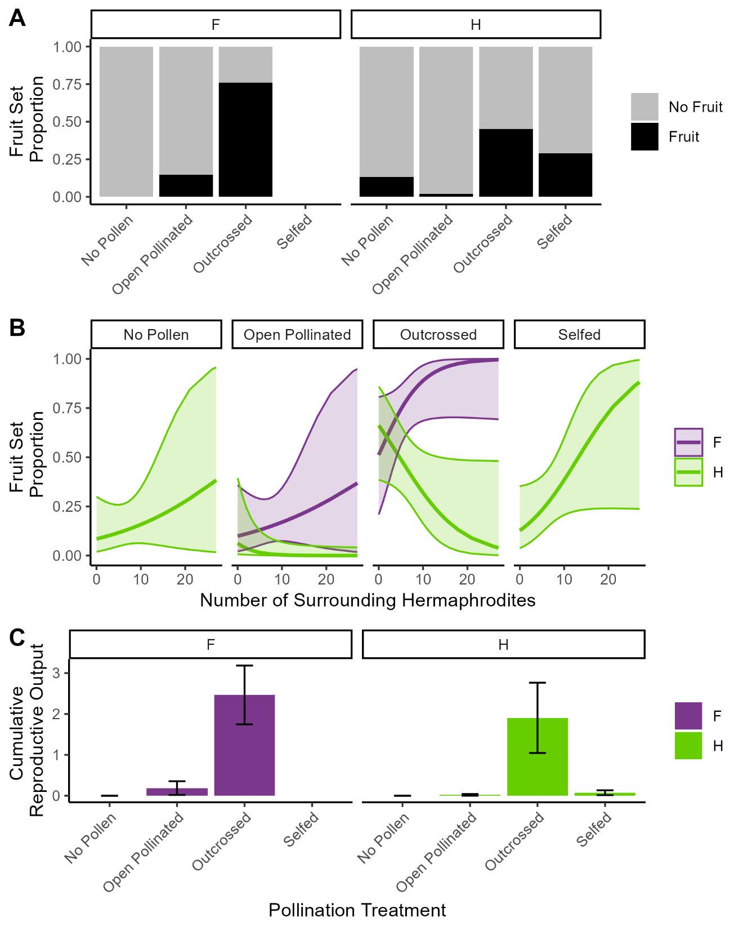

Figure XXX. Fruit set proportion for all treatments in the pollination treatment for females (left panel) and hermaphrodites (right panel) (A). Fruit set proportion as the number of surrounding hermaphrodites increases for each sex (female=purple, hermaphrodite=green) and pollination treatment (B). Cumulative reproductive output for all treatments in the pollination treatment for females (left panel and purple) and hermaphrodites (right panel and green) (C). Cumulative reproductive output is the product of fruit set, seed set, and germination rate.

Table XX. Pollen limitation calculations for fruit Set
Population | Sex | Outcrossed | Open | Pollen Limitation | 95% CI
 |  | Mean | Mean
High hermaphrodite | Female | 0.793 ±0.415 | 0.168 ±0.381 | 1.55 | (0.825, 3.068)
High hermaphrodite | Hermaphrodite | 0.376 ±0.495 | 0.043 ±0.204 | 2.18 | (0.843, 6.122)
Low hermaphrodite | Female | 0.751 ±0.441 | 0.144 ±0.356 | 1.65 | (0.914, 3.109)
Low hermaphrodite | Hermaphrodite | 0.537 ±0.508 | 0.001 ±0 | 6.29 | (5.881, 6.573)

Discussion
We compared the floral morphology, pollen deposition, and reproductive output for hermaphrodites and females in one low hermaphrodite population and one high hermaphrodite population in Silene acaulis. We found strong evidence of differential selection between females and hermaphrodites for floral morphology. Specifically, females had longer stigmas and in females with the longest stigmas, pollen receipt was highest. The sex ratio of the population and surrounding an individual plant did not affect pollen receipt, but ovule production and fruit set did depend on sex ratio. Plants were more likely to develop ovules when hermaphrodites were common. However, hermaphrodites were less likely to set fruit as the number of surrounding hermaphrodites increased. Both sexes were substantially pollen limited and generally had low reproductive output. We found evidence of inbreeding depression decreasing the reproductive output of hermaphrodites. Based on these results, we argue that these Colorado populations of Silene acaulis show evidence of an early transition from gynodioecy to a dioecious state. We describe the lines of evidence throughout the discussion of results below.

Sexual divergence in patterns of selection
Both females and hermaphrodites were pollen limited. Females lack the reproductive assurance of having nearby pollen (on the same flower and plant) and thus, must capitalize on pollen receipt (CITATION). We found that females with the longest stigmas were more likely to receive pollen and received the most pollen. Others have established that pollen capture is more likely and efficient on flowers with longer stigmas (DULBERGER & HOROVITZ, 2008). This effect was much stronger in females compared to hermaphrodites and as has been previously established, females generally have longer stigmas than hermaphrodites (Hermanutz & Innes, 1994; Shykoff, 1992). The development of longer stigmas is likely a compensatory mechanism by which females substantially increase chances of fertilization (Shykoff, 1992). Hermaphrodites with longer stigmas were more likely to receive pollen, but the number of pollen grains deposited on the stigma did not depend on stigma length as it did in females. This result differs slightly from the results of Shykoff (1992), where Jacqui Shykoff found that females and hermaphrodites did not differ in the number of pollen grains deposited. In our model, only the interaction between stigma length and sex determined the number of pollen grains deposited, sex alone was only marginally significant. Thus variation in stigma length among the sexes seems to be an important key for both the likelihood of pollen deposition and the number of pollen grains deposited.
Sexual conflict in hermaphrodites may be another reason that we found stronger selection for longer stigmas in females than hermaphrodites (Wang et al., 2021). Silene acaulis is protandrous, as many hermaphrodite angiosperms are, with anthers developing and releasing pollen before the stigma is exposed and receptive. The time the anthers are dispersing pollen (male function) and the time that the stigma is receptive (female function) during flowering are in direct conflict as the length of time spent in the female vs male phase increase reproductive success for female and male function (Wang et al., 2021). However, as the length of time in one stage increases, the time allotted to the other sex decreases. This sexual conflict may constrain the stigma growth possible in hermaphrodites. Females that do not rely on male function for fitness have more time for stigma growth. This first line of evidence showing that both the stigma length and the strength of selection for stigma length differs between the sexes indicating sexual divergence in patterns of selection. Selection for stigma length improves female fitness in the female sex, but is constrained in hermaphrodites.

Maintenance of females in populations
Female advantage hypothesis (Gavini, 2023)

Similar to Canelles et al. (2018) and Hermanutz and Innes (1994), we found limited evidence that seed set differs substantially between females and hermaphrodites, but fruit set was a different story. Females had superior fruit set for both the open and outcrossed treatments in our pollination experiment. To be maintained in a population for gynodioecious species with a cyto-nuclear mating system, females must only maintain female reproductive rate that equals that of a hermaphrodite (Charlesworth and Delph citations). Silene acaulis females exceed this lower limit in all populations where it has been studied (Hermanutz, Morris and Doak, Delph citations). In our study, the fruit set of females did increase as the number of surrounding hermaphrodites increased for both the open and outcrossed pollination treatments. However, the number of surrounding females was not important. Negative frequency dependence would predict that female fitness would increase as hermaphrodites become more common as female fitness depends on pollen supplied by nearby pollinators. Competition for pollen within the female sex should increase as the number of females increase in the population, decreasing female fitness. We did not see any indication of female frequency limiting female fitness. Pollen limitation also did not differ significantly between population with low vs high hermaphrodite frequencies. Potentially, females in both populations were pollen limited regardless of the population sex ratio, but by having many hermaphrodite plants close, fitness did improve. This third line of evidence indicates the maintenance and even stability of females in populations of Silene acaulis regardless of population sex ratio.

The divide in resources allocated to female reproduction in hermaphrodites
Theoretically, pollen limitation should favor hermaphrodites in a population. As hermaphrodites become less common, pollen should be more limited and confer a fitness advantage to any pollen producing individuals (Delph et al., 2007; Saur Jacobs & Wade, 2003). Conversely, females with any morphological variation that confers fitness advantages in pollen receipt will be favored under strong selection. Contrary to what we expected, females did not differ from hermaphrodites in pollen limitation and were even less pollen limited than hermaphrodites in the population where hermaphrodites were rare. We found no evidence of frequency dependence that would theoretically advantage hermaphrodites in a pollen limited environment. Granted, for Silene acaulis the historical environment under which selection acted in these populations and the current operational sex ratio arose was decades to centuries ago, when pollinator prevalence and resource availability may have differed substantially. However, since both sexes, and especially hermaphrodites are pollen limited, male function is likely more important to hermaphrodite fitness than female function.
Reflecting on this sexual divide in contributions to hermaphrodite fitness, the allocation of resources to female function varies in hermaphrodites. Stigma length, in addition to pollen deposition, was also related to the likelihood of developing ovules. Similar to Hermanutz and Innes (1994), we found that individuals with longer stigmas were more likely to have normally developing ovules. One explanation for this phenomenon is that the potential for fertilization in a certain number of ovules relies on space for at least the same number of pollen grains to be deposition on the stigma. Ovaries with ovules that were aborted early were common among flowers on S. acaulis plants on both sexes, but more common on hermaphrodites. Hermanutz and Innes (1994) found that degenerative ovules in hermaphrodites generally occurred in flowers with shorter styles. The style length was also related to fruit set. Hermanutz and Innes (1994) found that hermaphrodites with long stigmas had 100% fruit set in all populations, but flowers with medium and especially short length styles had reduced fruit set. We found variation among individuals in the proportion of ovaries with developed ovules. However, there was some evidence of a more bimodally-shaped divide between hermaphrodites with normal and degenerated ovules in the high hermaphrodite population. All flowers collected on 10 plants had ovaries without ovules and all but 6 of the remaining plant had normally developed ovules in all flowers collected. Plants in the low hermaphrodite population had a greater variance in the likelihood of ovule production.
Furthermore, fruit set declined in hermaphrodites as the number of surrounding hermaphrodites increased both at the population level and microhabitat level for the outcrossed pollination treatment. However, fruit set in the self-pollination treatment increased as the number of nearby hermaphrodites increased. Increased numbers of hermaphrodites might lead to less resources allocated to female function in individuals of a population generally, the lack of inbreeding in a population with more available mates (pollen from hermaphrodites) may also improve fruit set due to selfing.
While preliminary, these ovule and fruit set results may suggest a functional divide between the hermaphrodites in populations where “male” competition is theoretically higher (high hermaphrodite). The maintenance of high hermaphrodite populations, with a stable frequency of females could favor the introduction of female-sterile morphs that exhibit a “male” character. This third line of evidence describes a potential divide in hermaphrodites, in which some individuals allocate more resources to male function than female function. Subspecies of Silene acaulis in Europe have been identified as trioecious (Maurice et al., 1998). Plants designated “male” are identified by having straight, reduced styles that do not surpass the mouth of the corolla. However, Maurice et al. (1998) found half the individuals designated “male” based on style length morphology set fruit, while a third of “hermaphrodites” in their study did not set fruit. Based on these results the shift to trioecy could be incomplete in Europe and of a similar nature in North America.

Limited effect of sex ratio in sexual divergence
Canelles et al. (2018) hypothesized that sexual dimorphism and reproductive compensation is modulated by environment. They proposed that climate severity may promote resource allocation toward just male function in hermaphrodites. However, they found no evidence for this hypothesis. If sex ratio is really what modulates sexual dimorphism and reproductive output, then there may be an indirect interaction between environment and macroevolution in S. acaulis. Alatalo and Molau (1995) found that the sex ratio becomes more female-biased at high elevations in Norway. Similarly, Svoen et al. (2019) found that female frequency increased with latitude in Sweden. We have also established that female frequency increases with elevation in the Colorado Rockies and latitude based on a citizen science dataset (Chandler and DeMarche Unpublished Data).
The populations we chose to use for this study varied from hermaphrodite biased with as sex ratio of 0.75 (0.68, 0.80) to more equal with a sex ratio of 0.43 (0.36, 0.50). Contrary to our expectations we found that population-level sex ratio and micro sex ratio had no effect on pollination. Only ovule production and fruit set were affected by sex ratio. However, our inferences related to general trends of sex ratio are limited by the lack of replication. We only compared females and hermaphrodites in one low and one high hermaphrodite population. Thus, the scope of this study cannot provide broad implications for how low and high hermaphrodite populations generally behave in S. acaulis and other gynodioecious species. The low hermaphrodite population was a harsher site with a higher elevation (+500 feet) and on a more exposed, south facing aspect. The high hermaphrodite population was just above tree line, in a less exposed, east facing aspect.
Assuming that the allocation of resources to male function is the inverse of resources allocated to female function, our results oppose the hypothesis proposed by Canelles et al. (2018). They predicted that hermaphrodites would allocate more resources to male function in severe climates, where hermaphrodites are rare. We found that female function declined as hermaphrodites became more common. Suggesting that rather than female competition between female and hermaphrodites driving an increase in male character in hermaphrodites, male competition within the hermaphrodite sex is actually promoting this shift. However, this phenomenon may be unique to areas where both sexes are severely pollen limited potentially due to low pollinator abundances. We are further limited in the conclusions we can draw related to shifts toward “male” character as we did not measure pollen production or pollen viability in this study.

Conclusions
Based on the results of this study, we concluded that Silene acaulis populations of Colorado show early signs of transition toward a trioecious state, as is observed in Europe. Patterns of selection differ between females and hermaphrodites in flower morphology and females are compensating for a lack of male fitness by having a higher fruit set. While increased numbers of hermaphrodites in a population did not relieve pollen limitation for either sex, the likelihood of developing ovules did increase, and females were more likely to produce fruit. Conversely, hermaphrodites were less likely to produce fruit and abortion of ovules was more common among individuals as the number of surrounding hermaphrodites increased. While preliminary, these lines of evidence suggest a divergence in hermaphrodites toward more “male” character or maintaining hermaphroditism.
Many of the patterns we identify here were previously established in Silene acaulis. Here we added the population-level and micro-level sex ratio as potential drivers of dimorphic selection. These findings are the beginning steps to bridge the gap between population-level behaviors and sexual selection that describe the transition from sub dioecy toward dioecy. Populations of S. aculis vary substantially in sex ratio as Hermanutz and Innes (1994) reported OSRs as low as 0.2 and as high as 1 as reported in Maurice et al. (1998). This variability in sex ratio provides a landscape of variable selective environments, and particularly through intraspecific competition. We find that increased competition among hermaphrodites in a high hermaphrodite population may drive the increase of “male” character among individuals. While not a new concept, even in S. acualis, this study is the first to link sex ratio to interactions between the sexes in populations. Dimorphic floral traits, particularly in female function suggest the potential that Silene acaulis in the Colorado Rocky Mountains may be transitioning to a trioecious mating system, as others have established in Europe.
To fully understand this transition from hermaphroditism to dioecy, we must know the genetic sex determination of this species, the extent of sexual differentiation between females and hermaphrodites, how widespread early ovule abortion is across both hermaphrodites and females, and most importantly, the dynamics of these mechanisms across populations throughout the S. acaulis range and varying sex ratios. Researchers in collaboration with JGI are already in the process of making a reference genome and determining the sex determination of Silene acauli. While specific mating system questions have been heavily studied in Silene acaulis, these studies rarely examine more than one small geographic area. Often, studies that examine similar questions in different geographic locations have consistent results, this isn’t always the case and the effect sizes differ. Studies will only be able to draw inferences for a species by including experiments across broader regions of the species range, a caveat of this study as well.

References
Alatalo, J. M., & Molau, U. (1995). Effect of altitude on the sex ratio in populations of Silene acaulis (Caryophyllaceae). Nordic Journal of Botany, 15(3), 251-256. https://doi.org/10.1111/j.1756-1051.1995.tb00150.x
Alonso, C. (2005). Pollination success across an elevation and sex ratio gradient in gynodioecious Daphne laureola. American journal of botany, 92(8), 1264-1269. https://doi.org/10.3732/ajb.92.8.1264
Asikainen, E., & Mutikainen, P. (2003). Female frequency and relative fitness of females and hermaphrodites in gynodioecious Geranium sylvaticum (Geraniaceae). American journal of botany, 90(2), 226-234. https://doi.org/10.3732/ajb.90.2.226
Bates, D., Maechler, M., Bolker, B., & Walker, S. (2015). Fitting Linear Mixed-Effects Models Using lme4. Journal of Statistical Software, 67(1), 1-48. https://doi.org/10.18637/jss.v067.i01
Canelles, Q., Saura-Mas, S., Brotons, L., García, M. B., Lloret, F., Villellas, J., & Morris, W. F. (2018). Environmental stress effects on reproduction and sexual dimorphism in the gynodioecious species Silene acaulis. Environmental and Experimental Botany, 146, 27-33. https://doi.org/10.1016/j.envexpbot.2017.06.010
Charlesworth, B., & Charlesworth, D. (1978). A Model for the Evolution of Dioecy and Gynodioecy. The American Naturalist, 112(988), 975-997.
Charlesworth, D. (1981). A further study of the problem of the maintenance of females in Gynodioecious species. Heredity, 46(1), 27-39. https://doi.org/10.1038/hdy.1981.3
Darwin, C. (1877). The different forms of flowers on plants of the same species. D. Appleton.
Delph, L., Touzet, P., & Bailey, M. (2007). Merging theory and mechanism in studies of gynodioecy. Trends in Ecology & Evolution, 22(1), 17-24. https://doi.org/10.1016/j.tree.2006.09.013
Delph, L. F., & Carroll, S. B. (2001). Factors affecting relative seed fitness and female frequency in a gynodioecious species, Silene acaulis [Periodical]. EVOLUTIONARY ECOLOGY RESEARCH, 3(4), 487-505.
DULBERGER, R., & HOROVITZ, A. (2008). Gender polymorphism in flowers of Silene vulgaris (Moench) Garcke (Caryophyllaceae). Botanical Journal of the Linnean Society, 89(2), 101-117. https://doi.org/10.1111/j.1095-8339.1984.tb01004.x
Field, D. L., Pickup, M., & Barrett, S. C. H. (2013). COMPARATIVE ANALYSES OF SEX-RATIO VARIATION IN DIOECIOUS FLOWERING PLANTS. Evolution, 67(3), 661-672. https://doi.org/10.1111/evo.12001
Gavini, S. S. (2023). Sexual dimorphism and female advantage hypothesis in the gynomonoecious-gynodioecious Dianthus plumarius (Caryophyllaceae). AoB plants, 15(6). https://doi.org/10.1093/aobpla/plad084
Hermanutz, L. A., & Innes, D. J. (1994). Gender variation in Silene acaulis (Caryophyllaceae) [research-article]. Plant systematics and evolution, 191(1/2), 69-81.
Lloyd, D. G. (1974). Theoretical sex ratios of dioecious and gynodioecious angiosperms. Heredity, 32(1), 11-34. https://doi.org/10.1038/hdy.1974.2
Maurice, S., Desfeux, C., Mignot, A., & Henry, J. P. (1998). Is Silene acaulis (Caryophyllaceae) a trioecious species? Reproductive biology of two subspecies [Journal Article]. Canadian Journal of Botany, 76(3), 478-485. https://doi.org/10.1139/cjb-76-3-478
Morris, W. F., & Doak, D. F. (1998). Life history of the long‐lived gynodioecious cushion plant <i>Silene acaulis</i> (Caryophyllaceae), inferred from size‐based population projection matrices. American Journal of Botany, 85(6), 784-793. https://doi.org/10.2307/2446413
Renner, S. S. (2014). The relative and absolute frequencies of angiosperm sexual systems: Dioecy, monoecy, gynodioecy, and an updated online database. American journal of botany, 101(10), 1588-1596. https://doi.org/https://doi.org/10.3732/ajb.1400196
Saur Jacobs, M., & Wade, M. J. (2003). A Synthetic Review of the Theory of Gynodioecy [research-article]. The American Naturalist, 161(6), 837-851. https://doi.org/10.1086/375174
Shykoff, J. A. (1992). SEX POLYMORPHISM IN SILENE ACAULIS (CARYOPHYLLACEAE) AND THE POSSIBLE ROLE OF SEXUAL SELECTION IN MAINTAINING FEMALES. American journal of botany, 79(2), 138-143. https://doi.org/10.1002/j.1537-2197.1992.tb13630.x
Shykoff, J. A., Kolokotronis, S.-O., Collin, C. L., & López-Villavicencio, M. (2003). Effects of male sterility on reproductive traits in gynodioecious plants: a meta-analysis. Oecologia, 135(1), 1-9. https://doi.org/10.1007/s00442-002-1133-z
Svoen, M. E., Muller, E., Brysting, A. K., Kalas, I. H., & Eidesen, P. B. (2019). Female advantage? Investigating female frequency and establishment performance in high-Arctic Silene acaulis [Report]. Botany, 97(4), 245. https://doi.org/10.1139/cjb-2018-0150
Wang, H., Barrett, S. C. H., Li, X. Y., Niu, Y., Duan, Y. W., Zhang, Z. Q., & Li, Q. J. (2021). Sexual conflict in protandrous flowers and the evolution of gynodioecy*. Evolution, 75(2), 278-293. https://doi.org/10.1111/evo.14113

