Results

Variation in First Flowering Day (FFD)

We identified 24 flowering plant species in the Stevens Data set that met the criteria for analysis described in the methods. The first flowering day (FFD) varies extensively both among years within a species and among species. Median FFD varied across the species from a low of X to a high of Y and included early, mid and late spring flowering species (Fig. X) .

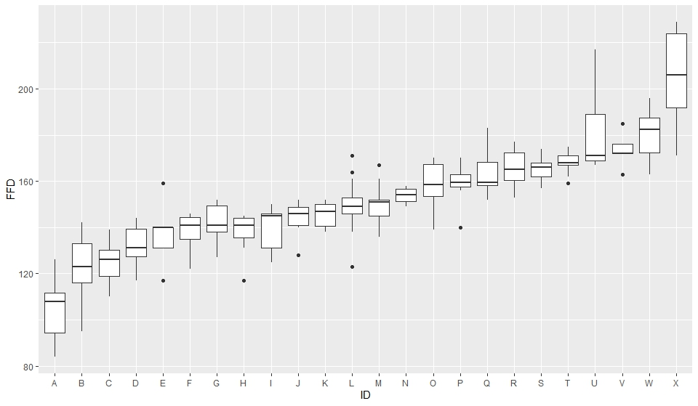

Figure X. Box plots of the first flowering day of 24 plant species from the Bluestem Prairie reserve in Clay county, MN. Observations were made between 1942-1961 and 2012-2020. Box plots indicate distribution quartiles and standard error bars. The species codes are as follows:A=Anemo paten;B=Ranun rhomb;C=Calth palus;D=Ceras arven;E=Ranun abort;F=Oxali viola;G=Sisyr angus;H=Litho canes;I=Trill cernu;J=Litho incis;K=Pedic canad;L=Zizia aurea;M=Vicia ameri;N=Cypri candi;O=Achil mille;P=Anemo canad;Q=Oxytr lambe;R=Rosa arkan;S=Penst grand;T=Penst graci;U=Campa rotun;V=Zigad elega;W=Amorp canes;X=Oenot nutta.