# Abstract

# Introduction

One of the best documented biotic effects of climate change is changing flowering phenology, or flower timing (Wolkovich et al. 2012, Schwartz et al. 2006, Parmesan 2006, Miller-Rushing and Primack 2008, Cleland et al. 2007). Flowering phenology is important for plant-pollinator interactions as sasynchrony between flower timing and pollinator emergence can be detrimental for plant reproduction and pollinator health(Cleland et al. 2012, Kharouba and Wolkovich 2020, Kharouba et al. 2018, Visser and Gienapp 2019). Asynchrony is problematic for plant and pollinator populations, the communities they inhabit, and the ecosystem services they provide.

Flowering can be triggered by a number of environmental cues such as photoperiod, amount of precipitation or soil moisture, and temperature. Climate change may alter these environmental cues resulting in the changing flowering phenology. Most phenology research has focused on temperature and CO2 levels changing with global warming. In prairies, flowering phenology has been strongly linked with temperature (Reed et al. 2019). Reed et al. found advancement of phenological events due to temperature. However, temperature is not the only climate or environmental variable affected by the accumulation of greenhouse gases, overall precipitation is expected to increase in the Midwest (IPCC 2014).How climate change is altering snowpack and local temperatures.

Snowpack alters flowering phenology in montane and tundra species. Inouye et al. (2002) found a significant correlation between date of first bare ground and date of first flowering for *Delphinium barbeyi*, a subalpine species. Similarly, Sherwood et al. (2017) found advanced emergence, bud break, and flowering in a montane forb when snowpack was reduced. However, the snow removal treatment also resulted in increased frost damage among buds due to the lack of insulation from snow and freezing night temperatures. Species in the tundra had similar responses. Bjorkman et al. (2015) found that snowmelt was strongly related to flowering time for four arctic tundra species, while manipulating temperatures was not consistent driver of flowering phenology.

Though there have been several studies on the effects of snowpack on flowering phenology for montane and tundra species, from our understanding, no studies have been conducted on the effects of snowpack on the flowering of prairie species. Therefore, this study examines the effect that snowpack and snow accumulation have on flowering phenology for 21 prairie forbs. The goals of this study are:

1. Simultaneously assess direct and indirect effects of temperature and precipitation variables through path analysis.
2. Determine if bare ground is an integral intermediate step between winter precipitation and flowering phenology.
3. Compare phenological responses, whether advanced or delayed, across several species using a long-term data set.

# Methods

## Data collection

We used historical data collected by O.A. Stevens and SET to create a dataset of first flowering days (FFD) for 25 flowering plant species. The observations were made at Bluestem Prairie (link), a tallgrass prairie site in Clay county Minnesota that has been a Nature Conservancy preserve since 1975. Individual data points represent the day of the year on which a given plant species was observed flowering at the site although all species were not observed in all years. The Stevens dataset represents continuous data from 1910 to 1961 (Travers And Dunnell 2009); subsequent observations are from 2012 through 2020. Thus, there is a 52-year gap in data at the end of the past century. The plant species analyzed in this study were limited to those that met a series of minimum data requirements. The focal species had a minimum of five years of observations and at least one observation prior to 1962 and one after.

In order to quantify different environmental variables related to annual climate patterns, we used daily climate data collected in Fargo, North Dakota, USA, as part of the National Atmospheric and Oceanic Administration (NOAA) National Climatic Data Center (NCDC) observing network (http://www.ncdc.noaa.gov/oa/ncdc.html). The climate data collection site (46 ° 56’ N, 96 ° 49’ W) is located at the Fargo International Airport 32 km west of the flowering observation site. The climate dataset includes daily estimates of maximum and minimum temperature, snowpack (0=bare ground) and snowfall beginning in 1942. However, snowpack data is unavailable for 1997 through 2004. As a result, we were able to analyze data for a total of 29 years (1942-1961 and 2012-2020).

## Climate Variables

We used the raw climate data to calculate four variables regarding annual patterns of temperature or winter snowfall. The first climate variable we calculated for each year was intended to quantify the relative warmth of the late winter/early spring season when the earliest flowering on the prairie is initiated. This variable, Accumulated Degree Growing Unit (AGDU), is was calculated as the day of the year on which the sum of the growing units of the year exceeded 300. Growing units are defined as a daily measure of the difference between the average temperature and 35˚ F; units were set to zero if the average temperature was below 35 ˚ F (citation). We chose 300 units as the cutoff because this number of units is typically accumulated by the end of March. Thus, in years with warmer spring months the AGDU value will be relatively lower and vice versa.

Three different winter precipitation variables were calculated. The winter snowfall amount for a given year (TSNOW) was calculated as the sum of daily snowfall over the first 90 days of a given year. A second variable associated with winter snowfall was the Date of Bare Ground (DOBG) or the day of the year when snowpack first reached zero. A couple records indicated a short period, one to two days, of snowpack late in the season which were excluded for a more realistic representation of first bare ground. The third variable associated with winter snowfall was Snowpack on Day X (SPDX), a variable designed to estimate the extent of snowpack just prior to the growing season. To calculate SPDX for each species we used linear regression and model selection to identify which day in March represented the optimal day for best predicting the first flowering day (FFD) for that species from snowpack. The most predictive day was determined separately for each plant species. We ran separate linear regressions where FFD was the dependent variable and snowpack on day X was the independent variable for each day in March. AIC values were determined for each regression and the model associated with the lowest AIC value was chosen and used to assign the day in March consistently used for SPDX in that species. Thus, SPDX values increase with increase and decrease with increasing and decreasing snowpack on the selected day of March. Each of the four climate variables were not independent of each other.

## Model development

Our goal was to use Structural Equation Modelling (citation) to simultaneously assess the relationships between each of the four climate variables and the first flowering day (FFD) of the focal plant species, given the covarying nature of the climate variables. We used the *lavaan* package in R to incorporate path analysis and examine the relationships among the climate variables and the dependence of FFD on each of the climate variables individually. In our initial, full model, we included AGDU and TSNOW as exogenous variables and DOBG, SPDX, and FFD as endogenous variables (Fig. 1). The assumption was that FFD could have direct and indirect effects from both temperature (AGDU) and winter snowfall (TSNOW) through their indirect effects on snowpack in March (SPDX) and the date at which the snow melted (DOBG). The model included regressions for each endogenous variable, variances within all variables, and residual covariances between the exogenous variables (citations). We considered both direct and indirect regressions. To best compensate for missing data points over the course of the 29 years analyzed, we applied full information maximum likelihood (FIML) estimation to determine path coefficients and model statistics. We used regression estimates for indirect and direct effects to interpret the relationships between latent variables in each of the species.

In order to identify the best overall structural equation model for analyzing relationships among climate and flowering variables we used a model selection approach and compared the fit of the full model (above) to three other reduced models that omitted either DOBG, SPDX, and AGDU. After using the lavaan program to conduct path analyses of the three reduced models, we used Akaike Information Criterion (AIC) to select the model of the four that best represented the data based on the lowest AIC value.

# Results

## Variation in first flowering day (FFD)

We identified 24 flowering plant species in the Stevens Data set that met the criteria for analysis described in the methods. None of the species were observed in every year of the survey; sample size by species ranged from X to Y. The first flowering day (FFD) varied extensively both among years within a species and among species. Median FFD varied across the species from a low of X to a high of Y and included early, mid, and late spring flowering species (Fig. X)1)

## Model selection

## Model selection comparisons of AIC values among the three reduced models and the full model indicated that the best explanatory model was the reduced model which excluded DOBG indicating that the influence of temperature and snowfall on flowering date was relatively negligent through an indirect effect on when the ground first became bare of snow each spring.

Based on the chi squared statistic estimating goodness of fit of the reduced model for FFD of each species the model was a good representation of the relationships among the exogenous and endogenous variables for all but five species *(Anemone patens*, *Caltha palustris*, *Lithospermum canescens*, *Campanula rotundifolia*, and *Amorpha canescens)*. These five species were removed from further analysis and consideration.

The results of path analysis are presented in Figure 3 for each of the remaining species arranged by order of seasonal flowering sequence. The direct relationship between AGDU and FFD was significant in 12 out of 19 species analyzed suggesting an important role of temperature in determining flowering time for a majority of species. All twelve of species with significant AGDU effects had positive coefficients, indicating that warmer temperatures earlier in the year led to earlier flowering. The five first flowering species had strong and significant relationships between AGDU and FFD. Later flowering species typically had weaker, inconclusive relationships and few were significant. (say something here about general effects of AGDU on SPDX). Winter temperatures (AGDU) also had indirect effects on flowering time (FFD) through intermediary effects on the snowpack in March (SPDX) for 1 species (*Zigadenus elegans*).

The relationship between snowfall in the winter months (TSNOW) and snowpack in March (SPDX) was a predictably strong one. The path coefficient between the two variables was positive and significant for all species. TSNOW was expected to be related to SPDX because both describe winter snowfall. However, only three out of the 19 species had a significant relationship between SPDX and FFD. In one species (*Cypripedium candidum*) the path coefficient was negative indicating that relatively large amounts of winter snowfall led to earlier flowering relative to years when there was less winter snowfall. However in the other two species (*Zigadenus elegans* and *Rosa arkansana*) the coefficient was positive. There were significant indirect effects of TSNOW on FFD for the same three species through its effects on SPDX(Table 1).

# Discussion

In this study we built a model to analyze relationships between temperature (AGDU), snowfall (TSNOW), snowpack (SPDX), date of first bare ground (DOBG), and first flowering day (FFD) for 21 prairie species. The model for all species improved when we excluded DOBG. We expected that the date of first bare ground would influence first flowering day as was reported by Inouye (2002) for montane species in Colorado. However, only a few of the species had a significant relationship between DOBG and FFD suggesting that when the winter snow melts is not important for determining when plants begin flowering. An explanation for the lack of relationship between DOBG and FFD is that early DOBG could lead to increased frost damage in sensitive buds while later DOBG extends the date at which buds could emerge (Sherwood 2017). Plants themselves may also compensate for a late start by shortening other growth stages, resulting in the same flower timing regardless of DOBG (Semenchuk 2016). In contrast, temperature seems to be a consistent determinant of flower timing.

AGDU and FFD had a positive and significant relationship in most of the species. A higher AGDU means a colder spring suggesting that temperature is important for growth and development. This was especially the case for earlier flowering species. These results mirror those of other studies of both upper Midwestern prairie plants (citations) and those in other temperate communities (citations). HOW AND WHY SHOULD TEMPERATURE BE IMPORTANT. ARE THESE RESULTS DIFFERENT FROM ALPINE ENVIRONMENTS

Snowpack in March was largely unimportant, with the exception of three species. Two species (*Rosa arkansana* and *Zigadenus elegans*) had positive regression coefficients meaning the deeper the snow on day X in March, the later the species flowered. This outcome would be expected if snow cover impaired earlier flowering. DOBG may have been important in these species. One species (*Cypripedium candidum*) has a negative regression coefficient suggesting that the amount of moisture from snow melting is important in determining the flowering phenology*.* All three species had significant indirect effects between TSNOW and FFD through SPDX. Interestingly, these three species also flower later in the season, after June. This could be explained by soil moisture. Soil moisture from snowpack can take months to dissipate (Wang 2017). Snowmelt and early evapotranspiration could affect the soil moisture available for species that flower later in the season (Wang 2017). These three species may have to compensate for the conditions that resulted from snowpack by shifting flowering phenology.

Overall, our results suggest that snowpack does not have a strong relationship with flower timing. Snowpack may not inhibit flowering because, even with a late start, growing plants may be able to catch up (citation). We expected snowpack to influence early flowering species and not later flowering species but, our results indicate that growth and flowering begin regardless of snow cover. In comparison with snowpack, air temperature had a much stronger effect on when plants flower. The five earliest flowering species had significant regression coefficients for the effect of AGDU on FFD. However, there were also several other species with significant relationships between AGDU and FFD with flowering dates interspersed throughout the growing season. We can therefore draw the conclusion that temperature is more strongly associated with flowering phenology than snowpack for prairie species.

Further research is needed to better understand the relationships between changing climatic conditions and flowering phenology. We only considered snow cover and melt but, other forms of precipitation might be more tightly related to triggering flowering. Patricola and Cook (2013) found that precipitation is expected to increase for April and May with climate change and decrease for July and August. These changes could have implications for flowering phenology.

Literature Cited

IPCC, 2014: Climate Change 2014: Synthesis Report. Contribution of Working Groups I, II and III to the Fifth Assessment Report of the Intergovernmental Panel on Climate Change [Core Writing Team, R.K. Pachauri and L.A. Meyer (eds.)]. IPCC, Geneva, Switzerland, 151 pp.

Christina M. Patricola and Kerry H. Cook 2013: Mid-twenty-first century warm season climate change in the central United States. Part I: regional and global model predictions. *Climate Dynamics,* 40, 551-568. <https://doi.org/10.1007/s00382-012-1605-8>

Reed et al. 2019?

Table 1. Statistical summary of regression coefficients for direct and indirect effects for reduced model. AD = indirect effect for TSNOW on FFD mediated by SPDX, BD = indirect effect for AGDU on FFD mediated by SPDX. Number of asterisks indicate level of significance for p-value: *p ≤ 0.05, **p ≤ 0.01, ***p ≤ 0.001.

|  |  |  |  |  |  |  |
| --- | --- | --- | --- | --- | --- | --- |
| Species | A  SPDX~TSNOW | B  SPDX~AGDU | C  FFD~AGDU | D  FFD~SPDX | AD | BD |
| *Ranunculus rhomboides* | 0.471** | 0.178 | 0.737*** | 0.295 | 0.139 | 0.053 |
| *Cerastium arvense* | 0.281*** | 0.066 | 0.427*** | 0.348 | 0.098 | 0.023 |
| *Ranunculus abortivus* | 0.508*** | 0.098 | 0.595*** | 0.679 | 0.345 | 0.066 |
| *Oxalis violacea* | 0.405*** | 0.139* | 0.319* | 0.146 | 0.059 | 0.020 |
| *Sisyrinchium angustifolium* | 0.281*** | 0.066 | 0.334** | 0.405 | 0.114 | 0.027 |
| *Trillium cernuum* | 0.553*** | 0.056 | -0.211 | 1.288 | 0.712 | 0.072 |
| *Lithospermum incisum* | 0.553*** | 0.056 | 0.486*** | -0.061 | -0.033 | -0.003 |
| *Pedicularis canadensis* | 0.151** | 0.083* | -0.048 | 1.359 | 0.205 | 0.113 |
| *Zizia aurea* | 0.427*** | 0.102* | 0.652*** | 0.307 | 0.131 | 0.031 |
| *Vicia americana* | 0.134*** | 0.081** | 0.371 | -0.452 | -0.060 | -0.037 |
| *Cypripedium candidum* | 0.398*** | 0.074 | 0.113 | -0.438* | -0.174* | -0.032 |
| *Achillea millefolium* | 0.257*** | 0.036 | 0.529** | 0.042 | 0.011 | 0.002 |
| *Anemone canadensis* | 0.398*** | 0.074 | 0.491*** | -0.092 | -0.037 | -0.007 |
| *Oxytre lambe* | 0.493*** | 0.008 | 0.133 | 0.573 | 0.283 | 0.004 |
| *Rosa arkansana* | 0.398*** | 0.074 | 0.364** | 0.700** | 0.279** | 0.052 |
| *Penstemon grandifloras* | 0.438*** | 0.097 | -0.077 | 0.382 | 0.167 | 0.037 |
| *Penstemon gracilis* | 0.459*** | 0.106 | 0.241* | 0.067 | 0.031 | 0.007 |
| *Zigadenus elegans* | 0.144*** | 0.091** | 0.301*** | 0.467*** | 0.067* | 0.043* |
| *Oenothera nuttallii* | 0.340* | 0.178 | -0.177 | 1.236 | 0.421 | 0.220 |

**FIGURE LEGENDS**

Figure 1. Box plots of the first flowering day (FFD) of 24 plant species from the Bluestem Prairie reserve in Clay county, MN. Observations were made between 1942-1961 and 2012-2020. Box plots indicate distribution quartiles and standard error bars. The species codes are as follows: A=Ranun rhomb;B=Ceras arven;C=Ranun abort;D=Oxali viola;E=Sisyr angus; F=Trill cernu;G=Litho incis;H=Pedic canad;I=Zizia aurea;J=Vicia ameri;K=Cypri candi;L=Achil mille;M=Anemo canad;N=Oxytr lambe;O=Rosa arkan;P=Penst grand;Q=Penst graci; R=Zigad elega; S=Oenot nutta.

Figure 2. Path diagrams with direct effect estimates labeled. Number of asterisks indicate level of significance for p-value: *p ≤ 0.05, **p ≤ 0.01, ***p ≤ 0.001.

Figure 3. Simple linear regressions of FFD as a function of SPDX for each species with best-fit lines based on least-square estimates. Results for species are organized in order of flowering sequence over the season from early spring to late summer

**FIGURES**

Figure 1.

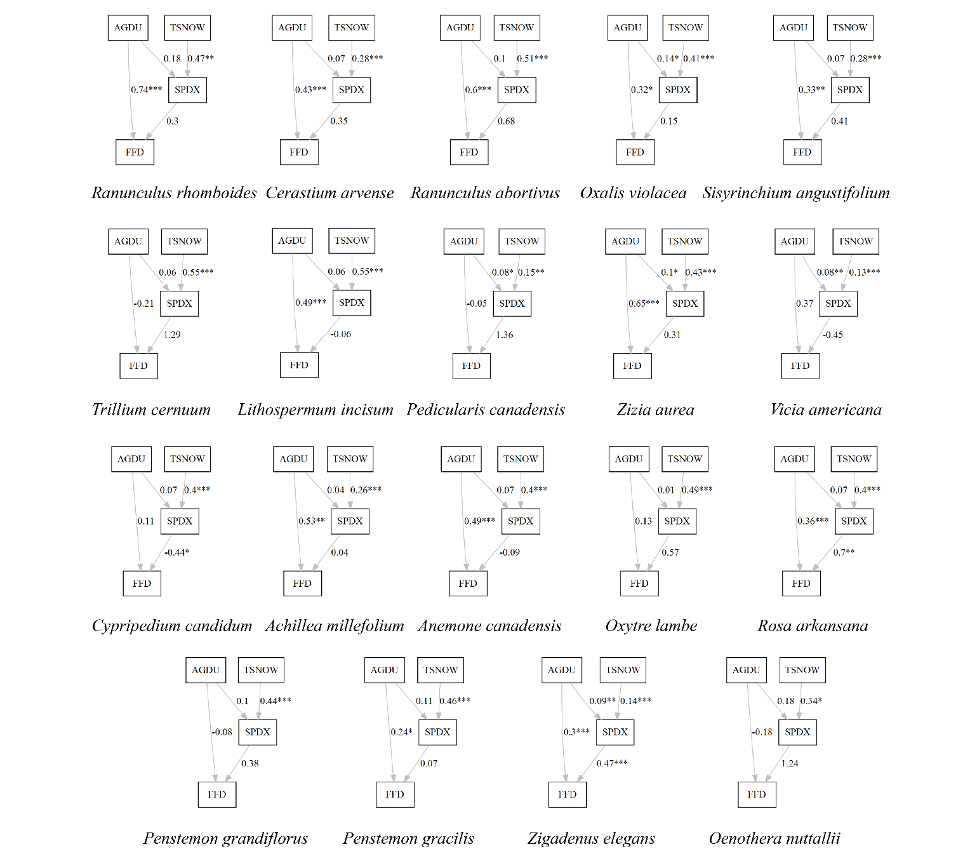

Figure 2.

Figure 3.