**Appendix**

Table. Differences between genets separated by region using a one-way analysis of variance.

|  |  |  |  |  |  |  |
| --- | --- | --- | --- | --- | --- | --- |
|  | **North** | | | **South** | | |
| **Variable** | **Different** | **F-value** | **p-value** | **Different** | **F-value** | **p-value** |
| Cell Membrane Stability (Heat) | No | 1.383 | 0.143 | No | 1.461 | 0.107 |
| Cell Membrane Stability (Cold) | No | 0.156 | 0.968 | No | 0.789 | 0.743 |
| Chlorophyll Fluorescence (Heat) | No | 1.177 | 0.289 | No | 0.687 | 0.853 |
| Chlorophyll Fluorescence (Cold) | No | 1.194 | 0.273 | **Yes** | **1.764** | **0.032** |
| Photosynthetic Rate (Heat) | No | 1.065 | 0.413 | No | 1.852 | 0.050 |
| Photosynthetic Rate (Cold) | No | 1.220 | 0.264 | No | 1.548 | 0.106 |
| Pollen Germination (Tmax) | No | 1.078 | 0.459 | No | 2.371 | 0.054 |
| Pollen Germination (Topt) | No | 1.132 | 0.423 | No | 2.025 | 0.094 |
| Pollen Germination (Tmin) | No | 2.125 | 0.093 | No | 2.204 | 0.070 |
| Pollen Tube Growth Rate (Tmax) | No | 0.546 | 0.885 | No | 2.292 | 0.061 |
| Pollen Tube Growth Rate (Topt) | No | 0.559 | 0.875 | No | 1.700 | 0.158 |
| Pollen Tube Growth Rate (Tmin) | No | 1.074 | 0.462 | No | 0.784 | 0.634 |

Table. Difference in variation between the two regions for all variables using Bartlett’s test of homogeneity of variances.

|  |  |  |  |  |
| --- | --- | --- | --- | --- |
|  | **Variable** | **Difference** | **More Variation** | **p-value** |
| **Sporophyte** | Cell Membrane Stability (Heat) | No | - | 0.853 |
| Cell Membrane Stability (Cold) | No | - | 0.416 |
| Chlorophyll Fluorescence (Heat) | **Yes** | **North** | **1.68E-04** |
| Chlorophyll Fluorescence (Cold) | **Yes** | **South** | **9.26E-04** |
| Photosynthetic Rate (Heat) | No | - | 0.541 |
| Photosynthetic Rate (Cold) | No | - | 0.552 |
| **Gametophyte** | Pollen Germination (Tmax) | No | - | 0.515 |
| Pollen Germination (Topt) | No | - | 0.972 |
| Pollen Germination (Tmin) | No | - | 0.1557* |
| Pollen Tube Growth Rate (Tmax) | No | - | 0.107 |
| Pollen Tube Growth Rate (Topt) | No | - | 0.532 |
| Pollen Tube Growth Rate (Tmin) | No | - | 0.487 |

Table. Results from principal component analysis with all gametophytic and sporophytic variables. Importance of components shown for each principal component.

|  |  |  |  |  |  |  |  |  |
| --- | --- | --- | --- | --- | --- | --- | --- | --- |
|  | **PC1** | **PC2** | **PC3** | **PC4** | **PC5** | **PC6** | **PC7** | **PC8** |
| **Standard deviation** | 1.353 | 1.237 | 1.098 | 1.031 | 0.911 | 0.790 | 0.716 | 0.634 |
| **Proportion of Variance** | 0.229 | 0.191 | 0.151 | 0.133 | 0.104 | 0.078 | 0.064 | 0.050 |
| **Cumulative Proportion** | 0.229 | 0.420 | 0.571 | 0.704 | 0.808 | 0.886 | 0.950 | 1.000 |

Table. Results from principal component analysis with gametophytic and sporophytic variables. Loadings for each variable on all principal components.

|  |  |  |  |  |  |  |  |  |
| --- | --- | --- | --- | --- | --- | --- | --- | --- |
|  | **PC1** | **PC2** | **PC3** | **PC4** | **PC5** | **PC6** | **PC7** | **PC8** |
| **Tmin Germination** | -0.256 | 0.589 | -0.189 | 0.175 | -0.130 | -0.417 | 0.393 | -0.419 |
| **Tmax Germination** | 0.457 | -0.270 | 0.135 | -0.358 | -0.099 | -0.685 | 0.285 | 0.109 |
| **Tmin PTGR** | 0.344 | 0.551 | -0.315 | 0.020 | -0.102 | 0.059 | -0.008 | 0.681 |
| **Tmax PTGR** | 0.552 | 0.282 | 0.009 | -0.212 | -0.184 | 0.109 | -0.484 | -0.540 |
| **HCMS** | -0.199 | 0.048 | -0.280 | -0.816 | -0.003 | 0.337 | 0.309 | -0.070 |
| **CCMS** | 0.258 | -0.362 | -0.381 | 0.317 | -0.570 | 0.287 | 0.364 | -0.129 |
| **HCHPL** | -0.354 | 0.087 | 0.407 | -0.159 | -0.773 | -0.050 | -0.203 | 0.188 |
| **CCHPL** | -0.266 | -0.236 | -0.676 | -0.069 | -0.081 | -0.378 | -0.511 | 0.029 |

Table. Mixed effects model of control values used in calculation for variable proportions.

|  |  |  |  |  |
| --- | --- | --- | --- | --- |
|  | **Region** | | **Genet** | |
| **Variable** | **Difference** | **p-value** | **Difference** | **p-value** |
| Conductivity of cell membrane max damage | No | 0.7917 | No | 0.853 |
| Chlorophyll fluorescence initial value | No | 0.453 | No | 0.125 |
| Net photosynthetic rate initial value | No | 0.2816 | No | 0.578 |

Table. Correlation matrix with correlation coefficient and p-value for each combination of variables.



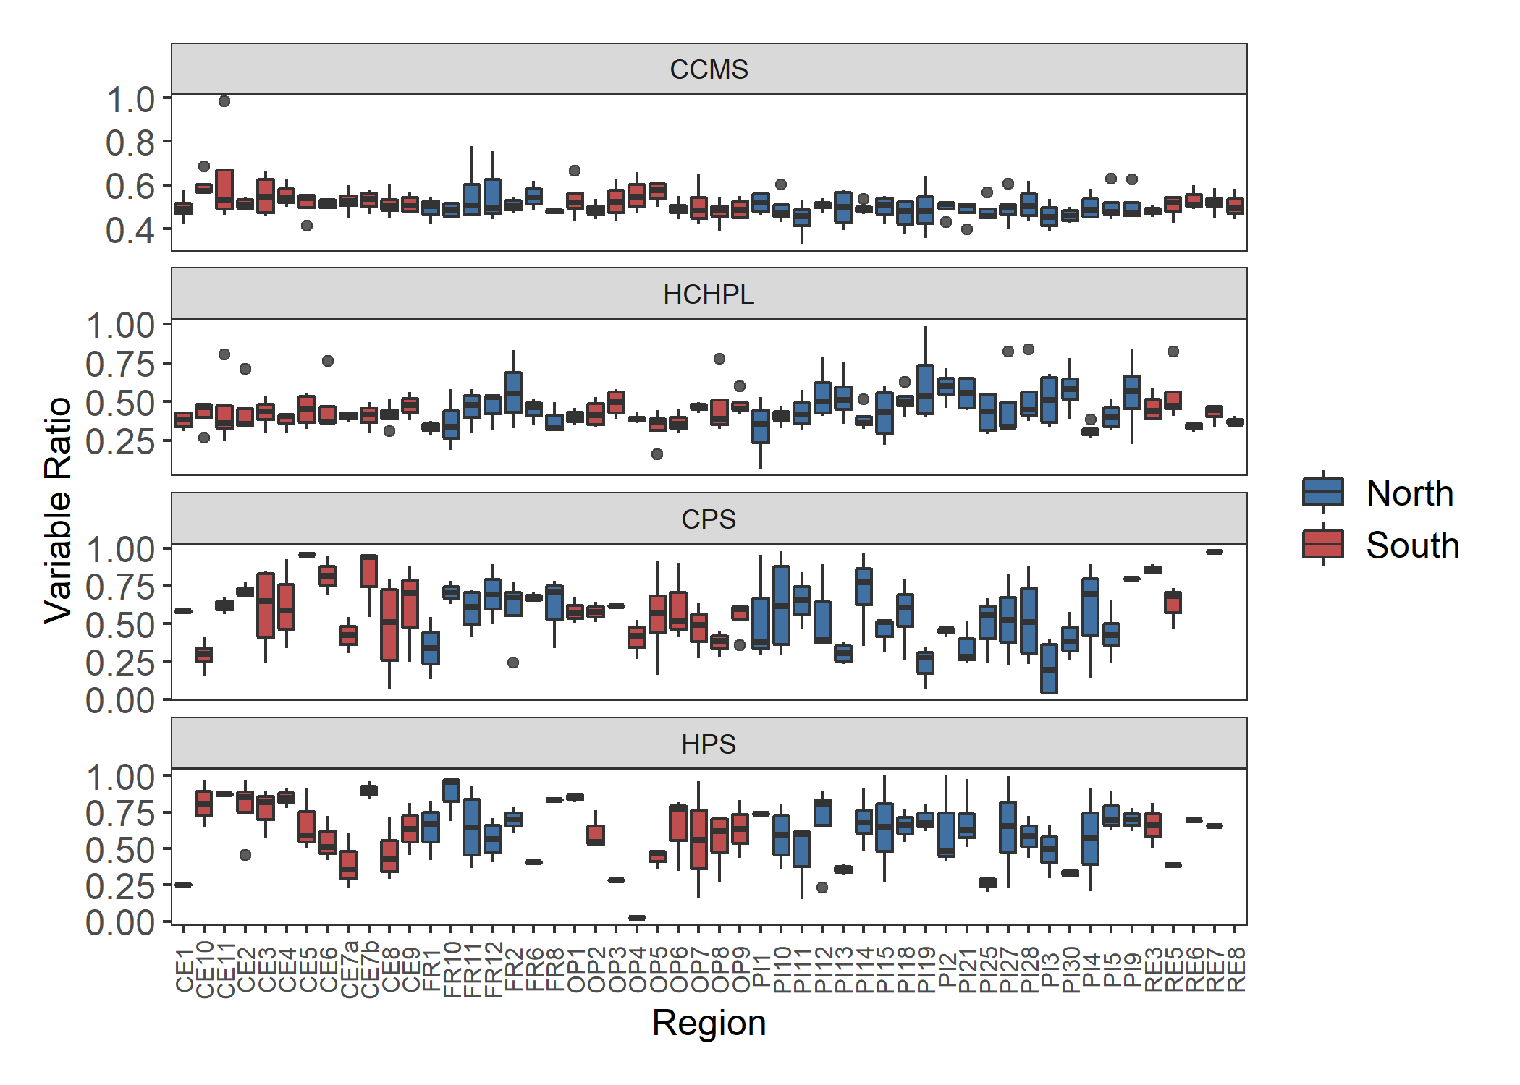

Figure.

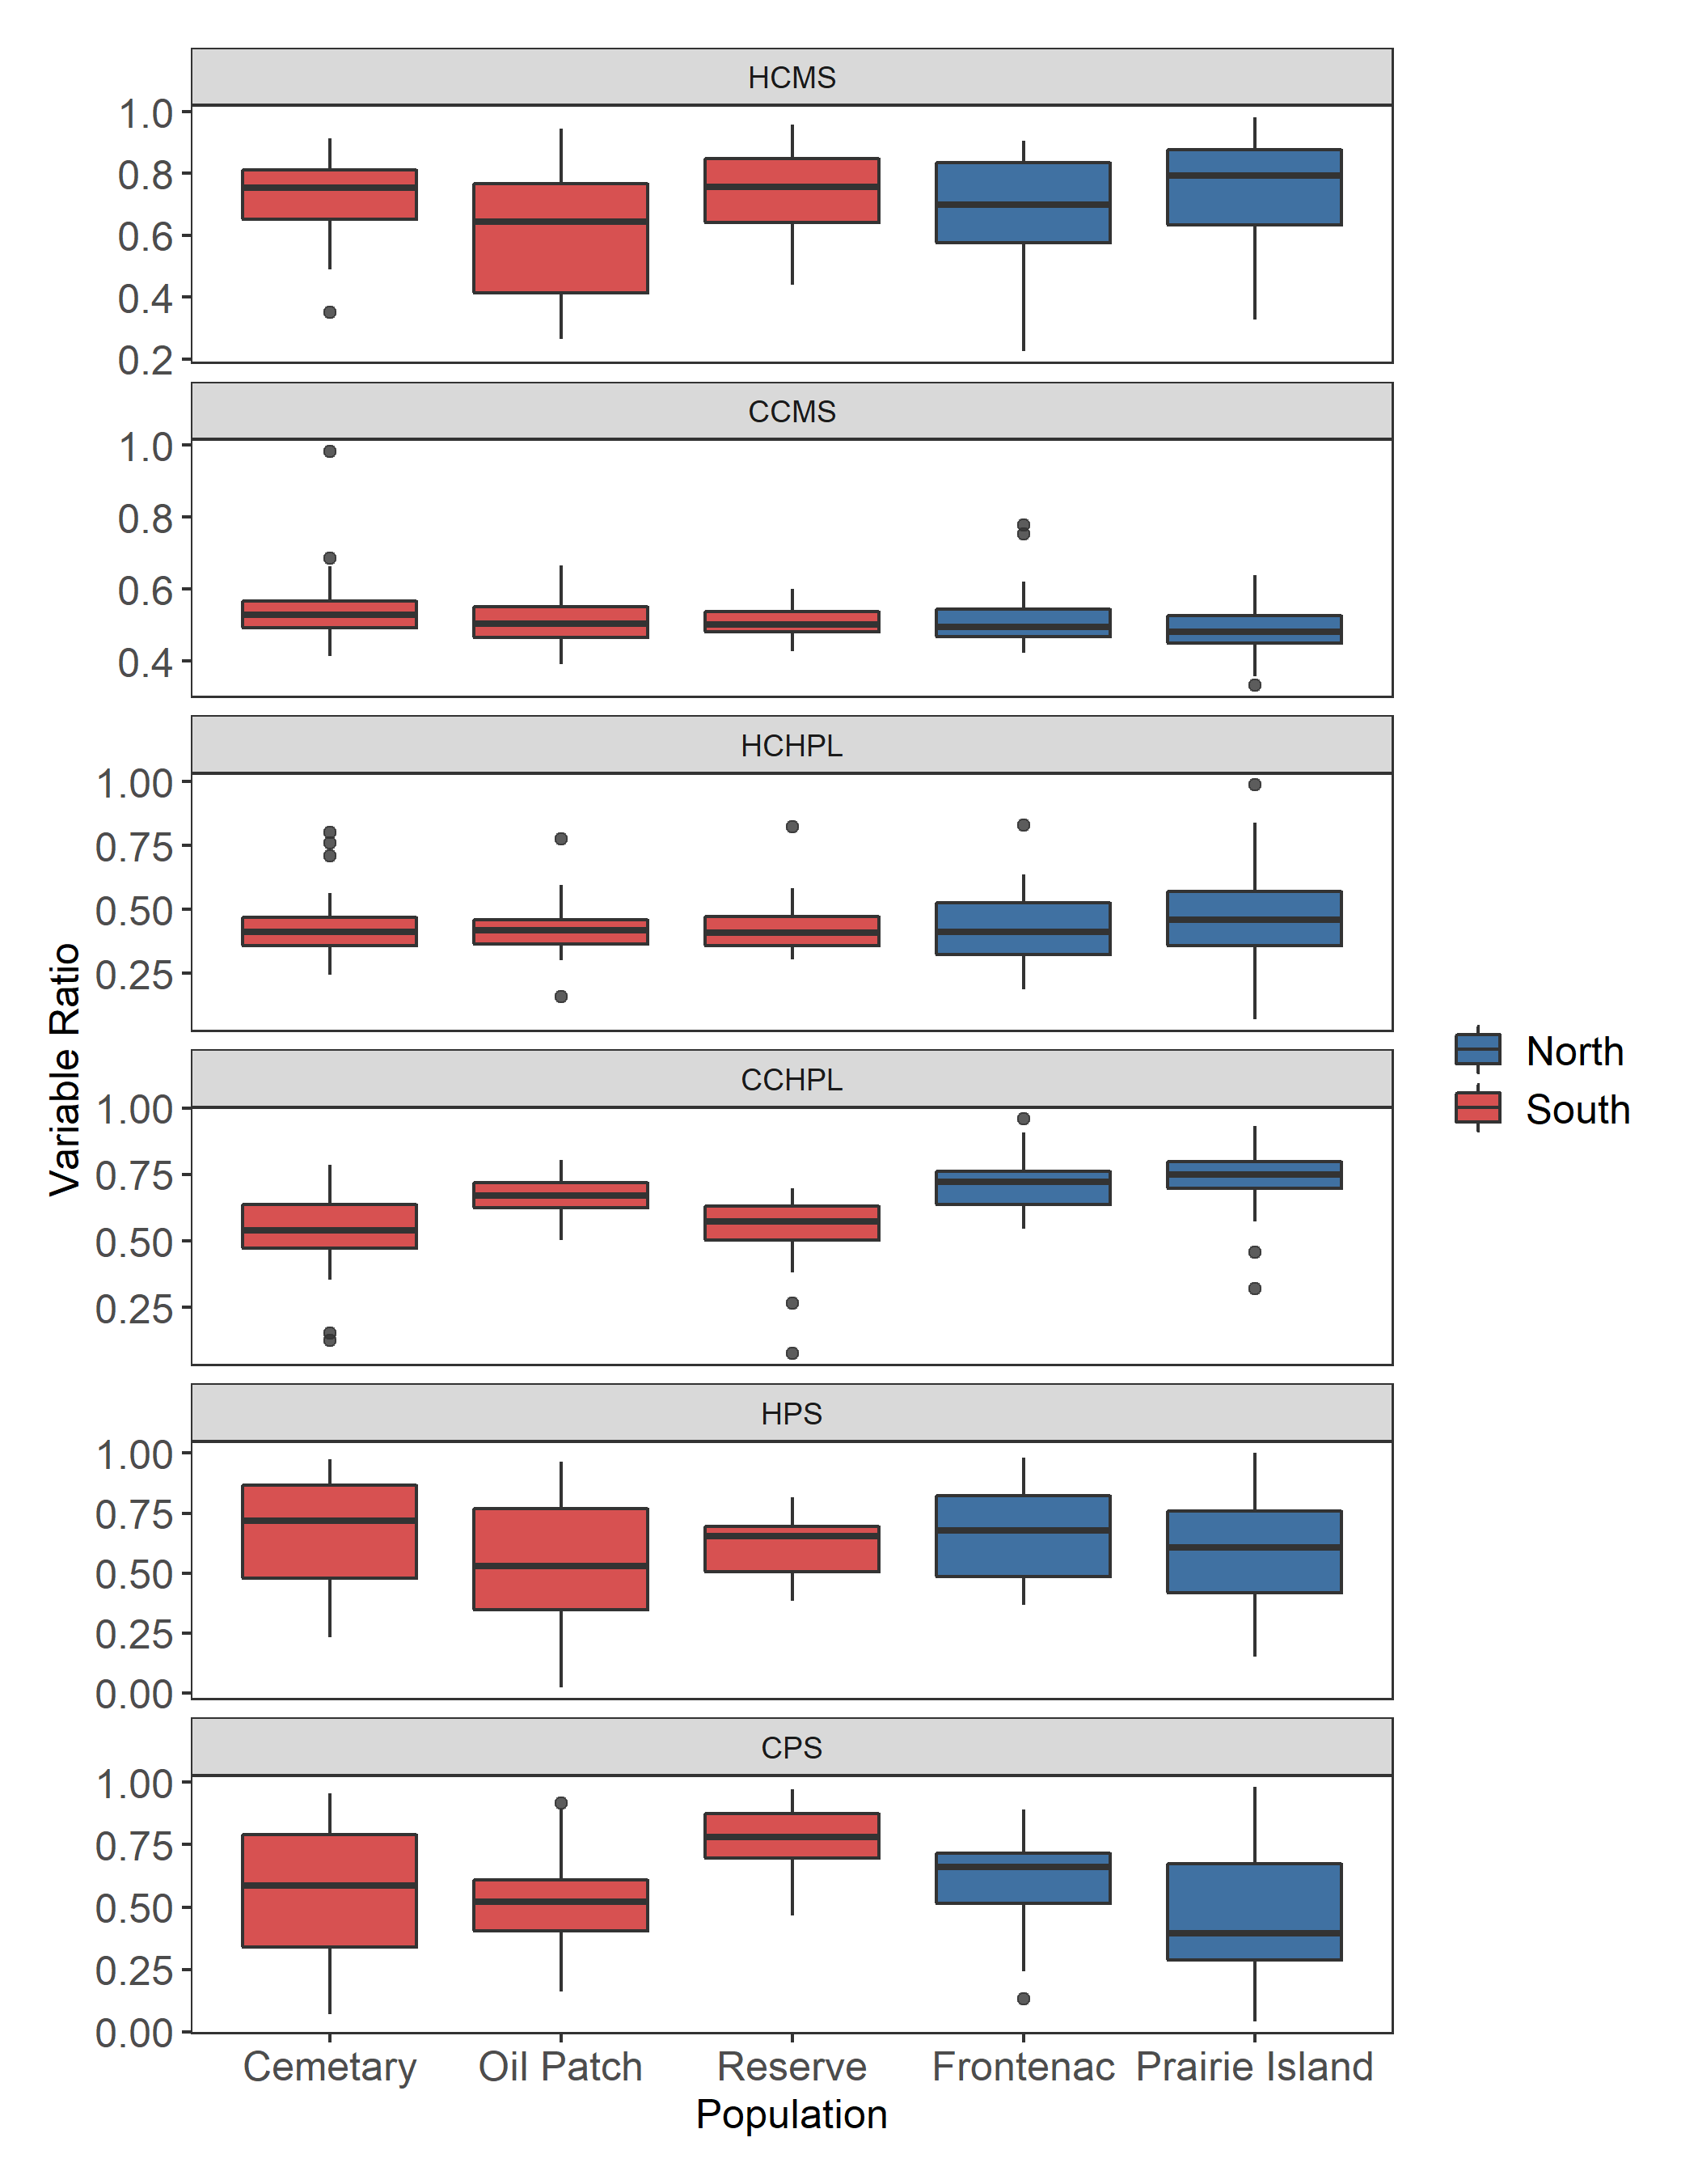

Figure. Differences between the populations for all sporophytic variables.

Figure. Principal component analysis with only sporophytic variables. A) PC1 and PC2, B) PC2 and PC3, C) PC1 and PC3. Ellipsoid indicating 95% confidence interval.

Figure. Pollen germination profiles for genets with at least 3 ramets that flowered. Color indicates region of origin.

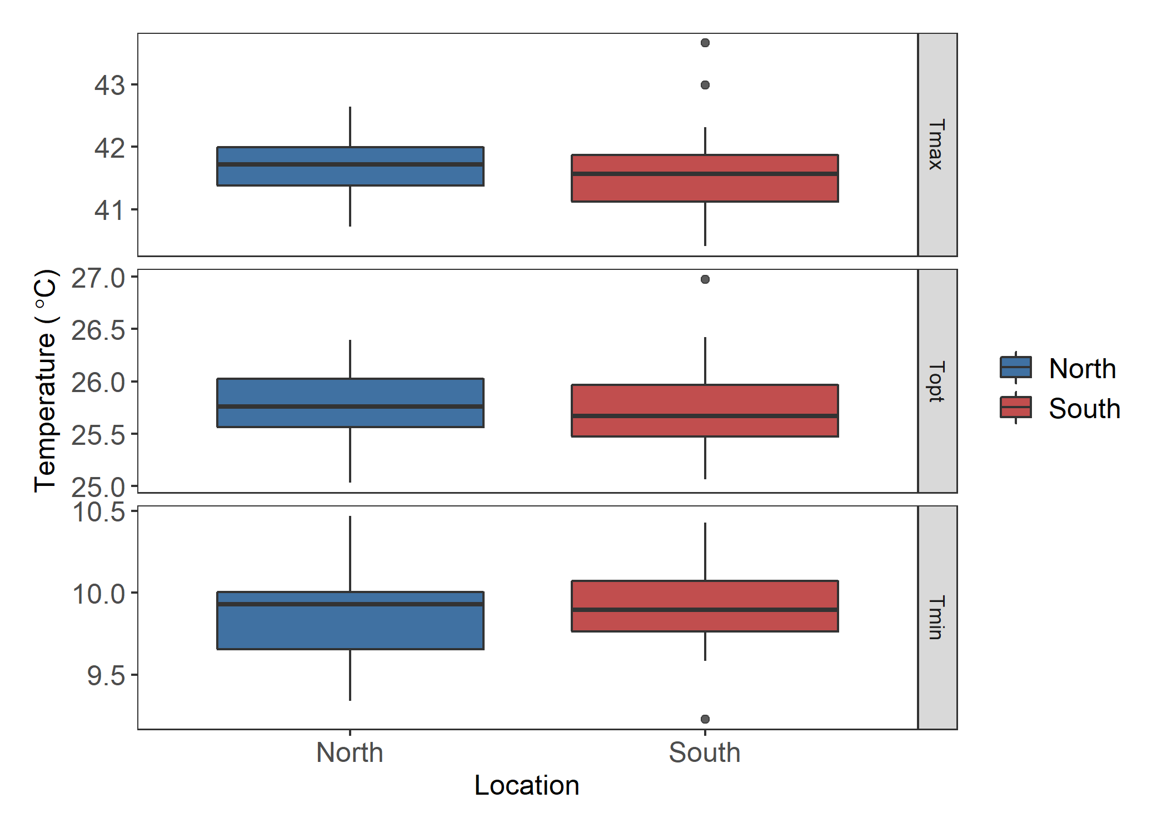

Figure. Pollen tube growth rate values extracted from a quadratic fit for the maximum, optimal, and minimum temperatures.

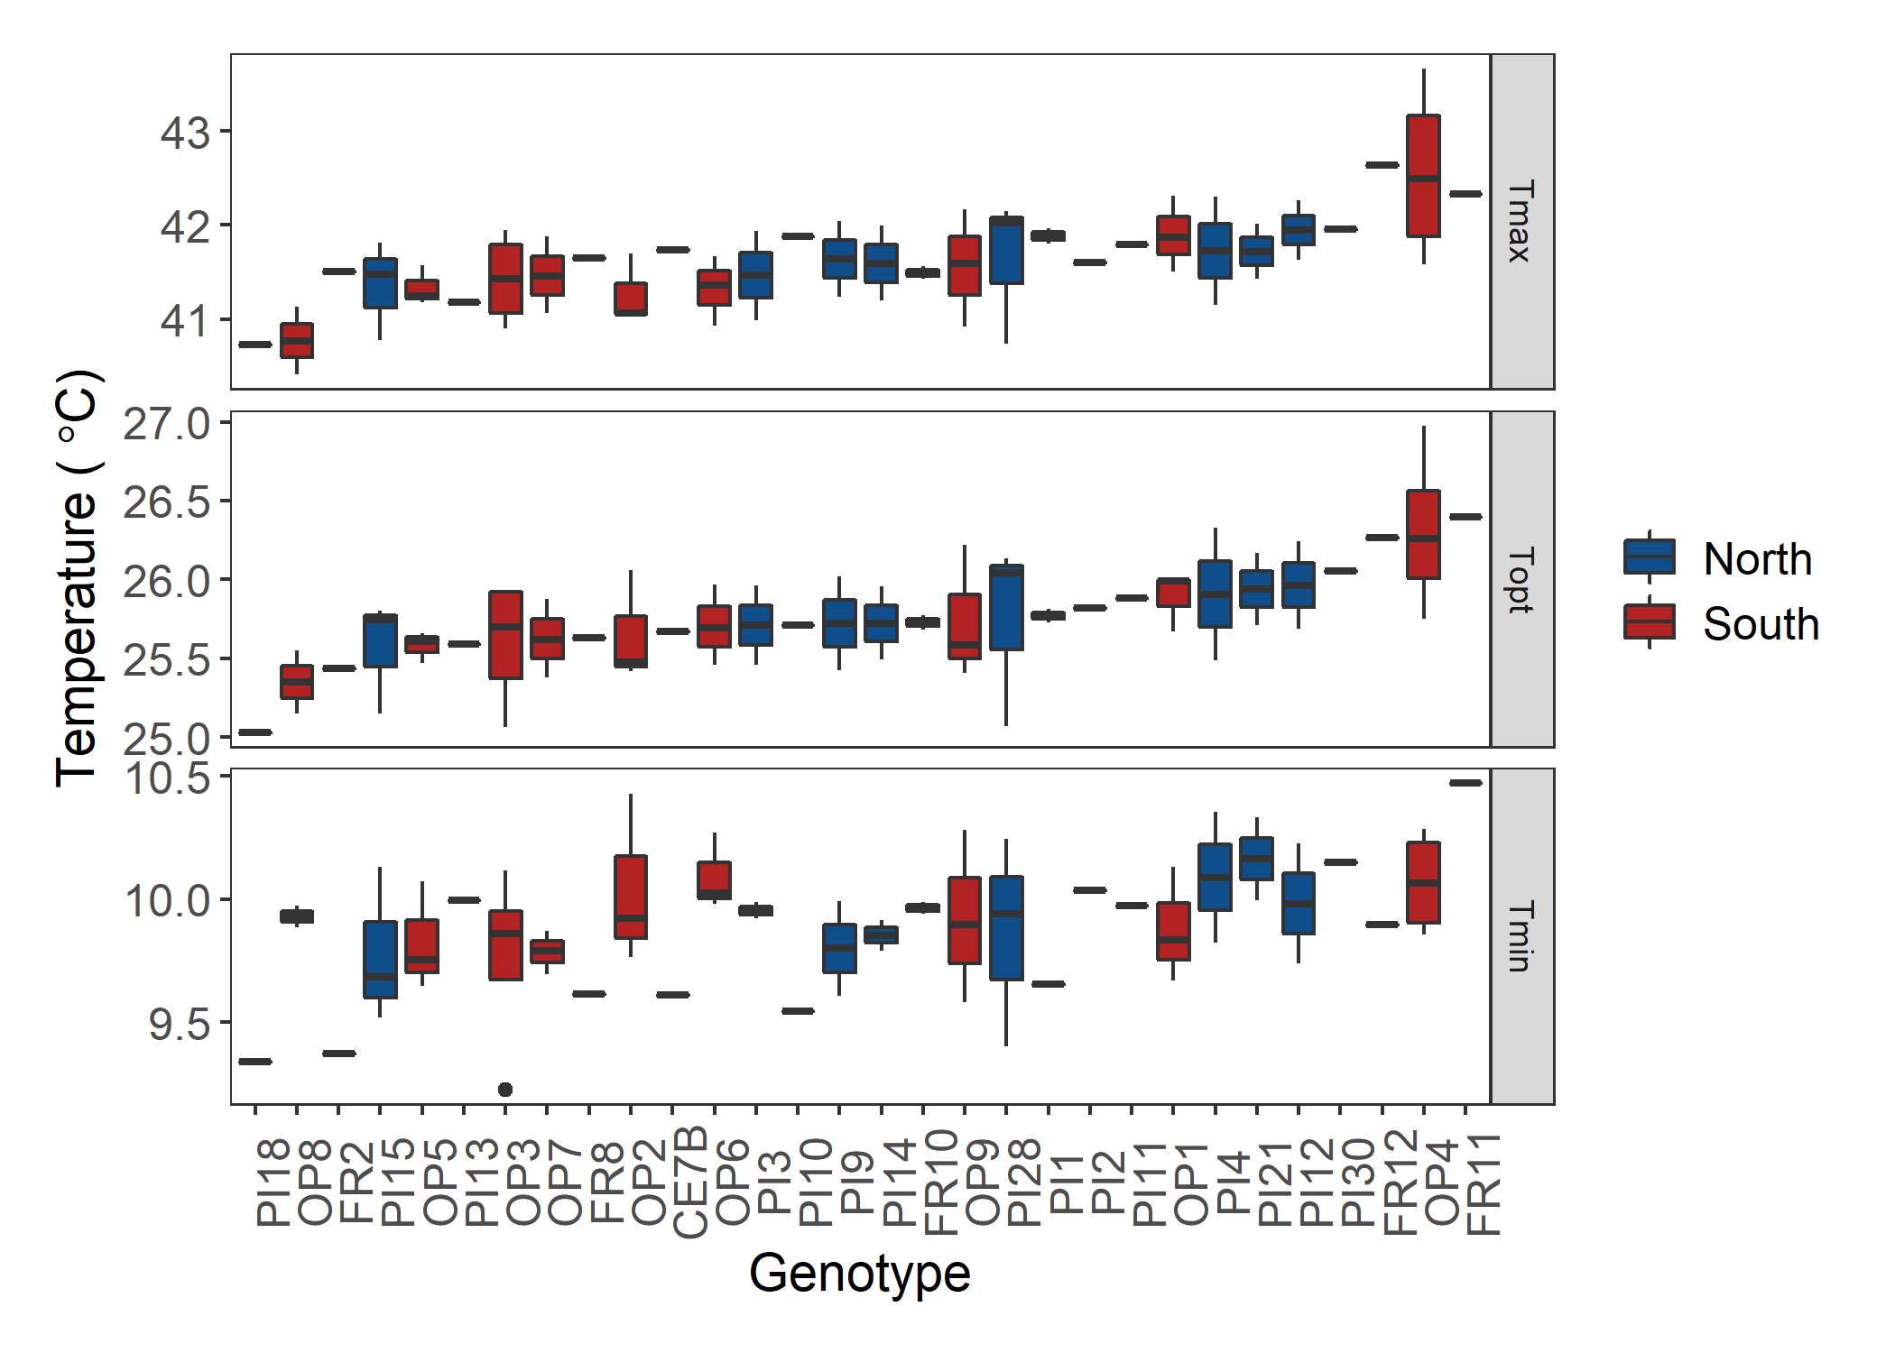

Figure. Genotype differences for the maximum (Tmax), optimal (Topt), and minimum (Tmin) pollen tube growth rate temperatures extracted form the quadratic fits of the pollen tube growth rate data for each individual. There were no significant differences between the genets for pollen tube growth rate.

Figure. Pollen tube growth rate profiles for genets with at least 3 ramets that flowered. Color indicates region of origin.