**Appendix**

Table. Mixed effects model results for each variable. Full model included region as a fixed effect with block and genet nested in population as random effects. Random effect terms were dropped when the model overfit the data.

|  |  |  |  |  |  |  |  |  |  |  |  |
| --- | --- | --- | --- | --- | --- | --- | --- | --- | --- | --- | --- |
|  |  | **Fixed** | | | | **Random Effects** | | | | | |
|  |  | Region | | | | Block | | | Population: Genet | | |
|  | **Variable** | F-value | df | p-value | LRT | | p-value | LRT | | p-value |
| **Sporophyte** | Cell Membrane Stability (Heat) | 3.673 | 49.948 | 0.061 | **4.728** | | **0.030** | 3.320 | | 0.068 |
| Cell Membrane Stability (Cold) | **6.482** | **191.020** | **0.012** | **15.731** | | **7.30E-05** | - | | - |
| Chlorophyll Fluorescence (Heat) | **4.418** | **51.122** | **0.041** | 0.222 | | 0.637 | 0.018 | | 0.892 |
| Chlorophyll Fluorescence (Cold) | **66.369** | **49.933** | **9.97E-11** | 1.018 | | 0.313 | 2.082 | | 0.149 |
| Photosynthetic Rate (Heat) | 1.24E-05 | 1 | 0.997 | - | | - | - | | - |
| Photosynthetic Rate (Cold) | 3.269 | 46.752 | 0.07702 | 0.148 | | 0.701 | 1.674 | | 0.196 |
| **Gametophyte** | Pollen Germination (Tmax) | **14.280** | **1** | **3.70E-04** | - | | - | - | | - |
| Pollen Germination (Topt) | **12.850** | **1** | **6.85E-04** | - | | - | - | | - |
| Pollen Germination (Tmin) | 0.960 | 1 | 0.331 | - | | - | - | | - |
| Pollen Tube Growth Rate (Tmax) | 0.330 | 1 | 0.568 | - | | - | - | | - |
| Pollen Tube Growth Rate (Topt) | 0.087 | 1 | 0.770 | - | | - | - | | - |
| Pollen Tube Growth Rate (Tmin) | 0.683 | 1 | 0.683 | - | | - | - | | - |

Table. Difference in variation between the two regions for all variables using Bartlett’s test of homogeneity of variances.

|  |  |  |  |  |
| --- | --- | --- | --- | --- |
|  | **Variable** | **Difference** | **More Variation** | **p-value** |
| **Sporophyte** | Cell Membrane Stability (Heat) | No | - | 0.896 |
| Cell Membrane Stability (Cold) | No | - | 0.131 |
| Chlorophyll Fluorescence (Heat) | **Yes** | **North** | **2.48E-04** |
| Chlorophyll Fluorescence (Cold) | No | - | 0.057 |
| Photosynthetic Rate (Heat) | No | - | 0.444 |
| Photosynthetic Rate (Cold) | No | - | 0.602 |
| **Gametophyte** | Pollen Germination (Tmax) | No | - | 0.515 |
| Pollen Germination (Topt) | No | - | 0.972 |
| Pollen Germination (Tmin) | No | - | 0.1557* |
| Pollen Tube Growth Rate (Tmax) | No | - | 0.107 |
| Pollen Tube Growth Rate (Topt) | No | - | 0.532 |
| Pollen Tube Growth Rate (Tmin) | No | - | 0.487 |

Table. Mixed effects model results for the difference between population for all sporophytic variables. One-way anova results for the gametophytic variables for the difference between population. Block overfit the model when included for the gametophyte and was therefore excluded from the gametophytic variable models.

|  |  |  |  |  |  |  |
| --- | --- | --- | --- | --- | --- | --- |
|  |  | **Fixed** | | | **Random Effect** | |
|  |  | Population | | | Block | |
|  | **Variable** | F-value | df | p-value | LRT | p-value |
| **Sporophyte** | Cell Membrane Stability (Heat) | **5.563** | **188.06** | **2.97E-04** | **4.210** | **0.040** |
| Cell Membrane Stability (Cold) | **2.824** | **188.06** | **0.026** | **15.342** | **8.97E-05** |
| Chlorophyll Fluorescence (Heat) | 1.732 | 188.25 | 0.145 | 0.188 | 0.665 |
| Chlorophyll Fluorescence (Cold) | **32.341** | **188.22** | **2.20E-16** | 1.477 | 0.224 |
| Photosynthetic Rate (Heat) | 1.473 | 126.00 | 0.214 | -2.84E-04 | 0.214 |
| Photosynthetic Rate (Cold) | **3.717** | **138.74** | **6.62E-03** | 0.032 | 0.858 |
| **Gametophyte** | Pollen Germination (Tmax) | **6.069** | **3** | **1.17E-03** | - | - |
| Pollen Germination (Topt) | **6.861** | **3** | **5.02E-04** | - | - |
| Pollen Germination (Tmin) | 2.656 | 3 | 0.057 | - | - |
| Pollen Tube Growth Rate (Tmax) | 0.400 | 3 | 0.753 | - | - |
| Pollen Tube Growth Rate (Topt) | 0.197 | 3 | 0.898 | - | - |
| Pollen Tube Growth Rate (Tmin) | 0.459 | 3 | 0.712 | - | - |

Table. Results from principal component analysis with all gametophytic and sporophytic variables. Importance of components shown for each principal component.

|  |  |  |  |  |  |  |  |  |
| --- | --- | --- | --- | --- | --- | --- | --- | --- |
|  | **PC1** | **PC2** | **PC3** | **PC4** | **PC5** | **PC6** | **PC7** | **PC8** |
| **Standard deviation** | 1.314 | 1.216 | 1.146 | 1.021 | 0.966 | 0.789 | 0.684 | 0.643 |
| **Proportion of Variance** | 0.216 | 0.185 | 0.164 | 0.130 | 0.117 | 0.078 | 0.059 | 0.052 |
| **Cumulative Proportion** | 0.216 | 0.401 | 0.565 | 0.695 | 0.812 | 0.890 | 0.948 | 1.000 |

Table. Results from principal component analysis with gametophytic and sporophytic variables. Loadings for each variable on all principal components.

|  |  |  |  |  |  |  |  |  |
| --- | --- | --- | --- | --- | --- | --- | --- | --- |
|  | **PC1** | **PC2** | **PC3** | **PC4** | **PC5** | **PC6** | **PC7** | **PC8** |
| **Tmin Germination** | -0.189 | 0.377 | -0.586 | 0.224 | -0.069 | 0.422 | 0.385 | 0.313 |
| **Tmax Germination** | 0.511 | -0.286 | 0.088 | -0.299 | -0.103 | 0.625 | 0.324 | -0.232 |
| **Tmin PTGR** | 0.417 | 0.456 | -0.360 | 0.123 | -0.009 | -0.206 | -0.112 | -0.646 |
| **Tmax PTGR** | 0.628 | 0.195 | -0.072 | -0.150 | -0.025 | -0.069 | -0.354 | 0.639 |
| **HCMS** | 0.035 | -0.352 | -0.516 | -0.468 | 0.215 | -0.466 | 0.351 | 0.058 |
| **CCMS** | 0.271 | -0.325 | 0.021 | 0.575 | -0.522 | -0.319 | 0.326 | 0.095 |
| **HCHPL** | -0.235 | 0.126 | -0.090 | -0.476 | -0.815 | -0.037 | -0.160 | -0.053 |
| **CCHPL** | -0.064 | -0.534 | -0.489 | 0.215 | -0.025 | 0.253 | -0.595 | -0.082 |

Table 2. Results from principal component analysis with sporophytic variables. Importance of components shown for each principal component.

|  |  |  |  |  |  |  |
| --- | --- | --- | --- | --- | --- | --- |
|  | **PC1** | **PC2** | **PC3** | **PC4** | **PC5** | **PC6** |
| **Standard deviation** | 1.159 | 1.1372 | 1.0038 | 0.968 | 0.8775 | 0.8058 |
| **Proportion of Variance** | 0.224 | 0.2155 | 0.1679 | 0.1562 | 0.1283 | 0.1082 |
| **Cumulative Proportion** | 0.224 | 0.4394 | 0.6073 | 0.7634 | 0.8918 | 1 |

Table. Results from principal component analysis with gametophytic variables. Importance of components shown for each principal component.

|  |  |  |  |  |  |  |
| --- | --- | --- | --- | --- | --- | --- |
|  | **PC1** | **PC2** | **PC3** | **PC4** | **PC5** | **PC6** |
| **Standard deviation** | 1.703 | 1.28 | 1.0046 | 0.673 | 0.0008 | 0.0001 |
| **Proportion of Variance** | 0.483 | 0.2731 | 0.1682 | 0.0755 | 0 | 0 |
| **Cumulative Proportion** | 0.483 | 0.7563 | 0.9245 | 1 | 1 | 1 |

Table. Mixed effects model of control values used in calculation for variable proportions.

|  |  |  |  |  |
| --- | --- | --- | --- | --- |
|  | **Region** | | **Genet** | |
| **Variable** | **Difference** | **p-value** | **Difference** | **p-value** |
| Conductivity of cell membrane max damage | No | 0.445 | No | 0.097 |
| Chlorophyll fluorescence initial value | No | 0.795 | No | 0.869 |
| Net photosynthetic rate initial value | No | 0.303 | No | 0.380 |

Table. Correlation matrix with correlation coefficient and p-value for each combination of variables.

|  |  |  |  |  |  |  |  |  |  |  |  |
| --- | --- | --- | --- | --- | --- | --- | --- | --- | --- | --- | --- |
|  |  | **Tmin Germ** | **Tmax Germ** | **Tmin PTGR** | **Tmax PTGR** | **Hot CMS** | **Cold CMS** | **Hot CHPL** | **Cold CHPL** | **Cold PS** | **Hot PS** |
| **Tmin Germination** | **Correlation** | - | **-0.264** | 0.266 | -0.073 | 0.015 | -0.130 | 0.112 | 0.101 | 0.240 | -0.052 |
| **p-value** | - | **0.040** | 0.038 | 0.576 | 0.911 | 0.317 | 0.392 | 0.440 | 0.228 | 0.730 |
| **Tmax Germination** | **Correlation** | **-0.264** | - | 0.061 | **0.371** | 0.112 | 0.167 | -0.078 | 0.065 | 0.062 | 0.054 |
| **p-value** | **0.040** | - | 0.639 | **0.003** | 0.392 | 0.198 | 0.552 | 0.621 | 0.758 | 0.719 |
| **Tmin PTGR** | **Correlation** | 0.266 | 0.061 | - | **0.456** | -0.004 | 0.042 | -0.069 | -0.127 | 0.164 | 0.066 |
| **p-value** | 0.038 | 0.639 | - | **2.18E-04** | 0.977 | 0.745 | 0.596 | 0.331 | 0.412 | 0.662 |
| **Tmax PTGR** | **Correlation** | -0.073 | **0.371** | **0.456** | - | 0.030 | 0.106 | -0.103 | -0.144 | 0.133 | 0.137 |
| **p-value** | 0.576 | **0.003** | **2.18E-04** | - | 0.818 | 0.416 | 0.428 | 0.267 | 0.508 | 0.358 |
| **Hot CMS** | **Correlation** | 0.015 | 0.112 | -0.004 | 0.030 | - | -0.131 | 0.060 | **0.145** | **0.205** | **0.194** |
| **p-value** | 0.911 | 0.392 | 0.977 | 0.818 | - | 0.067 | 0.401 | **0.043** | **0.038** | **0.019** |
| **Cold CMS** | **Correlation** | -0.130 | 0.167 | 0.042 | 0.106 | -0.131 | - | -0.131 | -0.093 | -0.084 | 0.076 |
| **p-value** | 0.317 | 0.198 | 0.745 | 0.416 | 0.067 | - | 0.066 | 0.191 | 0.402 | 0.362 |
| **Hot CHPL** | **Correlation** | 0.112 | -0.078 | -0.069 | -0.103 | 0.060 | -0.131 | - | 0.102 | 0.092 | -0.069 |
| **p-value** | 0.392 | 0.552 | 0.596 | 0.428 | 0.401 | 0.066 | - | 0.154 | 0.358 | 0.408 |
| **Cold CHPL** | **Correlation** | 0.101 | 0.065 | -0.127 | -0.144 | **0.145** | -0.093 | 0.102 | - | -0.151 | -0.030 |
| **p-value** | 0.440 | 0.621 | 0.331 | 0.267 | **0.043** | 0.191 | 0.154 | - | 0.129 | 0.718 |
| **Cold PS** | **Correlation** | 0.240 | 0.062 | 0.164 | 0.133 | **0.205** | -0.084 | 0.092 | -0.151 | - | 0.131 |
| **p-value** | 0.228 | 0.758 | 0.412 | 0.508 | **0.038** | 0.402 | 0.358 | 0.129 | - | 0.186 |
| **Hot PS** | **Correlation** | -0.052 | 0.054 | 0.066 | 0.137 | **0.194** | 0.076 | -0.069 | -0.030 | 0.131 | - |
| **p-value** | 0.730 | 0.719 | 0.662 | 0.358 | **0.019** | 0.362 | 0.408 | 0.718 | 0.186 | - |

Table. T-test results for differences between region within block. Paired t-tests were used as a northern and southern plant were paired with one another and experienced the same green house conditions. An unpaired t-test was used for photosynthesis because there were missing data points for some genets.

|  |  |  |  |  |  |  |  |  |  |  |
| --- | --- | --- | --- | --- | --- | --- | --- | --- | --- | --- |
|  |  |  | **Block A** | | **Block B** | | **Block C** | | **Block D** | |
|  | **Variable** | **Method** | t-statistic | p-value | t-statistic | p-value | t-statistic | p-value | t-statistic | p-value |
| **Sporophyte** | Cell Membrane Stability (Heat) | Paired | **-2.910** | **0.015** | -0.853 | 0.403 | -1.640 | 0.113 | -0.539 | 0.595 |
| Cell Membrane Stability (Cold) | Paired | 0.758 | 0.456 | **2.190** | **0.040** | **2.073** | **0.049** | 0.939 | 0.358 |
| Chlorophyll Fluorescence (Heat) | Paired | -0.374 | 0.712 | -1.650 | 0.113 | -1.933 | 0.065 | -0.728 | 0.474 |
| Chlorophyll Fluorescence (Cold) | Paired | **-5.889** | **3.82E-06** | **-4.746** | **9.77E-05** | **-5.982** | **3.50E-06** | **-4.106** | **4.33E-04** |
| Photosynthetic Rate (Heat) | Unpaired | 0.541 | 0.594 | 1.144 | 0.261 | -1.367 | 0.187 | 0.021 | 0.984 |
| Photosynthetic Rate (Cold) | Unpaired | -0.664 | 0.511 | 1.542 | 0.137 | 1.219 | 0.231 | 1.782 | 0.083 |

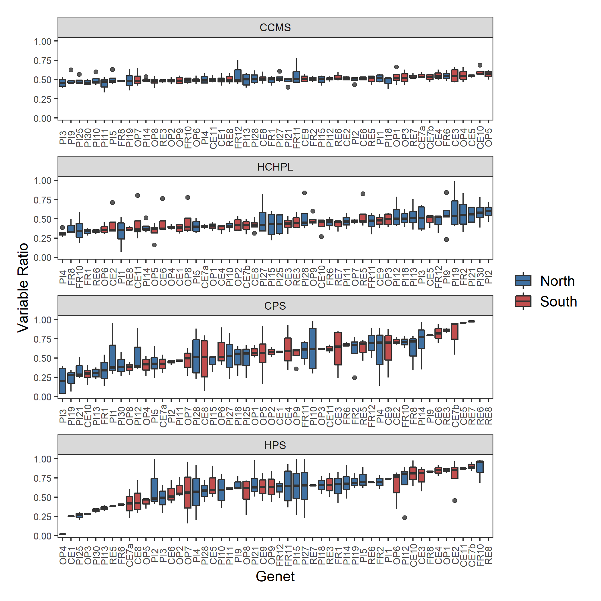

Figure. Genotype differences for temperature tolerance traits including cold cell membrane stability (CCMS), hot chlorophyll fluorescence (HCHPL), cold photosynthesis (CPS), and hot photosynthesis (HPS). Genets ordered by the sum of median ratios for HCMS and CCHPL. There are no significant differences between the variables shown here.

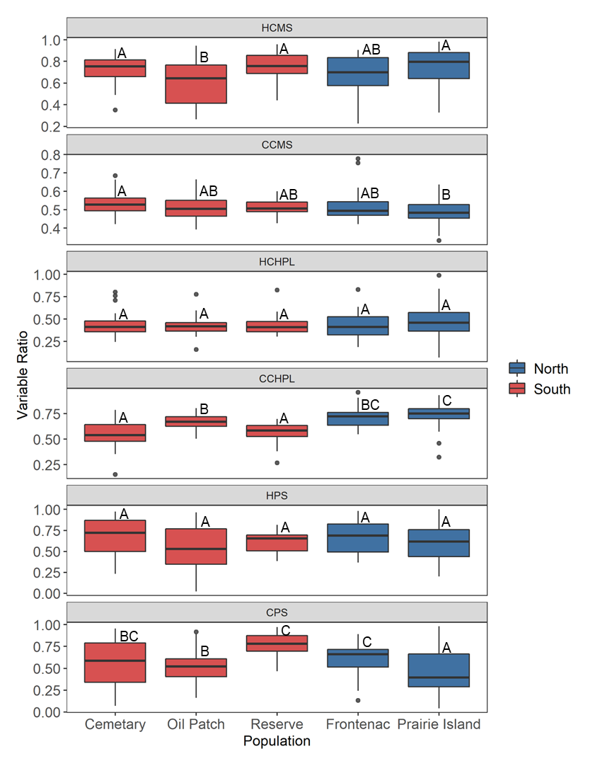

Figure. Differences between the populations for all sporophytic variables. Letters denote significant differences between populations from a linear mixed effects model with population as the fixed effect and block as the random effect.

Figure. Block differences for the cold chlorophyll treatment. Astrisks indicate a significant difference between plants from the north and south from paired t-test analysis for each block individually.

Figure. Scatter plot of the significant correlations.

Figure. Pollen germination profiles for genets with at least 3 ramets that flowered. Color indicates region of origin.

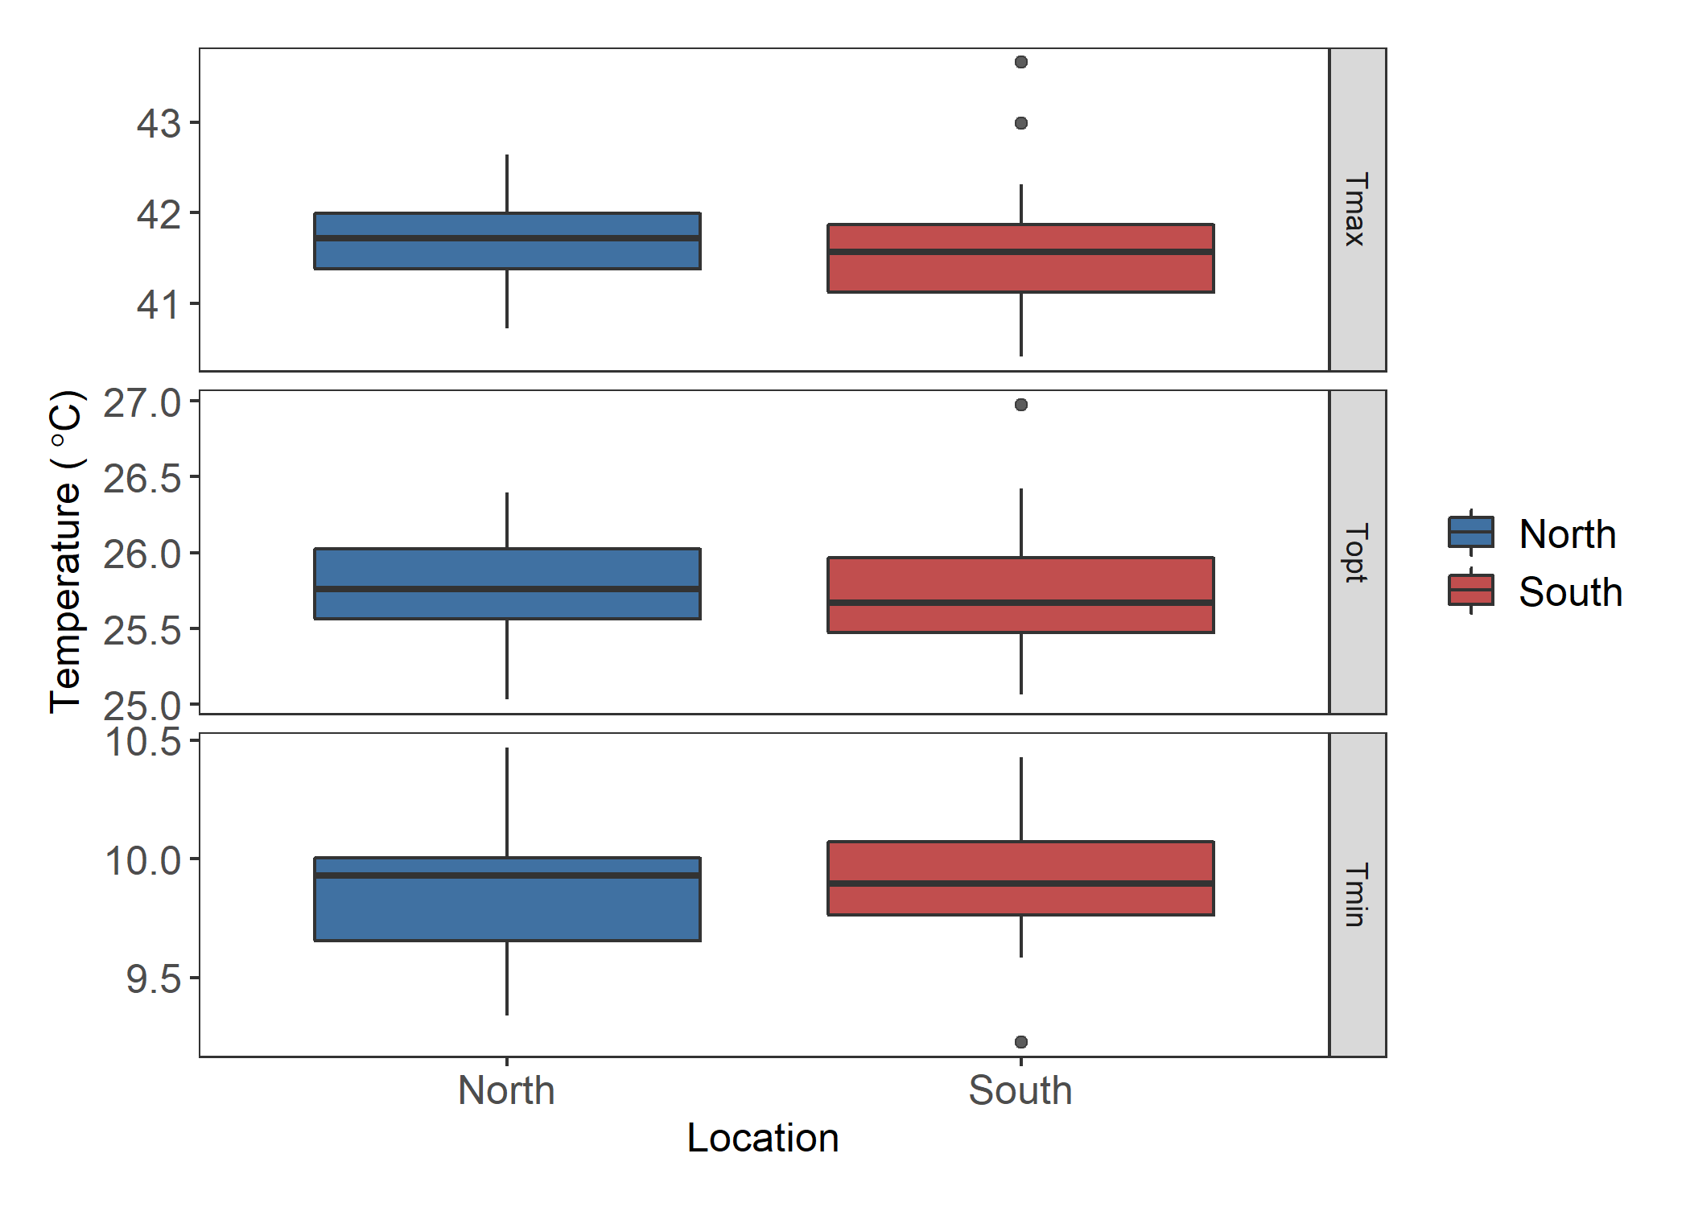

Figure. Pollen tube growth rate values extracted from a quadratic fit for the maximum, optimal, and minimum temperatures.

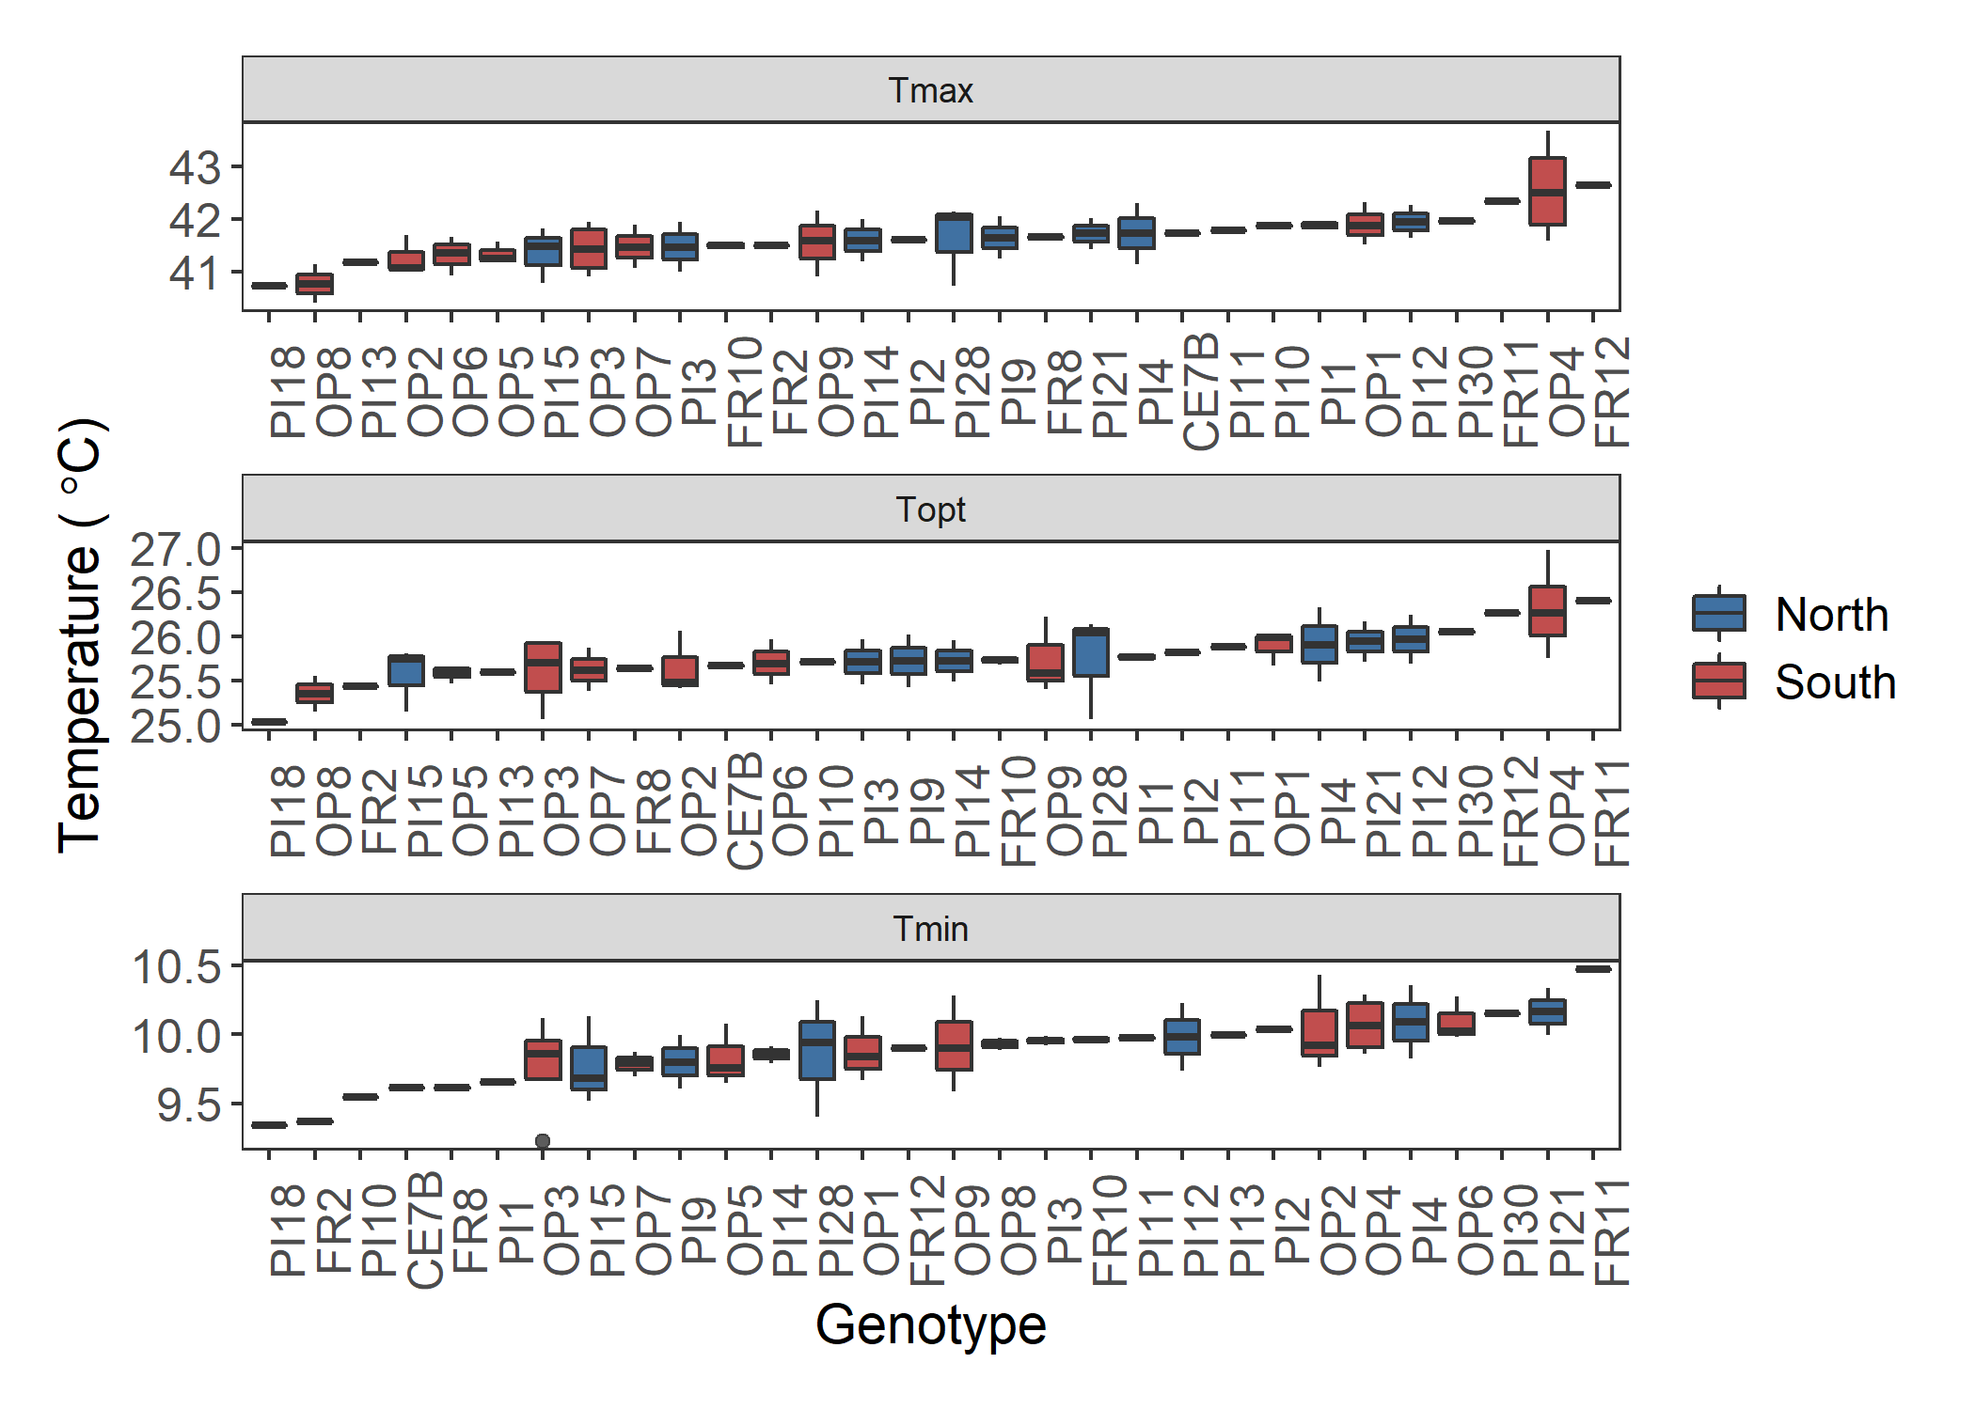

Figure. Genotype differences for the maximum (Tmax), optimal (Topt), and minimum (Tmin) pollen tube growth rate temperatures extracted form the quadratic fits of the pollen tube growth rate data for each individual. There were no significant differences among the genets for pollen tube growth rate. Each plot is in order of increasing PTGR.

Figure. Pollen tube growth rate profiles for genets with at least 3 ramets that flowered. Color indicates region of origin.

Figure. Principal component analysis with sporophytic and gametophytic variables, excluding photosynthesis. A) PC1 and PC2, B) PC2 and PC3, C) PC1 and PC3. Ellipsoid indicating 95% confidence interval.