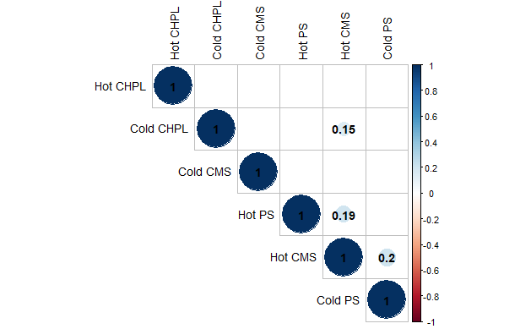

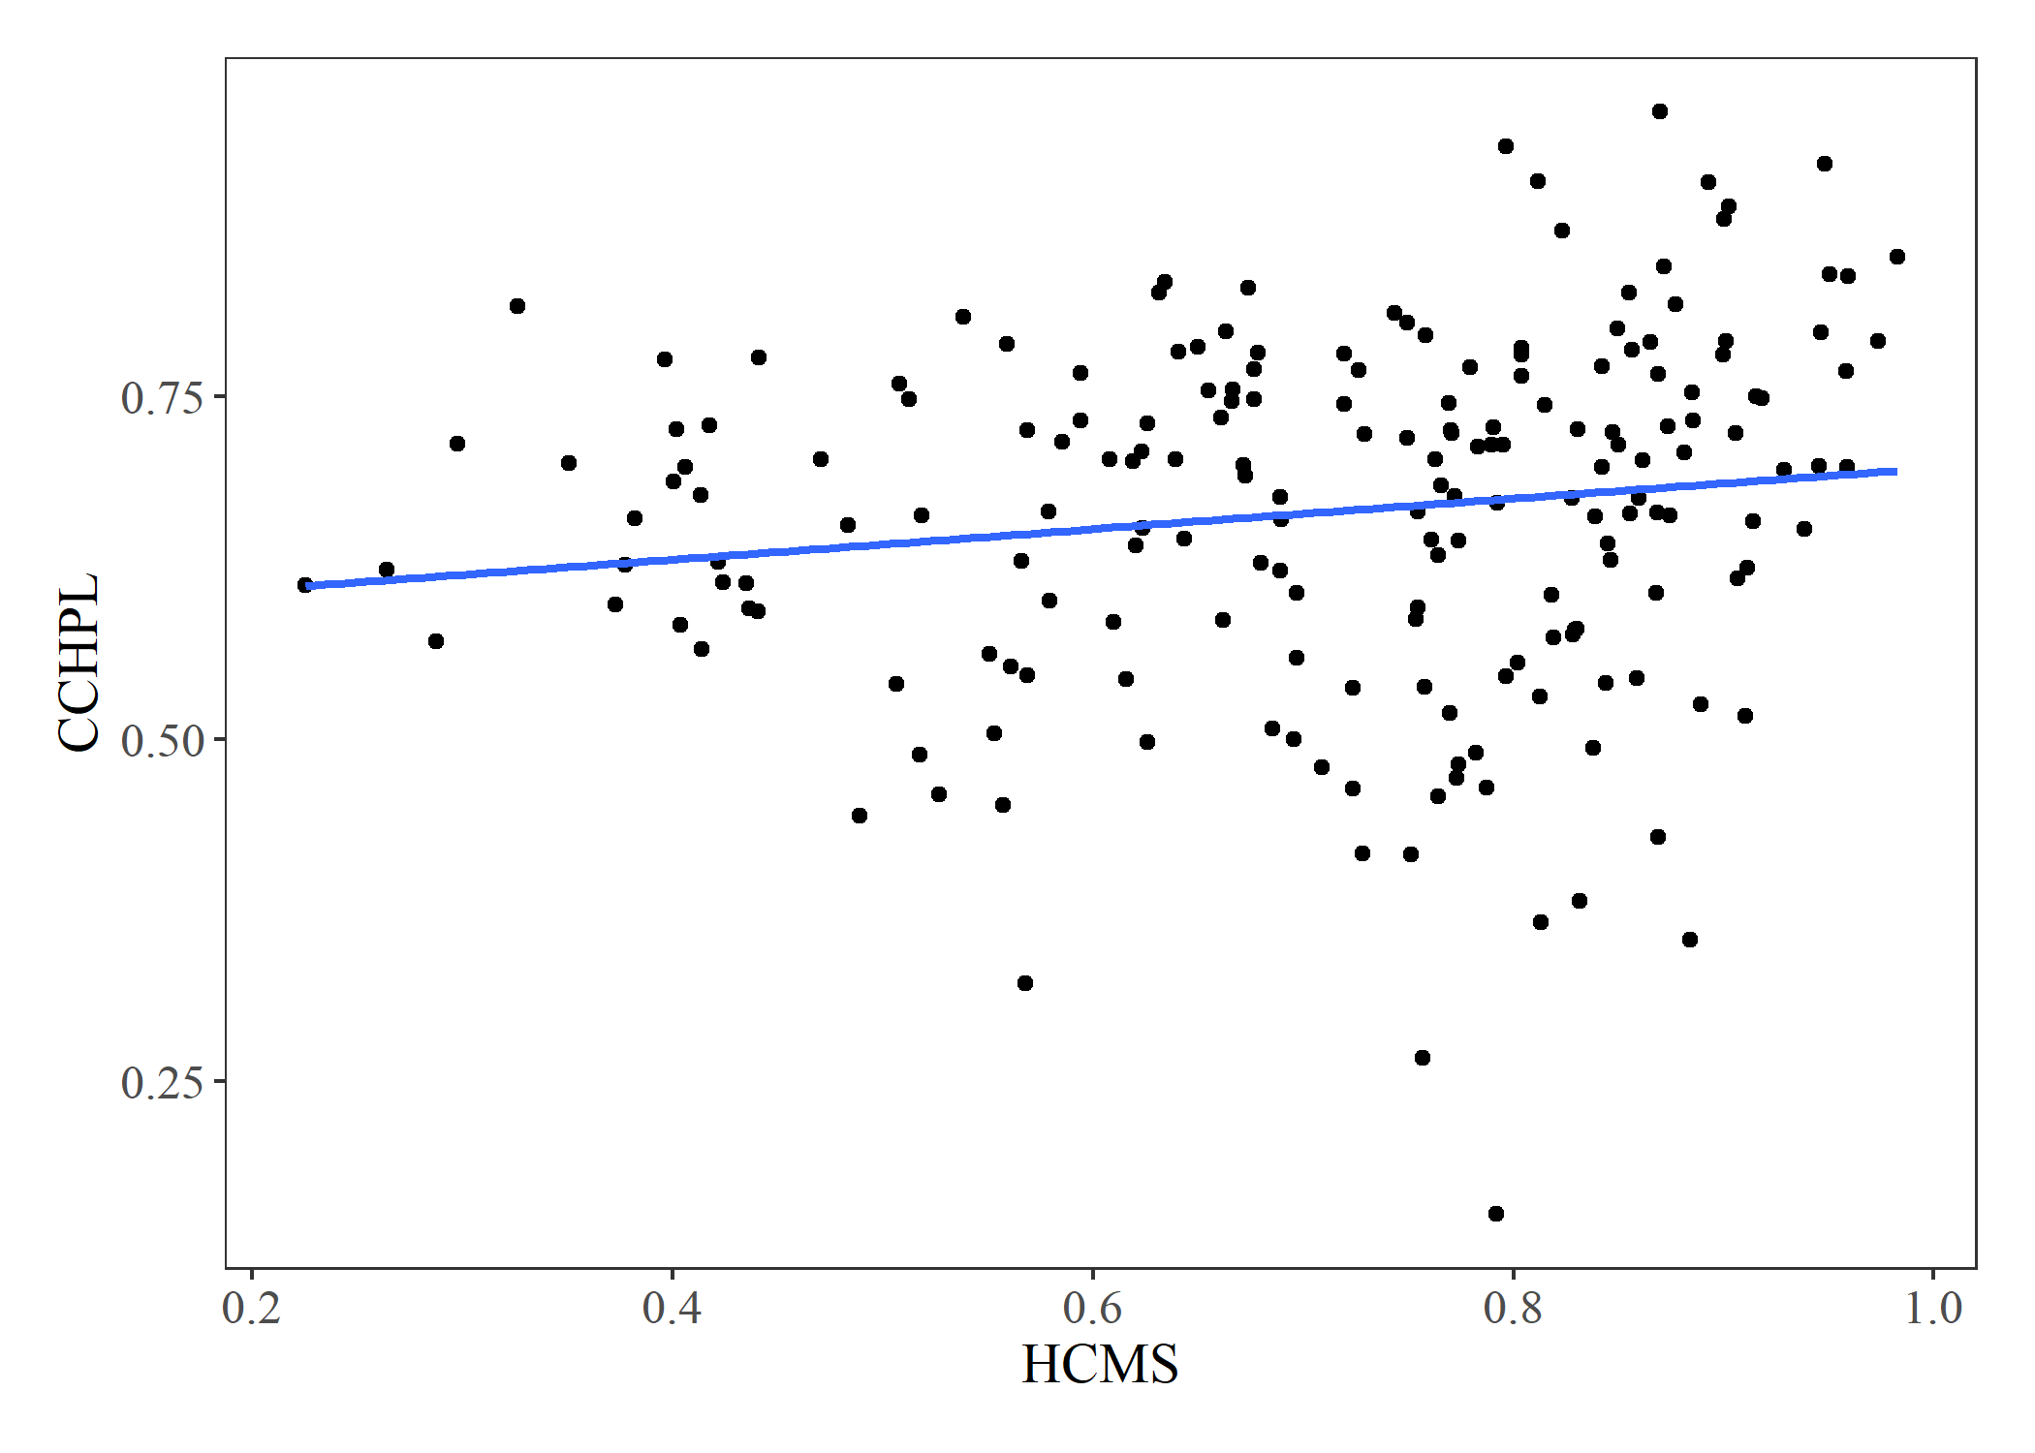

There were significant correlations between HCMS and CCHPL of opposite relationships. As CCMS increases, HCHPL decreases, while CCHPL increases as HCMS increases. This negative and positive relationship between these two variables may be related to the incorporation of certain components in membranes to facilitate cold or heat tolerance. Plants that are tolerant of heat may incorporate a higher percentage of saturated fatty acids into the cell membranes to add rigidity to membranes. Chlorophyll may require a more rigid medium to properly absorb and transfer energy to the reaction center. To withstand colder temperatures, plants tolerant to cold incorporate higher proportions of sterols in membranes (Dufourc, 2008). Though sterols increase fluidity of the membrane, they may also be large enough to disrupt absorption of photons in the thylakoid membrane and ultimately the fluorescence that is emitted during the light reaction or increase fluidity to the point that chlorophyll molecules again cannot transfer energy to the reaction center.

There was a statistically significant negative correlation between HCMS and CCMS. Since HCMS and CCMS are negatively correlated, the mechanisms driving hot and cold tolerance are presumable antagonistic. A plant that is more tolerant of high temperatures will be less cold tolerant.

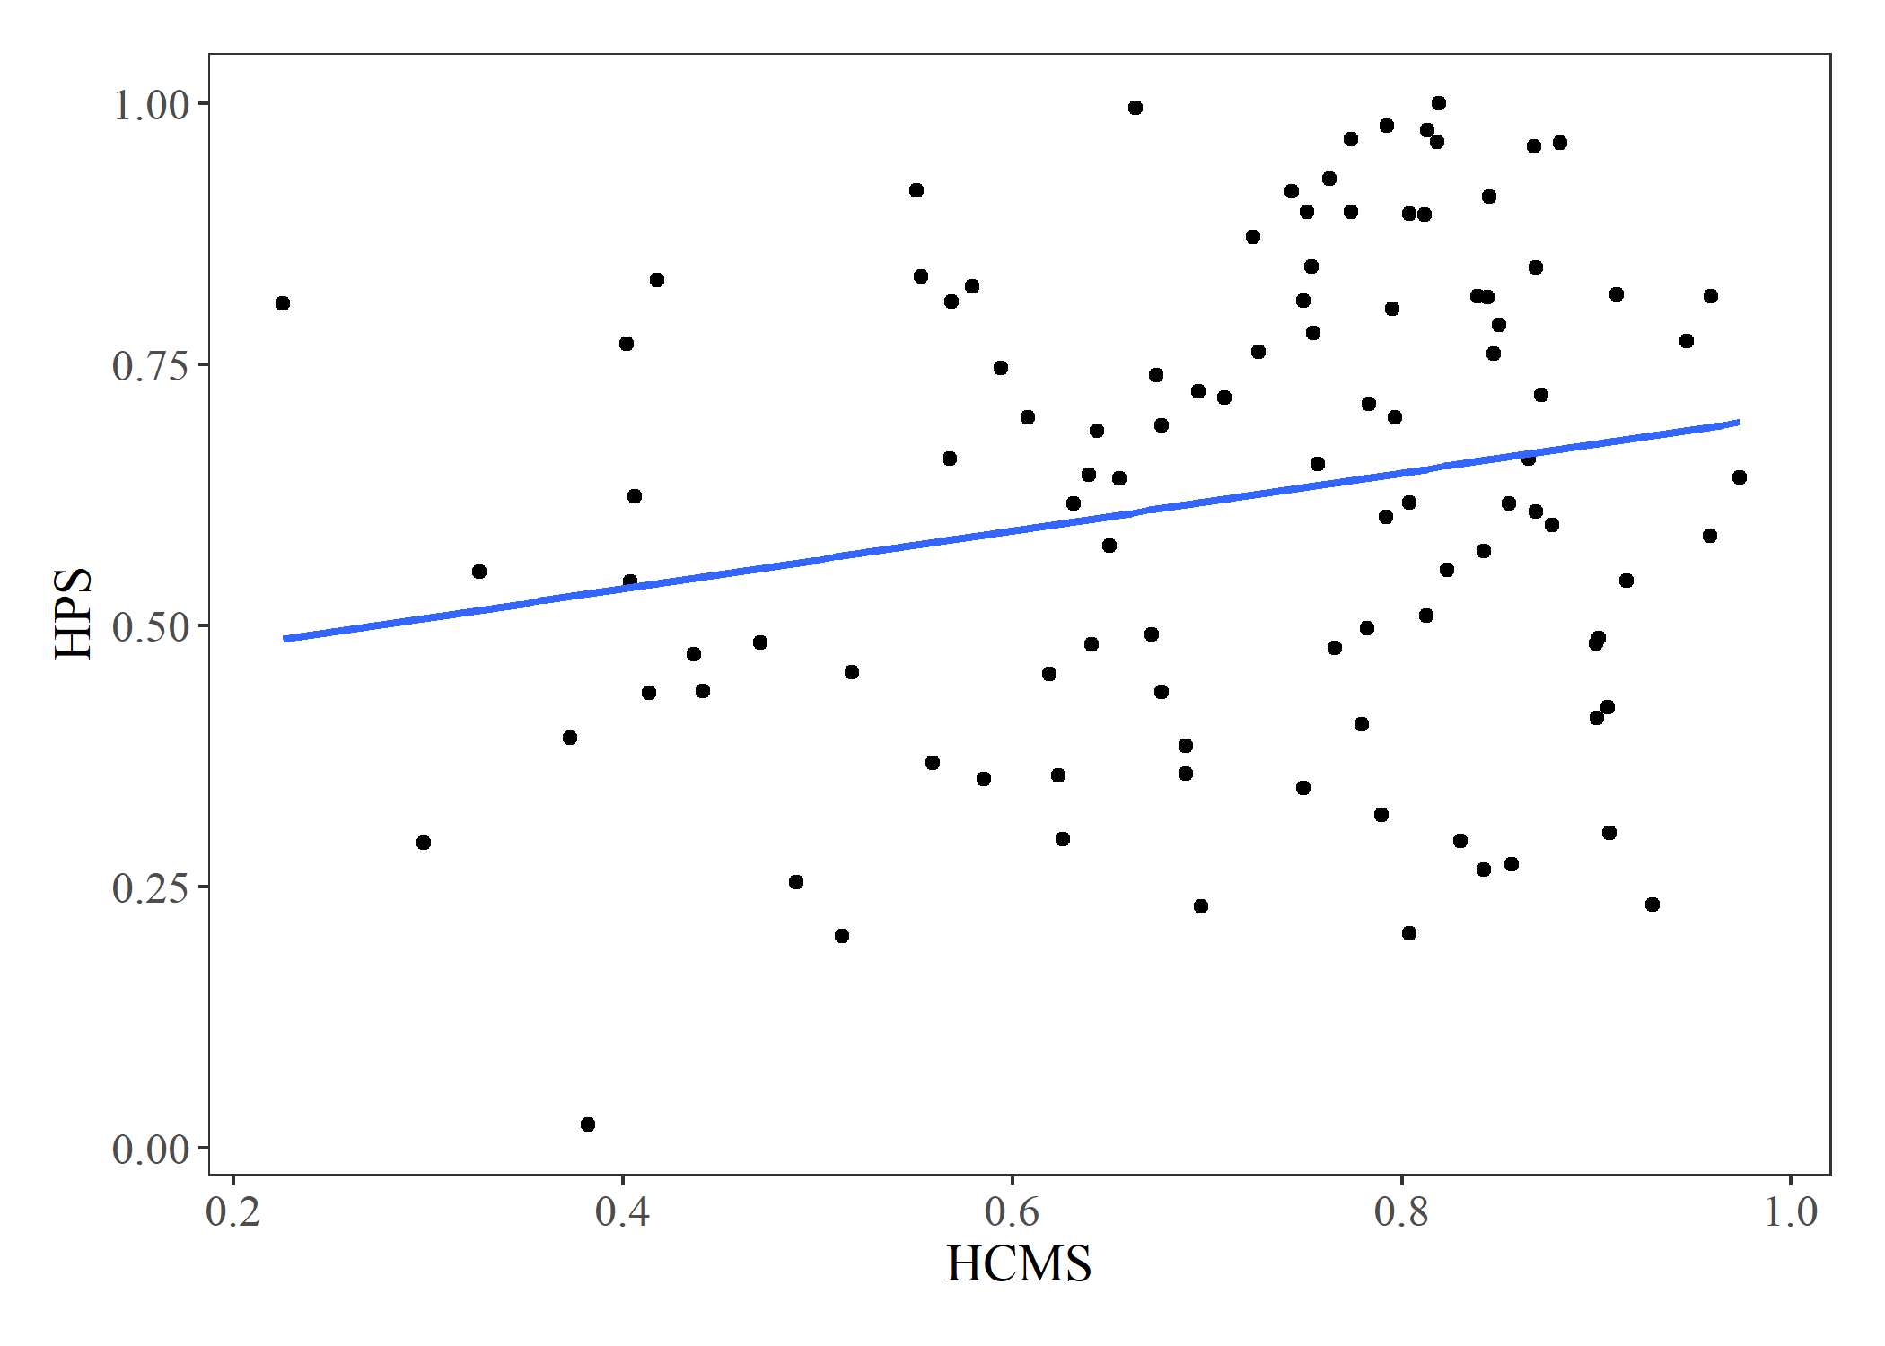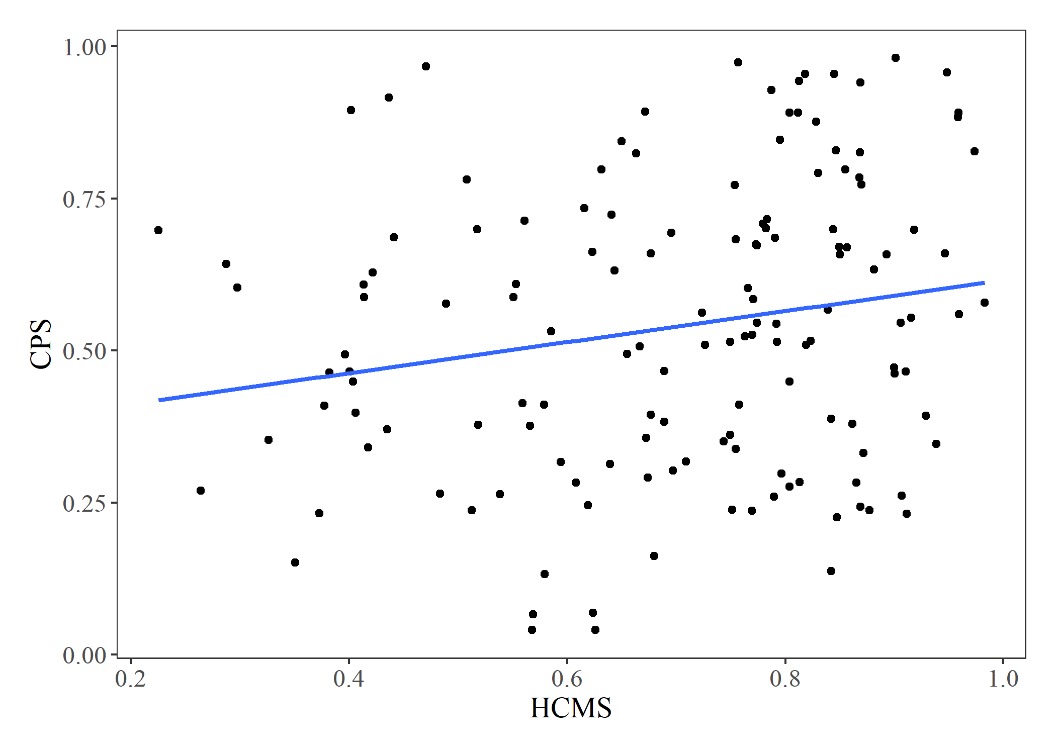

There was a significant correlation between both hot and cold photosynthesis and HCMS. Just as with the chlorophyll variables, components incorporated in the membrane in plants that are more tolerant of heat may improve photosynthetic rate by providing a more rigid membrane for the light reaction to proceed efficiently.

Dufourc, E. J. (2008). The role of phytosterols in plant adaptation to temperature. *Plant Signaling & Behavior*, *3*(2), 133-134. <https://doi.org/10.4161/psb.3.2.5051>