**All plants**

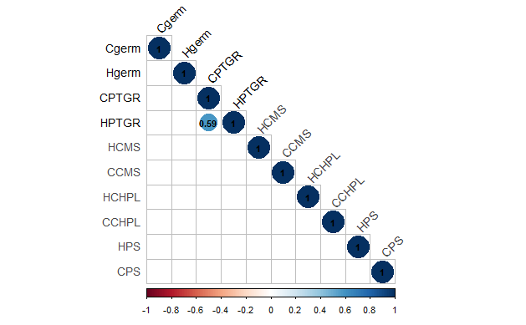

**Northern Plants**

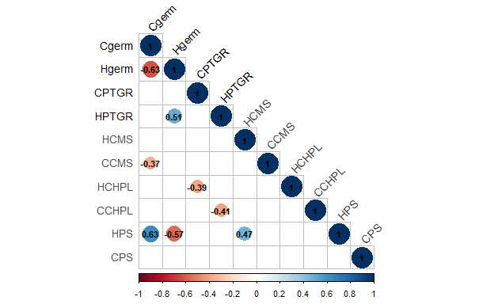

**Southern Plants**