**Methods**

***Plant Collection***

*Solanum carolinense* plants from three populations in Texas and two populations in Minnesota were collected between October 2019 and August 2020. The three southern populations were from Colin County, Texas near McKinney (Oil Patch: 33.173465 N, -96.615402 W; Reserve: 33.159962 N, -96.619011 W; and Cemetery: 33.173672, -96.615096 W). Each population consisted of between 10 and 50 plants in the fruiting stage of their life history. The Reserve population was located approximately 1.5 km from the Oil Patch and Cemetery populations which were adjacent to each other (Figure 1). The two populations from the north were from Houston County, Minnesota and from here on will be referred to as plants from the northern region or Prairie Island (44.07959 N, -91.684545 W) and Frontenac (44.523056 N, -92.338611 W). These populations are separated by approximately 50 miles (Figure 2).

(Insert a paragraph about how plants were collected and potted prior to the experiment: individual plants in the field were sampled with a minimum inter-plant distance of 1 m, rhizomes were dug up – minimum size10 cm- and placed in ziploc bags, labelled and placed in cooler with blue ice, shipped to Fargo with blue ice then placed in refrigerator, ………………………..

In Colin County TX, the average monthly low temperature is 18°C (65°F) and the average monthly high is 43°C (111°F). In Houston County, MN, the average, the average monthly low temperature is -14°C (7°F) and the average monthly high is 29°C (85°F).

***Greenhouse Design***

After the dormancy period, sections of rhizome were equally cut to grow ramets (genetically identical) in cone-shaped containers in the greenhouse. In total, four ramets (blocks A, B, C, and D) were grown from each genet (genetically independent), separated temporally. We started 10 or 12 ramets each week (sub-block 1-20), randomly selected from the 52 genets. Of the 10 or 12 ramets planted each week, half were from the southern region and half were from the northern region. All ramets in block A were planted over five weeks before planting the ramets in block B and so on. The northern ramets were randomly assigned to either the left or right side of the respective southern pair within the tray that held the cone-shaped containers. The plants were fertilized regularly and transplanted to larger containers when they outgrew the small cone-shaped containers. Once the plants had leaves of a reasonable size, we began collecting sporophytic data from one sub-block each week. Gametophytic data were acquired when plants began flowering.

***Sporophytic: Chlorophyll Fluorescence***

We used a chlorophyll meter to measure chlorophyll fluorescence. Two intact leaves were removed from the middle of the plant and cut into half on either side of the midveins. One leaf was used for the heat treatment and the other was used for the cold treatment. One half was placed in the treatment and the other half was placed in the control of room temperature. The chlorophyll fluorescence was measured for both halves before and after the temperature treatment.

The high temperature treatment was 60°C for 1 hour. The leaf halves in the cold treatment were subjected to 4°C for 1 hour followed by 1 hour in -18°C. The leaf halves were moved to room temperature for two hours prior to the second cold treatment measurement. Leaves in all treatments were kept in complete darkness.

The chlorophyll stability value was calculated as the inverse of the proportion of treatment final to treatment initial divided by the proportion of the control final to control initial.

$$1-\frac{{{Treatment}_{final}}/{{Treatment}_{initial}}}{{{Control}_{final}}/{{Control}_{initial}}}$$

***Sporophytic: Cell Membrane Stability***

We used a handheld conductivity meter to measure cell membrane stability after a temperature treatment and again after a maximum damage treatment. Two large, intact leaves were removed from the middle of the plant, washed and each hole punched into 20 rounds. One leaf was used for the high temperature treatment and the second leaf was used for the cold temperature treatment. Ten of the 20 leaf rounds were placed in a test tube for the temperature treatment and 10 were placed in a test tube for the control treatment.

Prior to the high temperature treatment, 10 mL of deionized water was added to the control and temperature treatment test tubes. The high temperature treatment test tubes were placed in a water bath at 55°C for 20 minutes, while the control test tubes were left at room temperature. Both treatments were moved to room temperature for 10 minutes prior to the first conductivity measurement.

The low temperature treatment test tubes were placed at 10°C for 24 hours followed by 24 hours at 4°C to acclimate the leaf rounds to cooler temperatures. The test tubes were then placed at -18°C for 1 hour. The control treatment test tubes remained at room temperature. 10 mL of deionized water were added to all test tubes in both treatment and were placed at room temperature for 1 hour prior to the first conductivity measurement.

All treatments groups were subjected to a maximum damage treatment after the first conductivity measurements. The test tubes were placed in a water bath at 98°C for 1 hour and then left to cool at room temperature for 15 minutes before the second conductivity measurement.

The cell membrane stability value used for data analysis was calculated as one minus the proportion of treatment final to treatment group maximum divided by one minus the proportion of control final to control group maximum conductivity.

$$\frac{{{1-(Treatment}_{value}}/{{Treatment}_{max})}}{1-({{Control}_{value}}/{{Control}_{max})}}$$

***Sporophytic: Photosynthetic Rate***

We used a LI-6400 infrared gas analyzer with a red/blue light source to measure photosynthetic rate before and after the temperature treatment. The following settings were used for photosynthesis measurements: flow rate 500 μmol s-1, reference CO2 420 μmol CO2 mol-1, reference H2O 0 mmol H2O mol-1, ParIn_μml 400 μmol m-2 s-1.

The high temperature treatment was 33°C and the low temperature treatment was 10°C. Each ramet was subjected to both treatments with a rest period of one week between the temperature treatments. Ramets A and C were subjected to the high temperature treatment first and ramets B and D were subjected to the low temperature treatment first.

***Gametophytic: Pollen Variables***

Once a plant from the north and from the south flowered, we removed a mature flower from both plants. Since *Solanum carolinense* is buzz pollinated, a device crafted from a nose hair remover and a paper clip was used to mimic the vibrations needed to release pollen from the anther. Pollen from one flower was dispersed over five plates with a 3% Bacto-Agar based growth medium (sucrose, Ca(NO3)2, MgSO4, KNO3, H3BO3). The plates were each placed at one of the five temperature treatments (10°C, 20°C, 25°C, 30°C, 40°C) for 16 hours. After the temperature treatments, the plate was covered with a thin layer of ethanol to halt further pollen tube growth. Four pictures of each plate were taken using a microscope and ImageJ was used to collect pollen germination and pollen tube growth rate data.

Pollen germination was measured by counting the number of pollen grains that produced pollen tubes and the number of pollen grains that did not produce pollen tubes in the first picture taken. A pollen tube was had to be at least half the diameter of the pollen grain to be included in the count. We used the percent of pollen grains with tubes out of the total number of pollen grains for data analysis.

Pollen tube growth rate was determined by measuring the 10 longest pollen tubes in each of the 4 pictures, calculating the mean of the 20 longest out of the 40 measured, and dividing that length in millimeters by 16 hours. Pollen tubes were only included if they were completely visible in the picture.

***Data Analysis***

All data were analyzed in R (version 4.1.2). For each of the sporophytic variables, we used linear mixed effects models (LMM; function lmer) to determine if there were differences between north and south. Region was the fixed effect and ramet and genet nested in population were the random effects. We dropped the genet nested in population term for cell membrane stability to avoid overfitting the model. We used an analysis of variance model (stats; function aov) to determine if there were differences between genets for each of the sporophytic variables.

Description of paired analysis

For the gametophytic variables, we fit temperature performance curves (rTCP: function nls.multstart) for each plant that flowered. We fit two plants with all 25 temperature performance curves available in the rTCP packages and used AIC values to select the quadratic_2008 and the weibull_1995 models. We opted to use the quadratic_2008 model because the temperature maximum values determined by the weibull_1995 model were infinite for some of the plants. From the quadratic curves of all plants that flowered, we extracted the temperature minimum, temperature optimum, and temperature maximum values and used analysis of variance to determine if there were differences between region and genet.

We used correlation analysis to determine if there were any correlations between all the variables. To further determine if there were relationships between the variables and whether those differed for region and population, we conducted principal component analysis (PCA). We used PCA on all of the sporophytic variables and then both sporophytic variables and gametophytic variables excluding photosynthesis. For the gametophytic and the photosynthesis data, we did not have full data sets and using both limited the sample size for PCA, therefore we opted to remove photosynthesis.

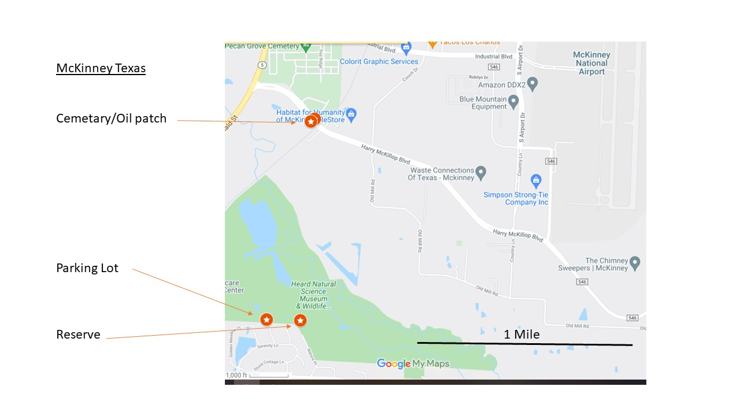

Figure 1. Horsenettle populations near McKinney Texas.

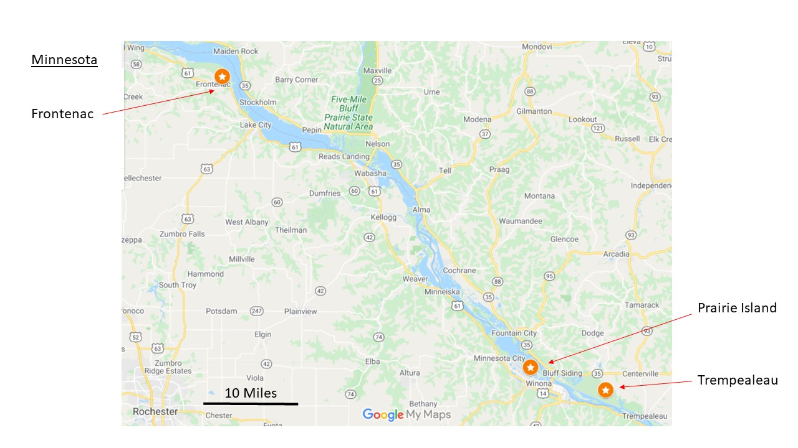

Figure 2. Horsenettle populations near Winona, Minnesota