**Results**

Table 1. Results from the mixed linear model for the difference in region and the one-way analysis of variance results for the difference between individual genets. Asterisk indicates analysis with one outlier removed determined using Grubbs test for one outlier.

|  |  |  |  |  |  |  |
| --- | --- | --- | --- | --- | --- | --- |
|  |  | **Region** | | | **Genet** | |
|  | **Variable** | **Difference** | **More Tolerant** | **p-value** | **Difference** | **p-value** |
| **Sporophyte** | Cell Membrane Stability (Heat) | No | - | 0.067 | **Yes** | **0.021** |
| Cell Membrane Stability (Cold) | **Yes** | **South** | **0.006** | No | 0.86 |
| Chlorophyll Fluorescence (Heat) | **Yes** | **North** | **0.043** | No | 0.364 |
| Chlorophyll Fluorescence (Cold) | **Yes** | **North** | **4.18E-10** | **Yes** | **6.14E-09** |
| Photosynthetic Rate (Heat) | No | - | 0.768 | No | 0.643 |
| Photosynthetic Rate (Cold) | No | - | 0.442 | No | 0.0892 |
| **Gametophyte** | Pollen Germination (Tmax) | **Yes** | **North** | **0.00037** | **Yes** | **0.0251** |
| Pollen Germination (Topt) | **Yes** | **North** | **0.00069** | **Yes** | **0.0351** |
| Pollen Germination (Tmin) | No | - | 0.331 | **Yes** | **0.0153\*** |
| Pollen Tube Growth Rate (Tmax) | No | - | 0.568 | No | 0.418 |
| Pollen Tube Growth Rate (Topt) | No | - | 0.77 | No | 0.608 |
| Pollen Tube Growth Rate (Tmin) | No | - | 0.683 | No | 0.496 |

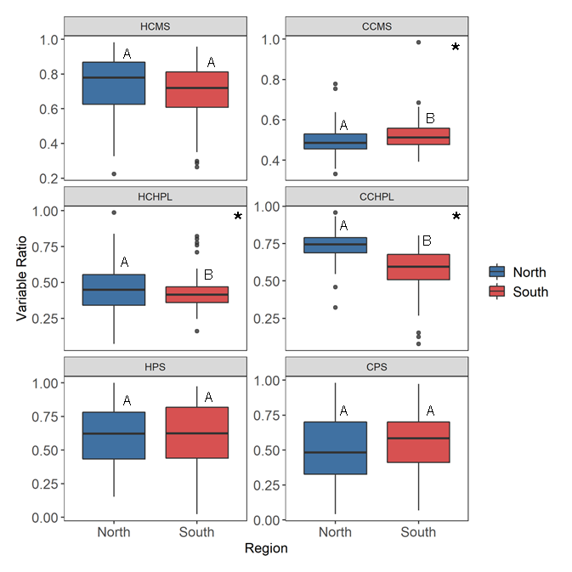Figure 1. Regional differences for temperature tolerance traits including hot and cold cell membrane stability (HCMS, CCMS), hot and cold chlorophyll fluorescence (HCHPL, CCHPL), hot and cold net photosynthetic rate (HPS, CPS). Different letters represent significant difference between regions. Variables with significant differences denoted with asterisks: CCMS (F = 7.792, p = 0.006), HCHPL (F = 4.334, p = 0.043), and CCHPL (F = 64.652, p = 1.6e-10).

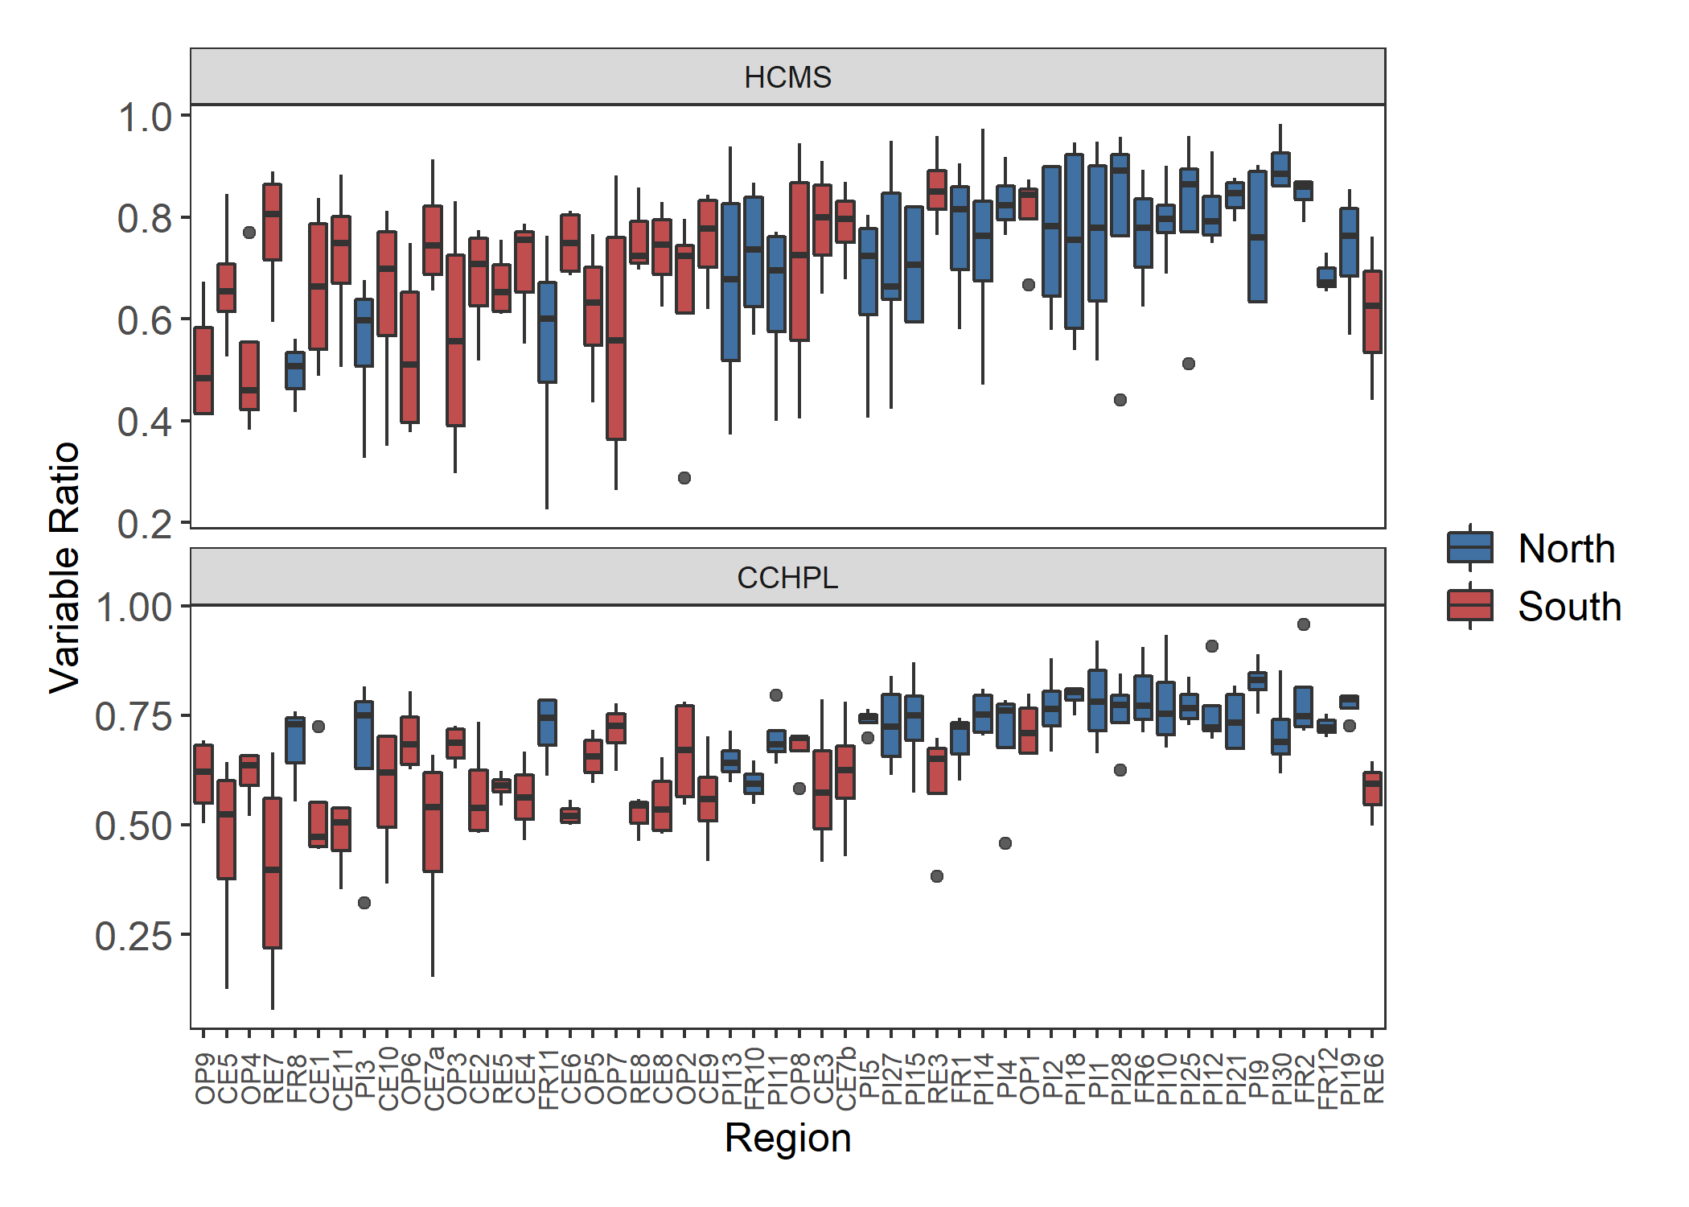

Figure 2. Genotype differences for temperature tolerance traits including hot cell membrane stability (HCMS) and cold chlorophyll fluorescence (CCHPL). There is a significant difference between the genets for HCMS (F = 1.5, p = 0.032) and CCHPL (F = 3.341, p = 6.1e-9). Plots of genet effect for other variables in appendix.

Figure 3. Cell membrane stability across temporally independent blocks and colored by region. There is a significant difference between blocks for hot cell membrane stability (HCMS, p = 0.022) and cold cell membrane stability (CCMS, p = 5.7e-5).

***Sporophytic Variables***

*Cell Membrane Stability*

Cell membrane stability (CMS) was a measurement of cytoplasm leakage when leaf tissue was exposed to a heat treatment and a cold treatment. Tolerance was quantified using the ratio of a conductivity measurement after a temperature treatment to a conductivity measurement after a maximum damage treatment. An increased CMS indicates higher tolerance of the temperature treatment. When *Solanum carolinense* plants from the north were compared to the south, we found no significant difference in the hot treatment, but there was a significant difference in the cold treatment (figure 1). Conversely, we found a significant difference between genotypes in the hot treatment, but not in the cold treatment (figure 2). For both the hot and cold treatments, there was a significant block effect (figure 3), meaning that plants grown at different times in the greenhouse had different CMS ratios.

*Chlorophyll fluorescence*

We used chlorophyll fluorescence as another temperature tolerance index. The chlorophyll content was measured before and after temperature treatments and the inverse ratio of the measurements was used as a proxy for temperature tolerance. As the chlorophyll ratio increases, the individual sporophyte is more tolerant of the temperature treatment. There was a significant difference between plants originating in the north and south for both the hot and cold treatments (figure 1). Northern plants were more tolerant than southern plants in both treatments. We found a significant difference between individual genotypes for the cold treatment, but not for the hot treatment (figure 2). Independently, the southern plants also showed a significant difference between genets (Appendix table). The two regions did differ in variation within the southern and northern regions for both hot and cold chlorophyll fluorescence. Northern plants had more variation in the hot treatment (Bartlett’s test p-value = 1.68E-4) and southern plants had more variation in the cold treatment (Bartlett’s test p-value = 9.26E-4) (Appendix table).

*Net Photosynthesis*

We used photosynthesis as a physiological indicator of temperature tolerance. Both previous variables mentioned could directly influence temperature tolerance through their involvement in photosynthesis. Photosynthesis was measured using a LI-6400 infrared gas analyzer before and after a temperature treatment. The results are presented as a proportion of the net photosynthesis after the treatment to the net photosynthesis before the treatment. Increased proportions indicate more temperature tolerance for the treatment. For both the cold and hot treatments, there was no significant difference between north and south (figure 1). There was no significant difference between genotypes for both the hot and cold treatments.

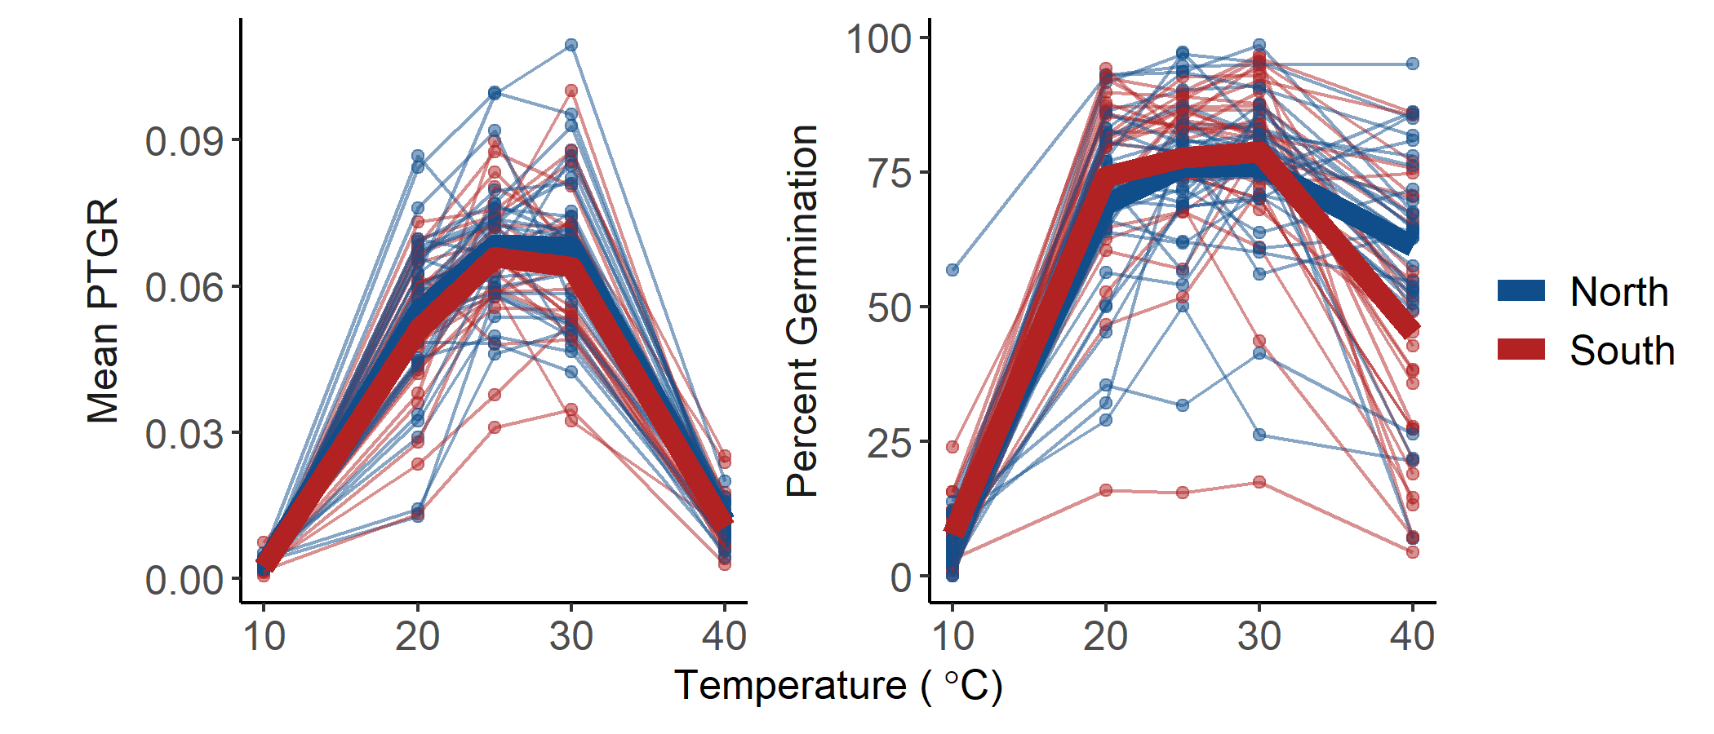

Figure 4. Percent germination and mean pollen tube growth rate (PTGR) for *Solanum carolinense* pollen grains from the north (blue) and south (red) across a temperature gradient (10°C, 20°C, 25°C, 30°C, 40°C). Thin lines and points represent each individual plant that flowered. Thick lines indicate the mean value for the region at each temperature.

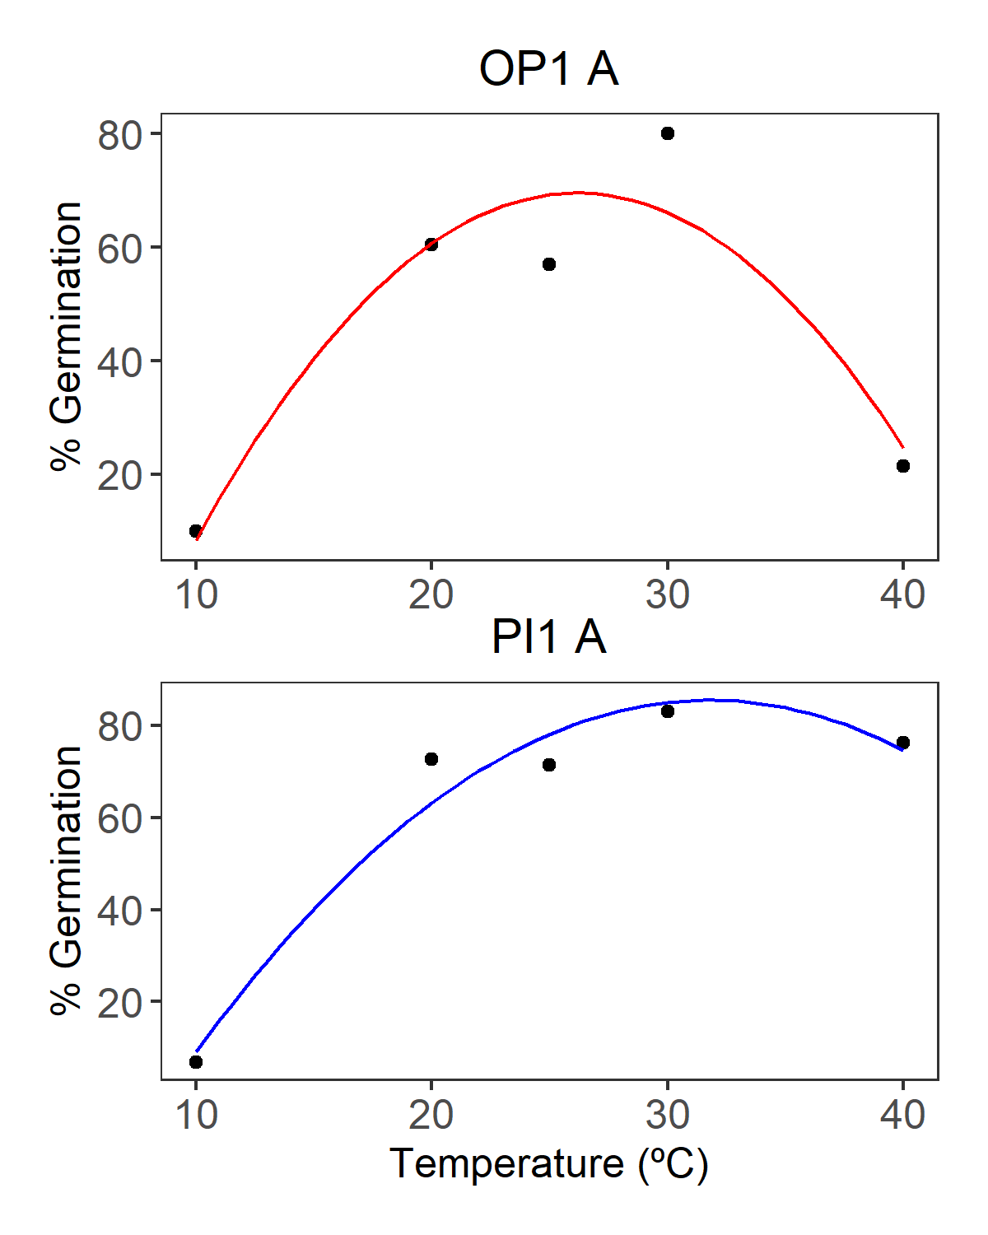

Figure 5. Quadratic fit curve for pollen germination of one genet from the southern region (OP1 A, red) and one genet from the northern region (PI1 A, blue).

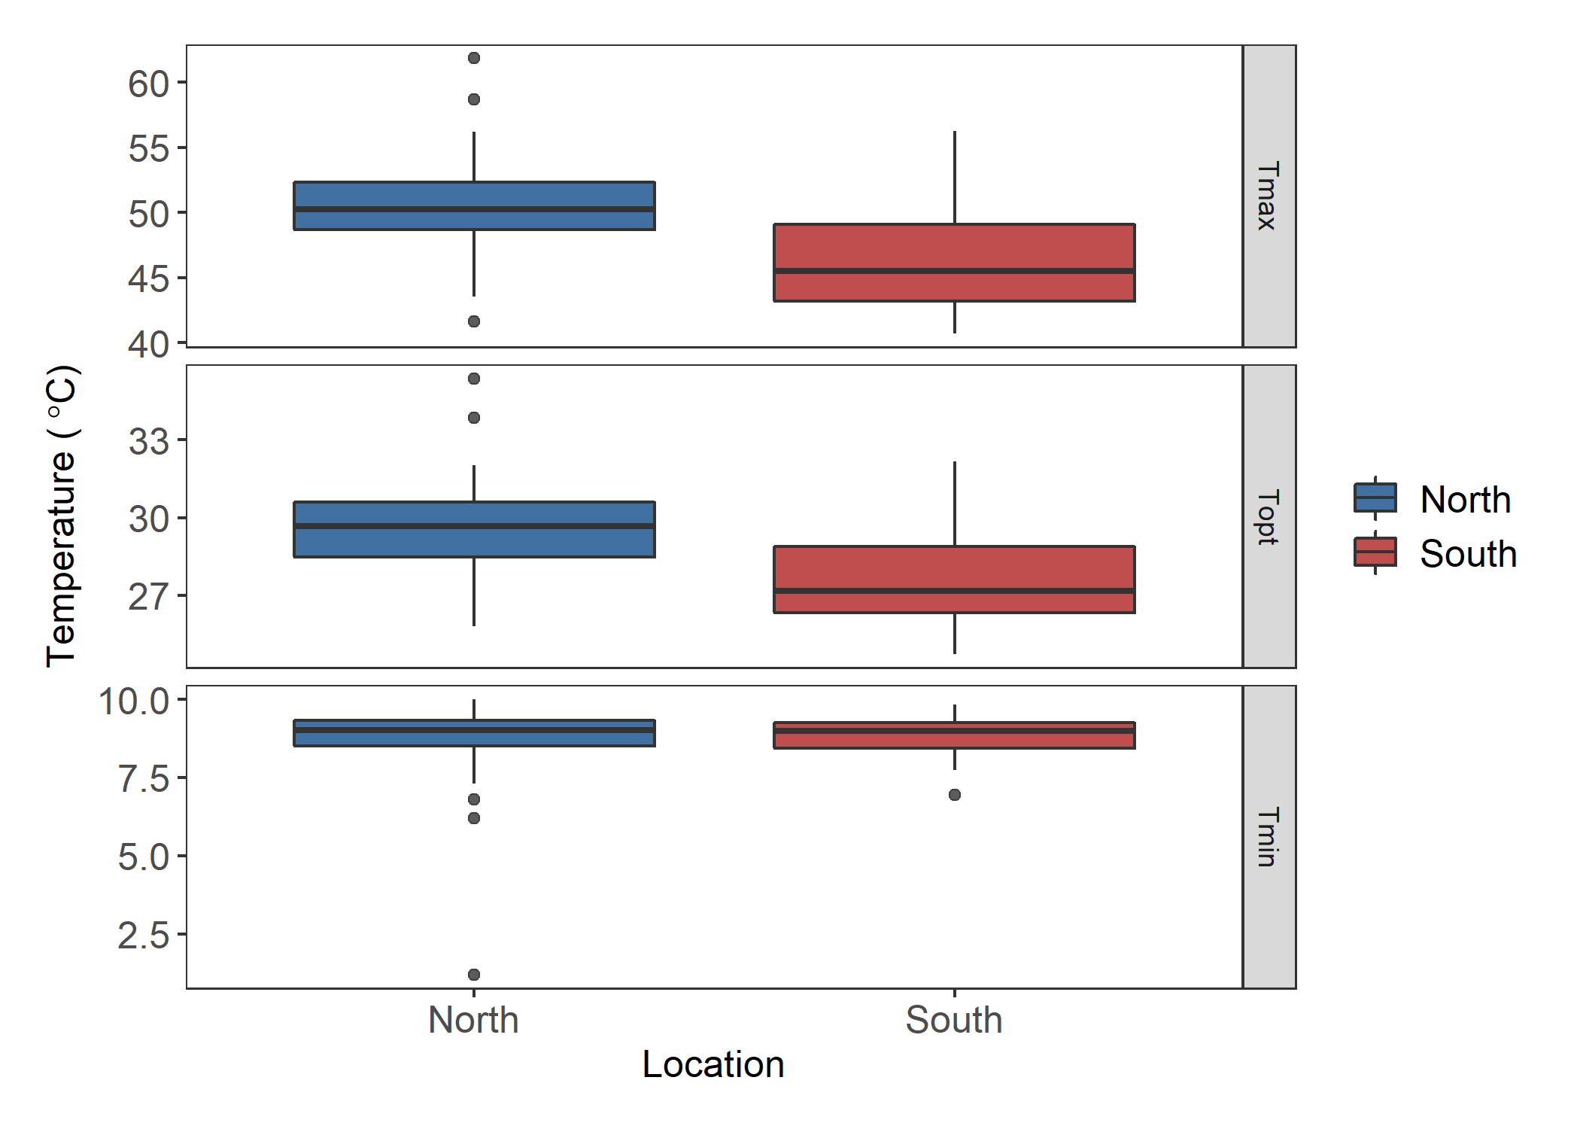

A

B

*

A

B

*

A

A

Figure 6. Estimates for the maximum (Tmax), optimal (Topt), and minimum (Tmin) germination temperature extracted from quadratic fits of the germination data for each individual. Asterisks and different letters indicate significant differences. There is a significant difference between regions for Tmax (F = 14.28, p = 3.7E-4) and Topt (F = 12.85, p = 6.85E-4).

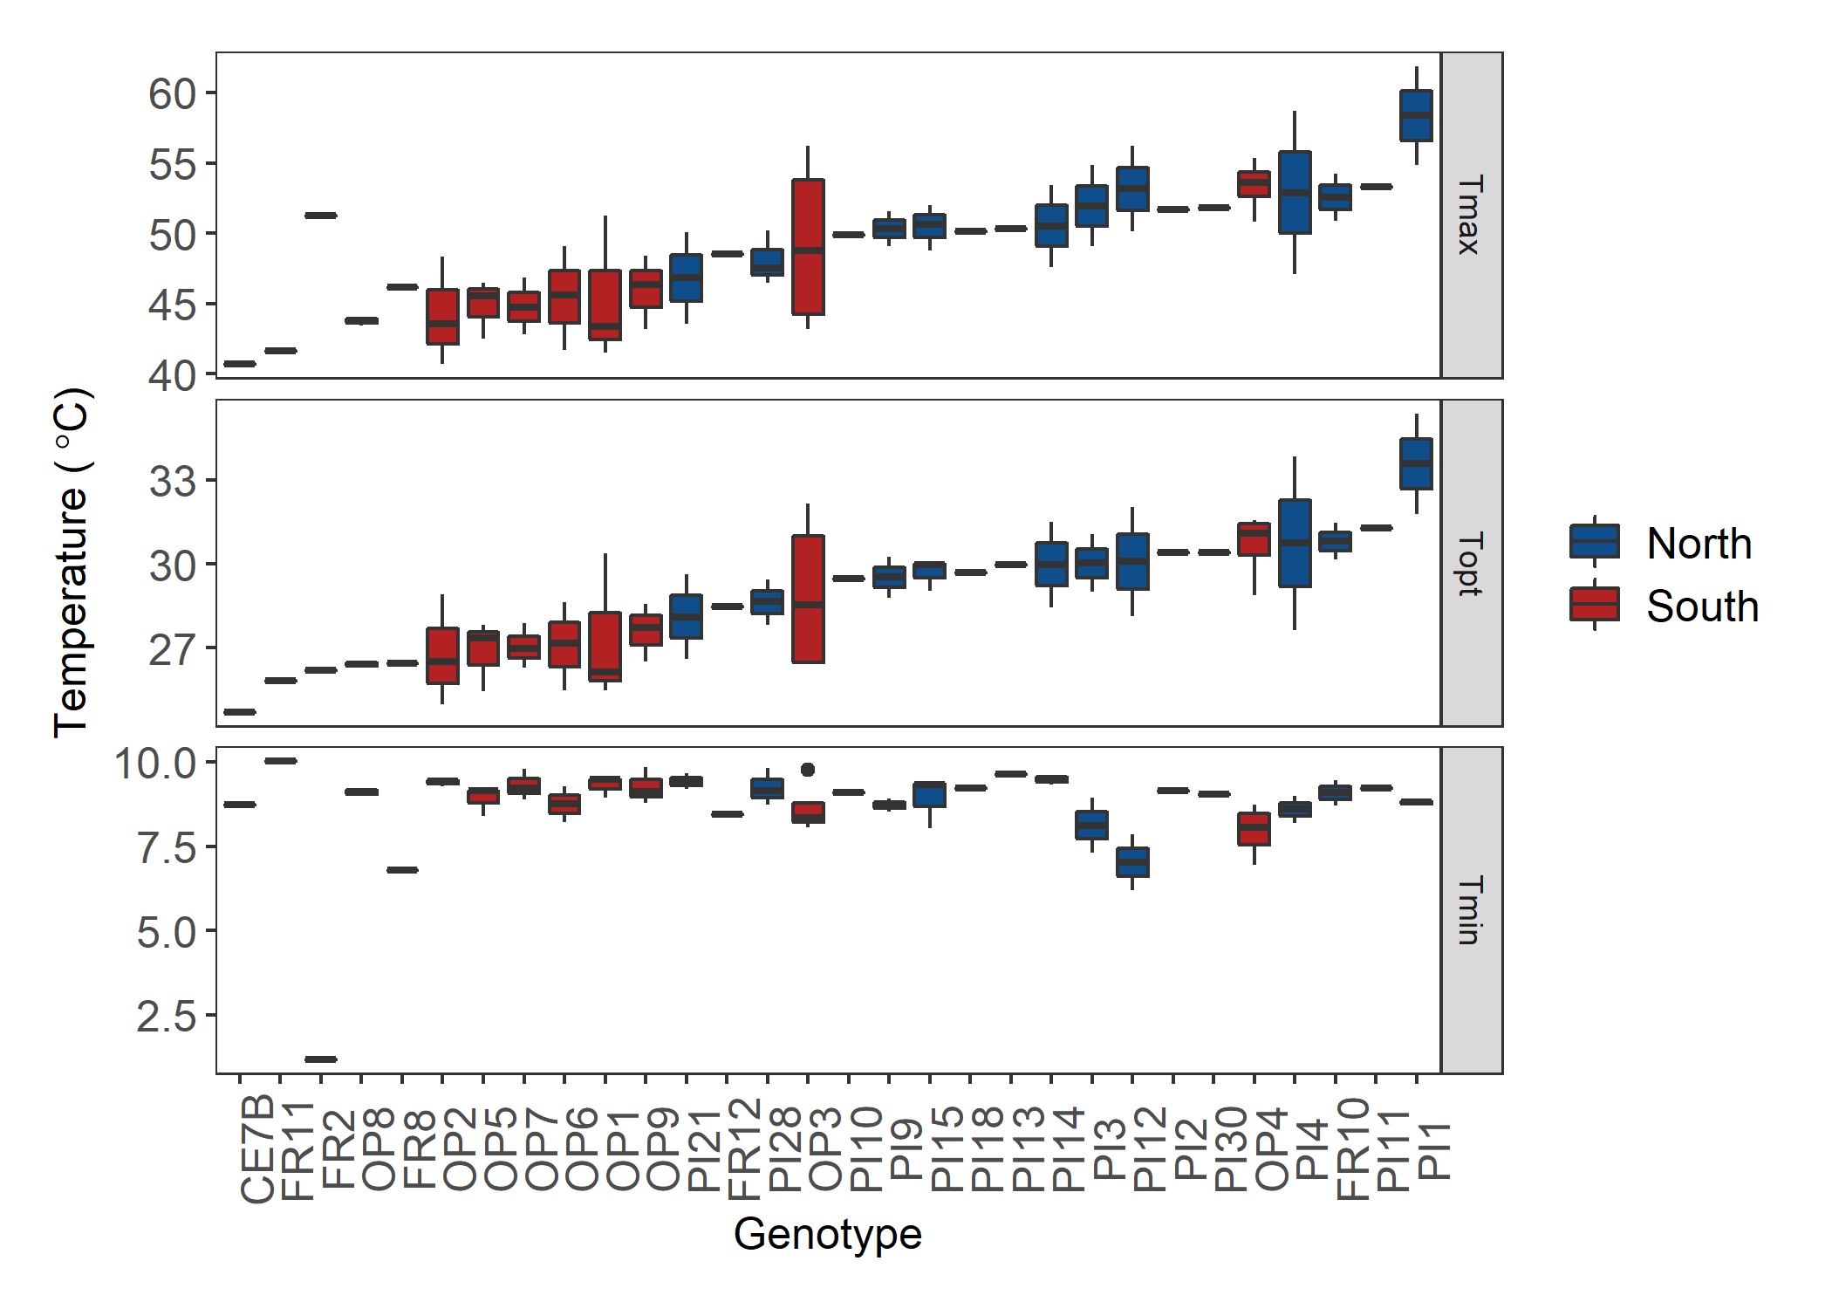

*

Figure 7. Genotype differences for the maximum (Tmax), optimal (Topt), and minimum (Tmin) pollen germination temperatures extracted form the quadratic fits of the germination data for each individual. There is a significant difference between the genets for Tmax (F = 2.064, p = 0.025), Topt (F = 1.952, p = 0.035), and Tmin (F = 2.284, p = 0.0135). Asterisk indicates the outlier removed for analysis. Plots of genet effect for other variables in appendix.

***Gametophytic Variables***

*Pollen Germination*

Pollen germination was determined by the percentage of the number of pollen grains that produced pollen tubes or germinated out of the total number of pollen grains. We measured pollen germination for all individuals that flowered at five different temperatures (figure 4). We fit quadratic curves to the temperature performance profile of each genet (figure 5). From the quadratic fit, we calculated the minimum (Tmin), maximum (Tmax), and optimal (Topt) temperature of pollen germination for each individual. There was a significant difference between regions for Tmax and Topt (figure 6). Genets from the north germinated more readily at high temperatures than genets from the south. There was no significant difference between the two regions for Tmin. The genets were significantly different from one another for Tmin, Tmax, and Topt (figure 7). One outlier was identified using the Grubbs test for one outlier (outliers; function grubbs.test) and subsequently dropped from the analysis.

*Pollen Tube Growth Rate*

Pollen tube growth rate was calculated by dividing the average length of the longest 40 tubes on a plate by the time the plate remained in the temperature treatment (figure 4). The pollen tube growth rates for each individual were also fit with a quadratic curve to estimate the Tmin, Tmax, and Topt. There was no significant difference between genets from the north and south for any of the calculated variables (Appendix). There was no significant difference between genets for the calculated variables (Appendix).

Figure 8. Correlation matrix of sporophytic and gametophytic variables with significant Pearson’s correlations. Blue colors indicate positive correlations and red colors indicate negative correlations.

***Correlations***

We used correlation analysis and principal component analysis to identify relationships between hot and cold tolerance and the sporophytic and gametophytic variables. Pearson’s correlations were determined for all variables. There were no significant correlations between the gametophytic and sporophytic variables (figure 8). Of the sporophytic variables, only four correlations were significant, and the strongest correlation was 0.21 between hot cell membrane stability and cold photosynthesis. There was one negative correlation between cold and hot cell membrane stability (-0.14). There were three significant correlation coefficients between the gametophytic variables. Maximum and minimum pollen tube growth rate were positively correlated (pearson’s correlation 0.45). Maximum and minimum pollen germination were negatively correlated (pearson’s correlation -0.33). Maximum pollen tube growth rate and maximum pollen germination were positively correlated (pearson’s correlation 0.3).

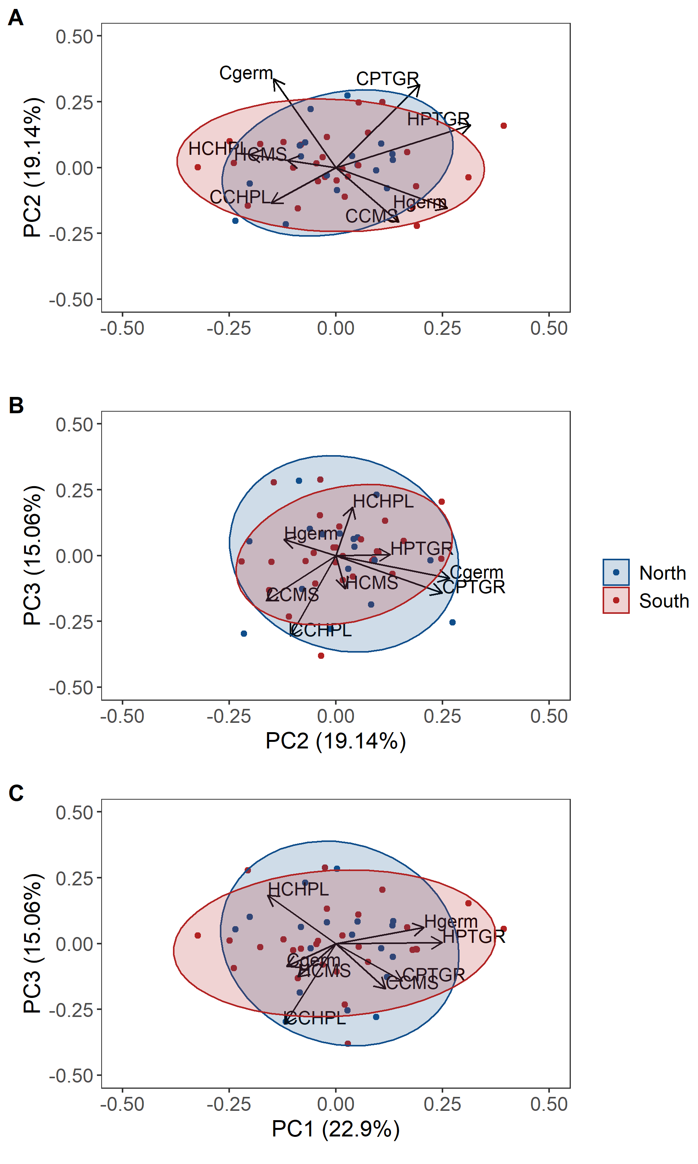

Figure. Principal component analysis with gametophytic and sporophytic variables. A) PC1 and PC2, B) PC2 and PC3, C) PC1 and PC3. Ellipsoid indicating 95% confidence interval. PC1 explains 22.9% of the variance, PC2 explains 19.14% of the variance, and PC3 explains 15.06% of the variance. Tables with principal component importance for PC1 – PC8 and principal component loadings in the Appendix.

***Principal component analysis***

The first three principal components explained 60.34% of the variance. PC1 primarily loaded on the heat tolerance variables (figure 9 and 11). There was more variation in southern plants along the PC1 axis. PC2 primarily loaded on the cold tolerance variables (figure 9 and 10). PC3 primarily loaded on the chlorophyll variables with heat and cold tolerance in opposite directions (figure 10 and 11). Northern plants showed more variation along the PC3 axis.