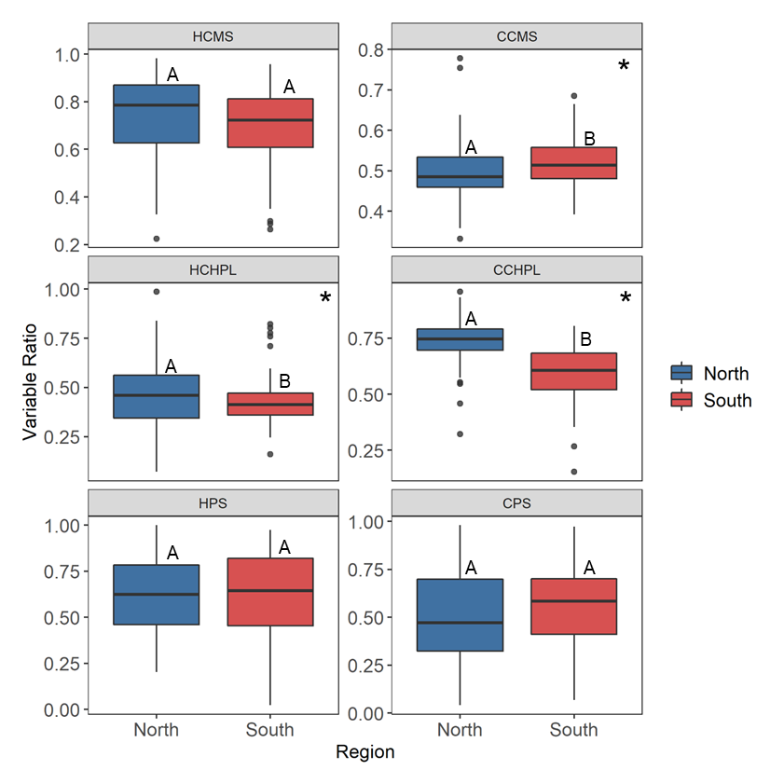Figure 1. Regional differences for temperature tolerance traits including hot and cold cell membrane stability (HCMS, CCMS), hot and cold chlorophyll fluorescence (HCHPL, CCHPL), hot and cold net photosynthetic rate (HPS, CPS). Center line of boxplot is the median value for the region. The letters represent statistically significant differences between regions. Variables with significant differences denoted with asterisks: CCMS (F1,50 = 7.792, p = 0.006), HCHPL (F1,51 = 4.334, p = 0.043), and CCHPL (F1,50 = 64.652, p = 1.6e-10).

**Results**

Table 1. Results from the mixed linear model for the difference in region and the one-way analysis of variance results for the difference between individual genets. Asterisk indicates analysis with one outlier removed determined using Grubbs test for one outlier.

|  |  |  |  |  |  |  |
| --- | --- | --- | --- | --- | --- | --- |
|  |  | **Region** | | | **Genet** | |
|  | **Variable** | **Expectations** | **Observed** | **p-value** | **Difference** | **p-value** |
| **Sporophyte** | Cell Membrane Stability (Heat) | S > N | - | 0.06102 | **Yes** | **0.013** |
| Cell Membrane Stability (Cold) | N > S | **S > N** | **0.0117** | No | 0.886 |
| Chlorophyll Fluorescence (Heat) | S > N | **N > S** | **0.405** | No | 0.38 |
| Chlorophyll Fluorescence (Cold) | N > S | N > S | **9.96E-11** | **Yes** | **1.05E-07** |
| Photosynthetic Rate (Heat) | S > N | - | 0.997 | No | 0.127 |
| Photosynthetic Rate (Cold) | N > S | - | 0.77 | No | 0.883 |
| **Gametophyte** | Pollen Germination (Tmax) | S > N | **N > S** | **0.00037** | **Yes** | **0.0251** |
| Pollen Germination (Topt) | S > N | **N > S** | **0.000685** | **Yes** | **0.0351** |
| Pollen Germination (Tmin) | S > N | - | 0.331 | **Yes** | **8.71E-08** |
| Pollen Tube Growth Rate (Tmax) | S > N | - | 0.568 | No | 0.418 |
| Pollen Tube Growth Rate (Topt) | S > N | - | 0.77 | No | 0.608 |
| Pollen Tube Growth Rate (Tmin) | S > N | - | 0.683 | No | 0.496 |

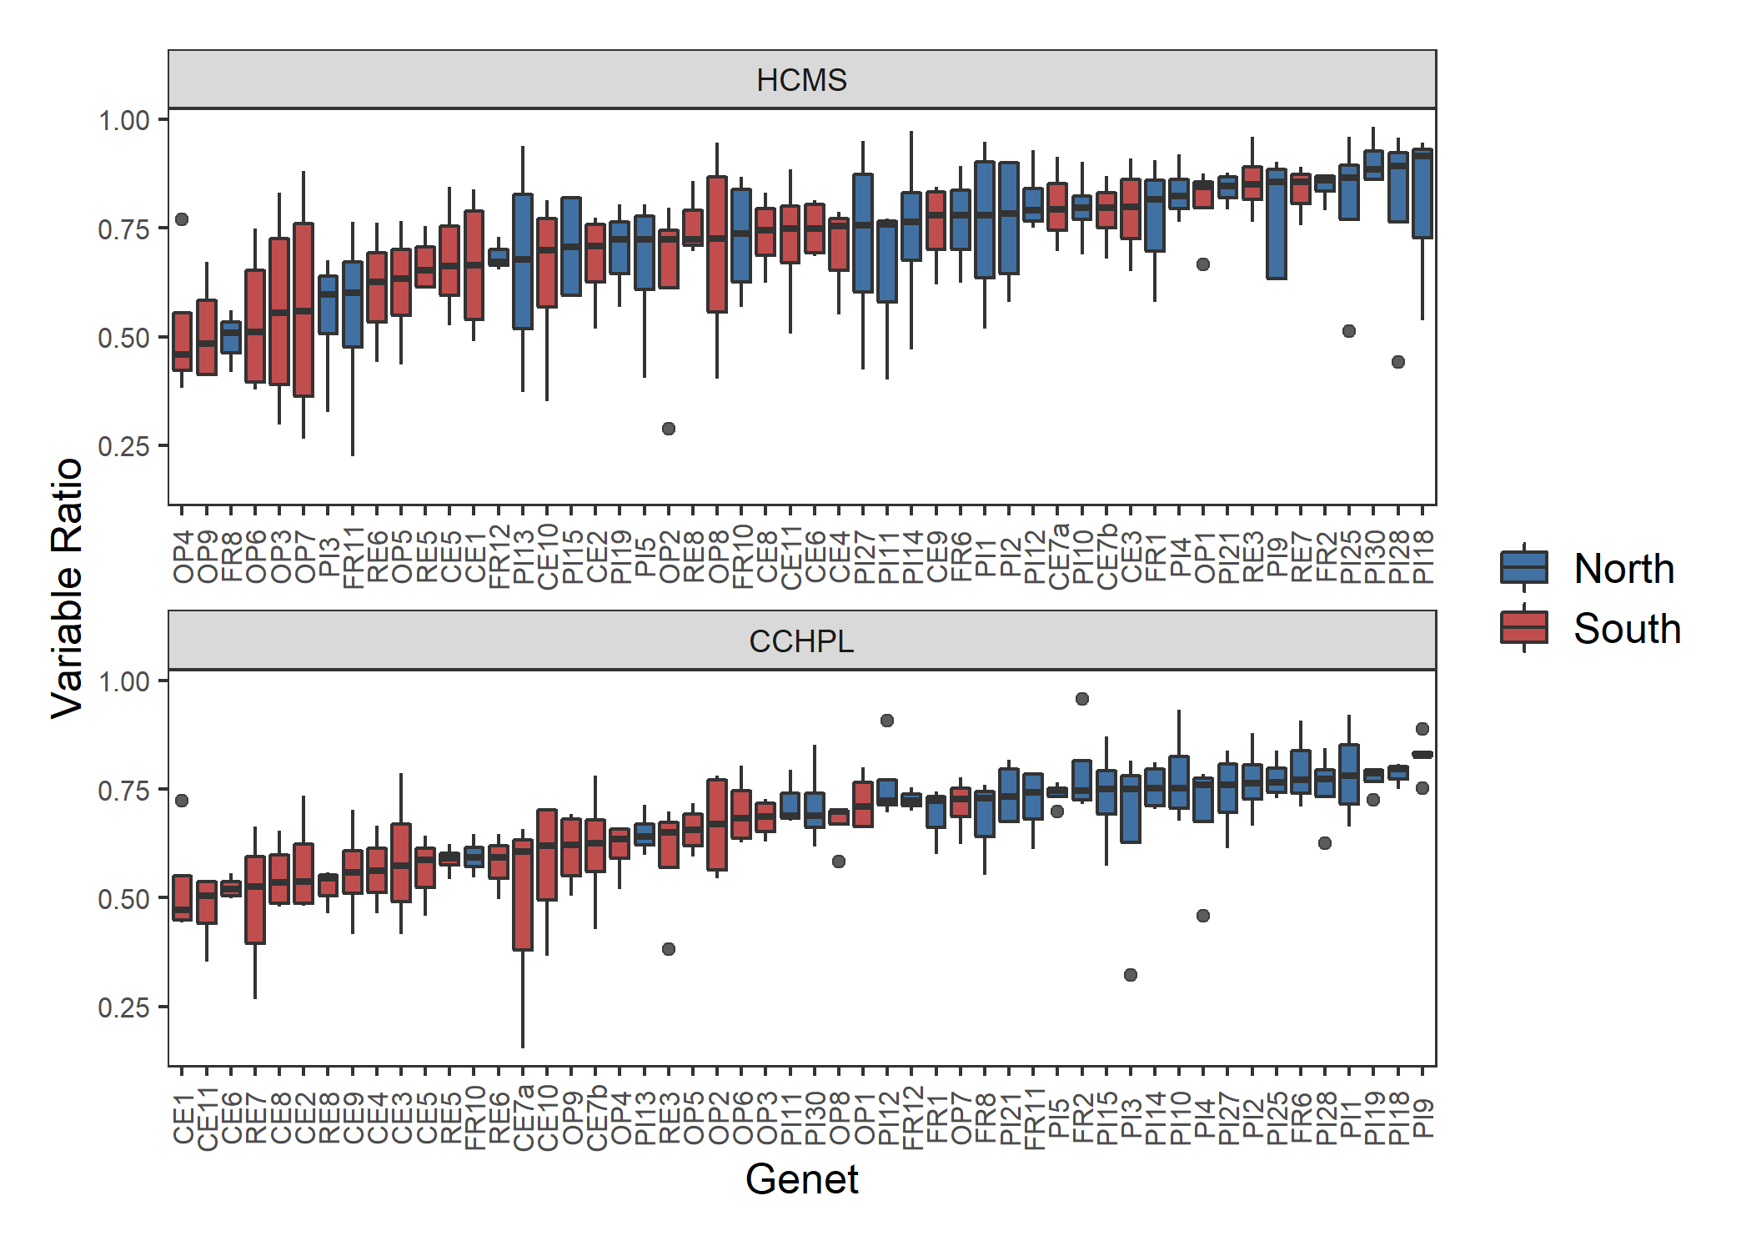

Figure 2. Genotype differences for temperature tolerance traits including hot cell membrane stability (HCMS) and cold chlorophyll fluorescence (CCHPL). Genets ordered by increasing ratio for each variable. Center line in boxplot is the median of the measurements taken for the ramets of one genet. There is a significant difference among the genets for HCMS (F = 1.5, p = 0.029) and CCHPL (F = 3.341, p = 6.1e-9). Plots of genet effect for other variables in appendix.

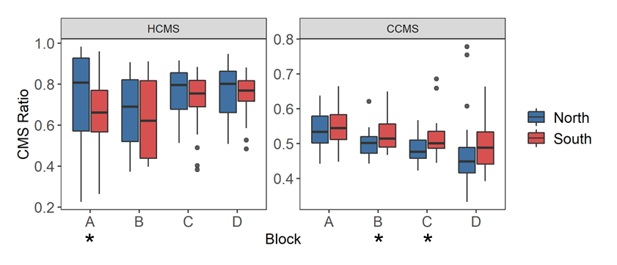

Figure 3. Cell membrane stability across temporally independent blocks and colored by region. The center line of the boxplot is the median of the measurements taken for each region within a ramet. There is a significant difference between blocks for hot cell membrane stability (HCMS, p = 0.0297) and cold cell membrane stability (CCMS, p = 7.30e-05). Astrisks indicate a significant difference between regions from a paired t-test of regions for each block independently. There was a significant difference between regions for HCMS block A (t = -2.910, p = 0.015), CMS block B (t = 2.190, p = 0.040), and CMS block C (t = 2.073, p = 0.049). Results from paired t-tests between blocks for each variable located in the appendix.

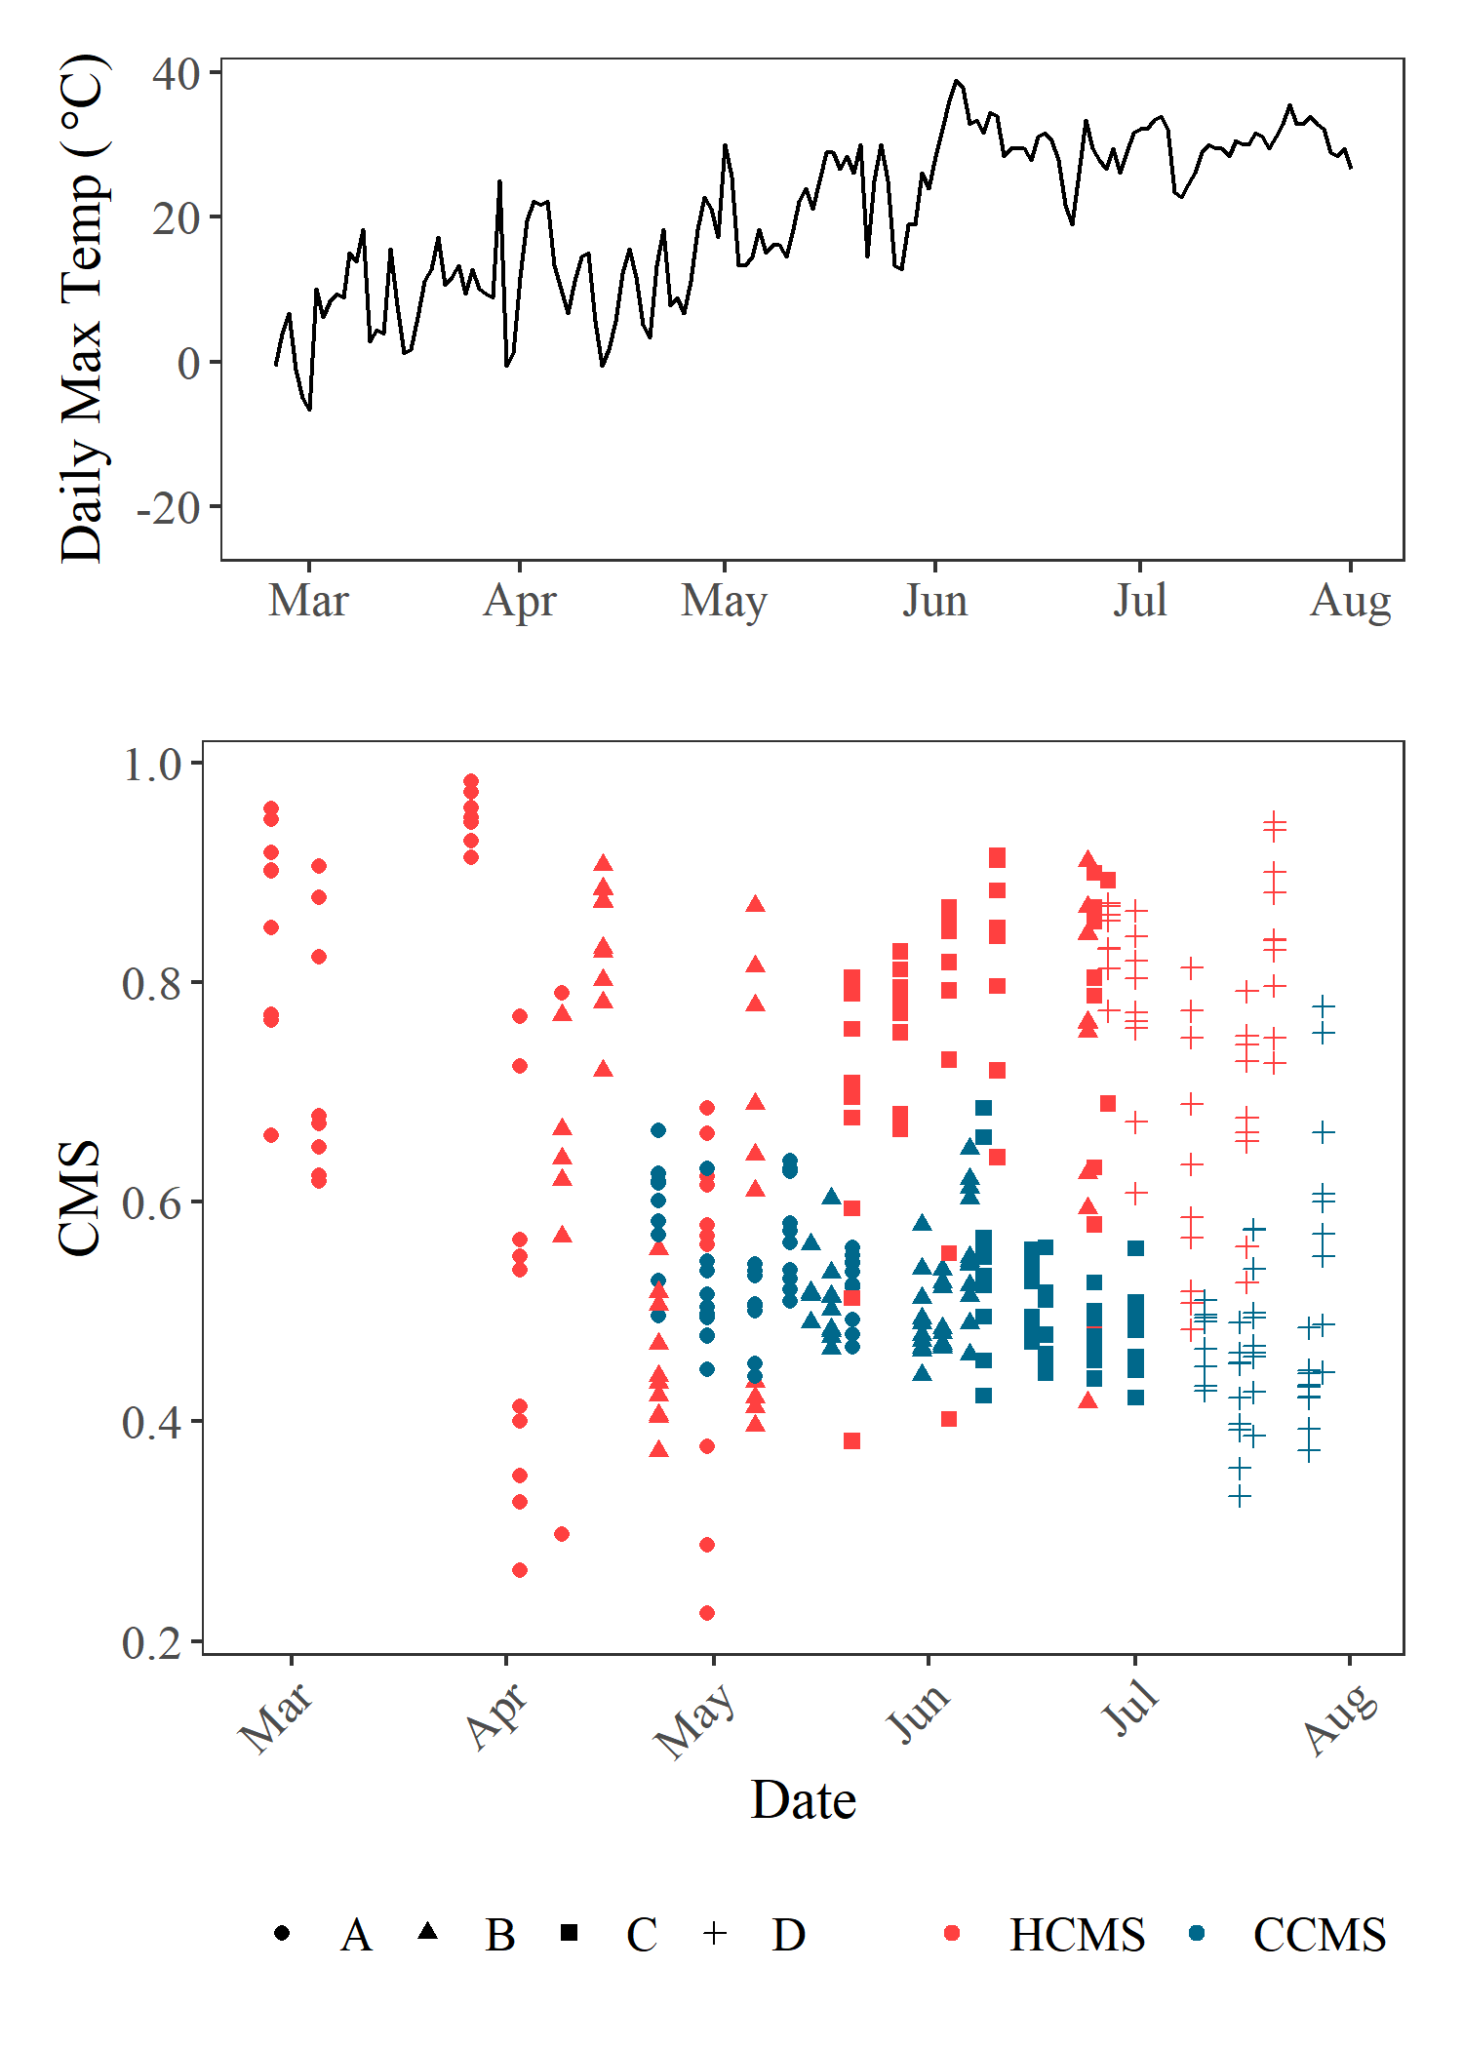

Figure 4. Top plot: daily max temperature for spring and summer from the NOAA station at the Hector International Airport, Fargo, ND. Bottom plot: CMS (cell membrane stability) values for the hot (red) and cold (blue) treatments of CMS and the dates the measurements were taken. Shapes indicate the ramet of each data point.

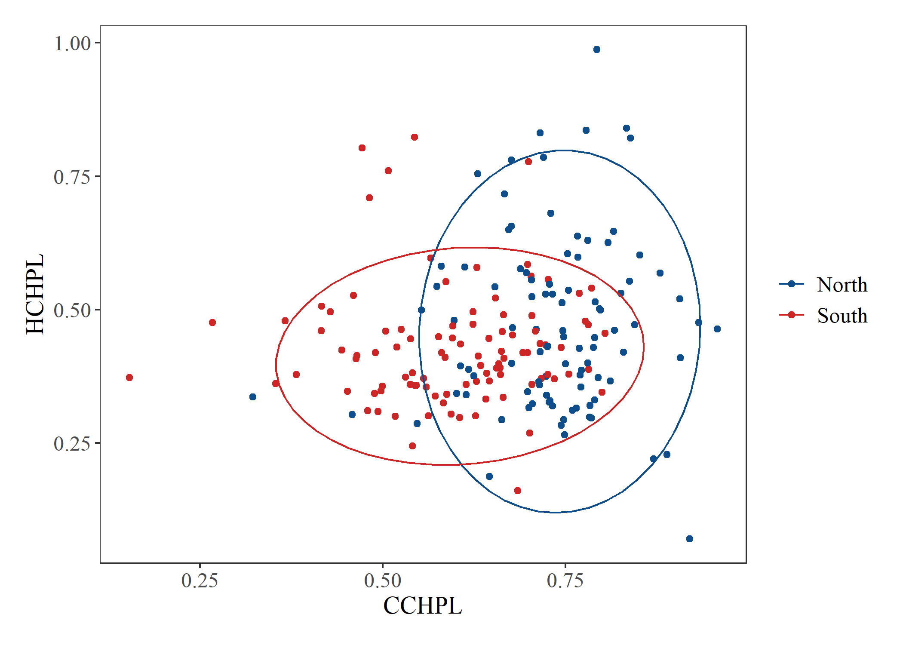

Figure 5. Hot chlorophyll vs cold chlorophyll for plants from the north and south. Ellipse indicating 95% confidence interval for multivariate T distribution. Results from Bartlett’s test for heterogeneity of variance between regions for all variable located in the appendix.

Figure 6. Principal component analysis of the sporophytic variables. A) PC1 and PC2, B) PC2 and PC3, C) PC1 and PC3. Ellipsoid indicating 95% confidence interval. PC1 explains 22.38% of the variance, PC2 explains 21.55% of the variance, and PC3 explains 16.79% of the variance. Tables with principal component importance for PC1 – PC8 and principal component loadings in the Appendix.

***Sporophytic Variables***

*Cell Membrane Stability*

Cell membrane stability (CMS) was a measurement of cytoplasm leakage when leaf tissue was exposed to a heat treatment and a cold treatment. Tolerance was quantified using the ratio of a conductivity measurement after a temperature treatment to a conductivity measurement after a maximum damage treatment. An increased CMS ratio indicates higher tolerance of the temperature treatment. When *Solanum carolinense* plants from the north were compared to the south, we found no significant difference in the hot treatment, but there was a significant difference in the cold treatment (figure 1). We found a significant difference among genotypes in the hot treatment, but not in the cold treatment (figure 2).

Because, we could not grow all of the experimental plants at the same time due to lack of space, we made the above comparisons among regions and genotypes in five different temporal blocks over the course of the spring and summer. To avoid confounding treatments with temporal effects plants from different regions were paired with each other within blocks. When we tested for the presence of block effects we found significant effects for both hot and cold CMS (figure 3). Plants grown at different times in the greenhouse had different CMS ratios. We started growing the plants in the winter and early spring and outside temperatures gradually rose during that time (figure 4). Acclimation to higher temperatures later in the year could account for the block differences observed. The most even temperatures were in the winter, when the earliest ramet was planted. When plants from the north and south were compared for hot CMS (HCMS) in just ramet A in a paired t-test, there was a significant difference between the regions (figure 3). Northern plants had a higher CMS in extreme heat than those from the south. For cold CMS (CCMS), there was a significant difference between regions for blocks B and C (figure 3). In both cases, southern plants were more tolerant of the cold temperatures than northern plants.

*Chlorophyll fluorescence*

We used chlorophyll fluorescence, following either a heat stress or cold stress, as another temperature tolerance index. The chlorophyll content was measured before and after temperature treatments and the inverse ratio of the measurements was used as a proxy for temperature tolerance. As the chlorophyll ratio increases, the individual sporophyte is more tolerant of the temperature treatment. There was a significant difference between plants originating in the north and south for both the hot and cold treatments (figure 1). Northern plants were more tolerant than southern plants in both treatments regardless of block. We found a significant difference between individual genotypes for the cold treatment, but not for the hot treatment (figure 2). The two regions also differed in variation for hot chlorophyll fluorescence. Northern plants had significantly more variation in the hot treatment than southern plants (Bartlett’s test p-value = 1.68E-4) (figure 5).

*Net Photosynthesis*

We used net photosynthetic rate after thermal stress as a physiological indicator of temperature tolerance. Both previous variables mentioned could directly influence temperature tolerance through their involvement in photosynthesis. The results are presented as a proportion of the net photosynthetic rate after the treatment (heat or cold) to the net photosynthesis before the treatment. Increased proportions indicate higher temperature tolerance of the thermal stress. For both the cold and hot treatments, there was no significant difference between north and south (figure 1). There was no significant difference between genotypes for both the hot and cold treatments.

*Sporophytic PCA*

We conducted principal component analysis to identify relationships between all of the sporophytic variables simultaneously. The first three principal components explained 60% of the variation. HCMS (hot cell membrane stability) and HPS (hot net photosynthetic rate) primarily loaded on PC1. PC2 was mostly influenced by CCHPL (cold chlorophyll fluorescence) and PC3 by HCHPL (hot chlorophyll fluorescence). CCMS (cold cell membrane stability) and CPS (cold net photosynthetic rate) loaded evenly on two or more of the three axes. There was little divergence between the north and south. PC2 does show some division between the two regions through the opposite results we observed for CCMS and both chlorophyll fluorescence treatments. Northern plants have a higher chlorophyll fluorescence ratio for both treatments, while southern plants had less cell membrane damage in the cold treatment. PC1 did divide HCMS and CCMS, suggesting an antagonistic relationship between the two variables. Hot and cold treatment variables were also divided on PC3. HPS and HCHPL were opposite in direction to CPS and CCHPL. We extracted eigenvalues for each of the principal components to compare the regions. There was a significant difference between northern and southern plants for PC2 (F1,101 = 27.93, p = 7.27e-07) and PC3 (F1,101 = 5.258, p = 0.024).

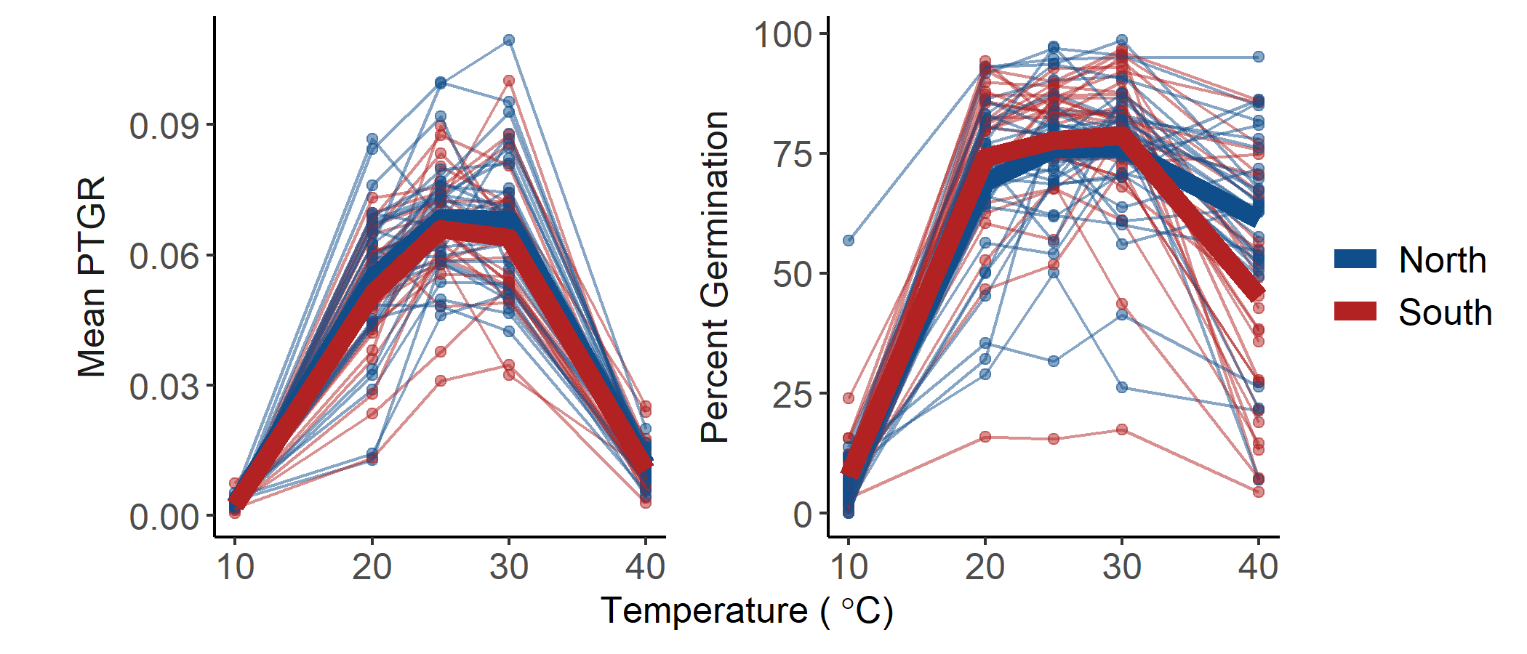

Figure 4. Percent germination and mean pollen tube growth rate (PTGR) for *Solanum carolinense* pollen grains from the north (blue) and south (red) across a temperature gradient (10°C, 20°C, 25°C, 30°C, 40°C). Thin lines and points represent each individual plant that flowered. Thick lines indicate the mean value for the region at each temperature.

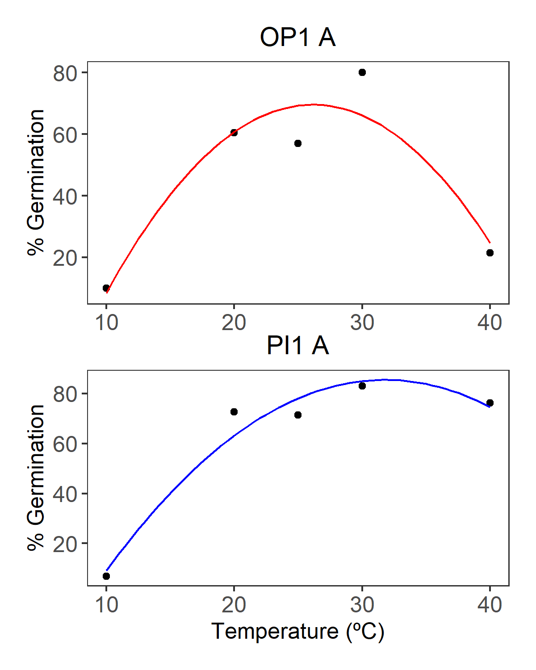

Figure 5. Examples of quadratic fit curve for pollen germination of one genet from the southern region (OP1 A, red) and one genet from the northern region (PI1 A, blue).

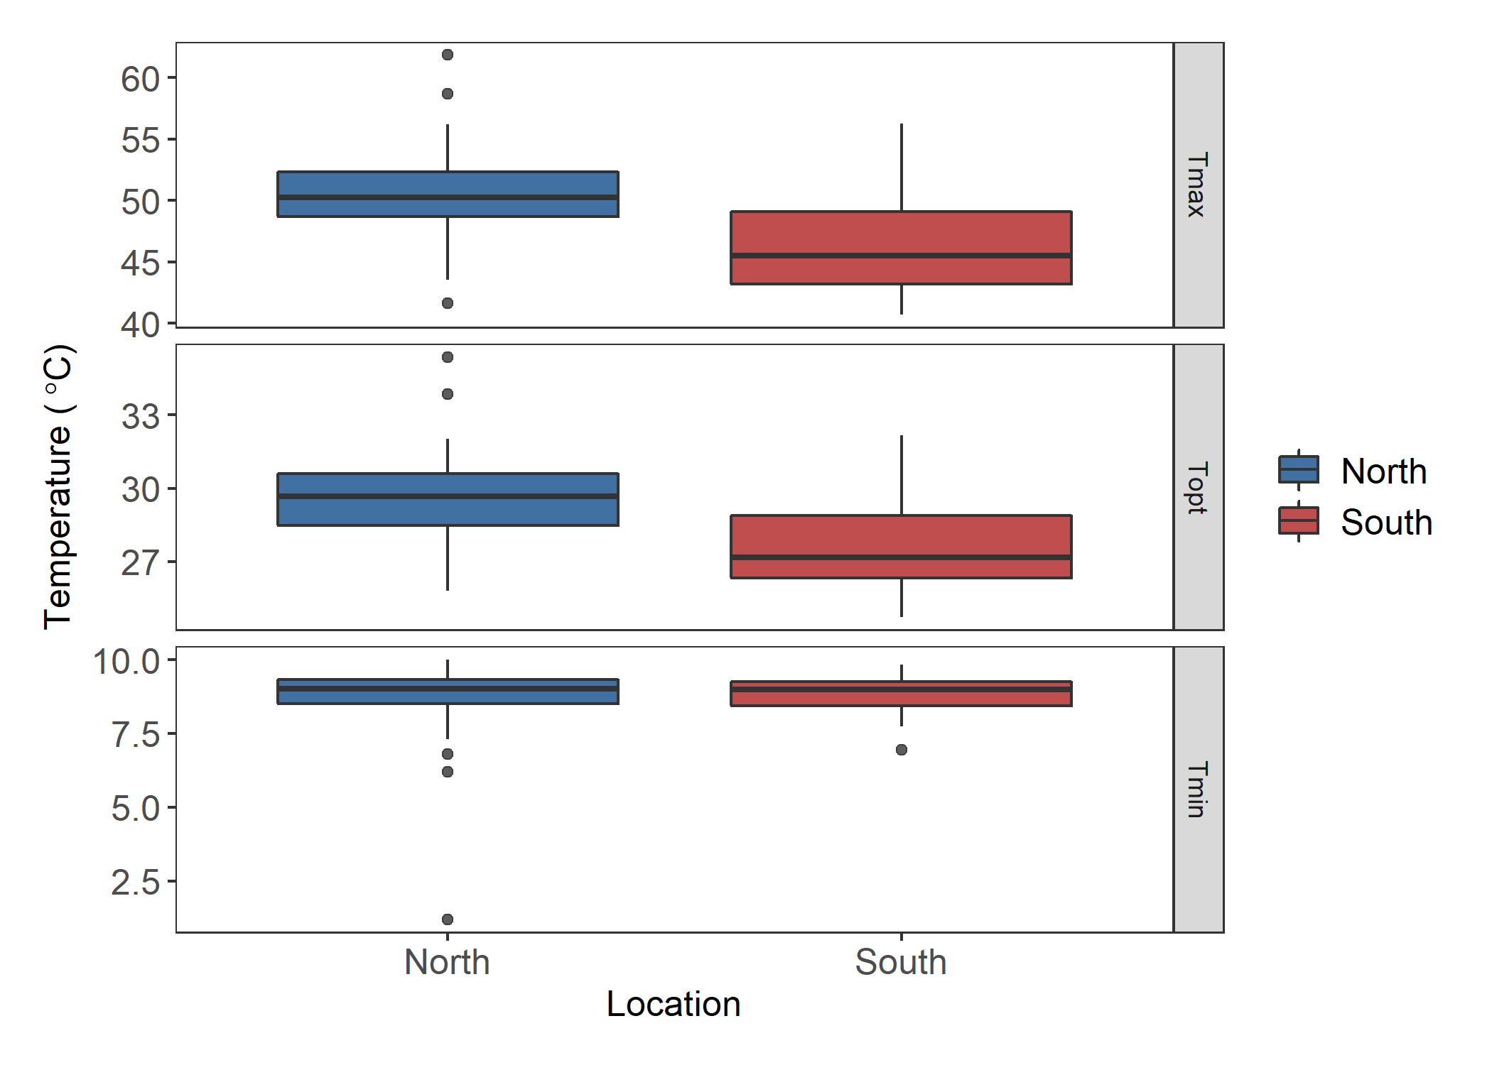

A

B

*

A

B

*

A

A

Figure 6. Estimates for the maximum (Tmax), optimal (Topt), and minimum (Tmin) germination temperature extracted from quadratic fits of the germination data for each individual. Asterisks and different letters indicate significant differences. There is a significant difference between regions for Tmax (F = 14.28, p = 3.7E-4) and Topt (F = 12.85, p = 6.85E-4).

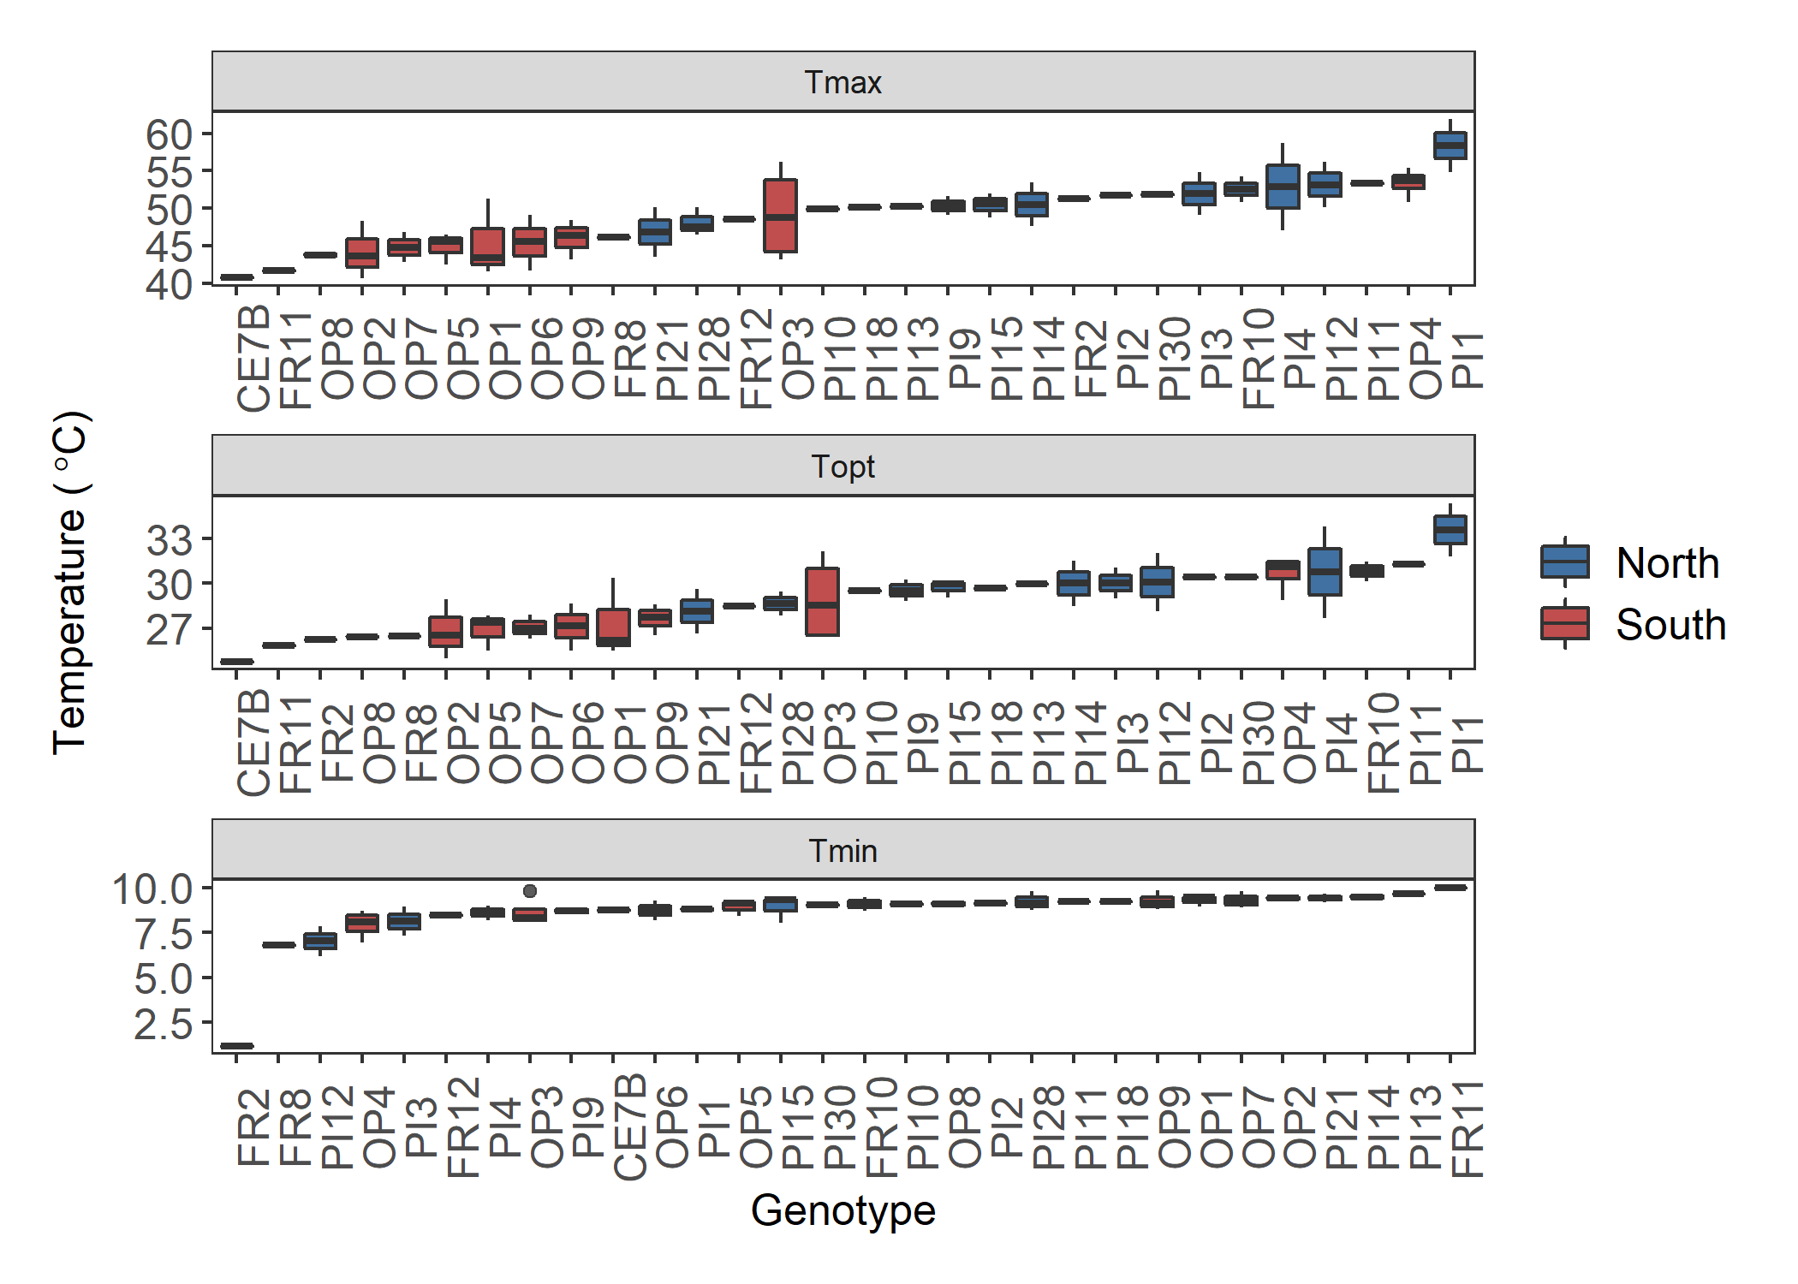

*

Figure 7. Boxplots of the maximum (Tmax), optimal (Topt), and minimum (Tmin) pollen germination temperatures by genet. There is a significant difference between the genets for Tmax (F = 2.064, p = 0.025), Topt (F = 1.952, p = 0.035), and Tmin (F = 2.284, p = 0.0135). Asterisk indicates the outlier removed for analysis. Plots of genet effect for other variables in appendix.

Figure. Plot of the results of Principal component analysis of the gametophytic variables.

***Gametophytic Variables***

*Pollen Germination*

Pollen germination was determined by the percentage of the number of pollen grains that produced pollen tubes or germinated out of the total number of pollen grains. We measured pollen germination for all individuals that flowered at five different temperatures (figure 4). We fit quadratic curves to the temperature performance profile of each genet (figure 5). From the quadratic fit, we calculated the minimum (Tmin), maximum (Tmax), and optimal (Topt) temperature of pollen germination for each individual. There was a significant difference between regions for Tmax and Topt (figure 6). Genets from the north germinated more readily at high temperatures than genets from the south. There was no significant difference between the two regions for Tmin. The genets were significantly different from one another for Tmin, Tmax, and Topt (figure 7). One outlier was identified using the Grubbs test for one outlier (outliers; function grubbs.test) and subsequently dropped from the analysis.

*Pollen Tube Growth Rate*

Pollen tube growth rate was calculated by dividing the average length of the longest 40 tubes on a plate by the time the plate remained in the temperature treatment (figure 4). The pollen tube growth rates for each individual were also fit with a quadratic curve to estimate the Tmin, Tmax, and Topt. There was no significant difference between genets from the north and south for any of the calculated variables (Appendix). There were also no significant differences between genets for the calculated variables (Appendix).

*Gametophytic PCA*

We conducted principal component analysis to explore the relationships between the gametophytic variables. The first three components explained 92.5% of the variance. As for the sporophytic PCA, there was little divergence between the two regions for gametophytic PCA. However, there was division between northern and southern plants along PC1. Tmax and Topt loaded in the opposite direction of Tmin. Conversely, all PTGR variables load evenly on the first two principal components and in the same direction.

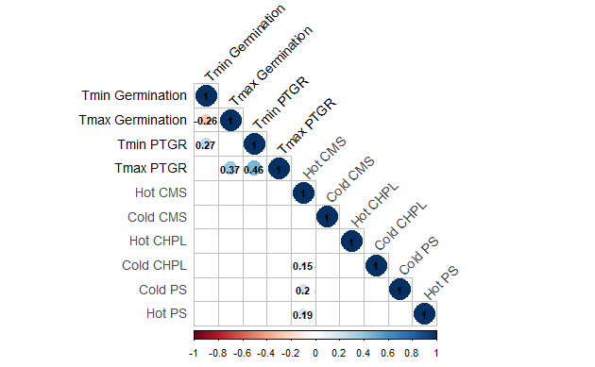

Figure 8. Correlation matrix of sporophytic (dark gray) and gametophytic variables (black) with significant Pearson’s correlations. Blue colors indicate positive correlations and red colors indicate negative correlations.

***Correlations and PCA***

We used correlation analysis and principal component analysis to identify relationships between hot and cold tolerance for the sporophytic and gametophytic variables. Pearson’s correlations were determined for all pairings of all variables. There were no significant correlations between the gametophytic and sporophytic variables (figure 8). Of the sporophytic variables, only three correlations were significant (correlation plots located in appendix). Both hot and cold photosynthesis had a slight positive correlation with HCMS (HPS Pearson’s correlation 0.19, CPS Pearson’s correlation 0.2). CCHPL was also weakly correlated with HCMS (Pearson’s correlation 0.15). There were three significant correlation coefficients between the gametophytic variables. Maximum and minimum pollen tube growth rate were positively correlated (Pearson’s correlation 0.45). Maximum and minimum pollen germination were negatively correlated (Pearson’s correlation -0.33). Maximum pollen tube growth rate and maximum pollen germination were positively correlated (Pearson’s correlation 0.3).

For the full PCA, we included all gametophytic and sporophytic variables, except HPS and CPS. For both photosynthesis and the gametophytic variables, there were missing values due to plants dying or not flowering. To increase the sample size for the full PCA and incorporate both the sporophyte and gametophyte, we excluded the photosynthesis variables. The first three principal components accounted for 57% of the variation. Again, there was little divergence between region and any divergence followed the same patterns as the independent PCAs (PCA plots and loadings located in the appendix).