**Intraspecific variation in responses to extreme and moderate temperature stress in the wild species, *Solanum carolinense***

Abstract

Adaptation or acclimation to local temperature regimes has often been used as a proxy for predicting how plant populations will respond to impending novel conditions driven by human-caused climate change. To understand how plants may successfully respond over the long-term to increasing air temperatures in the future, we explored how northern and southern populations of a single species, *Solanum carolinense*, differ in temperature tolerance traits in a two-part study. We first asked if long-term heat influences plant development by examining how development in moderate heat affected reproductive structures and reproductive success. We then compared how plants from the two regions respond to extreme heat and cold in both vegetative and reproductive traits. We found that moderate heat was generally detrimental to the development of reproductive structures and seed production. Plants in heat produced 16 fewer seeds on average than plants in the control. Reproductive structures that developed in heat were also reduced in size and to a greater extent in the northern populations relative to populations from the south. In the second experiment, we found that temperature-sensitivity differed between southern populations that regularly experience extreme heat and northern populations that do not. In contrast to our expectations, northern populations appeared more heat-tolerant than southern populations. Our results are consistent with an avoidance mechanism to mitigate extreme heat in pollen germination. We conclude that rising temperatures have the potential to incur substantial consequences to the reproductive success of individuals in this species and that populations may mitigate stressful temperature conditions as a result of evolutionary processes.

**Introduction**

Climate change is rapidly altering environmental conditions at regional and local scales, leading to relatively rapid shifts in temperature regimes, precipitation patterns, and the severity of weather events (Seneviratne, Xuebin. et al. 2021). As a result, there is widespread interest in understanding how plants, a mostly sessile taxonomic group, will cope with these rapid changes (Demarche et al. 2018; Doak and Morris 2010; Molina-Montenegro and Naya 2012; Valladares et al. 2014). Plants respond to environmental change in three ways while avoiding extinction; adapt relatively rapidly, acclimate to tolerate new conditions by shifting phenotypes that are relatively plastic, or by shifting ranges (Janzen 1967; Molina-Montenegro and Naya 2012; Schlichting 1986). Because environmental conditions across a species’ range are often heterogeneous, in particular for species with large ranges, selective pressures are likely to differ among populations. Divergent selection in two regions can result in differing trait optima in the separate populations through local adaptation (Kawecki and Ebert 2004). Alternatively, plants in populations with different environments may be phenotypically plastic in their response to environmental conditions, resulting in populations with divergent traits, but little genetic divergence among those populations. Temperature is a variable that varies greatly in both severity and consistency with geographic region and often determines a species’ distribution (Von Büren and Hiltbrunner 2022). To understand how plants will respond to a warming world and test for local adaptation of plants to regional thermal environments, we examined how heat and cold stress affected traits across latitudes in a widespread weed, *Solanum carolinense* (Solanaceae).

Based on the IPCC Sixth Assessment Report (Seneviratne et al. 2021), temperatures are changing at unprecedented rates throughout the world. The National Climate Assessment (USGCRP 2018) reported that temperatures in the Midwestern and Southeastern United States have been steadily rising since the 1970’s. Changes to temperature regimes are expected to ultimately lead to temperatures that are above what is currently optimal for plant cellular processes, especially those involved in reproductive success (Jiang et al. 2019a; Müller et al. 2016; Sato et al. 2006; Xu et al. 2017b). Researchers have experimentally established that development in moderately high temperatures affects floral morphology (Charles and Harris 1972, Sato, Kamiyama et al. 2006, Müller, Xu et al. 2016), ovule viability (Xu, Wolters-Arts et al. 2017), pollen viability (Sato, Kamiyama et al. 2006, Din, Khan et al. 2015, Müller, Xu et al. 2016, Xu, Wolters-Arts et al. 2017, Poudyal, Rosenqvist et al. 2019), fruit set (Charles and Harris 1972, Sato, Kamiyama et al. 2006, Din, Khan et al. 2015), and seed set (Din, Khan et al. 2015) in crop species. For many of these studies, heat was detrimental to development and reproduction. Sato et al. (2006) found that elevated temperatures decreased fruit set and pollen viability as well as stamen height in tomato. Poudyal et al. (2019) found that pollen viability decreased in heat, but more tolerant tomato accessions had higher pollen germination than sensitive accessions. Xu et al. (2017) found that long-term mild heat decreased pollen viability, pollen number, female fertility, and fruit set. Charles and Harris (1972) found that flower production, fruit set, fruit size, pollen germination, and distance between the stigma and antheridial cone all decreased at high temperatures in tomatoes. Lastly, Muller et al. (2016) found that long-term mild heat resulted in floral deformations and low pollen viability in tomatoes. Researchers have repeatedly shown that heat has negative effects on reproductive traits and correlates of male and female reproductive success in crop species.

While many in this field have established that heat or temperature stress in general is detrimental to vegetative and reproductive traits, the question remains: can plants evolve tolerance or other strategies to mitigate temperature stress quickly enough to track climate change? First, selection for further trait divergence might not occur if species can acclimate to novel temperatures through phenotypic plasticity. However, acclimation would require a species to have evolved acceptable levels of phenotypic plasticity and the responses to cues that improve or maintain fitness. In the case that a species can not acclimate or track the climate through evolution of tolerance to a set of temperatures, populations in areas with temperature stress may face local extinction unless they have the potential to migrate to more favorable conditions- range shifts. Lastly, local conditions introduce the possibility of divergent selection to act on the genetic diversity already within the population. Adaptation would involve a shift in tolerance towards traits that improve the chances of survival or reproduction for individuals in a population experiencing thermal stress. For example, we would expect traits associated with tolerating cold in plant populations in a colder region to differ from populations in a warmer region. In a place for time substitution, local adaptation to region specific climate conditions can be studied as a proxy for how populations in areas of warming could respond to changes in climate.

Here we present the results of two experimental studies on *Solanum carolinense*, where we sought to understand how tolerant plants are to heat and cold and ultimately inform predictions of plant evolution in a warming environment. Our objectives were to (1) determine if local thermal conditions have divergently selected for temperature tolerance traits between northern and southern latitudes or not and (2) experimentally test the effects of moderate heat (32°C) versus control (25°C) temperatures during flower and fruit development on phenotypic expression of pre- and post-pollination reproductive traits. We hypothesized that southern populations of *Solanum carolinense* evolved greater tolerance to moderate and extreme heat in reproductive and vegetative stages, because these plants have adapted to tolerate the extreme maximum temperatures and higher average temperatures. Conversely, we expected the opposite for plants from more northern populations – higher tolerance to extreme cold and lower tolerance to heat stress in general.

Methods

*Solanum carolinense* L. (Solanaceae), also known as horsenettle, is a weedy, herbaceous perennial that originated in southeastern North America. All other species in this clade are neotropical, suggesting that this species likely arose through dispersal to North America and independent diversification. Once established in the southeast, *Solanum carolinense* utilized its natural adaptability and propensity to reproduce both sexually and asexually to expand its range north- and west-ward (Figure 1).

Figure 1. Map of the distribution of *Solanum carolinense* (grey dots), northern (blue dots) and southern regions (red dots), and populations of origin for plants in this study. The populations Frontenac (top blow-up, blue) and Prairie Island (top blow-up, purple) were in the northern region and the populations Cemetery (bottom blow-up, red), Oil Patch (bottom blow-up, orange), and Reserve (bottom blow-up, green) were located in the southern region.

We collected *Solanum carolinense* plants from multiple populations in Minnesota and Texas between October 2019 and August 2020 (Figure 1). The Minnesota plants collectively will be referred to as the northern plants and include the populations Prairie Island (44.07959 N, -91.684545 W) and Frontenac (44.523056 N, -92.338611 W). Approximately 80 Km separated the two populations (Figure 1). In Houston County, MN where these plants were collected, the average daily temperatures vary from a low of -9°C to a high of 22°C over the course of the year. The Texas plants together will be referred to as the southern plants. All three Texas populations were located within a circle with a 1.5 Km radius near McKinney TX (Oil Patch: 33.173465 N, -96.615402 W; Reserve: 33.159962 N, -96.619011 W; and Cemetery: 33.173672 N, -96.615096 W). In Colin County TX, where these plants were collected, the average daily temperatures vary from a low of 6°C to a high of 29°C over the course of the year.

We collected plants by removing rhizomes of at least 10 cm from individual plants in the field and placing them in ziplock bags. We assumed that each rhizome represented a unique genotype (genet) because we maintained an interval of at least 1 meter between collections. The number of rhizomes (genets) collected at each population were as follows: Prairie Island (n= 29); Frontenac (n= 13); Oil Patch (n= 9); Reserve (n= 6); and Cemetery (n= 11).

The field-collected rhizomes were shipped to Fargo, ND, and stored in a 4°C refrigerator prior to a growth and dormancy period to establish an experimental population. After one to several weeks in the refrigerator, the rhizomes were potted in one-gallon containers with a standard potting mix, allowing above and belowground material to grow for several months in a greenhouse. The above ground material was then cut and the pots were again stored in a 4°C refrigerator to induce a period of dormancy.

After the dormancy period (3 months), equal sections of rhizome (at least 2 cm for thick rhizomes and increased lengths for thinner rhizomes) were cut into four equal-sized pieces. These were ultimately used to grow genetically identical plants (ramets) from each genet at different times (temporal blocks A, B, C and D) because of a lack of sufficient space to grow them all at once. The rhizome pieces were placed in 3.8 cm diameter cone-shaped containers in the greenhouse.

Of the ramets planted each week, half were from the southern region and half were from the northern region. Since we had a total of 26 genets from the south, we randomly selected 26 of the 42 genets from the northern populations using a random number generator. All ramets in block A were planted over the course of five weeks prior to the planting of the ramets in block B and so on. Each northern plant was paired with a southern plant spatially on the greenhouse benches. The plants were fertilized every other week with 10-10-10 fertilizer and transplanted to larger, 4.5 L containers when they outgrew the small cone-shaped containers. These conditions were established for Experiment 2, which occurred prior to Experiment 1. We switched the order of the experiments for the sake of clarity in this story.

**Experiment 1: The effect of long-term moderate heat on reproductive traits**

Just prior to Experiment one, we removed the aboveground portions of each plant and stored them at 4° C for a final dormancy period of 3-9 months. Two ramets of all 26 genets from the north and south were placed in a randomized grid pattern in a growth chamber (Conviron PGC-FLEX). Due to space constraints in the environmental chambers, only A and B ramets were grown initially. Ramets C and D were placed in the chambers six months later. For initial growth, all plants were exposed to “control” conditions (25°C day/25°C night; fluorescent and incandescent lighting for 14 hours per day. Plants were fertilized once every two weeks with a high phosphorus fertilizer (12-55-6) to promote flower production (Super Bloom, Scotts).

Upon flowering, two ramets per genet were randomly assigned to the control conditions (25°C day/25°C night; 14hr/10hr) and the other two to the heat treatment conditions (32°C day/25°C night; 14hr/10hr). By necessity, these were in different chambers (control: Conviron PGC-FLEX; heat treatment: Conviron E7/2). Plants were watered daily. Subsequent flowers and fruits developed at either elevated temperatures (32°C) or control temperatures (25°C).

Pre-Pollination Phase

The first three hermaphroditic flowers (*Solanum carolinense* is andromonecious) per plant that developed in the respective treatments were collected in ethanol and used for flower morphology measurements, ovule counts, and pollen size measurements. Floral morphology traits (length of the style, stigma, and one anther) were measured under a dissecting scope. The number of ovules in each ovary was counted following a modified staining protocol adapted from Diaz and Macnair (1999). Pollen diameters of approximately 100 grains were measured with the use of a microscope (Axio Scope A.1 Carl Zeiss, Germany) at 400x total magnification and the circle diameter measurement tool on the Zen 3.1 software.

Post-Pollination Phase

We pollinated three additional flowers and collected the pollen of one more flower to measure subsequent female and male reproductive traits. Mature flowers were pollinated with a mix of pollen from 2 to 5 flowers, represented by northern and southern plants, that developed in the control conditions. Pollinations were accomplished by applying a mixture of pollen on the stigma with a dissection probe. Each pollinated flower was labelled with a jewelry tag. Once flowers were pollinated, the plant remained in their respective treatments for one week before we moved them into a greenhouse for the remainder of fruit maturation (Average Daily Temperatures 25.1°C day / 21.3°C night). Once fruits were at least one month old, they were harvested. We measured fruit set (number of fruits produced / three flowers pollinated) and the seed set (number of viable seeds, aborted seeds, and unfertilized ovules per fruit). The number of viable seeds, aborted seeds, and unfertilized ovules were counted under a dissecting scope.

In-vitro pollen germination at 40°C was used as a proxy for male reproductive success in high temperatures, selected based on results from Experiment 2. Pollen germination at extreme temperatures was measured following a protocol from Reddy and Kakani (2007). Pollen from each plant was dispersed over a petri dish containing 3% Bacto-Agar based growth medium (sucrose, Ca(NO3)2, MgSO4, KNO3, H3BO3)and incubated at 40°C for 16 hours. Four pictures of each plate were taken using a compound microscope (Leica DM500 microscope, Leica ICC50 HD camera) and the LAS EZ 2.1.0 software. We measured pollen germination (Germ) for each plate by counting the number of pollen grains per image that had produced pollen tubes and dividing that by the total number of pollen grains observed.

**Experiment 2: Life-stage specific responses to extreme temperature**

Temperature tolerance variables

To assess the impact of extreme heat on plants, we measured three vegetative variables (cell membrane stability (CMS), chlorophyll content (CHPL), and net photosynthetic rate (PS).) and two reproductive variables (the propensity for pollen grains to germinate (GERM) and the growth rate of pollen tubes (PTGR). We measured each variable on each plant in two temperature treatments, hot treatment (acronym preceded by “H”) and an extreme cold treatment (acronym preceded by “C”).

CMS was calculated according to the protocol from Gajanayake et al. (2011) and Fang and To (2016). Ion leakage from leaf material exposed to either heat (HCMS: 55°C water bath for ten minutes) or cold (CCMS: -18°C) was measured using an electrical conductivity probe and compared to the conductivity of leaf material in control (27°C) and maximum damage (98°C) treatments. Difference in chlorophyll content (CHPL) of leaves was estimated, as in Gitelson et al., (1998) for material exposed to either a hot temperature treatment (HCHPL: 60°C for 1 hr) or a cold temperature treatment (CCHPL: 4°C for 1 hr followed by -18°C for 1 hr) using a chlorophyll meter (Opti-Sciences CCM-300). The chlorophyll meter measures the fluorescence emitted at 735nm/700nm for a constant leaf area. Chlorophyll content before and after treatments was used to estimate the difference in chlorophyll content in mg/m2. PS was a measure of the effects of temperature treatments on the photosynthetic capabilities of leaves. PS was estimated as the ratio of net photosynthetic rates before and after a temperature treatment (HPS: 33°C, CPS: 10°C for 48 hrs). More detailed methods are available in the Supporting Information.

We focused on two pollen traits for estimates of male thermotolerance during the reproductive stage: 1) the propensity for pollen grains to germinate (pollen germination) and 2) the growth rate of pollen tubes while exposed to a range of temperatures. We paired measurements of pollen traits from plants in the north and south by sampling mature anthers of plants flowering simultaneously. Pollen from each flower in a pair was dispersed over five petri dishes containing the mixture described in experiment 1 (3% Bacto-Agar based growth medium (sucrose, Ca(NO3)2, MgSO4, KNO3, H3BO3). The dusted plates were each placed at one of the five temperature treatments (10°C, 20°C, 25°C, 30°C, 40°C) for 16 hours. Four pictures of each plate were taken using a compound microscope (Leica DM500 microscope, Leica ICC50 HD camera) and the LAS EZ 2.1.0 software. We measured pollen germination (Germ) for each plate by counting the number of pollen grains per image that had produced pollen tubes and dividing that count by the total number of pollen grains observed. Pollen tube growth rate (PTGR) was calculated by dividing the length of the 20 longest pollen tubes measured using ImageJ (Schneider et al. 2012) by the time allowed for growth (16 hours). Detailed methods provided in the Supporting Information. Each experimental plant was cut back to soil level and stored at 4°C for 3-9 months.

Data Analysis

The effect of long-term moderate heat on reproductive traits

Flower date was analyzed for regional differences using a linear mixed effects model in the *lme4* package (Bates et al. 2015) with region as the fixed effect and genet as the random effect. Differences in flower type development between the treatments were analyzed using a chi-squared test in the *stats* package (R Core Team 2020). All pre and post pollination traits were analyzed with different versions of mixed effects models depending on the data type. The general structure for the model was region, treatment, and the interaction of region and treatment as fixed effects and genet as the random intercept. We used general linear mixed effects models (*lme4*; function lmer) for anther and style plus stigma length. To avoid overfitting the model for pollen diameter, we omitted genet as a random effect and used a general linear model (*stats*; function lm). We used generalized mixed effects models (*lme4*; function glmer) with a Poisson distribution for all count data, which included counts of ovules, viable seeds, unfertilized ovules, and aborted seeds. Since pollen germination at 40°C was a proportion, we used a generalized mixed effects model (*lme4*; function glmer) with a binomial distribution for analysis. We conducted correlation analysis for mean anther and mean style plus stigma lengths (*stats*; function cor.test).Fruit set was analyzed using a chi-squared test (*stats*; function chisq.test).

Life-stage specific responses to extreme temperature

To measure differences in vegetative traits between plant origins and among genets, we fit linear mixed effects models using the lmer function from the *lme4* package (Kuznetsova et al. 2017). Region (north vs. south) was considered the fixed effect and block (A, B, C, D) and genet were random intercepts. Since there was a significant block effect in some of the variables, we compared plants from the north and south within blocks using a paired t-test (*stats*; function t.test).

For the reproductive variables, we fit quadratic temperature performance curves (determined using model selection) to the multiple temperature measurements taken for each plant that flowered using the nls.multstart function in the *rTPC* package (Padfield and O'Sullivan 2021). From the quadratic curves of each plant that flowered, we extracted three key values for both pollen germination and pollen tube growth rate: the temperature minimum, temperature optimum, and temperature maximum. We then used the key values in an analysis of variance (*stats*; function aov) to determine if the response curves differed between regions. One outlier was identified using the Grubbs’ test for outliers, grubbs.test function in the *outliers* package (Komsta 2011), and subsequently dropped from the analysis.

We used Pearson’s method for correlation analysis (*stats*; function cor) to identify associations between vegetative and reproductive variables. The Holm-Bonferroni method (*stats*; function p.adjust) was used to adjust p-values to account for multiple correlations. All data were analyzed in R 4.1.2 (R Core Team 2020).

Results

**Experiment 1: The effect of long-term moderate heat on reproductive traits**

Pre-pollination

We found that long-term moderate heat negatively impacted style plus stigma length, anther length, pollen grain diameter, and ovule number (Table 1, Figure 2). However, flowering time and first flower type (hermaphrodite and male) did not differ between the treatments or region of origin. On average, flowers that developed in the heat treatment had smaller floral structures. Style plus stigma length decreased by 14% (Χ2=240, p<0.001) and anther length decreased by 11% (Χ2=183, p<0.001) in long term moderate heat conditions relative to the control. Style plus stigma length also differed by region of origin. Plants from Texas on average had 5% longer style plus stigma than plants from Minnesota (Χ2=11, p=0.001). The relationship between anther and style plus stigma length changed with development in heat. Mean anther length and style plus stigma length were correlated in the control treatment (r=0.55, t52=4.81, p<0.001), but not in the heat treatment (r=0.21, t40=1.35, p=0.184; Figure 3). Development in heat increased the average number of ovules by approximately 1 ovule (Χ2=11, p=0.001) and reduced pollen size by 10% (F1,100=82, p<0.001). Neither trait differed by region. We found significant interactions between treatment and region in style plus stigma length (Χ2=6, p=0.014), anther length (Χ2=9, p=0.002), and ovule number (Χ2=53, p<0.001; Figure 2).

Post-pollination

Pollen development in long-term moderate heat did not affect germination at high temperatures and germination did not differ between regions (Table 1). Fruit set was also not affected by the heat treatment. The number of viable seeds was affected by heat (Χ2=100, p<0.001) and on average decreased seed set by 16 seeds. The number of unfertilized ovules increased by six in the heat treatment compared to the control (Χ2=11, p<0.001) and the number of aborted seeds increased by about 1.64 seeds on average (Χ2=42, p<0.001). We note here that the average number of aborted seeds in the control group was relatively low with an average number of 0.63 seeds. The number of unfertilized ovules did differ by region (Χ2=6, p=0.011). There was a significant interaction between the treatment and region for the number of unfertilized ovules (Χ2=64, p<0.001) and aborted seeds (Χ2=12, p<0.001; Figure 2).

Table 1. ANOVA results with the fixed effects temperature treatment (control and heat), region of origin (north and south), and the interaction between treatment and region. Genet was included as a random effect (excluded in pollen grain size due to overfitting the model).

|  |  |  |  |  |  |  |  |
| --- | --- | --- | --- | --- | --- | --- | --- |
| Variable | Treatment | | | Region | | Treatment:Region | |
| dF | Χ2 | p | Χ2 | p | Χ2 | p |
| Style + Stigma Length (mm) | 1 | **240.11** | **<0.001** | **10.50** | **0.001** | **6.00** | **0.014** |
| Anther Length (mm) | 1 | **183.57** | **<0.001** | 0.27 | 0.605 | **9.29** | **0.002** |
| Ovule Number | 1 | **10.93** | **<0.001** | 0.036 | 0.849 | **52.87** | **<0.001** |
| Pollen Grain Size (μm) * | 1,100 | **F=82.27** | **<0.001** | 0.00 | 0.979 | 0.00 | 0.981 |
| Pollen Germination (40°C) | 1 | 0.10 | 0.748 | 1.51 | 0.219 | 0.01 | 0.931 |
| Viable Seed | 1 | **99.71** | **<0.001** | 2.85 | 0.091 | 0.03 | 0.867 |
| Unfertilized Ovules | 1 | **11.34** | **<0.001** | **6.41** | **0.011** | **64.16** | **<0.001** |
| Aborted Seeds | 1 | **41.77** | **<0.001** | 1.99 | 0.158 | **11.62** | **<0.001** |

*Model excluded genet random effect to avoid overfitting model. Bolded values: statistically significant (α=0.05).

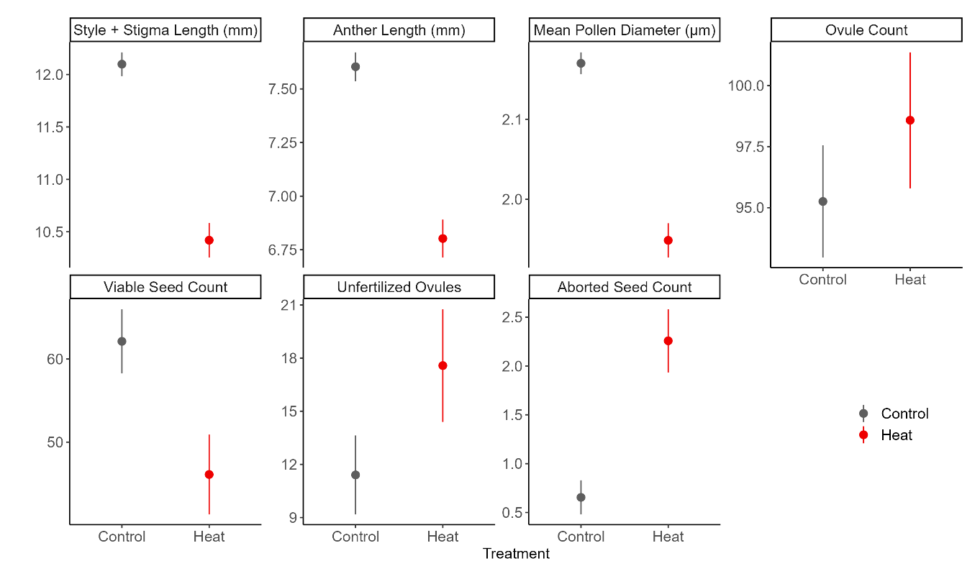

Figure 1. The effects of long-term moderate heat on morphological traits and seed set. Plant development in heat reduced the size of the stigma + style, anther, and pollen grains. The number of ovules increased. Development and fertilization in heat reduced the number of viable seeds per fruit. The number of unfertilized ovules and aborted seeds increased.

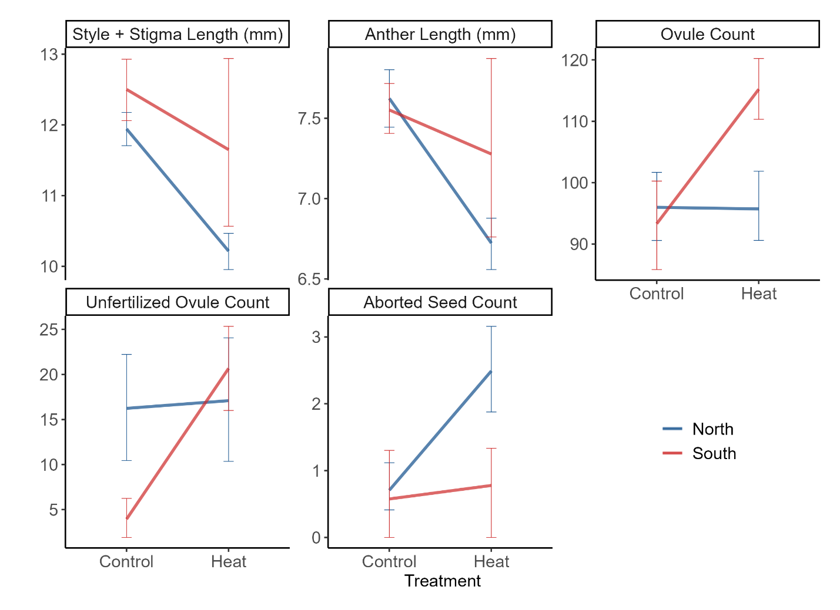

Figure 2. Statistically significant interactions in Experiment 1 between heat treatment and region.

Figure 3. Correlation of anther and style plus stigma length averaged across genets in Experiment 1. Control shown in dark grey and heat treatment in red. Correlation between morphological traits (r=0.55, t52=4.81, p<0.001) deteriorated in the heat treatment (r=0.21, t40=1.35, p=0.184).

**Experiment 2: Life-stage specific responses to extreme temperature**

Vegetative traits

Of the six vegetative traits measured in this experiment, three differed between regions. In extreme heat (HCHPL: F1,51=4.418, p =0.041) and cold (CCHPL: F1,50=66.369, p <0.001), northern plants retained chlorophyll content more effectively than southern plants (Table 2). The chlorophyll content of northern plants was 8% and 19% higher than southern plants for the heat and cold treatments respectively. In contrast, southern plants had a 5% higher cell membrane stability in the extreme cold treatment than did northern plants (CCMS: F1,191=66.369, p <0.001; Table 2).

There was no overall significant difference between regions for HCMS, but heat tolerance was higher for northern than for southern plants in block A (Supplementary Information). Temperatures in the greenhouse progressively rose throughout the spring and summer leading to a block effect in both the hot and cold treatments of CMS (Supporting Information Fig. S2). The block effect on CMS may be due to the capacity of *S. carolinense* to induce temperature tolerance and acclimate to environmental conditions (Clarke et al. 2004). In block A, northern plants had a higher HCMS, but this difference degraded in the later blocks during the times when greenhouse temperatures were higher during plant development (Supporting Information Fig. S3). We considered block A values the baseline HCMS and determined that northern plant have higher baseline heat tolerance. Finally, there were no regional effects on photosynthetic rate in response to either cold or heat.

Table 2. Vegetative and reproductive temperature tolerance results from mixed effects linear models with the fixed effect region (north vs south) and the random effects genet and block (omitted for reproductive). Due to overfitting the model genet was omitted from CCMS, HPS, and Tmin PTGR. Block was not included in the analysis for reproductive traits and CPS. Random effect statistical values reported in the Supporting Information (Table S2), as well as results from a mixed model using only control values (Supporting Information Table S3).

|  |  |  |  |  |  |  |
| --- | --- | --- | --- | --- | --- | --- |
| Variable | | Region | | | | |
| Expected | Observed | dF | F | p |
| Vegetative | Cell Membrane Stability (Heat) | S > N | - | 1, 50 | 3.673 | 0.0610 |
| Cell Membrane Stability (Cold) | N > S | S > N | **1, 191** | **6.482** | **0.012** |
| Chlorophyll Content (Heat) | S > N | N > S | **1, 51** | **4.418** | **0.041** |
| Chlorophyll Content (Cold) | N > S | N > S | **1, 50** | **66.369** | **<0.001** |
| Photosynthetic Rate (Heat) | S > N | - | 1 | 0 | 0.997 |
| Photosynthetic Rate (Cold) | N > S | - | 1, 47 | 3.269 | 0.077 |
| Reproductive | Pollen Germination (Tmax) | S > N | N > S | **1, 26** | **12.054** | **0.002** |
| Pollen Germination (Topt) | S > N | N > S | **1, 24** | **10.916** | **0.003** |
| Pollen Germination (Tmin)* | S > N | - | 1, 21 | 0.151 | 0.702 |
| Pollen Tube Growth Rate (Tmax) | S > N | - | 1, 29 | 0.446 | 0.509 |
| Pollen Tube Growth Rate (Topt) | S > N | - | 1, 29 | 0.121 | 0.731 |
| Pollen Tube Growth Rate (Tmin) | S > N | - | 1, 59 | 0.168 | 0.683 |

* Outlier removed. Bolded values: statistically significant (α=0.05).

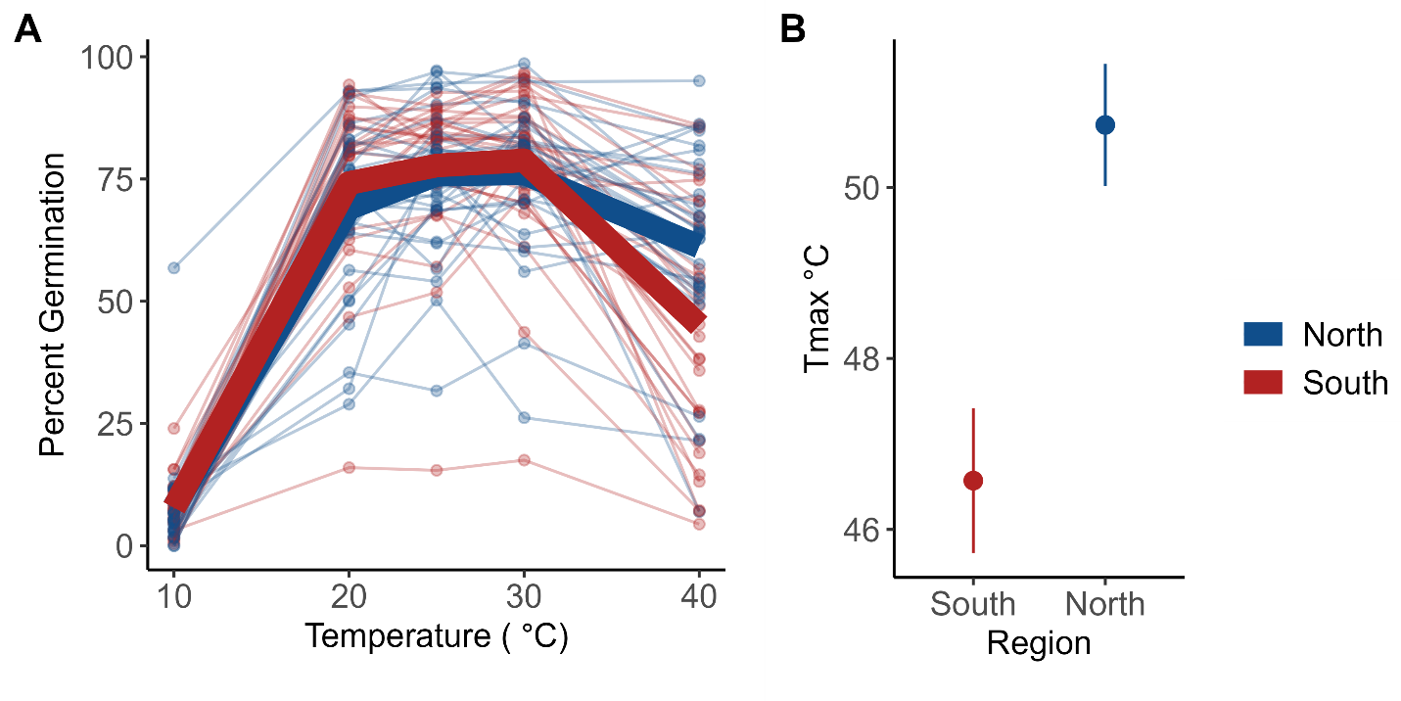

Figure 4. Results from Experiment 2 measures of pollen germination. (A) Percent pollen germination per genet (points) and regional mean (bolded lines: blue=northern, red=southern) . (B) Mean (±se) Tmax for northern (blue) and southern (red) genets. Tmax is the upper x-intercept of the quadratic fit for each individual (i.e., the highest temperature predicted with pollen germinatipn). Pollen from the northern region germinates at higher temperatures compared to pollen from the south (Tmax: F1,26=12, p =0.002).

Reproductive traits

There was a significant difference between regions for Tmax (Figure 4, Table 2) and Topt (Table 2). Pollen from plants from the north germinated more readily at high temperatures (Tmax: F1,26=12, p =0.002) and had higher thermal optima (Topt: F1,24=11, p =0.003) than pollen from plants from the south. There was no significant difference between the two regions for Tmin. One outlier was identified using the Grubbs’ test for outliers and subsequently dropped from the analysis. There were no significant differences in pollen tube growth rate between plants from the north and south for Tmax, Topt or Tmin.

Vegetative and Reproductive Tolerance correlations

After a Holm-Bonferroni correction for multiple correlations, there were no significant correlations between the vegetative variables and reproductive and vegetative variables. However, there were two significant correlation coefficients between reproductive variables. Tmax and Tmin of pollen tube growth rates were positively correlated (r = 0.46). There was also a significant correlation between Tmax for pollen tube growth rate and for pollen germination (r = 0.3).

Discussion

The results of the combined experiments we present here indicate that not only do relatively extreme temperatures affect viable seed production and morphological traits but, the responses to heat differ between plants from northern and southern populations in both moderate and extreme temperature conditions. As in other studies (Muller et al. 2016, Fahad et al. 2017), we found that exposure to higher temperatures during plant and floral growth led to negative effects on traits tied to successful reproduction. In experiment one, where plants were exposed to moderate heat (32 °C) and control conditions (25 °C) during floral development, there was a significant treatment effect on 7 of the 8 characteristics we measured (Table 1, Figure 1) including floral morphology measurements, pollen size and ovule fate (viable, aborted, unfertilized). Regardless of where they were from, flowers were smaller and the number of viable seeds decreased in hot conditions.

Several other studies have found that heat affects the floral structures in other taxa, but not necessarily in the same way (Lyrene 1994). Muller et al. (2016) found anther deformations when tomato flowers developed in mild heat (32°C/26°C ). Charles and Harris (1972) found that as temperatures increased the distance between the antheridial cone and the stigma (herkogamy) in tomatoes decreased (longer pistil or shorter stamen). We didn’t specifically look at herkogamy, but different style lengths could have implications for pollen competition (Ramesha et al. 2011) and the position of anthers relative to the stigma could affect the receipt of outcross versus self pollen from pollinators. We did find that the correlation between the length of male and female reproductive structures breaks down in heat (Figure 3) suggesting that the fundamental proportions of floral structures are disrupted. The change to position of integral reproductive structures in heat could affect rates of self-pollination and inbreeding for *Solanum carolinense*.

The effect of heat on viable seed production and pollen size in our study represent important responses to temperature stress that could have fitness consequences. Pollen diameter dropped significantly in Experiment 1, when flowers developed in hotter conditions (Figure 1). McCallum and Chang (2016) found evidence of pollen size influencing siring success; larger pollen grains were more competitive (sired more seeds) than smaller pollen grains in common morning glory. Our result of reduced viable seed counts in fruits developed in moderate heat has mixed support in the literature for a close relative, tomatoes. Xu et al. (2017) found that heat had little influence on seed number compared to other reproductive traits, but Din et al. (2015) found that seed set was reduced in heat, especially in more temperature sensitive accessions. They attributed this difference to heat reducing pollen viability, or pollen tube growth in the style. In sum, these results suggest that the stress of warmer temperatures during floral development can have important negative effects with potential evolutionary consequences.

Regional differences

Despite the fact that all of the plants used in our experiments were the same species and were grown in approximately the same conditions, there were significant differences between the responses to hot temperatures between plants from northern versus southern latitudes (Figure 2). These differences are consistent with long-term local adaptation of plants to the thermal patterns and environments in the two different places (MN and TX). The floral morphology reductions in response to heat described previously, were not consistent between northern and southern plants. Reductions in the length of female and male floral structures were significantly more dramatic in plants from northern populations relative to southern populations (Table 1 – treatment x region effects, Figure 2). These patterns and the increase in ovule counts for southern plants suggest that they will maintain allocations of energy to floral structures despite the heat stress. In contrast, northern plants may reduce their energy allocation to floral structures as an alternative strategy for tolerating heat stress.

Another key difference between northern and southern plants was how heat, during pollination and fruit development, influenced the number of aborted and unfertilized ovules. In southern plants, heat led to increases in the number of ovules that were unfertilized, while in plants from the north, heat led to increases in the number of aborted ovules. In control conditions, southern plants had a much lower percentage of ovules that were unfertilized than northern plants. In heat, the percentage was about the same for the two regions. The reduced efficiency of fertilization in southern plants when exposed to heat may be the result of two separate phenomena. First, in heat, southern plants produced more ovules and generally had longer styles than northern plants. The increased number of unfertilized ovules may be a result of southern plants producing a larger number of ovules during development and the inability of a full pollen load to fertilize the excess ovules. Second, prolonged heat exposure and termination of pollen tube growth in the longer styles of flowers on southern plants could also contribute to the number of ovules that went unfertilized in heat. Both of the above phenomena and the generally low seed abortion rate suggest that pollen is the limiting factor.

A similar result to ours was attained by Jiang (2019), who found, in peas, that ovules maintained viability in heat stress, but pollen viability decreased. Indeed, pollen germination has been shown to be negatively affected by heat in many studies (Jiang et al. 2019b; Müller et al. 2016; Poudyal et al. 2019; Sato et al. 2006; Xu et al. 2017a). In Experiment 1, we found no evidence that pollen development in heat reduces pollen germination (Table 2), but in Experiment 2, we established that heat generally reduces pollen germination for pollen from northern and to a greater extent southern plants.

A second set of evidence that regional differences in *Solanum carolinense* have evolved over time comes from the divergent patterns of tolerance to extreme temperatures between northern and southern plants in experiment two (Table 2). Contrary to our expectations, we found that in multiple life stages, northern plants were more tolerant of extreme heat than are southern plants. Typically, heat tolerance is measured by exposing plant material to heat and quantifying cell membrane stability and chloroplast integrity under high relative to control levels of heat (Fang and To 2016; Gajanayake et al. 2011; Martineau et al. 1979; Murty and Majumder 1962). In Experiment 2, we found northern plants had higher chlorophyll content (HCHPL) and baseline cell membrane stability (HCMS) under hot conditions, as well as higher maximum and optimal temperatures for pollen germination in comparison to southern plants (Table 2, Figure 1).

Plants from the north had more stable chlorophyll content in both the hot (HCHPL) and cold treatments (CCHPL; Table 2). The capacity of northern plants to outperform southern plants in both extreme cold and heat might be due to northern plants experiencing a larger range of temperatures and broad adaptation to stress in general. Between 2018 and 2021, temperatures during the growing season (March to September) in Houston County, MN ranged from -28°C to 34°C (62°C difference), while in Collin County, TX they ranged from -7°C to 42°C (49°C difference). If the evolution of tolerance to extreme cold in the north, where wintering rhizomes remain in frozen ground for months, yields general physiological tolerance to any temperature extremes, then northern plants should be more tolerant than southern. Heat shock proteins, that play an important role in maintaining tolerance to heat in plant cells (Feder and Hofmann 1999; Frank et al. 2009; Heckathorn et al. 1998), can also confer tolerance to cold by stabilizing protein configurations and functions in cells at stressful temperatures (Neta-Sharir et al. 2005). Therefore, selection for extreme temperature tolerance may be more common in northern latitudes. Northern plants will suffer severe fitness consequences if they do not maximize growth and reproduction during the relatively short growing season, whereas southern plants can avoid growing and reproducing during the hottest portions of summer and still have months of mild temperatures available.

The results from reproductive trait comparisons also countered our expectations for the direction of temperature tolerance. Pollen from the north had a higher propensity to produce pollen tubes (Germ) at high temperatures than their southern counterparts (Table 2, Figure 1). Again, this is evidence that northern plants are more heat tolerant. One possible explanation for these results is that there is an avoidance strategy in southern populations where maximum summer temperatures can reach over 38°C consistently. Under these conditions, there could well be a selective advantage to pollen remaining dormant rather than germinating at high temperatures. In contrast, there may be no selection for dormancy at relatively high temperatures in the north. This explanation is supported by a theory regarding pollen dormancy developed in Rutley et al. (2022). They proposed the “two baskets model” categorizing pollen and stating that there are active (high-ROS) and backup (low-ROS) subpopulations of pollen within anthers of flowering species. Active pollen readily germinate and have fast metabolisms, increasing pollen tube growth rates, and typically outcompete the smaller, partially dehydrated backup pollen with low metabolisms. The two subpopulations of pollen are adaptive under different conditions. In stressful environments, such as extreme heat or drought, asynchrony in pollen germination permits some pollen to remain dormant and grow pollen tubes later in more favorable conditions. In favorable conditions, active pollen tubes grow faster and are more likely to fertilize ovules than backup pollen. While the two-pollen system has not been established in *Solanum carolinense*, there have been studies demonstrating these two pollen types in *Solanum lycopersicum*, tomato (Jegadeesan et al. 2018; Keller and Simm 2018; Luria et al. 2019).

Predictions about how species will be affected by climate change can be improved with a better understanding of how different populations of the same species differ in their responses to heat now but at different latitudes with different thermal patterns. The future climate experienced by plants in Minnesota is predicted to more closely resemble that experienced by plants in Texas now and in the past including both higher average temperatures in summer months and higher maximum daily temperatures (IPCC 2014). Growing seasons are already getting longer in northern populations (Badh et al. 2009; Dunnell and Travers 2011). Given the responses to heat by plants in our experiments in the form of relatively moderate heat (32°C) during floral development, pollen tube growth and fruit maturation and extreme heat (40-60°C) in acute doses, we suggest that plants in the two regions we studied have evolved differences that represent differing strategies for surviving thermal stress. There is little evidence that southern plants have evolved greater cellular tolerances to extreme heat despite growing in an environment that can have daily maximum temperatures above 40.5° C. The stability of cellular membranes, chlorophyll and pollen germination capabilities were reduced after exposure to extreme heat in southern relative to northern plants (Table 2, Figure 1). If plants in the south have shifted to an avoidance strategy where the temperature extremes of summer months are avoided by dormancy of pollen or flowering patterns shifted earlier or later, then selection for tolerance of high heat may not occur. In contrast, northern plants that experience relatively short seasons when growth and flowering are possible will need to flower and develop fruit during the hottest times of the year to produce viable seed. However, as climate change leads to longer, hotter growing seasons, our expectation is that an upper limit to tolerance of heat will ultimately lead to different phenological patterns and perhaps dormancy. Thus, the evolutionary consequences of climate change for flowering plants is likely to be a complex shift in phenological and physiological patterns.

**References**

Badh, A., Akyuz, A., Vocke, G., and Mullins, B. 2009. Impact of Climate Change on the Growing Seasons in Select Cities of North Dakota, United States of America. The International Journal of Climate Change: Impacts and Responses **1**(1): 105-118. doi:<https://doi.org/10.18848/1835-7156/CGP/v01i01/37130>.

Bates, D., Maechler, M., Bolker, B., and Walker, S. 2015. Fitting Linear Mixed-Effects Models Using lme4. Journal of Statistical Software **67**(1): 1-48. doi:10.18637/jss.v067.i01.

Charles, W.B., and Harris, R.E. 1972. Tomato fruit-set at high and low-temperatures. Canadian journal of plant science. **52**(4): 497-506. doi:10.4141/cjps72-080.

Clarke, S.M., Mur, L.A.J., Wood, J.E., and Scott, I.M. 2004. Salicylic acid dependent signaling promotes basal thermotolerance but is not essential for acquired thermotolerance in Arabidopsis thaliana. The Plant journal : for cell and molecular biology **38**(3): 432-447. doi:10.1111/j.1365-313X.2004.02054.x.

Demarche, M.L., Doak, D.F., and Morris, W.F. 2018. Both life‐history plasticity and local adaptation will shape range‐wide responses to climate warming in the tundra plant *Silene acaulis*. Global Change Biology **24**(4): 1614-1625. doi:10.1111/gcb.13990.

Diaz, A., and Macnair, M.R. 1999. Pollen tube competition as a mechanism of prezygotic reproductive isolation between Mimulus nasutus and its presumed progenitor M. guttatus. The New phytologist **144**(3): 471-478. doi:10.1046/j.1469-8137.1999.00543.x.

Doak, D.F., and Morris, W.F. 2010. Demographic compensation and tipping points in climate-induced range shifts. Nature **467**(7318): 959-962. doi:10.1038/nature09439.

Dunnell, K.L., and Travers, S.E. 2011. Shifts in the flowering phenology of the northern Great Plains: Patterns over 100 years. American Journal of Botany **98**(6): 935-945. doi:10.3732/ajb.1000363.

Fang, J.-Y., and To, N.A. 2016. Heat tolerance evaluation in commercial African violet cultivars using physiological and pollen parameters. Scientia horticulturae **204**: 33-40. doi:10.1016/j.scienta.2016.03.034.

Feder, M.E., and Hofmann, G.E. 1999. Heat-shock proteins, molecular chaperones, and the stress response: Evolutionary and Ecological Physiology. Annual Review of Physiology **61**(1): 243-282. doi:10.1146/annurev.physiol.61.1.243.

Frank, G., Pressman, E., Ophir, R., Althan, L., Shaked, R., Freedman, M., Shen, S., and Firon, N. 2009. Transcriptional profiling of maturing tomato (Solanum lycopersicum L.) microspores reveals the involvement of heat shock proteins, ROS scavengers, hormones, and sugars in the heat stress response. Journal of experimental botany **60**(13): 3891-3908. doi:10.1093/jxb/erp234.

Gajanayake, B., Trader, B.W., Reddy, K.R., and Harkess, R.L. 2011. Screening Ornamental Pepper Cultivars for Temperature Tolerance Using Pollen and Physiological Parameters. HortScience **46**(6): 878-884. doi:10.21273/HORTSCI.46.6.878.

Gitelson, A.A., Buschmann, C., and Lichtenthaler, H.K. 1998. Leaf chlorophyll fluorescence corrected for re-absorption by means of absorption and reflectance measurements. Journal of Plant Physiology **152**(2): 283-296. doi:<https://doi.org/10.1016/S0176-1617(98)80143-0>.

Heckathorn, S.A., Downs, C.A., Sharkey, T.D., and Coleman, J.S. 1998. The Small, Methionine-Rich Chloroplast Heat-Shock Protein Protects Photosystem II Electron Transport during Heat Stress1. Plant Physiology **116**(1): 439-444. doi:10.1104/pp.116.1.439.

Janzen, D.H. 1967. Why Mountain Passes are Higher in the Tropics. The American naturalist **101**(919): 233-249. doi:10.1086/282487.

Jegadeesan, S., Chaturvedi, P., Ghatak, A., Pressman, E., Meir, S., Faigenboim, A., Rutley, N., Beery, A., Harel, A., Weckwerth, W., and Firon, N. 2018. Proteomics of Heat-Stress and Ethylene-Mediated Thermotolerance Mechanisms in Tomato Pollen Grains [Original Research]. Frontiers in Plant Science **9**. doi:10.3389/fpls.2018.01558.

Jiang, Y., Lahlali, R., Karunakaran, C., Warkentin, T.D., Davis, A.R., and Bueckert, R.A. 2019a. Pollen, ovules, and pollination in pea: Success, failure, and resilience in heat. Plant, cell and environment **42**(1): 354-372. doi:10.1111/pce.13427.

Jiang, Y., Lahlali, R., Karunakaran, C., Warkentin, T.D., Davis, A.R., and Bueckert, R.A. 2019b. Pollen, ovules, and pollination in pea: Success, failure, and resilience in heat. Plant, Cell & Environment **42**(1): 354-372. doi:10.1111/pce.13427.

Kawecki, T.J., and Ebert, D. 2004. Conceptual issues in local adaptation. Ecology letters **7**(12): 1225-1241. doi:10.1111/j.1461-0248.2004.00684.x.

Keller, M., and Simm, S. 2018. The coupling of transcriptome and proteome adaptation during development and heat stress response of tomato pollen. BMC Genomics **19**(1). doi:10.1186/s12864-018-4824-5.

Komsta, L. 2011. outliers: Tests for outliers.

Kuznetsova, A., Brockhoff, P.B., and Christensen, R.H.B. 2017. lmerTest Package: Tests in Linear Mixed Effects Models. Journal of Statistical Software **82**(13): 1 - 26. doi:10.18637/jss.v082.i13.

Luria, G., Rutley, N., Lazar, I., Harper, J.F., and Miller, G. 2019. Direct analysis of pollen fitness by flow cytometry: implications for pollen response to stress. The Plant Journal **98**(5): 942-952. doi:10.1111/tpj.14286.

Lyrene, P.M. 1994. Environmental Effects on Blueberry Flower Size and Shape Are Minor. Journal of the American Society for Horticultural Science **119**(5): 1043-1045. doi:10.21273/jashs.119.5.1043.

Martineau, J.R., Specht, J.E., Williams, J.H., and Sullivan, C.Y. 1979. Temperature Tolerance in Soybeans. I. Evaluation of a Technique for Assessing Cellular Membrane Thermostability 1. Crop Science **19**(1): 75-78. doi:10.2135/cropsci1979.0011183x001900010017x.

Molina-Montenegro, M.A., and Naya, D.E. 2012. Latitudinal Patterns in Phenotypic Plasticity and Fitness-Related Traits: Assessing the Climatic Variability Hypothesis (CVH) with an Invasive Plant Species. PLoS ONE **7**(10): e47620. doi:10.1371/journal.pone.0047620.

Muller, F., and Rieu, I. 2016. Acclimation to high temperature during pollen development. Plant Reproduction **29**(1-2): 107-118. doi:10.1007/s00497-016-0282-x.

Murty, K.S., and Majumder, S.K. 1962. Modifications of the technique for determination of chlorophyll stability index in relation to studies of drought resistance in rice [research-article]. Current Science **31**(11): 470-471.

Müller, F., Xu, J., Kristensen, L., Wolters-Arts, M., De Groot, P.F.M., Jansma, S.Y., Mariani, C., Park, S., and Rieu, I. 2016. High-Temperature-Induced Defects in Tomato (Solanum lycopersicum) Anther and Pollen Development Are Associated with Reduced Expression of B-Class Floral Patterning Genes. PLOS ONE **11**(12): e0167614. doi:10.1371/journal.pone.0167614.

Neta-Sharir, I., Isaacson, T., Lurie, S., and Weiss, D. 2005. Dual Role for Tomato Heat Shock Protein 21: Protecting Photosystem II from Oxidative Stress and Promoting Color Changes during Fruit Maturation. The Plant Cell **17**(6): 1829-1838. doi:10.1105/tpc.105.031914.

Padfield, D., and O'Sullivan, H. 2021. rTPC: Functions for Fitting Thermal Performance Curves.

Poudyal, D., Rosenqvist, E., and Ottosen, C.O. 2019. Phenotyping from lab to field - tomato lines screened for heat stress using F-v/F-m maintain high fruit yield during thermal stress in the field [Article]. Functional Plant Biology **46**(1): 44-55. doi:10.1071/fp17317.

R Core Team. 2020. R: A language and environment for statistical computing. *In* R Foundation for Statistical Computing. R Foundation for Statistical Computing, Vienna, Austria.

Ramesha, B.T., Yetish, M.D., Ravikanth, G., Ganeshaiah, K.N., Ghazoul, J., and Shaanker, R.U. 2011. Stylish lengths: Mate choice in flowers. Journal of Biosciences **36**(2): 229-234. doi:10.1007/s12038-011-9057-6.

Reddy, K.R., and Kakani, V.G. 2007. Screening Capsicum species of different origins for high temperature tolerance by in vitro pollen germination and pollen tube length. Scientia horticulturae **112**(2): 130-135. doi:10.1016/j.scienta.2006.12.014.

Rutley, N., Harper, J.F., and Miller, G. 2022. Reproductive resilience: putting pollen grains in two baskets. Trends in Plant Science **27**(3): 237-246. doi:10.1016/j.tplants.2021.09.002.

Sato, S., Kamiyama, M., Iwata, T., Makita, N., Furukawa, H., and Ikeda, H. 2006. Moderate Increase of Mean Daily Temperature Adversely Affects Fruit Set of Lycopersicon esculentum by Disrupting Specific Physiological Processes in Male Reproductive Development. Annals of Botany **97**(5): 731-738. doi:10.1093/aob/mcl037.

Schlichting, C. 1986. The Evolution of Phenotypic Plasticity in Plants. Annual review of ecology and systematics **17**(1): 667-693. doi:10.1146/annurev.ecolsys.17.1.667.

Schneider, C.A., Rasband, W.S., and Eliceiri, K.W. 2012. NIH Image to ImageJ: 25 years of image analysis. Nature Methods **9**(7): 671-675. doi:10.1038/nmeth.2089.

Seneviratne, S.I., Xuebin., Z., Adnan, M., Badi, W., Dereczynski, C., Di Luca, A., Ghosh, S., Iskandar, I., Kossin, J., Lewis, S., Otto, F., Pinto, I., Satoh, M., Vicente-Serrano, S.M., Wehner, M., and Zhou, B. 2021. Weather and Climate Extreme Events in a Changing Climate. C.U. Press, Cambridge, United Kingdom and New York.

USGCRP. 2018. Impacts, Risks, and Adaptation in the United States: Fourth National Climate Assessment. U.S. Global Change Research Program, Washington, DC, USA.

Valladares, F., Matesanz, S., Guilhaumon, F., Araújo, M.B., Balaguer, L., Benito‐Garzón, M., Cornwell, W., Gianoli, E., Kleunen, M., Naya, D.E., Nicotra, A.B., Poorter, H., and Zavala, M.A. 2014. The effects of phenotypic plasticity and local adaptation on forecasts of species range shifts under climate change. Ecology Letters **17**(11): 1351-1364. doi:10.1111/ele.12348.

Von Büren, R.S., and Hiltbrunner, E. 2022. Low winter temperatures and divergent freezing resistance set the cold range limit of widespread alpine graminoids. Journal of Biogeography **49**(8): 1562-1575. doi:10.1111/jbi.14455.

Xu, J., Wolters-Arts, M., Mariani, C., Huber, H., and Rieu, I. 2017a. Heat stress affects vegetative and reproductive performance and trait correlations in tomato (Solanum lycopersicum). Euphytica **213**(7). doi:10.1007/s10681-017-1949-6.

Xu, J., Wolters-Arts, A.M.C., Mariani, C., Huber, H., and Rieu, I. 2017b. Heat stress affects vegetative and reproductive performance and trait correlations in tomato (solanum lycopersicum). Euphytica **213**(7): 1-12. doi:10.1007/s10681-017-1949-6.