**Abstract**

Temperatures in various locations across the globe are gradually increasing due to climate change. *Solanum carolinense*, a species closely related to eggplant and tomato, has arange that spans much of the United States, including locations where temperature increases are projected. Previous studies found that moderate heat substantially influenced reproductive processes in crop species, particularly accessions sensitive to heat. Thus, we investigated the impact of long-term moderate heat on flower development before pollination and the fertilization post-pollination in *Solanum carolinense*. The pre-pollination traits we measured were style and stigma length, stamen length, ovule number, and pollen size. The post-pollination traits that were included in this study were pollen germination at 40°C, fruit set, and viable seed count. We found that heat affects flower morphology, pollen size, and viable seed number. These results have implications for the persistence of wild non-crop populations in locations with gradually rising temperatures.

**Introduction**

Climate change is rapidly changing local temperatures, and, in many locales, are projected to increase. According to the National Climate Assessment (Melillo et al., 2014) temperatures in the Midwestern and Southeastern United States have been steadily rising. Average daily maximum temperatures in the southeastern region have made moderate increases compared to other regions in the United States, but minimum and average temperatures have been increasing. The subtle increases of temperature regimes will lead to long-term temperatures that are above optimal for plant cellular processes, especially affecting reproductive processes (Jiang et al., 2019b; Müller et al., 2016; Sato et al., 2006; J. Xu et al., 2017).

High temperatures affect several physiological and structural properties of plants. Such as photosynthesis (Poudyal et al., 2019) and cell membrane integrity (Gajanayake et al., 2011). Reproductive processes are also affected and have been extensively studied in crop species, wherein fruit yield and quality are of utmost importance. In crop species, development in moderately high temperatures affected floral morphology (Charles & Harris, 1972; Müller et al., 2016; Sato et al., 2006), ovule viability (Jiemeng Xu et al., 2017), pollen viability (Din et al., 2015; Müller et al., 2016; Poudyal et al., 2019; Sato et al., 2006; J. Xu et al., 2017), fruit set (Charles & Harris, 1972; Din et al., 2015; Sato et al., 2006), and seed set (Din et al., 2015). Most of the studies on the effect of temperature on sexual reproduction are in tomatoes. Sato et al. (2006) found that elevated temperatures decreased fruit set and pollen viability as well as stamen height in tomato. Poudyal (2019) found that pollen viability decreased in heat, but more tolerant tomato accessions had higher pollen germination than sensitive accessions. Xu et al. (2017) found that long-term mild heat decreased pollen viability, pollen number, female fertility and fruit set. Charles and Harris (1972) found that flower production, fruit set, fruit size, pollen germination, and distance between the stigma and antheridial cone all decreased at high temperatures in tomato. Muller et al. (2016) found that long-term mild heat resulted in floral deformations and low pollen viability in tomatoes.

While there are countless studies examining how high temperatures affects sexual reproduction, there are few studies that have addressed how high temperatures affect wild, non-crop species. However, sexual reproduction is important for the persistence of wild populations throughout their range, that may consist of heterogeneous conditions. Rising temperatures could restrict the success of sexual reproduction in multiple ways. Changes in flower morphology has the potential to influence how pollinators interact with flowers and reduction in ovule and pollen viability decreases changes of fertilization, seed formation, and fruit development. Each process reduces the potential number of offspring and in that fitness. Wild, non-crop species may be just as vulnerable to high temperatures, if not more than the crop species. We attempted to fill this gap in the literature by examining high temperature sensitivity in traits commonly used in crop-species in a wild species closely related to tomato.

In this study, we investigated the effect of long-term high temperatures on reproductive traits in *Solanum carolinense*. We included both pre-pollination (developmental) traits and post-pollination traits to understand how heat interacts with multiple elements throughout the process of sexual reproduction. Our objectives were to 1) identify stages of sexual reproduction when *Solanum carolinense* plants are vulnerable to heat. If *Solanum carolinense* responds to long-term heat stress in a similar way as tomato, then we predict that development in heat affects floral morphology, male and female viability, and fruit and seed set in ways that are detrimental to fitness. The second objective was to 2) compare plants from populations in Texas and Minnesota and recognize potential adaptations that allow populations to persist at high temperatures. If *Solanum carolinense* plants from southern regions experience elevated heat regularly and have, to some extent, locally adapted to those conditions (as determined in chapter 1), then plants from Texas would be less sensitive to long-term high heat or have avoidance mechanisms that are not present in the north. The third objective was to 3) examine variation in reproductive traits at the population level and the plasticity of traits across environmental conditions.

**Methods**

## Species Description

*Solanum carolinense* L. (Solanaceae), also known as horsenettle, is an herbaceous perennial with spines that line the stem and midrib of the variably lobed leaves. This species reproduces asexually by rhizome and sexually. *Solanum carolinense* is indeterminate and andromonoecious, meaning that both staminate and hermaphroditic flowers are produced. The flowers are buzz pollinated, requiring pollinators that buzz at a certain frequency to release pollen from the stamen. Once pollinated, fertilization is complicated by a self-incompatibility (SI) system at the S-locus. The SI system discourages inbreeding by degrading pollen tubes with the same S-allele in the style, prior to fertilization (Mena-Ali et al., 2009; Mena-Ali & Stephenson, 2007). However, as flowers age, the SI system degrades and the potential for successful self-fertilization with fruit production increases (Travers et al., 2004). The fruit are small yellow to green, tomato-like berries that are dispersed by small mammals.

## Field Collection and

*Solanum carolinense* plants were collected from two populations in Houston County, Minnesota and three populations in Collin County, Texas between October 2019 and August 2020. The Minnesota plants collectively will be referred to as the northern region and included the populations Prairie Island (44.07959 N, -91.684545 W) and Frontenac (44.523056 N, -92.338611 W). Approximately 80 Km separated the two populations. In Houston County, MN, the average monthly low temperature is -14°C (7°F) and the average monthly high is 29°C (85°F). The Texas plants together will be referred to as the southern region. All three TX populations were within a 1.5 Km radius near McKinney (Oil Patch: 33.173465 N, -96.615402 W; Reserve: 33.159962 N, -96.619011 W; and Cemetery: 33.173672, -96.615096 W). In Colin County TX, the average monthly low temperature is 18°C (65°F) and the average monthly high is 43°C (111°F).

*Solanum carolinense* is a perennial that reproduces by sexual reproduction and dispersal of seeds in a tomato-like fruit by frugivores and by asexual reproduction by the growth of ramets (genetically identical clones) from the rhizome. Genets (individual plants) were sampled by digging up plants with an inter-plant distance of 1 meter and cutting at least 10 cm of rhizome. The rhizomes were given unique ID numbers, placed in zip lock bags, and shipped to Fargo in a cooler with blue ice. The rhizomes were stored in a 4°C refrigerator until they were planted in one-gallon containers and grown through the summer of 2020. In October, the above ground material was cut and the rhizomes in pots were stored again at 4°C for a three-month period of dormancy. During the spring and summer of 2021, four ramets (A, B, C, and D) cut from the rhizome of each genet were grown and used in a previous study (methods described in Chapter 1). In October and November, the above ground material for all ramets of each genet was cut and the plants were returned to 4°C for a dormancy period.

## Growth Conditions and Experimental Design

On January 12, 2022, ramets A and B for all genets were placed in a randomized grid pattern in a Conviron PGC-FLEX growth chamber. One ramet from each genet was randomly assigned to the heat and the other was assigned to the control treatment. For initial growth, all plants were placed in the same, “control” conditions. For the control growth conditions, the chamber was set at 25°C day/25°C night with fluorescent lights at setting 2 and incandescent lights at setting 1 for 14 hours per day. As plants grew to heights at which the incandescent bulbs damaged upper leaves on some plants, the incandescent setting was reduced to 0. Plants were regularly fertilized with a high phosphorus fertilizer to promote flower production.

Once a ramet flowered, all flowers and buds were removed before placing the plants in either the heat or control treatment chambers. The control treatment chamber (Conviron PGC-FLEX) was set at the same conditions used for initial growth. The heat treatment chambers (Conviron E7/2) were set at 32°C day/25°C night with the same light settings as the control. Plant in the treatment groups were watered daily. The date of first flowering and the date when a ramet flowered again in the treatment were recorded. The flower type, hermaphroditic or staminate, produced for the first flowering in the treatment was also recorded.

## Pre-pollination

Three hermaphroditic flowers that completely developed in the respective treatments were collected and used for flower morphology measurements, ovule counts, and pollen size measurements. The ovules were stained following a modified protocol adapted from Diaz and Macnair (1999). The flowers with petals removed were fixed in Eppendorf tubes with ethanol for 24 hours and washed with deionized water. The tubes were then filled with 1M NaOH and placed in a hot plate at 70°C for 2 minutes to soften the floral structures before a final wash in deionized water. The flowers were then stained in 0.1% aniline blue with 0.1M K3PO4 for 24 hours in darkness. The length of the style and stigma and one anther were measured under a dissecting scope. The ovary and one anther were sectioned and mounted on a microscope slide with 50% glycerol. Fluorescence microscopy (Axio Imager A.1 LED/DL Carl Zeiss, Germany) was intended to be used for determining ovule viability based on the percentage of callose formation in ovules. The heat treatment did not incur visible callose formation for this species, thus only ovule number was recorded using microscopy. Pollen diameter was measured using Microscopy (Axio Scope A.1 Carl Zeiss, Germany) at 400x total magnification and the circle diameter measurment tool on the Zen 3.1 software. Pictures of pollen grains from the slide of one flower per plant were taken and used for measurements. All pollen in a picture were measured and the number of pictures required to measure at least 100 pollen grains were used.

## Post-pollination

Pollen germination at 40°C was used as a male performance trait. In the previous study, there was variation in pollen germination at high temperatures. We used 40°C to determine how plants differ in germination at high temperatures and whether pollen development in long-term high heat affects pollen germination at high temperatures. One flower that completely developed in the treatment group was collected for pollen germination. Pollen from a mature flower, identified by petals in an open position perpendicular to the anthers and a fully developed stigma (if flower was hermaphroditic). Since horsenettle is naturally buzz pollinated, a device crafted from parts from robotic vacuum cleaner was used to vibrate stamen and release pollen. Pollen was dispersed on a petri dish with a 3% Bacto-Agar based growth medium (sucrose, Ca(NO3)2, MgSO4, KNO3, H3BO3) following the protocol of Reddy and Kakani (2007) and placed in a drying oven at 40°C for 16 hours. Three pictures of the pollen on the petri dish were taken using microscopy (Leica DM500 microscope, Leica ICC50 HD camera) and the LAS EZ 2.1.0 software. To avoid sampling bias, petri dish was positioned so pollen visible to the naked eye was under the objective. The petri dish was not repositioned once pollen grains were viewed under magnification. Pollen germination was measured by counting the number of pollen grains that produced tubes of at least half the diameter of the pollen grain and dividing by the total number of pollen grains in a picture. All pollen grains in a picture were counted. The number of pictures used depended on the number required to count at least 100 pollen grains.

Female performance was determined by the number of ovules that were fertilized and developed into seeds. Once all flowers for morphological and male performance traits were collected, three flowers on one plant were pollinated with a mix of pollen from flowers in the control treatment. Horsenettle has a self incompatibility system, which prevents plants with the same S allele from fertilizing one another. The self incompatibility system is a measure to prevent inbreeding. Since we haven’t identified the S alleles for these plants, we mixed pollen from multiple populations from the north and south to ensure that there was the opportunity for fertilization between our crosses. Paternity was disregarded for these measurements. Since pollen developed in the control conditions, the only alternation is the treatment in which the ovules developed. The flowers were pollinated by applying mixed pollen on the stigma with a probe and labeling the flower with a jewelry tag. Once flowers were pollinated, the plant remained in the treatment for one week before being moved into a greenhouse for fruit to develop.

Once fruits were at least one month old, they were harvested. The number of seeds, aborted seeds, and unfertilized ovules were counted. The variables used as measures of female performance were fruit set and seed set. Fruit set was the number of fruits produced divided by the number of flowers pollinated, which was three for all plants. Seed set was the number of viable seeds produced divided by the average number of ovules for flowers of the same plant.

*Data Analysis*

All data analysis was conducted in R 4.1.2 (R Core Team, 2020). Flower date was analyzed for regional differences using a linear mixed effects model in the *lmerTest* package (Kuznetsova et al., 2017) with region and population as the fixed effects and genet nested in population as the random effect. Treatment effects were only analyzed for northern plants because of low sample size in southern plants. Differences in flower type development between the treatments in the northern plants were analyzed using a chi-squared test in the *stats* package (R Core Team, 2020). Stamen length, style and stigma length, and ovule number were analyzed for regional differences in the control treatment using a linear mixed effects model (*lmerTest*; function lmer) with region and population as fixed effects and genet nested in population as the random effect. A linear mixed effects model (*lmerTest*; function lmer) with treatment and population as the fixed effects and genet nested in population as the random effect was used for treatment differences. The ratios of style and stigma to stamen length for northern plants were analyzed using a linear mixed effects model with treatment as the fixed effect and population as a random effect. To test differences in variation between the treatment groups of the ratio, we used the Bartlett test of homogeneity of variances (*stats*; function bartlett.test). We also conducted correlation analysis for mean stamen and mean style and stigma lengths (*stats*; function cor.test).Mean pollen diameter was compared between regions using a linear mixed effects model (*lmerTest*; function lmer) with region as the fixed effect and genet nested in population as the random effect. The treatment effect on mean diameter of pollen grains in the northern plants was analyzed using a linear mixed effects model (*lmerTest*; function lmer) with treatment as the fixed effect and population as the random effect.

Since there was a larger sample size for southern plants in the treatment groups for pollen germination at 40°C because staminate flowers could be used, region and treatment were analyzed in a two-way analysis of variance model (*stats*; function aov). Fruit set was analyzed for only northern plants using a chi-squared test (*stats*; function chisq.test). Seed number was analyzed using the same linear mixed effects models as described for ovule number.

**Results**

*Flowering*

There was no significant difference between the regions for the day after growth initiation that the plant flowered (Appendix). There were 48 plants from the northern region that initially flowered and 17 from the southern region (Figure 1). After all plants that flowered were placed in the treatments, not all the plants flowered a second time. There were 21 plants in the control group and 24 plants in the heat treatment group that flowered for the northern plants. For the southern plants, 8 in the control and 6 in the heat treatment flowered again. Since the number of plants that flowered in the two regions differed substantially,

Figure 1. The number of genets that flowered in the control and heat treatments before and after they were placed in the treatments. Counts for the northern and southern regions shown independently.

*Flower Development*

The flower type for the first flower after placement in the treatment was recorded. There was no significant difference between treatment groups for flower type of northern plants. Flower type did limit the data collected since staminate flowers were not used for variables such as ovule number, style and stigma length, stamen length, pollen diameter, fruit set, and seed number (Figure 2). Thus, treatment effects were only considered from plants from northern populations. There was a significant difference between regions for style and stigma length and stamen length in the controlled conditions (Figure 3, table 1). Southern plants had larger floral structures than northern plants. There were significant treatment effects for northern plants in both style and stigma length and stamen length (Figure 4, table 2). In both cases, development in heat reduced the lengths of the structures. For the ratio of style and stigma length to stamen length, there was no significant difference between treatments for the means, but there was a significant difference between variances (Bartlett’s K2 = 14.14, p = 1.70e-04; Figure 5). There was a significant, positive correlation (Pearson’s correlation = 0.761, p = 9.611e-05) between the two variables for the control treatment, but not for the heat treatment (Pearson’s correlation = -0.250, p = 0.333; Figure 6).

There were no significant differences in ovule number between regions or treatments. Mean pollen diameter did not differ between the two regions, but there was a significant treatment difference. The diameter of pollen that developed in heat is significantly smaller than pollen that developed in the control conditions (Figure 7, table 2).

Figure 2. Number of plants with hermaphroditic and staminate flowers for the treatment groups. Counts for northern and southern plants displayed independently.

Table 1. Results from mixed effects models for regional differences in the control treatment.

|  |  |  |  |  |  |  |
| --- | --- | --- | --- | --- | --- | --- |
|  | Fixed Effects | | | | Random Effects | |
| **Variable** | Region | | Population | | Population:Genet | Population |
| F | p | F | p | p | p |
| First Flower | 1.458 | 0.235 | 0.019 | 0.892 | 0.804 | - |
| Stigma and Style Length | **4.453** | **0.045** | 1.200 | 0.284 | **6.24E-11** | - |
| Stamen Length | **12.071** | **0.002** | 13.916 | 0.001 | **9.09E-06** | - |
| Ovule Number | 0.093 | 0.763 | 2.822 | 0.106 | **0.017** | - |
| Mean Pollen Diameter | 0.522 | 0.633 | - | - | - | 0.449 |
| Seed Number | 0.189 | 0.669 | 2.032 | 0.173 | **5.38E-06** | - |

Table 2. Results from mixed effects models for treatment differences in plants from northern populations.

|  |  |  |  |  |  |  |
| --- | --- | --- | --- | --- | --- | --- |
|  | Fixed Effects | | | | Random Effects | |
| **Variable** | Treatment | | Population | | Population:Genet | Population |
| F | p | F | p | p | p |
| Stigma and Style Length | **34.408** | **6.04E-08** | 0.017 | 0.899 | **1.30E-07** | - |
| Stamen Length | **70.210** | **2.27E-13** | **53.226** | **7.09E-07** | **1.95E-01** | - |
| Ovule Number | 0.553 | 0.459 | **6.531** | **0.017** | **2.69E-01** | - |
| Mean Pollen Diameter | **25.544** | **1.46E-05** | - | - | **-** | 0.678 |
|  |  |  |  |  |  |  |
| Seed Number | **12.742** | **0.001** | 0.163 | 0.693 | **5.59E-05** | - |

Table 3. Results from the two-way ANOVA for pollen germination at 40°C and the chi-squared tests for flower type and fruit set.

|  |  |  |  |  |
| --- | --- | --- | --- | --- |
| Variable | Region | | Treatment | |
| F | p | F | p |
| Pollen Germination (40°C) | **9.180** | **0.004** | 3.916 | 0.054 |
|  |  |  | χ2 | p |
| Flower Type |  |  | 0.370 | 0.543 |
| Fruit Set |  |  | 6.143 | 0.105 |

Figure 3. Regional differences for the length of the stigma and style and the length of the stamen from flowers that developed in the control treatment. Asterisks and letters indicate differences that are statistically significant. There are significant differences between regions for style and stigma length (F25 = 4.453, p = 0.045) and stamen length (F25 = 12.071, p = 0.002).

Figure 4. Treatment differences for the length of the stigma and style and the length of the stamen from flowers that originated in northern populations. Asterisks and letters indicate differences that are statistically significant. There are significant differences between regions for style and stigma length (F98 = 34.408, p = 6.044e-08) and stamen length (F107 = 70.272, p = 2.272e-13).

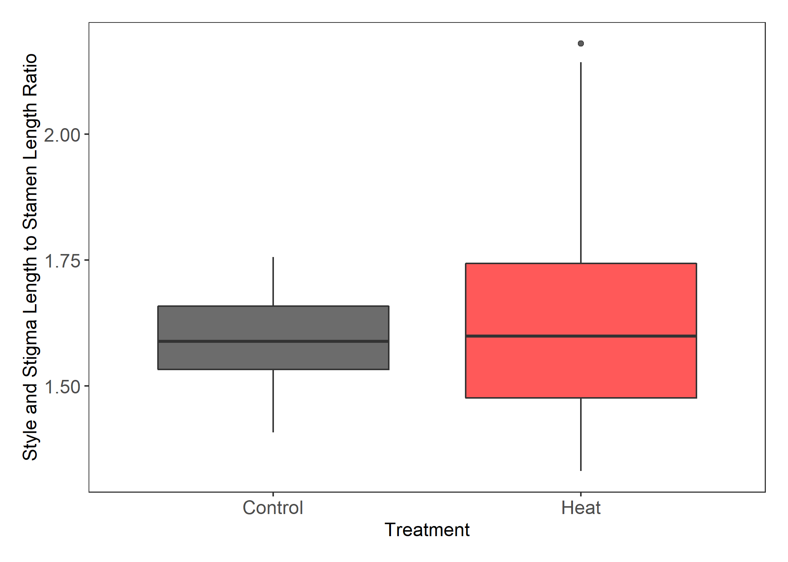

Figure 5. Treatment differences for the ratio of style and stigma length to stamen length. No significant difference between means, but there is a significant difference between variances (Bartlett’s K2 = 14.14, p = 1.70e-04).

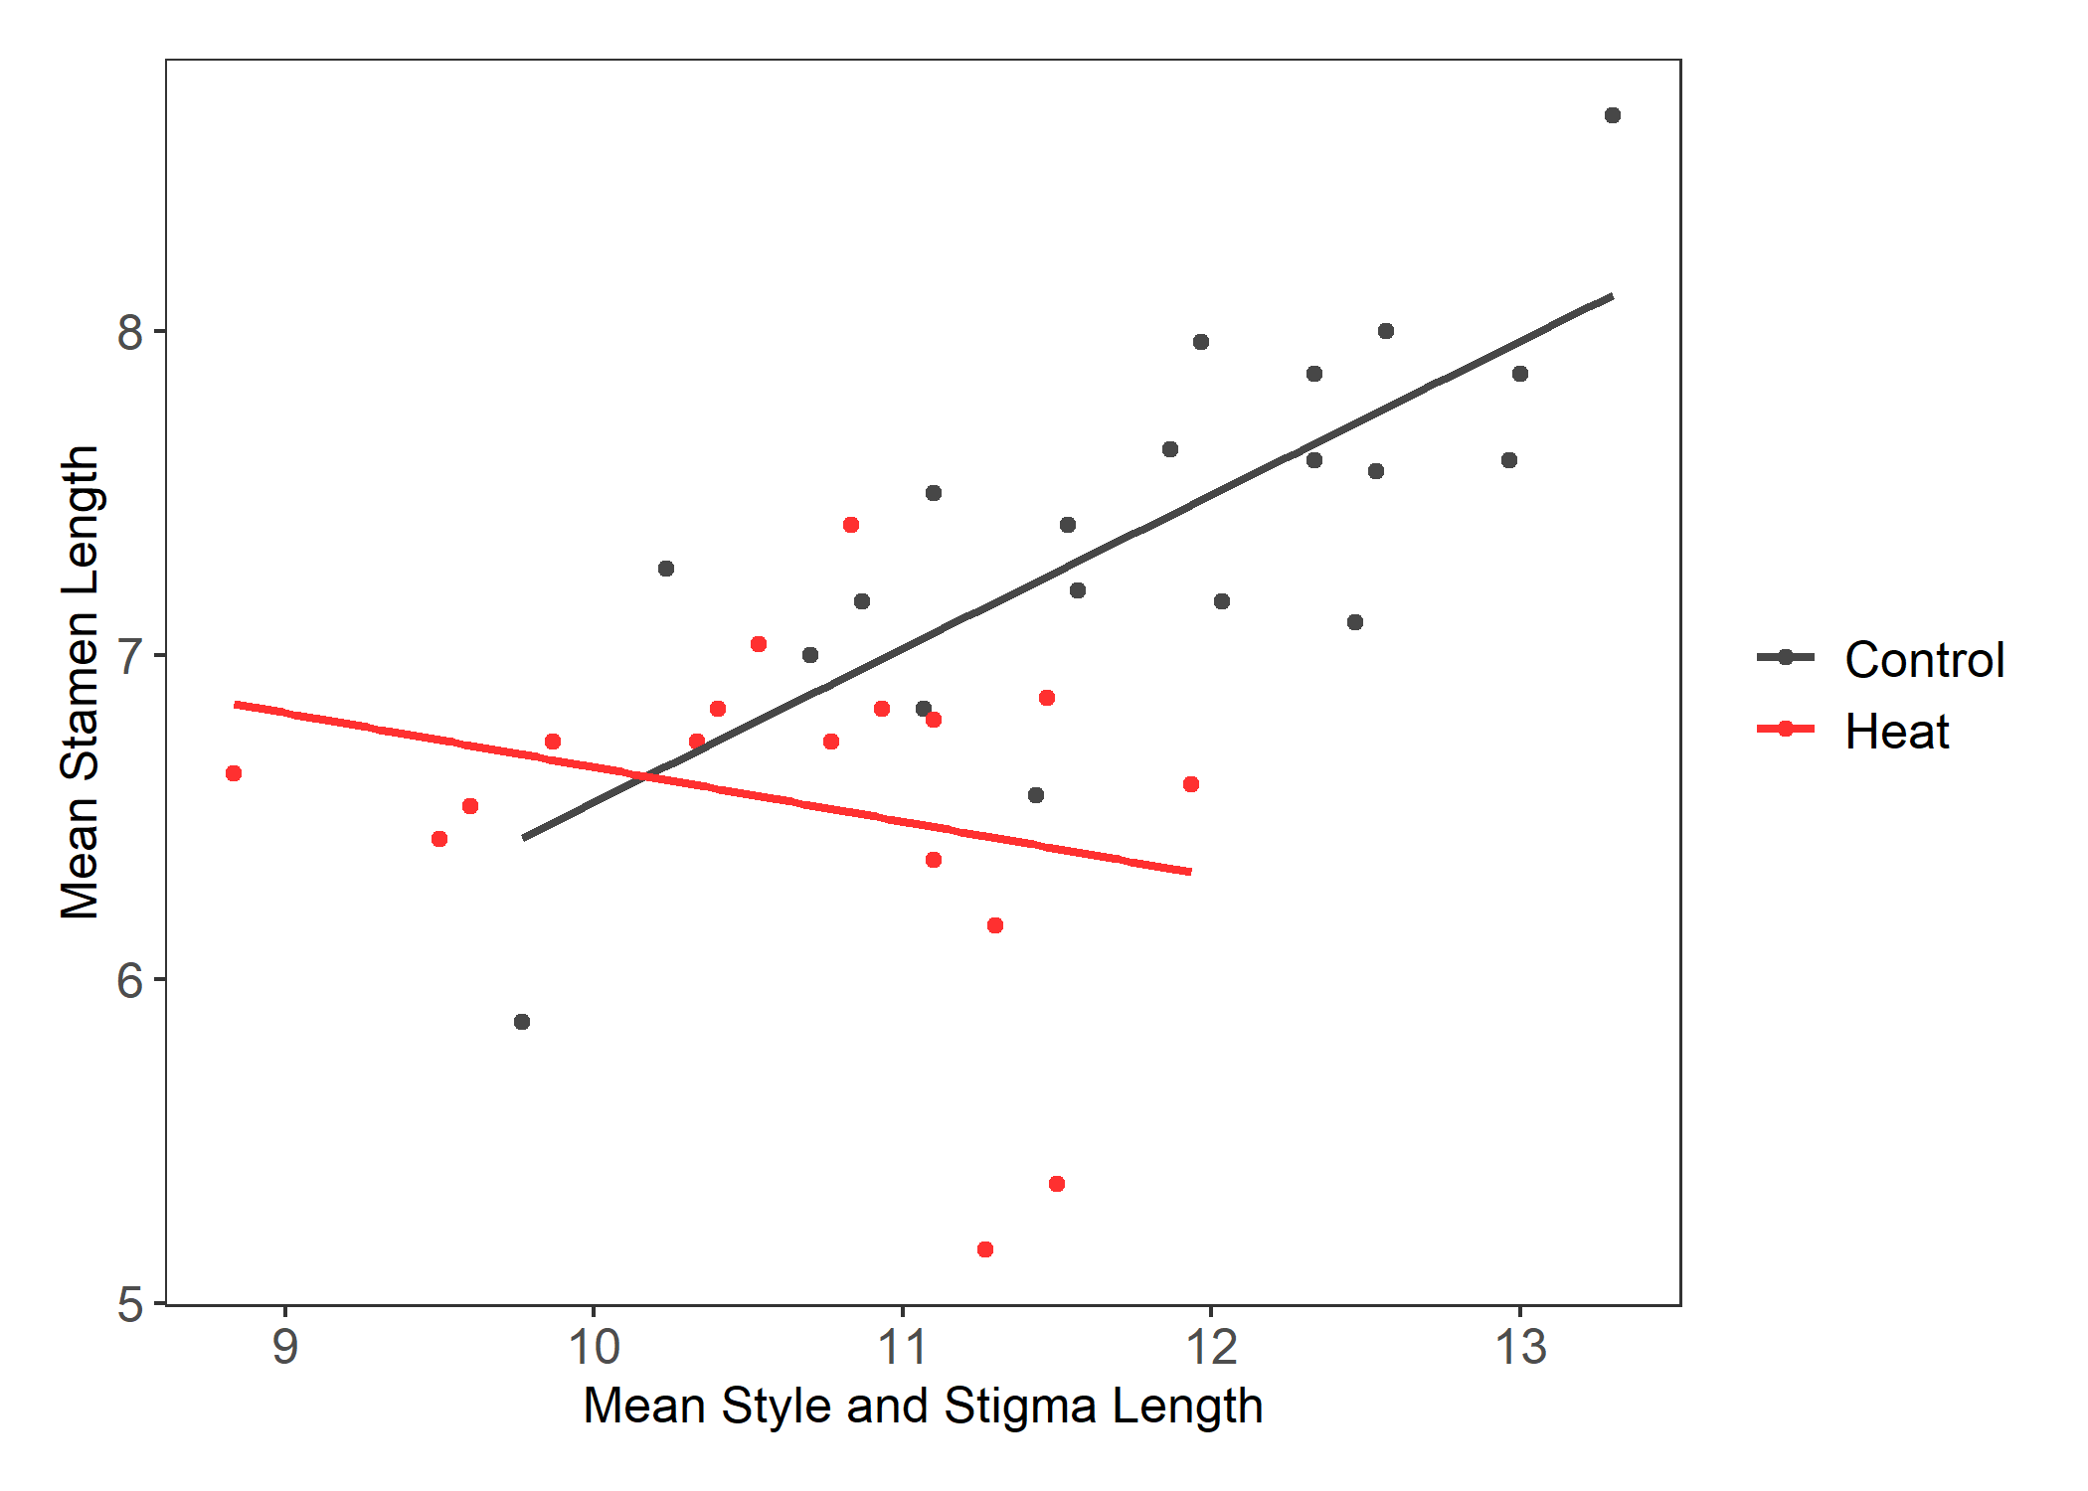

Figure 6. Treatment differences of correlations between the mean style and stigma length and mean stamen lengths for individual genets. The control treatment Pearson’s correlation (0.761) was significant (p = 9.611e-05). The heat treatment Pearson’s correlation (-0.250) was not statistically significant (p = 0.333).

Figure 7. The mean pollen diameter of northern plants from flowers that developed in the respective treatment groups. Asterisk and letters indicate differences that are statistically significant. There was a significant difference between treatment groups (F34 = 25.544, p = 1.456e-05).

*Post-pollination*

Pollen germination at 40°C was significantly different between regions, but not treatment groups (Figure 8, table 3). In both treatment groups, northern plants had significantly higher pollen germination than southern plants. There were no significant differences between treatment groups for fruit set (Figure 9, table 3). There were no significant differences between regions for viable seed count. There was a significant difference between treatment groups for plants from northern populations (Figure 10, table 2). There were fewer viable seeds produced when ovules developed in the heat treatment and underwent pollination and fertilization in the heat treatment.

Figure 8. Regional differences of pollen germination at 40°C in the two treatment groups. Letters represent significant differences between groups. There was a significant difference between regions (F = 9.180, p = 0.004), but no difference between treatment groups.

Figure 9. Counts of plants with the proportion of fruits that developed from three pollinated flowers for plants that originated in northern populations. Color shows treatment groups.

Figure 10. The number of viable seeds from flowers of northern plants that developed in the respective treatment groups. Asterisk and letters indicate differences that are statistically significant. There was a significant difference between treatment groups (F46 = 12.742, p = 8.514e-04).

**Discussion**

In this study we investigated how long-term mild heat affects sexual reproductive traits in plants from TX and MN. Unfortunately, small sample size due to inconsistent flowering and production of staminate flowers limited the comparisons we could draw across regions. Two populations from the southern region (Cemetery and Reserve) did not flower in the controlled conditions. One population, Oil Patch, that is located in relatively close proximity to Cemetery did flower. Perhaps conditions in the environmental chambers do not match those the two populations naturally experience and they didn’t have the phenotypic plasticity to acclimate as Oil Patch did. Because we did not perform controlled crosses prior to this study and used genets collected in the field, maternal effects could also influence flowering and other results we attained.

Staminate flowers act as pollen donors to improve male fitness of a plant (Connolly & Anderson, 2003). *Solanum carolinense* does not offer nectar as a pollinator reward and therefore, pollen is the source of attraction for pollinators to the staminate and hermaphroditic flowers. Heat did not affect the flower type for the first flowers in the treatment group. We did not record flower type for flowers after the initial flower(s) produced in the treatment groups. Our result might have differed had we included further observations of flower type. As far as we know, this is the first study to examine the effect of temperature on flower type in an andromonoecious species.

Style and stigma length and stamen length were significantly smaller in the heat treatment than the control treatment. Muller et al. (2016) found anther deformations when flower development occurred in mild heat (32°C/26°C ). Other studies also found changes in floral structures due to temperature, but stamen and pistil formation were often observed in association with one another. A study on blueberry found that cooler temperatures recessed anthers further in the corolla and warmer conditions increased style length (Lyrene, 1994). Charles and Harris (1972) found that as temperatures decreased the distance between the antheridial cone and the stigma in tomatoes (longer stigma or shorter anthers). Unlike *Solanum carolinense*, the stamen of tomato flowers are fused and the style and stigma do not extend beyond the antheridial cone. As the stigma extended further into the antheridial cone, pollination was less likely, affecting fruit set. We also compared the ratio of style and stigma length to stamen length for the treatment groups. There was no significant difference in the ratio between the treatments, but flowers developed in heat did have significantly more variation than those that developed in the control. To further understand the increased variation in the heat treatment, we conducted correlation analysis and found that in the control treatment style and stigma length was correlated with stamen length, but the correlation breaks down in heat. This suggests that the fundamental proportions of floral structures are disrupted in heat. The change to position of integral reproductive structures in heat could affect rates of pollination and fertilization for *Solanum carolinense*, and thus, influence fitness.

We found that pollen that developed in long-term low heat were significantly smaller than those in controlled conditions. There are fitness implications for changes in pollen size. McCallum and Chang (2016) found evidence of pollen size influencing siring success. Another explanation for this observation is that long-term heat induces an increase in the proportion of smaller, low-ROS pollen. There have been multiple studies with evidence suggesting that pollen grains fall in one of two categories. Rutley et al. (2022) described this phenomenon as the “two-basket” model, with low-ROS and high-ROS pollen based on the dual nature of pollen found in other studies (Jegadeesan et al., 2018; Luria et al., 2019). High-ROS pollen have higher metabolic rates, are typically larger in size, and readily germinate once mature. On the other hand, low-ROS pollen are partially dehydrated with low metabolic rates, are smaller in size, and remain dormant when environmental conditions are not favorable for germination.

Even though there was a size difference in pollen, there was no significant difference between treatment groups for pollen germination at 40°C. There was, however, a difference between regions. These results match that of the last chapter and suggest that southern plants have adapted to higher temperatures by producing a higher proportion of low-ROS pollen to selectively germinate and avoid high temperature stress. Our study confirmed that the temperature at which pollen develops doesn’t affect germination. Muller et al. (2016) found that long-term mild heat during development did reduce pollen germination. However, we presume they tested germination after incubation at room temperature and not at high temperatures, which may be one reason our results differed from this study and others that also found that development in heat reduced pollen viability (Jiang et al., 2019a; Poudyal et al., 2019; Sato et al., 2006; Jiemeng Xu et al., 2017).

There were no statistically significant differences between the proportions of fruit that developed from fertilization of three flowers in the heat and control conditions. These results are inconsistent with previous studies in tomato (Charles & Harris, 1972; Farinon et al., 2022; Sato et al., 2006; Sherzod et al., 2020; J. Xu et al., 2017). Xu et al. (2017) found that fruit set was more strongly affected by long-term mild heat than any of the other reproductive traits considered. Farinon et al. (2022) also found a reduction in fruit set with increased temperatures in the field and reported that this traits has a strong gene x environment interaction. Our results could be affected by the low sample size. While plants may have flowered in the treatment groups, some did not produce enough hermaphroditic flowers to collect for ovule counts and separately pollinate three flowers in one day. It is notable that plants in the control treatment always had at least one fruit that developed from the three pollinations. On the other hand, there were plants in the heat treatment that produced no fruit from three pollinations. Xu et al. (2017) also mentions that fruit set involves several traits that could affect fruit production. Thus, our results are likely a culmination of the effect of heat acting on the flower development and the fertilization process. *Solanum carolinense* may differ from tomato in response to heat stress and fruit production.

Our results also differed from some studies in tomato for seed set, but corroborated other studies. We found that heat throughout the development of maternal tissues and fertilization reduced the number of viable seeds produced. Xu et al. (2017) found that heat had little influence on seed number compared to other reproductive traits. Din et al. (2015) found that seed set was reduced in heat, especially in more temperature sensitive accessions. Din et al. (2015) attributed this difference to heat reducing pollen viability, or pollen tube growth in the style. Since ovule number was not affected by heat, the difference in viable seed number we attained, might also be a product of low pollen viability at 32°C compared to 25°C. Viable seeds and unfertilized ovules dominated the counts, with few aborted seeds. This suggests that male viability may be the limiting factor and not female viability. Jiang (2019a) also found disparity between ovule and pollen viability of peas when exposed to heat. Ovules maintained viability in heat stress, while pollen viability decreased.

**Conclusion**

Overall, our results indicate that long-term mild heat affects developmental processes, specifically for floral structures and pollen, and post-pollination processes, such as seed production. Changes in floral proportions could affect how pollinators interact with flowers, influencing rates of pollination, which is essential for sexual reproduction in this species, with a self-incompatibility system. A reduction in viable seed number when pollinated in heat directly affects fitness, as the potential progeny decreases. Our findings imply that as temperatures rise, the success of sexual reproduction may decline in this species and potentially others. To fully understand how sensitive plants are to higher temperatures, we must determine the molecular underpinnings of temperature stress and tolerance.

* Seed set

**References**

Charles, W. B., & Harris, R. E. (1972). TOMATO FRUIT-SET AT HIGH AND LOW-TEMPERATURES. *Canadian journal of plant science.*, *52*(4), 497-506. <https://doi.org/10.4141/cjps72-080>

Connolly, B. A., & Anderson, G. J. (2003). Functional significance of the androecium in staminate and hermaphroditic flowers of Solanum carolinense (Solanaceae). *Plant systematics and evolution*, *240*(1/4), 235-243. <https://doi.org/10.1007/s00606-003-0029-7>

Diaz, A., & Macnair, M. R. (1999). Pollen tube competition as a mechanism of prezygotic reproductive isolation between Mimulus nasutus and its presumed progenitor M. guttatus. *The New phytologist*, *144*(3), 471-478. <https://doi.org/10.1046/j.1469-8137.1999.00543.x>

Din, J. U., Khan, S. U., Khan, A., Qayyum, A., Abbasi, K. S., & Jenks, M. A. (2015). Evaluation of potential morpho-physiological and biochemical indicators in selecting heat-tolerant tomato (Solanum lycopersicum Mill.) genotypes. *Horticulture, Environment, and Biotechnology*, *56*(6), 769-776. <https://doi.org/10.1007/s13580-015-0098-x>

Farinon, B., Picarella, M. E., & Mazzucato, A. (2022). Dynamics of Fertility-Related Traits in Tomato Landraces under Mild and Severe Heat Stress. *Plants*, *11*(7), 881. <https://doi.org/10.3390/plants11070881>

Gajanayake, B., Trader, B. W., Reddy, K. R., & Harkess, R. L. (2011). Screening Ornamental Pepper Cultivars for Temperature Tolerance Using Pollen and Physiological Parameters. *HortScience*, *46*(6), 878-884. <https://doi.org/10.21273/HORTSCI.46.6.878>

Jegadeesan, S., Chaturvedi, P., Ghatak, A., Pressman, E., Meir, S., Faigenboim, A., . . . Firon, N. (2018). Proteomics of Heat-Stress and Ethylene-Mediated Thermotolerance Mechanisms in Tomato Pollen Grains. *Frontiers in Plant Science*, *9*, Article 1558. <https://doi.org/10.3389/fpls.2018.01558>

Jiang, Y., Lahlali, R., Karunakaran, C., Warkentin, T. D., Davis, A. R., & Bueckert, R. A. (2019a). Pollen, ovules, and pollination in pea: Success, failure, and resilience in heat. *Plant, Cell & Environment*, *42*(1), 354-372. <https://doi.org/10.1111/pce.13427>

Jiang, Y., Lahlali, R., Karunakaran, C., Warkentin, T. D., Davis, A. R., & Bueckert, R. A. (2019b). Pollen, ovules, and pollination in pea: Success, failure, and resilience in heat. *Plant, cell and environment*, *42*(1), 354-372. <https://doi.org/10.1111/pce.13427>

Kuznetsova, A., Brockhoff, P. B., & Christensen, R. H. B. (2017). lmerTest Package: Tests in Linear Mixed Effects Models. *Journal of Statistical Software*, *82*(13), 1 - 26. <https://doi.org/10.18637/jss.v082.i13>

Luria, G., Rutley, N., Lazar, I., Harper, J. F., & Miller, G. (2019). Direct analysis of pollen fitness by flow cytometry: implications for pollen response to stress. *The Plant Journal*, *98*(5), 942-952. <https://doi.org/10.1111/tpj.14286>

Lyrene, P. M. (1994). Environmental Effects on Blueberry Flower Size and Shape Are Minor. *Journal of the American Society for Horticultural Science*, *119*(5), 1043-1045. <https://doi.org/10.21273/jashs.119.5.1043>

McCallum, B., & Chang, S. M. (2016). Pollen competition in style: Effects of pollen size on siring success in the hermaphroditic common morning glory, Ipomoea purpurea. *American journal of botany*, *103*(3), 460-470. <https://doi.org/10.3732/ajb.1500211>

Melillo, J. M., Richmond, T. T. C., & Yohe, G. W. (2014). *Climate Change Impacts in the United States:*

*The Third National Climate Assessment*. U. S. G. P. Office.

Mena-Ali, J. I., Keser, L. H., & Stephenson, A. G. (2009). The effect of sheltered load on reproduction in Solanum carolinense, a species with variable self-incompatibility. *Sexual Plant Reproduction*, *22*(2), 63-71. <https://doi.org/10.1007/s00497-008-0092-x>

Mena-Ali, J. I., & Stephenson, A. G. (2007). Segregation analyses of partial self-incompatibility in self and cross progeny of Solanum carolinense reveal a leaky S-allele. *Genetics*, *177*(1), 501-510. <https://doi.org/10.1534/genetics.107.073775>

Muller, F., & Rieu, I. (2016). Acclimation to high temperature during pollen development. *Plant Reproduction*, *29*(1-2), 107-118. <https://doi.org/10.1007/s00497-016-0282-x>

Müller, F., Xu, J., Kristensen, L., Wolters-Arts, M., De Groot, P. F. M., Jansma, S. Y., . . . Rieu, I. (2016). High-Temperature-Induced Defects in Tomato (Solanum lycopersicum) Anther and Pollen Development Are Associated with Reduced Expression of B-Class Floral Patterning Genes. *PLOS ONE*, *11*(12), e0167614. <https://doi.org/10.1371/journal.pone.0167614>

Poudyal, D., Rosenqvist, E., & Ottosen, C. O. (2019). Phenotyping from lab to field - tomato lines screened for heat stress using F-v/F-m maintain high fruit yield during thermal stress in the field [Article]. *Functional Plant Biology*, *46*(1), 44-55. <https://doi.org/10.1071/fp17317>

R Core Team. (2020). *R: A language and environment for statistical computing*.In *R Foundation for Statistical Computing* R Foundation for Statistical Computing. <https://www.R-project.org/>

Reddy, K. R., & Kakani, V. G. (2007). Screening Capsicum species of different origins for high temperature tolerance by in vitro pollen germination and pollen tube length. *Scientia horticulturae*, *112*(2), 130-135. <https://doi.org/10.1016/j.scienta.2006.12.014>

Rutley, N., Harper, J. F., & Miller, G. (2022). Reproductive resilience: putting pollen grains in two baskets. *Trends in Plant Science*, *27*(3), 237-246. <https://doi.org/10.1016/j.tplants.2021.09.002>

Sato, S., Kamiyama, M., Iwata, T., Makita, N., Furukawa, H., & Ikeda, H. (2006). Moderate Increase of Mean Daily Temperature Adversely Affects Fruit Set of Lycopersicon esculentum by Disrupting Specific Physiological Processes in Male Reproductive Development. *Annals of Botany*, *97*(5), 731-738. <https://doi.org/10.1093/aob/mcl037>

Sherzod, R., Yang, E. Y., Cho, M. C., Chae, S. Y., & Chae, W. B. (2020). Physiological traits associated with high temperature tolerance differ by fruit types and sizes in tomato (Solanum lycopersicum L.). *Horticulture, Environment, and Biotechnology*, *61*(5), 837-847. <https://doi.org/10.1007/s13580-020-00280-4>

Travers, S. E., Mena-Ali, J., & Stephenson, A. G. (2004). Plasticity in the self-incompatibility system of Solanum carolinense. *Plant Species Biology*, *19*(3), 127-135. <https://doi.org/10.1111/j.1442-1984.2004.00109.x>

Xu, J., Wolters-Arts, A. M. C., Mariani, C., Huber, H., & Rieu, I. (2017). Heat stress affects vegetative and reproductive performance and trait correlations in tomato (solanum lycopersicum). *Euphytica*, *213*(7), 1-12. <https://doi.org/10.1007/s10681-017-1949-6>

Xu, J., Wolters-Arts, M., Mariani, C., Huber, H., & Rieu, I. (2017). Heat stress affects vegetative and reproductive performance and trait correlations in tomato (Solanum lycopersicum). *Euphytica*, *213*(7). <https://doi.org/10.1007/s10681-017-1949-6>