**Abstract**

**Introduction**

Climate change is rapidly changing local temperatures, and, in many locales, temperatures are projected to increase.

In this study, we investigated the effect of long-term high temperatures on reproductive traits in *Solanum carolinense*. We included both pre-pollination, or developmental traits and post-pollination traits to understand how heat interacts with multiple elements throughout the process of sexual reproduction. Our objectives were to

1. Identify stages of sexual reproduction when plants are vulnerable to heat
2. Compare plants from populations in Texas and Minnesota and recognize potential adaptations that allow populations to persist at high temperatures
3. Examine variation in reproductive traits at the population level and the plasticity of traits across environmental conditions

**Methods**

## Species Description

*Solanum carolinense* L. (Solanaceae), also known as horsenettle, is an herbaceous perennial with spines that line the stem and midrib of the variably lobed leaves. This species reproduces both sexually and asexually by rhizomes. *Solanum carolinense* grows indeterminately and is andromonoecious, meaning that both staminate and hermaphroditic flowers are produced. The flowers are “buzz- pollinated”, requiring bumblebee pollinators that vibrate their abdomens at a relatively high frequency to release pollen from the stamen. Fertilization is complicated by a gametophytic self-incompatibility (SI) system. The SI system reduces inbreeding by degrading pollen tubes of self and closely related pollen, prior to fertilization (Mena-Ali et al., 2009; Mena-Ali & Stephenson, 2007). However, as flowers age, the SI system degrades and the potential for successful self-fertilization with fruit production increases (Travers et al., 2004). The fruit are small yellow to green, tomato-like berries that are dispersed by small mammals.

## Field Collection and

*Solanum carolinense* plants were collected from two populations in Houston County, Minnesota and three populations in Collin County, Texas between October 2019 and August 2020 (map reference for SCAR 1 chapter). The Minnesota plants collectively will be referred to as the northern plants and include the populations Prairie Island (44.07959 N, -91.684545 W) and Frontenac (44.523056 N, -92.338611 W). Approximately 80 Km separated the two populations. In Houston County, MN, the average monthly low temperature is -14°C (7°F) and the average monthly high is 29°C (85°F). The Texas plants together will be referred to as the southern plants. All three TX populations were within a circle with a 1.5 Km radius near McKinney TX (Oil Patch: 33.173465 N, -96.615402 W; Reserve: 33.159962 N, -96.619011 W; and Cemetery: 33.173672, -96.615096 W). In Colin County TX, the average monthly low temperature is 18°C (65°F) and the average monthly high is 43°C (111°F).

*Solanum carolinense* is a perennial that reproduces asexually by the growth of ramets (genetically identical plants connected by rhizomes). Genets (individual genotypes) were sampled by collecting the below ground portion of individual plants and saving 10cm of root and rhizome. Sampled plants were a minimum of 1 meter apart, ensuring that unique genotypes were collected with each plant. The rhizomes were given unique ID numbers, placed in zip lock bags, and shipped to Fargo in a cooler with blue ice. The rhizomes were stored in a 4°C refrigerator until they were planted in one-gallon containers and allowed to grow under greenhouse conditions. In October, the above ground material was cut and the pots plus below ground tissues were stored again at 4°C for a three-month period of dormancy. During the spring and summer of 2021, four ramets (A, B, C, and D) were cut from the rhizome of each genet, grown in separate plots and used in a previous study (methods described in Chapter 1). In October and November, the above ground material for all ramets of each genet was cut and the plants were returned to 4°C for a dormancy period.

## Growth Conditions and Experimental Design

On January 12, 2022, ramets A and B for all genets were placed in a randomized grid pattern in a Conviron PGC-FLEX growth chamber. For initial growth, all plants were placed in the same, “control” conditions. For the control growth conditions, the chamber was set at 25°C day/25°C night with fluorescent lights at setting 2 and incandescent lights at setting 1 for 14 hours per day. As plants grew to heights at which the incandescent bulbs damaged upper leaves on some plants, the incandescent setting was reduced to 0. Plants were regularly fertilized with a high phosphorus fertilizer to promote flower production (Bloom, company).

Once a plant flowered, all flowers and buds were removed and it was moved to its heat treatment. The control treatment chamber (Conviron PGC-FLEX) was set at the same conditions used for initial growth. The heat treatment chamber (Conviron E7/2) was set at 32°C day/25°C night with the same light settings as the control. One ramet from each genet was randomly assigned to the heat treatment and the other to the control treatment. Plant were watered daily to avoid confounding of water stress effects. The date of first flowering and the date when a ramet flowered again in the treatment were recorded. The flower type, hermaphroditic or staminate, produced for the first flowering in the treatment was also recorded.

## Pre-pollination dependent variables

The first three hermaphroditic flowers that developed in the respective treatments were collected and used for flower morphology measurements, ovule counts, and pollen size measurements. The ovules were stained following a modified protocol adapted from Diaz and Macnair (1999). The flowers with petals removed were stored in Eppendorf tubes (1.5 ml) with ethanol for 24 hours and then washed with deionized water. The tubes were then filled with 1M NaOH and placed in a heating block at 70°C for 2 minutes to soften the floral structures before a final wash in deionized water. The flowers were then stained in 0.1% aniline blue with 0.1M K3PO4 for 24 hours in darkness. The length of the style plus the stigma and the length of one anther were measured under a dissecting scope. The ovary and anther were sectioned and mounted on a microscope slide with 50% glycerol. The number of ovules in each ovary was counted. Pollen diameter of at least 100 grains was measured using Microscopy (Axio Scope A.1 Carl Zeiss, Germany) at 400x total magnification and the circle diameter measurment tool on the Zen 3.1 software.

## Post-pollination dependent variables

Pollen germination percentage was calculated for grains on artificial media at 40°C. In the previous study, there was variation in pollen germination at high temperatures. We used 40°C to determine how plants differ in germination at high temperatures and whether pollen development in long-term high heat affects pollen germination at high temperatures. One flower from each plant in the treatment group was collected for pollen germination. Pollen was collected from the mature flower, identified by petals in an open position perpendicular to the anthers and a fully developed stigma (if flower was hermaphroditic). Since horsenettle is naturally buzz pollinated, we used a handmade device to vibrate stamens and release pollen directly onto an agar/growth medium contained in petri dishes. We used a 3% Bacto-Agar based growth medium (sucrose, Ca(NO3)2, MgSO4, KNO3, H3BO3) following the protocol of Reddy and Kakani (2007) Immediately after dispersal of pollen, the plate was placed in a drying oven at 40°C for 16 hours. Three pictures of the pollen on the petri dish were taken using a microscope mounted with a camera (MICROSCOPE TYPE). To avoid sampling bias, each petri dish was positioned so pollen visible to the naked eye was under the objective. The petri dish was not repositioned once pollen grains were viewed under magnification. Pollen germination was measured by counting the number of pollen grains that produced tubes of at least half the diameter of the pollen grain. The final pollen germination variable equaled the number of grains germinated divided by the total number of pollen grains assessed. All pollen grains in a picture were counted. The number of pictures used depended on the number required to count at least 100 pollen grains.

Female reproductive traits measured include fruit set and seed set. Once all flowers for morphological and male performance traits were collected, three flowers on each plant were pollinated with a mix of pollen from flowers (average number of different pollen donors per mix) in the control treatment. The goal was to isolate the effect of heat on the ovules and ovary, not the pollen. Horsenettle has a self incompatibility system, which prevents plants with the same S allele from fertilizing one another. The self incompatibility system is a measure to prevent inbreeding. We mixed pollen from multiple populations from the north and south to ensure that there was the opportunity for fertilization. The flowers were pollinated by applying mixed pollen on the stigma with a probe and labeling the flower with a jewelry tag. Once flowers were pollinated, the plant remained in the treatment for one week before being moved into a greenhouse for fruit to develop.

Once fruits were at least one month old, they were harvested. The number of seeds, aborted seeds, and unfertilized ovules were counted. The variables used as measures of female performance were fruit set and seed set. Fruit set was the number of fruits produced divided by the number of flowers pollinated, which was three for all plants. Seed set was the number of viable seeds produced divided by the average number of ovules for flowers of the same plant.

*Data Analysis*

All data analysis was conducted in R 4.1.2 (R Core Team, 2020). Flower date was analyzed for regional differences using a linear mixed effects model in the *lmerTest* package (Kuznetsova et al., 2017) with region and population as the fixed effects and genet nested in population as the random effect. Treatment effects were only analyzed for northern plants because of low sample size in southern plants. Differences in flower type development between the treatments in the northern plants were analyzed using a chi-squared test in the *stats* package (R Core Team, 2020). Stamen length, style and stigma length, and ovule number were analyzed for regional differences in the control treatment using a linear mixed effects model (*lmerTest*; function lmer) with region and population as fixed effects and genet nested in population as the random effect. A linear mixed effects model (*lmerTest*; function lmer) with treatment and population as the fixed effects and genet nested in population as the random effect was used for treatment differences. The ratios of style and stigma to stamen length for northern plants were analyzed using a linear mixed effects model with treatment as the fixed effect and population as a random effect. To test differences in variation between the treatment groups of the ratio, we used the Bartlett test of homogeneity of variances (*stats*; function bartlett.test). We also conducted correlation analysis for mean stamen and mean style and stigma lengths (*stats*; function cor.test).Mean pollen diameter was compared between regions using a linear mixed effects model (*lmerTest*; function lmer) with region as the fixed effect and genet nested in population as the random effect. The treatment effect on mean diameter of pollen grains in the northern plants was analyzed using a linear mixed effects model (*lmerTest*; function lmer) with treatment as the fixed effect and population as the random effect.

Since there was a larger sample size for southern plants in the treatment groups for pollen germination at 40°C because staminate flowers could be used, region and treatment were analyzed in a two-way analysis of variance model (*stats*; function aov). Fruit set was analyzed for only northern plants using a chi-squared test (*stats*; function chisq.test). Seed number was analyzed using the same linear mixed effects models as described for ovule number.

**Results**

*Flowering*

There was no significant difference between the regions for the day after growth initiation that the plant flowered (Appendix). There were 48 plants from the northern region that initially flowered and 17 from the southern region (Figure 1). After all plants that flowered were placed in the treatments, not all the plants flowered a second time. There were 21 plants in the control group and 24 plants in the heat treatment group that flowered for the northern plants. For the southern plants, 8 in the control and 6 in the heat treatment flowered again. Since the number of plants that flowered in the two regions differed substantially,

Figure 1. The number of genets that flowered in the control and heat treatments before and after they were placed in the treatments. Counts for the northern and southern regions shown independently.

*Flower Development*

The flower type for the first flower after placement in the treatment was recorded. There was no significant difference between treatment groups for flower type of northern plants. Flower type did limit the data collected since staminate flowers were not used for variables such as ovule number, style and stigma length, stamen length, pollen diameter, fruit set, and seed number (Figure 2). Thus, treatment effects were only considered from plants from northern populations. There was a significant difference between regions for style and stigma length and stamen length in the controlled conditions (Figure 3, table 1). Southern plants had larger floral structures than northern plants.

There were significant temperature treatment effects for northern plants in both style and stigma length and stamen length (Figure 4, table 2). In both cases, development in heat reduced the lengths of the structures. For the ratio of style and stigma length to stamen length, there was no significant difference between treatments for the means, but there was a significant difference between variances (Bartlett’s K2 = 14.14, p = 1.70e-04; Figure 5). There was a significant, positive correlation (Pearson’s correlation = 0.761, p = 9.611e-05) between the two variables for the control treatment, but not for the heat treatment (Pearson’s correlation = -0.250, p = 0.333; Figure 6).

There were no significant differences in ovule number between regions or treatments. Mean pollen diameter did not differ between the two regions, but there was a significant treatment difference. The diameter of pollen that developed in heat is significantly smaller than pollen that developed in the control conditions (Figure 7, table 2).

Figure 2. Number of plants with hermaphroditic and staminate flowers for the treatment groups. Counts for northern and southern plants displayed independently.

Table 1. Results from analysis of floral morphology variables using mixed effects models for regional and population differences. Analysis is just of plants in control treatment.

|  |  |  |  |  |  |  |
| --- | --- | --- | --- | --- | --- | --- |
|  | Fixed Effects | | | | Random Effects | |
| **Variable** | Region | | Population | | Population:Genet | Population |
| F | p | F | p | p | p |
| First Flower | 1.458 | 0.235 | 0.019 | 0.892 | 0.804 | - |
| Stigma and Style Length | **4.453** | **0.045** | 1.200 | 0.284 | **6.24E-11** | - |
| Stamen Length | **12.071** | **0.002** | 13.916 | 0.001 | **9.09E-06** | - |
| Ovule Number | 0.093 | 0.763 | 2.822 | 0.106 | **0.017** | - |
| Mean Pollen Diameter | 0.522 | 0.633 | - | - | - | 0.449 |
| Seed Number | 0.189 | 0.669 | 2.032 | 0.173 | **5.38E-06** | - |

Table 2. Results from mixed effects models for treatment differences in plants from northern populations.

|  |  |  |  |  |  |  |
| --- | --- | --- | --- | --- | --- | --- |
|  | Fixed Effects | | | | Random Effects | |
| **Variable** | Treatment | | Population | | Population:Genet | Population |
| F | p | F | p | p | p |
| Stigma and Style Length | **34.408** | **6.04E-08** | 0.017 | 0.899 | **1.30E-07** | - |
| Stamen Length | **70.210** | **2.27E-13** | **53.226** | **7.09E-07** | **1.95E-01** | - |
| Ovule Number | 0.553 | 0.459 | **6.531** | **0.017** | **2.69E-01** | - |
| Mean Pollen Diameter | **25.544** | **1.46E-05** | - | - | **-** | 0.678 |
| Viable Seed Number | 12.742 | 0.001 | 0.163 | 0.693 | **5.59E-05** | - |

Table 3. Results from the two-way ANOVA for pollen germination at 40°C and the chi-squared tests for flower type and fruit set.

|  |  |  |  |  |
| --- | --- | --- | --- | --- |
| Variable | Region | | Treatment | |
| F | p | F | p |
| Pollen Germination (40°C) | **9.180** | **0.004** | 3.916 | 0.054 |
|  |  |  | χ2 | p |
| Flower Type |  |  | 0.370 | 0.543 |
| Fruit Set |  |  | 6.143 | 0.105 |

Figure 3. Regional differences for the length of the stigma and style and the length of the stamen from flowers that developed in the control treatment. Asterisks and letters indicate differences that are statistically significant. There are significant differences between regions ( for style and stigma length (F25 = 4.453, p = 0.045) and stamen length (F25 = 12.071, p = 0.002).

Figure 4. The length of the stigma plus style and the length of the stamen from flowers in hot and control conditions (strictly northern populations). Asterisks and letters indicate differences that are statistically significant. There are significant differences between regions for style and stigma length (F98 = 34.408, p = 6.044e-08) and stamen length (F107 = 70.272, p = 2.272e-13).

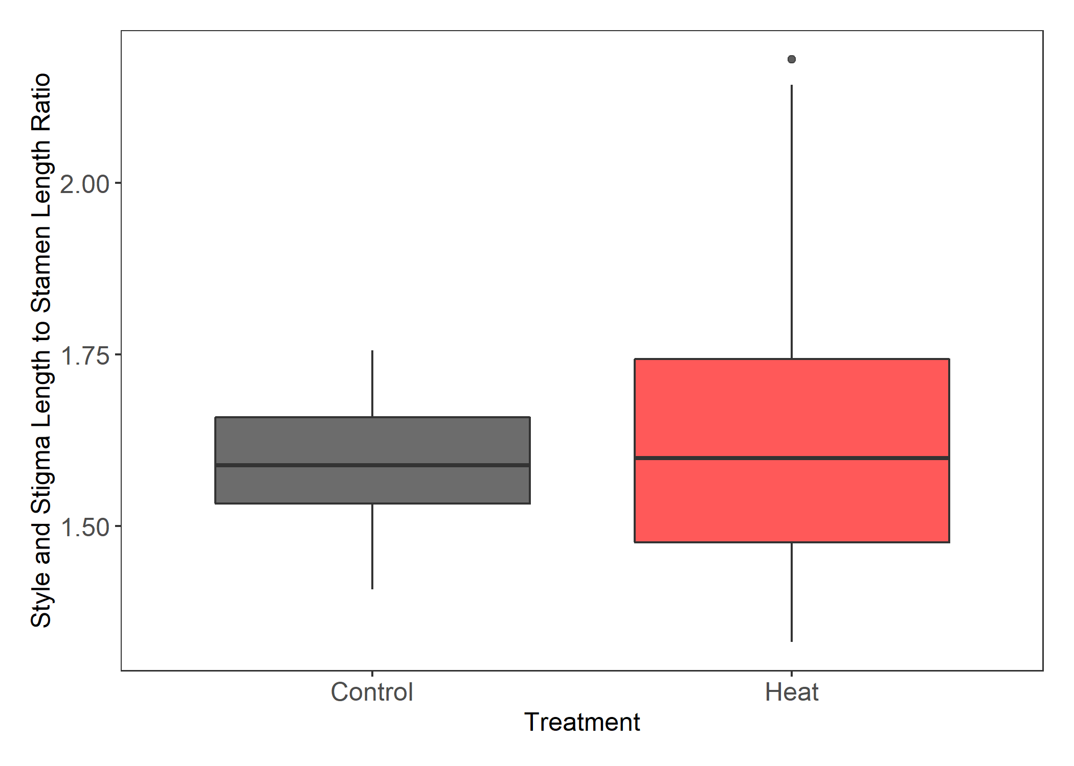

Figure 5. Treatment differences for the ratio of style and stigma length to stamen length. No significant difference between means, but there is a significant difference between variances (Bartlett’s K2 = 14.14, p = 1.70e-04).

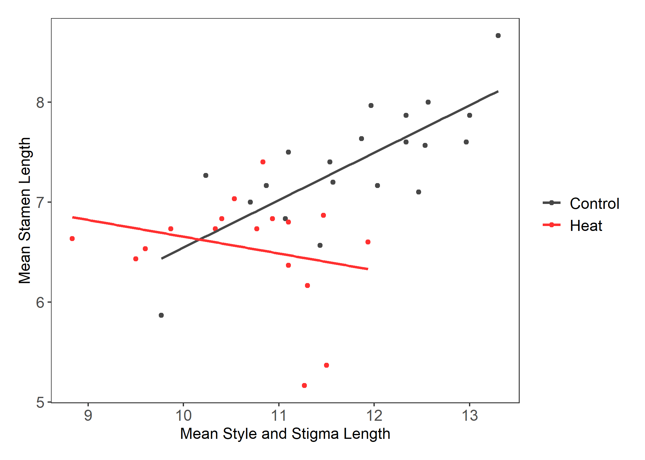

Figure 6. Treatment differences of correlations between the mean style and stigma length and mean stamen lengths for individual genets. The control treatment Pearson’s correlation (0.761) was significant (p = 9.611e-05). The heat treatment Pearson’s correlation (-0.250) was not statistically significant (p = 0.333).

Figure 7. The mean pollen diameter of northern plants from flowers that developed in the respective treatment groups. Asterisk and letters indicate differences that are statistically significant. There was a significant difference between treatment groups (F34 = 25.544, p = 1.456e-05).

*Post-pollination*

Pollen germination at 40°C was significantly different between regions, but not treatment groups (Figure 8, table 3). In both treatment groups, northern plants had significantly higher pollen germination than southern plants. There were no significant differences between treatment groups within northern plants for fruit set (Figure 9, table 3). There were no significant differences between regions for viable seed count. There was a significant difference between treatment groups for plants from northern populations (Figure 10, table 2). There were fewer viable seeds produced when ovules developed in the heat treatment and underwent pollination and fertilization in the heat treatment.

Figure 8. Regional differences of pollen germination at 40°C in the two treatment groups. Letters represent significant differences between groups. There was a significant difference between regions (F = 9.180, p = 0.004), but no difference between treatment groups.

Figure 9. Counts of plants with four different fruit sets based on three pollinated flowers for plants that originated in northern populations. Color shows treatment groups.

Figure 10. The number of viable seeds from flowers of northern plants that developed in the respective treatment groups. Asterisk and letters indicate differences that are statistically significant. There was a significant difference between treatment groups (F46 = 12.742, p = 8.514e-04).

**Discussion**

*Pre-pollination*

* Flowering
  + - Two populations from the southern region (Cemetery and Reserve) did not flower in the controlled conditions. The population (Oil Patch) in relatively close proximity to Cemetery did flower. Perhaps conditions in the environmental chambers do not match those the populations naturally experience. Because we did not perform controlled crosses prior to this study and used genets collected in the field, maternal effects could also be influence flowering and other results we attained.
* Effect of heat on Flower Type
  + - Staminate flowers act as pollen donors to improve male fitness of a plant (Connolly & Anderson, 2003). *Solanum carolinense* does not offer nectar as a pollinator reward and therefore, pollen is the source of attraction for pollinators to the staminate and hermaphroditic flowers. Heat did not affect the flower type for the first flowers in the treatment group.
* Effect of heat on Flower Morphology
  + Styles
    - A study on blueberry found that cooler temperatures recessed anthers further in the corolla and warmer conditions increased style length (Lyrene, 1994).
    - We found that the length of styles and stigmas were significantly smaller in the heat treatment than the control.
  + Stamen
    - We also compared the ratio of style and stigma length to stamen length for the treatment groups. There was no significant difference in the ratio between the treatment, but flowers developed in heat did have significantly more variation in the ratio than those that developed in the control. To further understand the increased variation in the heat treatment, we conducted correlational analysis and found that in the control treatment style and stigma length was correlated with stamen length, but the correlation breaks down in heat. Charles and Harris (1972) found that as temperatures increased the distance between the antheridial cone and the stigma in tomatoes decreased. Unlike *Solanum carolinense*, the stamen of tomato flowers are fused and the style and stigma do not extend beyond the antheridial cone. As the stigma extended further into the antheridial cone, pollination was less likely, affecting fruit set. As in this study, we found that the fundamental proportions of floral structures are disrupted in heat. The change to position of integral reproductive structures in heat could also affect rates of pollination and fertilization for *Solanum carolinense*, and thus, influence fitness.
* Effect of heat on Gamete
  + Ovule number
    - (Osorio et al., 2022)
  + Pollen size
    - We found that pollen that developed in long-term low heat were significantly smaller than those in controlled conditions. There are fitness implications for changes in pollen size. McCallum and Chang (2016) found evidence of pollen size influencing siring success.
    - Another explanation for this observation is that long-term heat induces an increase in the proportion of smaller, low-ROS pollen. There have been multiple studies with evidence suggesting that pollen grains fall in one of two categories. Rutley et al. (Rutley et al., 2022) described this phenomenon as the “two-basket” model, with low-ROS and high-ROS pollen. High-ROS pollen have higher metabolic rates, are typically larger in size, and readily germinate once mature. On the other hand, low-ROS pollen are partially dehydrated with low metabolic rates, are smaller in size, and remain dormant when environmental conditions are not favorable for germination.
  + Pollen Germination
    - There was no significant difference between treatment groups for pollen germination at 40°C, but there was a difference between regions. These results match that of the last chapter and suggest that southern plants have adapted to higher temperatures by producing a higher proportion of low-ROS pollen to selectively germinate and avoid high temperature stress. The variance for the southern plants differed distinctly between treatments. Pollen that developed in the control treatment had a large range of pollen germination proportions at 40°C, while pollen that developed in the heat treatment remained on the lower end. As described in previously, long-term heat might induce the increased production of low-ROS pollen, reducing the pollen germination at high, unfavorable temperatures.

*Post-pollination*

* Pollen germination
  + - Pollen dormancy (Jegadeesan et al., 2018; Luria et al., 2019; Rutley et al., 2022)
* Fruit set
* Seed set

**References**

Charles, W. B., & Harris, R. E. (1972). TOMATO FRUIT-SET AT HIGH AND LOW-TEMPERATURES. *Canadian journal of plant science.*, *52*(4), 497-506. <https://doi.org/10.4141/cjps72-080>

Connolly, B. A., & Anderson, G. J. (2003). Functional significance of the androecium in staminate and hermaphroditic flowers of Solanum carolinense (Solanaceae). *Plant systematics and evolution*, *240*(1/4), 235-243. <https://doi.org/10.1007/s00606-003-0029-7>

Diaz, A., & Macnair, M. R. (1999). Pollen tube competition as a mechanism of prezygotic reproductive isolation between Mimulus nasutus and its presumed progenitor M. guttatus. *The New phytologist*, *144*(3), 471-478. <https://doi.org/10.1046/j.1469-8137.1999.00543.x>

Jegadeesan, S., Chaturvedi, P., Ghatak, A., Pressman, E., Meir, S., Faigenboim, A., . . . Firon, N. (2018). Proteomics of Heat-Stress and Ethylene-Mediated Thermotolerance Mechanisms in Tomato Pollen Grains. *Frontiers in Plant Science*, *9*, Article 1558. <https://doi.org/10.3389/fpls.2018.01558>

Kuznetsova, A., Brockhoff, P. B., & Christensen, R. H. B. (2017). lmerTest Package: Tests in Linear Mixed Effects Models. *Journal of Statistical Software*, *82*(13), 1 - 26. <https://doi.org/10.18637/jss.v082.i13>

Luria, G., Rutley, N., Lazar, I., Harper, J. F., & Miller, G. (2019). Direct analysis of pollen fitness by flow cytometry: implications for pollen response to stress. *The Plant Journal*, *98*(5), 942-952. <https://doi.org/10.1111/tpj.14286>

Lyrene, P. M. (1994). Environmental Effects on Blueberry Flower Size and Shape Are Minor. *Journal of the American Society for Horticultural Science*, *119*(5), 1043-1045. <https://doi.org/10.21273/jashs.119.5.1043>

McCallum, B., & Chang, S. M. (2016). Pollen competition in style: Effects of pollen size on siring success in the hermaphroditic common morning glory, Ipomoea purpurea. *American journal of botany*, *103*(3), 460-470. <https://doi.org/10.3732/ajb.1500211>

Mena-Ali, J. I., Keser, L. H., & Stephenson, A. G. (2009). The effect of sheltered load on reproduction in Solanum carolinense, a species with variable self-incompatibility. *Sexual Plant Reproduction*, *22*(2), 63-71. <https://doi.org/10.1007/s00497-008-0092-x>

Mena-Ali, J. I., & Stephenson, A. G. (2007). Segregation analyses of partial self-incompatibility in self and cross progeny of Solanum carolinense reveal a leaky S-allele. *Genetics*, *177*(1), 501-510. <https://doi.org/10.1534/genetics.107.073775>

Osorio, E. E., Davis, A. R., & Bueckert, R. A. (2022). High temperatures disturb ovule development in field pea (Pisum sativum). *Botany*, *100*(1), 47-61. <https://doi.org/10.1139/cjb-2021-0078>

R Core Team. (2020). *R: A language and environment for statistical computing*.In *R Foundation for Statistical Computing* R Foundation for Statistical Computing. <https://www.R-project.org/>

Reddy, K. R., & Kakani, V. G. (2007). Screening Capsicum species of different origins for high temperature tolerance by in vitro pollen germination and pollen tube length. *Scientia horticulturae*, *112*(2), 130-135. <https://doi.org/10.1016/j.scienta.2006.12.014>

Rutley, N., Harper, J. F., & Miller, G. (2022). Reproductive resilience: putting pollen grains in two baskets. *Trends in Plant Science*, *27*(3), 237-246. <https://doi.org/10.1016/j.tplants.2021.09.002>

Travers, S. E., Mena-Ali, J., & Stephenson, A. G. (2004). Plasticity in the self-incompatibility system of Solanum carolinense. *Plant Species Biology*, *19*(3), 127-135. <https://doi.org/10.1111/j.1442-1984.2004.00109.x>