**Abstract**

Temperatures in various locations across the globe are gradually increasing due to climate change. *Solanum carolinense*, a species closely related to eggplant and tomato, has arange that spans much of the United States, including locations where temperature increases are projected. Previous studies found that moderate heat substantially influenced reproductive processes in crop species, particularly accessions sensitive to heat. Thus, we investigated the impact of long-term moderate heat on flower development before pollination and the fertilization post-pollination in *Solanum carolinense*. The pre-pollination traits we measured were style plus stigma length, anther length, ovule number, and pollen size. The post-pollination traits that were included in this study were pollen germination at 40°C, fruit set, and viable seed count. We found that heat affects flower morphology, pollen size, and viable seed number. These results have implications for the persistence of wild non-crop populations in locations with gradually rising temperatures.

**Introduction**

The fitness of a species is determined by the propensity of individuals to survive and successfully reproduce. Environmental conditions can directly influence the relative fitness of a species by affecting reproductive traits and ultimately reproductive success. Reproductive traits can be affected by several different environmental causes. Female reproduction is broadly influenced by growth conditions such as nutrients (CITATIONS), moisture (CITATIONS), and heat (Jiemeng Xu et al., 2017). Male reproductive success is also dependent on environmental conditions. Pollen viability decreases with high temperatures (Din et al., 2015; Müller et al., 2016; Poudyal et al., 2019; Sato et al., 2006; J. Xu et al., 2017) and drought stress (CITATIONS). Because environmental conditions influence both female and male reproductive success, the number of seeds, and thus progeny, can vary due to environmental conditions, influencing the evolution of a species. Variation in reproductive traits within or among populations can be due to genetic variation or environmental variation, which can obscure selection based on genes alone. If a response to the environment is genetically mediated and increases the chances of survival, then variation can also be due to gene x environment interactions. To fully understand the vulnerability a species has to environmental change, we must understand the variation driving evolutionary responses.

Global warming is rapidly changing local temperatures, which in many locales, are projected to increase. According to the National Climate Assessment (Melillo et al., 2014) temperatures in the Midwestern and Southeastern United States have been steadily rising. Average daily maximum temperatures in the southeastern region have made moderate increases compared to other regions in the United States, but minimum and average temperatures have been rising. The subtle increases of temperature regimes will lead to long-term temperatures that are above optimal for plant cellular processes, especially affecting reproductive success (Jiang et al., 2019a; Müller et al., 2016; Sato et al., 2006; J. Xu et al., 2017). Thus, climate change has increased the relevance of understanding the effects environmental temperatures have on male and female reproductive traits. If environmental temperatures due indeed affect reproductive success, then adaptation to climate change may involve not only the genetic variation within a population, but also the gene x environment interactions.

There is evidence that environmental temperatures affect reproductive phenotype. In crop species, development in moderately high temperatures affected floral morphology (Charles & Harris, 1972; Müller et al., 2016; Sato et al., 2006), ovule viability (Jiemeng Xu et al., 2017), pollen viability (Din et al., 2015; Müller et al., 2016; Poudyal et al., 2019; Sato et al., 2006; J. Xu et al., 2017), fruit set (Charles & Harris, 1972; Din et al., 2015; Sato et al., 2006), and seed set (Din et al., 2015). Sato et al. (2006) found that elevated temperatures decreased fruit set and pollen viability as well as stamen height in tomato. Poudyal et al. (2019) found that pollen viability decreased in heat, but more tolerant tomato accessions had higher pollen germination than sensitive accessions. Xu et al. (2017) found that long-term mild heat decreased pollen viability, pollen number, female fertility, and fruit set. Charles and Harris (1972) found that flower production, fruit set, fruit size, pollen germination, and distance between the stigma and antheridial cone all decreased at high temperatures in tomato. Muller et al. (2016) found that long-term mild heat resulted in floral deformations and low pollen viability in tomatoes.

While there are countless studies examining how high temperatures affect sexual reproduction, there are few studies that have addressed the effect of high temperatures on wild, non-crop species. Wild populations that grow in natural, heterogeneous conditions, and have endured evolution by natural selection for many generations likely have different levels of genetic diversity than artificially selected crop accessions. Yet, rates of evolution may not match that of the rapidly changing climate. Rising temperatures could restrict the success of sexual reproduction and thus, persistence, of wild populations in several ways. Changes in flower morphology has the potential to influence how pollinators interact with flowers and reduction in ovule and pollen viability decreases changes of fertilization, seed formation, and fruit development. Each process reduces the potential number of offspring and in that, fitness. Wild, non-crop species may be just as vulnerable to high temperatures, if not more than crops. We attempted to fill this gap in the literature by examining high temperature sensitivity in a wild species closely related to tomato, *Solanum carolinense*.

Since it has been established that heat affects reproductive traits to some extent, we want to further investigate the effect of heat on sexual reproduction and identify the sources of variation driving differences among traits. We want to understand how environment affects reproductive phenotype and potential gene x environment interactions to comprehend and predict evolution in a warming environment. Broadly, our goals are:

1. To measure key reproductive traits in a weedy herb exposed to different temperatures during flower and fruit development as a means of quantifying phenotypic plasticity in these traits.
2. To test for local adaptation and differences in response to environmental conditions between divergent populations from warmer and cooler regions using a common garden approach.
3. To distinguish between environmental effects on traits associated with male and female reproductive success separately.

In this study, we investigated the effect of long-term high temperatures on reproductive traits in *Solanum carolinense*. We included both pre-pollination (developmental) traits and post-pollination traits to understand how heat may influence phenotype throughout the process of sexual reproduction. If *Solanum carolinense* responds to long-term heat stress as does tomato, then we predict significant negative effects on floral morphology, male and female viability, and fruit and seed set. However, because southern populations are in warmer environments, we also predict negative responses to heat will be reduced relative to northern populations. Our specific objectives to assess these patterns were:

1. To grow plants from northern (Minnesota) and southern (Texas) regions in a common garden setting to remove environmental variation between divergent genotypes
2. Experimentally test the effects of hot (32°C) temperatures versus control (25°C) temperatures during flower and fruit development on phenotypic expression of pre and post pollination reproductive traits
3. Compare the responses of plants from different regions to heat treatments to measure potential gene x environment effects and the potential for environmental effects to reduce the response to selection.

**Methods**

## Species Description

*Solanum carolinense* L. (Solanaceae), also known as horsenettle, is an herbaceous perennial with spines that line the stem and midrib of the variably lobed leaves. This species reproduces both sexually and asexually by rhizom. *Solanum carolinense* grows indeterminately and is andromonoecious, meaning that both staminate and hermaphroditic flowers are produced. The flowers are “buzz-pollinated”, requiring bumblebee pollinators that vibrate their abdomens at a relatively high frequency to release pollen from the anther. Fertilization is complicated by a gametophytic self-incompatibility (SI) system. The SI system reduces inbreeding by degrading pollen tubes of self and closely related pollen, prior to fertilization (Mena-Ali et al., 2009; Mena-Ali & Stephenson, 2007). However, as flowers age, the SI system degrades and the potential for successful self-fertilization with fruit production increases (Travers et al., 2004). The fruit are small yellow to green, tomato-like berries that are dispersed by small mammals.

## Field Collection and

*Solanum carolinense* plants were collected from two populations in Houston County, Minnesota and three populations in Collin County, Texas between October 2019 and August 2020 (map in SCAR 1 Figure 2). The Minnesota plants collectively will be referred to as the northern plants and include the populations Prairie Island (44.07959 N, -91.684545 W) and Frontenac (44.523056 N, -92.338611 W). Approximately 80 Km separated the two populations (map in SCAR 1 Figure 3). In Houston County, MN, the mean daily low temperature is -14°C (7°F) and the mean daily high is 29°C (85°F). The Texas plants together will be referred to as the southern plants. All three TX populations were within a circle with a 1.5 Km radius near McKinney TX (Oil Patch: 33.173465 N, -96.615402 W; Reserve: 33.159962 N, -96.619011 W; and Cemetery: 33.173672, -96.615096 W). In Colin County TX, the mean daily low temperature is 18°C (65°F) and the mean daily high is 43°C (111°F).

*Solanum carolinense* is a perennial that reproduces asexually by the growth of ramets (genetically identical plants connected by rhizomes). Genets (individual genotypes) were sampled by collecting the below ground portion of individual plants and saving 10cm of root and rhizome. Sampled plants were a minimum of 1 meter apart, ensuring that unique genotypes were collected with each plant. The rhizomes were given unique ID numbers, placed in zip lock bags, and shipped to Fargo in a cooler with blue ice. The rhizomes were stored in a 4°C refrigerator until they were planted in one-gallon containers and allowed to grow under greenhouse conditions. In October, the above ground material was cut and the pots plus below ground tissues were stored again at 4°C for a three-month period of dormancy. During the spring and summer of 2021, four ramets (A, B, C, and D) were cut from the rhizome of each genet, grown in separate plots and used in a previous study (methods described in Chapter 1). In October and November, the above ground material for all ramets of each genet was cut and the plants were returned to 4°C for a dormancy period.

## Growth Conditions and Experimental Design

On January 12, 2022, ramets A and B for all genets (26 from north and 26 from south) were placed in a randomized grid pattern in a Conviron PGC-FLEX growth chamber. Due to space constraints in the environmental chambers, only two ramets were for all genets were grown at a time. For initial growth, all plants were placed in the same, “control” conditions. For the control growth conditions, the chamber was set at 25°C day/25°C night with fluorescent lights at setting 2 and incandescent lights at setting 1 for 14 hours per day. As plants grew to heights at which the incandescent bulbs damaged upper leaves on some plants, the incandescent setting was reduced to 0. Plants were fertilized once every two weeks with a high phosphorus fertilizer to promote flower production (Super Bloom, Scotts).

Once a plant flowered, all flowers and buds were removed, and it was moved to its heat treatment. The control treatment chamber (Conviron PGC-FLEX) was set at the same conditions used for initial growth. The heat treatment chambers (Conviron E7/2) was set at 32°C day/25°C night with the same light settings as the control. One ramet from each genet was randomly assigned to the heat treatment and the other to the control treatment. Plants were watered daily to avoid confounding of water stress effects. The date of first flowering and the date when a ramet flowered again in the treatment were recorded. The flower type, hermaphroditic or staminate, produced for the first flowering in the treatment was also recorded.

## Pre-pollination dependent variables

The first three hermaphroditic flowers that developed in the respective treatments were collected and used for flower morphology measurements, ovule counts, and pollen size measurements. The ovules were stained following a modified protocol adapted from Diaz and Macnair (1999). The flowers with petals removed were stored in Eppendorf tubes (1.5 mL) with ethanol for 24 hours and then washed with deionized water. The tubes were then filled with 1M NaOH and placed in a heat block at 70°C for 2 minutes to soften the floral structures before a final wash in deionized water. The flowers were then stained in 0.1% aniline blue with 0.1M K3PO4 for 24 hours in darkness. The length of the style plus the stigma and the length of one anther were measured under a dissecting scope. The ovary and anther were sectioned and mounted on a microscope slide with 50% glycerol. The number of ovules in each ovary was counted. Pollen diameter of at least 100 grains was measured using Microscopy (Axio Scope A.1 Carl Zeiss, Germany) at 400x total magnification and the circle diameter measurment tool on the Zen 3.1 software.

## Post-pollination dependent variables

Pollen germination percentage was calculated for grains on artificial media at 40°C. In the previous study, there was variation in pollen germination at high temperatures. We used 40°C to determine how plants differ in germination at high temperatures and whether pollen development in long-term high heat affects pollen germination at high temperatures. One flower from each plant in the treatment group was collected for pollen germination. Pollen was collected from the mature flower, identified by petals in an open position perpendicular to the anthers and a fully developed stigma (if flower was hermaphroditic). Since horsenettle is naturally buzz pollinated, we used a handmade device to vibrate anthers and release pollen directly onto an agar/growth medium contained in petri dishes. We used a 3% Bacto-Agar based growth medium (sucrose, Ca(NO3)2, MgSO4, KNO3, H3BO3) following the protocol of Reddy and Kakani (2007). Immediately after dispersal of pollen, the plate was placed in a drying oven at 40°C for 16 hours. Three pictures of the pollen on the petri dish were taken using a microscope mounted with a camera (Leica DM500 microscope, Leica ICC50 HD camera) and the LAS EZ 2.1.0 software. To avoid sampling bias, each petri dish was positioned so pollen visible to the naked eye was under the objective. The petri dish was not repositioned once pollen grains were viewed under magnification. Pollen germination was measured by counting the number of pollen grains that produced tubes of at least half the diameter of the pollen grain. The final pollen germination variable equaled the number of grains germinated divided by the total number of pollen grains assessed. All pollen grains in a picture were counted. The number of pictures used depended on the number required to count at least 100 pollen grains.

Female reproductive traits measured include fruit set and seed set. Once all flowers for morphological and male performance traits were collected, three flowers on each plant were pollinated with a mix of pollen from flowers (2 to 5 flowers on average, north and south represented) in the control treatment. The goal was to isolate the effect of heat on the ovules and ovary, not the pollen. Horsenettle has a self incompatibility system, which prevents plants with the same S allele from fertilizing one another. The self incompatibility system is a measure to prevent inbreeding. We mixed pollen from multiple populations from the north and south to ensure that there was the opportunity for fertilization. The flowers were pollinated by applying mixed pollen on the stigma with a probe and labeling the flower with a jewelry tag. Once flowers were pollinated, the plant remained in the treatment for one week before we moved them into a greenhouse for fruit to finish development (Average Daily Temperatures 25.08°C day / 21.31°C night).

Once fruits were at least one month old, they were harvested. The number of seeds, aborted seeds, and unfertilized ovules were counted. The variables used as measures of female performance were fruit set and seed set. Fruit set was the number of fruits produced divided by the number of flowers pollinated, which was three for all plants. Viable seed number is the number of seeds produced per fruit.

*Data Analysis*

All data analysis was conducted in R 4.1.2 (R Core Team, 2020). Flower date was analyzed for regional differences using a linear mixed effects model in the *lmerTest* package (Kuznetsova et al., 2017) with region and population as the fixed effects and genet nested in population as the random effect. Treatment effects were only analyzed for northern plants for all variables except flower date and flower type because of low sample size in southern plants. Differences in flower type development between the treatments in the northern plants were analyzed using a chi-squared test in the *stats* package (R Core Team, 2020). Anther length, style plus stigma length, and ovule number were analyzed for regional differences in the control treatment using a linear mixed effects model (*lmerTest*; function lmer) with region and population as fixed effects and genet nested in population as the random effect. A linear mixed effects model (*lmerTest*; function lmer) with treatment and population as the fixed effects and genet nested in population as the random effect was used for treatment differences. The ratios of style plus stigma to anther length for northern plants were analyzed using a linear mixed effects model with treatment as the fixed effect and population as a random effect. To test differences in variation between the treatment groups of the ratio, we used the Bartlett test of homogeneity of variances (*stats*; function bartlett.test). We also conducted correlation analysis for mean anther and mean style plus stigma lengths (*stats*; function cor.test).Mean pollen diameter was compared between regions using a linear mixed effects model (*lmerTest*; function lmer) with region as the fixed effect and genet nested in population as the random effect. The treatment effect on mean diameter of pollen grains in the northern plants was analyzed using a linear mixed effects model (*lmerTest*; function lmer) with treatment as the fixed effect and population as the random effect.

Since there was a larger sample size for southern plants in the treatment groups for pollen germination at 40°C because staminate flowers could be used, region and treatment were analyzed in a two-way analysis of variance model (*stats*; function aov). Fruit set was analyzed for only northern plants using a chi-squared test (*stats*; function chisq.test). Seed number was analyzed using the same linear mixed effects models as described for ovule number.

**Results**

*Flowering*

There was no significant difference between the regions for the day after growth initiation that the plant flowered (Appendix). There was a significant difference between regions for the number of plants that initially flowered with 48 plants from the northern region and 17 from the southern region (Figure 1; Table 1). After all plants that flowered were placed in the treatments, not all the plants flowered a second time, but there were no significant differences between treatment groups. There were 21 plants in the control group and 24 plants in the heat treatment group that flowered for the northern plants. For the southern plants, 9 in the control and 6 in the heat treatment flowered again. Since the number of plants that flowered in the two regions differed substantially, we only considered northern plants in analyses for treatment differences.

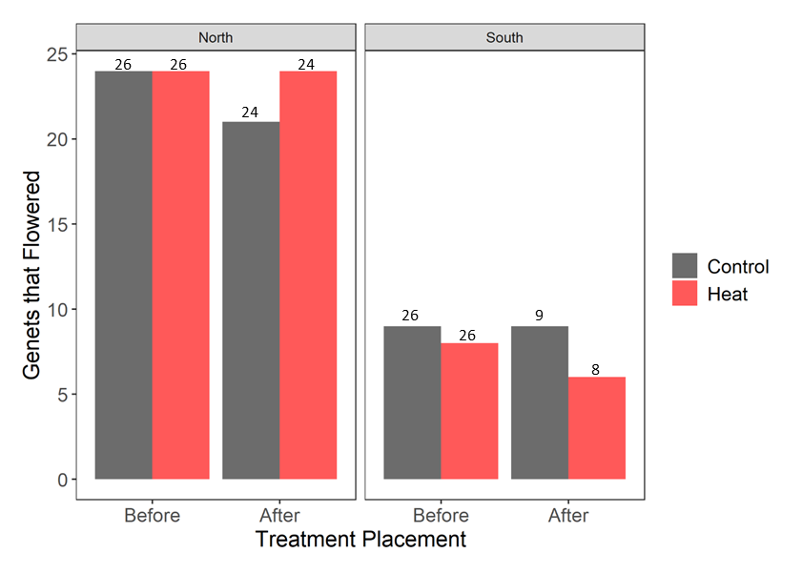

Figure 1. The number of genets that flowered in the control and heat treatments before and after they were placed in the treatments. Counts for the northern and southern regions shown independently. Numbers above the bars represent the number of plants within each group that were placed in the environmental chambers.

Table 1. Results from the chi-squared tests for the number of plants that flowered the first time and the second time in the treatments and chi-squared tests for flower type and fruit set.

|  |  |  |  |
| --- | --- | --- | --- |
| Variable | Test | χ2 | p |
| Plants that flowered 1st time | Region | **36.923** | **1.23E-09** |
| Plants that flowered 2nd time | Region | **33.130** | **8.62E-09** |
| Plants that flowered 2nd time | Treatment | 0.000 | 1.000 |
| Flower Type | Treatment | 0.370 | 0.543 |
| Fruit Set | Treatment | 5.547 | 0.136 |

*Flower Development*

The flower type for the first flower after placement in the treatment was recorded. There was no significant difference between treatment groups for flower type of northern plants (Table 1). Flower type did limit the data collected since staminate flowers were not used for variables such as ovule number, style plus stigma length, anther length, pollen diameter, fruit set, and seed number (Figure 2). Thus, treatment effects were only considered from plants from northern populations for all variables. There was a significant difference between regions for style plus stigma length and anther length in the controlled (25°C) conditions (Figure 3, table 2). Southern plants had larger floral structures than northern plants. We couldn’t test for the effect of heat on flower morphology in southern plants, as few plants flowered and those that did flower in the heat had mostly staminate flowers.

Figure 2. Number of plants with hermaphroditic and staminate flowers for the treatment groups. Counts for northern and southern plants displayed independently.

Table 2. Results from analysis of floral morphology variables using mixed effects models for regional and population differences. Analysis is just of plants in control treatment.

|  |  |  |  |  |  |  |
| --- | --- | --- | --- | --- | --- | --- |
|  | Fixed Effects | | | | Random Effects | |
| **Variable** | Region | | Population | | Population:Genet | Population |
| F | p | F | p | p | p |
| First Flower | 1.458 | 0.235 | 0.019 | 0.892 | 0.804 | - |
| Style + Stigma Length | **4.453** | **0.045** | 1.200 | 0.284 | **6.24E-11** | - |
| Anther Length | **12.071** | **0.002** | **13.916** | **0.001** | **9.09E-06** | - |
| Ovule Number | 0.093 | 0.763 | 2.822 | 0.106 | **0.017** | - |
| Mean Pollen Diameter | 0.522 | 0.633 | - | - | - | 0.449 |
| Pollen Germination (40°C) | 2.359 | 0.138 | - | - | - | - |
| Viable Seeds per Fruit | 0.189 | 0.669 | 2.032 | 0.173 | **5.38E-06** | - |

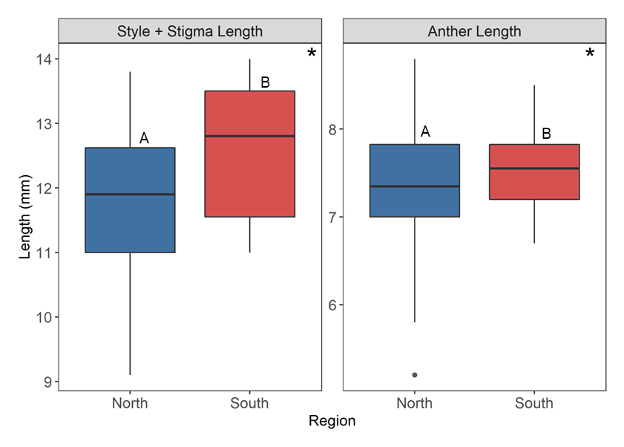

Figure 3. Regional differences for the length of the style plus stigma and the length of the anther from flowers that developed in the control treatment. Midline in boxplot indicates the median of the sample. Asterisks and letters indicate differences that are statistically significant. There are significant differences between regions (north (n) = 20; south (n) = 8) for style plus stigma length (F25 = 4.453, p = 0.045) and anther length (F25 = 12.071, p = 0.002).

There were significant temperature treatment effects for northern plants in both style plus stigma length and anther length (Figure 4, table 3). In both cases, development in heat reduced the lengths of the structures. For the ratio of style plus stigma length to anther length, there was no significant difference between treatments for the means, but there was a significant difference between variances (Bartlett’s K2 = 14.51, p = 1.40e-04; Figure 5). There was a significant, positive correlation (Pearson’s correlation = 0.761, p = 9.611e-05) between the two variables for the control treatment, but not for the heat treatment (Pearson’s correlation = -0.292, p = 0.225; Figure 6).

Table 3. Results from mixed effects models for treatment differences in plants from northern populations.

|  |  |  |  |  |  |  |
| --- | --- | --- | --- | --- | --- | --- |
|  | Fixed Effects | | | | Random Effects | |
| **Variable** | Treatment | | Population | | Population:Genet | Population |
| F | p | F | p | p | p |
| Style + Stigma Length | **48.332** | **3.49E-10** | 0.000 | 0.996 | **5.46E-07** | - |
| Anther Length | **67.849** | **4.33E-13** | **48.178** | **6.22E-07** | **0.025** | - |
| Ovule Number | 0.730 | 0.395 | **6.119** | **0.020** | 0.130 | - |
| Mean Pollen Diameter | **25.544** | **1.46E-05** | - | - | - | 0.678 |
| Pollen Germination (40°C) | 3.949 | 0.054 | - | - | - | - |
| Viable Seeds per Fruit | **12.742** | **0.001** | 0.163 | 0.693 | **5.59E-05** | - |

There were no significant differences in ovule number between regions or treatments. Mean pollen diameter did not differ between the two regions, but there was a significant treatment difference. The diameter of pollen that developed in heat is significantly smaller than pollen that developed in the control conditions (Figure 7, table 3).

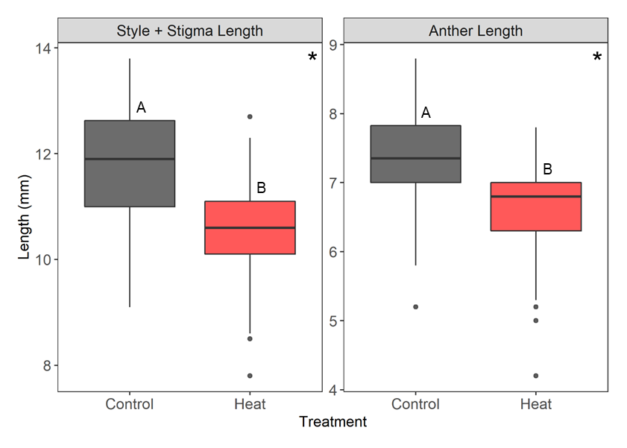

Figure 4. The length of the style plus stigma length of the anther from flowers in hot and control conditions (strictly northern populations). Midline in boxplot indicates the median of the sample. Asterisks and letters indicate differences that are statistically significant. There are significant differences between regions for style plus stigma length (F102 = 48.33, p = 3.49-10) and anther length (F109 = 67.85, p = 4.33e-13).

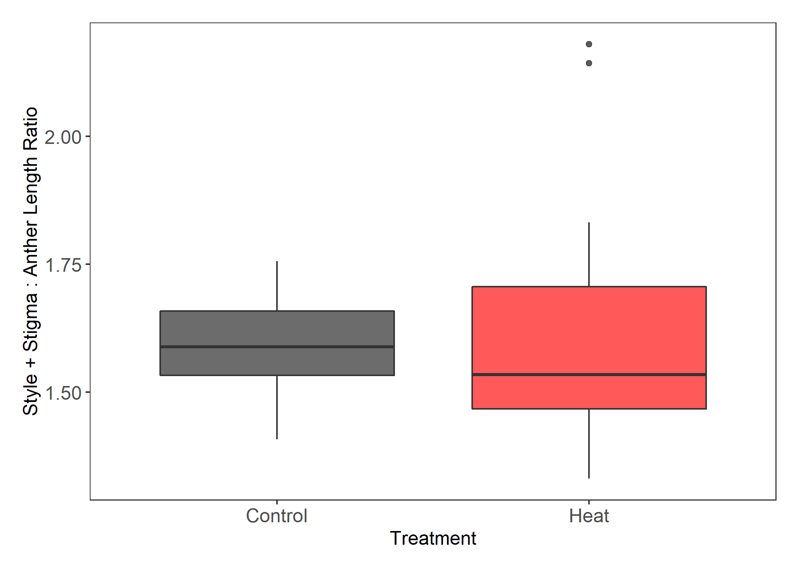

Figure 5. Treatment differences for the ratio of style plus stigma length to anther length. Midline in boxplot indicates the median of the sample. No significant difference between means, but there is a significant difference between variances (Bartlett’s K2 = 14.51, p = 1.40e-04).

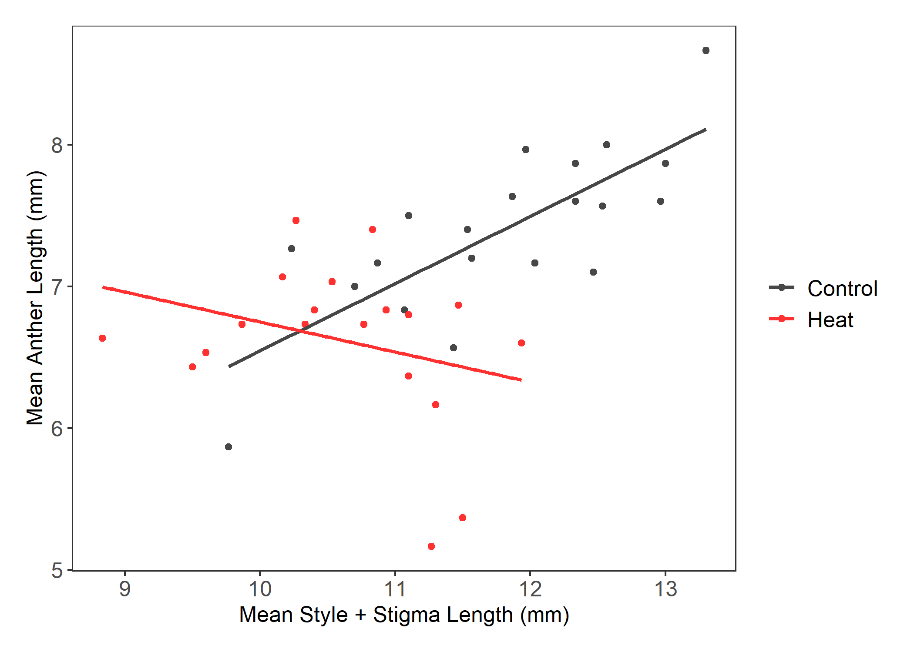

Figure 6. Treatment differences of correlations between the mean style plus stigma length and mean anther lengths for individual genets. The control treatment Pearson’s correlation (0.761) was significant (p = 9.611e-05). The heat treatment Pearson’s correlation (-0.292) was not statistically significant (p = 0.225).

Figure 7. The mean pollen diameter of 100 pollen grains per flower of northern plants from flowers that developed in the respective treatment groups. Midline in boxplot indicates the median of the sample. Asterisk and letters indicate differences that are statistically significant. There was a significant difference between treatment groups (F34 = 25.544, p = 1.456e-05).

*Post-pollination*

Pollen germination at 40°C was not significantly different between regions in the control or between treatment groups with only northern plants (table 2; table 3). When both north and south were analyzed using a two-way analysis of variance with treatment and region, there was a significant difference between regions, but not treatment groups (Figure 8). There were no significant differences between treatment groups within northern plants for fruit set (Figure 9, table 1). There were no significant differences between regions for viable seed count, but there was a significant difference between treatment groups for plants from northern populations (Figure 10, table 2). There were fewer viable seeds produced per fruit when ovules developed in the heat treatment and underwent pollination and fertilization in the heat treatment than those in the control (25°C) treatment.

Figure 8. Regional differences of pollen germination at 40°C in the two treatment groups. Letters represent significant differences between groups. There was a significant difference between regions (F46 = 9.180, p = 0.004), but no difference between treatment groups. Sample sizes: north control (n = 20), north heat (n = 20), south control (n = 6), south heat (n = 3).

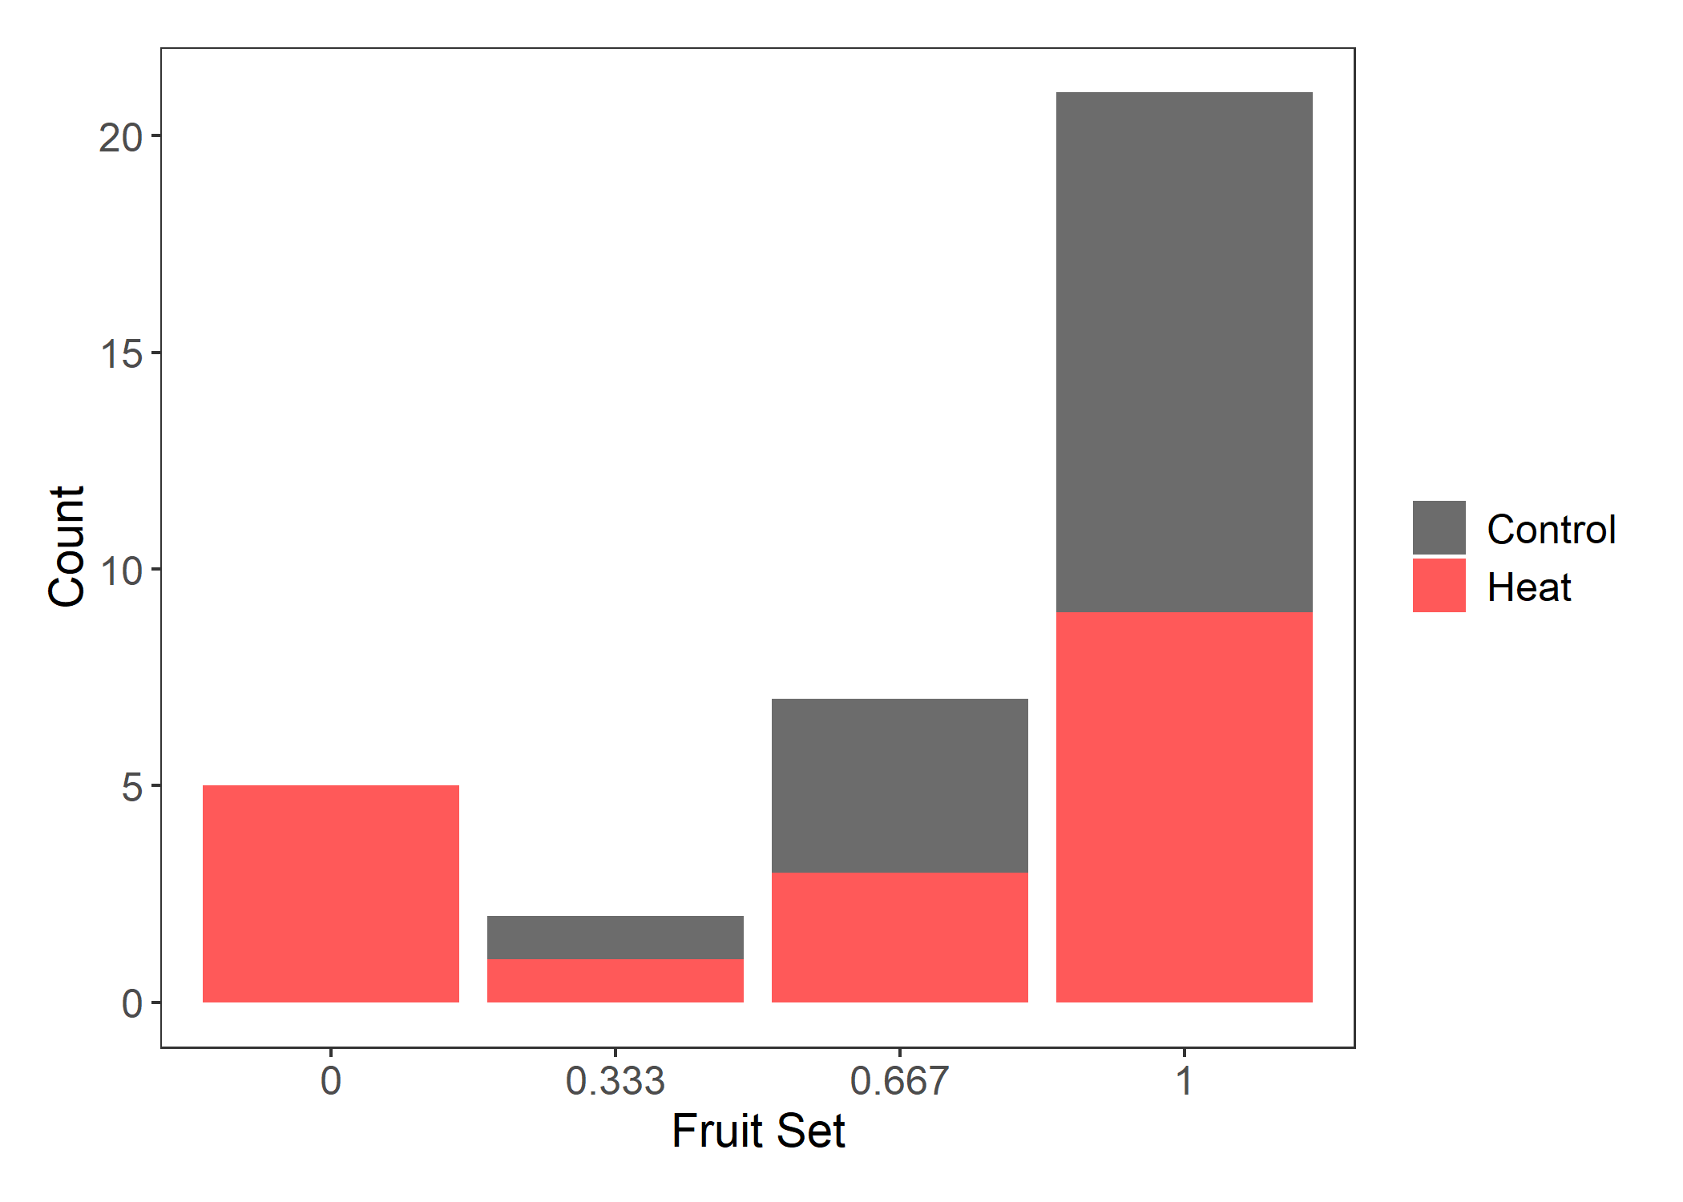

Figure 9. Counts of plants with the four different fruit sets based on three pollinated flowers for plants that originated in northern populations. Color shows treatment groups.

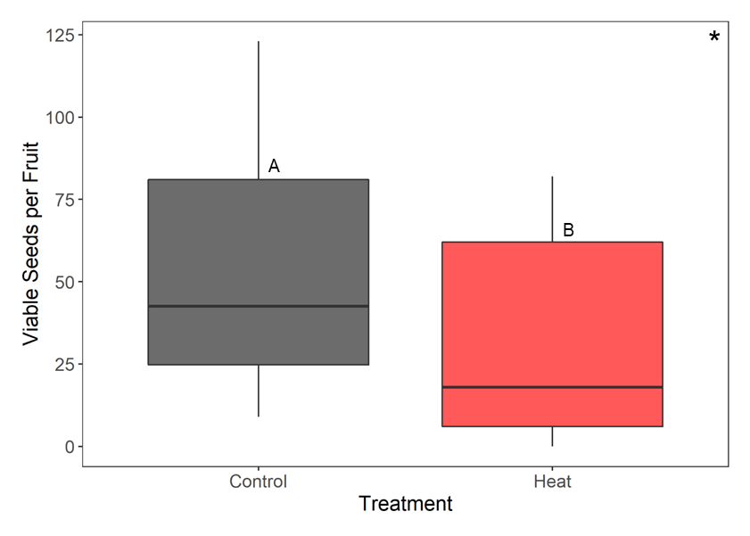

Figure 10. The number of viable seeds per fruit from flowers of northern plants that developed in the respective treatment groups. Asterisk and letters indicate differences that are statistically significant. There was a significant difference between treatment groups (F46 = 12.742, p = 8.514e-04).

Figure 11. Reaction norms for variables in control (25°C day / 25°C night) and moderate heat (32°C day / 25°C night) environmental conditions. Colors indicate region of origin. Solid lines connect mean for the variable across treatments. Error bars indicate the mean standard error of a nonparametric bootstrap for the confidence interval.

Table 4. Summary of the results for each of the dependent variables and implications of those results.

|  |  |  |  |  |
| --- | --- | --- | --- | --- |
| **Trait** | **North** | **South** | **Overall** | **Conclusion** |
| Propensity to Flower | Control = Heat | Control = Heat | **North > South** | No environmental effects; Initial divergence |
| Proportion Staminate Flowers | Control = Heat | Control = Heat | South = North | No environmental effects |
| Style + Stigma Length | **Control > Heat** | NA | **South > North** | PP; initial divergence; GxE |
| Anther Length | **Control > Heat** | NA | **South > North** | PP; initial divergence; GxE |
| Ovule Number | Control = Heat | Control = Hot | South = North | No environmental effects |
| Pollen Diameter | **Control > Heat** | NA | South = North | PP |
| Pollen Germination at 40°C | Control = Heat | Control = Heat | **North > South** | No environmental effects; Initial divergence |
| Fruit Set | Control = Heat | NA | NA | No environmental effects |
| Viable Seeds per Fruit | **Control > Heat** | NA | NA | PP |

**Discussion**

In this study we investigated how long-term mild heat affects sexual reproductive traits in plants from TX and MN. Based on previous studies in crop species, we predicted that heat would affect reproductive traits in *Solanum carolinense*. Heat did affect several of the traits including flower morphology, pollen diameter, and the number of viable seeds per fruit (Table 4). In all traits, heat reduced the size or number of reproductive structures.

Style plus stigma length and anther length were significantly smaller in the heat treatment than the control treatment. Muller et al. (2016) found anther deformations when flowers developed in mild heat (32°C/26°C ). A study on blueberry found that cooler temperatures recessed anthers further in the corolla and warmer conditions increased style length (Lyrene, 1994). Charles and Harris (1972) found that as temperatures increased the distance between the antheridial cone and the stigma in tomatoes (longer stigma or shorter anthers). Unlike *Solanum carolinense*, the stamen of tomato flowers are fused and the style plus stigma do not extend beyond the antheridial cone. As the stigma extended further into the antheridial cone, pollination was less likely, affecting fruit set. We also compared the ratio of style plus stigma length to anther length for the treatment groups. There was no significant difference in the ratio between the treatments, but flowers developed in heat did have significantly more variation than those that developed in the control. To further understand the increased variation in the heat treatment we conducted correlation analysis. We found that in the control treatment style plus stigma length was correlated with anther length, but the correlation breaks down in heat. This suggests that the fundamental proportions of floral structures are disrupted in heat. The change to position of integral reproductive structures in heat could affect rates of pollination and fertilization for *Solanum carolinense*, and thus, influence fitness.

We found that pollen that developed in long-term low heat were significantly smaller than those in controlled (25°C) conditions. There are fitness implications for changes in pollen size as well. McCallum and Chang (2016) found evidence of pollen size influencing siring success. Larger pollen grains were more competitive than smaller pollen grain size in common morning glory. Another explanation for this observation is that long-term heat induces an increase in the proportion of smaller, low-ROS pollen. There have been multiple studies with evidence suggesting that pollen grains fall in one of two categories. Rutley et al. (2022) described this phenomenon as the “two-basket” model, with low-ROS and high-ROS pollen based on the dual nature of pollen found in other studies (Jegadeesan et al., 2018; Luria et al., 2019). High-ROS pollen have higher metabolic rates, are typically larger in size, and readily germinate once mature. On the other hand, low-ROS pollen are partially dehydrated with low metabolic rates, are smaller in size, and remain dormant when environmental conditions are not favorable for germination. Either through pollen dormancy or reduction in pollen performance, size affects fitness.

We found that heat throughout the development of maternal tissues and fertilization reduced the number of viable seeds per fruit. Xu et al. (2017) found that heat had little influence on seed number compared to other reproductive traits. Din et al. (2015) found that seed set was reduced in heat, especially in more temperature sensitive accessions. Din et al. (2015) attributed this difference to heat reducing pollen viability, or pollen tube growth in the style. Since ovule number was not affected by heat, the difference in viable seed number we attained, might also be a product of low pollen viability at 32°C compared to 25°C. Viable seeds and unfertilized ovules dominated the counts, with few aborted seeds. This suggests that male viability may be the limiting factor and not female viability. Jiang (2019b) also found disparity between ovule and pollen viability of peas when exposed to heat. Ovules maintained viability in heat stress, while pollen viability decreased.

These differences in phenotype strictly due to environmental change suggests that phenotypic plasticity accounts for some of the variation within this species. Since these traits are tied to fitness, environment is partially responsible for obscuring evolutionary responses tied to natural selection. Phenotypic plasticity partially dissociates genotype from phenotype through molecular mechanisms such as histone modification or regulation of transcription factors (Nicotra et al., 2010). Furthermore, phenotypic plasticity itself is a traits that can vary within or among populations leading to variation through gene x environment interactions (Schlichting, 1986). Molina-Montenegro and Naya (2012) found that phenotypic plasticity of several traits increased in populations as latitude of origin increased. Since environmental conditions are rapidly changing, increased phenotypic plasticity may be advantageous and thus adaptive. We were therefore, interested in gene x environment interactions in *Solanum carolinense* plants and whether location of origin influenced how these plants respond to heat.

There was initial divergence between plants from the two regions for the propensity of a genet to flower, the length of male and female floral structures, and pollen germination at 40°C (Table 4). In both heat and the control treatments, almost all of the northern plants flowered. On the other hand, only one population from the southern region had plants that consistently flowered. Since temperatures in Texas are generally high and sexual reproduction is disrupted by heat in this species, populations in Texas may have evolved to allocate more resources to asexual reproduction than sexual reproduction (CITATION). For the plants that did flower, there was no significant difference for the propensity to flower in heat (32°C) vs control (25°C) temperatures. These results suggest local adaptation through selection acting on genetic variation.

The male and female floral structures were larger in plants from the south than those from the north. Based on qualitative observations, the fruit size seems to also differ between the two regions. Larger floral structures and fruit may provide more protection to ovules and seeds in conditions with higher temperatures (CITATION). Style + stigma and anther length also differed in the two treatment groups for northern plants. Because of low sample size, we did not analyze the differences that plants from the two regions have in the heat treatment. However, there does seem to be evidence of variable responses to heat among populations in the two regions (Figure 11). For both style + stigma and anther length, northern plant structures decreased when grown in heat, while structures in southern plants maintained the same average, but varied more between genets. This suggests that there may be a gene x environment interaction involved.

The last trait that differed between regions was pollen germination at 40°C. These results match that of the last chapter and suggest that southern plants have adapted to higher temperatures by producing a higher proportion of low-ROS pollen to selectively germinate and avoid high temperature stress. Our study confirmed that the temperature at which pollen develops doesn’t affect germination. Muller et al. (2016) found that long-term mild heat during development did reduce pollen germination. However, we presume they tested germination after incubation at room temperature and not at high temperatures, which may be one reason our results differed from this study and others that also found that development in heat reduced pollen viability (Jiang et al., 2019b; Poudyal et al., 2019; Sato et al., 2006; Jiemeng Xu et al., 2017).

**Conclusion**

Overall, our results indicate that environmental conditions affect reproductive processes in *Solanum carolinense* and ultimately fitness. Long-term mild heat during development reduced the size of floral structures and pollen diameter, and after pollination, reduced seed production. Our findings imply that as temperatures rise, the success of sexual reproduction may decline in this species and potentially others. As environment directly influences fitness, in this case, evolutionary processes that act on genetic variation may be shrouded. We found evidence of local adaptation between the two regions for the propensity to flower, pollen germination at 40°C, and in the size of floral structures. Since both the region of origin and treatment group affected flower morphology, there is some evidence suggesting a gene x environment interaction. Understanding the sources of variation driving responses to environmental change is important in predicting how and if species will persist in this rapidly changing world.

* Seed set

**References**

Charles, W. B., & Harris, R. E. (1972). TOMATO FRUIT-SET AT HIGH AND LOW-TEMPERATURES. *Canadian journal of plant science.*, *52*(4), 497-506. <https://doi.org/10.4141/cjps72-080>

Connolly, B. A., & Anderson, G. J. (2003). Functional significance of the androecium in staminate and hermaphroditic flowers of Solanum carolinense (Solanaceae). *Plant systematics and evolution*, *240*(1/4), 235-243. <https://doi.org/10.1007/s00606-003-0029-7>

Diaz, A., & Macnair, M. R. (1999). Pollen tube competition as a mechanism of prezygotic reproductive isolation between Mimulus nasutus and its presumed progenitor M. guttatus. *The New phytologist*, *144*(3), 471-478. <https://doi.org/10.1046/j.1469-8137.1999.00543.x>

Din, J. U., Khan, S. U., Khan, A., Qayyum, A., Abbasi, K. S., & Jenks, M. A. (2015). Evaluation of potential morpho-physiological and biochemical indicators in selecting heat-tolerant tomato (Solanum lycopersicum Mill.) genotypes. *Horticulture, Environment, and Biotechnology*, *56*(6), 769-776. <https://doi.org/10.1007/s13580-015-0098-x>

Farinon, B., Picarella, M. E., & Mazzucato, A. (2022). Dynamics of Fertility-Related Traits in Tomato Landraces under Mild and Severe Heat Stress. *Plants*, *11*(7), 881. <https://doi.org/10.3390/plants11070881>

Jegadeesan, S., Chaturvedi, P., Ghatak, A., Pressman, E., Meir, S., Faigenboim, A., . . . Firon, N. (2018). Proteomics of Heat-Stress and Ethylene-Mediated Thermotolerance Mechanisms in Tomato Pollen Grains. *Frontiers in Plant Science*, *9*, Article 1558. <https://doi.org/10.3389/fpls.2018.01558>

Jiang, Y., Lahlali, R., Karunakaran, C., Warkentin, T. D., Davis, A. R., & Bueckert, R. A. (2019a). Pollen, ovules, and pollination in pea: Success, failure, and resilience in heat. *Plant, cell and environment*, *42*(1), 354-372. <https://doi.org/10.1111/pce.13427>

Jiang, Y., Lahlali, R., Karunakaran, C., Warkentin, T. D., Davis, A. R., & Bueckert, R. A. (2019b). Pollen, ovules, and pollination in pea: Success, failure, and resilience in heat. *Plant, Cell & Environment*, *42*(1), 354-372. <https://doi.org/10.1111/pce.13427>

Kuznetsova, A., Brockhoff, P. B., & Christensen, R. H. B. (2017). lmerTest Package: Tests in Linear Mixed Effects Models. *Journal of Statistical Software*, *82*(13), 1 - 26. <https://doi.org/10.18637/jss.v082.i13>

Luria, G., Rutley, N., Lazar, I., Harper, J. F., & Miller, G. (2019). Direct analysis of pollen fitness by flow cytometry: implications for pollen response to stress. *The Plant Journal*, *98*(5), 942-952. <https://doi.org/10.1111/tpj.14286>

Lyrene, P. M. (1994). Environmental Effects on Blueberry Flower Size and Shape Are Minor. *Journal of the American Society for Horticultural Science*, *119*(5), 1043-1045. <https://doi.org/10.21273/jashs.119.5.1043>

McCallum, B., & Chang, S. M. (2016). Pollen competition in style: Effects of pollen size on siring success in the hermaphroditic common morning glory, Ipomoea purpurea. *American journal of botany*, *103*(3), 460-470. <https://doi.org/10.3732/ajb.1500211>

Melillo, J. M., Richmond, T. T. C., & Yohe, G. W. (2014). *Climate Change Impacts in the United States:*

*The Third National Climate Assessment*. U. S. G. P. Office.

Mena-Ali, J. I., Keser, L. H., & Stephenson, A. G. (2009). The effect of sheltered load on reproduction in Solanum carolinense, a species with variable self-incompatibility. *Sexual Plant Reproduction*, *22*(2), 63-71. <https://doi.org/10.1007/s00497-008-0092-x>

Mena-Ali, J. I., & Stephenson, A. G. (2007). Segregation analyses of partial self-incompatibility in self and cross progeny of Solanum carolinense reveal a leaky S-allele. *Genetics*, *177*(1), 501-510. <https://doi.org/10.1534/genetics.107.073775>

Molina-Montenegro, M. A., & Naya, D. E. (2012). Latitudinal Patterns in Phenotypic Plasticity and Fitness-Related Traits: Assessing the Climatic Variability Hypothesis (CVH) with an Invasive Plant Species. *PLoS ONE*, *7*(10), e47620. <https://doi.org/10.1371/journal.pone.0047620>

Muller, F., & Rieu, I. (2016). Acclimation to high temperature during pollen development. *Plant Reproduction*, *29*(1-2), 107-118. <https://doi.org/10.1007/s00497-016-0282-x>

Müller, F., Xu, J., Kristensen, L., Wolters-Arts, M., De Groot, P. F. M., Jansma, S. Y., . . . Rieu, I. (2016). High-Temperature-Induced Defects in Tomato (Solanum lycopersicum) Anther and Pollen Development Are Associated with Reduced Expression of B-Class Floral Patterning Genes. *PLOS ONE*, *11*(12), e0167614. <https://doi.org/10.1371/journal.pone.0167614>

Nicotra, A. B., Atkin, O. K., Bonser, S. P., Davidson, A. M., Finnegan, E. J., Mathesius, U., . . . van Kleunen, M. (2010). Plant phenotypic plasticity in a changing climate. *Trends in plant science*, *15*(12), 684-692. <https://doi.org/10.1016/j.tplants.2010.09.008>

Poudyal, D., Rosenqvist, E., & Ottosen, C. O. (2019). Phenotyping from lab to field - tomato lines screened for heat stress using F-v/F-m maintain high fruit yield during thermal stress in the field [Article]. *Functional Plant Biology*, *46*(1), 44-55. <https://doi.org/10.1071/fp17317>

R Core Team. (2020). *R: A language and environment for statistical computing*.In *R Foundation for Statistical Computing* R Foundation for Statistical Computing. <https://www.R-project.org/>

Reddy, K. R., & Kakani, V. G. (2007). Screening Capsicum species of different origins for high temperature tolerance by in vitro pollen germination and pollen tube length. *Scientia horticulturae*, *112*(2), 130-135. <https://doi.org/10.1016/j.scienta.2006.12.014>

Rutley, N., Harper, J. F., & Miller, G. (2022). Reproductive resilience: putting pollen grains in two baskets. *Trends in Plant Science*, *27*(3), 237-246. <https://doi.org/10.1016/j.tplants.2021.09.002>

Sato, S., Kamiyama, M., Iwata, T., Makita, N., Furukawa, H., & Ikeda, H. (2006). Moderate Increase of Mean Daily Temperature Adversely Affects Fruit Set of Lycopersicon esculentum by Disrupting Specific Physiological Processes in Male Reproductive Development. *Annals of Botany*, *97*(5), 731-738. <https://doi.org/10.1093/aob/mcl037>

Schlichting, C. (1986). The Evolution of Phenotypic Plasticity in Plants. *Annual review of ecology and systematics*, *17*(1), 667-693. <https://doi.org/10.1146/annurev.ecolsys.17.1.667>

Sherzod, R., Yang, E. Y., Cho, M. C., Chae, S. Y., & Chae, W. B. (2020). Physiological traits associated with high temperature tolerance differ by fruit types and sizes in tomato (Solanum lycopersicum L.). *Horticulture, Environment, and Biotechnology*, *61*(5), 837-847. <https://doi.org/10.1007/s13580-020-00280-4>

Travers, S. E., Mena-Ali, J., & Stephenson, A. G. (2004). Plasticity in the self-incompatibility system of Solanum carolinense. *Plant Species Biology*, *19*(3), 127-135. <https://doi.org/10.1111/j.1442-1984.2004.00109.x>

Xu, J., Wolters-Arts, A. M. C., Mariani, C., Huber, H., & Rieu, I. (2017). Heat stress affects vegetative and reproductive performance and trait correlations in tomato (solanum lycopersicum). *Euphytica*, *213*(7), 1-12. <https://doi.org/10.1007/s10681-017-1949-6>

Xu, J., Wolters-Arts, M., Mariani, C., Huber, H., & Rieu, I. (2017). Heat stress affects vegetative and reproductive performance and trait correlations in tomato (Solanum lycopersicum). *Euphytica*, *213*(7). <https://doi.org/10.1007/s10681-017-1949-6>