**Intraspecific variation in responses to extreme and moderate temperature stress in the wild species, *Solanum carolinense***

Emma K. Chandler and Steven E. Travers

**Introduction**

Methods

*Solanum carolinense* L. (Solanaceae), also known as horsenettle, is a weedy, herbaceous perennial that originated in southeastern North America. Since all other species in this clade are neotropical, this species likely arose through dispersal to North America and independent diversification. Once established in the southeast, *Solanum carolinense* utilized its natural adaptability and propensity to reproduce both sexually and asexually to expand its range north- and west-ward (Figure 1).

Figure 1. Map of the distribution of *Solanum carolinense* (grey dots), northern (blue dots) and southern regions (red dots), and populations of origin for plants in this study. The populations Frontenac (top blow-up, blue) and Prairie Island (top blow-up, purple) were in the northern region and the populations Cemetery (bottom blow-up, red), Oil Patch (bottom blow-up, orange), and Reserve (bottom blow-up, green) were located in the southern region.

We collected *Solanum carolinense* plants from multiple populations in Minnesota and Texas between October 2019 and August 2020 (Figure 1). The Minnesota plants collectively will be referred to as the northern plants and include the populations Prairie Island (44.07959 N, -91.684545 W) and Frontenac (44.523056 N, -92.338611 W). Approximately 80 Km separated the two populations (Figure 1). In Houston County, MN where these plants were collected, the average daily temperatures vary from a low of -9°C to a high of 22°C over the course of the year. The Texas plants together will be referred to as the southern plants. All three Texas populations were located within a circle with a 1.5 Km radius near McKinney TX (Oil Patch: 33.173465 N, -96.615402 W; Reserve: 33.159962 N, -96.619011 W; and Cemetery: 33.173672 N, -96.615096 W). In Colin County TX, where these plants were collected, the average daily temperatures vary from a low of 6°C to a high of 29°C over the course of the year.

Collections involved removing rhizomes of at least 10 cm from individual plants in the field and placing them in ziplock bags. We assumed that each rhizome represented a unique genotype (genet) because we maintained an interval of at least 1 meter between collections. The number of rhizomes (genets) collected at each population were as follows: Prairie Island (n= 29); Frontenac (n= 13); Oil Patch (n= 8); Reserve (n= 5); and Cemetery (n= 11).

The field-collected rhizomes were shipped to Fargo, ND, and stored in a 4°C refrigerator prior to a growth and dormancy period to establish an experimental population . After one to several weeks in the refrigerator, the rhizomes were potted in one-gallon containers with a standard potting mix, allowing above and belowground material to grow for several months in a greenhouse. The above ground material was then cut and the pots were again stored in a 4°C refrigerator to induce a period of dormancy.

After the dormancy period (3 months), equal sections of rhizome (at least 2 cm for thick rhizomes and increased lengths for thinner rhizomes) were cut into four equal-sized pieces. These were ultimately used to grow genetically identical plants (ramets) from each genet at different times (temporal blocks A, B, C and D) because of a lack of sufficient space to grow them all at once. The rhizome pieces were placed in 3.8 cm diameter cone-shaped containers in the greenhouse.

Of the ramets planted each week, half were from the southern region and half were from the northern region. Since we had a total of 26 genets from the south, we randomly selected 26 of the 42 genets from the northern populations using a random number generator. All ramets in block A were planted over the course of five weeks prior to the planting of the ramets in block B and so on. Each northern plant was paired with a southern plant spatially on the greenhouse benches. The plants were fertilized every other week with 10-10-10 fertilizer and transplanted to larger, 4.5 L containers when they outgrew the small cone-shaped containers. These conditions were established for Experiment 2, which occurred prior to Experiment 1. We switched the order of the experiments for the sake of clarity in this story.

**Experiment 1: The effect of long-term moderate heat on reproductive traits**

Just prior to Experiment one, we removed the aboveground portions of each plant and stored them at 4° C for a final dormancy period of 3-9 months. To begin with, two ramets of all 26 genets from the north and south were placed in a randomized grid pattern in a growth chamber (Conviron PGC-FLEX). Due to space constraints in the environmental chambers, only A and B ramets were grown initially. Ramets C and D were placed in the chambers six months later. For initial growth, all plants were exposed to “control” conditions (25°C day/25°C night; fluorescent and incandescent lighting for 14 hours per day. Plants were fertilized once every two weeks with a high phosphorus fertilizer (12-55-6) to promote flower production (Super Bloom, Scotts).

Upon flowering, two ramets per genet was randomly assigned to the control conditions (same as above) and the other two to the heat treatment conditions (32°C day/25°C night; 14hr/10hr). By necessity, these were in different chambers (control: Conviron PGC-FLEX; heat treatment: Conviron E7/2). Plants were watered daily. Subsequent flowers and fruits developed at either elevated temperatures (32°C) or control temperatures (25°C).

Pre-Pollination Phase

The first three hermaphroditic flowers (*Solanum carolinense* is andromonecious) per plant that developed in the respective treatments were collected in alcohol and used for flower morphology measurements, ovule counts, and pollen size measurements. Floral morphology traits (length of the style, stigma, and one anther) were measured under a dissecting scope. The number of ovules in each ovary was counted following a modified staining protocol adapted from Diaz and Macnair (1999). Pollen diameters of approximately 100 grains were measured with the use of a microscope (Axio Scope A.1 Carl Zeiss, Germany) at 400x total magnification and the circle diameter measurement tool on the Zen 3.1 software.

Post-Pollination Phase

We pollinated three additional flowers and collected the pollen of one more flower to measure subsequent female and male reproductive traits. Mature flowers were pollinated with a mix of pollen from 2 to 5 flowers, represented by northern and southern plants, that developed in the control conditions. Pollinations were accomplished by applying a mixture of pollen on the stigma with a dissection probe. Each pollinated flower was labelled with a jewelry tag. Once flowers were pollinated, the plant remained in their respective treatments for one week before we moved them into a greenhouse for the remainder of fruit maturation (Average Daily Temperatures 25.1°C day / 21.3°C night). We then measured fruit set (number of fruits produced / three flowers pollinated) and the seed set (number of viable seeds, aborted seeds, and unfertilized ovules per fruit). The number of viable seeds, aborted seeds, and unfertilized ovules were counted under a dissecting scope.

In-vitro pollen germination at 40°C was used as a proxy for male reproductive success in high temperatures, selected based on results from Experiment 2. Pollen germination at extreme temperatures was measured following a protocol from Reddy and Kakani (2007). Pollen from each plant was dispersed over a petri dish containing 3% Bacto-Agar based growth medium (sucrose, Ca(NO3)2, MgSO4, KNO3, H3BO3)and incubated at 40°C for 16 hours. Four pictures of each plate were taken using a compound microscope (Leica DM500 microscope, Leica ICC50 HD camera) and the LAS EZ 2.1.0 software. Pollen germination (Germ) was measured for each plate by counting the number of pollen grains per image that had produced pollen tubes and dividing that by the total number of pollen grains observed.

**Experiment 2: Life-stage specific responses to extreme temperature**

Temperature tolerance variables

To assess the impact of extreme heat on plants, we measured three vegetative variables (cell membrane stability (CMS), chlorophyll content (CHPL), and net photosynthetic rate (PS).) and two reproductive variables (the propensity for pollen grains to germinate (GERM) and the growth rate of pollen tubes (PTGR). We measured each variable on each plant in two temperature treatments, hot treatment (acronym preceded by “H”) and an extreme cold treatment (acronym preceded by “C”).

CMS was calculated according to the protocol from Gajanayake et al. (2011) and Fang and To (2016). Ion leakage from leaf material exposed to either heat (HCMS: 55°C water bath for ten minutes) or cold (CCMS: -18°C) was measured using an electrical conductivity probe and compared to the conductivity of leaf material in control (27°C) and maximum damage (98°C) treatments. Difference in chlorophyll content (CHPL) of leaves was estimated, as in Gittelson et al. (1998), for material exposed to either a hot temperature treatment (HCHPL: 60°C for 1 hr) or a cold temperature treatment (CCHPL: 4°C for 1 hr followed by -18°C for 1 hr) using a chlorophyll meter (Opti-Sciences CCM-300). The chlorophyll meter measures the fluorescence emitted at 735nm/700nm for a constant leaf area. Chlorophyll content before and after treatments was used to estimate the difference in chlorophyll content in mg/m2. PS was a measure of the effects of temperature treatments on the photosynthetic capabilities of leaves. PS was estimated as the ratio of net photosynthetic rates before and after a temperature treatment (HPS: 33°C, CPS: 10°C for 48 hrs). More detailed methods are available in the Supporting Information.

We focused on two pollen traits for estimates of male thermotolerance during the reproductive stage: 1) the propensity for pollen grains to germinate (pollen germination) and 2) the growth rate of pollen tubes while exposed to a range of temperatures. We paired measurements of pollen traits from plants in the north and south by sampling mature anthers of plants flowering simultaneously. Pollen from each flower in a pair was dispersed over five petri dishes containing the mixture described in experiment 1 (3% Bacto-Agar based growth medium (sucrose, Ca(NO3)2, MgSO4, KNO3, H3BO3). The dusted plates were each placed at one of the five temperature treatments (10°C, 20°C, 25°C, 30°C, 40°C) for 16 hours. Four pictures of each plate were taken using a compound microscope (Leica DM500 microscope, Leica ICC50 HD camera) and the LAS EZ 2.1.0 software. Pollen germination (Germ) was measured for each plate by counting the number of pollen grains per image that had produced pollen tubes and dividing that count by the total number of pollen grains observed. Pollen tube growth rate (PTGR) was calculated by dividing the length of the 20 longest pollen tubes measured using ImageJ (Schneider, Rasband et al. 2012) by the time allowed for growth (16 hours). Detailed methods provided in the Supporting Information. Each experimental plant was then cut back to soil level and stored at 4°C for 3-9 months.

Data Analysis

The effect of long-term moderate heat on reproductive traits

Flower date was analyzed for regional differences using a linear mixed effects model in the *lme4* package (Bates, Mächler et al. 2014) with region as the fixed effect and genet as the random effect. Differences in flower type development between the treatments were analyzed using a chi-squared test in the *stats* package (R Core Team 2020). All pre and post pollination traits were analyzed with different versions of mixed effects models depending on the data type. The general structure for the model was region, treatment, and the interaction of region and treatment as fixed effects and genet as the random intercept. We used general linear mixed effects models (*lme4*; function lmer) for anther and style plus stigma length. To avoid overfitting the model for pollen diameter, we omitted genet as a random effect and used a general linear model (*stats*; function lm). We used generalized mixed effects models (*lme4*; function glmer) with a Poisson distribution for all count data, which included counts of ovules, viable seeds, unfertilized ovules, and aborted seeds. Since pollen germination at 40°C was a proportion, we used a generalized mixed effects model (*lme4*; function glmer) with a binomial distribution for analysis. We conducted correlation analysis for mean anther and mean style plus stigma lengths (*stats*; function cor.test).Fruit set was analyzed using a chi-squared test (*stats*; function chisq.test).

Tvegetative*lme4* Bates, Mächler et al. 2014intercepts

reproductive

vegetativereproductiveAll data were analyzed in R 4.1.2 (R Core Team 2020).

Results



**Experiment 1:** **The effect of long-term moderate heat on reproductive traits**

Pre-pollination

Long-term moderate heat negatively influenced style plus stigma length, anther length, pollen grain diameter, and ovule number (Table 1, Figure 2). However, flowering time and first flower type (hermaphrodite and male) did not differ between the treatments or region of origin. On average, flowers that developed in the heat treatment had smaller floral structures. Style plus stigma length decreased by 14% (Χ2=240, p<0.001) and anther length decreased by 11% (Χ2=183, p<0.001) in long term moderate heat conditions relative to the control. Style plus stigma length also differed by region of origin. Plants from Texas on average had 5% longer style plus stigma than plants from Minnesota (Χ2=11, p=0.001). The relationship between anther and style plus stigma length changed with development in heat. Mean anther length and style plus stigma length were correlated in the control treatment (r=0.55, t52=4.81, p<0.001), but not in the heat treatment (r=0.21, t40=1.35, p=0.184; Figure 3). Development in heat increased the average number of ovules by approximately 1 ovule (Χ2=11, p=0.001) and reduced pollen size by 10% (F1,100=82, p<0.001). Neither trait differed by region. We found significant interactions between treatment and region in style plus stigma length (Χ2=6, p=0.014), anther length (Χ2=9, p=0.002), and ovule number (Χ2=53, p<0.001; Figure 2).

Post-pollination

Pollen development in long-term moderate heat did not affect germination at high temperatures and germination did not differ between regions (Table 1). Fruit set was also not affected by the heat treatment. The number of viable seeds was affected by heat (Χ2=100, p<0.001) and on average decreased seed set by 16 seeds. The number of unfertilized ovules increased by six in the heat treatment compared to the control (Χ2=11, p<0.001) and the number of aborted seeds increased by about 1.64 seeds on average (Χ2=42, p<0.001). We note here that the average number of aborted seeds in the control group was relatively low with an average number of 0.63 seeds. The number of unfertilized ovules did differ by region (Χ2=6, p=0.011). There was a significant interaction between the treatment and region for the number of unfertilized ovules (Χ2=64, p<0.001) and aborted seeds (Χ2=12, p<0.001; Figure 2).

Table 1. ANOVA results with the fixed effects temperature treatment (control and heat), region of origin (north and south), and the interaction between treatment and region. Genet was included as a random effect (excluded in pollen grain size due to overfitting the model).

|  |  |  |  |  |  |  |  |
| --- | --- | --- | --- | --- | --- | --- | --- |
| Variable | Treatment | | | Region | | Treatment:Region | |
| dF | Χ2 | p | Χ2 | p | Χ2 | p |
| Style + Stigma Length (mm) | 1 | **240.11** | **<0.001** | **10.50** | **0.001** | **6.00** | **0.014** |
| Anther Length (mm) | 1 | **183.57** | **<0.001** | 0.27 | 0.605 | **9.29** | **0.002** |
| Ovule Number | 1 | **10.93** | **<0.001** | 0.036 | 0.849 | **52.87** | **<0.001** |
| Pollen Grain Size (μm) * | 1,100 | **F=82.27** | **<0.001** | 0.00 | 0.979 | 0.00 | 0.981 |
| Pollen Germination (40°C) | 1 | 0.10 | 0.748 | 1.51 | 0.219 | 0.01 | 0.931 |
| Viable Seed | 1 | **99.71** | **<0.001** | 2.85 | 0.091 | 0.03 | 0.867 |
| Unfertilized Ovules | 1 | **11.34** | **<0.001** | **6.41** | **0.011** | **64.16** | **<0.001** |
| Aborted Seeds | 1 | **41.77** | **<0.001** | 1.99 | 0.158 | **11.62** | **<0.001** |

*Model excluded genet random effect to avoid overfitting model. Bolded values: statistically significant (α=0.05).

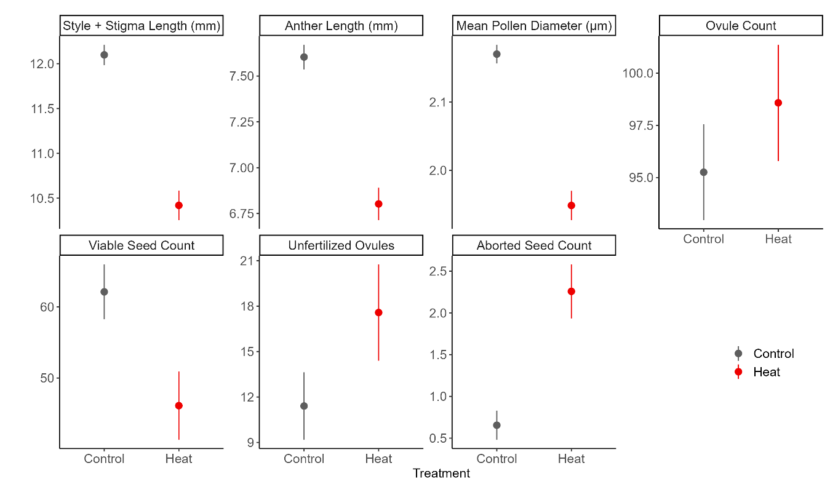

Figure 1. The effects of long-term moderate heat on morphological traits and seed set. Plant development in heat reduced the size of the stigma + style, anther, and pollen grains. The number of ovules increased. Development and fertilization in heat reduced the number of viable seeds per fruit. The number of unfertilized ovules and aborted seeds increased.

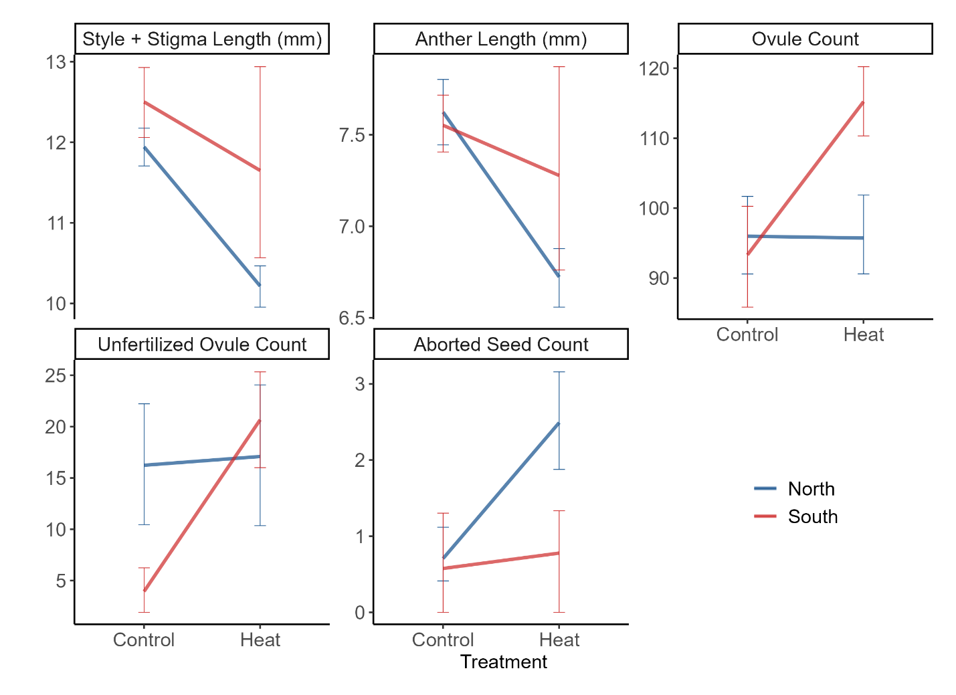

Figure 2. Statistically significant interactions in Experiment 1 between heat treatment and region.

Figure 3. Correlation of anther and style plus stigma length averaged across genets in Experiment 1. Control shown in dark grey and heat treatment in red. Correlation between morphological traits (r=0.55, t52=4.81, p<0.001) deteriorated in the heat treatment (r=0.21, t40=1.35, p=0.184).

**Experiment 2: Life-stage specific responses to extreme temperature**

Vegetative traits

Of the six vegetative traits measured in this experiment, three differed between regions. In extreme heat (HCHPL: F1,51=4.418, p =0.041) and cold (CCHPL: F1,50=66.369, p <0.001), northern plants retained chlorophyll content more effectively than southern plants (Table 2). The chlorophyll content of northern plants was 8% and 19% higher than southern plants for the heat and cold treatments respectively. In contrast, southern plants had a 5% higher cell membrane stability in the extreme cold treatment than did northern plants (CCMS: F1,191=66.369, p <0.001; Table 2).

There was no overall significant difference between regions for HCMS, but heat tolerance was higher for northern than for southern plants in block A (Supplementary Information). Temperatures in the greenhouse progressively rose throughout the spring and summer leading to a block effect in both the hot and cold treatments of CMS (Supporting Information Fig. S2). The block effect on CMS may be due to the capacity of *S. carolinense* to induce temperature tolerance and acclimate to environmental conditions (Clarke, Mur et al. 2004). In block A, northern plants had a higher HCMS, but this difference degraded in the later blocks during the times when greenhouse temperatures were higher during plant development (Supporting Information Fig. S3). We considered block A values the baseline HCMS and determined that northern plant have higher baseline heat tolerance. Finally, there were no regional effects on photosynthetic rate in response to either cold or heat.

Table 2. Vegetative and reproductive temperature tolerance results from mixed effects linear models with the fixed effect region (north vs south) and the random effects genet and block (omitted for reproductive). Due to overfitting the model genet was omitted from CCMS, HPS, and Tmin PTGR. Block was not included in the analysis for reproductive traits and CPS. Random effect statistical values reported in the Supporting Information (Table S2), as well as results from a mixed model using only control values (Supporting Information Table S3).

|  |  |  |  |  |  |  |
| --- | --- | --- | --- | --- | --- | --- |
| Variable | | Region | | | | |
| Expected | Observed | dF | F | p |
| Vegetative | Cell Membrane Stability (Heat) | S > N | - | 1, 50 | 3.673 | 0.0610 |
| Cell Membrane Stability (Cold) | N > S | S > N | **1, 191** | **6.482** | **0.012** |
| Chlorophyll Content (Heat) | S > N | N > S | **1, 51** | **4.418** | **0.041** |
| Chlorophyll Content (Cold) | N > S | N > S | **1, 50** | **66.369** | **<0.001** |
| Photosynthetic Rate (Heat) | S > N | - | 1 | 0 | 0.997 |
| Photosynthetic Rate (Cold) | N > S | - | 1, 47 | 3.269 | 0.077 |
| Reproductive | Pollen Germination (Tmax) | S > N | N > S | **1, 26** | **12.054** | **0.002** |
| Pollen Germination (Topt) | S > N | N > S | **1, 24** | **10.916** | **0.003** |
| Pollen Germination (Tmin)* | S > N | - | 1, 21 | 0.151 | 0.702 |
| Pollen Tube Growth Rate (Tmax) | S > N | - | 1, 29 | 0.446 | 0.509 |
| Pollen Tube Growth Rate (Topt) | S > N | - | 1, 29 | 0.121 | 0.731 |
| Pollen Tube Growth Rate (Tmin) | S > N | - | 1, 59 | 0.168 | 0.683 |

* Outlier removed. Bolded values: statistically significant (α=0.05).

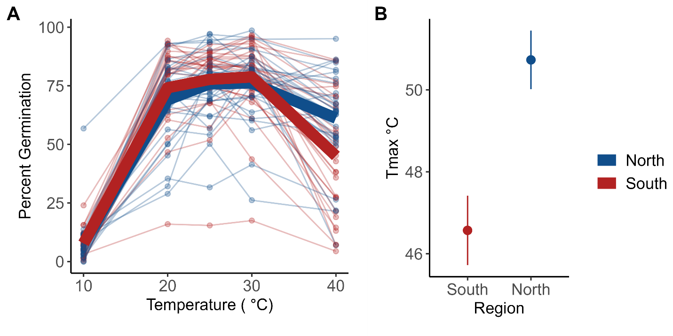

Figure 4. Results from Experiment 2 measures of pollen germination. (A) Percent pollen germination per genet (points) and regional mean (bolded lines: blue=northern, red=southern) . (B) Mean (±se) Tmax for northern (blue) and southern (red) genets. Tmax is the upper x-intercept of the quadratic fit for each individual (i.e., the highest temperature predicted with pollen germinatipn). Pollen from the northern region germinates at higher temperatures compared to pollen from the south (Tmax: F1,26=12, p =0.002).

Reproductive traits

There was a significant difference between regions for Tmax (Figure 4, Table 2) and Topt (Table 2). Pollen from plants from the north germinated more readily at high temperatures (Tmax: F1,26=12, p =0.002) and had higher thermal optima (Topt: F1,24=11, p =0.003) than pollen from plants from the south. There was no significant difference between the two regions for Tmin. One outlier was identified using the Grubbs’ test for outliers and subsequently dropped from the analysis. There were no significant differences in pollen tube growth rate between plants from the north and south for Tmax, Topt or Tmin.

Vegetative and Reproductive Tolerance correlations

After a Holm-Bonferroni correction for multiple correlations, there were no significant correlations between the vegetative variables and reproductive and vegetative variables. However, there were two significant correlation coefficients between reproductive variables. Tmax and Tmin of pollen tube growth rates were positively correlated (r = 0.46). There was also a significant correlation between Tmax for pollen tube growth rate and for pollen germination (r = 0.3).

Discussion

The results of the combined experiments we have conducted indicate that not only do relatively extreme temperatures affect viable seed production and morphological traits but, the responses to heat differ between plants from northern and southern populations in both moderate and extreme temperature conditions. As in other studies (Muller et al. 2016, Fahad et al. 2017), we found that exposure to higher temperatures during plant and floral growth led to negative effects on traits tied to successful reproduction. In experiment one, where plants were exposed to moderate heat (32 °C) and control conditions (25 °C) during floral development, there was a significant treatment effect on 7 of the 8 characteristics we measured (Table 1, Figure 1) including floral morphology measurements, pollen size and ovule fate (viable, aborted, unfertilized). Regardless of where they were from, flowers were smaller and the number of viable seeds decreased in hot conditions.

Several other studies have found that heat affects the floral structures in other taxa, but not necessarily in the same way (Lyrene 1994). Muller et al. (2016) found anther deformations when tomato flowers developed in mild heat (32°C/26°C ). Charles and Harris (1972) found that as temperatures increased the distance between the antheridial cone and the stigma (herkogamy) in tomatoes decreased (longer pistil or shorter stamen). We didn’t specifically look at herkogamy. Regardless, different sizes of the style could have implications for pollen competition (Travers and Shea 2001, Ramesha, Yetish et al. 2011) and the position of anthers relative to the stigma could affect the receipt of outcross versus self pollen from pollinators. We did find that the correlation between the length of male and female reproductive structures breaks down in heat (Figure 3) suggesting that the fundamental proportions of floral structures are disrupted in heat. The change to position of integral reproductive structures in heat could affect rates of self-pollination and inbreeding for *Solanum carolinense*.

The effect of heat on viable seed production and pollen size in our study represent important responses to temperature stress that could have fitness consequences. Pollen diameter dropped significantly in Experiment 1, when flowers developed in hotter conditions (Figure 1). McCallum and Chang (2016) found evidence of pollen size influencing siring success; larger pollen grains were more competitive (sired more seeds) than smaller pollen grains in common morning glory. Our result of reduced viable seed counts in fruits developed in moderate heat moderate heat has mixed support in the literature on a close relative, tomatoes. Xu et al. (2017) found that heat had little influence on seed number compared to other reproductive traits, but Din et al. (2015) found that seed set was reduced in heat, especially in more temperature sensitive accessions. They attributed this difference to heat reducing pollen viability, or pollen tube growth in the style. In sum, these results suggest that the stress of warmer temperatures during floral development can have important negative consequences with potential evolutionary consequences.

Regional differences

Despite the fact that all of the plants used in our experiments were the same species and were grown in approximately the same conditions, there were significant differences between the responses to hot temperatures between plants from northern versus southern latitudes (Figure 2). These differences are consistent with long-term local adaptation of plants to the thermal patterns and environments in the two different places (MN and TX). The floral morphology reductions in response to heat described previously, were not consistent between northern and southern plants. Reductions in the length of female and male floral structures were significantly more dramatic in plants from northern populations relative to southern populations (Table 1 – treatment x region effects, Figure 2). These patterns and the increase in ovule counts for southern plants suggest that they will maintain allocations of energy to floral structures despite the heat stress. In contrast, northern plants may reduce their energy allocation to floral structures as an alternative strategy for tolerating heat stress.

Another key difference between northern and southern plants was how heat, during pollination and fruit development, influenced the number of aborted and unfertilized ovules. In southern plants, heat led to increases in the number of ovules that were unfertilized, while in plants from the north, heat led to increases in the number of aborted ovules. In control conditions, southern plants had a much lower percentage of ovules that were unfertilized than northern plants. In heat, the percentage was about the same for the two regions. This regional difference is the pattern expected if pollen performance (growth rate, competitive ability, endurance) is more intolerant to heat during tube growth in the styles of southern plants. Fewer ovules may have been fertilized in southern plants because fewer tubes reached them in hot conditions. However, in the northern plants, pollen tubes appear to have successfully fertilized ovules even under hot conditions, but the fertilized ovules then aborted prior to reaching complete maturity. The reduced efficiency of fertilization in southern plants when exposed to heat may be the result of two separate phenomena. First, in heat, southern plants produced more ovules and generally had longer styles than northern plants. The increased number of unfertilized ovules may be a result of southern plants producing a larger number of ovules during development and the inability of a full pollen load to fertilize the excess ovules. Second, prolonged heat exposure and termination of pollen tube growth in the longer styles of flowers on southern plants could also contribute to the number of ovules that went unfertilized in heat. Both of the above phenomena and the generally low seed abortion rate suggest that pollen is the limiting factor.

A similar result to ours was attained by Jiang (2019), who found, in peas, that ovules maintained viability in heat stress, but pollen viability decreased. Indeed, pollen germination has been shown to be negatively affected by heat in many studies (Muller et al. 2016, (Sato, Kamiyama et al. 2006, Xu, Wolters-Arts et al. 2017, Jiang, Lahlali et al. 2019, Poudyal, Rosenqvist et al. 2019). In Experiment 1, we found no evidence that pollen development in heat reduces pollen germination (Table 2), but in Experiment 2, we established that heat generally reduces pollen germination for pollen from northern and to a greater extent southern plants.

The increase in unfertilized ovules we observed in Experiment 1 suggest that pollen performance during tube growth is negatively affected by heat and much more so in southern than northern plants. In experiment two, both northern and southern pollen tubes responded similarly to heat but flowers and pollen developed at room temperature in this case. Heat exposure during development, as was the case in experiment one, may ultimately be the phase at which pollen is sensitive to heat and to a greater extent in the south.

A second set of evidence that regional differences in *Solanum carolinense* have evolved over time comes from the divergent patterns of tolerance to extreme temperatures between northern and southern plants in experiment two (Table 2). Contrary to our expectations, we found that in multiple life stages, northern plants were more tolerant of extreme heat than are southern plants. Typically, heat tolerance is measured by exposing plant material to heat and quantifying cell membrane stability and chloroplast integrity under high relative to control levels of heat (Martineau et al. 1979, Murty and Majumdar 1962, Gajanayake et al. 2011, Fang and To, 2016, Mishra et al. 2016). In Experiment 2, we found northern plants had higher chlorophyll content (HCHPL) and baseline cell membrane stability (HCMS) under hot conditions, as well as higher maximum and optimal temperatures for pollen germination in comparison to southern plants (Table 2, Figure 1).

Plants from the north had more stable chlorophyll content in both the hot (HCHPL) and cold treatments (CCHPL; Table 2). The capacity of northern plants to outperform southern plants in both extreme cold and heat might be due to northern plants experiencing a larger range of temperatures and broad adaptation to stress in general. Between 2018 and 2021, temperatures during the growing season (March to September) in Houston County, MN ranged from -28°C to 34°C (62°C difference), while in Collin County, TX they ranged from -7°C to 42°C (49°C difference). If the evolution of tolerance to extreme cold in the north, where wintering rhizomes remain in frozen ground for months, yields general physiological tolerance to any temperature extremes, then northern plants should be more tolerant than southern. Heat shock proteins, that play an important role in maintaining tolerance to heat in plant cells (Feder and Hofman 1999, Frank et al. 2009, Heckathorn et al. 1999), can also confer tolerance to cold by stabilizing protein configurations and functions in cells at stressful temperatures (Neta-Sharir, et al. 2005). Therefore, selection for extreme temperature tolerance may be more common in northern latitudes. Northern plants will suffer severe fitness consequences if they do not maximize growth and reproduction during the relatively short growing season, whereas southern plants can avoid growing and reproducing during the hottest portions of summer and still have months of mild temperatures available.

The results from reproductive trait comparisons also countered our expectations for the direction of temperature tolerance. Pollen from the north had a higher propensity to produce pollen tubes (Germ) at high temperatures than their southern counterparts (Table 2, Figure 1). Again, this is evidence that northern plants are more heat tolerant. One possible explanation for these results is that there is an avoidance strategy in southern populations where maximum summer temperatures can reach over 38°C consistently. Under these conditions, there could well be a selective advantage to pollen remaining dormant rather than germinating at high temperatures. In contrast, there may be no selection for dormancy at relatively high temperatures in the north. This explanation is supported by a theory regarding pollen dormancy developed in Rutley et al. (2002). They proposed the “two baskets model” categorizing pollen and stating that there are active (high-ROS) and backup (low-ROS) subpopulations of pollen within anthers of flowering species. Active pollen readily germinate and have fast metabolisms, increasing pollen tube growth rates, and typically outcompete the smaller, partially dehydrated backup pollen with low metabolisms. The two subpopulations of pollen are adaptive under different conditions. In stressful environments, such as extreme heat or drought, asynchrony in pollen germination permits some pollen to remain dormant and grow pollen tubes later in more favorable conditions. In favorable conditions, active pollen tubes grow faster and are more likely to fertilize ovules than backup pollen. While the two-pollen system has not been established in *Solanum carolinense*, there have been studies demonstrating these two pollen types in *Solanum lycopersicum*, tomato (Jegadeesan, Chaturvedi et al. 2018, Keller and Simm 2018, Luria, Rutley et al. 2019).

Predictions about how species will be affected by climate change can be improved with a better understanding of how different populations of the same species differ in their responses to heat now but at different latitudes with different thermal patterns. The future climate experienced by plants in Minnesota is predicted to more closely resemble that experienced by plants in Texas now and in the past including both higher average temperatures in summer months and higher maximum daily temperatures (IPCC 2014). Growing seasons are already getting longer in northern populations (Badh et al. 2009, Dunnell and Travers 2011). Given the responses to heat by plants in our experiments in the form of relatively moderate heat (32°C) during floral development, pollen tube growth and fruit maturation and extreme heat (40-60°C) in acute doses, we suggest that plants in the two regions we studied have evolved differences that represent differing strategies for surviving thermal stress. There is little evidence that southern plants have evolved greater cellular tolerances to extreme heat despite growing in an environment that can have daily maximum temperatures above 40.5° C. The stability of cellular membranes, chlorophyll and pollen germination capabilities were reduced after exposure to extreme heat in southern relative to northern plants (Table 2, Figure 1). Moderate heat during floral development also led to an increase in unfertilized ovules in southern plants (Figure 3). If plants in the south have shifted to an avoidance strategy where the temperature extremes of summer months are avoided by dormancy of pollen or flowering patterns shifted earlier or later, then selection for tolerance of high heat may not occur. In contrast, northern plants that experience relatively short seasons when growth and flowering are possible will need to flower and develop fruit during the hottest times of the year to produce viable seed. However, as climate change leads to longer growing seasons we hypothesize that northern plants will shift strategies for stress reduction to more closely mirror southern plants. Thus, the evolutionary consequences of climate change for flowering plants is likely to be a complex shift in phenological and physiological patterns.

Conclusion

We found that *Solanum carolinense* populations have locally adapted to temperature conditions in the temperate, Midwest and hot, arid south. While the mechanism did not follow our expectations of heat-adapted southern and cold-adapted northern plants, we conclude that temperature adaptation takes the form of broad tolerance to hot and cold (north) or strategies of avoidance (south). One constant is that reproductive processes of horsenettle plants from both regions, and potentially other species, are detrimentally affected by long-term moderate heat. Even if survival is mitigated by avoidance or increased physiological tolerance, reductions in reproduction and therefore fitness affects population persistence. Climate predictions indicate that long-term moderate heat is likely to prevail in both the Midwest and southern United States. Local persistence may rely on a populations ability to track the climate and quickly shift phenology or physiological tolerance.

Further work is required to understand the potential for these shifts to occur in our beloved, wild populations. One such area that is understudied is the molecular underpinnings of temperature tolerance, such as heat shock proteins, at multiple life stages, including the male and female gametophyte in addition to the sporophyte. Another area is the adaptation of phenotypic plasticity as a trait, which may be important to populations that are broadly tolerant of temperature extremes such as northern horsenettle populations. Lastly, study on the mechanisms of avoidance in wild populations and possible consequences, such as early frost to phenological shifts or reduced fertilization to increased backup pollen, are necessary to grasp their vulnerability to global warming.

**References**

Barrett, S. C. H. (2015). "Influences of clonality on plant sexual reproduction." Proceedings of the National Academy of Sciences - PNAS **112**(29): 8859-8866.

Bates, D., M. Mächler, B. Bolker and S. Walker (2014). "Fitting Linear Mixed-Effects Models using lme4." arXiv pre-print server.

Beaudry, F. E. G., J. L. Rifkin, S. C. H. Barrett and S. I. Wright (2020). "Evolutionary Genomics of Plant Gametophytic Selection." Plant Communications **1**(6): 100115-100115.

Burkle, L. A. and R. E. Irwin (2009). "The effects of nutrient addition on floral characters and pollination in two subalpine plants, Ipomopsis aggregata and Linum lewisii." Plant Ecology **203**(1): 83-98.

Charles, W. B. and R. E. Harris (1972). "TOMATO FRUIT-SET AT HIGH AND LOW-TEMPERATURES." Canadian journal of plant science. **52**(4): 497-506.

Cipollini, M. L. and D. J. Levey (1997). "Why are Some Fruits Toxic? Glycoalkaloids in Solanum and Fruit Choice by Vertebrates." Ecology (Durham) **78**(3): 782-798.

Clarke, S. M., L. A. J. Mur, J. E. Wood and I. M. Scott (2004). "Salicylic acid dependent signaling promotes basal thermotolerance but is not essential for acquired thermotolerance in Arabidopsis thaliana." The Plant journal : for cell and molecular biology **38**(3): 432-447.

Conner, J. K. and L. A. Zangori (1998). "Combined effects of water, nutrient, and UV-B stress on female fitness in Brassica (Brassicaceae)." American journal of botany. **85**(7): 925-931.

Diaz, A. and M. R. Macnair (1999). "Pollen tube competition as a mechanism of prezygotic reproductive isolation between Mimulus nasutus and its presumed progenitor M. guttatus." The New phytologist **144**(3): 471-478.

Din, J. U., S. U. Khan, A. Khan, A. Qayyum, K. S. Abbasi and M. A. Jenks (2015). "Evaluation of potential morpho-physiological and biochemical indicators in selecting heat-tolerant tomato (Solanum lycopersicum Mill.) genotypes." Horticulture, Environment, and Biotechnology **56**(6): 769-776.

Dominguez, E., J. Cuartero and R. Fernandez-Munoz (2005). "Breeding tomato for pollen tolerance to low temperatures by gametophytic selection." Euphytica **142**(3): 253-263.

Eckert, C. G. (2001). "The loss of sex in clonal plants." Evolutionary ecology **15**(4-6): 501-520.

Fang, J.-Y. and N. A. To (2016). "Heat tolerance evaluation in commercial African violet cultivars using physiological and pollen parameters." Scientia horticulturae **204**: 33-40.

Fang, X., N. C. Turner, G. Yan, F. Li and K. H. M. Siddique (2010). "Flower numbers, pod production, pollen viability, and pistil function are reduced and flower and pod abortion increased in chickpea (Cicer arietinum L.) under terminal drought." Journal of Experimental Botany **61**(2): 335-345.

Gajanayake, B., B. W. Trader, K. R. Reddy and R. L. Harkess (2011). "Screening Ornamental Pepper Cultivars for Temperature Tolerance Using Pollen and Physiological Parameters." HortScience **46**(6): 878-884.

Galen, C. (2000). "High and dry: Drought stress, sex-allocation trade-offs, and selection on flower size in the alpine wildflower Polemonium viscosum (Polemoniaceae)." The American naturalist. **156**(1): 72-83.

Gitelson, A. A., C. Buschmann and H. K. Lichtenthaler (1998). "Leaf chlorophyll fluorescence corrected for re-absorption by means of absorption and reflectance measurements." Journal of plant physiology. **152**(2-3): 283.

Haileselassie, T., M. Mollel and I. Skogsmyr (2005). "Effects of Nutrient Level on Maternal Choice and Siring Success in Cucumis sativus (Cucurbitaceae)." Evolutionary Ecology **19**(3): 275-288.

Hatfield, J. L., K. J. Boote, B. A. Kimball, L. H. Ziska, R. C. Izaurralde, D. Ort, A. M. Thomson and D. Wolfe (2011). "Climate Impacts on Agriculture: Implications for Crop Production." Agronomy journal **103**(2): 351-370.

Hedhly, A., J. I. Hormaza and M. Herrero (2005). "Influence of genotype-temperature interaction on pollen performance: Variation in pollen performance." Journal of evolutionary biology **18**(6): 1494-1502.

Janzen, D. H. (1967). "Why Mountain Passes are Higher in the Tropics." The American naturalist **101**(919): 233-249.

Jegadeesan, S., P. Chaturvedi, A. Ghatak, E. Pressman, S. Meir, A. Faigenboim, N. Rutley, A. Beery, A. Harel, W. Weckwerth and N. Firon (2018). "Proteomics of Heat-Stress and Ethylene-Mediated Thermotolerance Mechanisms in Tomato Pollen Grains." Frontiers in Plant Science **9**.

Jiang, Y., R. Lahlali, C. Karunakaran, T. D. Warkentin, A. R. Davis and R. A. Bueckert (2019). "Pollen, ovules, and pollination in pea: Success, failure, and resilience in heat." Plant, Cell & Environment **42**(1): 354-372.

Jiang, Y., R. Lahlali, C. Karunakaran, T. D. Warkentin, A. R. Davis and R. A. Bueckert (2019). "Pollen, ovules, and pollination in pea: Success, failure, and resilience in heat." Plant, cell and environment **42**(1): 354-372.

Kawecki, T. J. and D. Ebert (2004). "Conceptual issues in local adaptation." Ecology letters **7**(12): 1225-1241.

Keller, M. and S. Simm (2018). "The coupling of transcriptome and proteome adaptation during development and heat stress response of tomato pollen." BMC Genomics **19**(1).

Komsta, L. (2011). outliers: Tests for outliers.

Kuznetsova, A., P. B. Brockhoff and R. H. B. Christensen (2017). "lmerTest Package: Tests in Linear Mixed Effects Models." Journal of Statistical Software **82**(13): 1 - 26.

Lohani, N., M. B. Singh and P. L. Bhalla (2020). "High temperature susceptibility of sexual reproduction in crop plants." Journal of Experimental Botany **71**(2): 555-568.

Luria, G., N. Rutley, I. Lazar, J. F. Harper and G. Miller (2019). "Direct analysis of pollen fitness by flow cytometry: implications for pollen response to stress." The Plant Journal **98**(5): 942-952.

Lyrene, P. M. (1994). "Environmental Effects on Blueberry Flower Size and Shape Are Minor." Journal of the American Society for Horticultural Science **119**(5): 1043-1045.

McCallum, B. and S. M. Chang (2016). "Pollen competition in style: Effects of pollen size on siring success in the hermaphroditic common morning glory, Ipomoea purpurea." American journal of botany **103**(3): 460-470.

Mena-Ali, J. I., L. H. Keser and A. G. Stephenson (2009). "The effect of sheltered load on reproduction in Solanum carolinense, a species with variable self-incompatibility." Sexual Plant Reproduction **22**(2): 63-71.

Mena-Ali, J. I. and A. G. Stephenson (2007). "Segregation analyses of partial self-incompatibility in self and cross progeny of Solanum carolinense reveal a leaky S-allele." Genetics **177**(1): 501-510.

Molina-Montenegro, M. A. and D. E. Naya (2012). "Latitudinal Patterns in Phenotypic Plasticity and Fitness-Related Traits: Assessing the Climatic Variability Hypothesis (CVH) with an Invasive Plant Species." PLoS ONE **7**(10): e47620.

Muller, F. and I. Rieu (2016). "Acclimation to high temperature during pollen development." Plant Reproduction **29**(1-2): 107-118.

Müller, F., J. Xu, L. Kristensen, M. Wolters-Arts, P. F. M. De Groot, S. Y. Jansma, C. Mariani, S. Park and I. Rieu (2016). "High-Temperature-Induced Defects in Tomato (Solanum lycopersicum) Anther and Pollen Development Are Associated with Reduced Expression of B-Class Floral Patterning Genes." PLOS ONE **11**(12): e0167614.

Nicotra, A. B., O. K. Atkin, S. P. Bonser, A. M. Davidson, E. J. Finnegan, U. Mathesius, P. Poot, M. D. Purugganan, C. L. Richards, F. Valladares and M. van Kleunen (2010). "Plant phenotypic plasticity in a changing climate." Trends in plant science **15**(12): 684-692.

Padfield, D. and H. O'Sullivan (2021). rTPC: Functions for Fitting Thermal Performance Curves.

Pedersen, S., V. Simonsen and V. Loeschcke (1987). "OVERLAP OF GAMETOPHYTIC AND SPOROPHYTIC GENE-EXPRESSION IN BARLEY." Theoretical and Applied Genetics **75**(1): 200-206.

Poudyal, D., E. Rosenqvist and C. O. Ottosen (2019). "Phenotyping from lab to field - tomato lines screened for heat stress using F-v/F-m maintain high fruit yield during thermal stress in the field." Functional Plant Biology **46**(1): 44-55.

R Core Team (2020). R: A language and environment for statistical computing. R Foundation for Statistical Computing. Vienna, Austria, R Foundation for Statistical Computing.

Ramesha, B. T., M. D. Yetish, G. Ravikanth, K. N. Ganeshaiah, J. Ghazoul and R. U. Shaanker (2011). "Stylish lengths: Mate choice in flowers." Journal of Biosciences **36**(2): 229-234.

Reddy, K. R. and V. G. Kakani (2007). "Screening Capsicum species of different origins for high temperature tolerance by in vitro pollen germination and pollen tube length." Scientia horticulturae **112**(2): 130-135.

Roldán, J. S. and L. Ashworth (2018). "Disentangling the role of herkogamy, dichogamy and pollinators in plant reproductive assurance." Plant Ecology & Diversity **11**(3): 383-392.

Rutley, N., J. F. Harper and G. Miller (2022). "Reproductive resilience: putting pollen grains in two baskets." Trends in Plant Science **27**(3): 237-246.

Sato, S., M. Kamiyama, T. Iwata, N. Makita, H. Furukawa and H. Ikeda (2006). "Moderate Increase of Mean Daily Temperature Adversely Affects Fruit Set of Lycopersicon esculentum by Disrupting Specific Physiological Processes in Male Reproductive Development." Annals of Botany **97**(5): 731-738.

Schlichting, C. (1986). "The Evolution of Phenotypic Plasticity in Plants." Annual review of ecology and systematics **17**(1): 667-693.

Schneider, C. A., W. S. Rasband and K. W. Eliceiri (2012). "NIH Image to ImageJ: 25 years of image analysis." Nature Methods **9**(7): 671-675.

Seneviratne, S. I., Z. Xuebin., M. Adnan, W. Badi, C. Dereczynski, A. Di Luca, S. Ghosh, I. Iskandar, J. Kossin, S. Lewis, F. Otto, I. Pinto, M. Satoh, S. M. Vicente-Serrano, M. Wehner and B. Zhou (2021). Weather and Climate Extreme Events in a Changing Climate. In   C*limate Change 2021: The Physical Science Basis. Contribution of Working Group I to the Sixth Assessment Report of the Intergovernmental Panel on Climate Change*. Cambridge, United Kingdom and New York**:** 1513–1766.

Tanksley, S. D., D. Zamir and C. M. Rick (1981). "Evidence for Extensive Overlap of Sporophytic and Gametophytic Gene Expression in Lycopersicon esculentum." Science (American Association for the Advancement of Science) **213**(4506): 453-455.

Travers, S. E., J. Mena-Ali and A. G. Stephenson (2004). "Plasticity in the self-incompatibility system of Solanum carolinense." Plant Species Biology **19**(3): 127-135.

USGCRP (2018). Impacts, Risks, and Adaptation in the United States: Fourth National Climate Assessment. D. R. Reidmiller, C.W. Avery, D.R. Easterling, K.E. Kunkel, K.L.M. Lewis, T.K. Maycock, and B.C. Stewart, U.S. Global Change Research Program, Washington, DC, USA.

Von Büren, R. S. and E. Hiltbrunner (2022). "Low winter temperatures and divergent freezing resistance set the cold range limit of widespread alpine graminoids." Journal of Biogeography **49**(8): 1562-1575.

Wahlert, G. A., F. Chiarini and L. Bohs (2014). "Phylogeny of the Carolinense Clade of Solanum (Solanaceae) Inferred from Nuclear and Plastid DNA Sequences." Systematic botany **39**(4): 1208-1216.

Willing, R. P. and J. P. Mascarenhas (1984). "Analysis of the Complexity and Diversity of mRNAs from Pollen and Shoots of Tradescantia." Plant physiology (Bethesda) **75**(3): 865-868.

Xu, J., A. M. C. Wolters-Arts, C. Mariani, H. Huber and I. Rieu (2017). "Heat stress affects vegetative and reproductive performance and trait correlations in tomato (solanum lycopersicum)." Euphytica **213**(7): 1-12.

Xu, J., M. Wolters-Arts, C. Mariani, H. Huber and I. Rieu (2017). "Heat stress affects vegetative and reproductive performance and trait correlations in tomato (Solanum lycopersicum)." Euphytica **213**(7).