Combined Objective:

1. Is there a correlation between sporophytic and gametophytic temperature tolerance in extreme, short-term temperature treatments?
2. Is there an effect of long-term moderate heat on pre and post pollination reproductive traits?
3. Do responses to temperature treatments differ between plants from Minnesota and Texas?

Methods

Species Description

*Solanum carolinense* L. (Solanaceae), also known as horsenettle, is a weedy, herbaceous perennial that originated in southeastern North America. *Solanum carolinense* has spines that line the stem and midrib of the variably lobed leaves, which is characteristic of the Carolinense clade of the subgroup Leptostemonum (Wahlert et al. 2014). Since all other species in this clade are neotropical, this species likely arose through dispersal to North America and independent diversification. *Solanum carolinense* reproduces both sexually and asexually. Asexually, this species utilizes clonal recruitment by growth from rhizomes. *Solanum carolinense* grows indeterminately and is andromonoecious, meaning that both staminate and hermaphroditic flowers are produced. The flowers are “buzz-pollinated”, requiring bumblebee pollinators that vibrate their abdomens at a relatively high frequency to release pollen from the anther. Fertilization is complicated by a gametophytic self-incompatibility (SI) system. The SI system reduces inbreeding by degrading pollen tubes of self and closely related pollen, prior to fertilization (Mena-Ali and Stephenson 2007; Mena-Ali et al. 2009). However, as flowers age, the SI system deteriorates and the potential for successful self-fertilization with fruit production increases (Travers et al. 2004). The fruit are small yellow to green, tomato-like berries that are dispersed by small mammals and birds (Cipollini and Levey 1997).

Figure 1. Map showing the distribution of *Solanum carolinense* (grey dots), northern (blue dots) and southern regions (red dots), and populations of origin for plants in this study. The populations Frontenac (top, blue) and Prairie Island (top, purple) were in the northern region and the populations Cemetery (bottom, red), Oil Patch (bottom, orange), and Reserve (bottom blow-up, green) were located in the southern region.

Field Collection

*Solanum carolinense* plants were collected from two populations in Houston County, Minnesota and three populations in Collin County, Texas between October 2019 and August 2020 (Figure 1). The Minnesota plants collectively will be referred to as the northern plants and include the populations Prairie Island (44.07959 N, -91.684545 W) and Frontenac (44.523056 N, -92.338611 W). Approximately 80 Km separated the two populations (Figure 1). In Houston County, MN, the mean daily low temperature is -14°C and the mean daily high is 29°C. The Texas plants together will be referred to as the southern plants. All three TX populations were located within a circle with a 1.5 Km radius near McKinney TX (Oil Patch: 33.173465 N, -96.615402 W; Reserve: 33.159962 N, -96.619011 W; and Cemetery: 33.173672 N, -96.615096 W). In Colin County TX, the mean daily low temperature is 18°C and the mean daily high is 43°C.

Collections involved digging up and cutting rhizomes of at least 10 cm in length and placing them in ziplock bags. Rhizomes were stored in a cooler with blue ice and shipped to Fargo, ND, where the collections were stored in a 4°C refrigerator. The rhizomes were potted in one-gallon containers with a standard potting mix and grown throughout the summer of 2020. In October, all above ground matter was cut and the rhizomes were again stored in a 4°C refrigerator to induce a period of dormancy.

**Life-stage specific responses to extreme temperature**

In January 2021, after the dormancy period (3 months), equal sections of rhizome (at least 2 cm for thick rhizomes and increased lengths for thinner rhizomes) were cut to grow ramets (genetically identical copies) in 3.8 cm diameter cone-shaped containers in the greenhouse. In total, four ramets (blocks A, B, C, and D) were grown from each genet at separate times. We started 10 or 12 ramets each week (sub-block 1-20), randomly selected from the 52 genets. Of the ramets planted each week, half were from the southern region and half were from the northern region. All ramets in block A were planted over five weeks prior to the planting of the ramets in block B and so on. Northern plants were paired with a southern plant and these pairs were randomly located on greenhouse benches. The plants were fertilized every other week with 10-10-10 fertilizer and transplanted to larger, 4.5 L containers when they outgrew the small cone-shaped containers. After approximately 10 weeks, we began collecting sporophytic measurements from one sub-block per week. Gametophytic data were measured when plants began flowering.

Temperature tolerance variables

To test the relationship of temperature tolerance between the sporophyte and gametophyte we used three sporophytic variables and two gametophytic variables. The sporophytic variables included cell membrane stability (CMS), chlorophyll content (CHPL), and net photosynthetic rate (PS). For each variable, there was an extreme hot treatment (acronym preceded by “H”) and an extreme cold treatment (acronym preceded by “C”).

CMS was calculated using the conductivity measurement of deionized water with 10 leaf rounds after a temperature treatment (HCMS: 55°C, CCMS: -18°C) and after a max damage treatment (98°C) relative to the control conductivity at room temperature (protocol from Gajanayake et al. (2011) and Fang and To (2016)). CHPL was the chlorophyll content estimated using a chlorophyll meter (Opti-Sciences CCM-300) before and after a temperature treatment (HCHPL: 60°C, CCHPL: -18°C) relative to control measurements of a treatment at room temperature. The chlorophyll meter measures the fluorescence emitted at 735nm/700nm for a constant leaf area and uses a ratio based on experiments by Gittelson et al. (1998) to estimate chlorophyll content in mg/m2. PS was the ratio of net photosynthetic rates before and after a temperature treatment (HPS: 33°C, CPS: 10°C). More detailed methods are available in the Supporting Information.

We measured two pollen traits as estimates of male thermotolerance during the gametophytic stage: 1) the propensity for pollen grains to germinate (pollen germination) and 2) the growth rate of pollen tubes while exposed to a range of temperatures. Once a plant from the north and from the south flowered, we removed a mature flower from both plants. Pollen from each flower was dispersed over five petri dishes containing 3% Bacto-Agar based growth medium (sucrose, Ca(NO3)2, MgSO4, KNO3, H3BO3; protocol from Reddy and Kakani (2007)). The dusted plates were each placed at one of the five temperature treatments (10°C, 20°C, 25°C, 30°C, 40°C) for 16 hours. Four pictures of each plate were taken using a microscope (Leica DM500 microscope, Leica ICC50 HD camera) and the LAS EZ 2.1.0 software. Pollen germination (Germ) was measured by counting the number of pollen grains that produced pollen tubes and dividing that by the total number of pollen grains observed. Pollen tube growth rate (PTGR) was calculated by dividing the length of the 20 longest pollen tubes measured using ImageJ (Schneider et al. 2012) by the time allowed for growth (16 hours). Detailed methods provided in the Supporting Information.

**The effect of long-term moderate heat on reproductive traits**

On January 2022, ramets A and B for all genets (26 from north and 26 from south) were placed in a randomized grid pattern in a Conviron PGC-FLEX growth chamber. Ramets C and D were placed in the chamber in May 2022. Due to space constraints in the environmental chambers, only two per genet were grown at a time. For initial growth, all plants were placed in the same, “control” conditions. In the control growth conditions, the chamber was set at 25°C day/25°C night with fluorescent lights at setting 2 and incandescent lights at setting 1 for 14 hours per day. As plants grew to heights at which the incandescent bulbs damaged upper leaves on some plants, the incandescent setting was reduced to 0. Plants were fertilized once every two weeks with a high phosphorus fertilizer to promote flower production (Super Bloom, Scotts).

Once a plant flowered, all flowers and buds were removed, and it was moved to its heat treatment. The control treatment chamber (Conviron PGC-FLEX) was set at the same conditions used for initial growth. The heat treatment chambers (Conviron E7/2) was set at 32°C day/25°C night with the same light settings as the control. One ramet from each genet was randomly assigned to the heat treatment. The other was assigned to the control treatment. Plants were watered daily. The date of first flowering (prior to treatment) and the date when a ramet flowered again (during the treatment) were recorded. The flower type (hermaphroditic or staminate) produced for the first flowering in the treatment was also recorded.

Pre-Pollination

The first three hermaphroditic flowers that developed in the respective treatments were collected and used for flower morphology measurements, ovule counts, and pollen size measurements. The ovules were stained following a modified protocol adapted from Diaz and Macnair (1999). The length of the style plus the stigma and the length of one anther were measured under a dissecting scope. The ovary and anther were sectioned and mounted on a microscope slide with 50% glycerol. The number of ovules in each ovary was counted. Pollen diameter of at least 100 grains was measured with the use of a microscope (Axio Scope A.1 Carl Zeiss, Germany) at 400x total magnification and the circle diameter measurement tool on the Zen 3.1 software.

Post-Pollination

The pollen germination percentage was calculated for grains on artificial media at 40°C. The same germination protocol mentioned in the greenhouse experiment was used.

Female reproductive traits measured include fruit set (number of fruits produced / number of flowers pollinated) and the number of viable seeds per fruit. Once all flowers for morphological and male performance traits were collected, the subsequent three flowers on each plant were pollinated with a mix of pollen from flowers (2 to 5 flowers on average, north and south represented) in the control treatment. The goal was to isolate the effect of heat during the development of the ovules and ovary, not during the development of the pollen. Horsenettle has a self-incompatibility system, which prevents plants with the same S allele from fertilizing one another. The self-incompatibility system is a measure to prevent inbreeding. We mixed pollen from multiple populations from the north and south to ensure that there was the opportunity for fertilization. The flowers were pollinated by applying the mixture of pollen on the stigma with a probe and labeling the flower with a jewelry tag. Once flowers were pollinated, the plant remained in the treatment for one week before we moved them into a greenhouse for the fruit to finish development (Average Daily Temperatures 25.08°C day / 21.31°C night).

Once fruits were at least one month old, they were harvested. The number of viable seeds, aborted seeds, and unfertilized ovules were counted under a dissecting scope. The variables used as measures of female performance were fruit set and seed set. Fruit set was the number of fruits produced divided by the number of flowers pollinated, which was three for all plants. Viable seed number is the number of seeds produced per fruit.

Data Analysis

*Life-stage specific responses to extreme temperature*

All data were analyzed in R 4.1.2 (R Core Team 2020). In order to measure differences in sporophytic traits between plant origins and among genets, we fit linear mixed effects models using the lmer function from the *lmerTest* package (Kuznetsova et al. 2017). Region (north vs. south) was considered the fixed effect and block (A, B, C, D) and genet were random effects. Since there was a significant block effect in some of the variables, we compared plants from the north and south within blocks using a paired t-test (*stats*; function t.test).

For the gametophytic variables, we fit quadratic temperature performance curves (determined using model selection) to the multiple temperature measurements taken for each plant that flowered using the nls.multstart function in the *rTPC* package (Padfield and O'Sullivan 2021). From the quadratic curves of each plant that flowered, we extracted three key values for both pollen germination and pollen tube growth rate: the temperature minimum, temperature optimum, and temperature maximum. We then used the key values in an analysis of variance (*stats*; function aov) to determine if the response curves differed between regions. One outlier was identified using the Grubbs’ test for outliers, grubbs.test function in the *outliers* package (Komsta 2011), and subsequently dropped from the analysis.

We used Pearson’s method for correlation analysis (*stats*; function cor) to identify associations between sporophytic and gametophytic variables. The Holm-Bonferroni method (*stats*; function p.adjust) was used to adjust p-values to account for multiple correlations.

*The effect of long-term moderate heat on reproductive traits*

Flower date was analyzed for regional differences using a linear mixed effects model in the *lmerTest* package (Kuznetsova et al. 2017) with region as the fixed effect and genet nested in region as the random effect. Differences in flower type development between the treatments were analyzed using a chi-squared test in the *stats* package (R Core Team 2020). Anther length and style plus stigma length were analyzed for regional and treatment differences using a linear mixed effects model (*lmerTest*; function lmer) with treatment and region as fixed effects and genet as a random effect. Ovule number was analyzed using the generalized linear mixed effects model (*lme4*; function glmer) with a Poisson distribution and the same effects used in the models for the other morphological traits.

To test differences in variation between the treatment groups of the ratio, we used the Bartlett test of homogeneity of variances (*stats*; function bartlett.test). We also conducted correlation analysis for mean anther and mean style plus stigma lengths (*stats*; function cor.test).Mean pollen diameter was compared between regions using a linear mixed effects model (*lmerTest*; function lmer) with region as the fixed effect and genet nested in population as the random effect. The treatment effect on mean diameter of pollen grains in the northern plants was analyzed using a linear mixed effects model (*lmerTest*; function lmer) with treatment as the fixed effect and population as the random effect.

Since there was a slightly larger sample size for southern plants in the treatment groups for pollen germination at 40°C because staminate flowers could be used, region and treatment were analyzed in a two-way analysis of variance model (*stats*; function aov). Fruit set was analyzed for only northern plants using a chi-squared test (*stats*; function chisq.test). Viable seed number, aborted seeds, and unfertilized ovules were analyzed using the same generalized linear mixed effects model as described for ovule number.

Results

**Life-stage specific responses to extreme temperature**

*Sporophyte*

Of the six sporophytic variables, three differed regionally. In extreme heat (HCHPL: F1,51=4.418, p =0.041) and cold (CCHPL: F1,50=66.369, p <0.001), northern plants retained chlorophyll content more effectively than southern plants (Table 1). The chlorophyll content of northern plants was 8% and 19% higher than southern plants for the heat and cold treatments respectively. Southern plants had a 5% higher cell membrane stability in the extreme cold treatment than northern plants (CCMS: F1,191=66.369, p <0.001; Table 1). There were no statistically significant correlations among sporophytic traits.

Table 1. Sporophyte and gametophyte temperature tolerance results from mixed effects linear models with the fixed effect region (north vs south) and the random effects genet and block (omitted for gametophyte). Due to overfitting the model genet was omitted from CCMS, HPS, and Tmin PTGR. Block was not included in the analysis for gametophytes and CPS. Random effect statistical values reported in the Supporting Information (Table S2), as well as results from a mixed model using only control values (Supporting Information Table S3).

|  |  |  |  |  |  |  |
| --- | --- | --- | --- | --- | --- | --- |
| Variable | | Region | | | | |
| Expected | Observed | dF | F | p |
| Sporophyte | Cell Membrane Stability (Heat) | S > N | - | 1, 50 | 3.673 | 0.0610 |
| Cell Membrane Stability (Cold) | N > S | S > N | **1, 191** | **6.482** | **0.012** |
| Chlorophyll Content (Heat) | S > N | N > S | **1, 51** | **4.418** | **0.041** |
| Chlorophyll Content (Cold) | N > S | N > S | **1, 50** | **66.369** | **<0.001** |
| Photosynthetic Rate (Heat) | S > N | - | 1 | 0 | 0.997 |
| Photosynthetic Rate (Cold) | N > S | - | 1, 47 | 3.269 | 0.077 |
| Gametophyte | Pollen Germination (Tmax) | S > N | N > S | **1, 26** | **12.054** | **0.002** |
| Pollen Germination (Topt) | S > N | N > S | **1, 24** | **10.916** | **0.003** |
| Pollen Germination (Tmin)* | S > N | - | 1, 21 | 0.151 | 0.702 |
| Pollen Tube Growth Rate (Tmax) | S > N | - | 1, 29 | 0.446 | 0.509 |
| Pollen Tube Growth Rate (Topt) | S > N | - | 1, 29 | 0.121 | 0.731 |
| Pollen Tube Growth Rate (Tmin) | S > N | - | 1, 59 | 0.168 | 0.683 |

* Outlier removed. Bolded values: statistically significant (α=0.05).

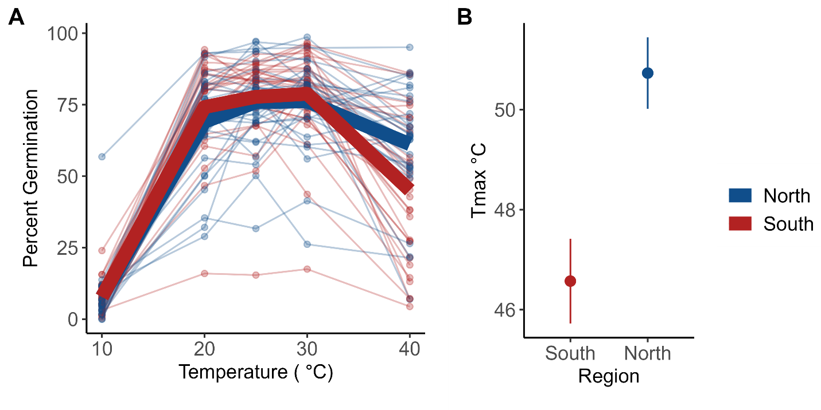

Figure 2. Genet percent germination mean (points) and regional mean (bolded lines) colored by region (A). Mean (±se) Tmax for northern (blue) and southern (red) genets (B). Tmax was the x-intercept of the quadratic fit for each individual at the highest germination temperature predicted. Plants from the northern region germinate at higher temperatures (Tmax: F1,26=12, p =0.002).

*Gametophyte*

Of all genets included in this study, 20 genets from the north flowered and 10 from the south flowered. The number of ramets that flowered for each genet differed, so the total number of plants that flowered were 32 from the north and 29 from the south. There was a significant difference between regions for Tmax (Fig. 1, Table 1) and Topt (Table 1). Plants from the north germinated more readily at high temperatures and had higher thermal optima than plants from the south. There was no significant difference between the two regions for Tmin. One outlier was identified using the Grubbs’ test for outliers and subsequently dropped from the analysis. For pollen tube growth rates, there were no significant differences between plants from the north and south for any of the three variables.

We used correlation analysis to identify relationships between hot and cold tolerance for the sporophytic and gametophytic variables. When all plants were included, there were no significant correlations between the gametophytic and sporophytic variables. However, there were two significant correlation coefficients between gametophytic variables. Maximum and minimum pollen tube growth rates were positively correlated (r = 0.46). The second correlation between maximum pollen tube growth rate and maximum pollen germination was also positive (r = 0.3).

**The effect of long-term moderate heat on reproductive traits**

*Pre-pollination*

We found that long-term moderate heat predicted style + stigma length, anther length, and pollen grain diameter (Table 2, Fig. 3). Flowering time and first flower type (hermaphrodite and male) did not differ between the treatments or region of origin. On average, flowers that developed in the heat treatment had smaller floral structures. Style + stigma length decreased by 14% (F1,281=240, p<0.001) and anther length decreased by 11% (F1,281=183, p<0.001) in long term moderate heat conditions relative to the control. Style + stigma length also differed by region of origin. Plants from Texas on average had 5% longer style + stigma than plants from Minnesota (F1,33=11, p=0.002). While the female gamete trait, ovule number, was not affected by heat, pollen size was reduced by 10% (F1,101=82, p<0.001). Neither trait differed by region. We found significant interactions between treatment and region in style + stigma length (F1,281=6, p=0.015), anther length (F1,281=9, p=0.003), and ovule number (F=7.27, p<0.001; Table 2, Fig. 4).

*Post-pollination*

Pollen development in long-term moderate heat did not affect germination at high temperatures, but similar to the first experiment, germination differed between regions. Fruit set was also not affected by pollination and fertilization in the heat treatment. However, we found that the number of viable seeds was affected by heat (F=-9.202, p<0.001) and on average decreased seed set by 16 seeds (Table 2, Fig. 3). The number of unfertilized ovules increased by 6 in the heat treatment compared to the control (F=2.01, p=0.045) and the number of aborted seeds increased by about 1.64 seeds on average (F=7.25, p<0.001; Fig. 3). We note here that the average number of aborted seeds in the control group was relatively low with an average number of 0.63 seeds. The number of unfertilized ovules did differ by region. There was a significant interaction between the treatment and region for the number of unfertilized ovules (F=8.01, p<0.001) and aborted seeds (F=-3.41, p<0.001; Table 2, Fig. 4).

Table 2. ANOVA results with the fixed effects temperature treatment (control and heat), region of origin (north and south), and the interaction between treatment and region. Genet was included as a random effect (excluded in pollen grain size due to overfitting the model).

|  |  |  |  |  |  |  |  |  |
| --- | --- | --- | --- | --- | --- | --- | --- | --- |
| Variable | Treatment | | | Region | | | Treatment:Region | |
| dF | F(z) | p | dF | F(z) | p | F | p |
| Style + Stigma Length (mm) | **1, 281** | **240.20** | **<0.001** | **1, 33** | **11.15** | **0.002** | **6.00** | **0.015** |
| Anther Length (mm) | **1, 281** | **183.35** | **<0.001** | 1, 33 | 0.40 | 0.530 | **9.29** | **0.003** |
| Ovule Number | **-** | -0.42 | 0.677 | **-** | -0.84 | 0.400 | **7.27** | **<0.001** |
| Pollen Grain Size (μm) * | **1, 100** | **82.27** | **<0.001** | 1, 100 | 0.00 | 0.979 | 0.00 | 0.981 |
| Pollen Germination (40°C) | 1, 75 | 0.05 | 0.826 | **1, 34** | **6.59** | **0.015** | 0.02 | 0.890 |
| Viable Seed | **-** | **-9.202** | **<0.001** | **-** | 1.67 | 0.095 | 0.17 | 0.867 |
| Unfertilized Ovules | **-** | **2.01** | **0.045** | **-** | **-3.92** | **<0.001** | **8.01** | **<0.001** |
| Aborted Seeds | **-** | **7.25** | **<0.001** | **-** | -0.72 | **0.47** | **-3.41** | **<0.001** |

*Model excluded genet random effect to avoid overfitting model. Bolded values: statistically significant (α=0.05).

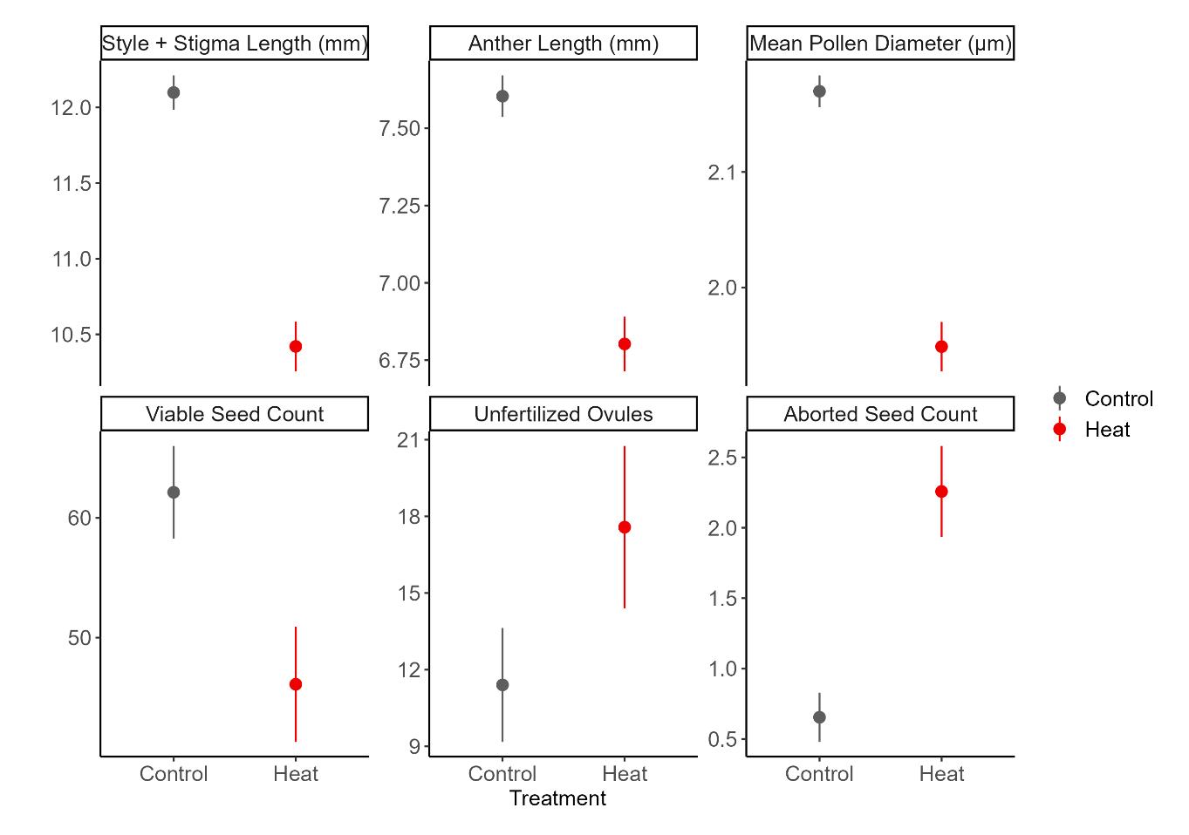

Figure 3. The effects of long-term moderate heat on morphological traits and seed set. Plant development in heat reduced the size of the stigma + style (F1,281=240, p<0.001), anther (F1,281=183, p<0.001), and pollen grains (F1,101=82, p<0.001). Development and fertilization in heat reduced the number of viable seeds per fruit (F=-9.202, p<0.001), unfertilized ovules (F=2.01, p=0.045) and increased the number of aborted seeds (F=7.25, p<0.001).

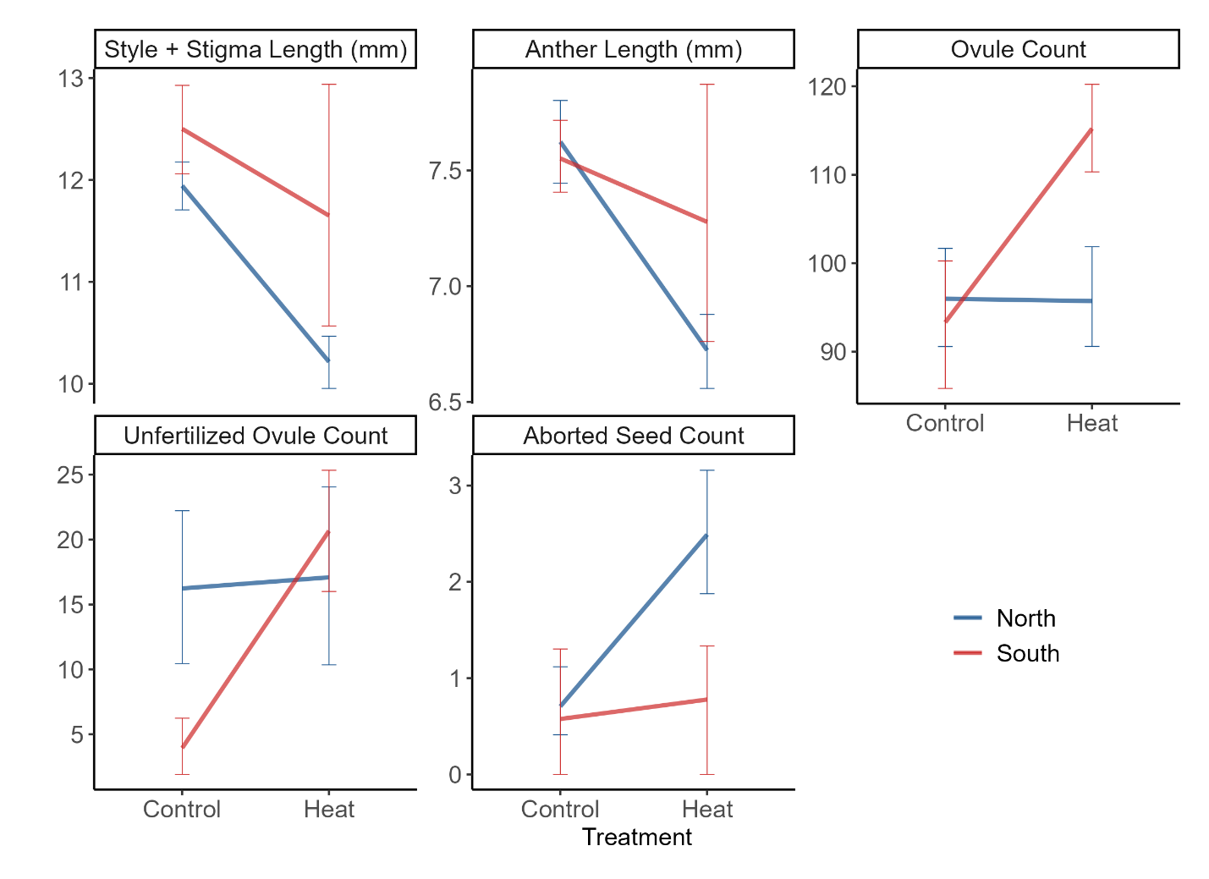

Figure 4. Interactions between treatment and region that were statistically significant.