**Intraspecific variation in responses to extreme and moderate temperature stress in the wild species, *Solanum carolinense* (Solanaceae)**

Abstract

Adaptation or acclimation to local temperature regimes has often been used as a proxy for predicting how plant populations will respond to impending novel conditions driven by human-caused climate change. To understand how plants may successfully respond to increasing air temperatures in the future, we explored how populations of *Solanum carolinense* in northern (MN) and southern (TX) regions of the continental United States differ in temperature tolerance traits in a two-experiment study. In the first experiment, we compared the heat and cold tolerance in vegetative (sporophyte) and reproductive (male gametophyte) traits. In the second experiment, we asked if long-term heat influences plant development by examining how development in moderate heat affected reproductive structures and reproductive success. We found that temperature-sensitivity differed between southern populations that regularly experience extreme heat and northern populations that do not. In contrast to our expectations, northern populations appeared more heat-tolerant than southern populations for vegetative traits such as chlorophyl stability and reproductive traits such as pollen germination and vice versa. Our results are consistent with a heat-avoidance, rather than tolerance, mechanism to mitigate extreme heat during pollen germination. In the second experiment, plants developing under the moderate heat treatment had significantly smaller reproductive structures and reduced seed production (27% fewer seeds on average than in the control treatment). Reproductive structures that developed in moderate heat were also reduced in size, particularly in the northern populations relative to populations from the south. We conclude that rising temperatures have the potential to incur substantial negative consequences to the reproductive success of individuals in this species and that some populations already mitigate stressful temperature conditions as a result of local adaptation and phenotypic plasticty.

**Introduction**

Climate change is rapidly altering environmental conditions at regional and local scales, leading to shifts in temperature regimes, precipitation patterns, and the severity of weather events (Seneviratne et al. 2021). As a result, there is widespread interest in understanding how plants, a mostly sessile taxonomic group, will cope with these rapid changes (Doak and Morris 2010; Molina-Montenegro and Naya 2012; Valladares et al. 2014; Demarche et al. 2018). Plants respond to environmental change by tolerating the new conditions or avoidance through adaptation, shifting phenotypes with sufficient plasticity, or through escape by shifting ranges (Janzen 1967; Molina-Montenegro and Naya 2012; Schlichting 1986).

We can begin to understand the process of adaptation to extreme temperatures by examining how plants have already responded to variable climate conditions across their native range. Because environmental conditions across a species’ range are often heterogeneous, in particular for species with large ranges, selective pressures are likely to differ among populations distant from one another. Divergent selection in two regions can result in differing trait optima in the separate populations through local adaptation (Kawecki and Ebert 2004). In the case of populations from different locations with different climates and thermal patterns, the expectation is that genetic divergence would lead to plants that are better adapted to either warmer or colder extremes regardless of the environment in which you grow them. In this scenario, climate change would result in the evolution of plants that are divergent from plants present before climate change and are better adapted to heat. For example, Franks et al. (xx) found that mustard plants (Brassica rapa) grown from seed collected after years of drought and relatively high temperatures were better adapted to drought and heat than were plants from seed collected prior to the drought and heat, even when they were grown side by side.

Alternatively, plants in populations with different environments may be phenotypically plastic in their response to environmental conditions, resulting in populations with different traits, but little genetic divergence (Stotz et al. 2021, Nicotra et al. 2010). In this scenario, plants from different regions with different climates would nonetheless be equally tolerant of temperature extremes when grown side by side in the same environment. A current area of interest is the extent of which phenotypic plasticity is adaptive or maladaptive in response to climate change (Ghalambor et al. 2007; Nicotra et al. 2010; Dupont et al. 2024). In this study, we explore how tolerant plants are to temperature extremes (both cold and hot), whether there is evidence of genetic divergence among populations from different climate conditions and whether trait patterns are consistent with adaptive expectations.

It is likely that increasing mean, maximum and minimum temperatures associated with climate change will have negative effects on important fitness-related traits in plants. Based on the IPCC Sixth Assessment Report (Seneviratne et al. 2021), temperatures are changing at unprecedented rates. The National Climate Assessment (USGCRP 2018) reported that temperatures in the Midwestern and Southeastern United States have been steadily rising since the 1970’s. Changes to temperature regimes are expected to ultimately lead to temperatures that are above what is currently optimal for plant cellular processes, especially those involved in reproductive success (Sato et al. 2006; Müller et al. 2016; Xu et al. 2017; Jiang et al. 2019). Researchers have experimentally established that development in moderately high temperatures negatively affects floral morphology (Charles and Harris 1972, Sato et al. 2006, Müller et al. 2016, Xu et al. 2016), ovule viability (Xu et al. 2017), pollen viability (Sato et al. 2006, Din, Khan et al. 2015, Müller et al. 2016, Xu et al. 2017, Poudyal et al. 2019), fruit set (Charles and Harris 1972, Sato et al. 2006, Din, Khan et al. 2015), and seed set (Din et al. 2015) in crop species. For many of these studies, heat was detrimental to development and reproduction. For example, Sato et al. (2006) found that elevated temperatures decreased fruit set and pollen viability as well as stamen height in tomato. Poudyal et al. (2019) found that pollen viability decreased in heat, but more tolerant tomato accessions had higher pollen germination than sensitive accessions. Xu et al. (2017) found that long-term moderate heat decreased pollen viability, pollen number, female fertility, and fruit set. Charles and Harris (1972) found that flower production, fruit set, fruit size, pollen germination, and distance between the stigma and antheridial cone all decreased at high temperatures in tomatoes. Lastly, Muller et al. (2016) found that long-term moderate heat resulted in floral deformations and low pollen viability in tomatoes. Researchers have repeatedly shown that heat has negative effects on reproductive traits, but few studies have examined how local adaptation and phenotypic plasticity may play a role in intraspecific variation in response to development in heat. We test the negative effects of heat on floral and reproductive characters to see if responses from genotypes that originate in different climates are consistent with expectations given the temperatures in the region of origin.

While many in this field have established that heat or temperature stress in general is detrimental to vegetative and reproductive traits in domesticated species, the question remains: can plants evolve tolerance or other strategies to mitigate temperature stress quickly enough to track climate change? First, selection for further trait divergence might not occur if species can acclimate to novel temperatures through phenotypic plasticity (Nicotra et al. 2010; Stotz et al. 2021). However, acclimation would require a species to have evolved appropriate levels of phenotypic plasticity and the responses to cues that improve or maintain fitness (Ghalambor et al. 2007; Molina-Montenegro and Naya 2013; Schlichting and Pigliucci 1995). For example, Molina-Montenegro and Naya (2013) found that phenotypic plasticity in response to temperatures increased with latitude to match temperature regimes of the region of origin in *Taraxacum officinale*. In the case that a species cannot acclimate, populations in areas with temperature stress may face extirpation unless they have the potential to migrate to more favorable habitat. Lastly, local conditions introduce the possibility of divergent selection to act on the genetic diversity already within the population. Adaptation would involve a shift in tolerance by evolution of traits that improve the chances of survival or reproduction for individuals in a population experiencing thermal stress. For example, Driedonks et al. (2018) found that wild tomato accessions from populations at low elevation and high annual temperature had high pollen viability under long-term moderate heat, leading the authors to conclude that those populations had locally adapted thermotolerance. Space-for-time substitutions are often used to study local adaptation to region-specific climate conditions as a proxy for how populations in areas of warming may respond to climate change.

To understand how plants will respond to a warming world and test for differences in temperature tolerance between plants from different thermal regimes, we examined how heat and cold stress affected traits across latitudes in a widespread weed, *Solanum carolinense* (Solanaceae). Our hypothesis was that plants from relatively warm environments would be more tolerant to extreme heat and plants from relatively cold environments would be more tolerant of extreme cold. Moreover, tolerance to heat would be negatively correlated with tolerance to cold due to tradeoffs in the mechanisms of thermotolerance.

We present the results of two experimental studies, where we sought to quantify heat and cold tolerance in plants from different latitudes and ultimately inform predictions of plant evolution in a warming environment. The objective of experiment 1 was to determine if there is evidence that local thermal conditions have divergently selected for temperature tolerance traits between northern and southern latitudes by measuring the tolerance of plants to heat and cold extremes when grown in a common environment. The objective of experiment 2 was to test for differences in tolerance specifically to heat by measuring developmental limitations when grown in hot environments.

We hypothesized that southern populations of *S. carolinense* evolved greater heat tolerance , relative to northern populations, because heat extremes in the south select for thermotolerance. Conversely, we expected the opposite for plants from more northern populations – higher tolerance to extreme cold and lower tolerance to heat stress in general. As a result, we expected northern plants would be less tolerant of heat when exposed to acute extremes of temperature (Experiment 1) and when grown in relatively high temperatures over a sustained period of time (Experiment 2).

Methods

*Solanum carolinense* L. (Solanaceae), also known as horsenettle, is a weedy, andromonoecious, perennial that originated in southeastern North America. As the genus suggests, *S. carolinense* is closely related to eggplant, tomatoes, and other common crops in *Solanum*. All other species in the Carolinense clade are neotropical, suggesting that this species likely arose through dispersal to North America and independent diversification (Wahlert et a. 2014). Once established in the southeast, *S. carolinense* utilized its natural adaptability and propensity to reproduce both sexually and asexually to expand its range north- and west-ward into colder and hotter environments (Figure 1).

Figure 1. Map of the distribution of *Solanum carolinense* (EDDMapS 2022; grey dots), northern (blue dots) and southern regions (red dots), and populations of origin for plants in this study. The populations Frontenac (top blow-up, blue) and Prairie Island (top blow-up, purple) were in the northern region and the populations Cemetery (bottom blow-up, red), Oil Patch (bottom blow-up, orange), and Reserve (bottom blow-up, green) were located in the southern region.

We collected *Solanum carolinense* plants from two populations in Minnesota and three populations in Texas between October 2019 and August 2020 (Figure 1). The Minnesota plants collectively will be referred to as the northern plants and include the populations Prairie Island (44.07959 N, -91.684545 W) and Frontenac (44.523056 N, -92.338611 W). Approximately 80 Km separated the two populations (Figure 1). In Houston County, MN where these plants were collected, the daily temperatures vary from a low of -34°C to a high of 38°C over the course of the year. The Texas plants together will be referred to as the southern plants. All three Texas populations were located within a circle with a 1.5 Km radius near McKinney TX (Oil Patch: 33.173465 N, -96.615402 W; Reserve: 33.159962 N, -96.619011 W; and Cemetery: 33.173672 N, -96.615096 W). In Colin County TX, where these plants were collected, the daily temperatures vary from a low of -10°C to a high of 45°C over the course of the year (Supporting Information Fig S1).

We harvested plants by removing rhizomes of at least 10 cm from mature plants in the field and placing them in ziplock bags. Southern and northern rhizomes were collected on October 25, 2019 and October 28, 2019 respectively. We assumed that each rhizome represented a unique genotype (genet) because we maintained an interval of at least 1 meter between collections. Other studies have assumed unique genotypes are found 1-2 m apart ( Wise et al. 2008; Elle 1999). The sample size was 42 genets from the north and 26 genets from the south.

The field-collected rhizomes were shipped to Fargo, ND, and stored in a 4°C refrigerator prior to a growth and dormancy period to establish an experimental population. After one week, the rhizomes were potted in 3.8 L containers with a ProMix BX standard potting mix and again stored in the 4°C refrigerator. After eight weeks plants were placed in the greenhouse allowing above and belowground material to grow for six months. The above ground material was then cut, and the pots were again stored in a 4°C refrigerator to induce a period of dormancy.

After the dormancy period (3 months), equal sections of rhizome (at least 2 cm for thick rhizomes and increased lengths for thinner rhizomes) were cut into four equal-sized pieces. These were ultimately used to grow genetically identical plants (ramets) from each genet at different times (temporal blocks A, B, C and D; Figure 2) because of a lack of sufficient space to grow them all at once. All ramets in block A were planted over the course of five weeks (10-12 plants per week) prior to the planting of the ramets in block B and so on. Of the ramets planted each week, half were from the southern region and half were from the northern region. Since we had a total of 26 genets from the south, we randomly selected 26 of the 42 genets from the northern populations using a random number generator. We tested a total of 26 genets from the northern and southern regions, with four ramets of each for a total of 208 plants. Each northern plant was paired with a southern plant spatially on the greenhouse benches. The rhizome pieces were originally placed in 3.8 cm diameter cone-shaped containers in the greenhouse. The plants were fertilized every other week with 10-10-10 fertilizer and transplanted to larger, 4.5 L containers when they outgrew the small cone-shaped containers.

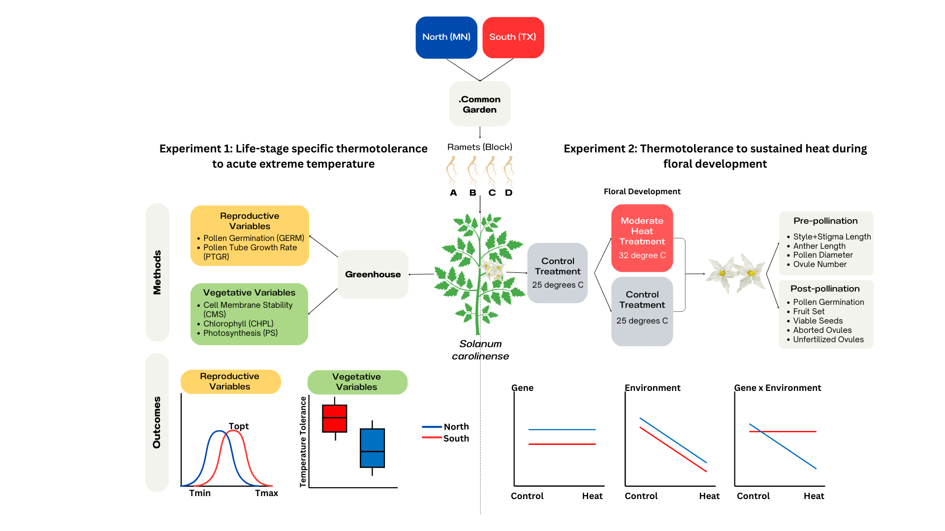

Figure 2. Conceptual diagram of methods and potential outcomes for Experiment 1 and Experiment 2.

**Experiment 1: Life-stage specific thermotolerance to acute extreme temperature**

We grew plants from the north and south in a common garden to remove environmental effects and tested for differences tolerance to acute exposure to extreme temperatures. Thermotolerant plants are expected to better survive maximum temperatures that could potentially damage plant tissues despite the short-term exposure to those temperatures. To assess the temperature tolerance limits on plants, we measured three vegetative variables (cell membrane stability (CMS), chlorophyll content (CHPL), and net photosynthetic rate (PS)) and two reproductive variables (the propensity for pollen grains to germinate (GERM) and the growth rate of pollen tubes (PTGR; Figure 2). We measured each variable on each plant for two temperature treatments always relative to a control treatment: hot treatment (acronym preceded by “H”) and extreme cold treatment (acronym preceded by “C”). We used standardized protocols for establishing thermotolerance in plants (Gajanayake et al. 2011, Fang and To 2016) whereby plants are exposed to extreme temperatures. The temperatures were chosen,not to mimic the natural environment, but rather to represent intermediate temperatures that do not completely destroy plant tissues and instead allow a comparison between more tolerant and less tolerant individuals. .

Vegetative temperature tolerance variables

CMS was calculated according to the widely used protocols from Gajanayake et al. (2011) and Fang and To (2016). Ion leakage from leaf material exposed to either heat (55°C water bath for ten minutes) or cold (-18°C) was measured using an electrical conductivity probe and compared to the conductivity of leaf material in control (27°C) and maximum damage (98°C) treatments. The heat treatment (55°C) used was based on the protocol from Fang and To (2016). The cold treatment (-18°C) was selected based on the standard methods used in Mishra et al. (2011), Difference in chlorophyll content of leaves was estimated, as in Gitelson et al., (1998) for material exposed to either a hot temperature treatment (60°C for 1 hr) or a cold temperature treatment (4°C for 1 hr followed by -18°C for 1 hr) using a chlorophyll meter (Opti-Sciences CCM-300). The chlorophyll meter measures the fluorescence emitted at 735nm/700nm for a constant leaf area. Chlorophyll content before and after treatments was used to estimate the difference in chlorophyll content in mg/m2. The heat treatment was selected based on PS was a measure of the effects of temperature treatments on the photosynthetic capabilities of leaves. PS was estimated as the ratio of net photosynthetic rates before and after a temperature treatment (HPS: 33°C, CPS: 10°C for 48 hrs) based on leaf measurements made with a Licor. Temperature treatments were based on standard values used in thermotolerance studies (e.g., Sherzod et al. 2019, Xu et al. 2014, Zhu et al. 2018, Poudyal et al. 2019) and the temperature limits of the environmental chambers used for this study.

Reproductive temperature tolerance variables

We focused on two pollen traits as reproductive variables for estimates of male thermotolerance during the reproductive stage: 1) the propensity for pollen grains to germinate (GERM) and 2) the growth rate of pollen tubes while exposed to a range of temperatures (PTGR). We paired measurements of pollen traits from plants in the north and south by sampling mature anthers of plants flowering simultaneously. Pollen germination at extreme temperatures was measured following a protocol from Kakani et al. (2002). Pollen from one flower per plant was dispersed over five petri dishes containing the mixture described in Reddy and Kakani (2007; 3% Bacto-Agar based growth medium (sucrose, Ca(NO3)2, MgSO4, KNO3, H3BO3)). The dusted plates were each placed at one of the five temperature treatments (10°C, 20°C, 25°C, 30°C, 40°C) for 16 hours. Temperature treatments were selected based on the protocol used in previous studies (Fang and To 2016, Singh et al. 2008, Reddy and Kakani 2007, Kakani et al. 2002). Four pictures of each plate were taken using a compound microscope (Leica DM500 microscope, Leica ICC50 HD camera) and the LAS EZ 2.1.0 software. We measured pollen germination (Germ) for each plate by counting the number of pollen grains per image that had produced pollen tubes and dividing that count by the total number of pollen grains observed. Pollen tube growth rate (PTGR) was calculated by dividing the length of the 20 longest pollen tubes measured using ImageJ (Schneider et al. 2012) by the time allowed for growth (16 hours). Detailed methods provided in the Supporting Information. Each experimental plant was cut back to soil level and rhizomes were stored at 4°C for 3-9 months.

**Experiment 2: Thermotolerance to sustained heat during floral development**

In contrast to experiment 1, in experiment 2 we tested for differences in thermotolerance between northern and southern plants by measuring their developmental response to heat sustained over a longer period of time. The rationale for this experimental design is that the vulnerability of plants to relatively high temperatures may be more nuanced than complete tissue or cellular breakdown (as tested in Experiment 1). Instead, a thermotolerant plant may be one that can continue to develop normal tissues (e.g. flowers) over a sustained period when exposed to high temperatures.

After Experiment 1, we removed the aboveground portions of each plant and stored them at 4° C for a final dormancy period of 3-9 months (depending on Experiment 1 temporal blocking). Two ramets of all 26 genets from the north and south were placed in a randomized grid pattern in a growth chamber (Conviron PGC-FLEX). Due to space constraints in the environmental chambers, only A and B ramets were grown initially. Ramets C and D were placed in the chambers six months later. For initial growth, all plants were exposed to “control” conditions (25°C day/25°C night; fluorescent and incandescent lighting for 14 hours per day. Plants were fertilized once every two weeks with a high phosphorus fertilizer (12-55-6) to promote flower production (Super Bloom, Scotts).

Upon flowering, two ramets per genet were randomly assigned to the control conditions (25°C day/25°C night; 14hr/10hr) and the other two to the heat treatment conditions (32°C day/25°C night; 14hr/10hr; Figure 2). By necessity, these were in different Conviron chamber models (control: Conviron PGC-FLEX; heat treatment: Conviron E7/2). Plants were watered daily. Subsequent flowers and fruits developed at either elevated temperatures (32°C) or control temperatures (25°C). The moderate heat treatment of 32°C was selected based on the temperatures used in previous studies with moderate heat treatments in tomatoes and to mimic temperatures in the warmer end of the range that populations of this species might encounter (Sato, Kamiyama et al. 2006, Müller et al. 2016, Xu et al. 2017). The control treatment of 25°C is halfway between the average daily temperatures for MN (22°C) and TX (29°C.

Pre-Pollination Phase Variables

The first three hermaphroditic flowers per plant that developed in the respective treatments were collected in ethanol and used for flower morphology measurements, ovule counts, and pollen size measurements. Floral morphology traits (length of the style+stigma and one anther) were measured under a dissecting scope. The number of ovules in each ovary was counted following a modified staining protocol adapted from Diaz and Macnair (1999). Pollen diameters of approximately 100 grains for one flower per genet were measured with the use of a microscope (Axio Scope A.1 Carl Zeiss, Germany) at 400x total magnification and the circle diameter measurement tool on the Zen 3.1 software.

Post-Pollination Phase Variables

We pollinated three additional hermaphrodite flowers and collected the pollen of one more flower to measure subsequent female and male reproductive traits. Mature flowers were pollinated with a mix of pollen from 2 to 5 flowers (depending on the number of plants flowering at the time) that developed in the control conditions, with at least one flower from a southern plant and one flower from a northern plant represented in the pollen mix. Pollinations were accomplished by applying a mixture of pollen on the stigma with a dissection probe. Each pollinated flower was labelled with a jewelry tag. After pollination, the plants remained in their respective treatments for one week before we moved them into a greenhouse for the remainder of fruit maturation (Average Daily Temperatures 25.1°C day / 21.3°C night). Once fruits were ripe (at least one month old), they were harvested. We measured fruit set (number of fruits produced / three flowers pollinated) and the seed set. The number of viable seeds, aborted seeds, and unfertilized ovules were counted under a dissecting scope. Seeds that were visibly flat were considered aborded. Small black or brown spots visible under a dissecting microscope were considered unfertilized ovules.

In-vitro pollen germination at 40°C was used as a proxy for male reproductive success in high temperatures. We used 40°C to distinguish between thermotolerant and non-thermotolerant genotypes. As described in experiment 1, pollen from each plant was dispersed over a petri dish containing 3% Bacto-Agar based growth medium (sucrose, Ca(NO3)2, MgSO4, KNO3, H3BO3)and incubated at 40°C for 16 hours. Four pictures of each plate were taken using a compound microscope (Leica DM500 microscope, Leica ICC50 HD camera) and the LAS EZ 2.1.0 software. We measured pollen germination (Germ) for each plate by counting the number of pollen grains per image that had produced pollen tubes and dividing that by the total number of pollen grains observed.

We grew plants from the north and south in a common garden to remove environmental effects and tested for differences in temperature tolerance limits and responses to a heat treatment during floral development. Altogether, we examined how the development of reproductive structures in heat affect the pre-pollination morphology including the length of style, stigma, and anthers, the number of ovules, and the size of pollen grains and post-pollination processes including fruit set, seed set, seed condition, and pollen germination rates.

Data Analysis

Experiment 1: Life-stage specific responses to extreme temperature

To analyze differences in vegetative traits between plant origins and among genets, we fit linear mixed effects models using the lmer function from the *lme4* package (Kuznetsova et al. 2017). Region (north vs. south) was considered the fixed effect and the temporal block (A, B, C, D) and genet were random intercepts. Since there was a significant block effect in some of the variables, we compared plants from the north and south within blocks using a paired t-test (function t.test).

For the reproductive variables (GERM, PTGR), we fit quadratic temperature performance curves, determined using model selection (Supporting Information Fig. S2), to the multiple temperature measurements taken for each plant that flowered using the nls.multstart function in the *rTPC* package (Padfield and O'Sullivan 2021). From the quadratic curves of each plant that flowered, we extracted three key values for both pollen germination and pollen tube growth rate: the temperature minimum, temperature optimum, and temperature maximum. We then used the key values in an analysis of variance (function aov) to determine if the response curves differed between regions. One outlier was identified using the Grubbs’ test for outliers, grubbs.test function in the *outliers* package (Komsta 2011), and subsequently dropped from the analysis.

We used Pearson’s method for correlation analysis (function cor) to identify associations between vegetative and reproductive variables. The Holm-Bonferroni method (function p.adjust) was used to adjust p-values to account for multiple correlations (Holm 1979). All data were analyzed in R 4.1.2 (R Core Team 2020).

Experiment 2: The effect of heat during development on reproductive traits

All pre and post pollination traits were analyzed with mixed effects models using the *lme4* package (Bates et al. 2015). The general structure for the models was region, treatment, the interaction of region and treatment, and temporal block (January vs June) as fixed effects and genet as the random intercept. The nuances of each individual model are described below. We used general linear mixed effects models (*lme4*; function lmer) for anther and style+stigma length. Since we collected data for the mean pollen diameter of one flower per block per genet and several genets only had one ramet (block) that flowered, we omitted genet as a random effect to avoid overfitting the data and used a general linear model (function lm). We used generalized mixed effects models (*lme4*; function glmer) with a Poisson distribution for all count data, which included counts of ovules, viable seeds, unfertilized ovules, and aborted seeds. We tested for overdispersion using the *DHARMa* package (Hartig and Lohse 2022). Since data of pollen germination at 40°C were proportions, we used a generalized linear model (function glm) with a binomial distribution for analysis. Since the model including genet as a random effect overfit the pollen germination data, we decided to drop genet. To examine significant interactions between region and treatment, we did a post-hoc analysis using the *emmeans* package (Lenth 2023; function emmeans).We conducted correlation analysis for mean anther and mean style+stigma lengths (function cor.test).The fruit set was analyzed using a chi-squared test (function chisq.test).

Results

**Experiment 1: Life-stage specific thermotolerance to acute extreme temperature**

Vegetative traits

Of the six vegetative traits measured in this experiment, two differed between regions. In extreme heat (HCHPL) and cold (CCHPL), northern plants retained chlorophyll content more effectively than southern plants (Table 1, Supporting Information Fig. S3). The chlorophyll content of northern plants was 8% and 19% higher than southern plants for the heat and cold treatments respectively. There was no significant difference between regions for cell membrane stability in extreme heat and cold (Table 1). However, there was a significant block effect for both CCMS (Likelihood Ratio = 15.731, p <0.001 ) and HCMS (Likelihood Ratio = 4.728, p = 0.030; Supporting Information Table S1). Southern plants had higher CCMS than northern plants in blocks B (t = 2.190, p = 0.040) and C (t = 2.073, p = 0.049), but generally CCMS decreased in all plants, regardless of region, with later Blocks (Supporting Information Fig. S4). Northern plants had a higher HCMS than southern plants (t = -2.910, p = 0.015) in block A, but this difference degraded in the later blocks (Supporting Information Fig. S4 and Table S3). Finally, there were no regional or block effects on photosynthetic rate in response to either cold or heat.

Table 1. Vegetative and reproductive temperature tolerance results from mixed effects linear models with the fixed effect region (north vs south) and the random effects genet and block (omitted for reproductive). Due to overfitting the model, genet was included as a fixed effect for CCMS, HPS, and Tmin PTGR. Statistics included in the table include the degrees of freedom (dF), F statistic (F), and p-value (p). Random effect statistical values reported in the Supporting Information (Table S1), as well as results from a mixed model using only control values (Supporting Information Table S3).

|  |  |  |  |  |  |  |
| --- | --- | --- | --- | --- | --- | --- |
| Variable | | Region | | | | |
| Expected | Observed | dF | F | p |
| Vegetative | Cell Membrane Stability (Heat) | S > N | - | 1, 50 | 3.673 | 0.0610 |
| Cell Membrane Stability (Cold) | N > S | S > N | 1, 50 | 0.057 | 0.811 |
| Chlorophyll Content (Heat) | S > N | N > S | **1, 51** | **4.418** | **0.041** |
| Chlorophyll Content (Cold) | N > S | N > S | **1, 50** | **66.369** | **<0.001** |
| Photosynthetic Rate (Heat) | S > N | - | 1, 49 | 2.940 | 0.090 |
| Photosynthetic Rate (Cold) | N > S | - | 1, 47 | 3.269 | 0.077 |
| Reproductive | Pollen Germination (Tmax) | S > N | N > S | **1, 26** | **12.054** | **0.002** |
| Pollen Germination (Topt) | S > N | N > S | **1, 24** | **10.916** | **0.003** |
| Pollen Germination (Tmin)* | S > N | - | 1, 21 | 0.151 | 0.702 |
| Pollen Tube Growth Rate (Tmax) | S > N | - | 1, 29 | 0.446 | 0.509 |
| Pollen Tube Growth Rate (Topt) | S > N | - | 1, 29 | 0.121 | 0.731 |
| Pollen Tube Growth Rate (Tmin) | S > N | - | 1, 31 | 0.171 | 0.682 |

* Outlier removed. Bolded values: statistically significant (α=0.05).

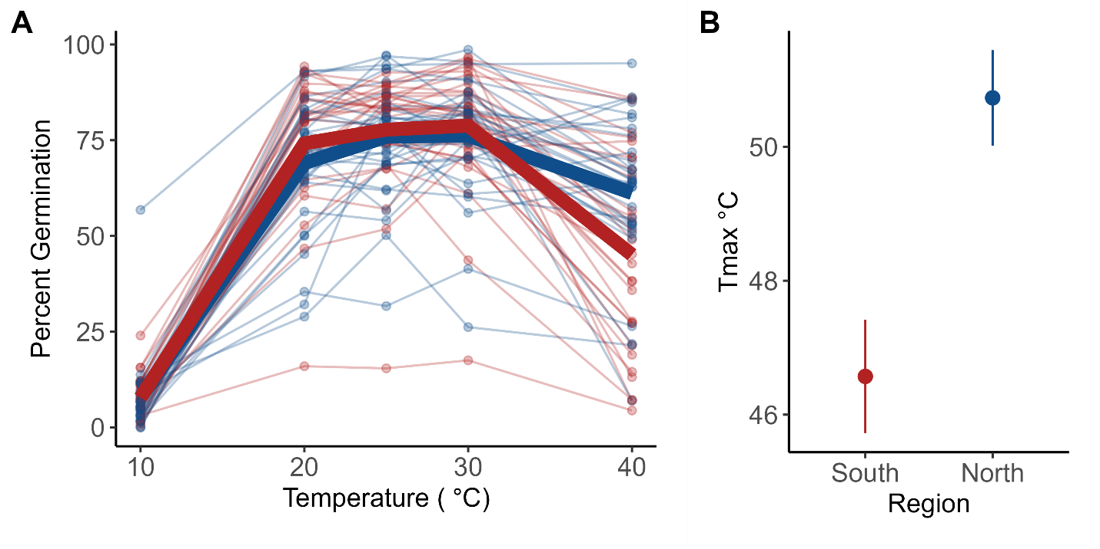

Figure 3. Pollen germination results from Experiment 2. (A) Percent pollen germination per genet (points) and regional mean (bolded lines: blue=northern, red=southern) . (B) Mean (±se) Tmax for northern (blue) and southern (red) genets. Tmax is the upper x-intercept of the quadratic fit for temperature performance curves for each individual (i.e., the highest temperature predicted with pollen germination).

Reproductive traits

There was a significant difference between regions for Tmax (Figure 3, Table 1) and Topt (Table 1) in pollen germination. Pollen from plants from the north were more likely to germinate at high temperatures (Tmax) and had higher thermal optima (Topt) than pollen from plants from the south. There was no significant difference between the two regions for Tmin. One outlier was identified using the Grubbs’ test for outliers and subsequently dropped from the analysis. There were no significant differences in pollen tube growth rate between plants from the north and south for Tmax, Topt or Tmin.

Vegetative and Reproductive Tolerance correlations

After a Holm-Bonferroni correction for multiple correlations, there were no significant correlations between the vegetative variables and any reproductive and vegetative variables. However, there were two significant correlation coefficients between reproductive variables (Supporting Information Fig. S5 and Table S4). Tmax and Tmin of pollen tube growth rates were positively correlated (r = 0.46). There was also a significant correlation between Tmax for pollen tube growth rate and for pollen germination (r = 0.3).

**Experiment 2: Thermotolerance to sustained heat during floral development** Pre-pollination

We found that long-term moderate heat negatively impacted style+stigma length, anther length, pollen grain diameter, and ovule number (Table 2, Supporting Information Fig. S5). On average, flowers that developed in the heat treatment had smaller floral structures. Style+stigma length decreased by 14% and anther length decreased by 12% in long term moderate heat conditions relative to the control (Table 2). Style+stigma length also differed by region of origin. Plants from Texas on average had 4% longer style+stigma than plants from Minnesota (Table 2). The relationship between anther length and style+stigma length changed with development in heat (Figure 4). Mean anther length and style+stigma length were correlated in the control treatment, but not in the heat treatment (Supporting Information Fig. S5). Development in heat increased the average number of ovules by approximately 1 ovule and reduced pollen size by 10%. Neither ovule count nor pollen size differed by region. We found significant interactions between treatment and region in style+stigma length, anther length, and ovule number (Table 2; Figure 5).

Post-pollination

Pollen development in long-term moderate heat did not affect germination at high temperatures and germination did not differ between regions (Table 2; Supporting Information Fig. S6). Fruit set was also not affected by the heat treatment. The number of viable seeds was affected by heat (Table 2; Supporting Information Fig. S6) and on average heat decreased seed set by 16 seeds. The number of unfertilized ovules increased by six in the heat treatment compared to the control and the number of aborted seeds increased by about 1.64 seeds on average (Table 2; Supporting Information Fig. S6). We note here that the average number of aborted seeds in the control group was relatively low with an average number of 0.63 seeds. The number of unfertilized ovules did differ by region. There was a significant interaction between the treatment and region for the number of unfertilized ovules and aborted seeds (Table 2; Figure 5).

Post-hoc comparisons of all significant interactions revealed that comparisons of the heat and control treatments were generally statistically significant (Table 3). In comparisons between control and heat treatments for northern plants, all except the interaction for ovule number were significant. Similarly, comparisons for the heat and control treatments for plants from the south were significant for all variables except aborted seeds. In the control treatment, northern and southern plants did not differ for any of the variables. In the heat treatment, northern and southern plants differed for style+stigma length and aborted seeds (Table 3). The comparisons of plants from the north in heat vs. south in the control were statistically significant for all variables except ovule number. Ovule number only varied for the two treatment groups in southern plants (Table 3; Figure 5).

Table 2. ANOVA results with the fixed effects temperature treatment (control and heat), region of origin (north and south), the interaction between treatment and region, and temporal block (January and June). Genet was included as a random effect (excluded in pollen grain size and pollen germination at 40°C due to overfitting the model). Results of temporal blocking in Supporting Information Table S5.

|  |  |  |  |  |  |  |  |
| --- | --- | --- | --- | --- | --- | --- | --- |
| Variable | Treatment | | | Region | | Treatment:Region | |
| dF | Χ2 | p | Χ2 | p | Χ2 | p |
| Style + Stigma Length (mm) | 1 | **242.98** | **<0.001** | **3.86** | **0.049** | **7.42** | **0.006** |
| Anther Length (mm) | 1 | **196.12** | **<0.001** | 0.32 | 0.573 | **6.99** | **0.008** |
| Ovule Number | 1 | **10.22** | **0.001** | 0.07 | 0.787 | **38.81** | **<0.001** |
| Pollen Grain Size (μm) * | 1,100 | **F=86.00** | **<0.001** | 0.01 | 0.923 | 0.16 | 0.691 |
| Pollen Germination (40°C) | 1 | 0.00 | 0.968 | 0.307 | 0.579 | 0.00 | 0.997 |
| Viable Seed | 1 | **164.44** | **<0.001** | 3.32 | 0.068 | 0.01 | 0.908 |
| Unfertilized Ovules | 1 | **88.88** | **<0.001** | **5.63** | **0.018** | **56.21** | **<0.001** |
| Aborted Seeds | 1 | **23.59** | **<0.001** | 1.39 | 0.239 | **11.41** | **<0.001** |

*Model excluded genet random effect to avoid overfitting model. Bolded values: statistically significant (α=0.05).

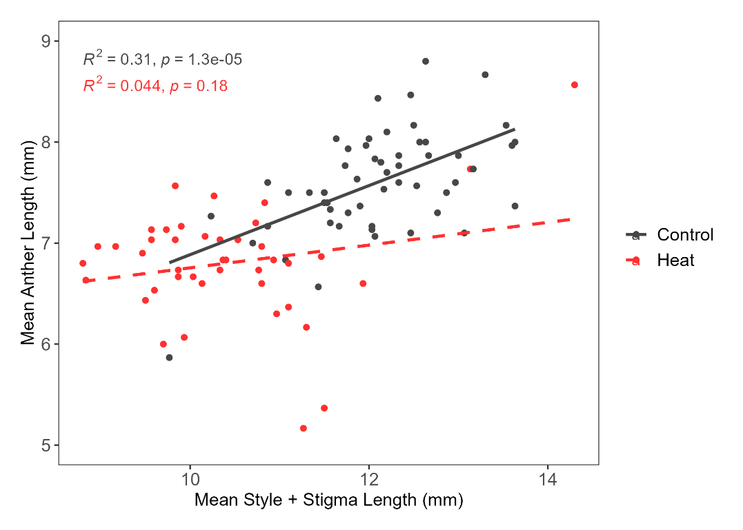

Figure 4. Correlation of Anther and Style+Stigma length averaged across genets in Experiment 1. Control shown in dark grey and heat treatment in red.

Table 3. P-values for post-hoc comparisons for significant interactions of treatment and region. The control and heat treatments are denoted with C and H respectively. The letters N and S indicate plants from the north and south respectively.

|  |  |  |  |  |  |  |
| --- | --- | --- | --- | --- | --- | --- |
| **Variables** | **CN-HN** | **CN-CS** | **CN-HS** | **HN-CS** | **HN-HS** | **CS-HS** |
| **Style+Stigma Length** | **p<0.0001** | 0.2051 | 0.3654 | **p<0.0001** | **0.0011** | **0.0011** |
| **Anther Length** | **p<0.0001** | 0.9987 | **0.0310** | **p<0.0001** | 0.2143 | **0.0011** |
| **Ovule Number** | 1.0000 | 0.9116 | 0.1013 | 0.9162 | 0.1011 | **p<0.0001** |
| **Unfertilized Ovules** | **<0.0001** | 0.0019 | **0.0414** | **<0.0001** | 0.3308 | **<0.0001** |
| **Aborted Seeds** | **<0.0001** | 0.8880 | 0.2634 | **0.0006** | **0.0029** | 0.3351 |

Bolded values: statistically significant (α=0.05).

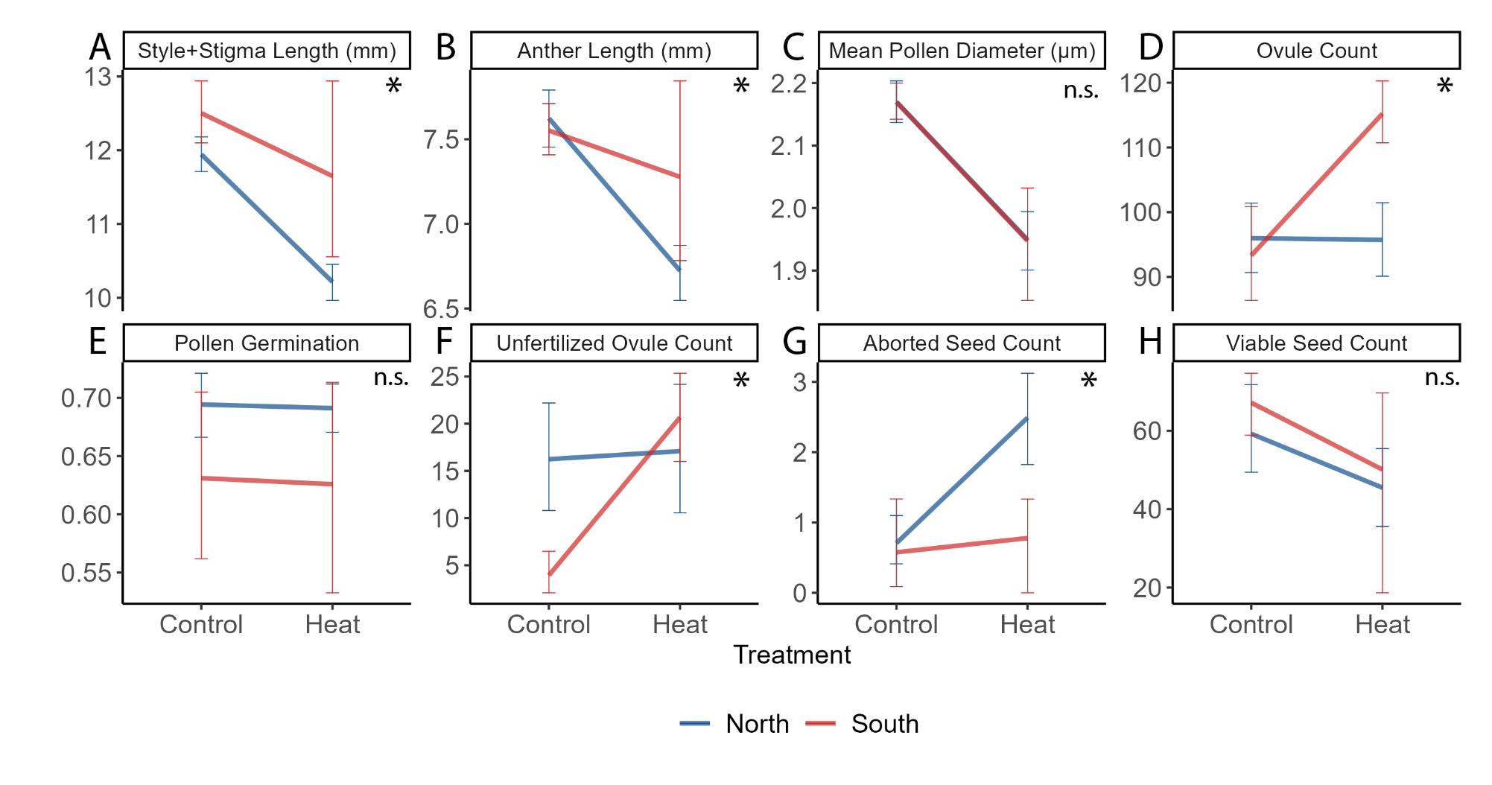

Figure 5. Interactions in Experiment 2 between heat treatment (heat and control) and region (North; blue and South; red). Error bars indicate the standard error and asterisk indicate at least one significant interaction.

Discussion

Regional differences

We found evidence that regional differences in *Solanum carolinense* have evolved over time based on the divergent patterns of tolerance to extreme temperatures between northern and southern plants observed in Experiment 1 (Table 1). Contrary to our expectations, we found that in multiple life stages, northern plants were more tolerant of extreme heat than are southern plants and southern plants were more tolerant of cold in terms of membrane stability. Typically, heat tolerance is measured by exposing plant material to heat and quantifying cell membrane stability and chloroplast integrity under high relative to control levels of heat (Murty and Majumder 1962; Martineau et al. 1979; Gajanayake et al. 2011; Fang and To 2016). In Experiment 1, we found northern plants had higher chlorophyll content (HCHPL) and baseline cell membrane stability (HCMS) under hot conditions, as well as lower membrane stability under cold conditions within blocks in comparison to southern plants (Supporting Information Fig. S4). There was a significant block effect for CMS in both the heat and cold treatment. The block effect on CMS may be due to the capacity of *S. carolinense* to induce temperature tolerance and acclimate to environmental conditions (Clarke et al. 2004). Temperatures in the greenhouse progressively rose throughout the spring and summer (Supporting Information Fig. S7), potentially inducing heat tolerance and pre-conditioning out plants for the temperature manipulations.

Plants from the north had more stable chlorophyll content in both the hot (HCHPL) and cold treatments (CCHPL; Table 1). The capacity of chloroplasts in northern plants to outperform southern plants in both extreme cold and heat might be due to northern plants experiencing a larger range of temperatures and broad adaptation to stress in general. Between 2018 and 2021, temperatures during the growing season (March to September) in Houston County, MN ranged from -28°C to 34°C (62°C difference), while in Collin County, TX they ranged from -7°C to 42°C (49°C difference). If responses in tolerance to extreme cold in the north, where wintering rhizomes remain in frozen ground for months, yields general physiological tolerance to any temperature extremes, then northern plants should be more tolerant than southern plants. Instead, we found that chloroplasts seem to be more tolerant in the north but not cell membranes. Heat shock proteins, that play an important role in maintaining tolerance to heat in plant cells (Feder and Hofmann 1999; Frank et al. 2009; Heckathorn et al. 1998), can also confer tolerance to cold by stabilizing protein configurations and functions in cells at stressful temperatures (Neta-Sharir et al. 2005). Therefore, selection for extreme temperature tolerance may be more common in northern latitudes. Northern plants will suffer severe fitness consequences if they do not maximize growth and reproduction during the relatively short growing season (Supporting Information Fig. S1), whereas southern plants can avoid growing and reproducing during the hottest portions of summer and still have months of mild temperatures available. Our results suggest that increased thermal tolerance applies to chloroplasts in the north but not to cell membranes.

The results from reproductive trait comparisons also countered our expectations for the direction of temperature tolerance. Pollen from the north had a higher propensity to produce pollen tubes (Germ) at high temperatures than their southern counterparts (Table 1, Figure 3). One possible explanation for these results is that there is an avoidance strategy in southern populations where maximum summer temperatures can reach over 38°C consistently. Under these conditions, there could well be a selective advantage to pollen remaining dormant rather than germinating at high temperatures. In contrast, there may be no selection for dormancy at relatively high temperatures in the north. This explanation is supported by a theory regarding pollen dormancy developed in Rutley et al. (2022). They proposed the “two baskets model” categorizing pollen and stating that there are active (high-ROS) and backup (low-ROS) subpopulations of pollen within anthers of flowering species. Active pollen readily germinates and has fast metabolisms, increasing pollen tube growth rates, and typically outcompete the smaller, partially dehydrated backup pollen with low metabolisms. The two subpopulations of pollen are adaptive under different conditions. In stressful environments, such as extreme heat or drought, asynchrony in pollen germination permits some pollen to remain dormant and grow pollen tubes later in more favorable conditions. In favorable conditions, active pollen tubes grow faster and are more likely to fertilize ovules than backup pollen. While the two-pollen system has not been established in *Solanum carolinense*, there have been studies demonstrating these two pollen types in *Solanum lycopersicum*, tomato (Jegadeesan et al. 2018; Keller and Simm 2018; Luria et al. 2019).

Despite the fact that all of the plants used in our experiments were the same species and were grown in approximately the same conditions, there were significant differences between the responses to development in heat among plants from northern versus southern latitudes (Figure 5). Reductions in the length of female and male floral structures were significantly more pronounced in plants from northern populations relative to southern populations (Table 2 – treatment x region effects, Figure 5). These patterns and the increase in ovule counts suggest that southern plants maintain allocations of energy to floral structures despite the heat stress. In contrast, northern plants may reduce their energy allocation to floral structures as an alternative strategy for tolerating heat stress. These differences are consistent with long-term local adaptation of plants to the thermal patterns and environments in the two different places (MN and TX).

Another key difference between northern and southern plants was how heat, during pollination and fruit development, influenced the number of aborted and unfertilized ovules. The reduced efficiency of fertilization in southern plants when exposed to heat may be the result of two separate phenomena. First, in heat, southern plants produced more ovules and generally had longer styles than northern plants. The increased number of unfertilized ovules may be a result of southern plants producing a larger number of ovules during development and the inability of a full pollen load to fertilize the excess ovules. Second, prolonged heat exposure and termination of pollen tube growth in the longer styles of flowers on southern plants could also contribute to the number of ovules that went unfertilized in heat. Both of the above phenomena and the generally low seed abortion rate suggest that pollen performance is the factor limiting fertilization and production of viable seeds in the heat treatment. We cannot ignore that interactions between the maternal genotypes and paternal genotypes from the northern and southern region due to pollen mixing may also contribute to fruit characteristics and responses to heat in our experiment.

A similar result to ours was attained by Jiang (2019), who found, in peas, that ovules maintained viability in heat stress, but pollen viability decreased. Indeed, pollen germination has been shown to be negatively affected by heat in many studies (Sato et al. 2006; Müller et al. 2016; Xu et al. 2017; Jiang et al. 2019; Poudyal et al. 2019). In Experiment 2, we found no evidence that pollen development in heat reduces pollen germination (Table 1), but in Experiment 1, we established that heat generally reduces pollen germination for pollen from northern and to a greater extent southern plants.

Predictions about how species will be affected by climate change can be improved with a better understanding of how different populations of the same species differ in their responses to heat now but at different latitudes with different thermal patterns. The future climate experienced by plants in Minnesota is predicted to more closely resemble that experienced by plants in Texas now and in the past including both higher average temperatures in summer months and higher maximum daily temperatures (IPCC 2014). Growing seasons are already getting longer in northern populations (Badh et al. 2009; Dunnell and Travers 2011). Given the responses to heat by plants in our experiments in the form of relatively moderate heat (32°C) during floral development, pollen tube growth and fruit maturation and extreme heat (40-60°C) in acute doses, we suggest that plants in the two regions we studied have evolved some differences that represent differing strategies for surviving thermal stress. There is little evidence that southern plants have evolved greater cellular tolerances to extreme heat despite growing in an environment that can have daily maximum temperatures above 40.5° C. The stability of chloroplasts and pollen germination capabilities were reduced after exposure to extreme heat in southern relative to northern plants (Table 1, Supporting Information Fig. S3). If plants in the south have shifted to an avoidance strategy where the temperature extremes of summer months are avoided by dormancy of pollen or flowering patterns shifted earlier or later, then selection for tolerance of high heat may not occur. In contrast, northern plants that experience relatively short seasons when growth and flowering are possible will need to flower and develop fruit during the hottest times of the year to produce viable seed. However, as climate change leads to longer, hotter growing seasons, our expectation is that an upper limit to tolerance of heat will ultimately lead to different phenological patterns and perhaps dormancy. Thus, the evolutionary consequences of climate change for flowering plants is likely to be a complex shift in phenological and physiological patterns.

Responses to heat

The results of the combined experiments we present here indicate that not only do high temperatures affect viable seed production and morphological traits but, the responses to heat differ between plants from northern and southern populations in both moderate and extreme temperature conditions. As in other studies (Muller et al. 2016, Fahad et al. 2017), we found that exposure to higher temperatures during plant and floral growth led to negative effects on traits tied to successful reproduction. In Experiment 2, where plants were exposed to moderate heat (32 °C) and control conditions (25 °C) during floral development, there was a significant treatment effect on 7 of the 8 characteristics we measured (Table 2, Supporting Information Fig. S6) including floral morphology measurements, pollen size and ovule fate (viable, aborted, unfertilized). Regardless of where they were from, flowers were smaller and the number of viable seeds decreased in hot conditions.

We didn’t specifically look at herkogamy, but the differing style lengths we observed could have implications for pollen competition (Ramesha et al. 2011) and the position of anthers relative to the stigma could affect the receipt of outcross versus self pollen from pollinators. We found that the correlation between the length of male and female reproductive structures breaks down in heat (Figure 4) suggesting that the fundamental proportions of floral structures are disrupted. Several other studies found that heat affects the floral structures in other taxa (Charles and Harris 1972, Sato et al. 2006, Müller et al. 2016, Xu et al. 2016), but not necessarily in the same way (Lyrene 1994). Muller et al. (2016) found anther deformations when tomato flowers developed in moderate heat (32°C/26°C). Charles and Harris (1972) found that as temperatures increased, the distance between the antheridial cone and the stigma (herkogamy) in tomatoes decreased (longer pistil or shorter stamen). Further investigations would be useful to determine if observed changes to positions of integral reproductive structures in heat affect rates of self-pollination and inbreeding in *S. carolinense*.

The effect of heat on viable seed production and pollen size in our study represent important responses to temperature stress that could have fitness consequences. Pollen diameter dropped significantly in Experiment 2, when flowers developed in hotter conditions (Supporting Information Fig. S5). McCallum and Chang (2016) found evidence of pollen size influencing siring success; larger pollen grains were more competitive (sired more seeds) than smaller pollen grains in common morning glory. We found that heat reduced the number of viable seeds. There is contrasting support for this result in the literature for the close relative, tomato. Xu et al. (2017) found that heat had little influence on seed number compared to other reproductive traits, but Din et al. (2015) found that seed set was reduced in heat, especially in more temperature sensitive accessions. They attributed this difference to heat reducing pollen viability, or pollen tube growth in the style. *Solanum carolinense* is likely responding to heat in the same way as tomato and may be even more sensitive to heat than some accessions of tomato. In sum, these results suggest that the stress of warmer temperatures during floral development can have important negative effects, such as reduced fitness, with potential evolutionary consequences. Declines in reproduction in moderate heat could lead to shifts in population temperature tolerance (adaptation), range shifts, or in extreme cases even mating system evolution. This species is clonal and has a self-incompatibility system that has been shown to break down (Travers et al. 2004; Mena-Ali and Stephenson 2007; Mena-Ali et al. 2009). Reductions in sexual reproduction output could favor the clonal or self-compatible nature sometimes apparent in this species. One population of Southern plants in this study rarely flowered, suggesting that this population primarily reproduces clonally and could be indicative of an unfavorable environment for sexual reproduction in TX even now. Future studies examining the interplay of a warming climate, population dynamics, and mating system evolution are key to address the broader questions our study insinuates.

**References**

Badh, A., Akyuz, A., Vocke, G., and Mullins, B. 2009. Impact of climate change on the growing seasons in select cities of North Dakota, United States of America. The International Journal of Climate Change: Impacts and Responses **1**(1): 105-118. doi:https://doi.org/10.18848/1835-7156/CGP/v01i01/37130.

Bates, D., Maechler, M., Bolker, B., and Walker, S. 2015. Fitting linear mixed-effects models using lme4. Journal of Statistical Software **67**(1): 1-48. doi:10.18637/jss.v067.i01.

Charles, W.B., and Harris, R.E. 1972. Tomato fruit-set at high and low temperatures. Canadian journal of plant science. **52**(4): 497-506. doi:10.4141/cjps72-080.

Clarke, S.M., Mur, L.A.J., Wood, J.E., and Scott, I.M. 2004. Salicylic acid dependent signaling promotes basal thermotolerance but is not essential for acquired thermotolerance in *Arabidopsis thaliana*. The Plant journal : for cell and molecular biology **38**(3): 432-447. doi:10.1111/j.1365-313X.2004.02054.x.

Demarche, M.L., Doak, D.F., and Morris, W.F. 2018. Both life‐history plasticity and local adaptation will shape range‐wide responses to climate warming in the tundra plant *Silene acaulis*. Global Change Biology **24**(4): 1614-1625. doi:10.1111/gcb.13990.

Diaz, A., and Macnair, M.R. 1999. Pollen tube competition as a mechanism of prezygotic reproductive isolation between *Mimulus nasutus* and its presumed progenitor *M. guttatus*. The New phytologist **144**(3): 471-478. doi:10.1046/j.1469-8137.1999.00543.x.

Doak, D.F., and Morris, W.F. 2010. Demographic compensation and tipping points in climate-induced range shifts. Nature **467**(7318): 959-962. doi:10.1038/nature09439.

Driedonks, N., Wolters-Arts, M., Huber, H., De Boer, G.-J., Vriezen, W., Mariani, C., and Rieu, I. 2018. Exploring the natural variation for reproductive thermotolerance in wild tomato species. Euphytica 214.

Dunnell, K.L., and Travers, S.E. 2011. Shifts in the flowering phenology of the northern Great Plains: Patterns over 100 years. American Journal of Botany **98**(6): 935-945. doi:10.3732/ajb.1000363.

Dupont, L., M. Thierry, L. Zinger, D. Legrand, and S. Jacob. 2024. Beyond reaction norms: the temporal dynamics of phenotypic plasticity. Trends in Ecology & Evolution **39**:41-51.

EDDMapS. 2022. Early Detection & Distribution Mapping System. The University of Georgia- Center for Invasive Species and Ecosystem Health.

Elle, E. 1999. Sex allocation and reproductive success in the andromonoecious perennial *Solanum carolinense* (Solanaceae). I. female success. American Journal of Botany*,* **86**(2), 278–286. <https://doi.org/10.2307/2656944>

Fang, J.-Y., and To, N.A. 2016. Heat tolerance evaluation in commercial African violet cultivars using physiological and pollen parameters. Scientia horticulturae **204**: 33-40. doi:10.1016/j.scienta.2016.03.034.

Feder, M.E., and Hofmann, G.E. 1999. Heat-shock proteins, molecular chaperones, and the stress response: Evolutionary and Ecological Physiology. Annual Review of Physiology **61**(1): 243-282. doi:10.1146/annurev.physiol.61.1.243.

Frank, G., Pressman, E., Ophir, R., Althan, L., Shaked, R., Freedman, M., Shen, S., and Firon, N. 2009. Transcriptional profiling of maturing tomato (*Solanum lycopersicum* L.) microspores reveals the involvement of heat shock proteins, ROS scavengers, hormones, and sugars in the heat stress response. Journal of experimental botany **60**(13): 3891-3908. doi:10.1093/jxb/erp234.

Franks, S., Sim, E., and Weis, A. 2007. Rapid Evolution of Flowering Time by an Annual Plant in Response to a Climate Fluctuation. Proceedings of the National Academy of Sciences. 104:1278-1282.

Gajanayake, B., Trader, B.W., Reddy, K.R., and Harkess, R.L. 2011. Screening ornamental pepper cultivars for temperature tolerance using pollen and physiological parameters. HortScience **46**(6): 878-884. doi:10.21273/HORTSCI.46.6.878.

Ghalambor, C. K., McKay J. K., Carroll S. P., and Reznick D. N. 2007. Adaptive versus non-adaptive phenotypic plasticity and the potential for contemporary adaptation in new environments. Functional ecology **21**:394-407.

Gitelson, A.A., Buschmann, C., and Lichtenthaler, H.K. 1998. Leaf chlorophyll fluorescence corrected for re-absorption by means of absorption and reflectance measurements. Journal of Plant Physiology **152**(2): 283-296. doi:https://doi.org/10.1016/S0176-1617(98)80143-0.

Hartig, F. and Lohse, L. 2022. DHARMa: Residual Diagnostics for Hierarchical (Multi-Level / Mixed) Regression Models. R package version 0.4.6. https://CRAN.R-project.org/package=DHARMa.

Heckathorn, S.A., Downs, C.A., Sharkey, T.D., and Coleman, J.S. 1998. The small, methionine-rich chloroplast heat-shock protein protects photosystem II electron transport during heat stress. Plant Physiology **116**(1): 439-444. doi:10.1104/pp.116.1.439.

Holm, S. 1979. A simple sequentially rejective multiple test procedure. Scandinavian Journal of Statistics **6**(2): 65-70.

Janzen, D.H. 1967. Why mountain passes are higher in the tropics. The American naturalist **101**(919): 233-249. doi:10.1086/282487.

Jegadeesan, S., Chaturvedi, P., Ghatak, A., Pressman, E., Meir, S., Faigenboim, A., Rutley, N., Beery, A., Harel, A., Weckwerth, W., and Firon, N. 2018. Proteomics of heat-stress and ethylene-mediated thermotolerance mechanisms in tomato pollen grains. Frontiers in Plant Science **9**. doi:10.3389/fpls.2018.01558.

Jiang, Y., Lahlali, R., Karunakaran, C., Warkentin, T.D., Davis, A.R., and Bueckert, R.A. 2019. Pollen, ovules, and pollination in pea: Success, failure, and resilience in heat. Plant, Cell & Environment **42**(1): 354-372. doi:10.1111/pce.13427.

Kakani, V. G., Prasad, P. V. V., Craufurd, P. Q., and Wheeler T. R. 2002. Response of *in vitro* pollen germination and pollen tube growth of groundnut (*Arachis hypogaea* L.) genotypes to temperature. Plant, Cell &amp; Environment **25**:1651-1661.

Kawecki, T.J., and Ebert, D. 2004. Conceptual issues in local adaptation. Ecology letters **7**(12): 1225-1241. doi:10.1111/j.1461-0248.2004.00684.x.

Keller, M., and Simm, S. 2018. The coupling of transcriptome and proteome adaptation during development and heat stress response of tomato pollen. BMC Genomics **19**(1). doi:10.1186/s12864-018-4824-5.

Komsta, L. 2011. outliers: Tests for outliers. R package version 0.15. <https://cran.r-project.org/web/packages/outliers/index.html>.

Kuznetsova, A., Brockhoff, P.B., and Christensen, R.H.B. 2017. lmerTest Package: Tests in Linear Mixed Effects Models. Journal of Statistical Software **82**(13): 1 - 26. doi:10.18637/jss.v082.i13.

Lenth, R. 2023. Emmeans: Estimated Marginal Means, aka Least-Squares Means. R package version 1.8.5. <https://CRAN.R-project.org/package=emmeans>.

Luria, G., Rutley, N., Lazar, I., Harper, J.F., and Miller, G. 2019. Direct analysis of pollen fitness by flow cytometry: implications for pollen response to stress. The Plant Journal **98**(5): 942-952. doi:10.1111/tpj.14286.

Lyrene, P.M. 1994. Environmental effects on blueberry flower size and shape are minor. Journal of the American Society for Horticultural Science **119**(5): 1043-1045. doi:10.21273/jashs.119.5.1043.

Martineau, J.R., Specht, J.E., Williams, J.H., and Sullivan, C.Y. 1979. Temperature Tolerance in Soybeans. I. Evaluation of a Technique for Assessing Cellular Membrane Thermostability. Crop Science **19**(1): 75-78. doi:10.2135/cropsci1979.0011183x001900010017x.

Mena-Ali, J. I., and Stephenson, A. G. 2007. Segregation analyses of partial self-incompatibility in self and cross progeny of *Solanum carolinense* reveal a leaky S-allele. Genetics **177**:501-510.

Mena-Ali, J. I., Keser, L. H., and Stephenson A. G. 2009. The effect of sheltered load on reproduction in *Solanum carolinense*, a species with variable self-incompatibility. Sexual Plant Reproduction **22**:63-71.

Mishra, A., Mishra, K. B., Höermiller, I. I., Heyer, A. G., and Nedbal L. 2011. Chlorophyll fluorescence emission as a reporter on cold tolerance in *Arabidopsis thaliana* accessions. Plant signaling & behavior **6**:301-310.

Molina-Montenegro, M.A., and Naya, D.E. 2012. Latitudinal Patterns in Phenotypic Plasticity and Fitness-Related Traits: Assessing the Climatic Variability Hypothesis (CVH) with an Invasive Plant Species. PLoS ONE **7**(10): e47620. doi:10.1371/journal.pone.0047620.

Muller, F., and Rieu, I. 2016. Acclimation to high temperature during pollen development. Plant Reproduction **29**(1-2): 107-118. doi:10.1007/s00497-016-0282-x.

Murty, K.S., and Majumder, S.K. 1962. Modifications of the technique for determination of chlorophyll stability index in relation to studies of drought resistance in rice. Current Science **31**(11): 470-471.

Müller, F., Xu, J., Kristensen, L., Wolters-Arts, M., De Groot, P.F.M., Jansma, S.Y., Mariani, C., Park, S., and Rieu, I. 2016. High-temperature-induced defects in tomato (*Solanum lycopersicum*) anther and pollen development are associated with reduced expression of b-class floral patterning genes. PLOS ONE **11**(12): e0167614. doi:10.1371/journal.pone.0167614.

Neta-Sharir, I., Isaacson, T., Lurie, S., and Weiss, D. 2005. Dual role for tomato heat shock protein 21: Protecting photosystem II from oxidative stress and promoting color changes during fruit maturation. The Plant Cell **17**(6): 1829-1838. doi:10.1105/tpc.105.031914.

Nicotra, A. B., Atkin, O. K., Bonser, S. P., Davidson, A. M., Finnegan, E. J., Mathesius, U., Poot, P., Purugganan, M. D., Richards, C. L., Valladares, F., and van Kleunen, M. 2010. Plant phenotypic plasticity in a changing climate. Trends in plant science **15**:684-692.

Nihranz, C. T., Walker, W. S., Brown, S. J., Mescher, M. C., De Moraes, C. M., & Stephenson, A. G. 2020. Transgenerational impacts of herbivory and inbreeding on reproductive output in *Solanum carolinense*. American Journal of Botany, **107**(2): 286–297. <https://doi.org/10.1002/ajb2.1402>

Padfield, D., and O'Sullivan, H. 2021. rTPC: functions for fitting thermal performance curves.

Poudyal, D., Rosenqvist, E., and Ottosen, C.O. 2019. Phenotyping from lab to field - tomato lines screened for heat stress using F-v/F-m maintain high fruit yield during thermal stress in the field. Functional Plant Biology **46**(1): 44-55. doi:10.1071/fp17317.

R Core Team. 2020. R: A language and environment for statistical computing. *In* R Foundation for Statistical Computing. R Foundation for Statistical Computing, Vienna, Austria.

Ramesha, B.T., Yetish, M.D., Ravikanth, G., Ganeshaiah, K.N., Ghazoul, J., and Shaanker, R.U. 2011. Stylish lengths: Mate choice in flowers. Journal of Biosciences **36**(2): 229-234. doi:10.1007/s12038-011-9057-6.

Reddy, K.R., and Kakani, V.G. 2007. Screening *Capsicum* species of different origins for high temperature tolerance by in vitro pollen germination and pollen tube length. Scientia horticulturae **112**(2): 130-135. doi:10.1016/j.scienta.2006.12.014.

Rutley, N., Harper, J.F., and Miller, G. 2022. Reproductive resilience: putting pollen grains in two baskets. Trends in Plant Science **27**(3): 237-246. doi:10.1016/j.tplants.2021.09.002.

Sato, S., Kamiyama, M., Iwata, T., Makita, N., Furukawa, H., and Ikeda, H. 2006. Moderate increase of mean daily temperature adversely affects fruit set of *Lycopersicon* *esculentum* by disrupting specific physiological processes in male reproductive development. Annals of Botany **97**(5): 731-738. doi:10.1093/aob/mcl037.

Schlichting, C. D. 1986. The evolution of phenotypic plasticity in plants. Annual review of ecology and systematics **17**(1): 667-693. doi:10.1146/annurev.ecolsys.17.1.667.

Schlichting, C. D., and Pigliucci, M. 1995. Gene regulation, quantitative genetics and the evolution of reaction norms. Evolutionary Ecology **9**(2): 154–68. <https://doi.org/10.1007/BF01237754>.

Schneider, C.A., Rasband, W.S., and Eliceiri, K.W. 2012. NIH Image to ImageJ: 25 years of image analysis. Nature Methods **9**(7): 671-675. doi:10.1038/nmeth.2089.

Seneviratne, S.I., Xuebin., Z., Adnan, M., Badi, W., Dereczynski, C., Di Luca, A., Ghosh, S., Iskandar, I., Kossin, J., Lewis, S., Otto, F., Pinto, I., Satoh, M., Vicente-Serrano, S.M., Wehner, M., and Zhou, B. 2021. Weather and climate extreme events in a changing climate. C.U. Press, Cambridge, United Kingdom and New York.

Singh, S. K., Kakani, V. G., Brand, D., Baldwin, B., and Reddy K. R. 2008. Assessment of cold and heat tolerance of winter-grown canola (*Brassica napus* L.) cultivars by pollen-based parameters. Journal of Agronomy and Crop Science (1986) **194**:225-236.

Stotz, G. C., Salgado‐Luarte, C., Escobedo, V. M., Valladares, F., and Gianoli, E. 2021. Global trends in phenotypic plasticity of plants. Ecology letters **24**:2267-2281.

Travers, S. E., Mena-Ali, J., and Stephenson, A. G. 2004. Plasticity in the self-incompatibility system of *Solanum carolinense*. Plant Species Biology **19**:127-135.

USGCRP. 2018. Impacts, risks, and adaptation in the united states: Fourth national climate assessment. U.S. Global Change Research Program, Washington, DC, USA.

Valladares, F., Matesanz, S., Guilhaumon, F., Araújo, M.B., Balaguer, L., Benito‐Garzón, M., Cornwell, W., Gianoli, E., Kleunen, M., Naya, D.E., Nicotra, A.B., Poorter, H., and Zavala, M.A. 2014. The effects of phenotypic plasticity and local adaptation on forecasts of species range shifts under climate change. Ecology Letters **17**(11): 1351-1364. doi:10.1111/ele.12348.

Von Büren, R.S., and Hiltbrunner, E. 2022. Low winter temperatures and divergent freezing resistance set the cold range limit of widespread alpine graminoids. Journal of Biogeography **49**(8): 1562-1575. doi:10.1111/jbi.14455.

Wahlert, G.A., Chiarini, F., and Bohs, L. 2014. Phylogeny of the Carolinense clade of *Solanum* (Solanaceae) inferred from nuclear and plastid DNA sequences. Botany **39**(4). doi:10.1600/036364414X682599.

Wise, M. J., Cummins, J. J., and De Young, C.. 2008. Compensation for floral herbivory in *Solanum carolinense*: identifying mechanisms of tolerance. Evolutionary Ecology **22**:19–37.

Xu, J., Wolters-Arts, M., Mariani, C., Huber, H., and Rieu, I. 2017. Heat stress affects vegetative and reproductive performance and trait correlations in tomato (*Solanum lycopersicum*). Euphytica **213**(7). doi:10.1007/s10681-017-1949-6.

Xu, Q., Xu, X., Shi, Y., Xu, J., and Huang, B. 2014. Transgenic tobacco plants overexpressing a grass PpEXP1 gene exhibit enhanced tolerance to heat stress. PLoS ONE **9**:e100792.

Zhu, L., Bloomfield, K. J., Hocart, C. H., Egerton, J. J. G., O'Sullivan, O. S., Penillard, A., Weerasinghe, L. K., and Atkin, O. K. 2018. Plasticity of photosynthetic heat tolerance in plants adapted to thermally contrasting biomes. Plant, Cell & Environment **41**:1251-1262.