## Supporting Information: Figures and Tables

**Article title**: Intraspecific variation in responses to extreme and moderate temperature stress in the wild species, *Solanum carolinense* (Solanaceae)

**Authors**: Emma K. Chandler, Steven E. Travers

**Corresponding author**: Steven E. Travers, North Dakota State University Biological Sciences Department, [steven.travers@ndsu.edu](mailto:steven.travers@ndsu.edu)

The following Supporting Information is available for this article:

**Fig. S1** Average daily maximum temperatures in MN and TX

**Fig. S2** Examples of quadratic fit curve for pollen germination

**Fig. S3** Differences between the regions for all sporophytic variables

**Fig. S4** Cell membrane stability across temporally independent blocks

**Fig. S5** Correlation matrix of all plants

**Fig. S6** Effects of long-term moderate heat on pre- and post-pollination traits

**Fig. S7** Daily max temperature for spring and summer of 2021

**Table S1** Mixed effects model results for each variable

**Table S2** T-test results for differences between region within block

**Table S3** Mixed effects model of control values used in calculation for variable proportions

**Table S4** Correlation matrix with correlation coefficient and p-value for each combination of variables

**Table S5** Effects of temporal block (January and June) for pre-and post-pollination traits

**Fig. S1** Average daily maximum temperature for the years 2011-2020 in Huston County, MN (North; blue) and Collin County, TX (South; red). The bars above the plot indicate the duration of the growing season or the periods at which temperatures are consecutively above 0°C*.*

**Fig. S2** Examples of quadratic fit curve for pollen germination of one genet from the southern region (OP1 A, red) and one genet from the northern region (PI1 A, blue).

**Fig. S3** Regional differences in temperature tolerance for the vegetative (sporophytic) traits. Asterisks and letters denote statistical significance.

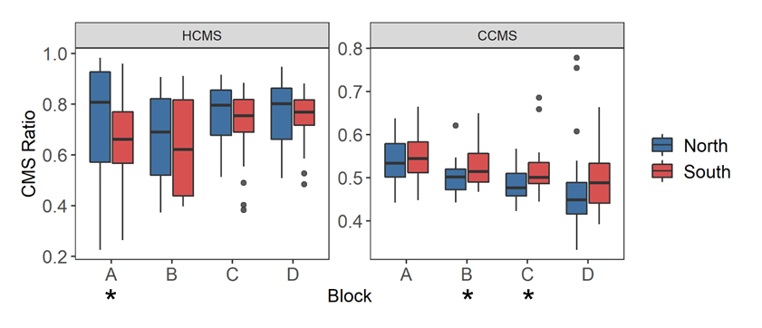

**Fig. S4** Cell membrane stability across temporally independent blocks and colored by region. The center line of the boxplot is the median of the measurements taken for each region within a ramet. Block effect identified in linear mixed effects models with a likelihood ratio test for CCMS (LR=15.731, p<0.001) and HCMS (LR=4.728, p=0.030). There is a significant difference between blocks for hot cell membrane stability (HCMS, p = 0.0297) and cold cell membrane stability (CCMS, p = 7.30e-05). Asterisks indicate a significant difference between regions from a paired t-test of regions for each block independently. There was a significant difference between regions for HCMS block A (t = -2.910, p = 0.015), CMS block B (t = 2.190, p = 0.040), and CMS block C (t = 2.073, p = 0.049).

**Fig. S5** Correlation matrix of all plants. Gametophytic (labels blue font) and sporophytic variables (labels red font) with significant Pearson’s correlations for all study plants.

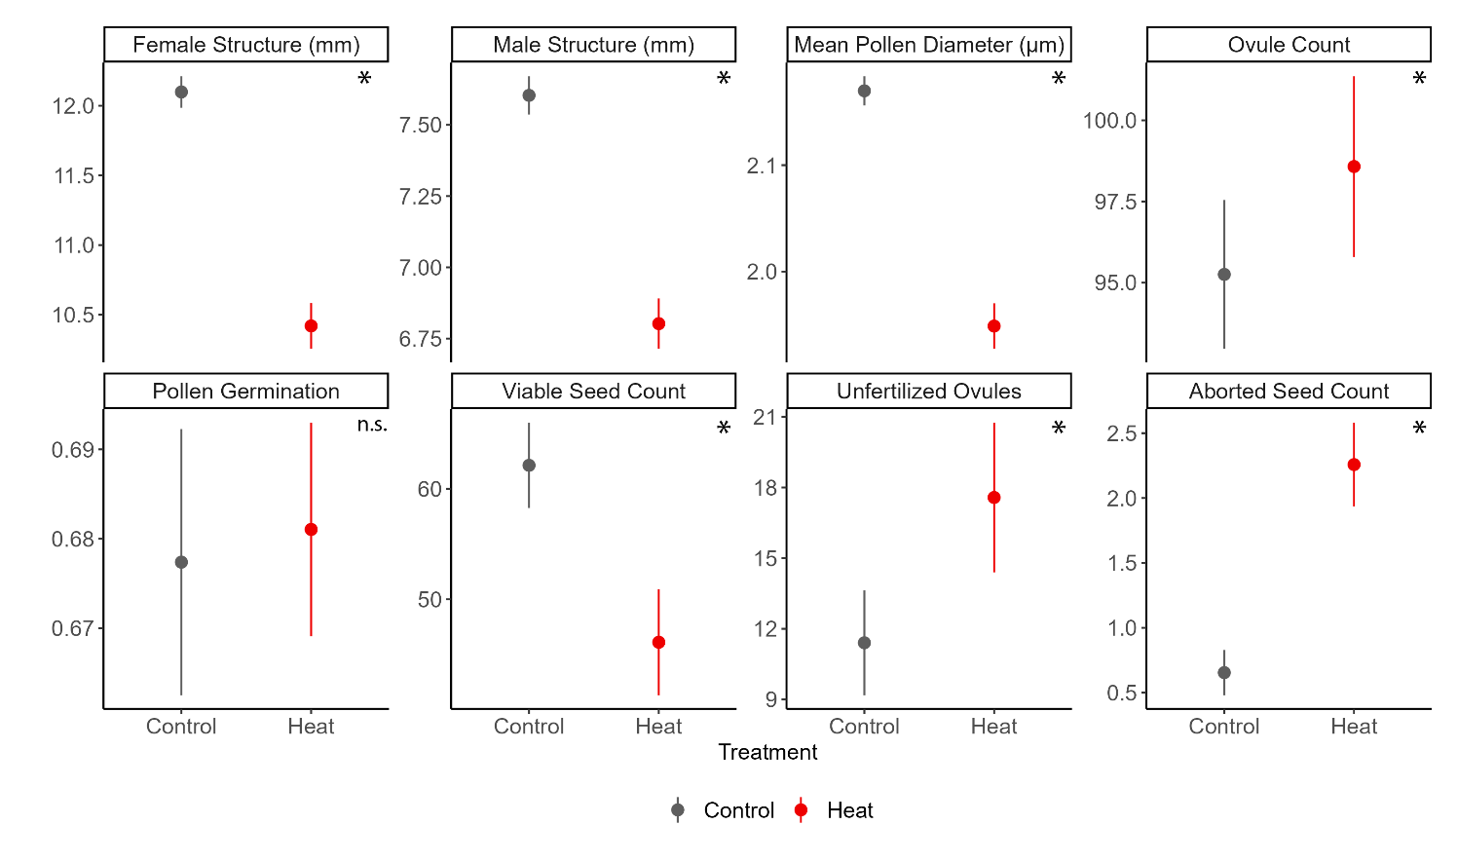

**Fig. S6** The effects of long-term moderate heat on pre- and post-pollination traits. Asterisks indicate statistical significance of p-value < 0.05.

**Fig. S7** Daily max temperature for spring and summer of 2021 from the NOAA station at the Hector International Airport, Fargo, ND.

**Table S1.** Mixed effects model results for each variable. Full model included region as a fixed effect with block and genet as random effects. Random effects tested with a likelihood ratio test. Random effect terms were included as fixed effects when the model overfit the data (F= F-statistic and not LRT). Bolded values indicate significant relationships.

|  |  |  |  |  |  |  |  |  |  |  |  |
| --- | --- | --- | --- | --- | --- | --- | --- | --- | --- | --- | --- |
|  |  | Region | | | Block | | Genet | | Population | | |
|  | Variable | F-value | df | p-value | LRT | p-value | LRT | p-value | F-value | df | p-value |
| Sporophyte | Cell Membrane Stability (Heat) | 0.706 | 1,46 | 0.405 | **4.496** | **0.034** | 0.724 | 0.395 | **4.778** | **3,50** | **0.005** |
| Cell Membrane Stability (Cold) | 10.358 | 1,188 | 0.002 | **15.342** | **<0.001** | - | - | 1.586 | 3,188 | 0.194 |
| Chlorophyll Content (Heat) | **4.166** | **1,48** | **0.047** | 0.199 | 0.656 | 0.047 | 0.829 | 0.783 | 3,51 | 0.509 |
| Chlorophyll Content (Cold) | **104.054** | **1,188** | **<0.001** | 1.477 | 0.224 | - | - | **11.139** | **3,188** | **<0.001** |
| Photosynthetic Rate (Heat) | 1.966 | 1,33 | 0.170 | - | - | 0.198 | 0.656 | 1.843 | 3,47 | 0.152 |
| Photosynthetic Rate (Cold) | **5.614** | **1,47** | **0.022** | 0.076 | 0.782 | 0.834 | 0.361 | **3.355** | **3,52** | **0.026** |
| Gametophyte | Pollen Germination (Tmax) | **5.937** | **1,52** | **0.018** | - | - | 3.405 | 0.065 | 1.840 | 2,47 | 0.170 |
| Pollen Germination (Topt) | **6.684** | **1,52** | **0.012** | - | - | 2.166 | 0.141 | **3.541** | **2,48** | **0.037** |
| Pollen Germination (Tmin)* | 0.030 | 1,41 | 0.865 | - | - | **5.421** | **0.020** | 0.199 | 2,36 | 0.820 |
| Pollen Tube Growth Rate (Tmax) | 0.037 | 1,54 | 0.848 | - | - | 1.606 | 0.205 | 0.481 | 2,50 | 0.621 |
| Pollen Tube Growth Rate (Topt) | 0.042 | 1,56 | 0.839 | - | - | 0.350 | 0.554 | 0.254 | 2,52 | 0.777 |
| Pollen Tube Growth Rate (Tmin) | 0.923 | 1,57 | 0.341 | - | - | - | - | 0.606 | 2,57 | 0.549 |

**Table S2.** Mixed effects model of control values used in calculation for variable proportions to determine baseline differences between regions without the temperature treatments.

|  |  |  |  |  |
| --- | --- | --- | --- | --- |
|  | Region | | Genet | |
| Variable | Difference | p-value | Difference | p-value |
| Conductivity of cell membrane max damage | No | 0.445 | No | 0.097 |
| Chlorophyll content initial value | No | 0.795 | No | 0.869 |
| Net photosynthetic rate initial value | No | 0.303 | No | 0.380 |

**Table S3.** T-test results for differences between region within block. Paired t-tests were used as a northern and southern plant were paired with one another and experienced the same green house conditions. An unpaired t-test was used for photosynthesis because there were missing data points for some genets. Bolded values indicate significant relationships.

|  |  |  |  |  |  |  |  |  |  |  |
| --- | --- | --- | --- | --- | --- | --- | --- | --- | --- | --- |
|  |  |  | Block A | | Block B | | Block C | | Block D | |
|  | Variable | Method | t-stat | p-value | t-stat | p-value | t-stat | p-value | t-stat | p-value |
| Sporophyte | Cell Membrane Stability (Heat) | Paired | **-2.910** | **0.015** | -0.853 | 0.403 | -1.640 | 0.113 | -0.539 | 0.595 |
| Cell Membrane Stability (Cold) | Paired | 0.758 | 0.456 | **2.190** | **0.040** | **2.073** | **0.049** | 0.939 | 0.358 |
| Chlorophyll Content (Heat) | Paired | -0.374 | 0.712 | -1.650 | 0.113 | -1.933 | 0.065 | -0.728 | 0.474 |
| Chlorophyll Content (Cold) | Paired | **-5.889** | **3.82E-06** | **-4.746** | **9.77E-05** | **-5.982** | **3.50E-06** | **-4.106** | **4.33E-04** |
| Photosynthetic Rate (Heat) | Unpaired | 0.541 | 0.594 | 1.144 | 0.261 | -1.367 | 0.187 | 0.021 | 0.984 |
| Photosynthetic Rate (Cold) | Unpaired | -0.664 | 0.511 | 1.542 | 0.137 | 1.219 | 0.231 | 1.782 | 0.083 |

**Table S4.** Correlation matrix with correlation coefficient and p-value for each combination of variables. Bolded text indicates correlations that are statistically significant with p-values adjusted using the Holm’s-Bonferroni method for multiple correlations.

|  |  |  |  |  |  |  |  |  |  |  |  |
| --- | --- | --- | --- | --- | --- | --- | --- | --- | --- | --- | --- |
|  |  | Tmin Germ | Tmax Germ | Tmin PTGR | Tmax PTGR | Hot CMS | Cold CMS | Hot CHPL | Cold CHPL | Cold PS | Hot PS |
| Tmin Germination | Corr | - |  |  |  |  |  |  |  |  |  |
| p-value | - |  |  |  |  |  |  |  |  |  |
| Tmax Germination | Corr | -0.264 | - |  |  |  |  |  |  |  |  |
| p-value | 0.341 | - |  |  |  |  |  |  |  |  |
| Tmin PTGR | Corr | 0.266 | 0.061 | - |  |  |  |  |  |  |  |
| p-value | 1.000 | 1.000 | - |  |  |  |  |  |  |  |
| Tmax PTGR | Corr | -0.073 | **0.371** | **0.456** | - |  |  |  |  |  |  |
| p-value | 1.000 | **0.030** | **0.002** | - |  |  |  |  |  |  |
| Hot CMS | Corr | 0.015 | 0.112 | -0.004 | 0.030 | - |  |  |  |  |  |
| p-value | 1.000 | 1.000 | 1.000 | 1.000 | - |  |  |  |  |  |
| Cold CMS | Corr | -0.130 | 0.167 | 0.042 | 0.106 | -0.131 | - |  |  |  |  |
| p-value | 1.000 | 1.000 | 1.000 | 1.000 | 0.404 | - |  |  |  |  |
| Hot CHPL | Corr | 0.112 | -0.078 | -0.069 | -0.103 | 0.060 | -0.131 | - |  |  |  |
| p-value | 1.000 | 1.000 | 1.000 | 1.000 | 1.000 | 0.598 | - |  |  |  |
| Cold CHPL | Corr | 0.101 | 0.065 | -0.127 | -0.144 | 0.145 | -0.093 | 0.102 | - |  |  |
| p-value | 1.000 | 1.000 | 1.000 | 1.000 | 0.385 | 1.000 | 1.000 | - |  |  |
| Cold PS | Corr | 0.240 | 0.062 | 0.164 | 0.133 | 0.205 | -0.084 | 0.092 | -0.151 | - |  |
| p-value | 1.000 | 1.000 | 1.000 | 1.000 | 0.344 | 1.000 | 1.000 | 1.000 | - |  |
| Hot PS | Corr | -0.052 | 0.054 | 0.066 | 0.137 | 0.194 | 0.076 | -0.069 | -0.030 | 0.131 | - |
| p-value | 1.000 | 1.000 | 1.000 | 1.000 | 0.174 | 1.000 | 1.000 | 1.000 | 1.000 | - |

|  |  |  |  |  |  |  |
| --- | --- | --- | --- | --- | --- | --- |
| Variable | Population | | | Temporal Block | | |
| dF | Χ2 | p | Χ2 | p |
| Female Structure (mm) | 1 | 0.35 | 0.556 | **6.68** | **0.010** |
| Male Structure (mm) | 1 | **46.81** | **<0.001** | **20.20** | **<0.001** |
| Ovule Number | 1 | **30.50** | **<0.001** | **90.38** | **<0.001** |
| Pollen Grain Size (μm) * | 1 | **5.73** | **0.017** | **8.91** | **0.003** |
| Pollen Germination (40°C) | 1 | - | - | 0.02 | 0.944 |
| Viable Seed | 1 | **4.01** | **0.045** | **155.67** | **<0.001** |
| Unfertilized Ovules | 1 | **3.90** | **0.048** | **381.62** | **<0.001** |
| Aborted Seeds | 1 | 0.45 | 0.502 | **27.51** | **<0.001** |

**Table S5.** Effects of temporal block (January and June) for pre-and post-pollination traits. Bolded variables indicate significant variables at the α=0.05 level.