**Results**

*Flowering*

There was no significant difference between the regions for the day after growth initiation that the plant flowered (Appendix). There were 48 plants from the northern region that initially flowered and 17 from the southern region (Figure 1). After all plants that flowered were placed in the treatments, not all the plants flowered a second time. There were 21 plants in the control group and 24 plants in the heat treatment group that flowered for the northern plants. For the southern plants, 8 in the control and 6 in the heat treatment flowered again. Since the number of plants that flowered in the two regions differed substantially,

Figure 1. The number of genets that flowered in the control and heat treatments before and after they were placed in the treatments. Counts for the northern and southern regions shown independently.

*Flower Development*

The flower type for the first flower after placement in the treatment was recorded. There was no significant difference between treatment groups for flower type of northern plants. Flower type did limit the data collected since staminate flowers were not used for variables such as ovule number, style and stigma length, stamen length, pollen diameter, fruit set, and seed number (Figure 2). Thus, treatment effects were only considered from plants from northern populations. There was a significant difference between regions for style and stigma length and stamen length in the controlled conditions (Figure 3, table 1). Southern plants had larger floral structures than northern plants. There were significant treatment effects for northern plants in both style and stigma length and stamen length (Figure 4, table 2). In both cases, development in heat reduced the lengths of the structures. There were no significant differences in ovule number between regions or treatments. Mean pollen diameter did not differ between the two regions, but there was a significant treatment difference. The diameter of pollen that developed in heat is significantly smaller than pollen that developed in the control conditions (Figure 5, table 2).

Figure 2. Number of plants with hermaphroditic and staminate flowers for the treatment groups. Counts for northern and southern plants displayed independently.

Table 1. Results from mixed effects models for regional differences in the control treatment.

|  |  |  |  |  |  |  |
| --- | --- | --- | --- | --- | --- | --- |
|  | Fixed Effects | | | | Random Effects | |
| **Variable** | Region | | Population | | Population:Genet | Population |
| F | p | F | p | p | p |
| First Flower | 1.458 | 0.235 | 0.019 | 0.892 | 0.804 | - |
| Stigma and Style Length | **4.453** | **0.045** | 1.200 | 0.284 | **6.24E-11** | - |
| Stamen Length | **12.071** | **0.002** | 13.916 | 0.001 | **9.09E-06** | - |
| Ovule Number | 0.093 | 0.763 | 2.822 | 0.106 | **0.017** | - |
| Mean Pollen Diameter | 0.522 | 0.633 | - | - | - | 0.449 |
| Seed Number | 0.189 | 0.669 | 2.032 | 0.173 | **5.38E-06** | - |

Table 2. Results from mixed effects models for treatment differences in plants from northern populations.

|  |  |  |  |  |  |  |
| --- | --- | --- | --- | --- | --- | --- |
|  | Fixed Effects | | | | Random Effects | |
| **Variable** | Treatment | | Population | | Population:Genet | Population |
| F | p | F | p | p | p |
| Stigma and Style Length | **34.408** | **6.04E-08** | 0.017 | 0.899 | **1.30E-07** | - |
| Stamen Length | **70.210** | **2.27E-13** | **53.226** | **7.09E-07** | **1.95E-01** | - |
| Ovule Number | 0.553 | 0.459 | **6.531** | **0.017** | **2.69E-01** | - |
| Mean Pollen Diameter | **25.544** | **1.46E-05** | - | - | **-** | 0.678 |
| Seed Number | 12.742 | 0.001 | 0.163 | 0.693 | **5.59E-05** | - |

Table 3. Results from the two-way ANOVA for pollen germination at 40°C and the chi-squared tests for flower type and fruit set.

|  |  |  |  |  |
| --- | --- | --- | --- | --- |
| Variable | Region | | Treatment | |
| F | p | F | p |
| Pollen Germination (40°C) | **9.180** | **0.004** | 3.916 | 0.054 |
|  |  |  | χ2 | p |
| Flower Type |  |  | 0.370 | 0.543 |
| Fruit Set |  |  | 6.143 | 0.105 |

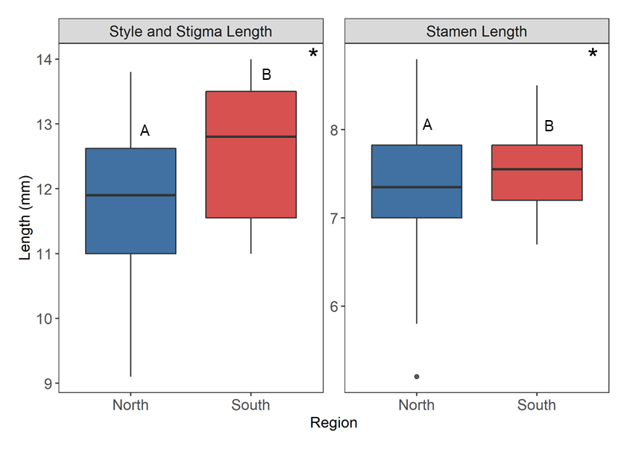

Figure 3. Regional differences for the length of the stigma and style and the length of the stamen from flowers that developed in the control treatment. Asterisks and letters indicate differences that are statistically significant. There are significant differences between regions for style and stigma length (F25 = 4.453, p = 0.045) and stamen length (F25 = 12.071, p = 0.002).

Figure 4. Treatment differences for the length of the stigma and style and the length of the stamen from flowers that originated in northern populations. Asterisks and letters indicate differences that are statistically significant. There are significant differences between regions for style and stigma length (F98 = 34.408, p = 6.044e-08) and stamen length (F107 = 70.272, p = 2.272e-13).

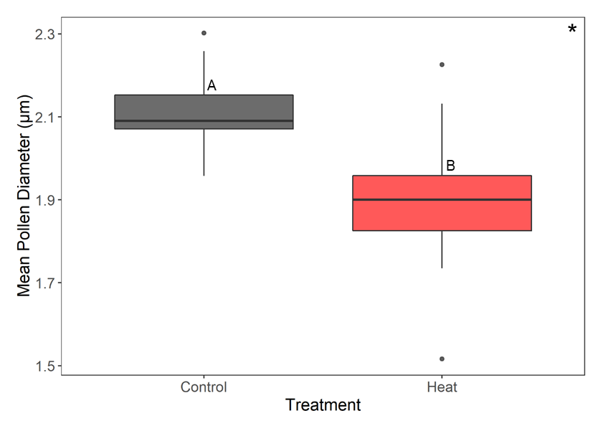

Figure 5. The mean pollen diameter of northern plants from flowers that developed in the respective treatment groups. Asterisk and letters indicate differences that are statistically significant. There was a significant difference between treatment groups (F34 = 25.544, p = 1.456e-05).

*Post-pollination*

Pollen germination at 40°C was significantly different between regions, but not treatment groups (Figure 6, table 3). In both treatment groups, northern plants had significantly higher pollen germination than southern plants. There were no significant differences between treatment groups for fruit set (Figure 7, table 3). There were no significant differences between regions for viable seed count. There was a significant difference between treatment groups for plants from northern populations (Figure 8, table 2). There were fewer viable seeds produced when ovules developed in the heat treatment and underwent pollination and fertilization in the heat treatment.

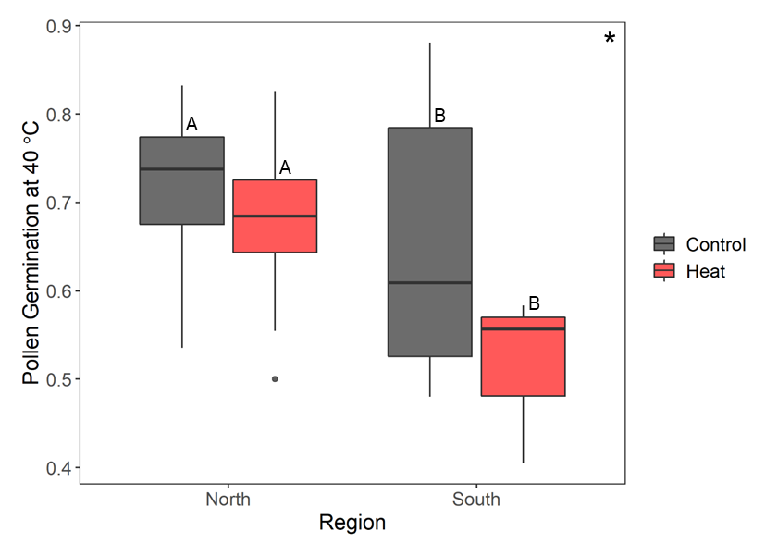

Figure 6. Regional differences of pollen germination at 40°C in the two treatment groups. Letters represent significant differences between groups. There was a significant difference between regions (F = 9.180, p = 0.004), but no difference between treatment groups.

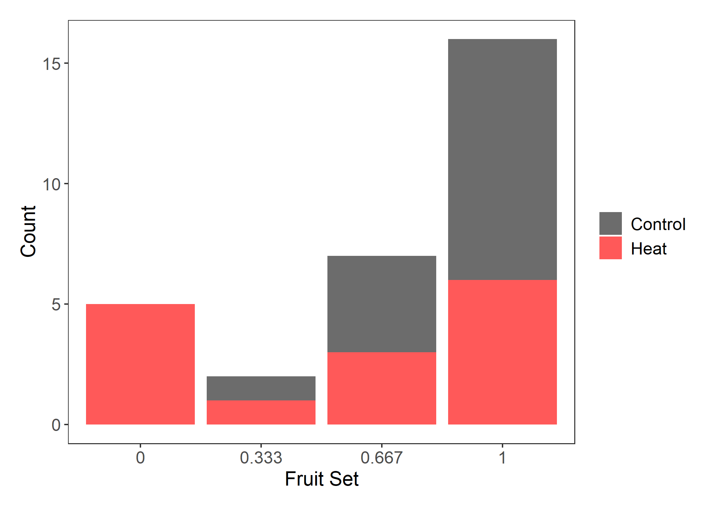

Figure 7. Counts of plants with the proportion of fruits that developed from three pollinated flowers for plants that originated in northern populations. Color shows treatment groups.

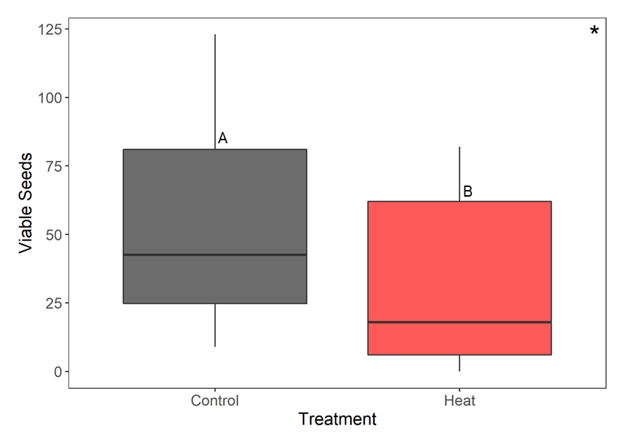

Figure 8. The number of viable seeds from flowers of northern plants that developed in the respective treatment groups. Asterisk and letters indicate differences that are statistically significant. There was a significant difference between treatment groups (F46 = 12.742, p = 8.514e-04).