## Supporting Information: Figures and Tables

**Article title**: Intraspecific variation in responses to extreme and moderate temperature stress in the wild species, *Solanum carolinense* (Solanaceae)

**Authors**: Emma K. Chandler, Steven E. Travers

**Corresponding author**: Steven E. Travers, North Dakota State University Biological Sciences Department, [steven.travers@ndsu.edu](mailto:steven.travers@ndsu.edu)

The following Supporting Information is available for this article:

**Fig. S1** Differences between the populations for all sporophytic variables

**Fig. S2** Cell membrane stability across temporally independent blocks

**Fig. S3** Daily max temperature for spring and summer of 2021

**Table S1** Mixed effects model results for the difference between population for all sporophytic variables

**Table S2** Mixed effects model results for each variable

**Table S3** Mixed effects model of control values used in calculation for variable proportions

**Fig. S1** Differences between the populations for all sporophytic variables. Letters denote significant differences between populations from a linear mixed effects model with population as the fixed effect and block as the random effect.

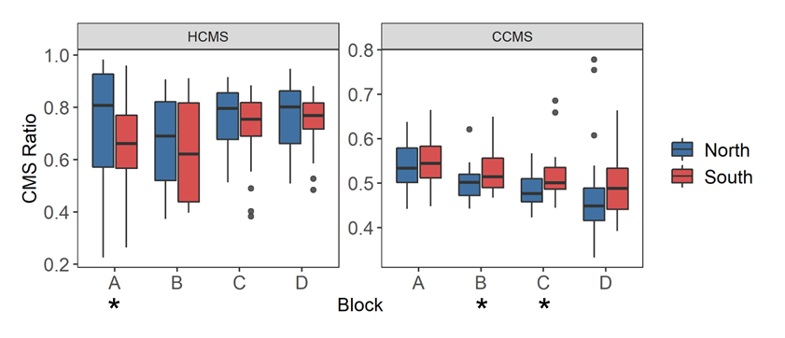

**Fig. S2** Cell membrane stability across temporally independent blocks and colored by region. The center line of the boxplot is the median of the measurements taken for each region within a ramet. There is a significant difference between blocks for hot cell membrane stability (HCMS, p = 0.0297) and cold cell membrane stability (CCMS, p = 7.30e-05). Asterisks indicate a significant difference between regions from a paired t-test of regions for each block independently. There was a significant difference between regions for HCMS block A (t = -2.910, p = 0.015), CMS block B (t = 2.190, p = 0.040), and CMS block C (t = 2.073, p = 0.049).

**Fig. S3** Daily max temperature for spring and summer of 2021 from the NOAA station at the Hector International Airport, Fargo, ND.

**Table S1.** Mixed effects model results for the difference between population for all sporophytic variables. One-way ANOVA results for the gametophytic variables for the difference between population. Block overfit the model when included for the gamtophyte and was therefore excluded from the gametophytic variable models. Bolded values indicate significant relationships.

|  |  |  |  |  |  |  |
| --- | --- | --- | --- | --- | --- | --- |
|  |  | Population | | | Block | |
|  | Variable | F-value | df | p-value | LRT | p-value |
| Sporophyte | Cell Membrane Stability (Heat) | **5.563** | **188.06** | **2.97E-04** | **4.210** | **0.040** |
| Cell Membrane Stability (Cold) | **2.824** | **188.06** | **0.026** | **15.342** | **8.97E-05** |
| Chlorophyll Content (Heat) | 1.732 | 188.25 | 0.145 | 0.188 | 0.665 |
| Chlorophyll Content (Cold) | **32.341** | **188.22** | **2.20E-16** | 1.477 | 0.224 |
| Photosynthetic Rate (Heat) | 1.473 | 126.00 | 0.214 | -2.84E-04 | 0.214 |
| Photosynthetic Rate (Cold) | **3.717** | **138.74** | **6.62E-03** | 0.032 | 0.858 |
| Gametophyte | Pollen Germination (Tmax) | **6.069** | **3** | **1.17E-03** | - | - |
| Pollen Germination (Topt) | **6.861** | **3** | **5.02E-04** | - | - |
| Pollen Germination (Tmin) | 2.656 | 3 | 0.057 | - | - |
| Pollen Tube Growth Rate (Tmax) | 0.400 | 3 | 0.753 | - | - |
| Pollen Tube Growth Rate (Topt) | 0.197 | 3 | 0.898 | - | - |
| Pollen Tube Growth Rate (Tmin) | 0.459 | 3 | 0.712 | - | - |

**Table S2.** Mixed effects model results for each variable. Full model included region as a fixed effect with block and genet nested in population as random effects. Random effect terms were dropped when the model overfit the data. Bolded values indicate significant relationships.

|  |  |  |  |  |  |  |  |  |  |
| --- | --- | --- | --- | --- | --- | --- | --- | --- | --- |
|  |  | Region | | | Block | | | Genet | |
|  | Variable | F-value | df | p-value | | LRT | p-value | LRT | p-value |
| Sporophyte | Cell Membrane Stability (Heat) | 3.673 | 1, 50 | 0.061 | | **4.728** | **0.030** | 3.320 | 0.068 |
| Cell Membrane Stability (Cold) | **6.482** | **1, 191** | **0.012** | | **15.731** | **7.30E-05** | - | - |
| Chlorophyll Content (Heat) | **4.418** | **1, 51** | **0.041** | | 0.222 | 0.637 | 0.018 | 0.892 |
| Chlorophyll Content (Cold) | **66.369** | **1, 50** | **9.97E-11** | | 1.018 | 0.313 | 2.082 | 0.149 |
| Photosynthetic Rate (Heat) | 1.24E-05 | 1, 129 | 0.997 | | - | - | - | - |
| Photosynthetic Rate (Cold) | 3.269 | 1, 47 | 0.07702 | | 0.148 | 0.701 | 1.674 | 0.196 |
| Gametophyte | Pollen Germination (Tmax) | **12.054** | **1, 26** | **0.002** | | - | - | 3.181 | 0.075 |
| Pollen Germination (Topt) | **10.916** | **1, 24** | **0.003** | | - | - | 1.728 | 0.189 |
| Pollen Germination (Tmin)* | 0.151 | 1, 21 | 0.702 | | - | - | **5.000** | **0.025** |
| Pollen Tube Growth Rate (Tmax) | 0.446 | 1, 29 | 0.509 | | - | - | 1.455 | 0.228 |
| Pollen Tube Growth Rate (Topt) | 0.121 | 1, 29 | 0.731 | | - | - | 0.309 | 0.578 |
| Pollen Tube Growth Rate (Tmin) | 0.168 | 1, 59 | 0.683 | | - | - | - | - |

**Table S3.** Mixed effects model of control values used in calculation for variable proportions to determine baseline differences between regions without the temperature treatments.

|  |  |  |  |  |
| --- | --- | --- | --- | --- |
|  | Region | | Genet | |
| Variable | Difference | p-value | Difference | p-value |
| Conductivity of cell membrane max damage | No | 0.445 | No | 0.097 |
| Chlorophyll content initial value | No | 0.795 | No | 0.869 |
| Net photosynthetic rate initial value | No | 0.303 | No | 0.380 |