Software Engineering
Software Requirements Specification
(SRS) Document

John Filipowicz, Mitchell Powell, Josh Ervin, Evan Charles, Chistopher Shimp
Radford University
http://webchase.weebly.com
10/24/2016

Review & Approval
Requirements Document Approval History
Approving Party | Version Approved | Signature | Date
John Filipowicz | 1.0.0.0.1 | John Filipowicz | 10/24/16
Dr. T. L. Lewis

Requirements Document Review History
Reviewer | Version Reviewed | Signature | Date
Mitchell Powell | 1.0.0.0.1 | Mitchell Powell | 10/24/16
Josh Ervin | 1.0.0.0.1 | Josh Ervin | 10/24/16
Evan Charles | 1.0.0.0.1 | Evan Charles | 10/24/16
Christopher Shimp | 1.0.0.0.1

Contents

1. Introduction 3
1.1 Purpose of this document 3
1.2 Scope of this document 3
1.3 Business Context 3
2. General Description 3
2.1 Product Functions 3
2.2 Similar System Information 3
2.3 User Characteristics 4
2.4 User Problem Statement 4
2.5 General Constraints 4
3. Functional Requirements 4
4. Interface Requirements 14
4.1 User Interfaces 14
4.2 Communications Interfaces 14
5. Performance Requirements 14
6. Other non-functional attributes 15
6.1 Security 15
6.2 Reliability 15
6.3 Maintainability 15
6.4 Reusability 15
7. Operational Scenarios 16
8. Preliminary Use Case Models and Sequence Diagrams 17
8.1 Use Case Model 17
8.2 Sequence Diagrams 17
9. Updated Schedule 18
10. Appendices 18
10.1 Definitions, Acronyms, Abbreviations 18
10.2 References 19

1. Introduction
1.1 Purpose of this document
The purpose of this document is to gather and define the necessary requirements for the Expert Web Crawler project. The intended audience of this document is Dr. Chase (the client, the Web Chase Team, and Dr. Lewis-Williams.
1.2 Scope of this document
The scope of this document defines the requirements necessary to complete each part of the Expert Web Crawler project. This document will not have a focus on design or development, only the functionality necessary for the final product to work successfully. The requirements elicitation team includes Dr. Chase (the client), university professors (the users), and the Web Chase team. The restrictions placed on the requirements elicitation process are the schedules of the team and the client.
1.3 Business Context
Dr. Chase is a professor in the Information Technology Department at Radford University, who is looking to create the Expert Web Crawler for other professionals in similar positions (university professors). The purpose of the Expert Web Crawler is to allow experts to search keywords that occur under a specified web address, and return any results from the search as a small snippet of the conversation in which they occurred, and a hyperlink to the web page on which they occurred.

2. General Description
2.1 Product Functions
The “Expert Web Crawler” application is intended to search a user specified web page and its nested web pages for specific terms or character combinations. This may be more than one web page and/or more than one term.
2.2 Similar System Information
The crawler will only interact with specified sites, their nested pages, and the local machine. Competition for our application will mainly be search engines including but not limited to: Google, Bing, Yahoo. These search engines are the closest to our application that we are aware of. While they are much more powerful than our application, we believe the simplicity and usability of our application will help us tremendously. To briefly expand on this, in order to search a specific website or exclude phrases with Google, you must be aware of the functionality existing and memorize the syntax. In contrast, our application has its functions clearly labeled and described, separated into their own text fields. Our application also does not track meta data of its users or feed them advertisements. Alongside usability, the ability to save query results locally limits the need for repetitive searches, internet connection for viewing results, and allows results to be easily shared.
An additional alternate to using our application may be to use an open source web crawler and then write your own application to utilize it. This obviously will not be a realistic option for most people.
2.3 User Characteristics
While the client requesting this application is well versed in how the system will operate internally, the goal is to abstract the inner workings in order to maintain the simplicity and usability of the system. The basic knowledge required to operate this application includes: knowing what a URL is, knowing what key terms you wish to search, understanding basically what depth is for this context, and basic GUI navigation skills. The concern here is being able to simply convey what depth represents.
2.4 User Problem Statement
As mentioned above, the alternative to using our application is most likely using a search engine. The downsides to search engines are sponsored results, single field entry resulting in complex queries, and non-labeled functionality, as well as other case by case downsides. There are also no ways, that we are aware of, to store the results of a search locally efficiently.
2.5 General Constraints
Due to the project deadlines, we do not have enough time to do any complex work within our system that isn’t critical to the systems purpose. Speed of the query depends on the input since the user may choose any level of depth they wish. With this in mind, most small depth queries should be no more than five seconds. If the user chooses a large depth, the query could potentially take much longer.

3. Functional Requirements
1. Users shall see the “Processing” graphic while their request is being searched.
  - Description
The graphic will be visible adjacent to the halt button while the web crawler is processing the request.
  - Criticality
(2): This is a non essential feature to the system because it allows the user to see that the application is processing their search request.
  - Technical issues
There is no specific timer to this graphic it will only appear when the system is running a search and will stop upon completion of the search.
  - Risks
n/a
  - Dependencies with other requirements
This requirement is dependent on the user’s search submissions. The text field for the key terms, URL, and depth must all be entered completely and the user must have clicked the “Search” button.
- There will exist a tab for the search page that brings the search page into frame.
  - Description
Users shall click the Search Page tab to return to the page to provide input for another search.
  - Criticality
(5): This is an essential feature to the system because it allows the user to create another search easily without restarting the system.
  - Technical issues
The tab will only be created when the first search is completed.
  - Risks
n/a
  - Dependencies with other requirements
This requirement is dependent on the user’s search submissions. The text field for the key terms, URL, and depth must all be entered completely and the user must have clicked the “Search” button for a first search.
- There will exist a tab for the output page that brings the output page into frame.
  - Description
Users shall click the Output Page tab to see all of the records that the system returned in the form of snippets.
  - Criticality
(5): This is an essential feature to the system because it allows the user to see what the system returned based on their search criteria.
  - Technical issues
The tab will only be created when a search is completed.
  - Risks
This will output URLs that may contain malicious code.
  - Dependencies with other requirements
This requirement is dependent on the user’s search submissions. The text field for the key terms, URL, and depth must all be entered completely and the user must have clicked the “Search” button for a search.
- There will exist a pop up page to verify the desired content to be saved.
  - Description
Users shall be provided a “Save pop up” page to verify what content they would like to save to their local drive.
  - Criticality
(4): This is an essential feature to the system because it allows the user to confirm what information they would actually like to save.
  - Technical issues
This will refer to the check boxes from the output page to decide the default input in the text field on this page.
  - Risks
n/a
  - Dependencies with other requirements
This requirement is dependent on the user clicking the initial save button which will trigger the “Save pop up” page.
- There will be a text field in the save pop up for what snippets to save.
  - Description
Users shall be able to provide an input in the text field on which content they wish to save. The default values in the text field will be the snippets with their
  - Criticality
(3): This is an essential feature to the system because it allows the user to confirm what information they would actually like to save.
  - Technical issues
The user may be able to save the same content twice from one record if they chose.
  - Risks
Improper input won’t allow the user to save their output tabs as expected.
  - Dependencies with other requirements
This requirement is dependent on the user clicking the final save button in the “Save pop up” page.
- The “Help” button displays the user manual.
  - Description
Users shall click the “Help” button to display the user manual.
  - Criticality
(3): This is an essential feature to the system because it allows the user to understand how the system will work and will give examples of a proper search and what to expect from the output.
  - Technical issues
The button will open the user manual, which is a static item that does not need to be updated in real time.
  - Risks
As long as the button is functional, there are no risks.
  - Dependencies with other requirements
No dependencies with other requirements.
- The output page will contain text surrounding key terms from each web page.
  - Description
Users shall see viewable text in each returned record surrounding their key term(s) in the output tab.
  - Criticality
(5): This is an essential feature to the system because it allows the user to view their key term(s) and the context that surrounds it.
  - Technical issues
There may or may not be surrounding text to the terms
  - Risks
A bug in displaying this requirement will disrupt the convenience of the program. The user would have to use the hyperlinks as an alternative.
  - Dependencies with other requirements
This requirement is dependent on the user clicking search button after submitting proper inputs in the URL, key terms, and depth text fields. It is also dependent on the functional output tab opening after the search is completed.
- Hyperlinks in the output page will open the link in a browser.
  - Description
Users shall be provided click able hyperlinks that will open to their respective web pages from the generated output.
  - Criticality
(4): This is an essential feature to the system because it allows the user to go to the source of the returned record.
  - Technical issues
The hyperlinks will have to be able to open a browser window or additional tab within an open browser.
  - Risks
The hyperlinks will not be marked for malicious code.
  - Dependencies with other requirements
This requirement is dependent on the user clicking search button after submitting proper inputs in the URL, key terms, and depth text fields. It is also dependent on the functional output tab opening after the search is completed.
- Users shall click the “add” button to create a new entry in the full listing of URLs.
  - Description
The “add” button associated with the search URLs will add any contents of the search URL text field to the search URL full listing.
  - Criticality
(5): This is an essential feature to the system because it allows the user to add other URLs as a base to search.
  - Technical issues
The more URLs that the system takes in the slower the process will be.
  - Risks
If inoperable, the crawler will not be able to view entered URLs in the full listing.
  - Dependencies with other requirements
This requirement is dependent on the user already completing the text field for the first URL.
- Users shall click the “add” button to create a new entry in the full listing of terms.
  - Description
The “add” button associated with the search terms will add any contents of the search term text field to the search term full listing.
  - Criticality
(5): This is an essential feature to the system because it allows the user to add other key terms as criteria to search.
  - Technical issues
The more key terms that the system takes in the slower the process will be.
  - Risks
If inoperable, the crawler will not be able to view entered terms in the full listing.
  - Dependencies with other requirements
This requirement is dependent on the user already completing the text field for the first key term.
- Users shall see a full list of URL(s) specified by the user for the search
  - Description
There will be a view only are displaying the specified URLs so far. The list is updated when the user adds another URL to the URL text field and selects the add URL button.
  - Criticality
(4): This is an essential feature to the system because it allows the user to see which URLs they have entered.
  - Technical issues
The list must show all the URLs entered by the user. Outputting the contents of the collection containing URLs is simple in nature.
  - Risks
If this is inoperable, the user may not recall all URLs entered so far to begin the search at.
  - Dependencies with other requirements
The list depends on both the associated text field and add button. Once the add button is used, the contents of the text field will be added to the full list.
- Users shall see a full list of key terms specified by the user for the search.
  - Description
There will be a view only area displaying the specified terms so far. The list is updated when the user adds another term to the term text field and selects the add term button.
  - Criticality
(4): This is an essential feature to the system because it allows the user to see all key terms they have entered.
  - Technical issues
The list must show the all terms entered by the user. Outputing the contents of the collection containing search terms is simple in nature.
  - Risks
If this is inoperable, the user may not recall all terms entered so far to be searched.
  - Dependencies with other requirements
The list depends on both the associated text field and add button. Once the add button is used, the contents of the text field will be added to the full list.
- User shall click the “save” button on the save pop up to confirm their save.
  - Description
On the save pop up page, the user may click this button to save the specified web page snippets. The default snippets and web pages depend on the check box requirement.
  - Criticality
(5): This is an essential feature to the system because it allows the user to save their desired content onto the local drive. If they cannot save their output, the application loses one of its main draws.
  - Technical issues
The user will have to specify where to save their content.
  - Risks
An inoperable save button renders the users ability to save output useless.
  - Dependencies with other requirements
This requirement is dependent on the “Save pop up” page requirement and the user specifying which content to save either through the check boxes or the text field using the numbers of each snippet.
- User shall click the “cancel” button on the save pop up to cancel the save.
  - Description
This button will be used to back out of saving an output file. It will close the save pop up on action
  - Criticality
(2): This is a non essential feature to the system because it allows the user to cancel their save if they so desire. The user will have the default frame option to close the pop up via the red x on every frame.
  - Technical issues
This button will only need to close the save pop up.
  - Risks
If the button doesn’t work the user will have to use alternate ways of closing the pop up.
  - Dependencies with other requirements
This requirement is dependent on the “Save pop up” page requirement.
- Users shall click the “expand” button to expand the number of snippets found on each web page.
  - Description
The “expand” button shows the additional snippets for each page, the number of which is indicated by a separate adjacent requirement.
  - Criticality
(3): This is an essential feature to the system because it allows the user to review more snippets found on each web page that was searched.
  - Technical issues
I have not implemented this sort of button before, however it is one of the more commonly used buttons within a GUI. There shouldn’t be anything special about it.
  - Risks
An inoperable expand button will limit the user to view only the first snippet per web page.
  - Dependencies with other requirements
This requirement is dependent on the “Output tab” requirement and a completed search.
- Users shall see the number of snippets within each web page that was searched.
  - Description
This indicator shows the number of items to be viewed upon using the expand button. This will be next to the expand button.
  - Criticality
(3): This is an essential feature to the system because it allows the user to decide whether or not they want to expand to see the additional snippets. This will also tell the user how relevant their key terms are within each page.
  - Technical issues
This requirement involves tracking an integer associated with each web page traveled to.
  - Risks
Technically there are risks at integer maximum or roughly six billion, but they are realistically not an issue since it is highly unlikely to find more than six billion hits on the same page. We may use an integer object instead of primitive if this becomes an issue.
  - Dependencies with other requirements
This requirement is dependent on the “Output tab” requirement and a completed search.
- Users shall click an “x” indicator on the tabs in order to close the respective tab.
  - Description
The “x” will be located on the right side of every tab besides the search tab. The search tab is not closeable because it may not have more than one open.
  - Criticality
(3): This is an essential feature to the system because it allows the user to close out of unused tabs.
  - Technical issues
We will need to simply have the button close its respective tab on action. Technicality wise this requirement is not complicated.
  - Risks
The user may not have saved their output before closing the tab.
  - Dependencies with other requirements
This requirement is dependent on the “Output tab” requirement and a completed search. Each completed search will create a new output tab which will be then closeable.
18. There will be a text field for the starting URL(s).
i. Description
The user will input their desired URL(s) into the text field to be used by the web crawler as a starting point to search for the terms to be specified in another field.
ii. Criticality
(5): This input is essential to the web crawlers functionality. Without a starting point the web crawler will not be able to produce any desired output.
iii. Technical Issues
The issues surrounding a URL should be simple. There is a class utilized within a Java package to handle URLs. On the GUI side, the entire group is familiar with how to take in a text field from a GUI as a String.
iv. Risks
Improper formatting of the desired URL could throw off the web crawler. Common mistakes will be accounted for; Such as leaving out “http://” or leading and trailing white space.
v. Dependencies with other requirements
This requirement will transfer the URL(s) as a String to the web crawler on the use of the “Search” button.

19. There will be a text field for the search term(s).
i. Description
The user will input their desired search term(s) into the text field to be used by the web crawler to decide what to include in the output. When a term is found, the crawler will make note of the current web page and the surrounding paragraph. Search terms will be separated by a comma.
ii. Criticality
(5): This input is essential to the web crawlers functionality. Without any search terms the crawler will not produce any input.
iii. Technical Issues
Search terms will be taken in, stored, and used as Strings. Acquiring a String from a GUI text field is not an issue. Choosing a delimiter will exclude that character from being search-able, which is a comma “,” in this case.
iv. Risks
The delimiter character being unsearchable leaves a chance a user wants to search for commas on a web page and fails to get the desired output. If you enter a comma as the only search term, it will be read as a delimiter and two empty strings are read as the input, which are invalid search terms.
v. Dependencies with other requirements
This requirement will transfer the search term(s) as a String to the web crawler on the use of the “Search” button.

20. There will be a text field for the depth.
i. Description
The user will input their desired depth into the text field to be used by the web crawler to set the number of nested hyperlinks to follow. The depth will be read in as a single integer.
ii. Criticality
(5): This input is essential to the web crawlers functionality. Without a set depth the crawler won’t know when to stop following loops.
iii. Technical Issues
The depth will be read in as an integer, so only the characters zero through nine will be accepted. If the field is left blank upon submission a default value will be used.
iv. Risks
A user can potentially significantly delay their output from being received by using a large depth. A large depth will also potentially produce a large output file, which could be inconvenient to navigate through.
v. Dependencies with other requirements
This requirement will transfer the depth as an integer to the web crawler on the use of the “Search” button.

21. There will be a “Search” button.
i. Description
There will be a button labeled “Search” that will send the items in the text fields to the web crawler to initiate a search.
ii. Criticality
(5): Without a way to initiate the web crawler no action will be taken or output displayed.
iii. Technical Issues
The listener associated with this button must have access to the three input text fields.
iv. Risks
A bug within the “Search” button will bring any chance of new output to a halt. Any bugs associated directly with the button will either be trivial or be actually associated with another piece of the application.
v. Dependencies with other requirements
This requirement depends on the three text fields of URL(s), search term(s), and the depth. Without the appropriate input, using the “Search” button will give an error to use proper input instead of initiating a search.

4. Interface Requirements
4.1 User Interfaces
- 4.1.1 GUI
The user is presented with the search page consisting of necessary fields for input to the crawler. Once the search is complete the application will then display the resulting output on the output page. Each record returned will have a check box that places that record in the default text field within the save pop-up. When saving the output, the user has the option to specify which records to save. The user will also have the option to display previously saved files on an output page.

- 4.1.2 CLI
N/A
4.2 Communications Interfaces
The hyperlinks within the output files should be able to be opened in the default browser of the machine with the specific link in the address bar. Additionally, the web crawler itself must be able to access the specific web pages by their URL as well as their nested web pages by the URLs within the original web pages.

5. Performance Requirements
o Performance: All actions handled by our application that do not utilize other software should respond in a singe second or less. All actions handled by our application that must reference the hard drive must respond in three seconds or less. All actions handled by our application that use the internet must respond in five seconds or less. The exception to the last of those response times will be if the user chooses to use a large depth (ex. 1000).

o Reliability: Our system only handles one customer at a time, but may be able to show multiple output pages at a time; Each representing their own file. A realistic maximum use case may be ten output pages open at once. A workload limitation would be much larger, possibly in the area of a hundred pages. It is not recommended to use one hundred pages at the same time, but it should be possible.
o Scalability: Since each instance of our application is separated from the rest, there are no concerns with scalability besides distribution of the application itself. Distribution will most likely simply be the application in its final form on our Git-Hub account.

• Platform – The planned platforms for the Expert Web Crawler are OSX, Windows, and Linux.

6. Other non-functional attributes

6.1 Security
In order to keep the system secure the records that are being made from the user input will be directly stored to the local machine. The privacy and confidentiality of the user is also protected under this practice. The information the user requests can only be accessed through that specific machine after each specific search. The system is also not vulnerable to denial of service attacks since it is not a web platform. A potential security risk may be that a link that contains the search terms may have malicious code.
Non-functional requirements: The system shall save records to the local drive where the file can only be accessed by the user of that specific machine.

6.2 Reliability
The only “downtime” that may occur is an improper installation due to our program being a localized application. The user should not expect frequent failures from the system since the pages that either fail to load or have no relevant context to the user’s search will not be returned to the user.
Non-functional requirements: The system shall open within a second of a user’s click. The system shall use a minimal amount of processing power and can be run for extended periods of time without failure or errors. The system shall not be unavailable for more than 1 minute per 100 hours of operation.

6.3 Maintainability
In order to have the most up to date software the user will have the option to install the latest version developed at that time. All versions of the system will still work, however future releases may contain bug fixes or additional features.
Non-functional requirement: Installation of a new version shall not alter previously saved records. New versions of this software shall be able to open previously saved records.

6.4 Reusability
The web crawler is a key component of the system that can be reused in other systems of a similar nature. The GUI could also be re-purposed easily for another project in need of a similarly complex GUI.

7. Operational Scenarios

1. The user is trying to find information on a website about his business and uses an
overly descriptive phrase to search for. This would lead the web crawler to search the
website and find nothing to return to the user. This could possibly lead to the crawler
failing but with proper catch cases the user should be returned a message saying
nothing was found.

2. Another situation could be that the user is trying to search web pages for a keyword
or phrase that comes up thousands of times. The system would want to load all this
data into the return file and could cause an overload of information. This might cause
the system to turn very slowly or create a file that is way too big. To avoid this
limitations can be set on data returned or depth crawled on the web pages.

3. A scenario that could also take place is when crawling the web pages there are links
to other pages that link back to the same page. Normally this would just make the
program scan through the same page twice. This could lead to duplicate results
returned as well as wasted time spent on the duplicate scanning taking place. This can
be avoided by comparing links in the layers of depth to the original web page scanned
to check for redundancy.

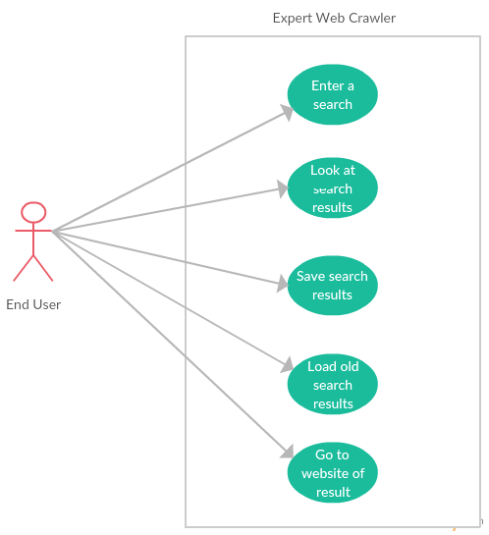
8. Preliminary Use Case Models and Sequence Diagrams
8.1 Use Case Model

8.2 Sequence Diagrams

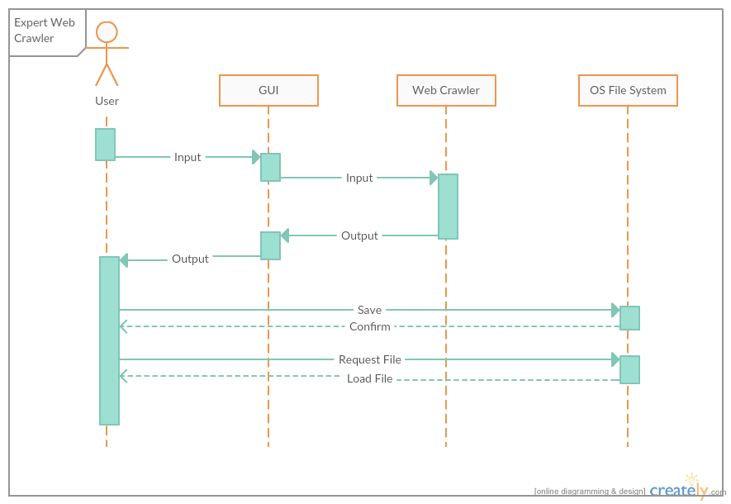
9. Updated Schedule

9. Updated Schedule
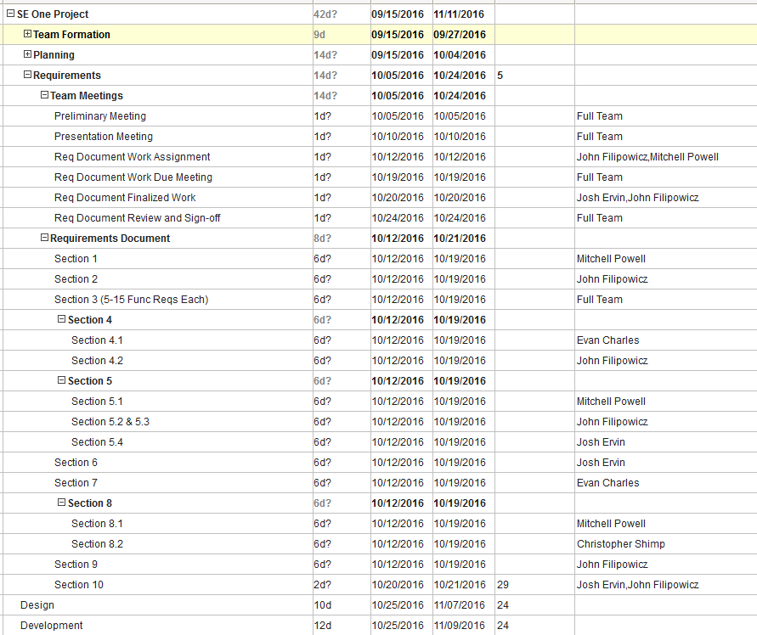

10. Appendices
10.1 Definitions, Acronyms, Abbreviations
1. Hyperlink: a link from a hypertext file or document to another location or file, typically activated by clicking on a highlighted word or image on the screen.
2. Snippet: Immediate surrounding context of the searched key term
3. Key term/ term: User provided input for the search.
4. GUI: Graphical User Interface
5. URL: Uniform Resource Locator
6. Depth: User provided input in the form of an integer specifying how deep the web crawler is to search.
7. Query: Search
10.2 References
N/A

