

A DOMAIN-SPECIFIC LANGUAGE APPROACH TO SUPPORT MONITORING AND SURVEILLANCE WITHIN WHOLESALE ELECTRICITY MARKETS

ERIC CHARLES GRASBY
May 2027

A dissertation submitted to the Graduate School
University of Arkansas at Little Rock

in partial fulfillment of the requirements for the degree of
DOCTOR OF PHILOSOPHY
in Computer and Information Science
Information Quality Track

in the Department of Information Science
in the College of Science, Technology, Engineering, and Math (CSTEM)

APPROVED BY

Committee Chair:
Professor name, Professor of Information Science, UA Little Rock
Co-chair:
Maria Gingras, Lead Market Monitor, Southwest Power Pool, Inc.

Committee members:
Dr. Elizabeth Pierce, Professor of Information Science, UA Little Rock
Dr. Ningning Wu, Professor of Information Science, UA Little Rock

Graduate School Dean:
Brian C. Berry, Professor of Chemistry
© 2027 by Eric Charles Grasby
All rights reserved.

Fair Use

This dissertation is protected by the copyright laws of the United States (Title 17 of the United States Code, revised in December 2022). Consistent with fair use as defined in Section 107 of Title 17, brief quotations from this material are allowed with proper acknowledgment. Use of this material for financial gain without the author’s express written permission is not allowed.

Duplication

I authorize the Head of Interlibrary Loan or the Head of Archives at the Ottenheimer
Library at the University of Arkansas at Little Rock to arrange for duplication of this dissertation for educational or scholarly purposes when so requested by a library user. The duplication will be at the user’s expense.

Abstract

This dissertation investigates an intersection between multiple domains of expertise related to electric markets and electric market monitoring. These domains are: 1) data and information quality, 2) language engineering, and 3) knowledge management. Electricity markets present unique opportunities for deriving new value from data and information assets due to the enormous volume of data generated, each day, by public utilities, transmission and market operators, and regulators. These data assets are critically necessary to both ensuring reliable operation of the North American Bulk Electric System (BES), as well as operating efficient markets for selling energy on a wholesale scale. The outcomes of these markets have tangible, long-term impacts on system reliability, prices for residential and commercial energy consumers, and electricity infrastructure development. Due to the complex nature of energy marketplaces, there are abundant opportunities for market participants to manipulate these markets. Market monitors are the professionals who work to ensure that the markets utilizing the BES remain fair, efficient, and open access in the face of such manipulative actions. They perform routine surveillance and forensic analysis to identify instances of fraud and market manipulation and refer such cases to regulatory authorities.
This research investigates the efficacy of designing and implementing a layer of abstraction between market monitors and the data that they use to perform their forensic analysis. Using domain-specific programming language engineering and information quality principles, the intent is to develop a system to ease data manipulation for market monitors.
Dedication
For anyone that has struggled with suicidal ideation, their mental health, their identity, or finding their place in the world, I want you to know this — I understand. I have been there. We are all in this together. This dissertation is my love letter to the world. I am thankful that I am still here to write it. Should this research bring any benefit to society, then it is dedicated to my fellow misfits.
And for my friend, Brenda (Fuller) Vammen. The world lost you too young. This achievement is for you, too.

Acknowledgements

Many people lent me their support during the development of this dissertation, and I am happy to acknowledge them here. My sincere thanks go to my research advisors, Dr. Daniel Berleant and Dr. Maria Gingras. Both took an interest in me and helped me shape my ideas for this research.
Dr. Berleant has been an instructor to me since the days of my undergraduate degree. I am thankful to have had the opportunity to perform my first rigorous research project under a professional of his caliber. Dr. Gingras (Maria) is both a professional and personal mentor to me, and I am thankful that she lent her time to become an affiliate faculty member of UA Little Rock and join my dissertation committee. Maria holds a wealth of knowledge in the market monitoring discipline, and her instruction, mentorship, and encouragement have made a tremendous difference in my life.
My thanks also go to other members of my dissertation committee, Dr. Elizabeth Pierce and Dr. Ningning Wu. The guidance that I have received from each of you throughout my academic career has been nothing short of a blessing. I must also thank Dr. John Talburt, who encouraged me to join the information quality program at UA Little Rock many years ago.
I also wish to acknowledge the contributions of my coworkers and friends within the Market Monitoring Unit (MMU) at Southwest Power Pool. Many of my colleagues in the MMU have lent their expertise to help me succeed in my work, and I could not have completed my dissertation without their support. Special thanks go to my colleague: Mark Rouse. Mark has been both a mentor and a friend for several years now, and I’m glad to be able to acknowledge him here.
Finally, I want to say thank you to my family for their support in helping me reach this point in my life, as well as my girlfriend, Rebecca Lush, who always makes sure that I take care of myself.

Protocol or IRB Approval Statement

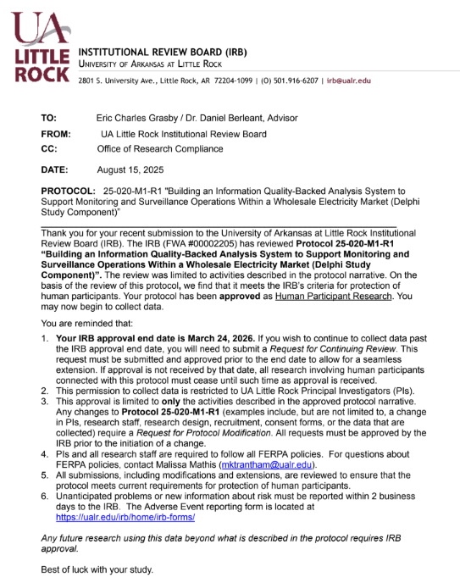

Table of Contents
List of Figures viii
List of Tables ix
List of Symbols, Abbreviations, and Nomenclature x
Chapter 1: Introduction 1
The North American Bulk Electric System 2
An Introduction to Electricity Markets 4
References 6

List of Figures
Figure 1 – Overall Cost of Energy, SPP Integrated Marketplace [3] [4] [5] [6] 2
Figure 2 - A Conceptual Illustration of the Bulk Electric System [7] 3

List of Tables
The list of tables is required if you present any numerical or textual information as tables in your manuscript, even if there is only one table. Each table in the list must have a number, a caption, and the page number on which it appears.

If you didn’t have a list of figures, you can auto-generate the list of tables using the list of figures instructions. However, if you have both figures and tables, the list of tables will have to be typed manually. You may need to make an appointment with a UA Little Rock thesis editor to get help with this part of the formatting if you don’t know how to create a manual list of tables.

Delete this page if not applicable to your manuscript.

List of Symbols, Abbreviations, and Nomenclature
APAC Asian-Pacific Region
AS Ancillary Services
BES Bulk Electric System
CRM Capacity Reserve Margin
DA Day-Ahead Market (DAMKT)
DSL Domain-Specific Language
DSRM Design Science Research Methodology
DQ Data Quality
EMEA Europe, the Middle-East, and Africa region
ETL Extract-Transform-Load
FERC Federal Energy Regulatory Commission
GPL General-Purpose Language
HHI Herfindahl-Hirschman Index
IQ Information Quality
ISO Independent System Operator
LMP Locational Marginal Price
MMU Market Monitoring Unit
MP Market Participant
MW Megawatt
NERC North-American Energy Reliability Corporation
RTO Regional Transmission Organization
RT Real-Time Market
SME Subject Matter Expert
SOX Sarbanes-Oxley Act of 2002
TCR / FTR Transmission Congestion / Financial Transmission Rights
TO / TOP Transmission Owner / Transmission Operator

Chapter 1: Introduction
This dissertation introduced information quality research into the electricity market monitoring industry, a regulatory component of organized electric markets in the United States [1]. Organized electric markets are a critical component of the North American Bulk Electric System (BES) and its function to reliably and economically deliver power to consumers. Often touted as the “world’s largest machine” [2] by electrical industry staff, the BES has become important to the lives of virtually every resident of the United States, Canada, and a portion of Mexico.
Given the high volume and value of transactions across multiple energy products, there are abundant incentives for market participants (MP) to manipulate these markets. Market monitors are the group of professionals that work to ensure that the electricity markets utilizing the BES remain fair, efficient, and open access. They ensure this by identifying and referring behavior that violates established marketplace rules to the Federal Energy Regulatory Commission (FERC). Wholesale markets clear billions of dollars (USD) in revenue each year. Figure 1 displays overall energy consumption and cost for one of these markets (Southwest Power Pool – SPP) from 2020 to 2023.
To illustrate the opportunity that superimposing information quality research on the market monitoring domain presents, this chapter shall introduce the concepts of the BES, electric markets, market monitoring, and provide details as to how applying information quality concepts to market monitoring will address a previously unsolved problem within the industry.

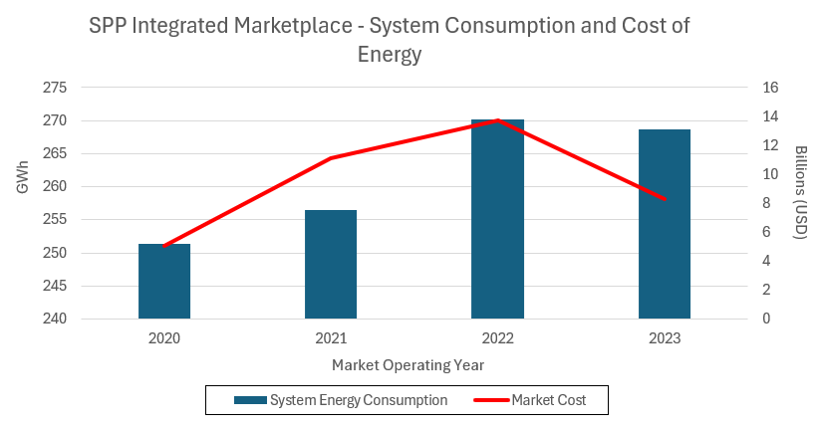
Figure 1 – Overall Cost of Energy, SPP Integrated Marketplace [3] [4] [5] [6]

The North American Bulk Electric System
The BES is a highly integrated system that facilitates the transmission of electric power (generalized as “energy”) from generation to energy consumption (generalized as a “load”) in a real-time and balanced manner. Built with more than 500,000 miles [REF HERE – 9] of physical transmission cabling and over 70,000 electrical substations [REF HERE – 10], the BES constantly serves energy to North American consumers and industries alike. With few (relatively recent) exceptions, energy is not stored in the system; it is generated (in response to a demand forecast) and then immediately transmitted and consumed by various loads. Figure 2 shows a conceptual configuration of some of the components involved in the operation of the BES.

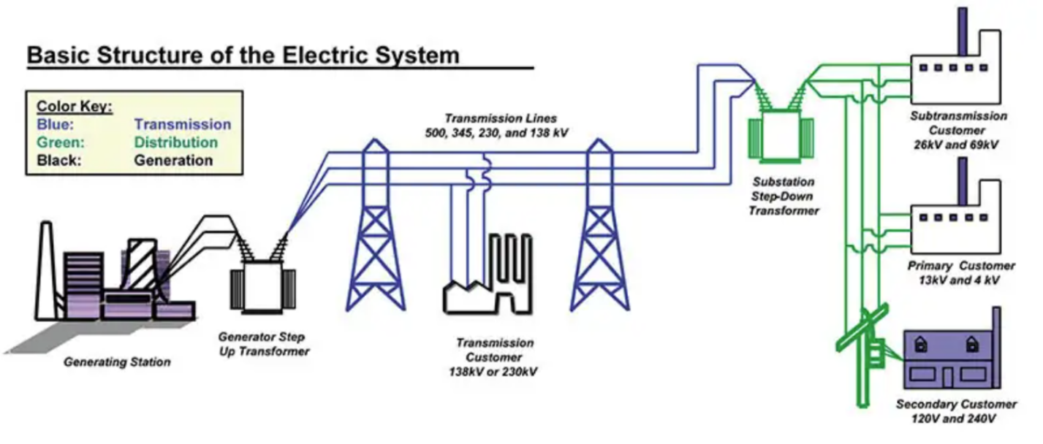
Figure 2 - A Conceptual Illustration of the Bulk Electric System [7]

The BES must always be precisely managed to balance power across the system and to exactly serve load. Deviations can create instances of voltage and frequency instability that have the potential to significantly damage BES infrastructure. Oftentimes, these deviations are caused by larger environmental events, such as periods of extreme hot or cold weather. Demand for electricity increases during these events, as do generator outages and fuel delivery problems [REF HERE]. No one entity manages the entire BES. Instead, this job is shared across different types of regional entities covering different geographic locales. This dissertation focuses, specifically, on organized markets, which pool resources managed by a Regional Transmission Organization (RTO) or an Independent System Operator (ISO). These entities serve multiple roles; their primary role is to function as grid operators.
These organizations frequently act as Reliability Coordinators (RC) and Balancing Authorities (BA), monitoring power flows, balancing the grid, and acting to restore system reliability during and after emergencies. They also operate energy markets. The RTO/ISO dispatches individual resources, in economic order, while respecting system constraints (a complex optimization concept termed security constrained economic dispatch [SCED]). It also serves as a revenue-neutral clearing house for the bulk of energy and transmission-related transactions (as well as various financial products).
Serving these various functions to provide electricity generates enormous amounts of data on an hourly basis. This data is diverse in terms of sourcing, formatting, usage, sensitivity, and volume. It is these data assets (those generated by the operation of the BES) that serve as the focus of this dissertation, specifically the data generated by electricity markets.

An Introduction to Electricity Markets
A large portion of the BES includes centrally organized electricity markets. These markets are of great importance to all stakeholders involved in the BES; they allow energy to be economically generated and purchased at the wholesale level.
Types of Markets
Electricity markets are designed to serve one of several purposes. ISOs typically deploy and operate these different market designs, in concert, as a marketplace [REF HERE]. Southwest Power Pool’s (SPP) Integrated Marketplace is such an example of this. To understand the scope of market monitoring activities, it is important to understand the main energy market designs that exist today. Arguably, there are five main types of electric energy market designs; each design may be deployed with possible variations on its theme (a marketplace that does not operate the function of a capacity market is one such example). Reference Table 1 for information on prevailing design types.

Market Type | Purpose
Capacity | Allows a load to purchase an agreement of firm capacity for service in the future, usually on the scale of months to years in the future.
Day-Ahead (DA) | Allows buyers and sellers to secure positions a day before the market sells energy to be consumed (operating day). This aids in realistic price formation.
Real-Time (RT) | Allows for adjustments between the DA market (what was expected on the day prior) and the system conditions that happen on the operating day.
Ancillary Services (AS) | Allows other providers to sell products that support grid reliability. For example, the ability of a generator to quickly “ramp up” to a certain production requirement is such a product sold in an AS market.
Transmission Congestion Rights (TCR) | Allows participants to hedge against congestion on the transmission system (adequate power can be produced in an area, but there may be difficulties in transmitting it to where it is consumed).
Table 1 - Prevailing Electricity Market Designs

BES Complexity and Energy Markets
The BES is a physical system upon which we superimpose a conceptual, economic market. This dichotomy is part of what makes energy markets so complex to both understand and govern with the data that they generate. Physical machines require continuous diagnostics to ensure that they are operating 1) effectively and 2) within adequate maintenance tolerances. The BES is no different.
Thermal generators that produce electricity are monitored for metrics, including wattage output, fuel consumption, and greenhouse gas emissions. High voltage transmission lines are monitored for temperature (heat is generated via electricity loss across conductors) and short-circuit events. Substations are monitored for transformer faults, tap configurations, and other mechanical system measurements. Each of these values is typically transmitted in a time-series format, resulting in constant streams of monitoring data. These time-series data streams are typically parsed into market intervals that constitute “units of work” for market activity.
Chapter 2: Literature Review

References

[1] | FERC, "An Introductory Guide to Electricity Markets regulated by the Federal Energy Regulatory Commission," Federal Energy Regulatory Commission, [Online]. Available: https://www.ferc.gov/introductory-guide-electricity-markets-regulated-federal-energy-regulatory-commission. [Accessed 18 11 2024].
[2] | N. Stenvig, "Exploring the world's largest machine," Oak Ridge National Laboratory, [Online]. Available: https://www.ornl.gov/blog/nils-stenvig-exploring-worlds-largest-machine. [Accessed 01 11 2024].
[3] | SPP Market Monitoring Unit, "2020 Annual State of the Market Report," 2021. [Online]. Available: https://www.spp.org/documents/65161/2020%20annual%20state%20of%20the%20market%20report.pdf. [Accessed 09 04 2024].
[4] | SPP Market Monitoring Unit, "2021 Annual State of the Market Report," 2022. [Online]. Available: https://www.spp.org/documents/67104/2021%20annual%20state%20of%20the%20market%20report.pdf. [Accessed 09 04 2025].
[5] | SPP Market Monitoring Unit, "2022 Annual State of the Market Report," 2023. [Online]. Available: https://www.spp.org/documents/69330/2022%20annual%20state%20of%20the%20market%20report.pdf. [Accessed 09 04 2024].
[6] | SPP Market Monitoring Unit, "2023 State of the Market Report," 2024. [Online]. Available: https://www.spp.org/documents/71645/2023%20annual%20state%20of%20the%20market%20report%20v2.pdf. [Accessed 09 04 2025].
[7] | A. Devasia, "Everything You Need to Know about NERC CIP Compliance," Safe and Sound Security, 26 9 2023. [Online]. Available: https://getsafeandsound.com/blog/what-is-nerc-cip-certification/. [Accessed 01 11 2024].
[8] | U.S. Department of Energy, "How it Works: The Role of a Balancing Authority," 08 2023. [Online]. Available: https://www.energy.gov/sites/default/files/2023-08/Balancing%20Authority%20Backgrounder_2022-Formatted_041723_508.pdf. [Accessed 19 03 2025].
[9] | National Renewable Energy Laboratory (NREL), "Explained: Causes of Three Recent Major Blackouts and What is Being Done in Response," [Online]. Available: https://www.nrel.gov/docs/fy24osti/87308.pdf. [Accessed 01 04 2025].
[10] | Federal Energy Regulatory Commission, "Electric Power Markets | Federal Energy Regulatory Commission," Federal Energy Regulatory Commission, [Online]. Available: https://www.ferc.gov/electric-power-markets. [Accessed 01 11 2024].
[11] | J. Koolemans-Beynen, "The Role of the Independent Market Monitor around the World," [Online]. Available: https://www.superservicios.gov.co/sites/default/files/inline-files/johanna\_presentation\_independent\_market\_monitor\_presentations2.pdf. [Accessed 01 11 2024].
[12] | National Renewable Energy Labs (NREL), "National transmission analysis maps next chapter of US grid evolution," National Renewable Energy Laboratory, 2024. [Online]. Available: https://www.nrel.gov/news/features/2024/national-transmission-planning-study.html. [Accessed 09 04 2025].

Across the time frame shown in Figure 1, the observed market generated an average revenue of over $9.5 billion, serving and average energy load of over 261 GWh. This figure was generated using data combined from multiple public reports [3] [4] [5] [6].
The North American Electric Reliability Corporation (NERC) serves as the Electric Reliability Operator (ERO) for the BES. In their Glossary of Terms (see References section), the BES refers to all high-voltage transmission lines and substations, generation resources, and all other equipment used in both inter/intra-state transmission of electric capacity.
The term “balancing” refers to the need to only generate power as it is needed for consumption, subject to system capacity and economic constraints.
Storage resources are a developing technology that can store energy for dispatch during reliability emergencies or intervals of energy scarcity
An important distinction to note is between the utility and retail sectors, shown in Figure 2. While referred to by several names (i.e. wholesale), utility generation and transmission refers to bulk energy (on the scale of MW) that is transmitted on the BES. The retail sector involves distribution of energy to residences and low consumption (on the scale of kW) commercial enterprises. This research focuses on wholesale energy markets and thus is concerned with the bulk energy generation and transmission domains.
Notable weather events that have materially impacted BES reliability include the 2020 Californian heat wave, as well as severe winter weather storms in 2021 and 2022 [REF HERE]
Economic order refers to the stacking of generator energy offers, in order, from least expensive to most expensive.
Economic dispatch (ED) is a concept that blends economics and the physical reality of the electric grid.

