

A DOMAIN-SPECIFIC LANGUAGE APPROACH TO SUPPORT MONITORING AND SURVEILLANCE WITHIN WHOLESALE ELECTRICITY MARKETS

ERIC CHARLES GRASBY
May 2027

A dissertation submitted to the Graduate School
University of Arkansas at Little Rock

in partial fulfillment of the requirements for the degree of
DOCTOR OF PHILOSOPHY
in Computer and Information Science
Information Quality Track

in the Department of Information Science
in the College of Science, Technology, Engineering, and Math (CSTEM)

M.S. in Information Quality, University of Arkansas at Little Rock, 2020.
G.C. in Information Quality, University of Arkansas at Little Rock, 2020.
B.Sc. in Information Science, University of Arkansas at Little Rock, 2018.
This dissertation, “A Domain-Specific Language Approach to Support Monitoring And Surveillance Within Wholesale Electricity Markets”, by Eric C. Grasby is approved by:

Committee Chair: _______________________________
J. Daniel Berleant Professor of Information Science

Co-chair: _______________________________
Maria Gingras
Lead Market Monitor, SPP

Committee Members: _______________________________
Dr. Elizabeth Pierce
Professor of Information Science

_______________________________
Dr. Ningning Wu
Professor of Information Science

Program Coordinator: _______________________________
Dr. John Talburt
Professor of Information Science

Graduate School Dean: _______________________________
Dr. Brian C. Berry
Professor of Chemistry

© 2027 by Eric Charles Grasby
All rights reserved.

Fair Use

This dissertation is protected by the copyright laws of the United States (Title 17 of the United States Code, revised in December 2022). Consistent with fair use as defined in Section 107 of Title 17, brief quotations from this material are allowed with proper acknowledgment. Use of this material for financial gain without the author’s express written permission is not allowed.

Duplication

I authorize the Head of Interlibrary Loan or the Head of Archives at the Ottenheimer
Library at the University of Arkansas at Little Rock to arrange for duplication of this dissertation for educational or scholarly purposes when so requested by a library user. The duplication will be at the user’s expense.

Abstract

This dissertation investigates an intersection between multiple domains of expertise related to electric markets and electric market monitoring. These domains are: 1) data and information quality, 2) language engineering, and 3) knowledge management. Electricity markets present unique opportunities for deriving new value from data and information assets due to the enormous volume of data generated, each day, by public utilities, transmission and market operators, and regulators. These data assets are critically necessary to both ensuring reliable operation of the North American Bulk Electric System (BES), as well as operating efficient markets for selling energy on a wholesale scale. The outcomes of these markets have tangible, long-term impacts on system reliability, prices for residential and commercial energy consumers, and electricity infrastructure development. Due to the complex nature of energy marketplaces, there are abundant opportunities for market participants to manipulate these markets. Market monitors are the professionals who work to ensure that the markets utilizing the BES remain fair, efficient, and open access in the face of such manipulative actions. They perform routine surveillance and forensic analysis to identify instances of fraud and market manipulation and refer such cases to regulatory authorities.
This research investigates the efficacy of designing and implementing a layer of abstraction between market monitors and the data that they use to perform their forensic analysis. Using domain-specific programming language engineering and information quality principles, the intent is to develop a system to ease data manipulation for market monitors.
Dedication
For anyone that has struggled with suicidal ideation, their mental health, their identity, or finding their place in the world, I want you to know this — I understand. I have been there. We are all in this together. This dissertation is my love letter to the world. I am thankful that I am still here to write it. Should this research bring any benefit to society, then it is dedicated to my fellow misfits.
And for my friend, Brenda (Fuller) Vammen. The world lost you too young. This achievement is for you, too.

Acknowledgements

Many people lent me their support during the development of this dissertation, and I am happy to acknowledge them here. My sincere thanks go to my research advisors, Dr. Daniel Berleant and Dr. Maria Gingras. Both took an interest in me and helped me shape my ideas for this research.
Dr. Berleant has been an instructor to me since the days of my undergraduate degree. I am thankful to have had the opportunity to perform my first rigorous research project under a professional of his caliber. Dr. Gingras (Maria) is both a professional and personal mentor to me, and I am thankful that she lent her time to become an affiliate faculty member of UA Little Rock and join my dissertation committee. Maria holds a wealth of knowledge in the market monitoring discipline, and her instruction, mentorship, and encouragement have made a tremendous difference in my life.
My thanks also go to other members of my dissertation committee, Dr. Elizabeth Pierce and Dr. Ningning Wu. The guidance that I have received from each of you throughout my academic career has been nothing short of a blessing. I must also thank Dr. John Talburt, who encouraged me to join the information quality program at UA Little Rock many years ago.
I also wish to acknowledge the contributions of my coworkers and friends within the Market Monitoring Unit (MMU) at Southwest Power Pool. Many of my colleagues in the MMU have lent their expertise to help me succeed in my work, and I could not have completed my dissertation without their support. Special thanks go to my colleague: Mark Rouse. Mark has been both a mentor and a friend for several years now, and I’m glad to be able to acknowledge him here.
I want to say thank you to my family for their support in helping me reach this point in my life, as well as my girlfriend, Rebecca Lush, who always makes sure that I take care of myself and that I go to bed on time.
And, finally, to Caroline – “may you always live in interesting times.”
Protocol or IRB Approval Statement



Table of Contents
List of Figures xi
List of Tables xii
List of Symbols, Abbreviations, and Nomenclature xiii
Chapter 1: Introduction 1
The North American Bulk Electric System 2
An Introduction to Electricity Markets 5
Entities 6
Independent System Operator (ISO) 6
Regional Transmission Operator (RTO) 7
Types of Markets 8
BES Complexity and Energy Markets 9
The Fall of Enron Corporation 11
Skills of a Market Monitor 14
Market Monitoring Firms 16
The Case for Information Quality Research in Market Monitoring 16
Conducting Information Quality Research in Market Monitoring 17
Subject Matter Expert (SME) Discussions 18
Design Science Methodology 18
Proposed Investigation 20
Limitations of this Research 21
Chapter 2: Literature Review 22
An Aging Workforce 22
Application to Market Monitoring Research 23
DSL Variations 26
Chapter 3: System Requirements and Use-Cases 28
Chapter 4: Proof-of-Concept Prototype Development 29
Chapter 5: System Evaluation 30
Chapter 6: Conclusion and Future Work 31
References 32
Appendix 34
Appendix A: IRB Certificates 34
Appendix B: Search Queries Used in Literature Review 34
Appendix C: Schedule of Research Milestones 34
Appendix D: Public Market Data Sources 34
Appendix E: Market Monitoring Firms 34
Appendix F: Delphi Study Questions 34

List of Figures
Figure 1 – Overall Cost of Energy, SPP Integrated Marketplace [3] [4] [5] [6] 2
Figure 2 - A Conceptual Illustration of the Bulk Electric System [7] 3
Figure 3 - Prevailing Energy Market Territories [1] 5
Figure 4 - Diverse Skill Sets of a Market Monitor 15
Figure 5: Design Science Research Methodology for this Dissertation 20

List of Tables
- Table 1: Prevailing Electricity Market Designs…………………………………………… 6
- Table 2: Prominent Cases of Market Manipulation …………………………………….. XX
- Table 3: Selection of Well-Known Domain-Specific Languages ………………………. XY

List of Symbols, Abbreviations, and Nomenclature
- APAC Asian-Pacific Region
- AS Ancillary Services
- BES Bulk Electric System
- CRM Capacity Reserve Margin
- DA Day-Ahead Market (DAMKT)
- DSL Domain-Specific Language
- DSRM Design Science Research Methodology
- DQ Data Quality
- EMEA Europe, the Middle-East, and Africa region
- ETL Extract-Transform-Load
- FERC Federal Energy Regulatory Commission
- GPL General-Purpose Language
- HHI Herfindahl-Hirschman Index
- IQ Information Quality
- ISO Independent System Operator
- LMP Locational Marginal Price
- MMU Market Monitoring Unit
- MP Market Participant
- MW Megawatt
- NERC North-American Energy Reliability Corporation
- RTO Regional Transmission Organization
- RT Real-Time Market
- SCADA Supervisory Control and Data Acquisition
- SCED Security-Constrained Economic Dispatch
- SME Subject Matter Expert
- SOX Sarbanes-Oxley Act of 2002
- TCR / FTR Transmission Congestion / Financial Transmission Rights
- TO / TOP Transmission Owner / Transmission Operator

Chapter 1: Introduction
This dissertation introduced information quality research into the electricity market monitoring industry, a regulatory component of organized electric markets in the United States [1]. Organized electric markets are a critical component of the North American Bulk Electric System (BES) and its function to reliably and economically deliver power to consumers. Often touted as the “world’s largest machine” [2] by electrical industry staff, the BES has become important to the lives of virtually every resident of the United States, Canada, and a portion of Mexico.
Given the high volume and value of transactions across multiple energy products, there are abundant incentives for market participants (MP) to manipulate these markets. Market monitors are the group of professionals that work to ensure that the electricity markets utilizing the BES remain fair, efficient, and open access. They ensure this by identifying and referring behavior that violates established marketplace rules to the Federal Energy Regulatory Commission (FERC). Wholesale markets clear billions of dollars (USD) in revenue each year. Figure 1 displays overall energy consumption and cost for one of these markets (Southwest Power Pool – SPP) from 2020 to 2023.
To illustrate the opportunity that superimposing information quality research on the market monitoring domain presents, this chapter shall introduce the concepts of the BES, electric markets, market monitoring, and provide details as to how applying information quality concepts to market monitoring will address a previously unsolved problem within the industry.

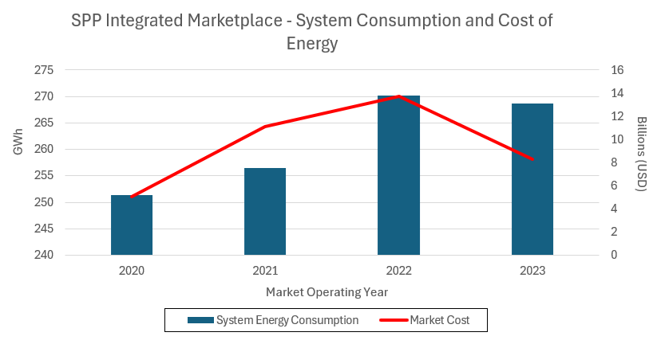
Figure 1 – Overall Cost of Energy, SPP Integrated Marketplace [3] [4] [5] [6]

The North American Bulk Electric System
The BES is a highly integrated system that facilitates the transmission of electric power (generalized as “energy”) from generation to energy consumption (generalized as a “load”) in a real-time and balanced manner. Built with more than 500,000 miles [REF HERE – 9] of physical transmission cabling and over 70,000 electrical substations [REF HERE – 10], the BES constantly serves energy to North American consumers and industries alike. With few (relatively recent) exceptions, energy is not stored in the system; it is generated (in response to a demand forecast) and then immediately transmitted and consumed by various loads. Figure 2 shows a conceptual configuration of some of the components involved in the operation of the BES.

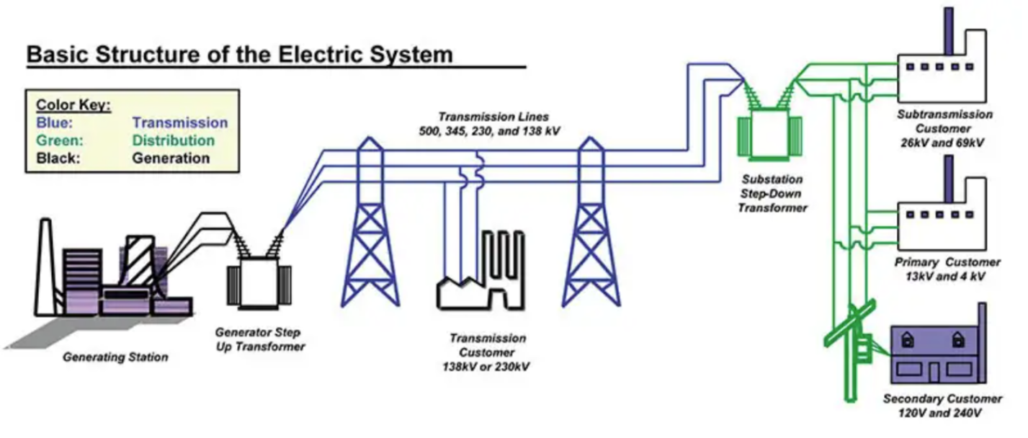
Figure 2 - A Conceptual Illustration of the Bulk Electric System [7]

The BES must always be precisely managed to balance power across the system and to exactly serve load. Deviations can create instances of voltage and frequency instability that have the potential to significantly damage BES infrastructure. Oftentimes, these deviations are caused by larger environmental events, such as periods of extreme hot or cold weather. Demand for electricity increases during these events, as do generator outages and fuel delivery problems [REF HERE]. No one entity manages the entire BES. Instead, this job is shared across different types of regional entities covering different geographic locales. This dissertation focuses, specifically, on organized markets, which pool resources managed by a Regional Transmission Organization (RTO) or an Independent System Operator (ISO). These entities serve multiple roles; their primary role is to function as grid operators.
These organizations frequently act as Reliability Coordinators (RC) and Balancing Authorities (BA), monitoring power flows, balancing the grid, and acting to restore system reliability during and after emergencies. They also operate energy markets. The RTO/ISO dispatches individual resources, in economic order, while respecting system constraints (a complex optimization concept termed security constrained economic dispatch [SCED]). It also serves as a revenue-neutral clearing house for the bulk of energy and transmission-related transactions (as well as various financial products).
Serving these various functions to provide electricity generates enormous amounts of data on an hourly basis. This data is diverse in terms of sourcing, formatting, usage, sensitivity, and volume. It is these data assets (those generated by the operation of the BES) that serve as the focus of this dissertation, specifically the data generated by electricity markets.

An Introduction to Electricity Markets
A large portion of the BES includes centrally organized electricity markets. These markets are of great importance to all stakeholders involved in the BES; they allow energy to be economically generated and purchased at the wholesale level.
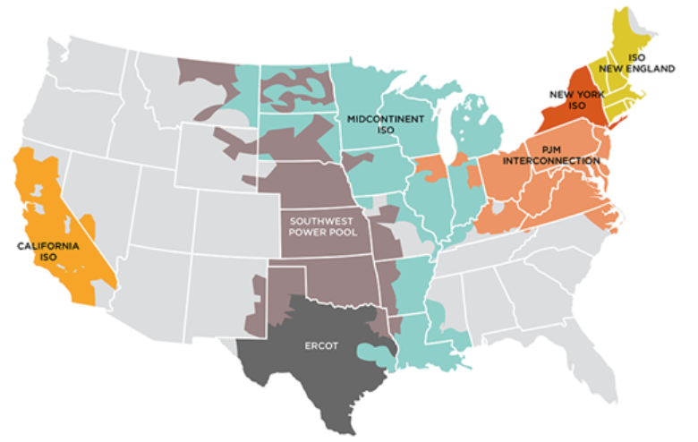
Figure 3 - Prevailing Energy Market Territories [1]

Figure 3 displays, at a high level, how the US energy grid is divided into different territories and notes the name of the entity that runs the organized market. These territories are typically governed by FERC, with the exception of Texas.

Entities
Electricity markets are operated by a small number of operational entities within North America. These entities mostly fall under the jurisdiction of FERC (see Figure XXYY). The prominent entities that are impacted by market monitoring include Independent System Operators (ISO) and Regional Transmission Organizations (RTO). These entities are filed as non-profit businesses and typically perform similar functions. FERC Orders 888 and 889 initiated the formalized incorporation of an ISO, while FERC Order 2000 set forth the criteria that differentiate an ISO from an RTO.

Independent System Operator (ISO)
ISOs are organizations that manage power generation and transmission across the bulk electric system. They operate in an advisory capacity for generation owners (public and investor-owned utilities, as well as independent power producers), transmission owners, and operators to effectively generate and trade power in an energy market. A common, helpful analogy that describes the function of an ISO is an air-traffic controller.
Air-traffic controllers merely monitor and route airplane traffic across the airspace over the United States. They own neither physical airplanes nor airlines, and function only as advisors to ensure safe passage of both private and commercial aircraft. ISOs work in a similar fashion. For example, the ISO over the California energy market territory (CAISO) owns none of the transmission infrastructure across which electric power is shipped. However, CAISO manages the flow of energy across this system and sends regular dispatch instructions to the generators that inject power into the BES.

Regional Transmission Operator (RTO)
RTOs are another entity that manage organized markets. They are categorized by a group of four core characteristics (and an additional seven broad operational functions) that separate them from being classified as ISOs. RTOs and ISOs share many similarities. Their operations are regulated by the same government entities, namely FERC and NERC, and they both have the same, conceptual goal: to reliably generate and deliver energy at competitive rates.
Both entities influence and deploy energy products and maintain both the configuration of their operating territory as well as the flow of energy across the BES. They also both support development and maintenance of open access transmission tariffs (OATT) that allow for unprejudiced access to energy under US federal law. And, most relevant to this research, they are both required to employ a market monitoring group to screen their organized markets for cases of market manipulation.
Their differences primarily lie in how their corporate structures are filed. Both types of entities must be registered non-profit organizations. However, ISOs have more flexibility where impartiality is concerned. RTOs work to maintain independence from their market participants and strictly focus on system reliability and economic efficiency. While ISOs are also concerned with these goals, they can, additionally, lobby government on behalf of their members.

Types of Markets
Electricity markets are designed to serve one of several purposes. ISOs typically deploy and operate these different market designs, in concert, as a marketplace [REF HERE]. Southwest Power Pool’s (SPP) Integrated Marketplace is such an example of this. To understand the scope of market monitoring activities, it is important to understand the main energy market designs that exist today. Arguably, there are five main types of electric energy market designs; each design may be deployed with possible variations on its theme (a marketplace that does not operate the function of a capacity market is one such example). Reference Table 1 for information on prevailing design types.

Market Type | Purpose
Capacity | Allows a load to purchase an agreement of firm capacity for service in the future, usually on the scale of months to years in the future.
Day-Ahead (DA) | Allows buyers and sellers to secure positions a day before the market sells energy to be consumed (operating day). This aids in realistic price formation.
Real-Time (RT) | Allows for adjustments between the DA market (what was expected on the day prior) and the system conditions that happen on the operating day.
Ancillary Services (AS) | Allows other providers to sell products that support grid reliability. For example, the ability of a generator to quickly “ramp up” to a certain production requirement is such a product sold in an AS market.
Transmission Congestion Rights (TCR) | Allows participants to hedge against congestion on the transmission system (adequate power can be produced in an area, but there may be difficulties in transmitting it to where it is consumed).
Table 1: Prevailing Electricity Market Designs

BES Complexity and Energy Markets
The BES is a physical system upon which we superimpose a conceptual, economic market. This dichotomy is part of what makes energy markets so complex to both understand and govern with the data that they generate. Physical machines require continuous diagnostics to ensure that they are operating 1) effectively and 2) within adequate maintenance tolerances. The BES is no different.
Thermal generators that produce electricity are monitored for metrics, including wattage output, fuel consumption, and greenhouse gas emissions. High voltage transmission lines are monitored for temperature (heat is generated via electricity loss across conductors) and short-circuit events. Substations are monitored for transformer faults, tap configurations, and other mechanical system measurements. Each of these values is typically transmitted in a time-series format, resulting in constant streams of monitoring data. These time-series data streams are typically parsed into market intervals that constitute “units of work” for market activity. Much of the analysis performed on wholesale electricity markets utilizes data secured from market intervals. Depending on the type of market that is under observation, an interval may range from a span of several seconds (dispatch instructions) to “between five and fifteen minutes” [REF HERE] (for calculation of real-time market prices).
These diagnostic data are only a fraction of the data that are used in the operation of the BES, and much of it feeds into market systems to calculate a realistic price of power at different locations throughout a market territory. Once the market solves, and locational prices are calculated, the market then must be settled. Market settlements are another area of market operations that generates complex and voluminous data. In SPP’s Integrated Marketplace , the Marketplace Protocols set forth an extensive settlement plan that determines how charges and credits are calculated and assigned to market participants. These settlement instructions also cover events where the market must be “repriced”, or re-settled, due to external factors that occur during the operation of a market, such as equipment outages, data communication errors, or extreme weather events.
What is Market Monitoring?
Market monitoring is a discipline that sits at the intersection of two major knowledge domains: forensics and economics. As such, it takes a scientific approach to testing and analyzing transactions that occur within a marketplace. According to a report published by the United States Energy Association (USEA), Market Monitoring is a necessary component of markets “to ensure that market(s) participants cannot exercise market power, collude or engage in any behavior that could give them a market share, or higher profits” [REF HERE].This need places the authority to request and analyze records generated by the operation of electricity markets into the hands of market monitoring units (MMUs).
Market monitors will generally screen for MP behavior that matches the following criteria:
- Exercised (or attempts to exercise) positions of market power
- Market gaming through oversights in current market protocols or policy (usually outlined in a governing document, known as a tariff).
- Committed cases of market manipulation through acts of collusion, cross-product manipulation, malevolent influence on price formation, or untoward manipulation schemes (economic withholding, uneconomic production, wash trades, “pump and dump” schemes, etc.)

The Fall of Enron Corporation
The Enron Corporation, a former American-based commodities and energy broker, is a well-known case study in American corporate governance (or, rather, lack thereof). The fall of Enron (first signaled in late 2000) uncovered deep, systemic problems of fraud and deceptive business practices that directly influenced both the market monitoring and information quality (IQ) disciplines. Outwardly, Enron appeared to be a stable and innovative company. At the turn of the century, Enron’s books reflected and ownership of $60 billion in assets. This included an internet-based energy trading desk (“Enron Online”) that cleared $2.5 billion in daily energy transactions [REF HERE]. Enron management, in reality, operated under a culture of willful non-compliance, including (but not limited to):
- Energy withholding practices that sometimes caused enormous energy prices in the California wholesale energy market
- Artificial energy shortages causing regular blackouts within the California service territory
- Scheduling energy transactions with the intent of inflating congestion on California’s electric transmission system
- Accounting fraud (enabled by a creative used of “mark-to-market” based accounting) which allowed Enron to report expected revenues before they were realized
These manipulative schemes had widespread impacts, including: 1) the bankruptcy of one of the largest utility companies in California, Pacific Gas and Electric (PG&E), 2) rolling blackouts, 3) increased transmission system congestion, and 4) higher than normal electricity bills for California ratepayers.
Enron’s activities constituted both fraud and a behavior known as market manipulation; a form of conduct that attempts to willfully circumvent established market rules in pursuit of (usually) large profits. Their usage of market manipulation, especially in California, was a signal to federal regulators that, at that time, there was not enough oversight into the operation of electricity markets. As a result, the United States Congress passed the Energy Policy Act of 2005 to introduce more stringent regulation over the energy industry.
Enron’s downfall resulted in a near-complete devaluation of their stock, the dismantling of Arthur Andersen (the auditor assigned to ensure that Enron was operating within the confines of financial reporting law), and a slew of legislation serving as the impetus for energy market monitoring in the United States. Additionally, Enron’s scandal was a significant contributor to the passing of the Sarbanes-Oxley (SOX) Act 0f 2002, imposing strict and detailed requirements on data that is used as input for financial reporting. As a result, SOX became another driving force in the implementation of information quality as both an academic discipline and as a business function.
In the years following the disbanding of Enron Corporation, FERC has pursued many more instances of deceptive behavior in organized energy markets. Through the help of market monitors and FERC enforcement staff, manipulation cases can be pursued and penalized before they become even more critical threats. Table 2 lists several high-profile cases of market manipulation that are distinct from the Enron case [REF HERE] [REF HERE] [REF HERE].

MP | Damages | Incident
JP Morgan (2013) | $410 mm | Purchased and operated antiquated generation plants and offered them into the market as competitive generators
GreenHat Energy, LLC (2021) | >$229 mm | Participated in insider trading to purchase enormous positions in PJM’s congestion market
Vitol Group (2024) | $2.3 mm | Sold physical power at a loss in the DA market to favor their transmission congestion positions (a behavior known as “cross-product manipulation”)
Table 2: Prominent Cases of Market Manipulation

Skills of a Market Monitor
Market monitors are one of several groups that function as “unsung heroes” in electricity markets (and within the larger context of the North American BES). The work that they perform on a routine basis helps to ensure a reliable and economically sound marketplace for buying and selling energy and energy-adjacent ancillary services. Market monitoring units are typically staffed with analysts from a wide variety of both technical and non-technical backgrounds. These include data analysts, statisticians, economists, accountants, technical writers, engineers, and other corporate staff dedicated to investigating events that occur in their jurisdictional markets.
Figure 4 illustrates a cross-section of several of the skill sets that market monitoring analysts might possess, based on the researcher’s experience of working as a market monitor within Southwest Power Pool’s (SPP) MMU. As one may imagine, it can be difficult to find an individual contributor that possesses an all-encompassing understanding of each of these knowledge areas.
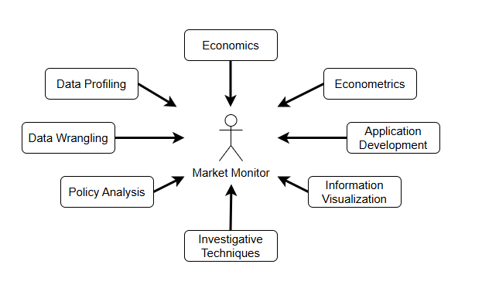
Figure 4 - Diverse Skill Sets of a Market Monitor
Market monitors have a wide breadth of responsibilities that must be covered by their individual skill sets. Routine market surveillance is a continuous process that must evolve with the behaviors and trading patterns of market participants. As such, market monitors observe and investigate market bids and offers made each operating data, analyze generator behavior to identify erratic response to dispatch commands, ensure that participants are not covertly colluding or engaging in price fixing, review out-of-market transactions that take place through bilateral settlement schedules (BSS), and ensure that RTOs and ISOs are acting within the rules defined by their FERC-approved tariff documents (excluding ERCOT, which does not fall under FERC jurisdiction).

Market Monitoring Firms
The current groups involved with electricity market monitoring (both in North America and internationally) include the organizations compiled in Appendix E. This list is not intended to be exhaustive, as other nations in the Asian-Pacific (APAC) and Middle Eastern (EMEA) regions of the world may not be reflected here. This roster of organizations with market monitoring authority illustrates the number of individuals that are involved with market monitoring on an international scale.

The Case for Information Quality Research in Market Monitoring
As stated above, market monitoring encompasses a wide range of activities and demands a mix of skill sets. These skill sets must be applied with the knowledge learned over time from others in the industry. Such activities include gathering transactional market data for screening, calculating metrics for market power and concentration analysis (for example, the classic Herfindahl-Hirschman Index [HHI] or the Residual Supply Index [RSI]), mitigating abuses of local market power by market participants, and performing policy analysis to determine efficient market design [REF HERE] [REF HERE]. It also requires calculating known system metrics, Capacity Reserve Margin (CRM) for example, and developing new metrics to measure and track market performance. Data collection, processing, and analysis enables each of these activities, but knowledge of how to make decisions on these data is typically learned through on-the-job training.
In Overview of Data Quality: Examining the Dimensions, Antecedents, and Impacts of Data Quality, one of the antecedents that can directly affect data quality is “information overload” [REF HERE]. This can be especially true in market monitoring, where users must derive a decision by “fusing” data from many different sources. In instances where users are not familiar with the sources, this has potential impact on both accuracy and trust in the final product.
As an example in an adjacent industry (electric utilities), Oyoo’s work in data validation for power and utilities organizations showed that information quality can contribute to the development and maintenance of Extract-Transform-Load (ETL) processes [REF HERE]. In this example, electric utilities may prioritize data templating and formatting over accuracy and trust. Market monitoring cannot afford to make this trade-off. Market monitors work in complex and high-volume data environments. Systems deployed in these environments must be accessible and user-friendly to help market monitors handle the inherent data and information complexity.

Conducting Information Quality Research in Market Monitoring
The case study of Enron Corporation sets both a unique and compelling stage for the role that information quality and information-science based research can play in improving the business impact of an independent market monitor. Included amidst Enron Corporation’s numerous failures of governance are a lack of access and an understanding of the complex data generated by the energy industry. The operation of such a large system and marketplace can lead to many siloed data stores, undocumented schemas, and a slew of other information quality-based problems that can also be seen in market monitoring.
Furthermore, the cross-section of skills that market monitors must possess (to effectively perform their job functions) also underscores the importance that data literacy and data quality improvement hold in the market monitoring domain. Both data and system architecture plans, proposed as part of the deliverables of this dissertation, are paramount to designing a system to aid market monitoring staff in their work.

Subject Matter Expert (SME) Discussions
The potential use of this dissertation is driven, in part, by the opinions of subject matter experts in the field of electric energy. In support of this investigation, the researcher has consulted multiple members (in different sectors) of the industry, including two (2) professionals in enterprise asset management, and a separate discussion with a staff member in energy regulation. One such staff member, Kennedy Oyoo, performed information systems research in a different sector of the energy grid, “power and utilities”, focusing on the distribution of electricity to end users.
Energy utilities struggle with a similar issue to those faced by market monitors – siloed data exists in different systems, and can exist with vastly different data quality scores (in terms of completeness, accuracy, etc.) Oyoo’s research found that a key step (data validation) was missing from the ETL processes of an energy utility. Part of the research completed in his project resulted in an information template-based prototype system that cleansed and validated utility data according to automated assertion rules [REF HERE]. Such a methodology has potential impacts for the market monitoring discipline, and may have an influence on the resulting system architecture of this dissertation.

Design Science Methodology
The roadmap of this project is based on the Design Science Research Methodology (DSRM), a research process for developing new product artifacts. The researcher chose DSRM for this project because the main research objective is to design and develop a domain-specific language for market monitors to use in their analysis.
Data and information quality problems exist today in the market monitoring body of knowledge that a DSL-based system can help address:

- Analysts in different teams that arrive at different values when trying to quantify metrics (market impact, for example)
- Lack of robust metadata assets such as data dictionaries and well-defined data stewardship roles
- Lack of a mature change management program for software (which, in turn, can impact report reproducibility)
- A lack of full automation and meta-automation, causing analysts to spend time performing tedious ETL and archival tasks

Domain-specific languages are powerful models for allowing users to systematically solve problems within a specific domain. As is discussed in the literature review (see Chapter 2), DSLs have had only limited exposure in electricity markets (and even less exposure in market monitoring). This discovered gap in existing research, complemented by the DQ and IQ issues discussed in the review, serves as the inspiration for this project. Figure XXYYAA provides more detail on the planned use of design science within this project.

Proposed Investigation
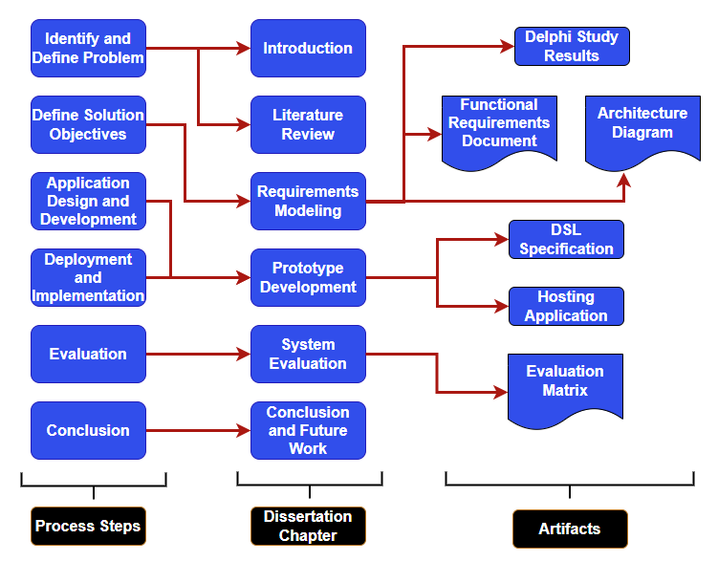Figure 5: Design Science Research Methodology for this Dissertation
In What Design Science Is Not (2008), Baskerville states that one view of design science is to be generative. That is, design science leads to the generation of artifacts that then influence the formulation of a theory [REF HERE]. This prospect of generativity seems to indicate that a design can be formed and improved based upon empirical evidence. Due to this idea, the researcher chose to employ a Delphi study (as the methodology for gathering expert sentiment) to influence the design of the DSL prototype discussed in this dissertation. The requirements solicitation chapter shall discuss the setup, conduct, and results of a Delphi study employed in market monitoring. It shall also explain how the results of this study influenced the design of the proof-of-concept system.
Overall, the investigation methodology for this dissertation is composed of five (5) main components. These components include 1) a literature review, 2) a Delphi study to gather opinion and synthesize system requirements, 3) a system architecture design, 4) development of the prototype system (and associated tooling and documentation), and 5) an evaluation discussion to determine to what degree the resultant software satisfies the system requirements.

Limitations of this Research
The scope of work proposed in this dissertation is limited to the objectives outlined in the Error: Reference source not found section. Specifically, it shall ultimately evaluate how well the developed prototype functions as a minimal viable product (MVP) for energy market analysis.
The proof-of-concept system discussed in this dissertation is not intended to be a production-ready system. It is also not expected to be used in a live scenario for market monitors to immediately put into service to support decision making. The data ingested into the proof-of-concept system will be based on realistic data scraped from public data systems shown in Appendix D. The evaluation of this system will be based on a matrix (mapping back to the functional requirements defined in Chapter 4) that “scores” how well the functionality of the prototype supports the intended requirements.
Further system optimization, bug fixes, scalability concerns, and use in live market monitoring scenarios are all considered “out of scope” for this dissertation and are reserved for future work. The researcher, however, may pursue future enhancements to this system as separate research endeavors.

Chapter 2: Literature Review
A review of the literature surrounding information quality research within market monitoring units signals that there is room for improvement in how value is generated from information assets. This gap is highlighted by several major issues (introduced in Chapter 1 and discussed in this literature review), including:
- Development of technology surrounding domain-specific language engineering
- An aging workforce in the electric utilities industry that is reaching the tipping point for replacement
- A lack of existing research on data and information quality within the market monitoring sphere
- A disruption of traditional energy market design due to advances in technology and the energy regulatory landscape
These issues represent a unique opportunity to obtain important value from the data assets both generated and used by professionals in the market monitoring sphere. The researcher will discuss each of these issues in the context of relevant literature, then introduce specific possible sources of data that enable the development of a domain-specific language for market monitors.

An Aging Workforce
Many technical industries are experiencing the problem of an aging workforce; trained professionals are reaching retirement age at a rate faster than that of replacement. A 2006 study showed that the largest staff segment, of a surveyed group of energy professionals, is at (or beyond) retirement age. This same study cited “retirements, restructuring, and technology changes” as being the primary drivers of staff leaving the energy professional [REF HERE]. Given the age of this study, many industries are currently going through a period of training new career professionals. Such a problem impacts market monitoring as well.
MMUs (as previously discussed) were cemented into operation by the US federal government, not long before that same 2006 study. An energy research lab at UC Berkeley shows that staffing across market monitoring groups is relatively low compared to other organizations in the industry. According to Goldman, Lesieutre, and Bartholomew, all operational market monitoring groups in the US had fewer than 20 FTEs (each) in employ by 2004 [REF HERE].
While these numbers appear low in comparison to other organizations with energy industry staff, this study declares that budgets and headcount (at that time) increased significantly for market monitoring work. As such, this shows a trend of growing demand for market monitoring staff in a workforce that, holistically, employs many individuals on (or beyond) the horizon of retirement. One claim to helping combat this “brain drain” problem is a technology framework that “facilitates knowledge retention” [REF HERE], including systems (supported by an IT organization) that capture necessary process knowledge.

Application to Market Monitoring Research
Domain-specific programming languages (DSLs) are powerful interfaces that subject-matter experts (SME), in any particular domain of expertise, to perform tasks similar to a proper software developer that builds applications in general-purpose languages (GPL). A well-defined DSL can save many hours of development time for specific groups that have IT oriented needs. DSLs also have the ability to lower the “barriers to entry” for SMEs that wish to write applications to handle work within their purview. With support from a DSL, a software engineer does not need to be deeply involved in business rules to understand how to develop an application (a common issue in the energy industry). Likewise, SMEs do not need to heavily codify their business rules into software requirements for an application to be developed when utilizing a domain-specific language.
Following the theme of how DSLs are able to abstract away complexity of big data processing tasks, this research aims to bring such a tool set to bear on tasks performed in energy market monitoring. Commands embedded into a domain-specific language have the potential to speed up many repetitive tasks in the market monitoring domain, especially regarding the generation of reports and stakeholder presentations.
An Analysis of Domain-Specific Languages
Consider programming languages on a spectrum from general purpose languages (GPLs) at one end to domain-specific languages (DSLs) on the opposite end [REF HERE]. DSLs are languages that are limited in purpose, scope, and grammar. Rather than supporting a programming language that can be utilized for constructing almost anything (as GPLs do), DSLs are created to solve issues within a single problem domain.

Language | Supporting Enterprise | Problem Domain | Paradigm
Structure Query Language (SQL) | Various | Data Retrieval | Declarative
Terraform (HCL) | Hashicorp | Cloud Infrastructure | Declarative
Apache Pig  (“Pig Latin”) | Yahoo, Apache Software Foundation | Data Retrieval | Declarative
awk | Bell Labs (originally) | Text Processing | Procedural
Table 3: Selection of Well-Known Domain-Specific Languages

Structured Query Language (SQL) [REF HERE] is one such example of a DSL. SQL queries are designed to retrieve data from databases for extraction, reference, and analysis. SQL dialects have been designed to interface across a broad range of database management systems (for example: PL/SQL for Oracle or T-SQL for Microsoft SQL Server databases).
Terraform (HCL) [REF HERE], a product of Hashicorp Corporation, is yet another example of a domain-specific language that is prevalent among cloud-based companies. Terraform is known as an "infrastructure-as-code" language, used to interact with numerous cloud platform providers (e.g. Amazon Web Services) to quickly deploy, scale, and spin-down cloud resources. Instead of requiring an engineer to use a console environment to configure cloud resources, that same engineer can write a set of scripts that will precisely configure and deploy all of their desired infrastructure at once.
Apache Pig [REF HERE] (and its associated programming language “Pig Latin”) is also a DSL. It is a declarative language used for data retrieval and processing. Developers at Yahoo created Pig as a way to abstract some of the complexity of SQL away from analysts who were working with large datasets. With fewer lines of code, an analyst could use Pig to parse and load a dataset into memory, perform processing tasks, and format and report the results. This was specifically useful to analysts processing large datasets because Pig was designed to take advantage of the high-performance computing facilities of Hadoop.
Yet another powerful example of DSLs can be seen in the ubiquitous Unix program: awk [REF HERE]. Originally created by Unix developers Aho, Weinberger and Kerninghan , awk is a scripting language designed to process textual data— one line at a time. The power of this systems allows individuals to write expressions that are simple to understand, efficient, and portable across different Linux implementations. Countless developers (including the author of this dissertation) have made use of awk’s utilities to process and format data in a headless environment.
Each of the languages represented in this review are, on their own, infeasible for writing general purpose applications. SQL, for example, should not be used to write a desktop program. They were, instead, each created to solve specific issues within their respective problem domains. Likewise, Terraform cannot be used to create web applications or develop billing software. One of the "upsides" of these languages are that they can quickly handle tasks within a specific problem domain.

DSL Variations
Each of the language examples provided here share a common characteristic in that they are external DSLs. They are interpreted and executed by a runtime program. This trait of DSLs separates them from another subset of domain-specific languages: internal DSLs. These are embedded languages (sometimes referred to as fluent interfaces) that rely on (usually) general-purpose languages to parse their individual syntactic structures and execute logic. These DSL features are sometimes referred to as syntactic sugar [REF HERE], implying that they make the experience of developing solutions in them “sweeter” than without them.
Another common characteristic of DSLs lies in the fact that they are often text-based programming environments. As discussed later in this literature review, graphical domain-specific languages also exist. These are usually seen in the form of either enterprise extract- transform-load (ETL) applications or language workbenches. Jetbrains MPS is a prominent example of the power of graphical DSL representations. Business users are usually positioned to take advantage of these product offerings because they pose abstract interfaces (environments that allow users to graphically model what they want instead of having to explicitly write source code in a general purpose language). With basic instruction, users can string together components that construct repeatable workflows without requiring them to possess deep programming knowledge.

Extant Domain-Specific Language Use Cases in the Energy Sector
The literature uncovered in this review supports the claim that DSLs can achieve high efficacy in financial contexts. Krasts, Kleins, and Teilans (2012) illustrates how domain-specific languages have been used in modeling the complex dynamics of financial settlements systems. Financial settlements often encounter errors during the settlement of a market. Using a DSL for modeling tasks, in these scenarios, appears to help developers and business users clearly visualize computer systems logic [REF HERE].
The literature, even more interestingly, shows that DSLs have been deployed in other areas of the energy sector, as identified by Sobernig, Strembeck, and Beck [REF HERE] in Developing a Domain Specific Language for Scheduling in the European Energy Sector. While this paper sets precedent for the use of DSLs in the energy industry, it presents an even larger gap that this dissertation addresses. Beck’s study explores employing a DSL to assist in tagging and scheduling energy interchange (which is an operational concern that only encompasses a single component of market monitoring). Additionally, and far more importantly, the implementation of their DSL was constrained to specific market interconnection in Europe, which is significantly less complex than the transmission and congestion issues that are seen throughout the North American Bulk Electric System. Market monitoring, while interested in aspects of transmission scheduling, encompasses a much broader scope of analytics in the energy sector.

The Data Domain in Market Monitoring
The data domain in market monitoring entities is a large ecosystem. It is common for monitoring analysts to synthesize information both from internal and external data sources. This type of ecosystem can quickly become a data swamp without careful attention to business rules and the possession of institutional knowledge for how processes are executed on market information.
FERC Order 760, a key piece of legislation that directly relates to this dissertation, is one such example of how market data is sourced and utilized by analysts. It dictates several key categories of data that RTO/ISO organizations must regularly provide to the Commission. Such data includes [REF HERE]:
- Supply offers and demand bids for energy and ancillary services
- Virtual offers and bids
- Energy/ancillary service awards
- Capacity market offers, designations, and prices
- Resource (electricity generation) output
- Marginal cost estimates
- Day-ahead market (DA) shift factors
- Financial Transmission Right (FTR) data
- Bilateral Contracts
- Interchange transactions (otherwise known as “scheduling and tagging”)

Understanding how to source and use this information impacts the accuracy of market monitoring analysis and enables FERC to accurately assess and penalize instances of market manipulation. Defined by the industry terms “ex-ante” and “ex-post”, assessments of market performance, market power, and market manipulation can be carried out prior to an event, or “after the fact” – when a market event has already occurred [REF HERE].

Public Data Systems for Wholesale Energy Markets
In a similar manner to how market operators provide regular data to FERC, RTOs and ISOs also regularly publish data that allows the general public a view into the operation and settlement of these markets. Table XXYYAS lists the existing systems that this research can utilize for test data. Much of the data contained in these systems match the data requirements for FERC Order 760 (though some identifiers may be omitted or obfuscated to preserve confidentiality).
The researcher intends to source data assets that model market conditions (especially for price formation) from these systems, and use such data for demonstrating the abilities of the prototype system, including: 1) visualization generator, 2) report creation, and 3) shadow calculations. The data assets that may be necessary to produce the demonstration deliverables include public records such as generator names and physical parameters, generation outages, transmission line data, and component data used to calculate marginal prices (energy, loss, and congestion factors).
Publishing Entity | Data Repository Name
PJM Corporation | Data Miner 2
Monitoring Analytics | Member Information Reporting Application (MIRA)
Electric Relability Council of Texas (ERCOT) | Market Data Transparency Service
California Independent System Operator (CAISO) | OASIS & Data Library
Midcontinent Independent System Operator (MISO) | MISO Data Exchange
Southwest Power Pool (SPP) | Public Data Portal
New York Independent System Operator (NYISO) | Operational Data Portal
Independent System Operator of New England (ISO-NE) | ISO Express
US Energy Information Administration (EIA) | Wholesale Energy Market Reports
Table 4: Public Energy Market Data Systems

Chapter 3: System Requirements and Use-Cases
Design science shall be used as the primary method of investigation in this dissertation due to its ability to derive insights from the development of new artifacts. However, design science is only a process that guides the investigation. To effectuate this process, the researcher has developed the following plan to build and evaluate a software system (powered by a domain-specific programming language) for potential use in the professional domain of energy market monitoring.
The plan includes the following details (illustrated by Figure YYYY):
- A literature review to both introduce the research area and to establish relevance and novelty
- A Delphi-based study using a panel of experts (within market monitoring) to identify the current needs of these experts, including:
  - The current landscape of a market monitor’s workflow
  - Perspectives from the entire market monitoring community, including market monitors that work outside of the United States
- A comprehensive data and system architecture plan for setting up and operating a DSL-enabled data analysis system
- Development of a prototype system to serve as a proof-of-concept for using a DSL in the context of market monitoring analysis
- Develop a traceability matrix [REF HERE] that can serve as a method of evaluation, for this system, to ensure that the prototype serves the intended functional requirements
- A discussion of the performance of the system (as this also impacts the system’s usability)
These deliverables shall be joined together to form a software system (for which a domain-specific language is the primary user interface). To aid in drawing quantitative conclusions from this system, the researcher plans to develop a traceability matrix from the requirements contained in the functional requirements document (FRD). This matrix will be joined to the test cases (TC) that are crafted directly from the requirements in the FRD.
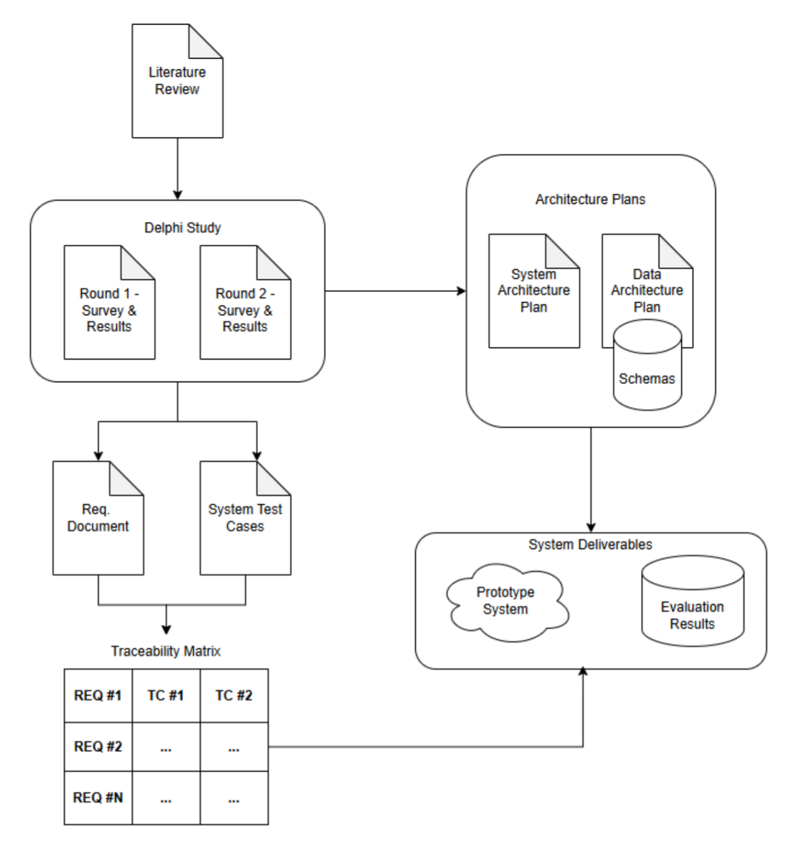Figure 6: Flowchart of Project Deliverables
There is precedent for the use of a traceability matrix when evaluating prototypical software. Ye utilized this approach in A Positive Data Control System for the Automation of Data Governance Functions. Ye’s research identified a table of ten (10) system conditions that should be considered in the development of a data control system [REF HERE]. Ye then evaluated this prototype to determine how closely the artifact conformed to those requirements.
Such a scheme for system evaluation is advantageous because it helps to calculate overall system scores – which are useful when determining if such a software application meets the needs of the intended user base. These scores are often used in data quality settings where quality is gauged on a percentage basis. As an example, a metric that may be computed while evaluating the proof-of-concept system is a conformance score of the number of test cases that pass for a given requirement (e.g. requirement ID R1.0.0). This example is illustrated by the following equation:
CONFORMANCE SCORE FORMULA GOES HERE
Another possible evaluation score is the number of test cycles completed to ensure that all test cases pass for a specific requirement. This evaluation scheme is also helpful because the researcher can justify why a given requirement may have changed (or been removed) during the design and development phases of this research. This traceability matrix is intended to be completed in concert with the requirements document, which is ultimately dependent on the completion of the Delphi study.

Requirements Solicitation via Delphi Study
As was previously discussed in this research, energy market monitoring is a niche industry. While data analytics is a common practice across most industries, there are undoubtedly analysis concepts that are unique to the practices of market monitors. It follows that the sensible way to design a language, one that is usable to market monitors, is to solicit the requirements from the users themselves. This technique is advantageous for several reasons:
- Users often think about what tools and techniques would make their jobs more efficient to perform
- In market monitoring, users most likely range in levels of experience, ensuring that the resulting system design is approachable and useful to analysts at different levels of expertise
- Given that the language (and associated tooling) shall help aid with on-boarding and knowledge transition for new employees, it is important to identify what issues current market monitors encounter when on-boarding new employees

Study Design
To effectuate the process of prompting the users for system requirements, the researcher chose to proctor a Delphi study – recruiting any member of the market monitoring community that wished to participate and share their thoughts.
The researcher opened recruitment for this expert panel to the Energy Intermarket Surveillance Group (EISG), a professional governing body of market monitors from around the globe. Parameters for recruitment into the Delphi study expert panel include the following:
- Participants must be over the age of 18
- Participants must be a member of the EISG
By identifying these parameters, the researcher can maintain a baseline of relevance. This helps to ensure that the survey questions posed in this study are answered by the same individuals that may (potentially) use such an analysis system. Before administering any questions (and before beginning recruitment) the researcher developed an investigation protocol and submitted the protocol in its entirety to the UA Little Rock Institutional Review Board (IRB). The IRB classified this Delphi study as human participant research. A link to the research protocol and the waiver of informed consent (provided to the panelists) is included in a GitHub repository, maintained by the researcher, at the following address: https://github.com/echarlesgrasby/dissertation/blob/master/ext/Delphi_WaiverInformedConsent_Grasby.pdf

Study Conduct
The study was conducted in two (2) rounds, where a “round” corresponds to a list of survey-style questions that were provided to the panelists. The questions included a mix of free-form text response questions, multiple choice questions, and questions provided in a Likert-style format. The questions were crafted and stored in Google Forms surveys (using UA Little Rock’s managed Google productivity suite) and “responder-ready” links were provided to the panelists via email.
The initial link was sent to the entire EISG population and members were provided with a “cut-off” time to provide their responses (at which point, round 1 was considered closed and no new responses were accepted). Participants who provided responses before the cut-off date constituted the Delphi panel. At the end of the first round, the EISG had a confirmed registration of 131 members; this Delphi panel consisted of 19 participants. This yielded a response rate of 19/131 (roughly a 15% response rate) for the first round of the study.

Chapter 4: Proof-of-Concept Prototype Development
Placeholder

Chapter 5: System Evaluation
Placeholder

Chapter 6: Conclusion and Future Work
Placeholder

References

[1] | FERC, "An Introductory Guide to Electricity Markets regulated by the Federal Energy Regulatory Commission," Federal Energy Regulatory Commission, [Online]. Available: https://www.ferc.gov/introductory-guide-electricity-markets-regulated-federal-energy-regulatory-commission. [Accessed 18 11 2024].
[2] | N. Stenvig, "Exploring the world's largest machine," Oak Ridge National Laboratory, [Online]. Available: https://www.ornl.gov/blog/nils-stenvig-exploring-worlds-largest-machine. [Accessed 01 11 2024].
[3] | SPP Market Monitoring Unit, "2020 Annual State of the Market Report," 2021. [Online]. Available: https://www.spp.org/documents/65161/2020%20annual%20state%20of%20the%20market%20report.pdf. [Accessed 09 04 2024].
[4] | SPP Market Monitoring Unit, "2021 Annual State of the Market Report," 2022. [Online]. Available: https://www.spp.org/documents/67104/2021%20annual%20state%20of%20the%20market%20report.pdf. [Accessed 09 04 2025].
[5] | SPP Market Monitoring Unit, "2022 Annual State of the Market Report," 2023. [Online]. Available: https://www.spp.org/documents/69330/2022%20annual%20state%20of%20the%20market%20report.pdf. [Accessed 09 04 2024].
[6] | SPP Market Monitoring Unit, "2023 State of the Market Report," 2024. [Online]. Available: https://www.spp.org/documents/71645/2023%20annual%20state%20of%20the%20market%20report%20v2.pdf. [Accessed 09 04 2025].
[7] | A. Devasia, "Everything You Need to Know about NERC CIP Compliance," Safe and Sound Security, 26 9 2023. [Online]. Available: https://getsafeandsound.com/blog/what-is-nerc-cip-certification/. [Accessed 01 11 2024].
[8] | U.S. Department of Energy, "How it Works: The Role of a Balancing Authority," 08 2023. [Online]. Available: https://www.energy.gov/sites/default/files/2023-08/Balancing%20Authority%20Backgrounder_2022-Formatted_041723_508.pdf. [Accessed 19 03 2025].
[9] | National Renewable Energy Laboratory (NREL), "Explained: Causes of Three Recent Major Blackouts and What is Being Done in Response," [Online]. Available: https://www.nrel.gov/docs/fy24osti/87308.pdf. [Accessed 01 04 2025].
[10] | Federal Energy Regulatory Commission, "Electric Power Markets | Federal Energy Regulatory Commission," Federal Energy Regulatory Commission, [Online]. Available: https://www.ferc.gov/electric-power-markets. [Accessed 01 11 2024].
[11] | National Renewable Energy Labs (NREL), "National transmission analysis maps next chapter of US grid evolution," National Renewable Energy Laboratory, 2024. [Online]. Available: https://www.nrel.gov/news/features/2024/national-transmission-planning-study.html. [Accessed 09 04 2025].
[12] | J. Koolemans-Beynen, "The Role of the Independent Market Monitor around the World," [Online]. Available: https://www.superservicios.gov.co/sites/default/files/inline-files/johanna\_presentation\_independent\_market\_monitor\_presentations2.pdf. [Accessed 01 11 2024].

Appendix

Appendix A: IRB Certificates
Placeholder

Appendix B: Search Queries Used in Literature Review
Google Scholar and IEEE Xplore were the primary academic databases that were queried for this dissertation.

High-level searches used to find seminal articles in the areas of energy markets, market monitoring, and domain-specific languages:
- MARKET MONITORING
- MARKET MONITORING AND DOMAIN SPECIFIC LANGUAGE
- DOMAIN-SPECIFIC LANGUAGE AND BULK ELECTRIC SYSTEM
- DOMAIN SPECIFIC LANGUAGE AND FORENSICS
- DOMAIN-SPECIFIC LANGUAGE

Boolean and grouping operators were also employed to narrow the scope of the relevant articles returned for this literature review. Some of the queries included:
- “MARKET MONITORING” AND (‘DOMAIN SPECIFIC LANGUAGE” OR “DOMAIN-SPECIFIC LANGUAGE”)
- “MARKET MONITORING” AND (“DOMAIN SPECIFIC LANGUAGE” OR “DOMAIN-SPECIFIC LANGUAGE”) AND (“ELECTRIC” OR “ELECTRICITY”) -STOCK
- (“INFORMATION QUALITY” OR “DATA QUALITY”) (“ELECTRICITY MARKET” OR “POWER MARKET” OR “ELECTRIC MARKET”)
- (“INFORMATION QUALITY” OR “DATA QUALITY”) (ELECTRICITY OR POWER OR ELECTRIC OR ENERGY) MARKET
- ("INFORMATION QUALITY" OR "DATA QUALITY") (ELECTRICITY OR POWER OR ELECTRIC OR ENERGY) "MARKET MONITORING"
- ("INFORMATION QUALITY" OR "DATA QUALITY") (ELECTRICITY OR POWER OR ELECTRIC OR ENERGY) WHOLESALE "MARKET MONITORING" -LABOR -LABOUR -"FINANCIAL MARKET"
- ALLINTITLE: WHOLESALE "INFORMATION QUALITY" OR "DATA QUALITY" OR ELECTRICITY OR POWER OR ELECTRIC OR ENERGY "MARKET MONITORING"
-LABOR -LABOUR -"FINANCIAL MARKET"
- ALLINTITLE: ELECTRICITY “INFORMATION QUALITY” OR “DATA QUALITY” OR “MARKET MONITORING” -LABOR -LABOUR (“dOMAIN-SPECIFIC LANGUAGE” OR “DOMAIN SPECIFIC LANGUAGE”) (“ELECTRICITY OR ELECTRIC OR POWER OR ENERGY)

Appendix C: Schedule of Research Milestones
Placeholder

Appendix D: Public Market Data Sources
Placeholder

Appendix E: Market Monitoring Firms
Placeholder

Appendix F: Delphi Study Questions
Placeholder

Across the time frame shown in Figure 1, the observed market generated an average revenue of over $9.5 billion, serving and average energy load of over 261 GWh. This figure was generated using data combined from multiple public reports [3] [4] [5] [6].
The North American Electric Reliability Corporation (NERC) serves as the Electric Reliability Operator (ERO) for the BES. In their Glossary of Terms (see References section), the BES refers to all high-voltage transmission lines and substations, generation resources, and all other equipment used in both inter/intra-state transmission of electric capacity.
The term “balancing” refers to the need to only generate power as it is needed for consumption, subject to system capacity and economic constraints.
Storage resources are a developing technology that can store energy for dispatch during reliability emergencies or intervals of energy scarcity
An important distinction to note is between the utility and retail sectors, shown in Figure 2. While referred to by several names (i.e. wholesale), utility generation and transmission refers to bulk energy (on the scale of MW) that is transmitted on the BES. The retail sector involves distribution of energy to residences and low consumption (on the scale of kW) commercial enterprises. This research focuses on wholesale energy markets and thus is concerned with the bulk energy generation and transmission domains.
Notable weather events that have materially impacted BES reliability include the 2020 Californian heat wave, as well as severe winter weather storms in 2021 and 2022 [REF HERE].
Economic order refers to the stacking of generator energy offers, in order, from least expensive to most expensive.
Economic dispatch (ED) is a concept that blends economics and the physical reality of the electric grid.
ERCOT, the electric system operator for Texas, is not within the jurisdiction of FERC. The Public Utility Commission of Texas, instead, has oversight of the ERCOT market territory. Alaska and Hawaii, additionally, maintain isolated electricity infrastructure.
The entities referred to in this chapter are not limited to the 2 categories listed. They also include Transmission Owners and Operators (TOs / TOPs), Regional Entities (RE), Balancing Authorities (Bas), Reliability Coordinators (RCs), and Federal Power Agencies. Oftentimes, an RTO or ISO will also support one or more of these functions (SPP, for example, hosts operational desks for performing reliability coordination).
While market systems are composed of many different products, they are generally referred to as a market clearing engine.
Settlements are also facilitated by shadow accounting, a process of maintaining a separate system (in addition to a production accounting system) to track transactions and ensure that accounts are appropriately balanced.
Data elements used to monitor and dispatch generation in the BES are collected and shared in the form of SCADA (Supervisory Control and Data Acquisition) [REF HERE].
A blackout (an event where power cannot be served) is a breakdown of a portion of grid infrastructure, caused by “an imbalance between power generation and power consumption” [REF HERE].
As Enron entered legal proceedings, their stock fell to under $1 per share (from a peak as high as $90 per share in mid-2000) [REF HERE].
18 CFR § 1c.2 (Prohibition of Electric Energy Market Manipulation) is an example of legislation that clearly calls for the need of monitoring in energy markets.
Energy market prices are typically set on a marginal, spatial basis (representing the cost of injecting another MW of energy, at a location, in a market territory) [REF HERE].
Bilateral settlement schedules are agreements between market participants that are used to trade energy outside of normal market operations [REF HERE], which help manage credit exposure in the marketplace.
A tariff is a governing document that outlines the rules for operating (and participating in) an energy market.
The US Energy Association (USEA) published a report outlining international, independent market monitoring groups. Many of the international groups on this list come from that report (see Appendix E).
Market power is often defined as “the ability of a seller to profitably maintain prices above competitive levels for a significant period of time” [REF HERE].
CRM is a metric (computed by taking the difference between total available capacity and peak system demand) that helps identify how reliable and prepared the [BES] system has been”, in normal operations [REF HERE].
See Appendix C for a schedule of the milestones and expected completion timeline for this project.
Appendix B contains a listing of different search phrases used for locating relevant research discussed in this chapter.
As of Q1 2025, Southwest Power Pool employs over 800 FTEs (including their internal market monitoring staff).
Kosar, Tomaz, et al. Indicate the “schism” between the two languages by discussing that “GPLs tend to be general, resulting in poor support for domain-specific notation [REF HERE].”
The name “awk” is an acronym formed from the first letters of the developer’s last names.
Current issues in North America show large pockets of stranded load, which have significant economic (and, by extension, reliability) implications. Congestion on the BES constitutes a market (Financial Transmission Rights – FTR) that settles for billions of dollars. This is all due to the fact that monies must be paid to rights holders for transmitting energy across a congested transmission infrastructure.
Atlan, a leading data governance company, classifies a data swamp as a repository that possesses: poor quality, undocumented code and data schemas, and leads to situations where users must “...spend considerable time on tasks such as data discovery, cleaning, integration, and management” [REF HERE].
A “virtual” transaction (as defined by Southwest Power Pool’s glossary of terms) is a transaction for purchasing (bid) or selling (offer) energy “at a specific price, settlement location, and period of time … that is not associated with a physical load” [REF HERE].
A shift factor is a percentage based value that determines how much energy a transmission line will receive when a generator injects energy into the transmission grid [REF HERE].
See Appendix D for a list of hyperlinks to view more information on these public sources of energy market data.
The results of this panel shall serve as the basis for constructing a comprehensive software requirements document used during the development of this system.
A given professional is a member of the EISG by virtue of working for an MMU that is an organizational member of the EISG. Many of these member organizations are the same as those listed in Appendix E.
A managerial member of the EISG was contacted via email to receive permission to conduct this study prior to beginning recruitment.

