

A DOMAIN-SPECIFIC LANGUAGE APPROACH TO SUPPORT MONITORING AND SURVEILLANCE WITHIN WHOLESALE ELECTRICITY MARKETS

ERIC CHARLES GRASBY
May 2027

A dissertation submitted to the Graduate School
University of Arkansas at Little Rock

in partial fulfillment of the requirements for the degree of
DOCTOR OF PHILOSOPHY
in Computer and Information Science
Information Quality Track

in the Department of Information Science
in the College of Science, Technology, Engineering, and Math (CSTEM)

M.S. in Information Quality, University of Arkansas at Little Rock, 2020.
G.C. in Information Quality, University of Arkansas at Little Rock, 2020.
B.S. in Information Science, University of Arkansas at Little Rock, 2018.
This dissertation, “A Domain-Specific Language Approach to Support Monitoring and Surveillance Within Wholesale Electricity Markets”, by Eric C. Grasby is approved by:

Committee Chair: _______________________________
Dr. J. Daniel Berleant Professor of Information Science

Co-chair: _______________________________
Dr. Maria Gingras
Lead Market Monitor, SPP

Committee Members: _______________________________
Dr. Elizabeth Pierce
Professor of Information Science

_______________________________
Dr. Ningning Wu
Professor of Information Science

Program Coordinator: _______________________________
Dr. John Talburt
Professor of Information Science

Graduate School Dean: _______________________________
Dr. Brian C. Berry
Professor of Chemistry

© 2027 by Eric Charles Grasby
All rights reserved.

Fair Use

This dissertation is protected by the copyright laws of the United States (Title 17 of the United States Code, revised in December 2022). Consistent with fair use as defined in Section 107 of Title 17, brief quotations from this material are allowed with proper acknowledgment. Use of this material for financial gain without the author’s express written permission is not allowed.

Duplication

I authorize the Head of Interlibrary Loan or the Head of Archives at the Ottenheimer
Library at the University of Arkansas at Little Rock to arrange for duplication of this dissertation for educational or scholarly purposes when so requested by a library user. The duplication will be at the user’s expense.

Abstract

This dissertation investigates an intersection between multiple domains of expertise related to electric markets and electric market monitoring. These domains are: 1) data and information quality, 2) language engineering, and 3) knowledge management. Electricity markets present unique opportunities for deriving new value from data and information assets due to the enormous volume of data generated, each day, by public utilities, transmission and market operators, and regulators. These data assets are critically necessary to both ensuring reliable operation of the North American Bulk Electric System (BES), as well as operating efficient markets for selling energy on a wholesale scale. The outcomes of these markets have tangible, long-term impacts on system reliability, prices for residential and commercial energy consumers, and electricity infrastructure development. Due to the complex nature of energy marketplaces, there are abundant opportunities for market participants to manipulate these markets. Market monitors are the professionals who work to ensure that the markets utilizing the BES remain fair, efficient, and open access in the face of such manipulative actions. They perform routine surveillance and forensic analysis to identify instances of fraud and market manipulation and refer such cases to regulatory authorities.
This research investigates the efficacy of designing and implementing a layer of abstraction between market monitors and the data that they use to perform their forensic analysis. Using domain-specific programming language engineering and information quality principles, the intent is to develop a system to ease data manipulation for market monitors.
Dedication
For anyone that has struggled with suicidal ideation, their mental health, their identity, or finding their place in the world, I want you to know this — I understand. I have been there. We are all in this together. This dissertation is my love letter to the world. I am thankful that I am still here to write it. Should this research bring any benefit to society, then it is dedicated to my fellow misfits.
And for my friend, Brenda (Fuller) Vammen. The world lost you too young. This achievement is for you, too.

Acknowledgements

Many people lent me their support during the development of this dissertation, and I am happy to acknowledge them here. My sincere thanks go to my research advisors, Dr. Daniel Berleant and Dr. Maria Gingras. Both took an interest in me and helped me shape my ideas for this research.
Dr. Berleant has been an instructor to me since the days of my undergraduate degree. I am thankful to have had the opportunity to perform my first rigorous research project under a professional of his caliber. Dr. Gingras (Maria) is both a professional and personal mentor to me, and I am thankful that she lent her time to become an affiliate faculty member of UA Little Rock and join my dissertation committee. Maria holds a wealth of knowledge in the market monitoring discipline, and her instruction, mentorship, and encouragement have made a tremendous difference in my life.
My thanks also go to other members of my dissertation committee, Dr. Elizabeth Pierce and Dr. Ningning Wu. The guidance that I have received from each of you throughout my academic career has been nothing short of a blessing. I must also thank Dr. John Talburt, who encouraged me to join the information quality program at UA Little Rock many years ago.
I also wish to acknowledge the contributions of my coworkers and friends within the Market Monitoring Unit (MMU) at Southwest Power Pool. Many of my colleagues in the MMU have lent their expertise to help me succeed in my work, and I could not have completed my dissertation without their support. Special thanks go to my colleague: Mark Rouse. Mark has been both a mentor and a friend for several years now, and I’m glad to be able to acknowledge him here.
I want to say thank you to my family for their support in helping me reach this point in my life, as well as my girlfriend, Rebecca Lush, who always makes sure that I take care of myself and that I go to bed on time.
Protocol or IRB Approval Statement



Table of Contents
List of Figures 13
List of Tables 14
List of Symbols, Abbreviations, and Nomenclature 15
Chapter 1: Introduction 1
The North American Bulk Electric System 2
An Introduction to Electricity Markets 5
Entities 6
Independent System Operator (ISO) 7
Regional Transmission Operator (RTO) 8
Types of Markets 8
BES Complexity and Energy Markets 9
The Fall of Enron Corporation 12
Skills of a Market Monitor 15
Market Monitoring Firms 17
The Case for Information Quality Research in Market Monitoring 17
Conducting Information Quality Research in Market Monitoring 19
Subject Matter Expert (SME) Discussions 19
Design Science Methodology 20
Proposed Investigation 22
Limitations of this Research 22
Chapter 2: Literature Review 24
An Aging Workforce 25
Application for Market Monitoring Research 26
An Analysis of Domain-Specific Languages 26
DSL Variations 29
Extant Domain-Specific Language Use Cases in the Energy Sector 30
The Data Domain in Market Monitoring 31
Public Data Systems for Wholesale Energy Markets 32
Chapter 3: System Requirements and Use-Cases 34
Requirements Solicitation via Delphi Study 37
Study Design 38
Panel Composition 39
Emergent Themes from Round 1 42
Anonymized Comments from Round 1 52
Emergent Themes from Round 2 53
Anonymized Comments from Round 2 54
Identified Use-Cases 55
Chapter 4: Proof-of-Concept Prototype Development 57
Architecture Plan 57
Unified Data Layer 57
Prototype Database 57
Data Retrieval 57
Metadata 57
Language Development 57
Grammar Design 57
Language Server Protocol Support 57
User Interface 57
Chapter 5: System Evaluation 58
Chapter 6: Conclusion and Future Work 59
Introduction 59
Future Work 59
Conclusion 59
References 60
Appendix 67
Appendix A: Search Queries Used in Literature Review 67
Appendix B: Public Market Data Sources 69
Appendix C: Market Monitoring Firms 70
Appendix D: Delphi Panel Survey Questions 71
Round 1 Questions 71
Round 2 Questions 74
Appendix E: Software Bill of Materials (SBOM) 77
Appendix F: Proof-of-Concept Version History 78

List of Figures
TODO: Manually generate the list of figures here…

List of Tables
Table 1: Prevailing Electricity Market Designs……………………………………… 6
Table 2: Prominent Cases of Market Manipulation …………………………….... XX
Table 3: Selection of Well-Known Domain-Specific Languages ……………….. XY
Table 4: Public Energy Market Data Systems ……………………………………..XZ

List of Symbols, Abbreviations, and Nomenclature
- APAC Asian-Pacific Region
- AS Ancillary Services
- BES Bulk Electric System
- CRM Capacity Reserve Margin
- DA Day-Ahead Market (DAMKT)
- DSL Domain-Specific Language
- DSRM Design Science Research Methodology
- DQ Data Quality
- EMEA Europe, the Middle East, and Africa region
- ETL Extract-Transform-Load
- FERC Federal Energy Regulatory Commission
- FRD Functional Requirements Document
- GPL General-Purpose Language
- HHI Herfindahl-Hirschman Index
- IQ Information Quality
- ISO Independent System Operator
- LMP Locational Marginal Price
- MMU Market Monitoring Unit
- MP Market Participant
- MW Megawatt
- NERC North-American Energy Reliability Corporation
- RTO Regional Transmission Organization
- RT Real-Time Market (RT)
- SBOM Software Bill of Materials
- SCADA Supervisory Control and Data Acquisition
- SCED Security-Constrained Economic Dispatch
- SME Subject Matter Expert
- SOX Sarbanes-Oxley Act of 2002
- TC Test Case
- TCR / FTR Transmission Congestion / Financial Transmission Rights
- TO / TOP Transmission Owner / Transmission Operator

Chapter 1: Introduction
This dissertation introduced information quality research into the electricity market monitoring industry, a regulatory component of organized electric markets in the United States (FERC, n.d.). Organized electric markets are a critical component of the North American Bulk Electric System (BES) and its function to reliably and economically deliver power to consumers. Often touted as the “world’s largest machine” (Stenvig, n.d.) by electrical industry staff, the BES has become important to the lives of virtually every resident of the United States, Canada, and a portion of Mexico.
Given the high volume and value of transactions across multiple energy products, there are abundant incentives for market participants (MP) to manipulate these markets. Market monitors are the group of professionals that work to ensure that the electricity markets utilizing the BES remain fair, efficient, and open access. They ensure this by identifying and referring behavior that violates established marketplace rules to the Federal Energy Regulatory Commission (FERC). Wholesale markets clear billions of dollars (USD) in revenue each year. Figure 1 displays overall energy consumption and cost for one of these markets (Southwest Power Pool – SPP) from 2020 to 2023.
To illustrate the opportunity that superimposing information quality research on the market monitoring domain presents, this chapter shall introduce the concepts of the BES, electric markets, market monitoring, and provide details as to how applying information quality concepts to market monitoring will address a previously unsolved problem within the industry.

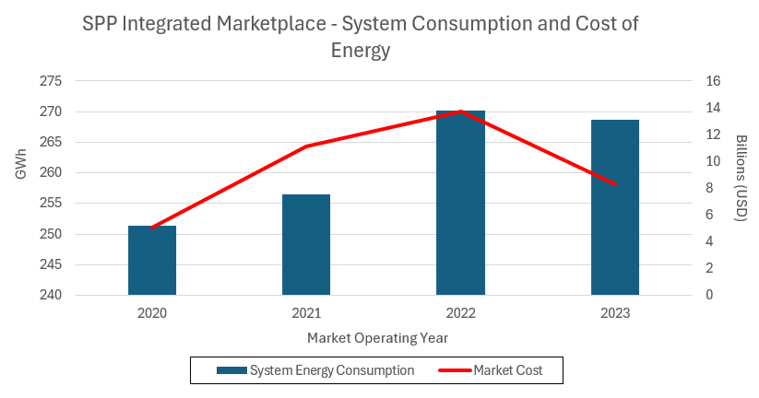
Figure 1 – Overall Cost of Energy, SPP Integrated Marketplace

The North American Bulk Electric System
The BES is a highly integrated system that facilitates the transmission of electric power (generalized as “energy”) from generation to energy consumption (generalized as a “load”) in a real-time and balanced manner. Built with more than 500,000 miles (NREL, 2024) of physical transmission cabling and over 79,000 electrical substations (CISA, 2023), the BES constantly serves energy to North American consumers and industries alike. With few (relatively recent) exceptions, energy is not stored in the system; it is generated (in response to a demand forecast) and then immediately transmitted and consumed by various loads. Figure 2 shows a conceptual configuration of some of the components involved in the operation of the BES.

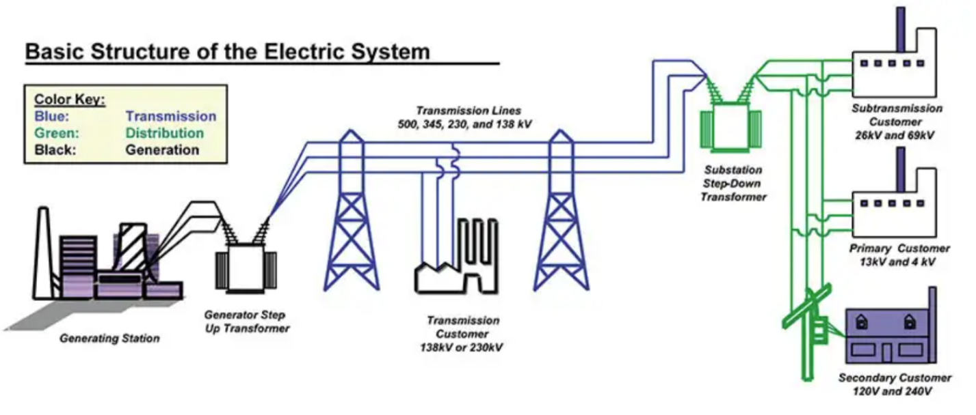
Figure 2 - A Conceptual Illustration of the Bulk Electric System (Devasia, 2023)

The BES must always be precisely managed to balance power across the system and to exactly serve load. Deviations can create instances of voltage and frequency instability that have the potential to significantly damage BES infrastructure. Oftentimes, these deviations are caused by larger environmental events, such as periods of extreme hot or cold weather. Demand for electricity increases during these events, as do generator outages and fuel delivery problems (U.S. Department of Energy, 2023). No one entity manages the entire BES. Instead, this job is shared across different types of regional entities covering different geographic locales. This dissertation focuses, specifically, on organized markets, which pool resources managed by a Regional Transmission Organization (RTO) or an Independent System Operator (ISO). These entities serve multiple roles; their primary role is to function as grid operators.
These organizations frequently act as Reliability Coordinators (RC) and Balancing Authorities (BA), monitoring power flows, balancing the grid, and acting to restore system reliability during and after emergencies. They also operate energy markets. The RTO/ISO dispatches individual resources, in economic order, while respecting system constraints (a complex optimization concept termed security constrained economic dispatch [SCED]). It also serves as a revenue-neutral clearing house for the bulk of energy and transmission-related transactions (as well as various financial products).
Serving these various functions to provide electricity generates enormous amounts of data on an hourly basis. This data is diverse in terms of sourcing, formatting, usage, sensitivity, and volume. It is these data assets (those generated by the operation of the BES) that serve as the focus of this dissertation, specifically the data generated by electricity markets.

An Introduction to Electricity Markets
A large portion of the BES includes centrally organized electricity markets. These markets are of great importance to all stakeholders involved in the BES; they allow energy to be economically generated and purchased at the wholesale level.
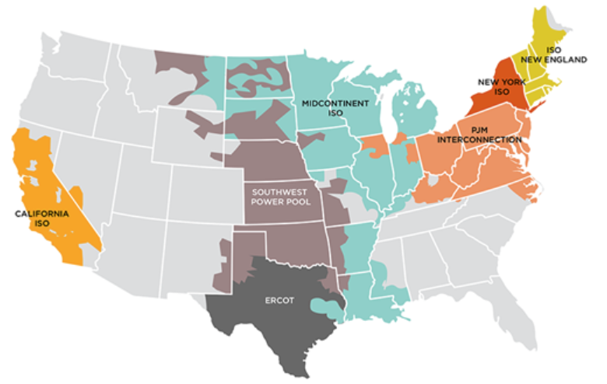
Figure 3 - Prevailing Energy Market Territories (FERC, n.d.)

Figure 3 displays, at a high level, how the US energy grid is divided into different territories and notes the name of the entity that runs the organized market. These territories are typically governed by FERC, with the notable exception of Texas.

Entities
Electricity markets are operated by a small number of operational entities within North America. These entities mostly fall under the jurisdiction of FERC (see Figure 3). The prominent entities that are impacted by market monitoring include Independent System Operators (ISO) and Regional Transmission Organizations (RTO). These entities are filed as non-profit businesses and typically perform similar functions. FERC Orders 888 and 889 initiated the formalized incorporation of an ISO, while FERC Order 2000 set forth the criteria that differentiate an ISO from an RTO.

Independent System Operator (ISO)
ISOs are organizations that manage power generation and transmission across the bulk electric system. They operate in an advisory capacity for generation owners (public and investor-owned utilities, as well as independent power producers), transmission owners, and operators to effectively generate and trade power in an energy market. A common, helpful analogy that describes the function of an ISO is an air-traffic controller.
Air-traffic controllers merely monitor and route airplane traffic across the airspace over the United States. They own neither physical airplanes nor airlines, and function only as advisors to ensure safe passage of both private and commercial aircraft. ISOs work in a similar fashion. For example, the ISO over the California energy market territory (CAISO) owns none of the transmission infrastructure across which electric power is shipped. However, CAISO manages the flow of energy across this system and sends regular dispatch instructions to the generators that inject power into the BES.

Regional Transmission Operator (RTO)
RTOs are another type of entity that manages organized markets. They are categorized by a group of four core characteristics (and an additional seven broad operational functions) that separate them from being classified as ISOs. RTOs and ISOs share many similarities. Their operations are regulated by the same government entities, namely FERC and NERC, and they both have the same, conceptual goal: to reliably generate and deliver energy at competitive rates.
Both entities influence and deploy energy products and maintain both the configuration of their operating territory as well as the flow of energy across the BES. They also both support development and maintenance of open access transmission tariffs (OATT) that allow for unprejudiced access to energy under US federal law. And, most relevant to this research, they are both required to employ a market monitoring group to screen their organized markets for cases of market manipulation.
Their differences primarily lie in how their corporate structures are filed. Both types of entities must be registered non-profit organizations. However, ISOs have more flexibility where impartiality is concerned. RTOs work to maintain independence from their market participants and strictly focus on system reliability and economic efficiency. While ISOs are also concerned with these goals, they can, additionally, lobby government on behalf of their members.

Types of Markets
Electricity markets are designed to serve one of several purposes. ISOs typically deploy and operate these different market designs, in concert, as a marketplace (FERC, n.d.). Southwest Power Pool’s (SPP) Integrated Marketplace is such an example of this. To understand the scope of market monitoring activities, it is important to understand the main energy market designs that exist today. Arguably, there are five main types of electric energy market designs; each design may be deployed with possible variations on its theme (a marketplace that does not operate the function of a capacity market is one such example). Reference Table 1 for information on prevailing design types.

Market Type | Purpose
Capacity | Allows a load to purchase an agreement of firm capacity for service in the future, usually on the scale of months to years in the future.
Day-Ahead (DA) | Allow buyers and sellers to secure positions a day before the market sells energy to be consumed (operating day). This aids in realistic price formation.
Real-Time (RT) | Allows for adjustments between the DA market (what was expected on the day prior) and the system conditions that happen on the operating day.
Ancillary Services (AS) | Allow other providers to sell products that support grid reliability. For example, the ability of a generator to quickly “ramp up” to a certain production requirement is such a product sold in an AS market.
Transmission Congestion Rights (TCR) | Allows participants to hedge against congestion on the transmission system (adequate power can be produced in an area, but there may be difficulties in transmitting it to where it is consumed).
Table 1: Prevailing Electricity Market Designs

BES Complexity and Energy Markets
The BES is a physical system upon which we superimpose a conceptual, economic market. This dichotomy is part of what makes energy markets so complex to both understand and govern with the data that they generate. Physical machines require continuous diagnostics to ensure that they are operating 1) effectively and 2) within adequate maintenance tolerances. The BES is no different.
Thermal generators that produce electricity are monitored for metrics, including wattage output, fuel consumption, and greenhouse gas emissions. High voltage transmission lines are monitored for temperature (heat is generated via electricity loss across conductors) and short-circuit events. Substations are monitored for transformer faults, tap configurations, and other mechanical system measurements. Each of these values is typically transmitted in a time-series format, resulting in constant streams of monitoring data. These time-series data streams are typically parsed into market intervals that constitute “units of work” for market activity. Much of the analysis performed on wholesale electricity markets utilizes data secured from market intervals. Depending on the type of market that is under observation, an interval may range from a span of several seconds (dispatch instructions) to “between five and fifteen minutes” (FERC, n.d.) (for calculation of real-time market prices).
These diagnostic data are only a fraction of the data that are used in the operation of the BES, and much of it feeds into market systems to calculate a realistic price of power at different locations throughout a market territory. Once the market solves, and locational prices are calculated, the market then must be settled. Market settlements are another area of market operations that generates complex and voluminous data. In SPP’s Integrated Marketplace, the Marketplace Protocols set forth an extensive settlement plan that determines how charges and credits are calculated and assigned to market participants. These settlement instructions also cover events where the market must be “repriced”, or re-settled, due to external factors that occur during the operation of a market, such as equipment outages, data communication errors, or extreme weather events.
What is Market Monitoring?
Market monitoring is a discipline that sits at the intersection of two major knowledge domains: forensics and economics. As such, it takes a scientific approach to testing and analyzing transactions that occur within a marketplace. According to a report published by the United States Energy Association (USEA), Market Monitoring is a necessary component of markets “to ensure that market(s) participants cannot exercise market power, collude or engage in any behavior that could give them a market share, or higher profits” (Koolemans-Beynen). This need places the authority to request and analyze records generated by the operation of electricity markets into the hands of market monitoring units (MMUs).
Market monitors will generally screen for MP behavior that matches the following criteria:
- Exercised (or attempts to exercise) positions of market power
- Market gaming through oversights in current market protocols or policy (usually outlined in a governing document, known as a tariff).
- Committed cases of market manipulation through acts of collusion, cross-product manipulation, malevolent influence on price formation, or untoward manipulation schemes (economic withholding, uneconomic production, wash trades, “pump and dump” schemes, etc.)

The Fall of Enron Corporation
The Enron Corporation, a former American-based commodities and energy broker, is a well-known case study in American corporate governance (or, rather, lack thereof). The fall of Enron (first signaled in late 2000) uncovered deep, systemic problems of fraud and deceptive business practices that directly influenced both the market monitoring and information quality (IQ) disciplines. Outwardly, Enron appeared to be a stable and innovative company. At the turn of the century, Enron’s books reflected and ownership of $60 billion in assets. This included an internet-based energy trading desk (“Enron Online”) that cleared $2.5 billion in daily energy transactions (Bondarenko, 2025). Enron management, in reality, operated under a culture of willful non-compliance, including (but not limited to):
- Energy withholding practices that sometimes caused enormous energy prices in the California wholesale energy market
- Artificial energy shortages causing regular blackouts within the California service territory
- Scheduling energy transactions with the intent of inflating congestion on California’s electric transmission system
- Accounting fraud (enabled by a creative used of “mark-to-market” based accounting) which allowed Enron to report expected revenues before they were realized
These manipulative schemes had widespread impacts, including: 1) the bankruptcy of one of the largest utility companies in California, Pacific Gas and Electric (PG&E), 2) rolling blackouts, 3) increased transmission system congestion, and 4) higher than normal electricity bills for California ratepayers.
Enron’s activities constituted both fraud and a behavior known as market manipulation; a form of conduct that attempts to willfully circumvent established market rules in pursuit of (usually) large profits. Their usage of market manipulation, especially in California, was a signal to federal regulators that, at that time, there was not enough oversight into the operation of electricity markets. As a result, the United States Congress passed the Energy Policy Act of 2005 to introduce more stringent regulation over the energy industry.
Enron’s downfall resulted in a near-complete devaluation of their stock, the dismantling of Arthur Andersen (the auditor assigned to ensure that Enron was operating within the confines of financial reporting law), and a slew of legislation serving as the impetus for energy market monitoring in the United States. Additionally, Enron’s scandal was a significant contributor to the passing of the Sarbanes-Oxley (SOX) Act 0f 2002, imposing strict and detailed requirements on data that is used as input for financial reporting. As a result, SOX became another driving force in the implementation of information quality as both an academic discipline and as a business function.
In the years following the disbanding of Enron Corporation, FERC has pursued many more instances of deceptive behavior in organized energy markets. Through the help of market monitors and FERC enforcement staff, manipulation cases can be pursued and penalized before they become even more critical threats. Table 2 lists several high-profile cases of market manipulation that are distinct from the Enron case (Reuters, 2013) (FERC, 2021) (Reuters, 2024).
MP | Damages | Incident
JP Morgan (2013) | $410 mm | Purchased and operated antiquated generation plants and offered them into the market as competitive generators
GreenHat Energy, LLC (2021) | >$229 mm | Participated in insider trading to purchase enormous positions in PJM’s congestion market
Vitol Group (2024) | $2.3 mm | Sold physical power at a loss in the DA market to favor their transmission congestion positions (a behavior known as cross-product manipulation)
Table 2: Prominent Cases of Market Manipulation

Skills of a Market Monitor
Market monitors are one of several groups that function as “unsung heroes” in electricity markets (and within the larger context of the North American BES). The work that they perform on a routine basis helps to ensure a reliable and economically sound marketplace for buying and selling energy and energy-adjacent ancillary services. Market monitoring units are typically staffed with analysts from a wide variety of both technical and non-technical backgrounds. These include data analysts, statisticians, economists, accountants, technical writers, engineers, and other corporate staff dedicated to investigating events that occur in their jurisdictional markets.
Figure 4 illustrates a cross-section of several of the skill sets that market monitoring analysts might possess, based on the researcher’s experience of working as a market monitor within Southwest Power Pool’s (SPP) MMU. As one may imagine, it can be difficult to find an individual contributor that possesses an all-encompassing understanding of each of these knowledge areas.
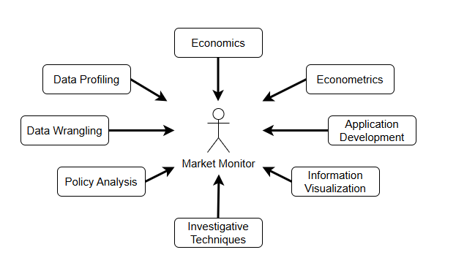
Figure 4 - Diverse Skill Sets of a Market Monitor

Market monitors have a wide breadth of responsibilities that must be covered by their individual skill sets. Routine market surveillance is a continuous process that must evolve with the behaviors and trading patterns of market participants. As such, market monitors observe and investigate market bids and offers made each operating data, analyze generator behavior to identify erratic response to dispatch commands, ensure that participants are not covertly colluding or engaging in price fixing, review out-of-market transactions that take place through bilateral settlement schedules (BSS), and ensure that RTOs and ISOs are acting within the rules defined by their FERC-approved tariff documents (excluding ERCOT, which does not fall under FERC jurisdiction).

Market Monitoring Firms
The current groups involved with electricity market monitoring (both in North America and internationally) include the organizations compiled in Appendix E. This list is not intended to be exhaustive, as other nations in the Asian-Pacific (APAC) and Middle Eastern (EMEA) regions of the world may not be reflected here. This roster of organizations with market monitoring authority illustrates the number of individuals that are involved with market monitoring on an international scale.

The Case for Information Quality Research in Market Monitoring
As stated above, market monitoring encompasses a wide range of activities and demands a mix of skill sets. These skill sets must be applied with the knowledge learned over time from others in the industry. Such activities include gathering transactional market data for screening, calculating metrics for market power and concentration analysis (for example, the classic Herfindahl-Hirschman Index [HHI] or the Residual Supply Index [RSI]), mitigating abuses of local market power by market participants, and performing policy analysis to determine efficient market design (Goldman, Lesieutre, & Bartholomew, 2004) (Gao, Bompard, Napoli, & Zhou, 2008). It also requires calculating known system metrics, Capacity Reserve Margin (CRM) for example, and developing new metrics to measure and track market performance. Data collection, processing, and analysis enables each of these activities, but knowledge of how to make decisions on these data is typically learned through on-the-job training.
In Overview of Data Quality: Examining the Dimensions, Antecedents, and Impacts of Data Quality, one of the antecedents that can directly affect data quality is “information overload” (Wang, Liu, Lin, Sindakis, & Aggarwal, 2023). This can be especially true in market monitoring, where users must derive a decision by “fusing” data from many different sources. In instances where users are not familiar with the sources, this has potential impact on both accuracy and trust in the final product.
As an example in an adjacent industry (electric utilities), Oyoo’s work in data validation for power and utilities organizations showed that information quality can contribute to the development and maintenance of Extract-Transform-Load (ETL) processes (Oyoo & Berleant, 2021). In this example, electric utilities may prioritize data templating and formatting over accuracy and trust. Market monitoring cannot afford to make this trade-off. Market monitors work in complex and high-volume data environments. Systems deployed in these environments must be accessible and user-friendly to help market monitors handle the inherent data and information complexity.

Conducting Information Quality Research in Market Monitoring
The case study of Enron Corporation sets both a unique and compelling stage for the role that information quality and information-science based research can play in improving the business impact of an independent market monitor. Included amidst Enron Corporation’s numerous failures of governance are a lack of both access and an understanding of the complex data generated by the energy industry. The operation of such a large system and marketplace can lead to many siloed data stores, undocumented schemas, and a slew of other information quality-based problems that can also be seen in market monitoring.
Furthermore, the cross-section of skills that market monitors must possess (to effectively perform their job functions) also underscores the importance that data literacy and data quality improvement hold in the market monitoring domain. Both data and system architecture plans, proposed as part of the deliverables of this dissertation, are paramount to designing a system to aid market monitoring staff in their work.

Subject Matter Expert (SME) Discussions
The potential use of this dissertation is driven, in part, by the opinions of subject matter experts in the field of electric energy. In support of this investigation, the researcher has consulted multiple members (in different sectors) of the industry, including two (2) professionals in enterprise asset management, and a separate discussion with a staff member in energy regulation. One such staff member, Kennedy Oyoo, performed information systems research in a different sector of the energy grid, “power and utilities”, focusing on the distribution of electricity to end users.
Energy utilities struggle with a similar issue to those faced by market monitors – siloed data exists in different systems, and can exist with vastly different data quality scores (in terms of completeness, accuracy, etc.) Oyoo’s research found that a key step (data validation) was missing from the ETL processes of an energy utility. Part of the research completed in his project resulted in an information template-based prototype system that cleansed and validated utility data according to automated assertion rules (Oyoo & Berleant, 2021). Such a methodology has potential impacts on the market monitoring discipline and may have an influence on the resulting system architecture of this dissertation.

Design Science Methodology
The roadmap of this project is based on the Design Science Research Methodology (DSRM), a research process for developing new product artifacts. The researcher chose DSRM for this project because the main research objective is to design and develop a domain-specific language for market monitors to use in their analysis.
Data and information quality problems exist today in the market monitoring body of knowledge that a DSL-based system can help address:

- Analysts in different teams that arrive at different values when trying to quantify metrics (market impact, for example)
- Lack of robust metadata assets such as data dictionaries and well-defined data stewardship roles
- Lack of a mature change management program for software (which, in turn, can impact report reproducibility)
- A lack of full automation and meta-automation, causing analysts to spend time performing tedious ETL and archival tasks
Domain-specific languages are powerful models for allowing users to systematically solve problems within a specific domain. As is discussed in the literature review (see Chapter 2), DSLs have had only limited exposure to electricity markets (and even less exposure to market monitoring). This discovered gap in existing research, complemented by the DQ and IQ issues discussed in the review, serves as the inspiration for this project. Figure 5 provides more detail on the planned use of design science within this project.
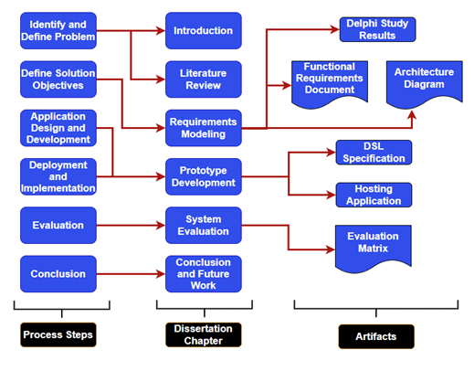
Figure 5 - Design Science Research Methodology for this Dissertation

Proposed Investigation
In What Design Science Is Not (2008), Baskerville states that one view of design science is to be generative. That is, design science leads to the generation of artifacts that then influence the formulation of a theory (Baskerville, 2008). This prospect of generativity seems to indicate that a design can be formed and improved based upon empirical evidence. Due to this idea, the researcher chose to employ a Delphi study (as the methodology for gathering expert sentiment) to influence the design of the DSL prototype discussed in this dissertation. The requirements solicitation chapter shall discuss the setup, conduct, and results of a Delphi study employed in market monitoring. It shall also explain how the results of this study influenced the design of the proof-of-concept system.
Overall, the investigation methodology for this dissertation is composed of five (5) main components. These components include 1) a literature review, 2) a Delphi study to gather opinion and synthesize system requirements, 3) a system architecture design, 4) development of the prototype system (and associated tooling and documentation), and 5) an evaluation discussion to determine to what degree the resultant software satisfies the system requirements.

Limitations of this Research
The scope of work proposed in this dissertation is limited to the objectives outlined in the Error: Reference source not found section. Specifically, it shall ultimately evaluate how well the developed prototype functions as a minimal viable product (MVP) for energy market analysis.
The proof-of-concept system discussed in this dissertation is not intended to be a production-ready system. It is also not expected to be used in a live scenario for market monitors to immediately put into service to support decision making. The data ingested into the proof-of-concept system will be based on realistic data scraped from public data systems shown in Appendix D. The evaluation of this system will be based on a matrix (mapping back to the functional requirements defined in Chapter 4) that “scores” how well the functionality of the prototype supports the intended requirements.
Further system optimization, bug fixes, scalability concerns, and use in live market monitoring scenarios are all considered “out of scope” for this dissertation and are reserved for future work. The researcher, however, may pursue future enhancements to this system as separate research endeavors.

Chapter 2: Literature Review
A review of the literature surrounding information quality research within market monitoring units signals that there is room for improvement in how value is generated from information assets. This gap is highlighted by several major issues (introduced in Chapter 1 and discussed in this literature review), including:
- Development of technology surrounding domain-specific language engineering
- An aging workforce in the electric utilities industry that is reaching the tipping point for replacement
- A lack of existing research on data and information quality within the market monitoring sphere
- A disruption of traditional energy market design due to advances in technology and the energy regulatory landscape
These issues represent a unique opportunity to obtain important value from the data assets both generated and used by professionals in the market monitoring sphere. The researcher will discuss each of these issues in the context of relevant literature, then introduce specific possible sources of data that enable the development of a domain-specific language for market monitors.

An Aging Workforce
Many technical industries are experiencing the problem of an aging workforce; trained professionals are reaching retirement age at a rate faster than that of replacement. A 2006 study showed that the largest staff segment, of a surveyed group of energy professionals, is at (or beyond) retirement age. This same study cited “retirements, restructuring, and technology changes” as being the primary drivers of staff leaving the energy profession (Ray & Snyder, 2006). Given the age of this study, many industries are currently going through a period of training new career professionals. Such a problem impacts market monitoring as well.
MMUs (as previously discussed) were cemented into operation by the US federal government, not long before that same 2006 study. An energy research lab at UC Berkeley shows that staffing across market monitoring groups is relatively low compared to other organizations in the industry. According to Goldman, Lesieutre, and Bartholomew, all operational market monitoring groups in the US had fewer than 20 FTEs (each) employed by 2004 (Goldman, Lesieutre, & Bartholomew, 2004).
While these numbers appear low in comparison to other organizations with energy industry staff, this study declares that budgets and headcount (at that time) increased significantly for market monitoring work. As such, this shows a trend of growing demand for market monitoring staff in a workforce that, holistically, employs many individuals on (or beyond) the horizon of retirement. One claim to helping combat this “brain drain” problem is a technology framework that “facilitates knowledge retention” (Ray & Snyder, 2006), including systems (supported by an IT organization) that capture necessary process knowledge.

Application for Market Monitoring Research
Domain-specific programming languages (DSLs) are powerful interfaces that allow subject-matter experts (SME), in any domain of expertise, to perform tasks similar to a proper software developer that builds applications in general-purpose languages (GPL). A well-defined DSL can save many hours of development time for specific groups that have IT oriented needs. DSLs can also lower the “barriers to entry” for SMEs that wish to write applications to handle work within their purview. With support from a DSL, a software engineer does not need to be deeply involved in business rules to understand how to develop an application (a common issue in the energy industry). Likewise, SMEs do not need to heavily codify their business rules into software requirements for an application to be developed when utilizing a domain-specific language.
Following the theme of how DSLs can abstract away complexity of big data processing tasks, this research aims to bring such a tool set to bear on tasks performed in energy market monitoring. Commands embedded into a domain-specific language have the potential to speed up many repetitive tasks in the market monitoring domain, especially regarding the generation of reports and stakeholder presentations.

An Analysis of Domain-Specific Languages
Consider programming languages on a spectrum from general purpose languages (GPLs) at one end to domain-specific languages (DSLs) on the opposite end (Kosar, et al., 2010). DSLs are languages that are limited in purpose, scope, and grammar. Rather than supporting a programming language that can be utilized for constructing almost anything (as GPLs do), DSLs are created to solve issues within a single problem domain.

Language | Supporting Enterprise | Problem Domain | Paradigm
Structure Query Language (SQL) | Various | Data Retrieval | Declarative
Terraform (HCL) | Hashicorp | Cloud Infrastructure | Declarative
Apache Pig  (“Pig Latin”) | Yahoo, Apache Software Foundation | Data Retrieval | Declarative
awk | Bell Labs (originally) | Text Processing | Procedural
Table 3: Selection of Well-Known Domain-Specific Languages

Structured Query Language (SQL) (Amazon Web Services) is one such example of a DSL. SQL queries are designed to retrieve data from databases for extraction, reference, and analysis. SQL dialects have been designed to interface across a broad range of database management systems (for example: PL/SQL for Oracle or T-SQL for Microsoft SQL Server databases).
Terraform (HCL) (Hashicorp), a product of Hashicorp Corporation, is yet another example of a domain-specific language that is prevalent among cloud-based companies. Terraform is known as an "infrastructure-as-code" language, used to interact with numerous cloud platform providers (e.g. Amazon Web Services) to quickly deploy, scale, and spin-down cloud resources. Instead of requiring an engineer to use a console environment to configure cloud resources, that same engineer can write a set of scripts that will precisely configure and deploy all of their desired infrastructure at once.
Apache Pig (Apache Software Foundation) (and its associated programming language “Pig Latin”) is also a DSL. It is a declarative language used for data retrieval and processing. Developers at Yahoo created Pig as a way to abstract some of the complexity of SQL away from analysts who were working with large datasets. With fewer lines of code, an analyst could use Pig to parse and load a dataset into memory, perform processing tasks, and format and report the results. This was specifically useful to analysts processing large datasets because Pig was designed to take advantage of the high-performance computing facilities of Hadoop.
Yet another powerful example of DSLs can be seen in the ubiquitous Unix program: awk (McBride). Originally created by Unix developers Aho, Weinberger and Kerninghan , awk is a scripting language designed to process textual data— one line at a time. The power of this language allows individuals to write expressions that are simple to understand, efficient, and portable across different Linux implementations. Countless developers (including the author of this dissertation) have made use of awk’s utilities to process and format data in a headless environment.
Each of the languages represented in this review are, on their own, infeasible for writing general purpose applications. SQL, for example, should not be used to write a desktop program. They were, instead, each created to solve specific issues within their respective problem domains. Likewise, Terraform cannot be used to create web applications or develop billing software. One “upside” of these languages is that they can quickly handle tasks within a specific problem domain.

DSL Variations
Each of the language examples provided here share a common characteristic in that they are external DSLs. They are interpreted and executed by a runtime program. This trait of DSLs separates them from another subset of domain-specific languages: internal DSLs. These are embedded languages (sometimes referred to as fluent interfaces) that rely on (usually) general-purpose languages to parse their individual syntactic structures and execute logic. These DSL features are sometimes referred to as syntactic sugar (Fowler, 2019), implying that they make the experience of developing solutions in them “sweeter” than without them.
Another common characteristic of DSLs lies in the fact that they are often text-based programming environments. As discussed later in this literature review, graphical domain-specific languages also exist. These are usually seen in the form of either enterprise extract- transform-load (ETL) applications or language workbenches. Jetbrains MPS is a prominent example of the power of graphical DSL representations. Business users are usually positioned to take advantage of these product offerings because they pose abstract interfaces (environments that allow users to graphically model what they want instead of having to explicitly write source code in a general-purpose language). With basic instruction, users can string together components that construct repeatable workflows without requiring them to possess deep programming knowledge.

Extant Domain-Specific Language Use Cases in the Energy Sector
The literature uncovered in this review supports the claim that DSLs can achieve high efficacy in financial contexts. Krasts, Kleins, and Teilans (2012) illustrates how domain-specific languages have been used in modeling the complex dynamics of financial settlements systems. Financial settlements often encounter errors during the settlement of a market. Using a DSL for modeling tasks, in these scenarios, appears to help developers and business users clearly visualize computer systems logic (Krasts, Kleins, & Teilans, 2012).
The literature, even more interestingly, shows that DSLs have been deployed in other areas of the energy sector, as identified in Developing a Domain Specific Language for Scheduling in the European Energy Sector (Sobernig, Strembeck, & Beck, 2013). While this paper sets precedent for the use of DSLs in the energy industry, it presents an even larger gap that this dissertation addresses. Beck’s study explores employing a DSL to assist in tagging and scheduling energy interchange (which is an operational concern that only encompasses a single component of market monitoring). Additionally, and far more importantly, the implementation of their DSL was constrained to specific market interconnection in Europe, which is significantly less complex than the transmission and congestion issues that are seen throughout the North American Bulk Electric System. Market monitoring, while interested in aspects of transmission scheduling, encompasses a much broader scope of analytics in the energy sector.

The Data Domain in Market Monitoring
The data domain in market monitoring entities is a large ecosystem. It is common for monitoring analysts to synthesize information both from internal and external data sources. This type of ecosystem can quickly become a data swamp without careful attention to business rules and the possession of institutional knowledge for how processes are executed on market information.
FERC Order 760, a key piece of legislation that directly relates to this dissertation, is one such example of how market data is sourced and utilized by analysts. It dictates several key categories of data that RTO/ISO organizations must regularly provide to the Commission. Such data includes (18 CFR Part 35, 2012):
- Supply offers and demand bids for energy and ancillary services
- Virtual offers and bids
- Energy/ancillary service awards
- Capacity market offers, designations, and prices
- Resource (electricity generation) output
- Marginal cost estimates
- Day-ahead market (DA) shift factors
- Financial Transmission Right (FTR) data
- Bilateral Contracts
- Interchange transactions (otherwise known as “scheduling and tagging”)
Understanding how to source and use this information impacts the accuracy of market monitoring analysis and enables FERC to accurately assess and penalize instances of market manipulation. Defined by the industry terms “ex-ante” and “ex-post”, assessments of market performance, market power, and market manipulation can be carried out prior to an event, or “after the fact” – when a market event has already occurred (Twomey, Green, Neuhoff, & Newbery, 2005).

Public Data Systems for Wholesale Energy Markets
In a similar manner to how market operators provide regular data to FERC, RTOs and ISOs also regularly publish data that allows the general public a view into the operation and settlement of these markets. Table XXYYAS lists the existing systems that this research can utilize for test data. Much of the data contained in these systems match the data requirements for FERC Order 760 (though some identifiers may be omitted or obfuscated to preserve confidentiality).
The researcher intends to source data assets that model market conditions (especially for price formation) from these systems and use such data for demonstrating the abilities of the prototype system, including: 1) visualization generator, 2) report creation, and 3) shadow calculations. The data assets that may be necessary to produce the demonstration deliverables include public records such as generator names and physical parameters, generation outages, transmission line data, and component data used to calculate marginal prices (energy, loss, and congestion factors).
Publishing Entity | Data Repository Name
PJM Corporation | Data Miner 2
Monitoring Analytics | Member Information Reporting Application (MIRA)
Electric Reliability Council of Texas (ERCOT) | Market Data Transparency Service
California Independent System Operator (CAISO) | OASIS & Data Library
Midcontinent Independent System Operator (MISO) | MISO Data Exchange
Southwest Power Pool (SPP) | Public Data Portal
New York Independent System Operator (NYISO) | Operational Data Portal
Independent System Operator of New England (ISO-NE) | ISO Express
US Energy Information Administration (EIA) | Wholesale Energy Market Reports
Table 4: Public Energy Market Data Systems

Chapter 3: System Requirements and Use-Cases
Design science shall be used as the primary method of investigation in this dissertation due to its ability to derive insights from the development of new artifacts. However, design science is only a process that guides the investigation. To effectuate this process, the researcher has developed the following plan to build and evaluate a software system (powered by a domain-specific programming language) for potential use in the professional domain of energy market monitoring.
The plan includes the following details (illustrated by Figure 6):
- A literature review to both introduce the research area and to establish relevance and novelty
- A Delphi-based study using a panel of experts (within market monitoring) to identify the current needs of these experts, including:
  - The current landscape of a market monitor’s workflow
  - Perspectives from the entire market monitoring community, including market monitors that work outside of the United States
- A comprehensive data and system architecture plan for setting up and operating a DSL-enabled data analysis system
- Development of a prototype system to serve as proof-of-concept for using a DSL in the context of market monitoring analysis
- Develop a traceability matrix (Sison & Greenberg, PMP, 2025) that can serve as a method of evaluation, for this system, to ensure that the prototype serves the intended functional requirements
- A discussion of the performance of the system (as this also shall impact the system’s usability)
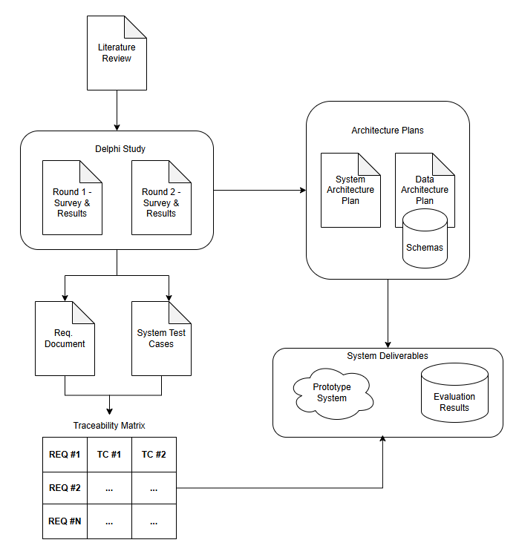
Figure 6 - Flowchart of Dissertation Deliverables
These deliverables shall be joined together to form a software system (for which a domain-specific language is the primary user interface). To aid in drawing quantitative conclusions from this system, the researcher plans to develop a traceability matrix from the requirements contained in the functional requirements document (FRD). This matrix will be joined to the test cases (TC) that are crafted directly from the requirements in the FRD.
There is precedent for the use of a traceability matrix when evaluating prototypical software. Ye utilized this approach in A Positive Data Control System for the Automation of Data Governance Functions. Ye’s research identified a table of ten (10) system conditions that should be considered in the development of a data control system (Ye, 2021). Ye then evaluated this prototype to determine how closely the artifact conformed to those requirements.
Such a scheme for system evaluation is advantageous because it helps to calculate overall system scores – which are useful when determining if such a software application meets the needs of the intended user base. These scores are often used in data quality settings where quality is gauged on a percentage basis. As an example, a metric that may be computed while evaluating the proof-of-concept system is a conformance score of the number of test cases that pass for a given requirement (e.g. requirement ID R1.0.0). This example is illustrated by the following equation:
$${Conformance Score}_{R1.0.0}= \left(\frac{\# Test Cases Passed}{\# Total Test Cases}\right) ×100\%$$
Another possible evaluation score is the number of test cycles completed to ensure that all test cases pass for a specific requirement. This evaluation scheme is also helpful because the researcher can justify why a given requirement may have changed (or been removed) during the design and development phases of this research. This traceability matrix is intended to be completed in concert with the requirements document, which is ultimately dependent on the completion of the Delphi study.

Requirements Solicitation via Delphi Study
As was previously discussed in this research, energy market monitoring is a niche industry. While data analytics is a common practice across most industries, there are undoubtedly analysis concepts that are unique to the practices of market monitors. It follows that the sensible way to design a language, one that is usable to market monitors, is to solicit the requirements from the users themselves. This technique is advantageous for several reasons:
- Users often think about what tools and techniques would make their jobs more efficient to perform
- In market monitoring, users most likely range in levels of experience, ensuring that the resulting system design is approachable and useful to analysts at different levels of expertise
- Given that the language (and associated tooling) shall help aid with on-boarding and knowledge transition for new employees, it is important to identify what issues current market monitors encounter when on-boarding new employees

Study Design
To effectuate the process of prompting the users for system requirements, the researcher chose to proctor a Delphi study – recruiting any member of the market monitoring community that wished to participate and share their thoughts.
The researcher opened recruitment for this expert panel to the Energy Intermarket Surveillance Group (EISG), a professional governing body of market monitors from around the globe. Parameters for recruitment into the Delphi study expert panel include the following:
- Participants must be over the age of 18
- Participants must be a member of the EISG
By identifying these parameters, the researcher can maintain a baseline of relevance. This helps to ensure that the survey questions posed in this study are answered by the same individuals that may (potentially) use such an analysis system. Before administering any questions (and before beginning recruitment) the researcher developed an investigation protocol and submitted the protocol in its entirety to the UA Little Rock Institutional Review Board (IRB). The IRB classified this Delphi study as human participant research. A link to the research protocol and the waiver of informed consent (provided to the panelists) is included in a GitHub repository, maintained by the researcher.
The study was conducted in two (2) rounds, where a “round” corresponds to a list of survey-style questions that were provided to the panelists. The questions included a mix of free-form text response questions, multiple choice questions, and questions provided in a Likert-style format. The questions were crafted and stored in Google Forms surveys (using UA Little Rock’s managed Google productivity suite) and “responder-ready” links were provided to the panelists via email. The initial link was sent to the entire EISG population and members were provided with a “cut-off” time to provide their responses (at which point, round 1 was considered closed and no new responses were accepted). Participants who provided responses before the cut-off date constituted the Delphi panel.
After the first round of survey questions were concluded, responses were processed to identify common sentiment and consensus across panelists. The researcher remained objective during the administration of the questions and during results processing. The identified themes were then arranged in a white paper and reported back to the users to help inform their responses going into the second round of questioning.

Panel Composition
At the end of the first round, the EISG had a confirmed registration of 131 members; this Delphi panel consisted of 19 participants. This yielded a response rate of 19/131 individuals (roughly a 15% response rate) for the first round of the study. Only 11 out of the original 19 participants opted to participate in the second round (roughly 58% of the original participants). Of the original 19 participants, 16 of the participants work for a market monitor based in the United States while 3 work for an internationally based market monitoring unit. Roughly 79% of the panelists work for an internal market monitor. The remaining 21% of the panelists work for an external market monitoring unit. Figures 7 and 8 illustrate the skill mix and tenure distribution of the panelists, respectively.
The majority of the participants (13 / 19) identify as a Market Analyst or Market Monitor as their professional role. However, other roles are also represented, on this panel, by one or more responders, including: managers, economists, data scientists, and traditional programmers or IT staff.
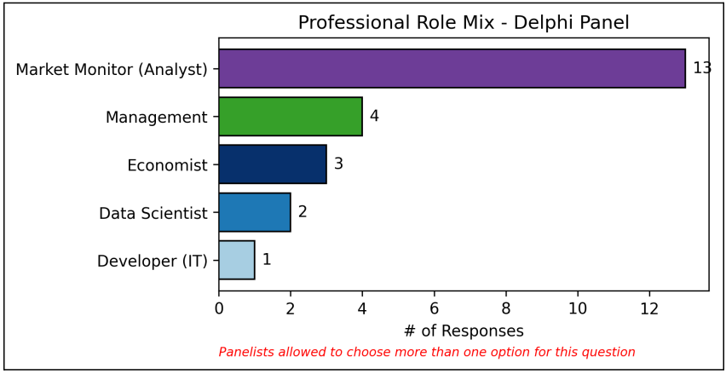
Figure 7 - Professional Role Representation on Delphi Panel

The distribution of tenure amongst the panelists is skewed to 15 years (or fewer) of market monitoring expertise, with a medium tenure period of 5 -10 years. Given the application of this study, such a distribution of experience in the industry is advantageous. This spread of expertise gives multiple perspectives on how technology is deployed (to date) in different business units and what opportunities exist for improvement.
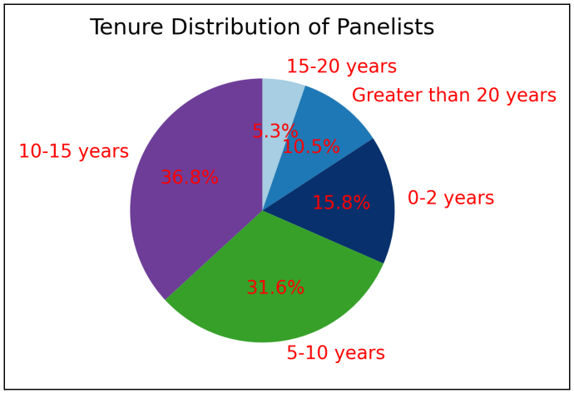
Figure 8 - Tenure Distribution of Panelists

The participants were also largely based within small business units (MMU) relative to the size of their organization. Every participant polled for the Delphi study is employed by an MMU staffed with 50 or fewer people. However, most of these MMUs were organized in a mid-size organization, staffed by 500 employees or greater.
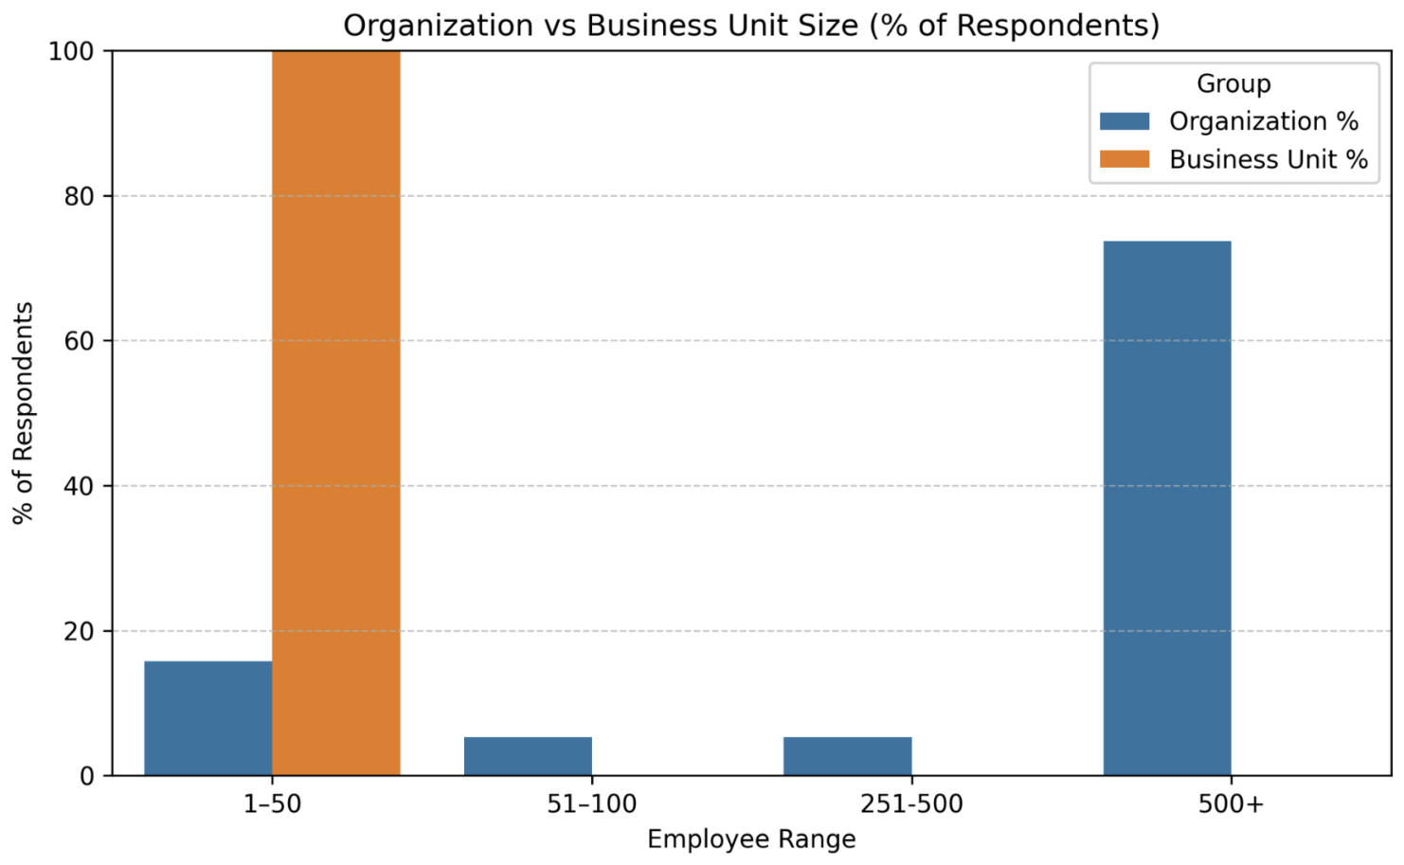
Figure 9 - Size of Organizations and Business Units

Emergent Themes from Round 1
Theme #1 - The participants, regardless of locale (based either in the United States or internationally) or monitoring scheme (internal vs external MMU), appear to have similar workflows.
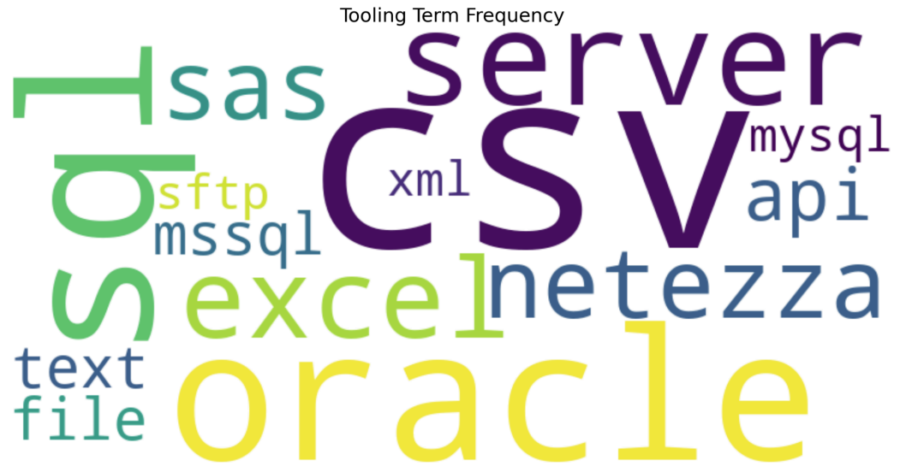
Figure 10 - Word Cloud of Technology Mentioned By Panelists
Market data is typically fetched from relational market databases or (to a lesser extent) from static flat files (e.g. CSV). Panelists also develop annual state of the market reports, which appear to be a time-consuming process.
The technology mix mentioned by the panelists includes the following word cloud. Participants, unanimously, seem to use a dialect of SQL and Excel spreadsheets (or CSV files) in their daily workflow. Some panelists also mentioned the additional use of a programming language (e.g. SAS or Python) to aid in task automation.

Theme #2 – Participants found the concept of a “set of commands” that aid in analysis to have potential productivity savings.
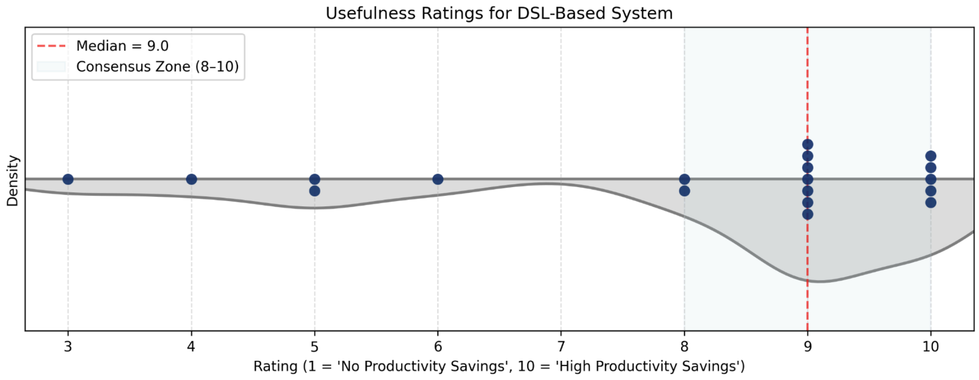
Figure 11 - Participant-Specified Ratings (1 - 10) of Expected Usefulness of a DSL for Market Monitoring

Ranking their expectations from 1 – 10, panel consensus indicates that a set of commands (i.e. a purpose-built DSL for market monitoring) could yield productivity savings for market monitoring staff. Figure 11 shows that participants tended to converge on consensus for this question, with the majority of responses falling between ranks 8 and 10 (inclusive).
In a similar question, participants were asked to provide a score for expected usefulness of a system to “streamline data gathering, processing, and reporting for market monitoring” on a 4 category Likert scale: No Value, Neutral, Some Value, High Value.
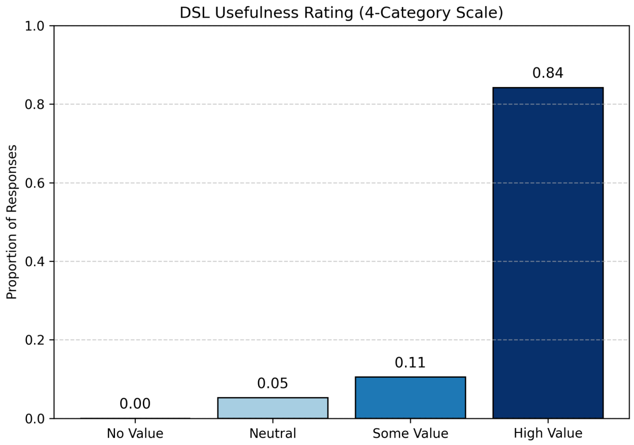
Figure 12 - Participant Ratings (4-point Likert scale) of Expected Usefulness of a DSL for Market Monitoring

Across both questions, most responses represented an expectation of high productivity savings. Note that responses from MC2 were mapped to the same bins as MC4 to allow comparison of the “usefulness ratings in the same graph (see Figure 13).
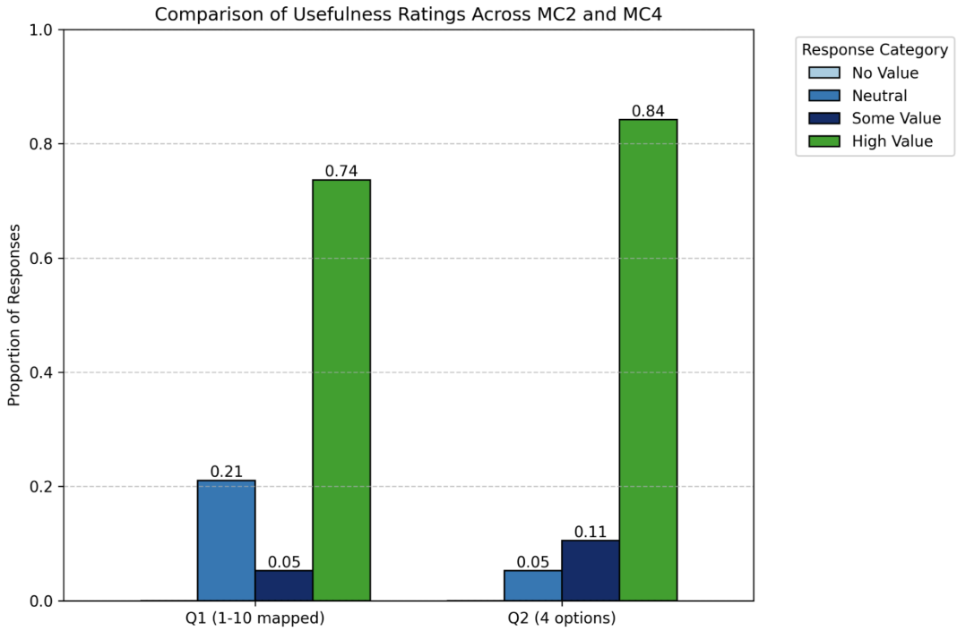
Figure 13 - Distribution of DSL Usefulness Perception - 2 Questions

Theme #3 – Participants tend to assist their coworkers with tasks.
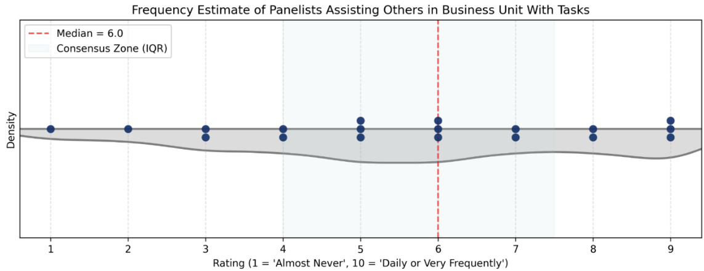
Figure 14 - Participant-Specified Frequency of Assisting Others with Work Tasks

On average, the panelists scored a 5.63 (rounded to 6) score when determining the frequency to which they assist colleagues with market monitoring tasks. This type of pattern is consistent with the tenure mix shown during the analysis of participant demographics. Given that over 80% of the panelists have at least 5 years of experience in their market monitoring roles, it follows that these more experienced professionals help train new staff.
It also could indicate that members of the market monitoring community tend to specialize in the types of tasks that they conduct. If someone is working on a task that is outside of their area of specialization, they may consult a team member for help. Some of the free-form responses provided by panelists support this claim. Additionally, the researcher (through working as a market monitor) has first-hand experience confirming this claim.
Such a trend also follows the concept that more experienced employees are typically expected to mentor less experienced (or younger) employees. For example, the promotion structure of Southwest Power Pool includes a position at the lead level (including Lead Market Monitors, Lead Economists, and Lead Programmers). Employees that have achieved lead status are expected to lead other employees through planning: policy, system architecture, and best practices. If employees that have achieved lead status through a longer tenure in their respective business units, it follows that they would often view themselves in a position of “assisting other employees.”

Theme #4 – Economists and analysts are expected to possess similar levels of expertise.
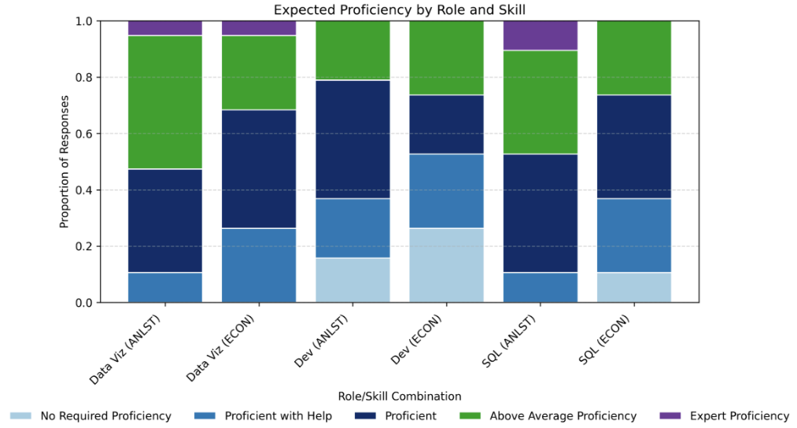
Figure 15 - Expectation of Proficiency for Analysts and Economists in Data Visualization, Programming, and SQL

Out of the themes identified in the Delphi study, Theme #4 is the most surprising to the researcher. Figure 15 shows a stacked bar chart with the proportion of expected proficiency levels for 3 different skills across 2 professional roles (analysts and economists).
On the surface, one may hypothesize that analysts are expected to possess more technical expertise than economists. However, empirical sentiment gathered in this study suggests that most panelists expect both roles to have a similar level of expertise across each functional area. If viewed from the idea that any professional should be able to analyze the market and identify insights, this expectation holds true.
Theme #5 – Participants wish to integrate new sources of data. At the same time, they are concerned with the current state of their data dictionaries and data governance programs.
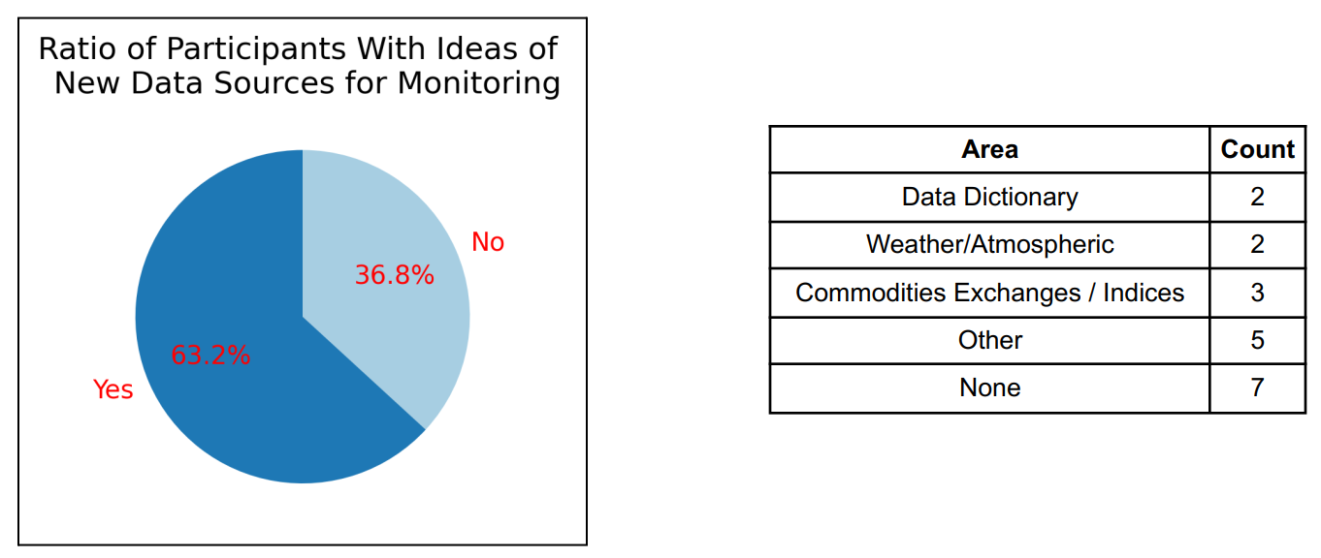
Figure 16 - Ratio of Participants (New Data Sources)

When posed with question FR8 (referring to ideas about new data sources for market analysis), at least two (2) respondents mentioned data dictionaries (in some form) as an idea for injecting a new data source into their work. Three (3) others mentioned fetching real-time pricing data from fuel indices. Yet another 2 participants mentioned utilizing weather data to enhance their analysis. Five (5) other individuals mentioned different sources of data, including using regulatory filings and large language models (LLM) to help analyze energy data. An unexpected outcome is that 7 panelists had “no ideas” for sources of new data for market analysis.
Snippets of responses to several questions indicate that panelists feel that their workflow could improve with stronger attention paid to the maintenance of data dictionaries and quality control:
- “Before automation – we need a stronger data governance. A defined list of data and standards needs to be developed…”
- “Could provide an interface to the data such as a data dictionary…”
- “More documentation of the meaning behind columns in data sets…”
- "There is an opportunity to better identify, label, and standardized queries and data sources…”
- “A comprehensive data dictionary would be tremendously helpful…"

Theme #6 – Employee turnover appears to exist in market monitoring units, though the panel was split on this topic.
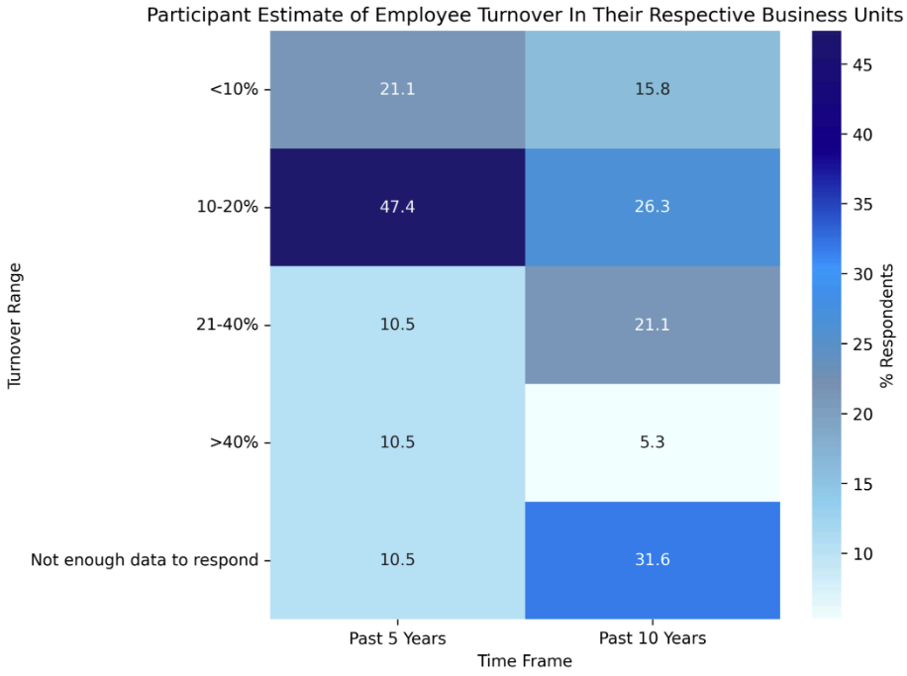
Figure 17 - Perceived Turnover in Participant MMUs Across 5 Year and 10 Year Time Horizons
An appreciable number of participants noted that they did not have enough information to accurately answer this question (over 30% of participants stated this on the 10-year time horizon, and about 10% stated this on the 5-year time horizon). However, given the wide distribution of tenure of the panelists present in this study, the researcher believes that this heatmap does show a trend that market monitoring units have experienced employee turnover.

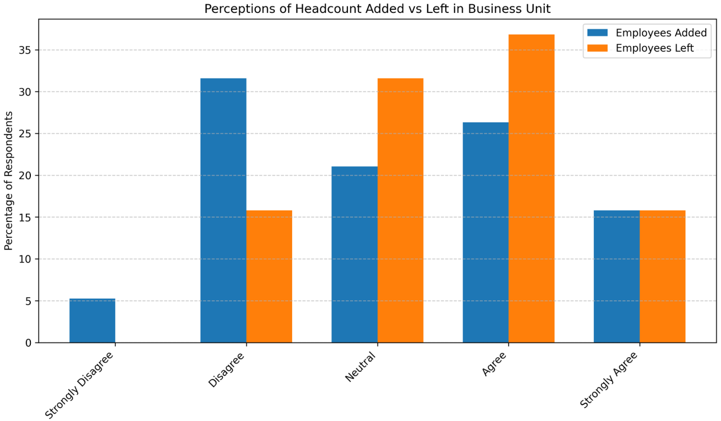
Figure 18 - Employee Churn Rate Perception Amongst Participants

The consensus split on Theme #6 is also supported by the information shown in Figure 18. Given a 5-point Likert-scale question in MC7 and MC8, there is no clear consensus that participants feel that many individuals have been added to their staff or that many individuals have left. One such interpretation is that there is a steady replacement rate of employees when staff do depart (supported by the information shown in Figure 17).
Employee turnover in an area where the analysis system discussed in this survey has potential benefits. As employees leave a business unit (or as new employees join), the institutional knowledge that the employees take with them is a valuable information asset. Such a system could be used to capture processes developed by senior employees and make them executable for newer employees.

Anonymized Comments from Round 1
The researcher has selected some of the interesting comments made in the free response questions from round 1 and included them (in an anonymized format) here:
Responses concerning “data trustworthiness”
- “A comprehensive data dictionary would be tremendously helpful.”
- “...Abundant opportunities for data quality improvement… allow more time and attention
- devoted to the things that are most impactful.”
- “Navigating large datasets where errors and inconsistencies in data can lead to confusion and misinterpretations.”
- “Consistent and accurate data is difficult to come by. It is necessary to establish data dictionaries and standard "sources of truth” but getting peers to agree and use them consistently is a challenge.”
Responses concerning “ideas for automation”
- “Natural language processing for parsing language out of reports, routines to pull relevant data out of semi-structured data.”
- “Automated training - build a new analyst up using introductory queries, then working hand-in-hand to develop more sophisticated modes of inquiry.”
- “We could use AI to help develop a curriculum and high-level language queries to allow new employees (to) begin understanding and performing the core functions of a market monitor quickly.”
Responses concerning “data challenges in market monitoring”

- "...Balancing infrastructure cost with performance and adapting existing systems to cloud-based networks.”
- “We need better data dictionaries to define our data. Using and linking data across varying systems can be a challenge…”
- “Identifying the abundance of locations where data can be found and access to that data. The manipulation of data across so many variations of storage organization.”
- “Knowing where to go for the data I’m interested in accessing (caused by not having a data dictionary)”
- “Understanding and locating relevant data. Data dictionaries are lacking.”

Emergent Themes from Round 2
Theme #7 – There is consensus across the Delphi panel on necessary features of the proof-of-concept system. Responses to the Likert-style questions in round #2 were processed using a custom Python script (written by the researcher) and in Figure 10, where the question codes (MC11 – MC15) map to the following system use-cases:
- Data tagging and identification
- Simplified analysis and/or interfaces for non-technical users
- Simplified analysis of semi-structure and unstructured data
- Reduced reliance on custom SQL code
- Automated generation of charts, figures, and visualizations for reports
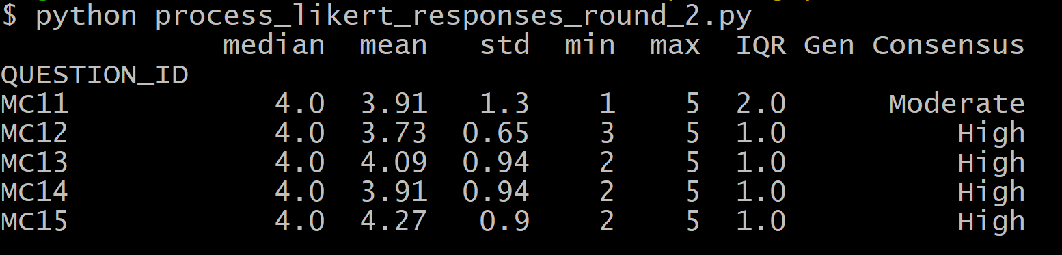
Figure 19 - Likert Response Cross-Tabulation from Round 2

Anonymized Comments from Round 2
Following the same format from round 1, the researcher has selected participants’ comments with meaningful feedback to include from round 2 in an anonymized format:
Responses concerning system use-cases
- “Interactive visualizations which offer drill-down functionality to allow users to see high-level context and detailed data in the same place.”
- “More interactive GIS-informed dashboards.”
- “At present, the work in my team … is relatively manual. We do not build any internal systems to process data. Our data extraction is mainly via SQL query[ies] directly on the … data warehouse or through reports produced by the market operator … Microsoft Excel / Power BI is used to manipulate such data.”
Responses concerning ideas for DSL syntax
- “Market manipulation detection such as linking outages to financial impacts across the market.”
- “The ability to plain text type, ‘Display [some domain such as outages] for [timeframe] and list any correlated data significance,’ would be helpful.”
- “… the simpler the better, no matter the subject, like in the example above, ‘DISPLAY something FROM period FOR whatever you define.”

Identified Use-Cases
Based on the results of the 2 round Delphi study, the following use-cases have been identified. These form the basis of the functional requirements document (FRD) for the proof-of-concept system:
  - Automated figure and visualization generation for reports
  - GIS-enabled analysis
  - Rapid import and export of offline data
  - Performing mitigated offer verification
  - Scheduled alerts and user subscription to alerts
  - Guided onboarding for users
Each of these use cases are explained in further detail, and then linked to the master FRD (“POC_Traceability_Matrix.xlsx”) here via a requirement ID:
https://github.com/echarlesgrasby/dissertation/blob/master/FRD/

Use Case #1 – Automated figure and visualization generation for reports
Use Case #2 – GIS-enabled analysis
Use Case #3 – Rapid import and export of offline data
Use Case #4 – Performing mitigated offer verification
Use Case #5 – Scheduled alerts and user subscription to alerts
Use Case #6 – Guided onboarding for users

Chapter 4: Proof-of-Concept Prototype Development
Placeholder for Chapter introduction

Architecture Plan
A simplified architecture diagram should go here, with an external link to a more comprehensive one. See Appendix E for a full software bill of materials (SBOM) for this project.

Unified Data Layer
How is the PoC going to get all of the data?

Prototype Database

Data Retrieval

Metadata

Language Development
The core purpose of the project!

Grammar Design

Language Server Protocol Support

User Interface
The researcher chose Streamlit (https://streamlit.io/) as the UI framework, for this project, due to its capability for rapid application development (RAD), and its expansive library of component plugins. This allows for much of the boilerplate code to be handled, which allows the researcher to focus primarily on feature development. Given that Streamlit is a Python-based framework, it also integrates well with the language interpreter and grammar for this project (which is also written in Python).

Chapter 5: System Evaluation
Placeholder

Chapter 6: Conclusion and Future Work

Introduction

Future Work
There are several different perspectives that can be extended, from this dissertation, as future work. As was discovered during the literature review, domain-specific languages have not been extensively explored in the market monitoring sphere. This research only explores a proof-of-concept approach of applying DSL technology to energy market analytics. Other possibilities for exploring future work in this area include (but are not limited to):
- Conducting subsequent Delphi studies and using feedback to customize the design for a specific market
- Developing a model context protocol (MCP) server to enable large language models (LLM) to interact with the DSL
- Investigating the usefulness and effort required to allow regulators (i.e. FERC) to use this product instead of market monitors
- Refining the proof-of-concept technology and connecting it to a large-scale market system (such as a digital twin of an energy market) to investigate how the language system performs at scale

Conclusion

References
Amazon Web Services. (n.d.). What is sql (structured query language)? What is sql (structured query language)? Retrieved 07 27, 2025, from https://aws.amazon.com/what-is/sql/
Apache Software Foundation. (n.d.). What is apache pig? What is apache pig? Retrieved 07 27, 2025, from https://pig.apache.org/about.htmlstatus
Atlan Pte, Ltd. (2023, 11 21). Data Swamp: Is it Sinking You In? Retrieved from https://atlan.com/data-swamp-explained/
Baskerville, R. (2008). What design science is not. European Journal of Information Systems, 17. doi:https://doi.org/10.1057/ejis.2008.45
Bondarenko, P. (2025, 12 29). Downfall and bankruptcy. Retrieved from Brittanica: https://www.britannica.com/event/Enron-scandal/Downfall-and-bankruptcy
CISA. (2023, 02 16). Sector Spotlight: Electricity Substation Physical Security. Retrieved from Cybersecurity and Infrastructure Security Agency Website: https://www.cisa.gov/sites/default/files/2023-02/Sector%20Spotlight%20Electricity%20Substation%20Physical%20Security_508.pdf
Devasia, A. (2023, 9 26). Everything You Need to Know about NERC CIP Compliance. (Safe and Sound Security) Retrieved 11 01, 2024, from https://getsafeandsound.com/blog/what-is-nerc-cip-certification/
Electric Power Engineers, LLC. (2024, 06 24). Shift Factor Analysis for Unlocking Grid Capacity in Renewable Energy Projects. Retrieved from EPE Consulting: https://epeconsulting.com/epe-intelligence/publications/grid-capacity-shift-factor-analysis-renewable-projects
Enhancement of Electricity Market Surveillance and Analysis through Ongoing Electronic Delivery of Data from Regional Transmission Organizations and Independent System Operators, FERC Order No. 760 (Federal Energy Regulatory Commission 04 19, 2012). Retrieved 12 02, 2024, from https://www.ferc.gov/sites/default/files/2020-06/OrderNo.760.pdf
FERC. (2021, 05 10). Ferc orders greenhat to respond to market manipulation allegations, proposes penalties. Retrieved from Federal Energy Regulatory Commission web site: https://www.ferc.gov/news-events/news/ferc-orders-greenhat-respond-market-manipulation-allegations-proposes-penalties
FERC. (n.d.). An Introductory Guide to Electricity Markets regulated by the Federal Energy Regulatory Commission. (Federal Energy Regulatory Commission) Retrieved 11 18, 2024, from https://www.ferc.gov/introductory-guide-electricity-markets-regulated-federal-energy-regulatory-commission
FERC. (n.d.). Electric Power Markets | Federal Energy Regulatory Commission. (Federal Energy Regulatory Commission) Retrieved 11 01, 2024, from Federal Energy Regulatory Commission Website: https://www.ferc.gov/electric-power-markets
Fowler, M. (2019, 08 28). Domain-specific languages guide. Retrieved from Martin Fowler Web site: https://martinfowler.com/dsl.html
Gao, C., Bompard, E., Napoli, R., & Zhou, J. (2008). Design of the electricity market monitoring system. Third International Conference on Electric Utility Deregulation and Restructuring and Power Technologies. Nanjing, China: IEEE. doi:https://doi.org/10.1109/DRPT.2008.4523386
Goldman, C., Lesieutre, B. C., & Bartholomew, E. (2004). A Review of Market Monitoring Activities at U.S. Independent System Operators. Berkeley, CA: Ernest Orlando Lawrence Berkeley National Laboratory (Energy Analysis Department). Retrieved from https://www.osti.gov/servlets/purl/821332
Hashicorp. (n.d.). What is terraform? What is terraform? Retrieved 07 27, 2025, from https://developer.hashicorp.com/terraform/intro
Hines, P., Apt, J., & Talukdar, S. (2009). Large blackouts in North America: Historical trends and policy implications. Energy Policy, 5249 - 5259. doi:https://doi.org/10.1016/j.enpol.2009.07.049
Inductive Automation. (n.d.). What is SCADA, Who Uses it and How SCADA Has Evolved. Retrieved 03 28, 2025, from Inductive Automation: https://inductiveautomation.com/resources/article/what-is-scada
Integrated marketplace (imp) glossary. (n.d.). Retrieved 09 10, 2025, from Southwest Power Pool Web site: https://www.spp.org/glossary/?term=bid
ISO New England. (n.d.). FAQs: Locational Marginal Pricing. Retrieved 11 07, 2024, from ISO-NE Web site: https://www.iso-ne.com/participate/support/faq/lmp
Koolemans-Beynen, J. (n.d.). The Role of the Independent Market Monitor around the World. Retrieved 11 01, 2024, from https://www.superservicios.gov.co/sites/default/files/inline-files/johanna\_presentation\_independent\_market\_monitor\_presentations2.pdf
Kosar, T., Nuno, O., Marjan, M., Maria, P. V., Matej, Č., Da Cruz, D., & Henriques Rangel, P. (2010). Comparing General-Purpose and Domain-Specific Languages: An Empirical Study. Computer Science and Information Systems, 7(2), 247 - 264. doi:https://doiserbia.nb.rs/Article.aspx?ID=1820-02141002247K
Krasts, O., Kleins, A., & Teilans, A. (2012). Domain specific languages for securities settlement systems. Second International Conference on Digital Information Processing and Communications (ICDIPC). Klaipeda, Lithuania: IEEE. doi:https://doi.org/10.1109/ICDIPC.2012.6257291
Linder, P. O. (n.d.). Enron Stock Price Chart and Data. Retrieved from https://famous-trials.com (original source): https://famous-trials.com/images/ftrials/Enron/documents/enronstockchart.pdf
McBride, J. (n.d.). Awk: A beginners guide for humans. 03. Retrieved 07 27, 2025, from https://dev.to/jpmcb/awk-a-beginners-guide-for-humans-3l25
NREL. (2024). National transmission analysis maps next chapter of US grid evolution. (National Renewable Energy Laboratory) Retrieved 04 09, 2025, from https://www.nrel.gov/news/features/2024/national-transmission-planning-study.html
NREL. (n.d.). Explained: Causes of Three Recent Major Blackouts and What is Being Done in Response. Retrieved 04 01, 2025, from National Renewable Energy Labs Website: https://www.nrel.gov/docs/fy24osti/87308.pdf
Oyoo, K., & Berleant, D. (2021). An Automated Data Validation Approach to Enterprise Asset Management for Power and Utilities Organizations. 2021 IEEE Electrical Power and Energy Conference (EPEC). IEEE. doi:https://ieeexplore.ieee.org/document/9621703/
Prohibition of Energy Market Manipulation, Title 18, Chapter 1, Subchapter A, Part 1c (U.S. Code of Federal Regulations 1 26, 2006).
Rahimi, A., & Sheffrin, A. (2003, 05 31). Effective Market Monitoring in Deregulated Electricity Markets. IEEE Transactions on Power Systems, 18(2), 486 - 493. doi:https://doi.org/10.1109/tpwrs.2003.810680
Ray, D., & Snyder, B. (2006). Strategies to Address the Problem of Exiting Expertise in the Electric Power Industry. Annual Hawaii International Conference on System Sciences (HICSS). Kauai, HI: IEEE. doi:https://doi.org/10.1109/HICSS.2006.440
Reuters. (2013, 07 30). JPMorgan to pay $410 million to settle power market case. Retrieved from Reuters.com: https://www.reuters.com/article/business/jpmorgan-to-pay-410-million-to-settle-powermarket-case-idUSBRE96T0NA/
Reuters. (2024, 01 05). Vitol to pay $2.3 mln to settle California power market manipulation changes. Retrieved from Reuters.com: https://www.reuters.com/business/energy/vitol-pay-23-mln-settle-california-power-market-manipulation-charges-2024-01-05/
Sison, M., & Greenberg, PMP, T. (2025, 12 04). What is a Requirements Traceability Matrix (RTM)? Retrieved from Project-Management.com: https://project-management.com/requirements-traceability-matrix-rtm/
Sobernig, S., Strembeck, M., & Beck, A. (2013). Developing a Domain Specific Language for Scheduling in the European Energy Sector. 6th International Conference, Software and Language Engineering (pp. 19 - 35). Indianapolis, IN: Springer International Publishing. doi:https://doi.org/10.1007/978-3-319-02654-1_2
Southwest Power Pool. (n.d.). Bilateral settlement schedules overview. Retrieved 04 19, 2025, from SPP Web site: https://www.spp.org/documents/28727
SPP Market Monitoring Unit. (2021). 2020 Annual State of the Market Report. Retrieved 04 09, 2024, from https://www.spp.org/spp-documents-filings/
SPP Market Monitoring Unit. (2022). 2021 Annual State of the Market Report. Retrieved 04 09, 2025, from https://www.spp.org/spp-documents-filings/
SPP Market Monitoring Unit. (2023). 2022 Annual State of the Market Report. Retrieved 04 09, 2024, from https://www.spp.org/spp-documents-filings/
SPP Market Monitoring Unit. (2024). 2023 State of the Market Report. Retrieved 04 09, 2025, from https://www.spp.org/spp-documents-filings/
Stenvig, N. (n.d.). Exploring the world's largest machine. (Oak Ridge National Laboratory) Retrieved 11 01, 2024, from https://www.ornl.gov/blog/nils-stenvig-exploring-worlds-largest-machine
Twomey, P., Green, R., Neuhoff, K., & Newbery, D. (2005, 03). A Review of the Monitoring of Market Power: The Possible Roles of TSOs in Monitoring for Market Power Issues in Congested Transmission Systems. Retrieved from MIT Center for Energy and Environmental Policy Research: https://ceepr.mit.edu/wp-content/uploads/2023/02/2005-002.pdf
U.S. Department of Energy. (2023, 08). How it Works: The Role of a Balancing Authority. Retrieved 03 19, 2025, from https://www.energy.gov/sites/default/files/2023-08/Balancing%20Authority%20Backgrounder_2022-Formatted_041723_508.pdf
Wang, J., Liu, Y., Lin, Z., Sindakis, S., & Aggarwal, S. (2023, 02). Overview of Data Quality: Examining the Dimensions, Antecedents, and Impacts of Data Quality. Journal of the Knowledge Economy, 74. Retrieved from https://link.springer.com/article/10.1007/s13132-022-01096-6
Yang, J. (2001). A Market Monitoring System for the Open Electricity Markets. Power and Engineering Society Summer Meeting. IEEE. doi:https://doi.org/10.1109/PESS.2001.970019
Ye, Y. (2021). A Positive Data Control System for the Automation of Data Governance Functions. Dissertation, University of Arkansas at Little Rock, Department of Computer Science. Retrieved from https://www.proquest.com/openview/27d92bdd40d671b51177d905f7c66d6b/1?pq-origsite=gscholar&cbl=18750&diss=y

Appendix

Appendix A: Search Queries Used in Literature Review
Google Scholar and IEEE Xplore were the primary academic databases that were queried for this dissertation.

High-level searches used to find seminal articles in the areas of energy markets, market monitoring, and domain-specific languages:
- MARKET MONITORING
- MARKET MONITORING AND DOMAIN SPECIFIC LANGUAGE
- DOMAIN-SPECIFIC LANGUAGE AND BULK ELECTRIC SYSTEM
- DOMAIN SPECIFIC LANGUAGE AND FORENSICS
- DOMAIN-SPECIFIC LANGUAGE

Boolean and grouping operators were also employed to narrow the scope of the relevant articles returned for this literature review. Some of the queries included:
- “MARKET MONITORING” AND (‘DOMAIN SPECIFIC LANGUAGE” OR “DOMAIN-SPECIFIC LANGUAGE”)
- “MARKET MONITORING” AND (“DOMAIN SPECIFIC LANGUAGE” OR “DOMAIN-SPECIFIC LANGUAGE”) AND (“ELECTRIC” OR “ELECTRICITY”) -STOCK
- (“INFORMATION QUALITY” OR “DATA QUALITY”) (“ELECTRICITY MARKET” OR “POWER MARKET” OR “ELECTRIC MARKET”)
- (“INFORMATION QUALITY” OR “DATA QUALITY”) (ELECTRICITY OR POWER OR ELECTRIC OR ENERGY) MARKET
- ("INFORMATION QUALITY" OR "DATA QUALITY") (ELECTRICITY OR POWER OR ELECTRIC OR ENERGY) "MARKET MONITORING"
- ("INFORMATION QUALITY" OR "DATA QUALITY") (ELECTRICITY OR POWER OR ELECTRIC OR ENERGY) WHOLESALE "MARKET MONITORING" -LABOR -LABOUR -"FINANCIAL MARKET"
- ALLINTITLE: WHOLESALE "INFORMATION QUALITY" OR "DATA QUALITY" OR ELECTRICITY OR POWER OR ELECTRIC OR ENERGY "MARKET MONITORING"
-LABOR -LABOUR -"FINANCIAL MARKET"
- ALLINTITLE: ELECTRICITY “INFORMATION QUALITY” OR “DATA QUALITY” OR “MARKET MONITORING” -LABOR -LABOUR (“DOMAIN-SPECIFIC LANGUAGE” OR “DOMAIN SPECIFIC LANGUAGE”) (“ELECTRICITY OR ELECTRIC OR POWER OR ENERGY)

Appendix B: Public Market Data Sources
- Data Miner 2, PJM Corporation
https://dataminer2.pjm.com/list
- Member Information Reporting Application (MIRA), Monitoring Analytics
https://www.monitoringanalytics.com/tools/tools.shtml
- Market Data Transparency Service, ERCOT
https://www.ercot.com/services/mdt
- Open Access Same-Time Information System, California ISO
http://oasis.caiso.com/mrioasis/logon.do
- CAISO Data Library, California ISO
https://www.caiso.com/library/market-data
- MISO Data Exchange, MISO
https://data-exchange.misoenergy.org/
- Marketplace Portal, Southwest Power Pool
https://portal.spp.org/
- Wholesale Energy Market Reports, US Energy Information Administration (EIA)
https://www.eia.gov/electricity/
- Operational Data Portal, New York ISO
https://www.nyiso.com/energy-market-operational-data
- ISO Express, ISO New England
https://www.iso-ne.com/markets-operations/iso-express

Appendix C: Market Monitoring Firms
Name of Firm | Market Affiliation | Country
Federal Energy Regulatory Commission (FERC) | Oversight for all US-based energy markets | USA
SPP Market Monitoring Unit | Southwest Power Pool (Internal) | USA
Potomac Economics | MISO, ERCOT, NYISO, ISO-NE (External) | USA
ISO-NE Internal Market Monitor | ISO-NE | USA
CAISO Market Monitoring Unit | California ISO (Internal) | USA
Monitoring Analytics | Pennsylvania, New Jersey, Maryland Interconnect (PJM) | USA
Market Surveillance Administrator | Alberta | Canada
Independent Electricity System Operator (IESO) | Ontario | Canada
Canada Energy Regulator | Oversight for all Canadian energy markets | Canada
Superintendencia de  Electricidad y Combustibles | _____ | Chile
Agencia Nacional de Energia Electricia | _____ | Brazil
Ente Regulador de la Electricidad | _____ | Argentina
Superintendencia de Electricidad | _____ | Bolivia
Regulation on Wholesale Energy Market Integrity and Transparency (REMIT) | European Union Agency for the Cooperation of Energy Regulators | Europe
AER | Australian Energy Regulator | Australia
NZEA | New Zealand Electricity Authority | New Zealand
PEMC | Philippine Electricity Market Corporation | Philippines

Appendix D: Delphi Panel Survey Questions

Round 1 Questions
Demographics
Question Code | Question | Details
D1 | Are you a market monitor based outside of the United States of America?
D2 | What segment of the industry do you currently work in? | - Internal  - External  - Regulatory
D3 | List the title of your position (check all boxes that apply) | - Market Monitor (Analyst)  - Management  - Economist  - Data Scientist  - Developer (IT)
D4 | Please indicate the number of years that you have worked in the energy industry (in general)

Free Response
Question Code | Question | Details
FR1 | Explain your workflow in whatever detail you are comfortable with. | Example: Screening  for gaming and manipulation, developing an  investigation, etc.
FR2 | Explain the data sources that you read  from / write to in the course of your  normal work. | Example:  Databases, APIs,  SFTP sites, commodities  exchanges, etc.
FR3 | Do you have semi-structured or unstructured data that you use in your  analysis? If so, what kinds of challenges do you have in handling, reviewing, and analyzing this data? | Example(s):  Semi-structured (XML  files)  Unstructured (images)
FR4 | What opportunities do you feel exist in your business unit for system improvement- specifically around data quality improvement and/or automation?
FR5 | What automation opportunities do you foresee could help make the market monitor/analyst role more accessible to new-hire employees (especially those that come from non-energy industries)?
FR6 | Do you foresee any opportunities to integrate artificial intelligence (AI) into your business unit’s processes? If so, please explain.
FR7 | Do you have concerns in reference to your analysts and economists not being proficient in writing SQL queries? If so, please describe them here.
FR8 | Do you have any thoughts on sources of new data, in the future, for market monitoring analytics? If so, please share your thoughts.
FR9 | What are the main analytical tools and techniques that you use within your market monitoring work? | You may include statistical or data mining techniques here, or software applications.

Multiple Choice
Question Code | Question | Details
MC1 | This question is cross tabulated with several multiple-choice sub-questions; these are designed to gauge how panelists view proficiency for various skill sets (SQL, general application development, and data visualization) across 2 types of roles (analysts and economists). | See Figure 9 below for a breakdown of how this question was posed to the panel participants.
MC2 | How much of a performance improvement would you expect in your business unit if your staff could get data needed to answer their questions with a set of commands, rather than writing complex queries? | Ranking (1 – 10)
MC3 | How much time do you spend assisting others in your business unit with their tasks? | Ranking (1 – 10)
MC4 | Do you see value in a system being created to streamline data gathering, processing, and reporting for market monitoring? | Specify:  No Value, Neutral, Some Value, High Value
MC5 | Please indicate the size of your organization | Number of employees in the company for which you work
MC6 | Please indicate the size of your business unit | Number of employees within your business unit
MC7 | Would you agree or disagree that many individuals have been added to your business unit (increased “headcount”) in the time that you have worked in market monitoring? | Select:  Strongly disagree, disagree, neutral, agree, strongly agree
MC8 | Would you agree or disagree that many individuals have left (found a new position outside of your business unit) in the time that you have worked in market monitoring? | Select:  Strongly disagree, disagree, neutral, agree, strongly agree
MC9 | Please estimate the average employee turnover rate, seen in your business unit, in the past 5 years. | Select: Greater than 40% turnover, 21% - 40%, 10% - 20%, Less than 10%, Not enough information to answer the question
MC10 | Please estimate the average employee turnover rate, seen in your business unit, in the past 10 years. | Select: Greater than 40% turnover, 21% - 40%, 10% - 20%, Less than 10%, Not enough information to answer the question

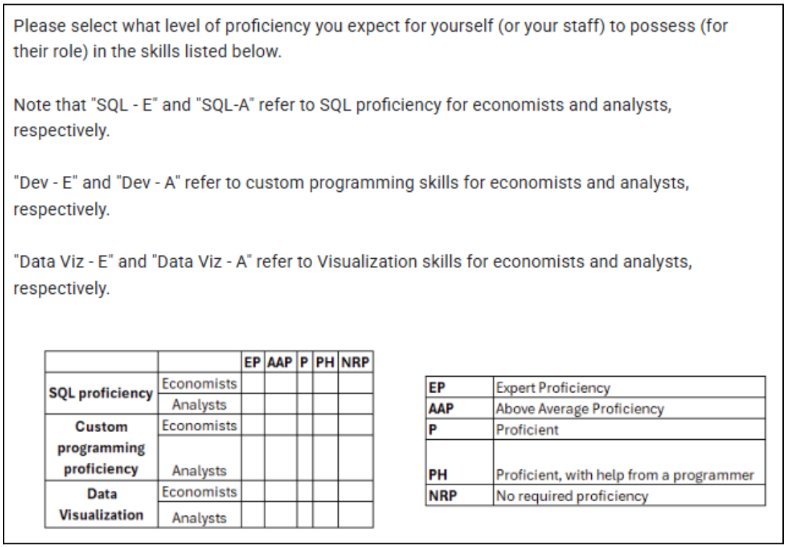
Figure 20 - Sub Questions for Question MC1

Round 2 Questions
Free Response
Question Code | Question | Details
FR10 | Desired feature (other – please explain) | Participants were allowed to include any other feature requests that may not have been explicitly listed in the survey questions
FR11 | For the main types of user roles that are present in your team and/or business unit (Analysts [Market Monitor], Economists, Report Writers, Programmers/Developers, and Management), are there any customizations that you think such a system should use for those roles? Feel free to include use-cases (basic modeling of the market and/or electric system), interface ideas (e.g. a user interface for a market screen), or personal anecdotes
FR12 | Built-in Support for Artificial Intelligence (AI) Processes. To what extent would you like to see artificial intelligence (AI) used in a system like the one posed in this survey study?
FR13 | Barries to Adoption. Please list any barriers to adoption that you see for a system to support market monitors.
FR14 | Follow-up to Validation of Use-Cases. If you selected "None of the Above" or "Other" in the previous question, please include any other use-cases that you would like to see here. Otherwise, feel free to skip this question.
FR15 | If you had a set of commands at your disposal that could perform often tedious tasks that you have to do in your role, what commands would you want? Think about the different types of tasks that you do. This could be anything from contacting market participants, looking up generation resource parameters, shadowing calculations, etc.  An example of such a command could be as simple as DISPLAY (generator/transmission) OUTAGES FROM (timestamp) TO (timestamp) FOR (resource-1, resource-2, resource-3)
FR16 | Comments/Questions for the Researcher. Feel free to include any other comments / questions that you have generated throughout the administration of this survey study.

Multiple Choice
Question Code | Question | Details
MC11 | Data tagging, identification (to make source data easier to find and interpret – data dictionary development)
MC12 | Simplified analysis and/or interfaces for non-technical users (e.g. stakeholders)
MC13 | Easier ways to analyze external, semi-structured or unstructured data
MC14 | Reduced reliance on custom SQL code
MC15 | Automated generation of charts and/or figures to include in reports or stakeholder communications
MC16 | Validation of Use-Cases. The following are several items that were identified by some participants in the previous round of survey questions. Please indicate if any of these use-cases would be important to you in an analysis system built for market monitors (please check all that apply). | Onboarding new staff, Templated Report Generation, Templated Data Ingestion, Counterfactual analysis, None of the Above, Other"
MC17 | Have you found the Delphi Panel methodology of this study insightful at all? | Yes, No, Maybe
MC18 | Did you read the white paper that summarized the results from round #1? | I read all of it, I read some of it, I skimmed it, I did not read it
MC19 | Do you think that using this type of research study (Delphi Method) could be helpful in other areas of market monitoring? | Yes, No, Maybe

Appendix E: Software Bill of Materials (SBOM)
Note that this SBOM only explicitly lists direct dependencies and major transitive dependencies for this project. Minor transitive dependencies are represented in Table XYZ in a summarized format. This SBOM was produced with a combination of a Python utility (“pipdeptree”) and a custom Python script to analyze and produce the summary statistics.
Component | Version | Source | License | Type | Dependency Relationship
Streamlit
Pandas
Openpyxl
Duckdb
Pyarrow
Lark
Vega-Lite
SQLAlchemy
Pyodbc
Geopandas

Appendix F: Proof-of-Concept Version History
TODO: Track the version changes for the proof-of-concept system and include the version history here.

Across the time frame shown in Figure 1, the observed market generated an average revenue of over $9.5 billion, serving and average energy load of over 261 GWh. This figure was generated using data combined from multiple public reports (SPP Market Monitoring Unit, 2021) (SPP Market Monitoring Unit, 2022) (SPP Market Monitoring Unit, 2023) (SPP Market Monitoring Unit, 2024).
See (SPP Market Monitoring Unit, 2021) (SPP Market Monitoring Unit, 2022) (SPP Market Monitoring Unit, 2023) (SPP Market Monitoring Unit, 2024).
The North American Electric Reliability Corporation (NERC) serves as the Electric Reliability Operator (ERO) for the BES. In their Glossary of Terms (see References section), the BES refers to all high-voltage transmission lines and substations, generation resources, and all other equipment used in both inter/intra-state transmission of electric capacity.
The term “balancing” refers to the need to only generate power as it is needed for consumption, subject to system capacity and economic constraints.
Storage resources are a developing technology that can store energy for dispatch during reliability emergencies or intervals of energy scarcity
An important distinction to note is between the utility and retail sectors, shown in Figure 2. While referred to by several names (i.e. wholesale), utility generation and transmission refers to bulk energy (on the scale of MW) that is transmitted on the BES. The retail sector involves distribution of energy to residences and low consumption (on the scale of kW) commercial enterprises. This research focuses on wholesale energy markets and thus is concerned with the bulk energy generation and transmission domains.
Notable weather events that have materially impacted BES reliability include the 2020 Californian heat wave, as well as severe winter weather storms in 2021 and 2022 (NREL).
Economic order refers to the stacking of generator energy offers, in order, from least expensive to most expensive.
Economic dispatch (ED) is a concept that blends economics and the physical reality of the electric grid.
ERCOT, the electric system operator for Texas, is not within the jurisdiction of FERC. The Public Utility Commission of Texas, instead, has oversight of the ERCOT market territory. Alaska and Hawaii, additionally, maintain isolated electricity infrastructure.
The entities referred to in this chapter are not limited to the 2 categories listed. They also include Transmission Owners and Operators (TOs / TOPs), Regional Entities (RE), Balancing Authorities (Bas), Reliability Coordinators (RCs), and Federal Power Agencies. Oftentimes, an RTO or ISO will also support one or more of these functions (SPP, for example, hosts operational desks for performing reliability coordination).
While market systems are composed of many different products, they are generally referred to as a market clearing engine.
Settlements are also facilitated by shadow accounting, a process of maintaining a separate system (in addition to a production accounting system) to track transactions and ensure that accounts are appropriately balanced.
Data elements used to monitor and dispatch generation in the BES are collected and shared in the form of SCADA (Supervisory Control and Data Acquisition) (Inductive Automation, n.d.).
A blackout (an event where power cannot be served) is an event where power cannot be served. It can be generally defined as “any unplanned disruption of electricity service to multiple customers that lasts more than 5 min” (Hines, Apt, & Talukdar, 2009).
As Enron entered legal proceedings, their stock fell to under $1 per share (from a peak as high as $90 per share in mid-2000) (Linder).
18 CFR § 1c.2 is an example of legislation that clearly calls for the need of monitoring in energy markets (Prohibition of Energy Market Manipulation, 2006).
Energy market prices are typically set on a marginal, spatial basis (representing the cost of injecting another MW of energy, at a location, in a market territory) (ISO New England, n.d.).
Bilateral settlement schedules are agreements between market participants that are used to trade energy outside of normal market operations (Southwest Power Pool), which help manage credit exposure in the marketplace.
A tariff is a governing document that outlines the rules for operating (and participating in) an energy market.
The US Energy Association (USEA) published a report outlining international, independent market monitoring groups. Many of the international groups on this list come from that report (see Appendix E).
Market power is often defined as “the ability of a seller to profitably maintain prices above competitive levels for a significant period of time” (Rahimi & Sheffrin, 2003).
CRM is a metric (computed by taking the difference between total available capacity and peak system demand) that helps identify how reliable and prepared the [BES] system has been”, in normal operations (Yang, 2001).
Appendix B contains a listing of different search phrases used for locating relevant research discussed in this chapter.
As of Q1 2025, Southwest Power Pool employs over 800 FTEs (including their internal market monitoring staff).
Kosar, Tomaz, et al. Indicate the “schism” between the two languages by discussing that “GPLs tend to be general, resulting in poor support for domain-specific notation (Kosar, et al., 2010).”
The name “awk” is an acronym formed from the first letters of the developer’s last names.
Current issues in North America show large pockets of stranded load, which have significant economic (and, by extension, reliability) implications. Congestion on the BES constitutes a market (Financial Transmission Rights – FTR) that settles for billions of dollars. This is all due to the fact that monies must be paid to rights holders for transmitting energy across a congested transmission infrastructure.
Atlan, a leading data governance company, classifies a data swamp as a repository that possesses poor quality, undocumented code and data schemas, and leads to situations where users must “...spend considerable time on tasks such as data discovery, cleaning, integration, and management” (Atlan Pte, Ltd., 2023).
A “virtual” transaction (as defined by Southwest Power Pool’s glossary of terms) is a transaction for purchasing (bid) or selling (offer) energy “at a specific price, settlement location, and period of time … that is not associated with a physical load” (Integrated marketplace (imp) glossary, n.d.).
A shift factor is a percentage-based value that determines how much energy a transmission line will receive when a generator injects energy into the transmission grid (Electric Power Engineers, LLC, 2024).
See Appendix D for a list of hyperlinks to view more information on these public sources of energy market data.
The results of this panel shall serve as the basis for constructing a comprehensive software requirements document used during the development of this system.
A given professional is a member of the EISG by virtue of working for an MMU that is an organizational member of the EISG. Many of these member organizations are the same as those listed in Appendix E.
A managerial member of the EISG was contacted via email to receive permission to conduct this study prior to beginning recruitment.
See “Delphi_WaiverInformedConsent_Grasby.pdf” in this GitHub repository, hosted by the researcher at: https://github.com/echarlesgrasby/dissertation/tree/master/ext.
Over 80% of participants in this Delphi panel have 5 years or greater experience in a market monitoring position.
Theme #6 was identified by processing the responses for MC9 and MC10.
See “process_likert_responses_round_2.py” in the following GitHub repository, maintained by the researcher: https://github.com/echarlesgrasby/dissertation/tree/master/snippets.
See Appendix D for more information.
The example referenced in this response comes from FR15 which suggested this syntactic possibility: “DISPLAY (generator/transmission) OUTAGES FROM (timestamp) TO (timestamp) FOR (resource-1, resource-2, resource-3)”
For questions MC11 through MC15, panelists were provided with the following prompt for each question: “The following prompts will ask you to rank your needs for each topic. Please give a 1 – 5 rank. If multiple questions have the same level of importance to you, feel free to use the same ranking value for multiple topics.”

