SEASUG Paper ###-2026
A Domain-Specific Computer Language for Market Monitoring: From Domain Logic to SAS Code
Eric Grasby; Daniel Berleant; Maria CB Gingras

ABSTRACT
This paper presents a proof-of-concept design of a domain-specific language (DSL) for use in wholesale electric market monitoring and applies the DSL to an industry use case. Wholesale electric markets competitively dispatch power plants, while respecting the constraints of the electric grid, to minimize the cost of electricity production. Market monitors are charged with analyzing data from these markets to screen for prohibited behavior among market participants to protect consumers from unduly high prices and to maintain the reliability of the electric grid.
To fulfill their duties, market monitors must extract, transform, and analyze data from multiple sources, often without sophisticated programming skills. Additionally, electric market data is complex and often fragmented, leading to issues that transcend simple programming problems. Together, these issues create a barrier for market monitors to efficiently and accurately complete their duties. This paper presents one viable solution to both problems: a DSL that allows a market monitor to declare the metrics that they wish to analyze and a transpiler that translates their input into valid code. This DSL leverages SAS® data sets for data management and SAS procedures, DATA step programming, and SAS macros to perform transformations.
Finally, this paper illustrates this proposed design by demonstrating how a user can generate SAS code to fulfill common and critical market monitoring tasks.
Keywords: domain-specific language, analyst abstraction, energy market, market monitoring, transpiler

INTRODUCTION
Energy is a ubiquitous commodity; its generation, transmission, and use is present in almost every aspect of modern society. Commonly recognized as the “world’s largest machine” [1], the North American Bulk Electric System (BES) is one of the most important systems to the lives of virtually every resident of the United States, Canada, and a portion of Mexico. Organized energy markets, which use the BES to transmit electricity, are constructs that allow a region to pool electric generating resources across many market participants and centrally commit and dispatch these resources to reliably and economically deliver energy to consumers.
Like any market, electric markets are subject to bad actors. However, when market participants engage in manipulative or fraudulent behavior in the electric market, such behaviors can not only impact prices but threaten the physical security of the electric grid and disrupt electric supply to end consumers. One such example is the fraud perpetrated by the Enron Corporation in the early 2000s. In the aftermath of the Enron scandal [2], the Federal Energy Regulatory Commission (FERC) mandated that all organized energy markets in the United States be independently monitored by an energy market monitoring authority.
By analyzing the detailed data generated by electricity markets, market monitors can scrutinize market transactions and identify malfeasance in physical and virtual power trades as well as opportunities for improvement to market design.
Each market monitoring authority consists of market monitors who are tasked with fulfilling the mandate in CFR 18 35.41 B. are the group of professionals that work to ensure that these markets remain fair, efficient, and open access. Ideally market monitors should be well versed in energy and market policy concepts. However, the nature of the current job landscape also dictates that they possess technical skills in programming and data analysis. The design outlined in this paper intends to put power back in the hands of market monitors. Rather than requiring them to maintain a technical programming skillset, we present a foundation for a domain-specific language (DSL) that allows market monitors to express their analytics in notations better suited to energy data. The language then translates these notations into valid SAS code which can process the energy market data on behalf of the analyst.

BACKGROUND

The business problem: why a domain-specific language?
Systems such as SAS already provide an abstraction layer for data processing – why propose to build a DSL on top of SAS at all? The answer to this question lies in the energy data landscape itself. Although the BES is operationally complex, the surrounding data infrastructure is even more fragmented. Market monitors routinely interact with disparate systems, siloed databases, undocumented schemas, and numerous other information quality issues that can impede their analysis.
Many of these issues are semantic problems, requiring an individual to encode their domain expertise into SAS or SQL scripts. Specialized analytical methods for electricity market analysis continue to be an active area of research [4]. A prevalent example in energy markets involves how timestamps are interpreted across time zones. Because energy market transactions can span across time zones, timestamps on these transactions may be recorded in local time, adjacent market time, or Coordinated Universal Time (UTC/GMT). If the time zone metadata is not readily apparent, analytical queries may produce fundamentally incorrect results, despite being written as syntactically valid.
Modern analytics platforms provide mechanisms for performing these conversions, but they tend to rely on the user understanding and correctly applying the domain-level semantics associated with the data (using the appropriate time zone, for example). By leveraging metadata and domain-aware rules, a DSL can transparently handle these operations without requiring the user to manually account for such details.
The proposed DSL is not intended to replace existing analytics platforms, like SAS, but instead provides a semantic layer that mitigates these information quality risks.

Why SAS®?
Using SAS as the target language for this DSL comes with several advantages. While the design and implementation of this language provide a parser and language transpiler to effectuate the execution of the language, there are other components that are required to provide users with a functional analysis system. These main components include a data processing engine, a reliable data typing scheme, and capabilities for data visualization and basic cartography.
The SAS ecosystem satisfies each of these system requirements. Base SAS and SAS/ACCESS provide mechanisms for processing data, as well as importing and exporting that data from a variety of external systems (including relational databases). When data is loaded from a source system, SAS houses that data in SAS datasets. These datasets, in turn, provide a reliable and universal API for data processing across all other SAS components. Base SAS also ships with a data typing system, so the upstream DSL does not have to enforce strict typing as part of the syntax (which translates to less cognitive burden on the user).
Additionally, the Output Delivery System (ODS) that ships with SAS provides first-class citizens for generating and formatting both data visualization graphs and spatial maps. The ODS principally provides this functionality through the SGPLOT and SGMAP procedures, respectively.
With each of these infrastructural components available within one platform, a DSL can remain focused on allowing the user to write intuitive data logic. It then offloads any technical complexity to SAS and returns results and error messages back to the user.

DELPHI STUDY
To identify relevant use cases during the implementation of this DSL, the researchers chose to proctor a Delphi study. Eligibility to participate in this study was determined by only two (2) requirements:
- The participant must be over the age of 18
- The participant must be a member of the Energy Intermarket Surveillance Group (EISG)
These eligibility requirements were introduced to both adhere to responsible research ethics and to establish a definition of “expert opinion” provided by each participant. Plainly, this ensured that the survey questions posed in this study were answered by the same individuals that may use a purpose-made DSL for energy market analytics. The study was conducted in two (2) rounds, where a round corresponds to a group of survey questions that were provided to the participants. These included a list of free-form text responses, multiple choice questions, and questions provided in a Likert format.

Panel Composition
At the time of administering this study, the EISG held a roster of 131 active members. Round #1 yielded a roughly 15% response rate (19 confirmed individuals participated in the first round). Only 11 of the original 19 participants elected to respond to round #2 (roughly a 58% retention rate of the original participants). Of the panelists, 16 of the EISG members were US-based market monitors. The remaining 3 worked for an internationally based market monitoring unit. Table 1 displays the professional role mix of the panelists, indicating that market monitoring analysts make up the largest portion of the panelists, with a mix of other roles including management, economists, data scientists, and a developer.

Role | Count of Role in Panel | Percentage (%)
Market Monitor (Analyst) | 13 | 68%
Management | 4 | 21%
Economist | 3 | 16%
Data Scientist | 2 | 11%
Developer/IT | 1 | 5%
Table 1. Professional Role Mix of Delphi Panel
In addition to a varied representational mix of professional market monitors, the Delphi participants also varied in their “length of tenure” at a market monitoring position. Table 2 identifies the tenure ranges of the participants. Panelists ranged in experience from fresh analysts (0-2 years, 16% of the initial panel) to a full career in energy market monitoring (greater than 20 years of experience, 11% of the initial panel). This panelist cross-section helps to ensure that the requirements developed for the DSL are applicable to a wider range of users.
Tenure Range | Participant Count | Percentage (%)
0-2 years | 3 | 16%
5-10 years | 6 | 32%
10-15 years | 7 | 37%
15-20 years | 1 | 5%
Greater than 20 years | 2 | 11%
Table 2. Tenure range of Delphi Panel

Thematic Coding
Of the questions posed during the Delphi study, the following are most applicable to determining the features of the language:
- Q5: “What are the primary data challenges that you face in market monitoring?”
- Q7: “Explain the data sources that you read from and write to in the course of your normal work.”
- Q41: “If you had a set of commands at your disposal that could perform often tedious tasks that you have to do in your role, what commands would you want?”
The participant responses were processed using thematic coding to identify the common data needs across the market monitoring discipline. The researchers analyzed individual responses for each question (49 total responses for the three questions discussed in this paper) and assigned initial codes to each response. The initial codes were then grouped into overarching themes, from which the language requirements are derived. Table 3, Table 4, and Table 5 show the final themes identified in each question, including the mention frequency from the participants, for Delphi study questions 5, 7, and 41, respectively.
Theme | Number of Mentions
Data Quality and Literacy | 6
Data Integration | 4
Data Volume and Scalability | 4
Metadata, Discovery, and Documentation | 4
Infrastructure and Computing Resources | 2
Analytics Lifecycle Management | 1
Visualization Creation and Reporting | 1
Data Governance | 1
Table 3. Coded Themes from Question 5
Theme | Number of Mentions
Database | 15
CSV | 9
Excel | 4
Vendor Data | 4
Public Data | 4
API | 4
SAS | 2
XML | 1
Table 4. Coded Themes from Question 7
Theme | Initial Thematic Codes | Number of Mentions
Market Surveillance and Monitoring | Display units that impact system constraints, show outages, identify data that correlates with outages, analyze profit and loss, analyze virtual transactions, identify demand response resources, shadow calculations | 7
Data Exploration and Querying | Show congested flowgates, “Display X For Period Y”, Perform “drill downs” | 4
Validation and Quality Assurance | Validate mitigated energy offers, validate meter data submissions, | 2
Portfolio and Resource Analysis | Analyze resources by various dimensions (fuel type, time-period, zone, affiliate entity) | 2
Metadata and Domain Knowledge | Metadata management, governance | 1
Reporting and Automation | Generate automated reports | 1
Table 5. Coded Themes from Question 41

Derived requirements and use cases
Once thematic coding was completed, the researchers used the resultant themes to derive basic requirements and possible use cases for the language proof-of-concept and implementation. These requirements are intentionally broad, as much of the functionality of this system is also determined by what a specific user base (set of market monitors) would request. Table 6 displays the derived requirements.
ID | Requirement | Passing Criteria
1 | The language shall be declarative. A user can define what they want the analysis and/or output to be, and the transpiler generates code in the target language to accomplish the task. | The user can write a script in the language’s declarative grammar and receives transpiled code in the target language.
2 | The language, where possible, should infer metadata needed for data selection, transformations, and filter criteria from a metadata repository. | The user can use the language to define metadata (e.g. tags) and associate it with a data set.
3 | The language shall, at a minimum, support database queries and CSV files as both read and write targets. The leading 2 data sources mentioned by Delphi participants. | A user can specify a database connection, CSV file paths, or both, and use these as sources and destinations for sourcing and sinking data.
4 | The language shall allow the user to generate textual reports of pre-defined metrics. These metrics are included as first-class citizens in the language. Examples include: calculating the Herfindahl-Hirschmann Index (HHI) for an operating period of an energy market. | The user can calculate the HHI for an operating period and retrieve this value from a report.
5 | The language shall allow the user to generate simple visualizations of pre-defined metrics to support market reporting. Examples include: generating fleet fuel-mix or capacity of generation on outage, or locating generating facilities or constraints on a cartographic map. | The user can create some pre-defined visualizations that provide metrics for market reporting.
Table 6. Derived DSL Requirements
From these requirements, the following use cases were selected. These are intended to display that the derived requirements are met by the prototype:
- Data loading and exporting
- Beginner-friendly data traceability
- Basic data visualization and calculation of metrics

Test Data
Briefly discuss the test data that will be used to satisfy the use cases.

DOMAIN-SPECIFIC LANGUAGE DESIGN

Limitations / Constraints
- Use of the resultant SAS code requires manual intervention (the user manually uploads the code to SODA)
- Execution model is currently solely preprocessor directives

Grammar specification
Discuss Lark grammar and provide an example of what you have so far…

Example DSL scripts
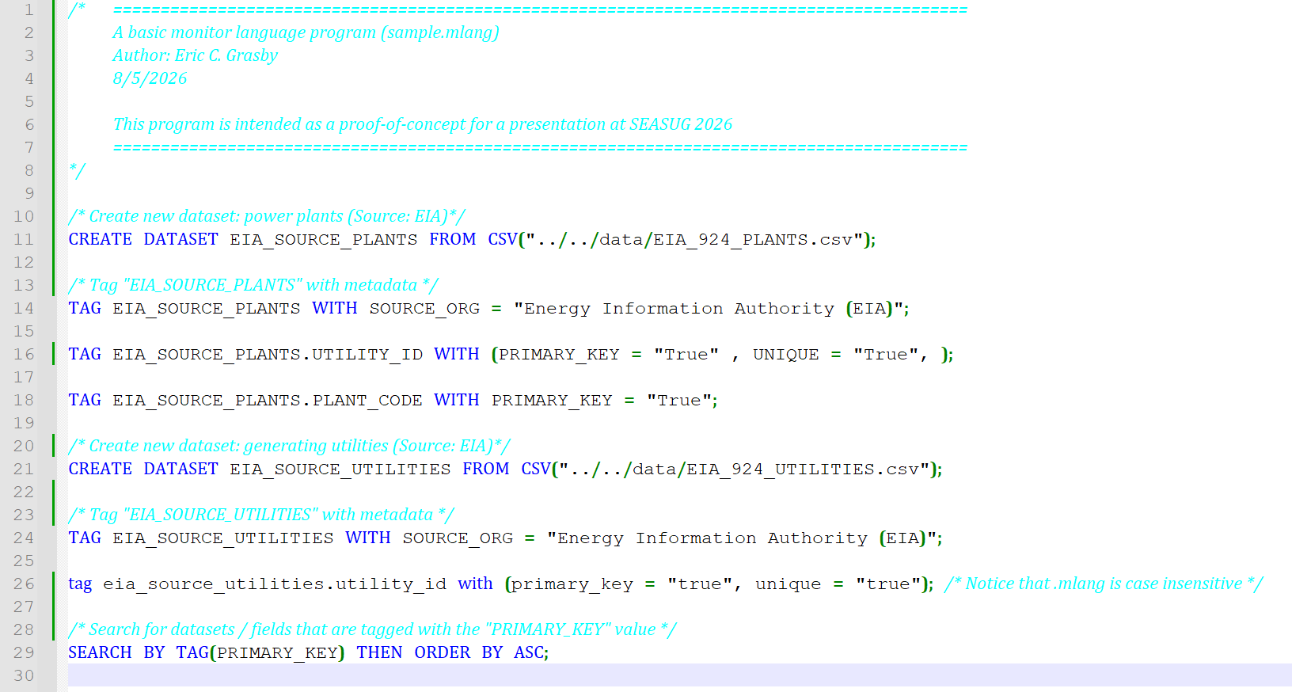
Figure 1. DSL program for importing and tagging market data
Include sample DSL scripts here that satisfy the use cases, or reference them in the Appendix

TRANSPILER IMPLEMENTATION
To implement this domain-specific language, the researchers used two (2) main technologies: Python (including the Lark parser framework [6]) and the SAS® OnDemand for Academics (SODA) [7] environment. The authors created a Python library that defines the grammar of the DSL, builds the lexer, parser, and transpiler, and then outputs valid SAS code. The code is then uploaded to SODA to check for execution errors and to retrieve any results.

Parser and transpiler architecture
Transpiler process flow shown below:
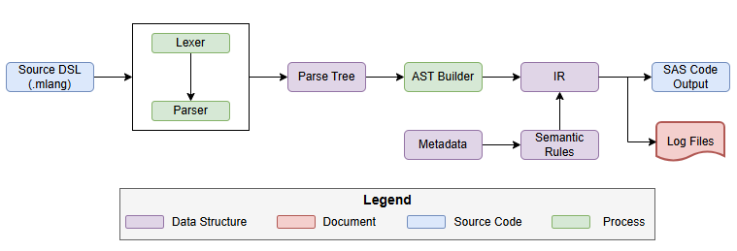
Figure 2. Source DSL to SAS code transpiler process

Transpiler strategy

Offloading procedural functionality to SAS

CONCLUSION
Conclusions…

Limitations
Given that this paper provides proof-of-concept for this DSL, there are several limitations with the current implementation of this solution, namely:
- The execution model of this DSL exists solely as preprocessor directives
- Use of the resultant SAS code requires manual intervention

Future Work
This paper presents a practical foundation for translating a custom domain-specific language into valid SAS code. Given the identified limitations of this current approach, the authors believe that the following areas are possible opportunities for future work on this system. Such future work topics include (but are not limited to): integrating language server protocol support, enhancing the current error handling feedback from the transpiler layer, and integrating the generated SAS output with a SAS runtime environment.

REFERENCES
[1] Oak Ridge National Laboratory, “Nils Stenvig: Exploring the world’s largest machine |ORNL.” https://www.ornl.gov/blog/nils-stenvig-exploring-worlds-largest-machine.
[2] P. Bondarenko, “Enron Scandal - Downfall and Bankruptcy,” Nov. 2024. Accessed: July 20, 2026. [Online]. Available: https://www.britannica.com/event/Enron-scandal/Downfall-and-bankruptcy
[3] Market behavior rules, 18 CFR § 35.41 B (2007). [Online] Available: https://www.ecfr.gov/current/title-18/chapter-I/subchapter-B/part-35/subpart-H/section-35.41
[4] M.-P. Cheong, D. Berleant, and G. Sheblé, “Information Gap Decision Theory as a tool for strategic bidding in competitive electricity markets,” Proceedings, 8th Int. Conf. on Probabilistic Methods Applied to Power Systems, Sept. 12-16, 2004, Ames, Iowa. [Online] Available: https://dberleant.github.io/papers/Mei_PMAPS04a.pdf
[5] S. Chuenjitwongsa, “How to: Conduct a Delphi Study,” Cardiff University, 2017. https://www.cardiff.ac.uk/__data/assets/pdf_file/0010/1164961/how_to_conduct_a_delphistudy.pdf
[6] E. Shinan and Contributors, “Lark: A parsing toolkit for Python,” GitHub. [Online]. Available: https://github.com/lark-parser/lark
[7] SAS Institute Inc., SAS® Studio: OnDemand for Academics. Cary, NC: SAS Institute Inc. [Online]. Available: https://www.sas.com/en_us/software/on-demand-for-academics.html

ACKNOWLEDGMENTS
We would like to acknowledge SPP and the Energy Information Authority (EIA) for providing sources of publicly available data which made the construction and evaluation of this project possible. Readers are encouraged to visit the following organizations’ websites for more information on sources of energy data:
- SPP (formerly Southwest Power Pool)
  - https://portal.spp.org/groups/integrated-marketplace
- EIA – The Energy Information Authority
  - https://www.eia.gov/electricity/
We would also like to acknowledge the members of the EISG that volunteered to participate in the Delphi study. Their responses were instrumental in influencing the design of this language and its tooling. Additionally, Eric would like to acknowledge both Mark Rouse and Bartosz “Bart” Jabłoński for inspiring excitement within him for learning SAS.

CONTACT INFORMATION
Your comments and questions are valued and encouraged. Contact the author(s) at:
Eric Grasby
Senior Market Monitor, SPP, Inc.
Doctoral Candidate, UA Little Rock, Department of Information Science
ecgrasby@ualr.edu
https://linkedin.com/in/echarlesgrasby
Daniel Berleant, PhD
Professor, School of Computer and Information Science, UA Little Rock
jdberleant@ualr.edu
https://www.linkedin.com/in/daniel-berleant-4938451/
Maria CB Gingras, PhD
https://www.linkedin.com/in/mariacbrun/

Appendix
See https://github.com/echarlesgrasby/seasug-2026-paper for version-controlled copies and examples of the DSL presented in this paper.

According to CFR 18 35.41 B. a seller (market participant) “must provide accurate and factual information and not submit false or misleading information or omit material information” [3] when communicating with either FERC or a market monitoring authority.
A Delphi study “is a research survey technique used as a way of collecting data from respondents within their domain of expertise.” Put plainly, it is a panel of experts that anonymously respond to survey questions. A researcher then analyzes their results to arrive at a consensus that serves as the solution to a problem. [5]
The Energy Intermarket Surveillance Group (EISG) is the international, professional, conference of energy market monitors. Any given professional is a member of the EISG by virtue of working for an MMU that is an organizational member of the EISG.
The research protocol for this Delphi study was approved by the UA Little Rock Institutional Review Board. The research protocol and copy of the waiver of informed consent can be found in this GitHub repository: https://github.com/echarlesgrasby/dissertation/tree/master/ext.
Participants were allowed to select more than one role that applied to them (in Table 1), so those that chose (Management) are also represented by other roles that they once performed.
Thematic codes are short descriptors attached to qualitative data that are used to identify the meaning of a phrase or response.
The terms lexing (tokenization) and parsing refer to distinct operations in computer science for working with text. A lexer takes an input string and splits it based upon a delimiter (usually a whitespace character) into atomic lexemes (e.g. “Brenda was the best programmer amongst us” would be “lexed” as : [“Brenda”, “was”, “the”, “best”, “programmer”, “amongst”, “us”]). Parsing then takes this tokenized text and applies syntactic rules to it to develop a parse tree (i.e. identifying “Brenda” as the subject of the sentence, “was” as the verb, “programmer” as the direct object, etc.).

