**War, Turmoil, and Tuberculosis Infection Rates: a data analysis  
Introduction**  
 During any public health crisis, national and international cooperation is necessary. Conflict, political turmoil, and violence in a society usually extends to affect other areas of life, such as infectious diseases and public health. Tuberculosis is a respiratory illness that primarily affects the lungs, as well as other parts of the body. It can be dated back to antiquity and is estimated to killing about 1.7 million people every year. Throughout history, the disease has experienced various waves of infection globally. Even in the 21st century there is still a struggle to control and eradicate tuberculosis. However, some countries have succeeded in getting their infection rates extremely low through vaccines and other treatments, while others have seen the opposite (Lawn & Zumla, 2011). Though, there are numerous factors that may be affecting this, war and armed conflicts likely have a significant effect as they inflict both physical and psychological traumas upon populations. For these reasons, war should be seen as an issue concerning both public and global health in which the international community should strive to alleviate. Through this data analysis, I will try to determine whether there is a correlation between infection rates of tuberculosis and nations in wartime.

There is already a decent amount of related research, particularly focusing on Afghanistan. Due to a weak healthcare system and years of armed conflict and poverty, Tuberculosis is a serious public health concern in this region (Okumura, 2002). Research has also been conducted around Europe and various other parts of the world on tuberculosis infectious rates, though not necessarily always considering the influence of war. However, there is plenty of evidence that war and a conflict-stricken society to have adverse effects on physical health.  
 By conducting a survey-adjusted logistic regression analysis, Korinek et al. found that older adults that experienced the Vietnam War in their young adulthood, were more likely to later develop cardiovascular conditions. In particular, women had an increase in likelihood of developing other health conditions, such as hypertension. This demonstrates how armed conflicts not only have immediate effects on one’s life, but also have long term health consequences (2020). Horáčková et al. further confirmed these finding by mapping the problems of Holocaust survivors residing in countries previously in the Soviet Union. Aside from their physical and psychological trauma due to Nazi experiments and torture, the survivors also had more frequent occurrences of osteoporosis, tumours (mostly in the lungs, breast, and colorectum area), gastrointestinal problems, and influences on women’s menstrual cycles (2020). In those of these studies, there is a clear link between population tragedy influencing the future health of victims and survivors.  
 Social conditions have a large effect on the spread of tuberculosis. Collis et al. writes that during World War 1, mortality and infection rates of tuberculosis and influenza likely rose due to weakened immune systems caused by food shortages. These rates rose for all ages, but particularly in young adults and adolescence. The influenza was worldwide, but looking at the mortality rates in England and Wales, there is a dramatic increase during the last year of the war, and then a dramatic decrease in the first year after the war (1940).

In 2009, a study was conducted by Ríos and Monleón-Getino by analyzing WHO data on tuberculosis infection rates in Europe, and used graphic representation to plot the findings. They found that Turkey, Portugal, countries that most recently achieved independence of the Soviet Union (except Armenia), and other eastern European countries had the most reported cases. While countries in Northern and Western Europe such as Norway, Sweden, Denmark, Iceland, the Netherlands, Luxembourg, the United Kingdom, and some Mediterranean countries such as Malta, Cyprus, Italy, and Israel had low rates. While this study did not go in depth to each countries’ political turmoil during these years, it is interesting to note the correlation of higher rates of tuberculosis infection amongst recently independent previous soviet states.  
 In 2016 another study (Eldholm et al.), population genomic analysis was used to determine if armed conflict and population displacement increased the spread and mutations of tuberculosis strains from Central Asia to Europe. The central Asian Clad (CAC) was estimated to have been introduced to Afghanistan coinciding with Soviet occupation between 1979 and 1989. This strain was diagnosed between 2003 and 2015 amongst Afghan refugees in Europe which suggested potentially a reactivation of latent illness. It was then followed by a local outbreak in Norway because of this. Eldholm et al. reflects on this history and concludes that armed conflict via a Soviet invasion, introduced the CAC to Afghanistan. Subsequently, this strain of tuberculosis was further spread to Europe when Afghans took refuge following the American invasion in 2001. Conflict and unstable conditions also contribute to mental illness. In a cross-sectional study conducted in 2019 (Qader et al.), a correlation was found between high rates of tuberculosis amongst mentally ill patients, suggesting the need for more tuberculosis care and prevention within mental health centres.  
 As stated by Zuber (2016) “there can be no sustainable development without peace and no peace without sustainable development”. Undoubtedly, peace and wartime have effects on quality of life, including patterns within health and disease. Shimony et al. also believed that because of the relationship between war and public health, the international community should strive and work together to promote peace and stability within conflict-ridden regions. War is not only a public health concern for the regions directly facing violence, but also for the regions that will likely have to take in refugees and those displaced by the violence. For these reasons, tuberculosis is a global burden, and it is necessary to achieve peace in order to also achieve global health (2019).  
**Methodology**  
 To determine if rates of tuberculosis infection coincide with events of war or armed conflict, I will use global tuberculosis data from between 1995 and 2013 that was compiled by the World Health Organization (2020). I selected this data in particular because tuberculosis is a disease that has been around since antiquity. While it may have gone through periods of higher rates because of a lack of treatment or vaccines, it is not an illness that only existed during a specific moment in history such as the Bubonic Plague, Spanish influenza, or Covid-19. An advantage of this data is that it is of a large sum of countries and is clear and numerical. However, some disadvantages is that some years had data gaps, which I had to filter out for the analysis. Another disadvantage is that it only covers 18 years, which might not give us as extensive of an analysis as it might be if we had more.  
 In total, I chose 9 countries to compare and will divide them up into 3 categories: countries at war in the Middle East, countries that were previously part of the Soviet Union, and countries in Western Europe that were living in peaceful times. My hypothesis is that countries in the Middle East will likely have the highest rates, as it is a region that has seen so much conflict for a long time, particularly during these years. Conversely, countries in Western Europe will likely have the lowest rates, as they did not experience war in this region during these years. To see if my hypothesis is correct, I will look at the data and see if significant increases or decreases in the cases coincide with armed-conflict or other turmoil that was or was not occurring in the regions during these years.

This line graph shows the total cases of tuberculosis between 1995 and 2013 in the Western European countries (France, Ireland, Netherlands). They were chosen to provide a comparison between nations living through times of peace. As predicted, western European countries had the lowest rates of tuberculosis. However, France shows much higher rates than Ireland or the Netherlands, particularly after 2005. Coincidentally, there was a period of violent riots in the suburbs of Paris in 2005 (Salanié et al., 2005).

This line graph shows the total cases of tuberculosis between 1995 and 2013 in countries that were previously a part of the Soviet Union (Belarus, Lithuania, Ukraine). They were chosen to provide a comparison between nations several years after this significant and historic political shift. Though these countries were not necessarily experiencing war, they were experiencing a shift to independence and political turmoil. Belarus and Lithuania remain at relatively low rates, with only occasional slight increases and decreases. The Ukraine however has significantly higher rates. It shows a steady increase from 1995 onward, and then a dramatic decline in 2010, and a dramatic increase after. It is interesting to note that a new president was elected in 2010 and increased again leading up to the Euromaidan Protests in 2013 (Retrieved March 18, 2021 from: <https://www.cfr.org/timeline/ukraines-post-independence-struggles>).

This line graph shows the total cases of tuberculosis between 1995 and 2013 in the Middle East (Afghanistan, Iraq, Yemen). They were chosen to provide a comparison between nations experiencing similar armed-conflicts and political turmoil. As predicted, middle eastern countries most consistently have the highest rates of tuberculosis. Afghanistan in particular, has a steady increase in the early 2000s, likely coincided with the US invasion that occurred during this time. However, there is also a dramatic decrease in the mid-2010s, which may coincide with President Obama announcing the withdrawal of US troops from the country (Retrieved March 18, 2021 from: <https://www.cfr.org/timeline/us-war-afghanistan>). Similarly, Iraq sees a gradual increase coinciding with the Iraq War, and the beginning of a small decline coinciding close to when US troops left in 2011 (Retrieved March 18, 2021 from: <https://www.cfr.org/timeline/iraq-war>).

**Conclusion** Though there are numerous factors that influence tuberculosis infection rates, it is obvious that when a nation is experiencing significant violence, it will coincide with higher rates of illness, as we see in Afghanistan. It is also interesting to note that this can also be true for nations that are not at war, but facing political instability such as the Ukraine or riots such as France. For future research, it should be recommended to look at data covering larger spans of time to see if further patterns can be determined.  
**References**Collis, C.B.E., D.M., M.R.C.P., E. L. (1940). Tuberculosis and influenza in relation to the world war, 1914-18. *Tubercle*, *21*(11-12), 3–16. <https://doi.org/10.1016/s0041-3879(40)80061-5>Council on Foreign Relations. (Retrieved on March 18, 2021). *The Iraq War*. Council on Foreign   
 Relations. <https://www.cfr.org/timeline/iraq-war>Council on Foreign Relations. (Retrieved on March 18, 2021). *Ukraine's Post-Independence   
 Struggles*. Council on Foreign Relations.   
 <https://www.cfr.org/timeline/ukraines-post-independence-struggles>Council on Foreign Relations. (Retrieved on March 18, 2021). *Timeline: U.S. War in Afghanistan*.   
 Council on Foreign Relations. <https://www.cfr.org/timeline/us-war-afghanistan>

 Eldholm, V., Pettersson, J. H., Brynildsrud, O. B., Kitchen, A., Rasmussen, E. M., Lillebaek, T.,   
 Rønning, J. O., Crudu, V., Mengshoel, A. T., Debech, N., Alfsnes, K., Bohlin, J., Pepperell,   
 C. S., & Balloux, F. (2016). Armed conflict and population displacement as drivers of the   
 evolution and dispersal of Mycobacterium tuberculosis. *Proceedings of the National   
 Academy of Sciences of the United States of America*, *113*(48), 13881–13886.   
 <https://doi.org/10.1073/pnas.1611283113>Horáčková, K., Ševčovičová, A., Hrstka, Z., Moravcová, M., Lásková, M., & Derňarová, Ľ. (2020).   
 Consequences of holocaust on physical health of survivors: bibliography review. *Central   
 European journal of public health*, *28*(3), 237–244.   
 <https://doi.org/10.21101/cejph.a5650>

Korinek, K., Young, Y., Teerawichitchainan, B., Kim Chuc, N. T., Kovnick, M., & Zimmer, Z. (2020).   
 Is war hard on the heart? Gender, wartime stress and late life cardiovascular conditions   
 in a population of Vietnamese older adults. *Social science & medicine (1982)*, *265*,   
 113380. <https://doi.org/10.1016/j.socscimed.2020.113380>

Lawn, S. D., & Zumla, A. I. (2011). Tuberculosis. *The Lancet*, *378*(9785), 57–72.   
 <https://doi.org/10.1016/s0140-6736(10)62173-3>Okumura, J. (2002). Reconstruction of healthcare in Afghanistant. *The Lancet*, 359, 1071–1072.

Qader, G., Seddiq, M. K., Rashidi, K. M., Hamim, A., Akhgar, M. H., Ahmad, B., Dryer, S., Somji,   
 A., Melese, M., & Suarez, P. G. (2019). Prevalence of tuberculosis among mentally ill   
 patients in conflict-stricken Afghanistan: A cross-sectional study. *International journal of   
 infectious diseases : IJID : official publication of the International Society for Infectious   
 Diseases*, *89*, 45–50. <https://doi.org/10.1016/j.ijid.2019.08.020>

Ríos, M., & Monleón-Getino, T. (2009). A graphical study of tuberculosis incidence and   
 trends in the WHO's European region (1980-2006). *European journal of epidemiology*,   
 *24*(7), 381–387. <https://doi.org/10.1007/s10654-009-9347-6>Salanié, B., Poupeau, F., Kastoryano, R., Dufoix, S., Cesari, J., Wenden, C. W. de, Roy, O. (2005).   
 *Riots in France*. SSRC Items. <https://items.ssrc.org/category/riots-in-france/>

Shimony, E., Shekhar, A., Bonow, R. O., Mokdad, A., Lupel, A., Rød-Larsen, T., Rudd, K., & Narula, J. (2019). Peace and Epidemiologic Transitions in Patterns of Health and Disease.   
 *European heart journal*, *40*(28), 2286–2288. <https://doi.org/10.1093/eurheartj/ehz471>World Health Organization.  (2020). *Tuberculosis data* (Global Tuberculosis Report) [Data set].    
 United Nations. <https://www.who.int/teams/global-tuberculosis-programme/data>

Zuber, R. (2016). There can be no sustainable development without peace and no peace without sustainable development. In *Spotlights on the SDGs: Global Action to Prevent War, 2*(15), 115-121.

Appendix

WHO TB rates by country 1995-2013

Elisa Chaudet

18/03/2021

This is the evaluation of the data provided by the WHO on TB between 1995-2013.

library(readr)  
library(ggplot2)  
library(dplyr)

##   
## Attaching package: 'dplyr'

## The following objects are masked from 'package:stats':  
##   
## filter, lag

## The following objects are masked from 'package:base':  
##   
## intersect, setdiff, setequal, union

library(knitr)  
library(rmarkdown)  
  
who <- read.csv("who.csv")  
who$total = rowSums(who[,6:61], na.rm=TRUE)  
  
# Plot  
#ggplot(data, aes(x=xValue, y=yValue)) + geom_line()  
  
  
filteredByTotal <- filter(who, total > 0)  
  
ggplot(subset(filteredByTotal, country %in% c("Afghanistan", "Iraq", "Yemen")), aes(x = year, y = total, color=country)) +   
 geom_line() +  
 ggtitle("Total Cases of Tuberculosis Between 1995-2013") +  
 ylab("Number of cases")

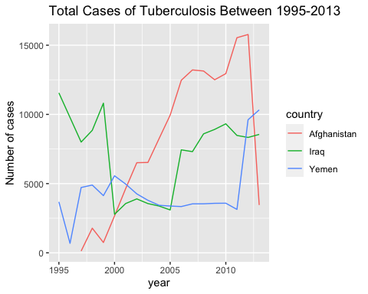

ggsave("all_countries.png")

## Saving 5 x 4 in image

ggplot(subset(filteredByTotal, country %in% c("Netherlands", "Ireland", "France")), aes(x = year, y = total, color=country)) +  
 geom_line() +  
 ggtitle("Total Cases of Tuberculosis Between 1995-2013") +  
 ylab("Number of cases")

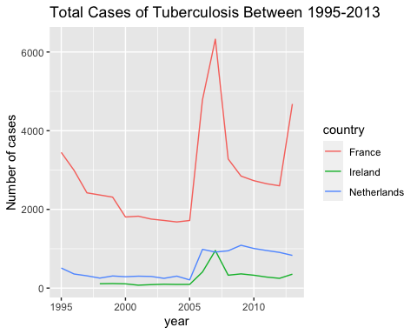

ggsave("all_countries.png")

## Saving 5 x 4 in image

ggplot(subset(filteredByTotal, country %in% c("Lithuania", "Belarus", "Ukraine")), aes(x = year, y = total, color=country)) +   
 geom_line() +  
 ggtitle("Total Cases of Tuberculosis Between 1995-2013") +  
 ylab("Number of cases")

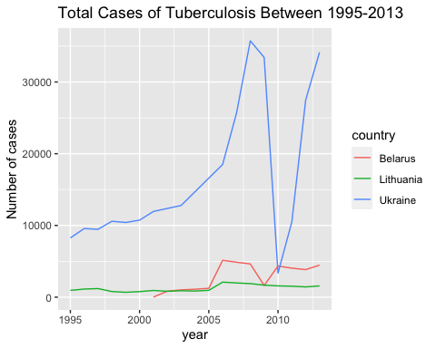

ggsave("all_countries.png")

## Saving 5 x 4 in image

#result <- aggregate(x = who$total, by = list(who$country), FUN = sum)  
#x = result$Group.1  
#y = as.numeric(result$x)  
  
  
#barplot(as.matrix(result$x), main="Total Cases", ylab= "Total", beside=TRUE, col=rainbow(5))